- Question 1 – Audits
As a Business Analyst, quarterly audits (Q1, Q2, Q3, Q4,Q5) are checkpoints to ensure the project is progressing correctly in terms of scope, time, quality, and documentation.
As a Business Analyst, I treat our quarterly audits (Q1, Q2, Q3, and Q4,Q5) as valuable checkpoints to make sure every project stays on track — not just in terms of timelines and scope, but also quality, documentation, and overall alignment between the client and the development team.

Quarter 1 Audit Report (Requirement Gathering Phase)
Stage | Requirement Gathering
Completed | 10 weeks (Task 1 to Task 10)
Checklists | BRD template  Electronic assets report  Deployers assignment report  Grouping of functionalities feature-client signoff  Email communication: To, CC, BCC

Quarter 2 Audit Report (Requirement Analysis Phase)
Stage | Requirement Analysis
Completed | 7 weeks (Task 11 to Task 22)
Checklists | UML diagrams  Domain & functional requirement mapping  Client signoff documentation  RTM (draft) review round  Email communication: To, CC, BCC

Quarter 3 Audit Report (Design Phase)
Stage | Design
Completed | 7 weeks (Task 23 to Task 27)
Checklists | Utilization of tools  Documented evidence on client recommendation  Stakeholder MOMs  Email communication: To, CC, BCC

Quarter 4 Audit Report (Development & Testing Phase)
Stage | Development & Testing
Completed | 8 weeks (Task 28 to Task 35)
Checklists | Development progress report  Unit testing evidence  Defect log and resolution matrix  Code review summary  Email communication: To, CC, BCC

Quarter 5 Audit Report (UAT & Deployment Phase)
Stage | UAT & Deployment
Completed | 6 weeks (Task 36 to Task 42)
Checklists | UAT signoff and feedback summary  Deployment checklist verification  Post-deployment report  Project closure document  Email communication: To, CC, BCC

- Question 2 – BA Approach Strategy
Below is my BA approach strategy for this project:
1. Stakeholder Analysis
- Identify stakeholders like Mr. Henry, Peter, Kevin, Ben, and internal team members.
- Prepare Stakeholder Matrix (interest vs influence).
2. Requirement Elicitation
- Conduct Interviews, Workshops, Brainstorming, Document Analysis, and Prototyping.
3. Documentation
- BRD (Business Requirements Document)
- Use Case Diagram
- SRS (System Requirements Specification)
- Activity Diagrams and Wireframes
4. Requirement Validation and Sign-off
- Review documents with stakeholders.
- Capture changes through formal Change Request process.
5. Communication Strategy
- Weekly meetings with Committee.
- Daily stand-ups with Project Manager and Developers.
- Email and shared folder for document access.
6. Change Request Handling
- Each change is logged, analyzed, effort-estimated, and approved before implementation.
7. UAT Support and Final Sign-off
- Prepare test cases.
- Coordinate testing with users.
- Obtain final UAT sign-off form to close the project.
- Question 3 – 3-Tier Architecture
3-Tier Architecture separates the system into 3 layers:
1. **Presentation Layer (UI/Web/Mobile Screen)**
- What users interact with.
- Example: Login Page, Product Search Page.
2. **Business Logic Layer (Application Layer)**
- Processes rules and decision logic.
- Example: Validating login, calculating prices.
3. **Data Layer (Database Layer)**
- Stores and retrieves data.
- Example: Product Table, User Table.
Text-based Illustration:
[ User Interface ]
|
V
[ Business Logic Layer ]
|
V
[ Database Layer ]
- Question 4 – BA Approach Strategy for Framing Questions
Before framing a question for stakeholders, I keep these points in mind:
- 5W1H (What, Why, Who, Where, When, How)
- SMART (Specific, Measurable, Achievable, Relevant, Time-bound)
- RACI (Who is Responsible, Accountable, Consulted, Informed)
- Reference system architecture: Understanding 3-tier behavior guides my clarity.
- Understand Use Cases and their scope.
- Ensure the question leads to clarity on workflows, UI screens, validations, alternate flows, and dependencies.
Example Thought Process:
Instead of asking “What do you need?”, I ask:
“What tasks should a farmer perform after logging in, and why are these important?”
- Question 5 – Elicitation Techniques
Technique | Description | Sub-Types (if any) | When to Use
1. Interviews | Conducting one-on-one or group discussions with stakeholders to collect detailed qualitative information. | • Structured: Fixed set of predefined questions.• Unstructured: Open-ended and exploratory.• Semi-structured: Combination of both. | When detailed insights or clarifications are needed from SMEs, end users, or clients.
2. Questionnaires / Surveys | Written or digital sets of questions to gather data from a large audience efficiently. | • Open-ended: Allows descriptive responses.• Close-ended: Multiple-choice or scale-based answers. | When you need feedback from a large group or when stakeholders are geographically dispersed.
3. Workshops / JAD (Joint Application Development) | Collaborative sessions between business, development, and user teams to elicit, review, and validate requirements. | • Requirements workshops (for scope & feature definition).• Design workshops (for solution visualization). | When cross-functional collaboration and consensus are required quickly.
4. Brainstorming | A group creativity technique to generate multiple ideas or solutions around a problem. | • Nominal Group Technique (NGT): Participants independently write ideas before discussion.• Round-Robin: Everyone contributes one idea in turns.• Brainwriting: Silent idea generation on paper/digital boards. | During project initiation or when seeking innovative ideas.
5. Document Analysis | Reviewing existing materials (BRDs, manuals, contracts, policy docs) to derive current and potential requirements. | • Process documentation analysis.• System documentation analysis.• Business rules extraction. | When projects involve enhancements, migrations, or replacing existing systems.
6. Observation / Job Shadowing | Watching end-users perform real-life tasks to understand workflows, pain points, and system dependencies. | • Active observation: BA participates in the activity.• Passive observation: BA only observes silently. | When users can’t express their needs clearly or to validate process efficiency.
7. Focus Groups | A moderated group discussion with selected participants to gain insights into user expectations or product usability. | • Exploratory: To discover ideas.• Usability testing: To validate features. | When validating design, features, or user satisfaction.
8. Prototyping | Building visual or functional models to help stakeholders visualize the final product. | • Throwaway / Rapid prototype: Built quickly and discarded after feedback.• Evolutionary prototype: Gradually refined until final system.• Incremental prototype: Developed in small, testable parts.• Extreme prototyping: Used mainly for web applications. | When requirements are unclear or stakeholders prefer visual interaction.
9. Brainwriting | Silent brainstorming technique where participants write down ideas independently, then share them collectively. | • 6-3-5 Method: 6 people write 3 ideas in 5 minutes, then rotate sheets.• Anonymous idea pooling: Digital submissions for unbiased input. | When avoiding bias, dominance, or groupthink in idea sessions.
10. Interface Analysis | Analyzing interactions between users, systems, and external entities to define integration requirements. | • User interface analysis.• System-to-system interface analysis.• Hardware interface analysis. | When defining integration points or data flow between systems.
11. Mind Mapping | Visual diagramming method to represent related ideas, requirements, or dependencies radiating from a central topic. | • Hierarchical maps: Show parent-child relationships.• Concept maps: Show interconnections and dependencies. | When consolidating ideas or simplifying complex requirement relationships.
12. Requirements Workshops (Joint Review Sessions) | Structured sessions to review, validate, or prioritize requirements with stakeholders. | • Review workshop: To validate requirements.• Prioritization workshop: To define MVP or roadmap. | Before final sign-offs or sprint planning, ensuring all stakeholders agree.

Question 6 – This Project: Elicitation Techniques Justification
The following elicitation techniques are suitable:
1. **Prototyping** – Farmers are new to online systems, so showing sample screens will help them express expectations better.
2. **Use Case Specs** – Helps clarify step-by-step interactions.
3. **Document Analysis** – Review similar ecommerce systems for agriculture supply.
4. **Brainstorming** – Conduct group discussions with farmers to understand their buying challenges.
These techniques ensure clarity while keeping the process user-friendly.
Question 7 – 10 Business Requirements
BR001 – Farmers should be able to search for products.
BR002 – Manufacturers should be able to upload products.
BR003 – System should provide a login and registration module.
BR004 – Farmers should be able to add products to cart or wishlist.
BR005 – Secure payment gateway supporting COD, UPI, Debit/Credit.
BR006 – Order confirmation email should be sent after purchase.
BR007 – Delivery tracking should be available for farmers.
BR008 – Admin should be able to approve/reject product listings.
BR009 – Farmers should be able to view order history.
BR010 – System should support rating and feedback for products.
Question 8 – Assumptions
- All users have basic mobile internet access.
- Farmers can understand simple app screens.
- Payment gateway APIs will be available.
- Manufacturers will maintain correct product data.
- Delivery service integration will be handled by external vendor.
Question 9 – Project Requirement Priority
BR001 – 8
BR002 – 8
BR003 – 10
BR004 – 7
BR005 – 9
BR006 – 6
BR007 – 7
BR008 – 6
BR009 – 4
BR010 – 3
Question 10 – Use Case Diagram
Actors: Farmer, Manufacturer, Admin
Farmer ----> (Search Products)
Farmer ----> (Buy Product)
Farmer ----> (Track Delivery)
Manufacturer ----> (Upload Product)
Admin ----> (Approve Product Listings)
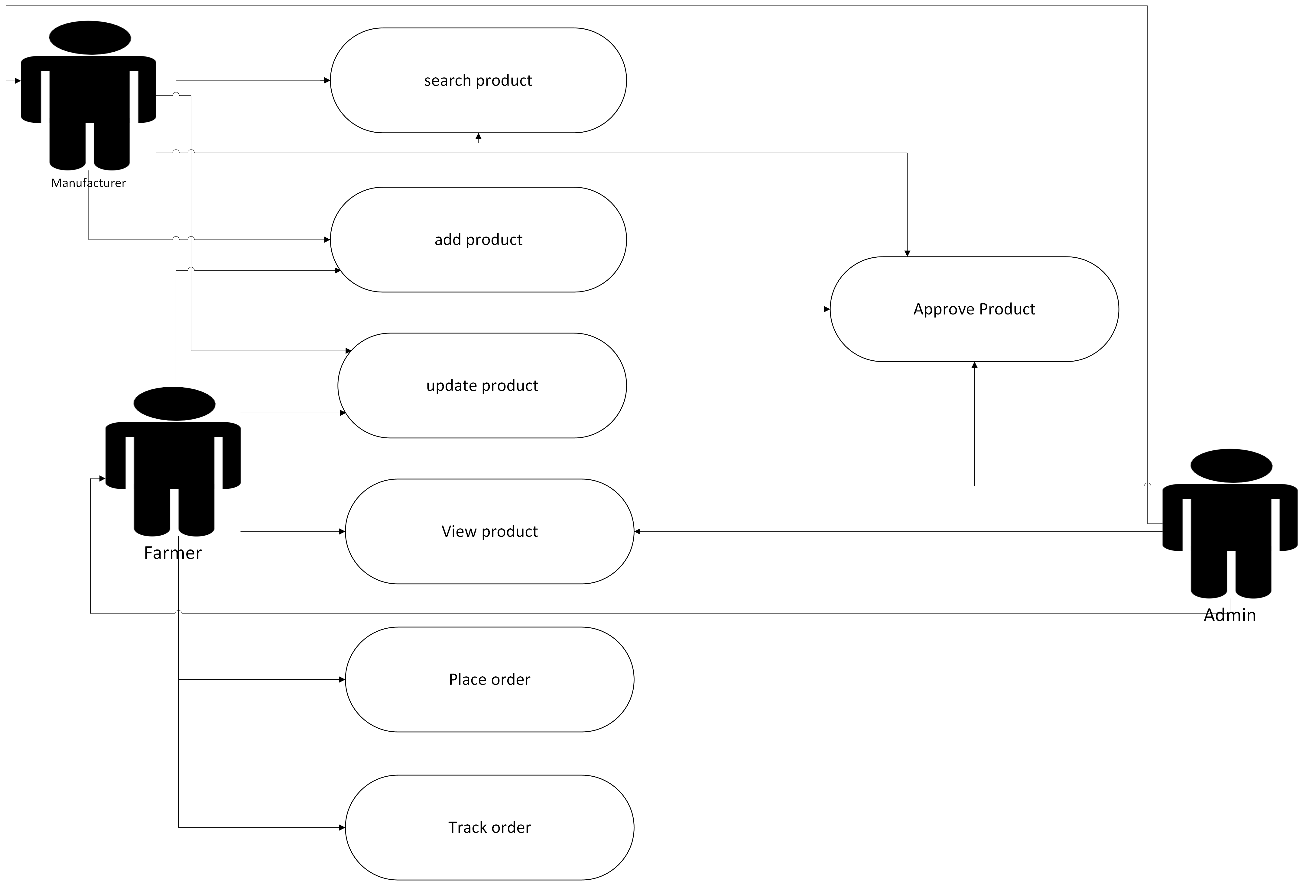

Question 11 – Use Case Specifications (5 Examples)

Use Case Specification Document – Online Agriculture Product Store

UC001 – User Registration
Use Case ID | UC001
Use Case Name | User Registration
Created By | BA Team
Created Date | March 25, 2025
Last Updated | April 1, 2025
Actor | Customer
Description | This use case describes how a user registers an account on the agriculture store platform.
Precondition | User has access to the website or mobile app.
Postcondition | User account is successfully created and stored in the system.
Normal Flow | 1. User clicks on 'Register' option.  2. System displays registration form.  3. User enters details such as name, email, mobile number, and password.  4. System validates the details.  5. System creates a new account and sends a confirmation message.
Alternative Flow | If email already exists, system prompts user to log in instead.
Exception Flow | If network is down, system displays an error message.

UC002 – Browse and Search Agricultural Products
Use Case ID | UC002
Use Case Name | Browse and Search Agricultural Products
Created By | BA Team
Created Date | March 25, 2025
Last Updated | April 1, 2025
Actor | Customer
Description | This use case describes how a user searches and views products available in the store.
Precondition | User must be logged in to access product details.
Postcondition | System displays search results based on user query.
Normal Flow | 1. User enters product name or category in search bar.  2. System retrieves matching results from database.  3. User applies filters like price, brand, and location.  4. System displays filtered product list.  5. User clicks on a product to view its details.
Alternative Flow | If no results found, system displays 'No products available'.

UC003 – Add Products to Cart and Checkout
Use Case ID | UC003
Use Case Name | Add Products to Cart and Checkout
Created By | BA Team
Created Date | March 25, 2025
Last Updated | April 1, 2025
Actor | Customer
Description | This use case describes how a customer adds products to cart and completes the purchase.
Precondition | User is logged in and has selected products.
Postcondition | Order is successfully placed and payment confirmation is received.
Normal Flow | 1. User selects a product and clicks 'Add to Cart'.  2. System adds product to user’s cart.  3. User navigates to cart and clicks 'Checkout'.  4. User enters delivery and payment details.  5. System validates payment and confirms order placement.
Alternative Flow | If payment fails, user is prompted to retry or choose another method.
Exception Flow | If session expires, system requests user to log in again.

UC004 – Manage Orders (Track/Cancel Order)
Use Case ID | UC004
Use Case Name | Manage Orders (Track/Cancel Order)
Created By | BA Team
Created Date | March 25, 2025
Last Updated | April 1, 2025
Actor | Customer
Description | This use case describes how a user tracks or cancels an existing order.
Precondition | User must be logged in and have at least one active order.
Postcondition | Order status updated successfully or order cancellation completed.
Normal Flow | 1. User navigates to 'My Orders' section.  2. System displays list of user orders.  3. User selects an order to view tracking details.  4. If required, user clicks 'Cancel Order'.  5. System updates order status and notifies user.
Alternative Flow | If order already shipped, cancellation is disabled.

UC005 – Admin Manages Product Inventory
Use Case ID | UC005
Use Case Name | Admin Manages Product Inventory
Created By | BA Team
Created Date | March 25, 2025
Last Updated | April 1, 2025
Actor | Admin
Description | This use case describes how the admin adds, updates, or removes products from the inventory.
Precondition | Admin must be logged in with valid credentials.
Postcondition | Product information is successfully updated in the database.
Normal Flow | 1. Admin logs in to the system.  2. Admin navigates to the product management section.  3. Admin adds, edits, or deletes product details.  4. System validates the inputs and updates the database.  5. System confirms successful update.
Alternative Flow | If product ID already exists, system prevents duplicate entry.

Question 12 – Activity Diagrams UC001-

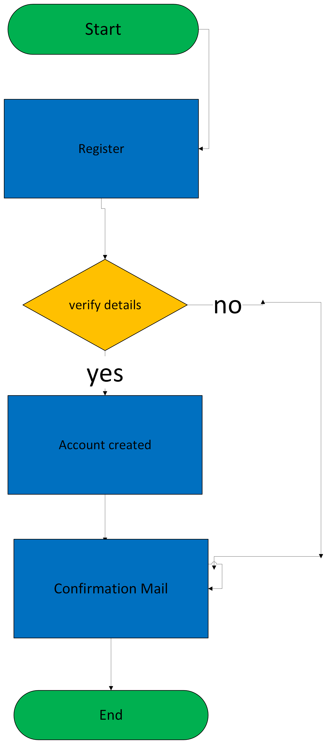
UC002
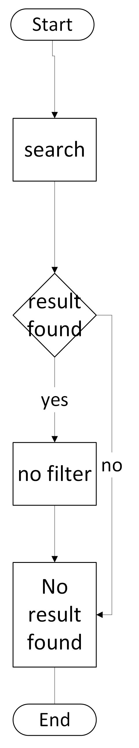

UC003
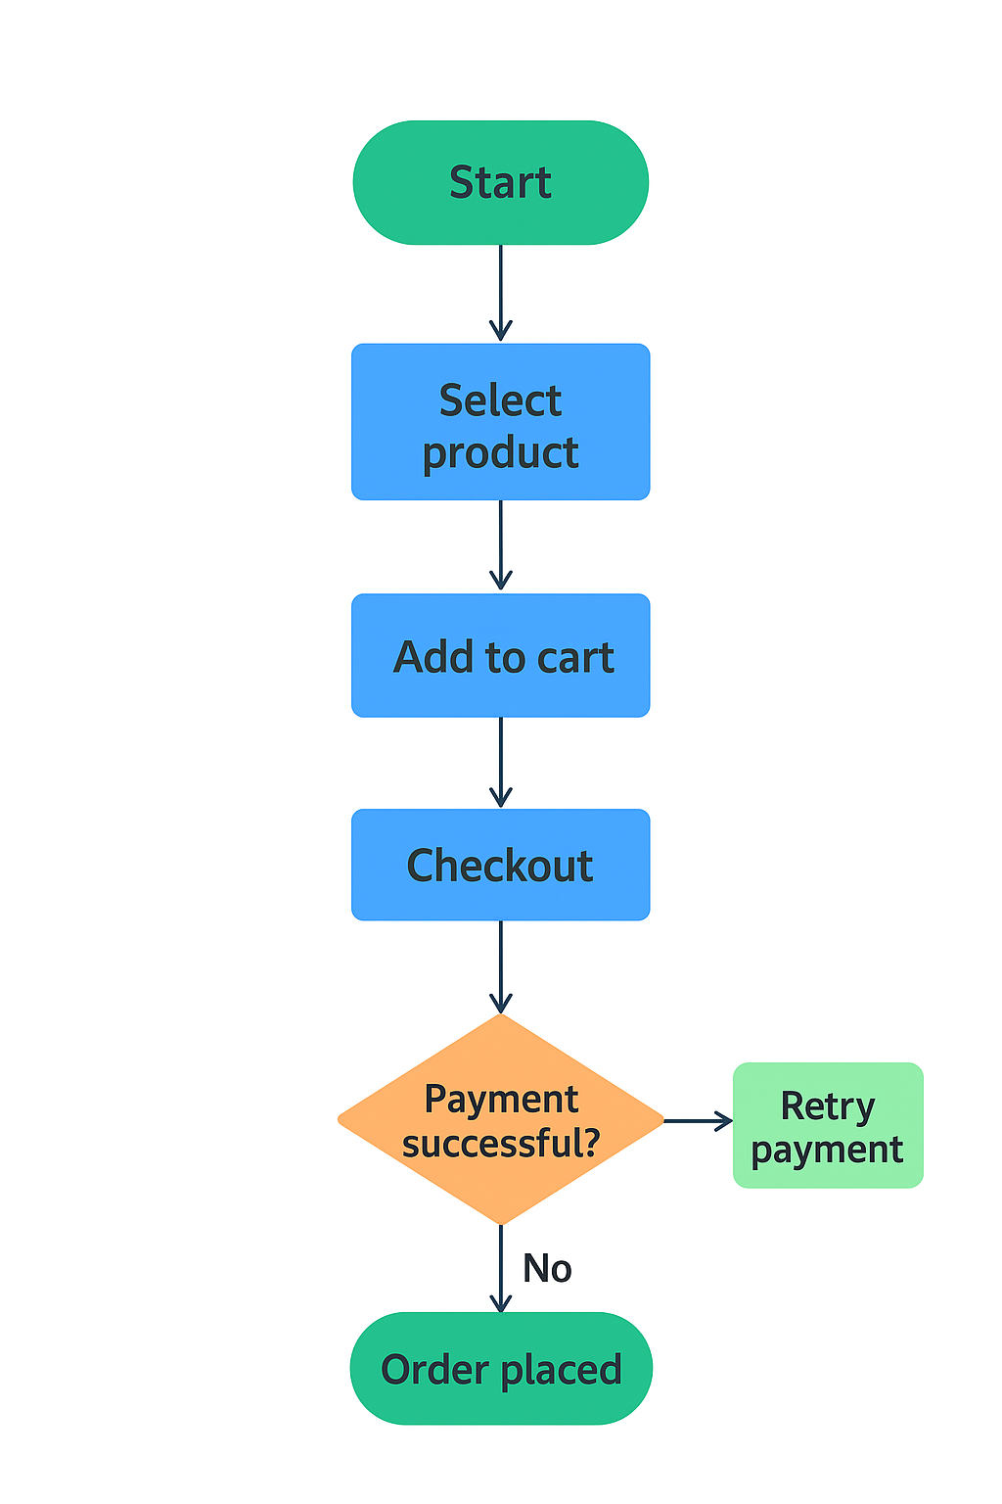

UC004-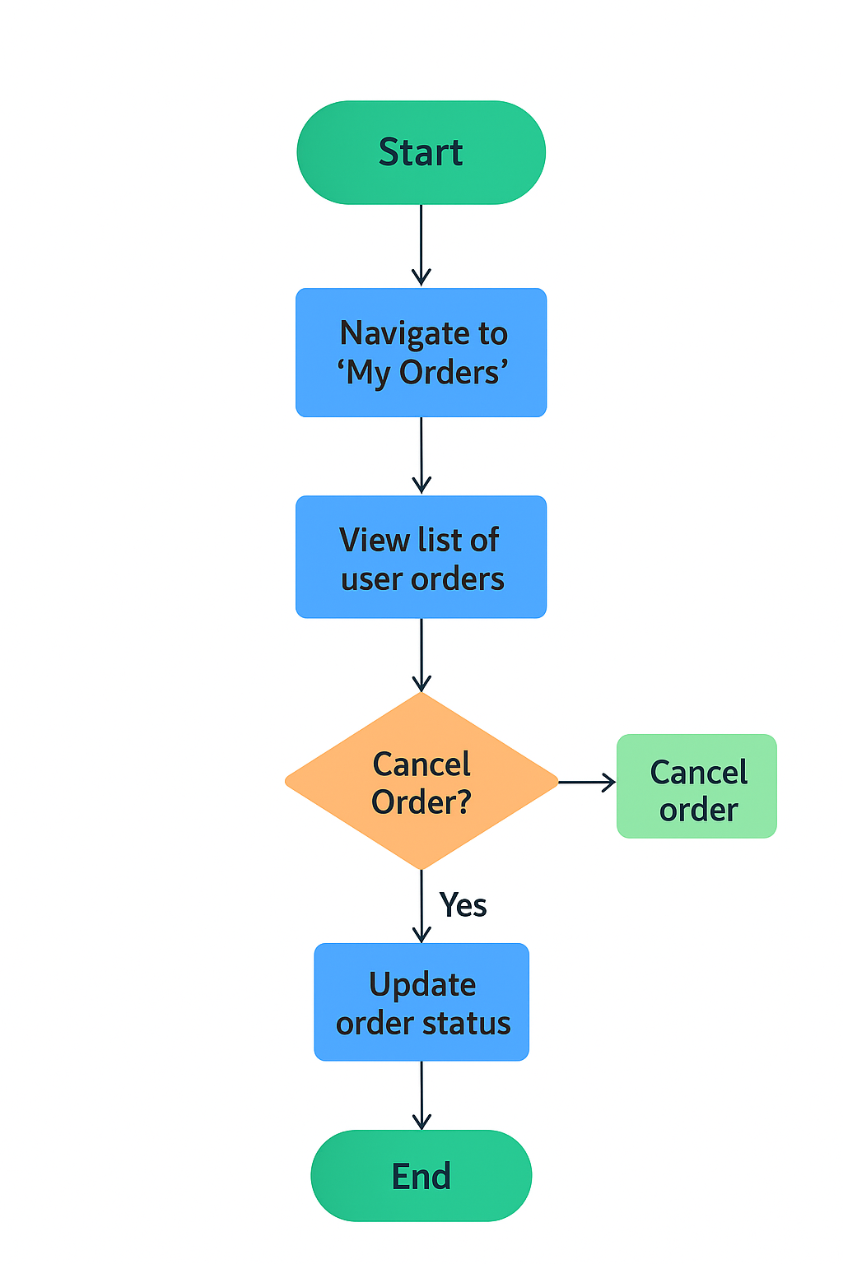

UC005-