Capstone Project1 – Part -3/3
Question 1 – Functional Requirements
1. System should allow to login to user by entering correct user id and password.
2. User should be able to search product by typing on search bar.
3. User should be able to add quantity number.
4. User can add or less the product from cart.
5. User can select the product for buy later.
6. User can add details of delivery i.e. phone number, email id and detailed address.
7. Manufacture should able to create a profile.
8. Manufacturer should able to upload a product details with display picture and instruction with using keywords.
9. System should allow User to add review, feedback with picture, videos and rating.
10. System should automatically show total of all cart items with adding additional taxes and charges for total payment amount.
11. System should give detail bifurcation of total payment amount i.e. product amount +other taxes+ charges minus coupon or discount.
12. User should able to track delivery status of product.
13. User should able to check order history.
14. User should able to payment via credit/debit card and UPI.
15. User should get order confirmation message and mail.
16. Users should able to add any discount and coupon code.
17. User should get forget password option after 3 attempts of incorrect login credential.
18. User should able to browse the categories.
19. System should allow manufacturer to edit, delete the product.
20. The system shall generate a unique order ID for every purchase.

Question 2–Minimum 5 page designs

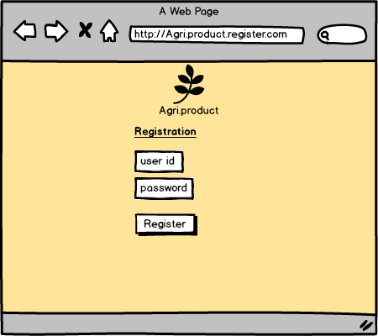

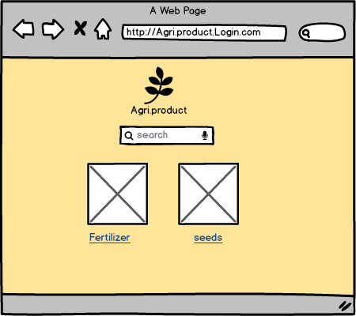
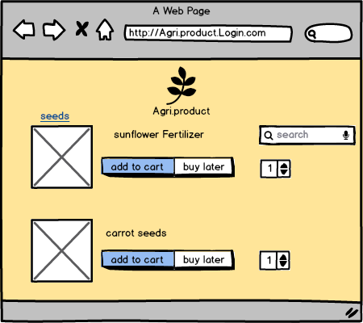
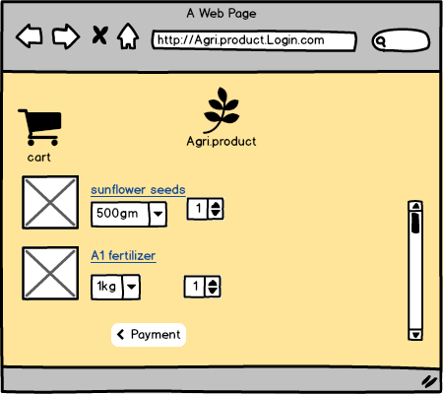
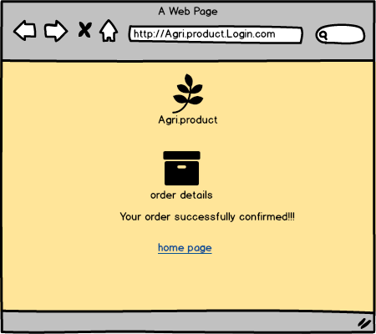

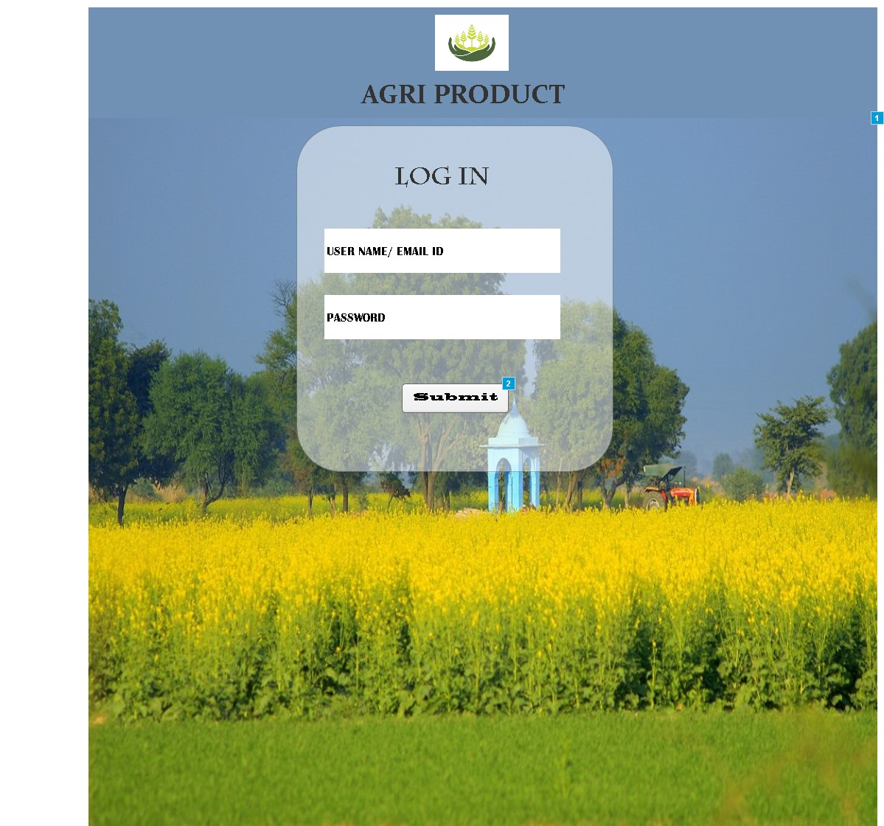

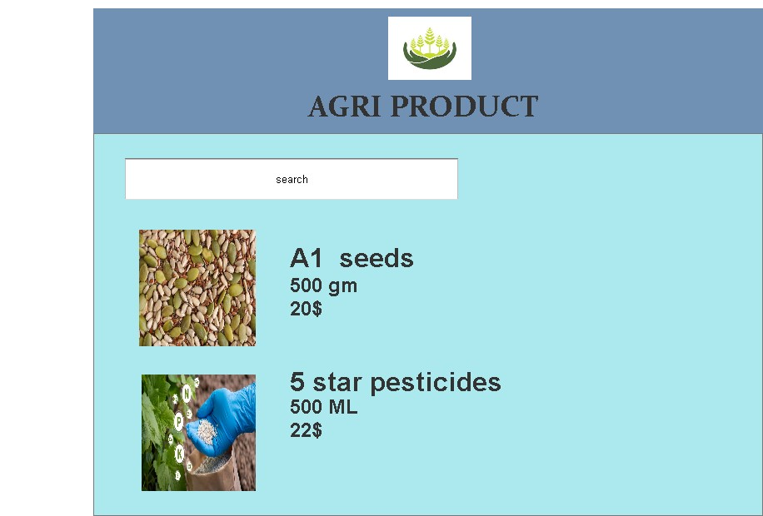
Diagram is Drawn and attached
Question 3 – Tools
1.Microsoft visio
For the preparation of the use case diagrams and activity diagrams of my project titled “Agricultural Online Store”, I have used Microsoft Visio as the primary tool .
Microsoft Visio is a professional diagramming and visualization tool developed by Microsoft, widely used by Business Analysts. It helps in creating clear, structured, and easy-to-understand diagrams that represent business processes, system flows, and data interactions. Visio provides a variety of built-in templates, UML symbols, and connectors, which make it simple to design different types of system diagrams efficiently.

Purpose and Application of Microsoft Visio in My Project: In the Agricultural Online Store project, Microsoft Visio has been used to design the following diagrams:

- Use Case Diagram: Visio helped in representing the interaction between the system and its users such as Manufacturer, users, and Admin. The diagram highlights major functionalities like product registration, browsing agricultural products, placing orders, making payments, and managing inventory. It clearly shows the system boundaries and relationships between various actors and the system’s core functions.

- Activity Diagram: This diagram was prepared in Visio to show the step-by-step flow of operations, such as how a user logs into the system, searches for a product, adds items to the cart, and completes the payment process. The visual flow helped to understand the process sequence, decision points, and overall system workflow, making it easier to identify process improvements.

Advantages
Advantages of Using Microsoft Visio: - Provides ready-made UML and business process templates suitable for all types of system diagrams. - Offers a user-friendly drag-and-drop interface that simplifies the diagram creation process.
Enhances visual clarity and makes documentation more professional and standardized. Allows easy editing, alignment, and formatting of diagrams for presentations and reports. - Ensures consistency and accuracy across all project-related diagrams. - Supports exporting diagrams into multiple formats (PDF, Image, or Word) for project documentation and client communication.
Conclusion:
In conclusion, Microsoft Visio has played a vital role in the design and documentation of my Agricultural Online Store project. It helped me to visualize complex processes in a structured and simplified way. Using Visio, I was able to prepare detailed and professional diagrams that supported requirement understanding, process analysis, and effective communication between stakeholders. Thus, Microsoft Visio proved to be an essential and reliable tool for creating all the system-related concepts and diagrams throughout the project.

2.Balsamiq
For the preparation of the above concepts and user interface designs of my project titled “Agricultural Online Store”, I have used Balsamiq as the primary tool
Balsamiq Mock-ups (or Balsamiq Wireframes) is a popular UI/UX design and prototyping tool used to create low-fidelity wireframes. It helps Business Analysts, Designers, and Developers to visualize and communicate the structure and functionality of a website or an application before actual development begins. The tool allows easy drag-and-drop components and provides a sketch-style interface that focuses more on layout and user experience rather than fine details of design..
Purpose and Application of Balsamiq in My Project: In the Agricultural Online Store project, Balsamiq has been used to design the following mockups and wireframe
- User Registration and Login Screen: I designed wireframes for user registration and login pages. These screens allow both Farmers and Buyers to create their accounts, log in, and access personalized features such as product listings.

- . Product Details Page: I created this page to show product descriptions, specifications, and a "Buy Now" or "Add to Cart" button. The design ensures that users can quickly understand product details before making a purchase decision.

- Shopping Cart and Checkout Page: The mockup for the shopping cart and checkout page shows how users can review selected items, update quantities, and proceed to payment. This helps in visualizing the flow of online transactions and improves user experience during the checkout process.
Advantages
Advantages of Using Balsamiq: - Provides an easy-to-use drag-and-drop interface for quick wireframe creation. - Focuses on functionality and structure instead of visual details, saving time in early design stages. - Enables rapid prototyping and quick feedback from stakeholders. - Supports collaboration and iteration with teams by allowing easy sharing and editing of mockups.
Conclusion:
In conclusion, Balsamiq was an essential tool in designing and conceptualizing the user interface of my Agricultural Online Store project. It helped in representing the structure, layout, and navigation flow of the system efficiently. The tool enabled me to create intuitive and user-friendly wireframes that made it easier to communicate design ideas to stakeholders and developers. Thus, Balsamiq played a crucial role in improving the clarity and quality of the project’s front-end design and ensuring a better user experience overall.

Question 4 – RTM

Question 5 – 10 Test Case Documents
Test case ID | TC001 | Test case NAME | Test security slanders
Project ID | P001 | PROJECT NAME | Online agriculture products store
Pm id | PM001 | Pm name | ABC
Test strategy ID | TS001 | TESTER ID | T001
Test plan ID | TP001 | TESTER NAME | XYZ
Test schedule ID | TC001 | DATE OF TEST | 01.11.2025
Scenario | Verify registration
steps | 1.Enter to application  2.click to registration  3.typer user id and password  4.Register
Input data | Email id-vaishnavi@gmail.com  Password-Vr@123
Expected behaviour | Email id-vaishnavi@gmail.com  Password-Vr@123
Comment
Result | pass

Test case ID | TC002 | Test case NAME | Test security slanders
Project ID | P001 | PROJECT NAME | Online agriculture products store
Pm id | PM001 | Pm name | ABC
Test strategy ID | TS001 | TESTER ID | T001
Test plan ID | TP001 | TESTER NAME | XYZ
Test schedule ID | TC001 | DATE OF TEST | 01.11.2025
Scenario | Verification of log in  With correct credentials
steps | 1.Enter to application  2.click on log in  3. enter registered email and correct password
Input data | Email id-vaishnavi@gmail.com  Password-Vr@123
Expected behaviour | In case of correct credential user will navigate to home page
Comment
Result | pass

Test case ID | TC003 | Test case NAME | Test security slanders
Project ID | P001 | PROJECT NAME | Online agriculture products store
Pm id | PM001 | Pm name | ABC
Test strategy ID | TS001 | TESTER ID | T001
Test plan ID | TP001 | TESTER NAME | XYZ
Test schedule ID | TC001 | DATE OF TEST | 01.11.2025
Scenario | Verification of log in  With incorrect credentials
steps | 1.Enter to application  2.click on log in  3. enter incorrect email and password
Input data | Email id-vai@gmail.com  Password-Vr@1
Expected behaviour | In case of incorrect credential user will not able enter to home page.
Comment
Result | PASS

Test case ID | TC004 | Test case NAME | Test security slanders
Project ID | P001 | PROJECT NAME | Online agriculture products store
Pm id | PM001 | Pm name | ABC
Test strategy ID | TS001 | TESTER ID | T001
Test plan ID | TP001 | TESTER NAME | XYZ
Test schedule ID | TC001 | DATE OF TEST | 01.11.2025
Scenario | Verify user searching via using keywords
steps | 1.Successful log in to application  2.search the product from categories available on home page or click on search button and type keywords
Input data | keyword Fertilizers or seeds
Expected behaviour | List of fertilizer should be displayed to user
Comment
Result | pass

Test case ID | TC005 | Test case NAME | Test security slanders
Project ID | P001 | PROJECT NAME | Online agriculture products store
Pm id | PM001 | Pm name | ABC
Test strategy ID | TS001 | TESTER ID | T001
Test plan ID | TP001 | TESTER NAME | XYZ
Test schedule ID | TC001 | DATE OF TEST | 01.11.2025
Scenario | Verify buy later option
steps | 1.Successful log in to application  2.Find the expected product  3.select quantity  4.click on buy later option
Input data | Click on ‘buy later’
Expected behaviour | Product should be added to list of buy later product
Comment
Result | pass

Test case ID | TC006 | Test case NAME | Test security slanders
Project ID | P001 | PROJECT NAME | Online agriculture products store
Pm id | PM001 | Pm name | ABC
Test strategy ID | TS001 | TESTER ID | T001
Test plan ID | TP001 | TESTER NAME | XYZ
Test schedule ID | TC001 | DATE OF TEST | 01.11.2025
Scenario | Verify buy add to cart
steps | 1.Successful log in to application  2.Find the expected product  3.select quantity  4.click on add to cart option
Input data | Click on ‘add to cart’
Expected behaviour | Product should be added to add to cart option.
Comment
Result | pass

Test case ID | TC007 | Test case NAME | Test security slanders
Project ID | P001 | PROJECT NAME | Online agriculture products store
Pm id | PM001 | Pm name | ABC
Test strategy ID | TS001 | TESTER ID | T001
Test plan ID | TP001 | TESTER NAME | XYZ
Test schedule ID | TC001 | DATE OF TEST | 01.11.2025
Scenario | Verify payment bill slip
steps | 1.Successful log in to application  2.Find the expected product  3.select quantity  4.click on add to cart option
Input data | Add one or more product into cart.
Expected behaviour | Payment total should include the total of all cart items price with adding additional charges.
Comment
Result | pass

Test case ID | TC008 | Test case NAME | Test security slanders
Project ID | P001 | PROJECT NAME | Online agriculture products store
Pm id | PM001 | Pm name | ABC
Test strategy ID | TS001 | TESTER ID | T001
Test plan ID | TP001 | TESTER NAME | XYZ
Test schedule ID | TC001 | DATE OF TEST | 01.11.2025
Scenario | Verify the payment selection options
steps | 1.Successful log in to application  2.Find the expected product  3.select quantity  4.click on add to cart option  5.click on payment
Input data | Click on payment option
Expected behaviour | Multiple payment options should be available for all users.
Comment
Result | pass

Test case ID | TC009 | Test case NAME | Test security slanders
Project ID | P001 | PROJECT NAME | Online agriculture products store
Pm id | PM001 | Pm name | ABC
Test strategy ID | TS001 | TESTER ID | T001
Test plan ID | TP001 | TESTER NAME | XYZ
Test schedule ID | TC001 | DATE OF TEST | 01.11.2025
Scenario | Verify the successful payment.
steps | 1.Successful log in to application  2.Find the expected product  3.select quantity  4.click on add to cart option  5.click on payment  6.select respected payment option  8.processing payment successfully
Input data | Click on respected payment option  And payment in done successfully
Expected behaviour | Order confirmation status page should pop up with order id
Comment
Result | pass

Test case ID | TC0010 | Test case NAME | Test security slanders
Project ID | P001 | PROJECT NAME | Online agriculture products store
Pm id | PM001 | Pm name | ABC
Test strategy ID | TS001 | TESTER ID | T001
Test plan ID | TP001 | TESTER NAME | XYZ
Test schedule ID | TC001 | DATE OF TEST | 01.11.2025
Scenario | Verify order confirmation
steps | 1.Successful log in to application  2.Find the expected product  3.select quantity  4.click on add to cart option  5.click on payment  6.select respected payment option  8.succefully payment done  9. Receives order confirmation.
Input data | Successfully payment done.
Expected behaviour | Order confirmation mail should be received in registered mail id
Comment
Result | pass

Question 6 – DB Design

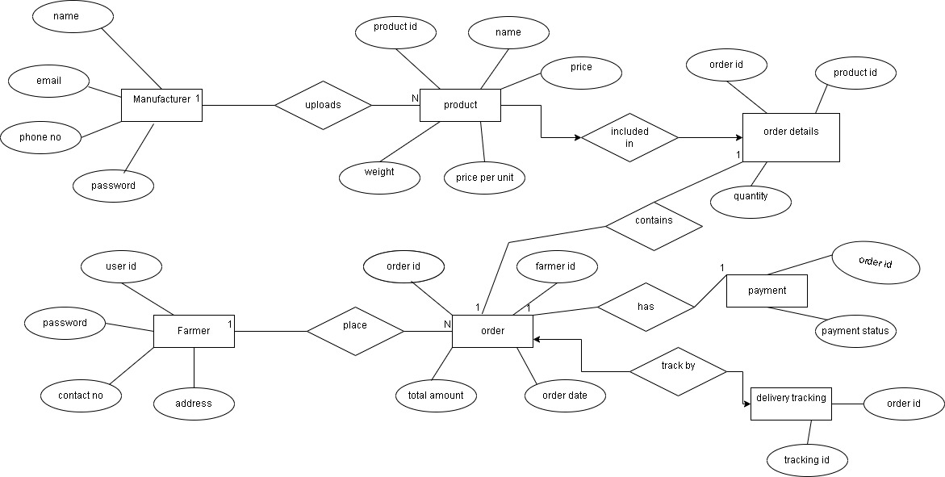

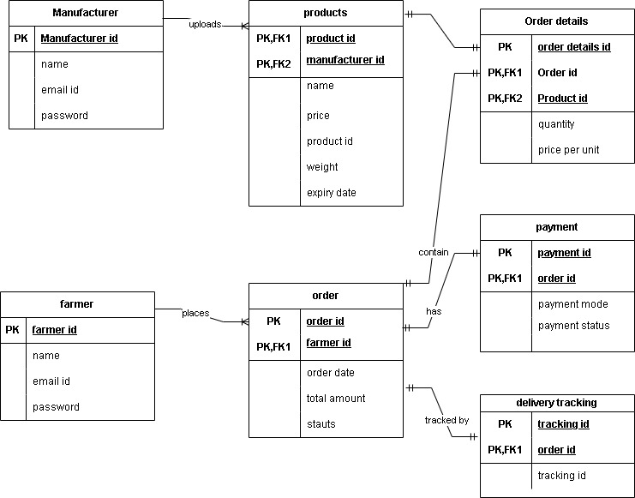

Question 7 – Data Flow Diagram

A Data Flow Diagram (DFD) is a graphical representation that shows how data moves through a system. It illustrates the flow of information between processes, data stores, and external entities. DFD helps to understand how input data is transformed into output through various system processes.

Example – Farmer Placing an Order When a farmer places an order for a product, the data flows between the Farmer, Order Management System, Product Database, and manufacturer.

Level 1 DFD Description: 1. Farmer sends order details (Product ID, Quantity) → Order System 2. Order System checks Product Database for availability 3. If available, Order System sends confirmation to Farmer and forwards order to Supplier for delivery 4. Supplier updates Order System after dispatching the product

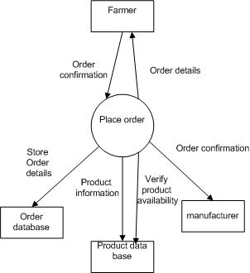

Question 8 – Change Request
Step 1- Receive and document the change request
- Record the details of change.
- Identify who requested a changes
- Use a change request form to document
1.Descrpition of change
2.Reason for change
3.Date of request
4.Requested by
Step2-change Impact analysis-
- Scope-does it add or remove the requirement (new tax rule, modified the calculations)
- Schedule-will timeline need adjustment.
- Cost-any additional cost(development, testing, compliance)
- Quality-will quality standards or deliverables be affected
- Resources- Does extra team, skills, team needed
- Risk-what new risks does the change introduce
Step3- Review and approval
- Present the analysis to change control board or project sponsors.
- The board will decide where to approve, defer or reject the change.
- Document the decision and take final sign off.
Step 4- Update the project plan
If approves
- Update the project plan, schedule, budget and scope statement.
- Adjust the risk register and communicate plan with team
- Inform all stakeholder of approval change request and its impact.
Question 9 – Change Request Vs an Enhancement

- Acknowledge the Request –
Thank you, Ben and Kevin, for sharing the new idea about allowing Farmers to sell their crop yields through the application and introducing an auction system. I understand this feature will enable Farmers to list their products, display them publicly, and sell them directly to customers.

- Classify the Request -
Since the project is already in process and this new functionality was not part of the original scope or baseline requirements, this is considered a Change Request (CR).

- Justification
This request adds new features (product listing, selling, and auction functionality) that weren’t initially planned. It may impact project timelines, budget, system design, database, and testing. It needs to go through a formal change control process to assess feasibility, effort, and impact.

- Next Steps as a BA
• Document the Change Request in the Change Request Form (CRF).
• Conduct an impact analysis (on scope, cost, schedule, and quality).
• Get approval from the project sponsor or change control board (CCB)
• Once approved, update: BRD, FRS, and Project Plan/Timelines.
If the original project scope already included a selling module (but without auction), and only the auction is being added, it could be considered an Enhancement — a minor improvement within the existing scope.

Question 10 – Estimations
Man hours are the required efforts of the resources to complete the project. There are three type of project.
- Small-up to 500 hrs.
- Medium-up to 1000 hrs.
- Large-up to 1500 hrs.
Analysis-
- As per the case study duration of this project is 18 months and current time size is around 11. This will come under medium project
- As trained resources available, trainers are not required.
- As a structured of the project is available. New enhancement infrastructure is not required.
Question 11 – UAT
Handling the UAT Phase
Step 1: Preparation for UAT
Before UAT begins, the BA ensures that all testing is complete, a UAT environment is ready, and test cases and data are approved by the client. Documents prepared include:
• UAT Test Plan.
• UAT Test Cases.
• UAT Entry & Exit Criteria.
• UAT Schedule and Sign-off template.
Step 2: Conducting
UAT during UAT, the client tests the system using real-world business scenarios. The BA coordinates between the client and technical team, tracks defects, and ensures issues are resolved.
• Schedule UAT sessions
• Provide demo/walkthrough
• Record feedback and issues
• Track defect logs
Step 3: UAT Sign-off
Once the client is satisfied, a UAT Sign-off Document is signed confirming the system meets business requirements. Deliverables include:
• UAT Summary Report
• Defect Resolution Report
• UAT Sign-off Document .

Question 12 – Project Closure Document
Step 1: Production Deployment
Deploy the system to production and ensure configurations, roles, and data are correct.
Step 2: Project Closure Activities
Conduct final review, ensure all deliverables are complete, collect client feedback, and prepare a Project Closure Report with lessons learned and pending items.
Step 3: Handover and Documentation
Ensure all documents (BRD, FRD, test cases, reports and manuals) are handed over. Conduct knowledge transfer sessions to the support team.

Step 4: Closure Sign-off.
Obtain final approval from client and internal management to officially close the project.

