Capstone Project 1 Part 2

Prepared By Mayur Mange
Batch 12th April, 2025

Online Agriculture Products Store

Question 1. 5 Quarterly Audits are planned Q1, Q2, Q3, Q4, Q5 for this Project
What is your knowledge on how these audits will happen for a BA?

Answer :
Company: APT IT Solutions
Client: SOONY (CSR Initiative by Mr. Henry and Committee)
Audit is a formal review that is involved in assessing and analyzing business process,
System and data to ensure compliance with regulations. Following are the Audits that
will happen for a BA

Stage | Quarter 1 Audit Report (Requirement Gathering Phase)
Completed | 10 Weeks (Week 1 to Week 10)
Check list | BRD Template
 | Elicitation Result Report
 | Duplicate Requirement Report
 | Grouping of Functionalities/Features-client signoff
 | Email Communication – To, CC, Bcc

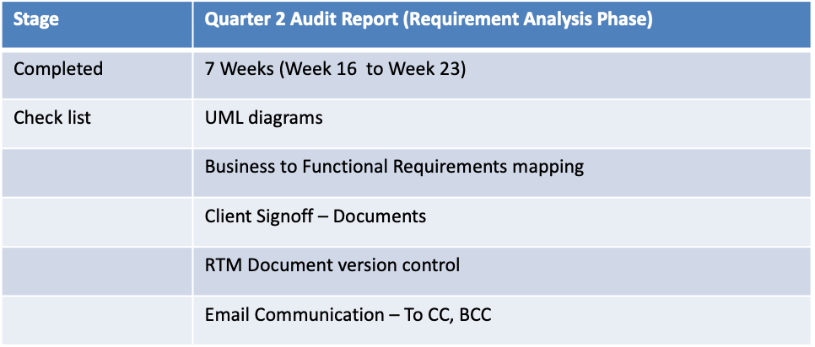

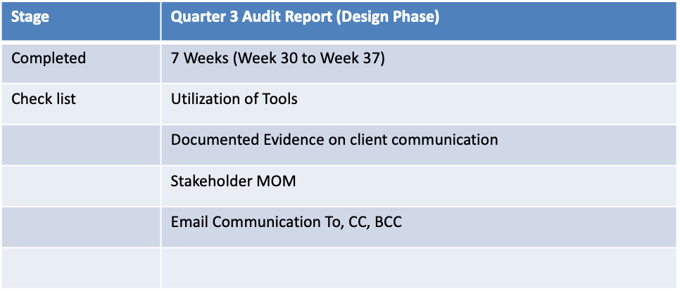

Stage | Quarter 4 Audit Report (Development)
Completed | 20 Weeks (Week 40 to Week 60)
Check list | JAD Session Report
 | End User Manual Preparation Document
 | BA and Developer MOM
 | Email Communication – To, CC, Bcc

Stage | Quarter 5 Audit Report (Testing Phase)
Completed | Weeks 20s (Week 60 to Week 80)
Check list | Test Case Summary
 | Training reports to end users
 | Lessons learnt document
 | Email Communication – To, CC, Bcc

Question 2 – BA Approach Strategy

Before the project is going to kick start, the committee asked Mr. Kartik to submit BA Approach Strategy,
Write BA Approach strategy (As a BA, what are the steps that you would need to follow to complete a project? What Elicitation Techniques to apply, how to do stakeholder analysis RACI/ILS, What Documents to write? What Process to Follow to sign off on the documents? How to take approval from the client? How to update the progress of the project
The stakeholders? How to take sign off on the UAT – Client Project Acceptance Form?)

Your team
Project Manager – Mr Vandanam
Senior Java Developer - Ms Juhi
Java Developer - Mr Teyson, Mr Tucker, Mr Bravo
Network Admin – Mr Mike
DB Admin – Mr John
Testers – Mr Jason and Ms Alekya
BA - Mr Mayur

Answer :
As a Business Analyst this are the steps to follow to ensure successful delivery of this project:
- Understanding Business goal, Talk to the committee Mr Henry, Mr Pandu and Mr Dooku to Understand the Problem and Goal.
- Plan requirement gathering, identify key stakeholders like farmers Peter, kevin and Ben, Manufacturers, testers, PM
- Gather and Document Requirements using proper Elicitation Methods to collect clear requirements
- Analyze and Prioritize Requirements and convert them into functional and non functional requirements
- Prepare Docs like SRS, BRD, RTM, User Stories etc
- Support the Design, Development and testing team by clarifying them and review deliverables
- Support Test Team and Business Users and Prepare for UAT and Go Live
- Get Sign off from the client

Elicitation Techniques to Apply

I will use a Mix of the Following Elicitation Techniques
- One on One interviews to gather clear insights from the farmers and subject matter experts
- Meeting and Workshops with the committee for finalizing the requirements
- Brainstorming sessions with the Development and testing Team
- Refer to the existing reports, templates for Documents Analysis

Stake Holder Analysis RACI/ILS

Stake Holder analysis is based on RACI and ILS Matrix, Steps of Identifying stake holders are
Identify Stake Holders
Stakeholders Listing Document
Stakeholders Summary
RACI Matrix

Stake Holder Analysis helps on identifying the key stake holders who are responsible for the project outcome, Identifying them is the key task and categorizing them in RACI matrix plays an important role, Project Manager usually Does a RACI matrix in a real time Project

R – Responsible
A – Accountable
C – Consulted
I - Informed

What Documents to Write ?

BRD Business Requirements Documents: Detailed Documentation of all business requirements gathered from stakeholders

FRS Functional Requirement Specification: Describes how the system will function to meet the business Requirements

NFR Non Functional requirement: Capture Performance, scalability and user experience expectations

Use Cases/User Stories : Define Specific Scenario of user interaction with the system

Wireframes and Mockups : Visual representation of the user interface and flow

Stakeholder Communication Plan : Define how and when to communicate project updates.

Change Request Log : Track all changes requested during the project life cycle.

UAT Plan : Detailed steps and criteria for User Acceptance Testing.

What Process to follow to sign off on the documents

Once the documents are prepared, as a BA, we have to take sign off on the above documents via Emails and physical sign off as well from the respective stakeholders
Project Vision Documents – Email to – Project Sponsor and CC to Financial Head, Project Coordinator and Project Manager.
Business Requirement Document – Project Sponsor (Email and Physical)
FRS/FSD and SRS/SRD – email to Project Sponsor and CC to Financial Head, Project Coordinator and Project Manager
How to take Approvals from the Client?
While taking approval for all the above documents, we have to call respective stakeholder and send Them an email with all the details

How to update the progress of the project The stakeholders?
- Weekly Meetings with stake holders, Online or in Person
- Share the status of completed work and work in progress and what is pending
- Progress Reports every week or month
- Include the tasks that are completed, issue faced and upcoming tasks
- Email Updates with details of percentage of project completed and highlights
- Share the work done to get feedback
- After each meeting, send a small summary of what was discussed and agreed

How to take sign off on the UAT – Client Project Acceptance Form?

Planning the UAT in Advance, Informing the client about the UAT date and Duration, making sure the App is ready for testing
During UAT have key stakeholders, peter, Ben, Kevin test the system based on predefined test cases
Document all issues found during UAT, and ensure that they are resolved before final signoff
Once UAT is complete and all issues are resolved, Present the client with Client Project Acceptance Form, Mr. Henry and the
Committee for their signatures
Once sign off is obtained, prepare a project closure report and hand over all documentation to the client.

Question No 3 - 3–Tier Architecture
Explain and Illustrate 3-tier architecture

Answer :
A 3-Tier Architecture is a way of designing software systems by dividing them into three layers
- Presentation Layer, User Interface
- Application Layer, Business Logic
- Data storage Layer, Database
This architecture separates the concern of user interface, business processing and data management, allowing for scalability, modularity And maintainability of the application. Each layer has its own Job, and they work together to make the application run smoothly.

Presentation Layer – Top Layer
It is also called as the client layer, This is the layer what the user sees, it includes web pages, mobile screens or forms, In our Case it can be Farmer login into the the Agriculture app and views product details, then he clicks on “Buy seeds” this layer accepts inputs and sends them to the business logic layer. All User interface will be visible on the screen, Eg : Application name, login User name and Password, Product List, new user registration, new arrivals etc

Application Layer/Business Layer – Middle Layer
This layer is also called as business layer, and helps define solution to complex business problems, it acts as a middle layer between client and database server, this layer contains the logic or the rules of the applications, it decides what to do when the user clicks or types
Something, Eg : If the farmer click on Buy Seeds, This layer will check if the seeds are in stock and then process the order. If the stock is available then process to payment. Reusable components or changing rules and regulations are included in the business logic Layer.

Data layer - Bottom Layer
In this layer the data or information is stored. This layer Performs operations like, insert, Update and delete to connect with the database. It Includes database like MySQL, it’s a storage place for all the information related to products, clients, credentials, Eg : it stores Product Info, User Orders, Prices etc

Question No 4- BA Approach Strategy for Framing Questions

Business Analyst should keep What points in his/her mind before he frames a Question to ask to the Stakeholder ( 5W 1H – SMART – RACI – 3 Tier Architecture – Use Cases, Use case Specs, Activity Diagrams, Models, Page designs)

Answer :
5W 1H frame work is a Questioning tool used to write and frame different questions to the client with which a BA get a detailed information and it will help him to understand the current situation of the client. Before a Business Analyst asks questions to stakeholders, they should think keeping in mind all the perspectives of 5W and 1H, Where, What, Who, When, and How? Type of Question will be
What Problem are we solving?
What is the Project Objective?
Why do we need this Feature?
Who is the client?
Who is going to use this system?
When should this Process Start?
Where will this be used?
How much is the Budget?
How do you do this currently?
What is the current Process farmers are using for purchase of Fertilizers, seeds, Pesticides?
This helps make sure that the requirement is complete and clear.

SMART
Frame Questions that are SMART. It stands for Specific, Measurable, Achievable, Relevant, and Time Bound. SMART questions help clarify requirements, gather specific information, and ensure that the responses are actionable and measurable.

Specific – Clear and Focused Question, What exactly should the system do?

Measurable- it can be tracked/Verified?, How many Orders should be handled daily?

Achievable- Realistic and Possible to do, Can this be done with current system?

Relevant- Important to Business, it solve a real need, How is this helpful to the farmer?

Time-Bound- has a timeline. When do you expect this feature to go live?

RACI Matrix

Responsible – The Person who does the work to achieve the task. They have responsibility for getting the work done. The person responsible are typically working level project team members, such as a the project manager, business analyst and developers

Accountable – The People who is responsible for the completion of the task. They are responsible for ensuring the work is completed

Consulted – The People from whom feedback is taken or they provide inputs. They provide information for the project.

Informed – People who are kept informed on the progress of the project. These people are not consulted or are into part of decision making.

3 Tier Architecture

- Presentation Layer – This Layer Displays Screens, Pages, On Page, Company Specific functionality
- Business Logic Layer – In a Business Logic Layer all reusable components, frequently changing components, governing body rules, regulation, Compliance
- Data Layer – In this Layer the data or information is stored. This Layer Performs operations like insert, update and delete to connect with the data base.

Use Cases – This is the representing functionality of the system and how user interact with the system, it ensure systems are developed to meet user needs and business requirements. Eg – Farmer logs in the app, brows the products, add seeds to the cart and place an order. Each task becomes an use case – Login, View Product, Add to Cart, Check Out

Use Case Specs – A Use case spec gives a step by step description of a use case, including actors, main flow, alternative flows and exceptions.

Activity Diagram – Activity diagrams are visual representations of a series of actions or flow of control in a system similar to a data flow diagram. It is a flow chart that shows step by step actions in a process using arrow and symbols, it is used to show the flow of work clearly to the clients and developers.
Purpose on Activity diagram can be described as
- Draw the activity flow of a system
- Describe the sequence from one activity to another
- Describe the parallel, branched, and concurrent flow of the system.

Models- Using Models to help stakeholder better understand the system

Page designs – Wireframes or page designs are simple sketches showing the layout of screens, like buttons, menus and fields.

By Considering above points, we can frame well thought questions that elicit the necessary information from stakeholders, leading to a clearer understanding of requirements and project expectations.

Question No 5 – Elicitation techniques

As a Business Analyst, What Elicitation techniques you are aware of? (BDRFOWJIPQU)
Answer

Answer: As a Business Analyst, these are the techniques I know and use to collect requirements from different stakeholders:

B – Brainstorming
In this technique, we gather a group of people (like stakeholders or users) and collect as many ideas as possible. It helps to generate new solutions or features quickly.

D – Document Analysis
This means studying existing documents like reports, old forms, software manuals, or system documents. It helps understand current processes and what can be improved.

R – Reverse Engineering
Used when the system is already running but no documentation is available. We try to understand how it works by analyzing inputs, outputs, and how things are connected.

F – Focus Group
Here, a selected group of users (usually 6–10) are brought together to discuss their needs or experiences. It helps get collective feedback in one session.

O – Observation
Sometimes it's better to watch how the user is doing a task instead of asking. This method helps in seeing the real problems or steps that users follow.

W – Workshop
This is a formal meeting where different people (users, developers, testers) come together to discuss and finalize requirements or make joint decisions.

J – JAD (Joint Application Development)
A special type of workshop where business users, developers, and analysts work together in the same session to define requirements, screens, and workflows in detail.

I – Interview
A common method where we ask direct questions to stakeholders one-on-one or in small groups. This helps collect specific and detailed information.

P - Prototyping
Here, we show a rough version of the screen or system (like a sketch or wireframe) to the users. It helps them give early feedback even before the system is built.

Q – Questionnaire / Survey
We send a list of questions (printed or online) to many users at once. It helps collect a lot of input quickly, especially from users in different locations.
U – Use case Specs
Describing interactions between actors (Users) and the system to illustrate how the system should behave and what actions it should support.

Question No 6 This Project Elicitation techniques

Which Elicitation Techniques can be used in this Project and Justify your selection of Elicitation Techniques?

Prototyping
Use case Specs
Document Analysis
Brainstorming

Answer: As a Business Analyst I have selected the following 4 elicitation Techniques for this Project based on the situation, types of users and business needs:

1. Prototyping
Most stakeholders like farmers and manufacturers are non-technical and may find it hard to explain their needs. Showing sample screens (UI mockups) helps them visualize the app and give accurate feedback.

Example:
A sample login screen or product catalog can be shown to Kevin and Ben for feedback on usability. Helps Ben to explain what kind of payment options or layout would make it easy to use.

2. Use Case Specifications
Use case specs help in writing step by step user actions for features like login, search, add to cart, and payment. Useful to capture stakeholder requirements in detail for developers and testers.
Example:
- Kevin said farmers should be able to browse products → captured in Use Case: Browse Product Catalogue
- Peter said login is mandatory to buy → captured in Use Case: Login and Buy Product

3. Document Analysis
The SOONY committee might have previous reports, purchase records, or process documents related to fertilizer sales or inventory. Analyzing existing documents gives a starting point and saves time by using what's already available.
Example: Product category lists, pricing, delivery processes, or emails can be used to create initial catalog structure.

4. Brainstorming
When meeting Mr. Henry or the project committee, brainstorming is useful to explore ideas and finalize what features should be included in the MVP (Minimum Viable Product).
Also helpful during initial requirement gathering phase when many features are being discussed.
Example: Mr. Henry, Peter, Kevin, Ben together in a brainstorming session can discuss what kind of delivery tracking or search features are most useful for farmers.

Question No 7 Business requirements

Fertilizers, seeds, pesticides details from the manufacturers and should be able to display them to the Farmers. To gather the business requirements from the client, you went to SOONY and met Mr. Henry. When Mr. Henry was asked about the project and what are they expecting from the project, Mr. Henry stated that he is expecting to have a login for all its users (fertilizers, seeds, pesticides manufacturers and Farmers) , a product catalogue of fertilizers, seeds, pesticides, a search option to search for products, payment process, and delivery tracking.
After doing the stakeholder analysis, you have found out that Peter, Kevin, Ben are the key stakeholders and you have scheduled an appointment to meet them. After meeting with them and trying to gather the stakeholder requirements, Kevin said that, a Farmer should be able to browse through the products catalogue once they visit the website and need to have a search option so that they can search for any product they need. Peter said that, if a farmer wants to buy any product or add them to buy-later list, they need to login first using their email id and password. If it is a new user, then they can create a new account by submitting their email ID and creating a secure password. Ben added saying that, Farmers needs to have an easy-to-use payment gateway which should include cash-on-delivery (COD), Credit/Debit card and UPI options so that the user’s experience should be better. Kevin mentioned that, a user gets an email confirmation regarding their order status. A delivery tracker to track the whereabouts of their order.

Identify Business Requirements (which includes Stakeholder Requirements)
BR001 – Farmers should be able to search for available products in fertilizers, seeds, pesticides
BR002 – Manufacturers should be able to upload and display their products in the application

Make Suitable Assumptions and Identify at least 10 Business requirements

Answer: Business Requirements are the requirements which are prescribed as the need for the application, it helps us segregate the data and gives us a clear understanding of the project

- BR001 - Farmers should be able to search for available products in fertilizers, seeds, and pesticides.
- BR002 - Manufacturers should be able to upload and display their products on the application.
- BR003 – The system should provide login functionality for all the users, Farmers and Manufacturers
- BR004 – New User should be able to register an account using email id and password
- BR005 – Farmer should be able to browse the apps product catalogue without login, but need to login to place order or save
- BR006 – Farmers should be able to add products to cart or a wish list
- BR007 – The Application should include a secure payment gateway supporting UPI, Credit/Debit Card, Netbanking and COD
- BR008 - Farmer should receive email confirmation after order is placed
- BR009 – Farmer should be able to track the delivery in the app
- BR010 – Manufacturers should be able to upload and display their products
- BR011 - Admin should be able to approve, reject or verify products uploaded by manufacturers
- BR012- Farmers should be able to cancel or return the product if not satisfied
- BR013 – Farmers should be able to rate their purchase in terms of Product, delivery and over all experience

Question No 8 Assumptions

List your Assumptions

Answers
- Farmers and manufacturers have basic internet access to use the website or mobile app.
- Farmers and manufacturers can use mobile apps or websites with simple and easy interfaces.
- Fertilizers, seeds, and pesticides will be displayed in separate categories for better browsing.
- Only verified manufacturers will be allowed to upload products to maintain quality and trust.
- Browsing is open to all, but login is required to order, save products, or track deliveries.
- Farmer and manufacturers should have active email address
- Farmer and manufacturer should have active mobile number to receive OTP during login and during product delivery
- Multiple payment option are supported like UPI, Debit/Credit cards, Net Banking and Cash on Delivery (COD) are available for farmers.
- Farmers have an active bank account with various payment facilities like UPI, Credit /Debit card or NB.
- Images, prices, descriptions, and specifications will be added by the manufacturers themselves.
- Farmers will get order confirmation and updates via email.
- The app will have a delivery tracking feature
- The app will have chat facility to contact with customer care officer for support.

Question No 9 This Project Requirements Priority

Give Priority 1 to 10 Numbers (1 Being low priority – 10 being high priority to these requirements after discussions with the Stakeholders)

Req Id | Req Description | Priority
BR001 | Farmers should be able to search for available Products in fertilizers, Seeds, Pesticides | 8
BR002 | Manufacturers should be able to upload and display their products in the application | 8
BR003 | The system should provide login functionality for all the users, Farmers and Manufacturers | 9
BR004 | New User should be able to register an account using email id and password | 9
BR005 | Farmer should be able to browse the apps product catalogue without login, but need to login to place order or save | 7
BR006 | Farmers should be able to add products to cart or a wish list | 7
BR007 | The Application should include a secure payment gateway supporting UPI, Credit/Debit Card, Net banking and COD | 9
BR008 | Farmer should receive email confirmation after order is placed | 10
BR009 | Farmer should be able to track the delivery in the app | 7
BR010 | Manufacturers should be able to upload and display their products | 8
BR011 | Admin should be able to approve, reject or verify products uploaded by manufacturers | 9
BR012 | Farmers should be able to cancel or return the product if not satisfied | 6
BR013 | Farmers can rate their purchase in terms of Product, delivery and over all experience | 6

Question No 10

Once the requirements are finalized, as a business analyst, one of the major roles is to act as a liaison between the client and the project team. To gather the requirements correctly from the client side and then to deliver those requirements to the project team in a way they understand. To make the project team understand the requirements, you need to convert those requirements into UML diagrams and screen mock-ups.

Use Case Diagram – Draw Use Diagram

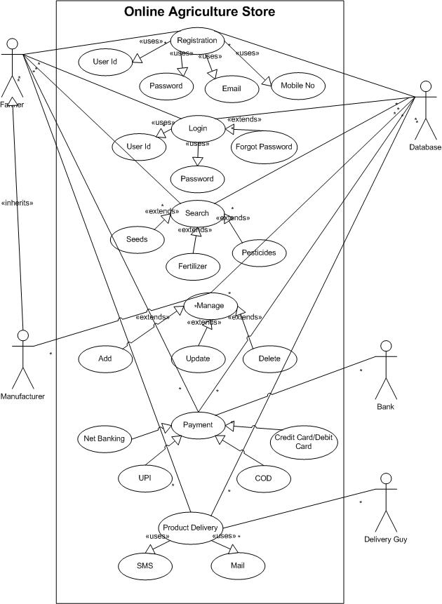
Question No 11 (Minimum 5) Use Case Specs

Prepare use case specs for all use cases

Use Case ID |  |  | 001
Use Case Name |  |  | New User Registers into the Portal
Created by | Mr Mayur | Last Updated | 30th June 2023
Date Created | 01st June 2025 | Last revision | 15th June 2025
Actors |  |  | Farmer, Manufacturer
Description |  |  | This Use case Describes how a farmer can register
Precondition |  |  | User must have active internet  User must have laptop/mobile  User must have active mobile connection  User must have active email address  User must not be logged in
Post Condition |  |  | Account gets Created, user id successfully created
Normal Flow of events/Basic Flow/Happy Path |  |  | User Open the Website/App  Enters Email Id User Id Password Mobile No  Clicks on register  Fills the details  Gets confirmation, user created successfully  Use case ends
Alternative Flow |  |  | If email exists, Shows Already registered  If Mobile exists, shows already registered  If user id already exists, shows already registered  If server issue, error will show server busy
Exception |  |  | Incase of Loss of Internet connectivity, use case display “Check your internet connectivity”
Frequency of Use |  |  | High
Assumptions |  |  | All users have valid email IDs and access to email for verification  All users have valid mobile Nos and access to Mobile for verification

Use Case ID |  |  | 002
Use Case Name |  |  | User can Browse the portal
Created by | Mr Mayur | Last Updated | 30th June 2023
Date Created | 01st June 2025 | Last revision | 15th June 2025
Actors |  |  | Farmer
Description |  |  | This Use case Describes how a farmer can browse through the portal
Precondition |  |  | User must have active internet  User must have laptop/mobile  Products have been uploaded and approved in the portal
Post Condition |  |  | Farmers view product listing
Normal Flow of events/Basic Flow/Happy Path |  |  | User Open the Website/App  Clicks on Products, Fertilizers, Seeds, Pesticides  Products are displayed with name price and description  Use case ends
Alternative Flow |  |  | If No products available, Shows No Products Found Message
Exception |  |  | Incase of Loss of Internet connectivity, use case display “Check your internet connectivity”
Frequency of Use |  |  | High
Assumptions |  |  | Product Data is already present in the database

Use Case ID |  |  | 003
Use Case Name |  |  | User can Add to Cart/Save for Later
Created by | Mr Mayur | Last Updated | 30th June 2023
Date Created | 01st June 2025 | Last revision | 15th June 2025
Actors |  |  | Farmer
Description |  |  | This Use case Describes how a farmer can Add the product to the cart or save it for later
Precondition |  |  | User must have active internet  User must have laptop/mobile  Farmer has to successfully login in to the portal
Post Condition |  |  | Product gets added to cart or wishlist
Normal Flow of events/Basic Flow/Happy Path |  |  | User Open the Website/App  Clicks on Products, Fertilizers, Seeds, Pesticides  User clicks on Add to cart or buy later  Product gets stored in the respective list  Use case ends
Alternative Flow |  |  | If not logged in, Redirect to login page
Exception |  |  | Incase of Loss of Internet connectivity, use case display “Check your internet connectivity”, Session Time out
Frequency of Use |  |  | High
Assumptions |  |  | User is already registered and have a Valid Account

Use Case ID |  |  | 004
Use Case Name |  |  | User can Place Order in the portal
Created by | Mr Mayur | Last Updated | 30th June 2023
Date Created | 01st June 2025 | Last revision | 15th June 2025
Actors |  |  | Farmer
Description |  |  | This Use case Describes how a farmer can Place Order in the Portal
Precondition |  |  | User must have active internet  User must have laptop/mobile  User is Logged in  Product is selected in the cart
Post Condition |  |  | Order is Placed Successfully
Normal Flow of events/Basic Flow/Happy Path |  |  | User Open the Website/App  Clicks on Products, Fertilizers, Seeds, Pesticides  User clicks on Add to cart or buy later  Product gets stored in the respective list  Farmer goes to the cart  Clicks on Proceed to Check Out  Address is Confirmed  System Places Order  Use case ends
Alternative Flow |  |  | If Product is not selected in cart or wish list, Show Error Message
Exception |  |  | Payment Process not initiated
Frequency of Use |  |  | High
Assumptions |  |  | Farmer has saved the delivery Address

Use Case ID |  |  | 005
Use Case Name |  |  | User can make Payment
Created by | Mr Mayur | Last Updated | 30th June 2023
Date Created | 01st June 2025 | Last revision | 15th June 2025
Actors |  |  | Farmer
Description |  |  | This Use case Describes how a farmer can make payment in portal
Precondition |  |  | User must have active internet  User must have laptop/mobile  User is Logged in  Product is selected in the cart  Order is ready to be placed
Post Condition |  |  | Payment Completed and Order Confirmed
Normal Flow of events/Basic Flow/Happy Path |  |  | User Open the Website/App  Clicks on Products, Fertilizers, Seeds, Pesticides  User clicks on Add to cart or buy later  Product gets stored in the respective list  Farmer goes to the cart, Clicks on Proceed to Check Out  Address is Confirmed,  Farmer Selects Payment Method, UPI, NB, Card, COD  Completed Payment, Confirmation Message is sent  Use case ends
Alternative Flow |  |  | If the payment gets failed, it give retry option
Exception |  |  | Payment gateway time out
Frequency of Use |  |  | High
Assumptions |  |  | Payment Gateway is integrated with the portal and is fully functional

Question No 12 (Minimum 5) Activity Diagram

Answer : Login Page

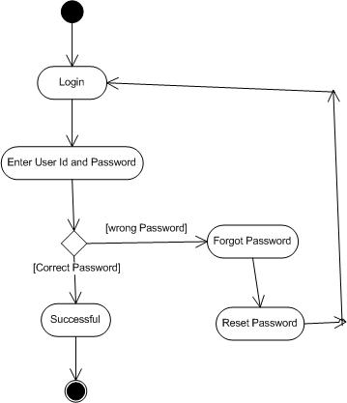

Sign up/Register

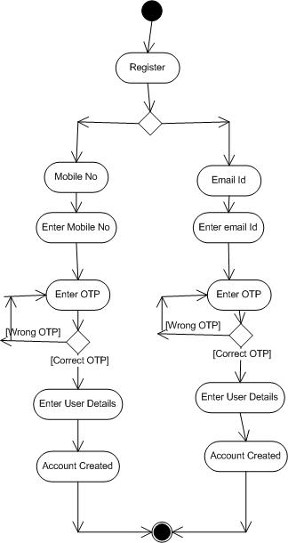

Buying Product

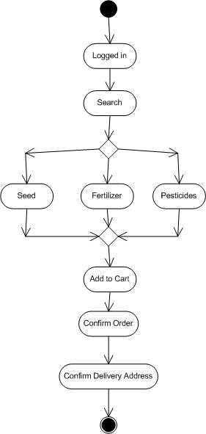

Payment

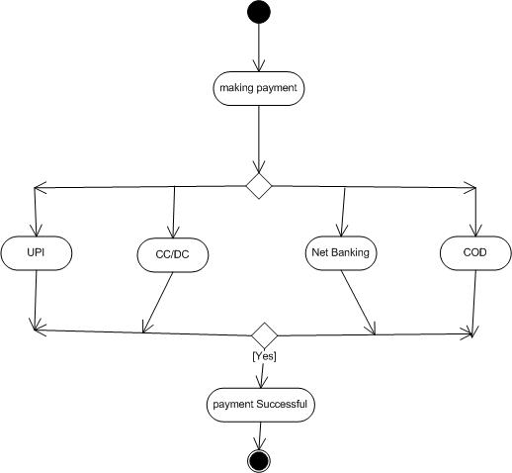

Delivery Confirmation Message

