Live Project: Waterfall Deliverables – Part -2
Document 6- Please prepare a use case diagram, activity diagram and a use case specification document.
Ans : Use Case diagram – CBI (Coding & Billing Interface) Software

Activity diagram –
Final State couldn’t copied.

Use Case Specification Document – CBI Software

Section | Details
1. Use Case Name | Validate and Submit Patient Chart
2. Use Case Description | This use case describes how a medical coder uses the CBI system to enter ICD-10 and CPT codes, validate them, apply modifiers, and submit the chart. The system assists with real-time validation and suggestions.
3. Actors | Primary: Medical Coder  Secondary: CBI System, Auditor
4. Basic Flow | 1. Coder logs into the CBI system.  2. Opens a patient chart.  3. Enters ICD-10 and CPT codes.  4. System validates codes.  5. System suggests modifiers.  6. Coder accepts modifiers.  7. Submits chart.  8. Audit record is generated.
5. Alternate Flow | AF1: If coder rejects modifiers, they can override or request help.  AF2: System may suggest alternate modifiers.
6. Exceptional Flows | EF1: If invalid codes are entered, system shows an alert and prevents submission.  EF2: If session times out, user must re-login.
7. Pre-Conditions | - Coder must be logged in.  - Chart data must be available.
8. Post-Conditions | - Chart submitted for audit.  - Audit record saved.
9. Assumptions | - Coder is trained on CBI.  - Code database is updated.
10. Constraints | - Must follow healthcare coding standards.  - System must be online.
11. Dependencies | - Depends on CBI validation engine.  - Submission triggers audit workflow.
12. Inputs and Outputs | Inputs: ICD-10, CPT codes, chart info  Outputs: Validation results, modifier suggestions, submission status, audit log
13. Business Rules | - Modifiers must match guidelines.  - Codes must validate before submission.  - No duplicate chart allowed.
14. Miscellaneous Info | - All activity is logged.  - System sends notifications.

Home Page :

Login Page :
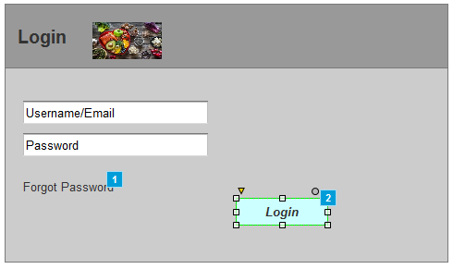
Search Page :
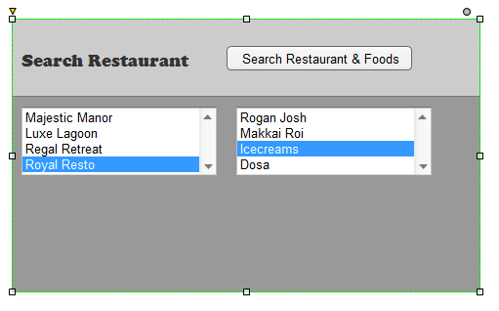
Add to cart Page :

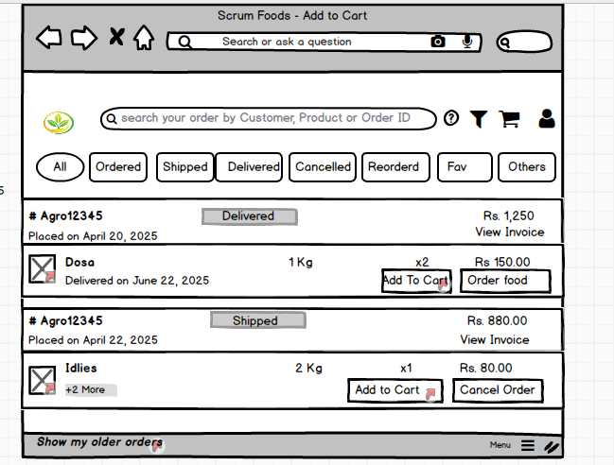

Payment Page :
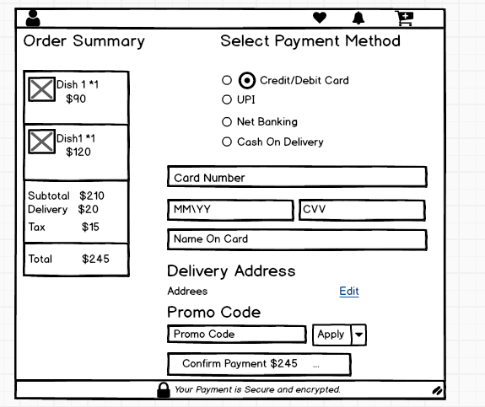
Logout Page :
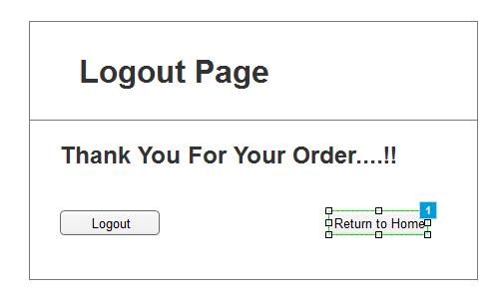
Document 8- Tools-Visio and Axure Write a paragraph on your experience using Visio and Axure for the project.
Ans :
My Experience Using Visio and Axure in the Project (in Simple English)
In this project, I used Microsoft Visio and Axure RP to help design and explain how the system will work. I used Visio to create clear diagrams like use case diagrams and process flow charts. These diagrams helped show how different users (like coders and auditors) interact with the system and what steps they follow. Visio made it easy to draw and understand these flows using simple symbols.
I also used Axure to design screen layouts and create a working model of the system (a prototype). With Axure, I made wireframes for each screen, like the home page, login page, search, cart, and payment pages. I added links between pages, so when someone clicks a button, it moves to the next screen—just like a real application. This helped in showing the full user journey clearly. Overall, both tools made it easy to plan and present the system in a simple and visual way.

Document 9- BA experience My experience as BA in following phases:
Ans :
1. Requirement Gathering:
In this phase, I used the MOSCOW technique to understand which requirements are Must have, Should have, Could have, or Won’t have. Since the client was not always available, I found the right contacts on their team to collect information quickly. I validated the collected requirements using the FURPS model (Functionality, Usability, Reliability, Performance, and Supportability). I also removed duplicate or repeated requirements to avoid confusion. We created prototypes to help the client give more accurate and detailed requirements.

2. Requirement Analysis:
Here, I created UML diagrams and activity diagrams to explain the process flows visually. These diagrams helped the team understand the project better. I shared these diagrams with the development team. If anyone disagreed or suggested changes, I listened, discussed, and updated the diagrams accordingly. I also prepared the Business Requirement Specification (BRS) and System Requirement Specification (SRS) documents.

3. Design Phase:
I used the use case diagrams to prepare test cases, including both positive and negative scenarios. I also made sure no test case was missed, as missing one could affect the project later. I prepared test data for testing and updated the Requirement Traceability Matrix (RTM) to make sure all the requirements were covered.

4. Development Phase:
I conducted JAD (Joint Application Development) sessions to clarify requirements with the technical team. If someone didn’t agree or wasn’t cooperating, I spoke to them one-on-one, explained the impact, and created a positive environment. I referred to the diagrams to support the coding phase and had regular meetings with the technical team and client. If someone missed a meeting, I recorded the session and followed up with a personal discussion.

5. Testing Phase:
I prepared test cases again from the use cases and performed high-level testing. If needed, I requested test data from the client. I kept the RTM updated and ensured the client reviewed and signed off the requirements. I also helped the client get ready for User Acceptance Testing (UAT).

6. Deployment Phase:
At this stage, I shared the final RTM with the client as part of the project closure. I helped create and share end-user manuals, and I planned and arranged training sessions for users. I also ensured all the concerned team members attended the training sessions.

