BRD

Project Name: Centralized Inventory & Delivery Optimization System
Client: Ice-Cream & Milk Products by MilkyWay
Prepared By: Mugdha Borhade – Business Analyst
Version: 1.0
Date: 11-Aug-2025

- Document Revisions

Version | Date | Author | Description of Change
1 | 11-Aug-25 | Mugdha Borhade | Initial draft for client review

- RASCI Chart for This Document

Activity | BA | PM | Dev Team | QA Team | Client SME | IT Ops
Requirement Gathering | R | S | I | I | C | I
BRD Preparation | R | A | I | I | C | I
Solution Design | C | S | R | I | C | I
Development | I | S | R | I | I | C
Testing & UAT | S | S | S | R | C | I
Deployment | I | S | C | I | I | R

4.1. Business Goals
- Ensure accurate real-time inventory tracking across all plants & warehouses.
- Reduce product wastage due to expiry.
- Achieve faster delivery times with optimized routing.
- Enable data-driven decision-making via analytics dashboards.

4.2. Business Objectives
- Centralize inventory data from multiple sites.
- Automate delivery route planning using location & traffic data.
- Improve customer satisfaction by reducing delivery delays.
- Provide warehouse managers with predictive replenishment alerts.

4.3. Business Rules
- Perishable products must be dispatched based on First Expiry First Out (FEFO).
- Orders cannot be assigned to warehouses with stock levels below safety thresholds.
- Delivery vehicles must comply with cold chain requirements.

4.4. Background
Currently, stock is tracked manually using spreadsheets at each warehouse.
Delivery assignments are done manually without considering real-time location data, leading to delays and inefficient logistics.

4.5. Project Objective
Develop a web-based and mobile-enabled platform to integrate inventory management with automated delivery scheduling.

4.6. Project Scope

4.6.1. In Scope Functionality
- Real-time inventory tracking
- Order management system
- Route optimization engine
- Role-based dashboards
- Reports & analytics

4.6.2. Out Scope Functionality
- Payment processing
- Manufacturing process automation

5. Assumptions
- All warehouses have stable internet connections.
- GPS-enabled vehicles or delivery partner API is available.
- Accurate initial master data will be provided by the client.

6. Constraints
- Perishable nature of products limits storage time.
- Seasonal demand fluctuations may impact delivery scheduling.
- Integration dependent on third-party mapping APIs.

7. Risks

Technological Risks
- API downtime from map service provider.

Skills Risks
- Limited in-house technical expertise for advanced route optimization.

Political Risks
- Regional regulations on cold storage transport.

Business Risks
- Loss of sales if inventory system fails.

Requirements Risks
- Scope creep due to evolving delivery requirements.

Other Risks
- User adoption resistance.

8. Business Process Overview

8.1. Legacy System (AS-IS)
- Inventory tracked manually in spreadsheets.
- Delivery planning done by phone calls and manual route mapping.
- No centralized visibility across warehouses.

8.2. Proposed Recommendations (TO-BE)
- Automated stock updates in centralized system.
- AI-driven delivery route optimization.
- Integrated dashboard for warehouse, sales, and logistics teams.
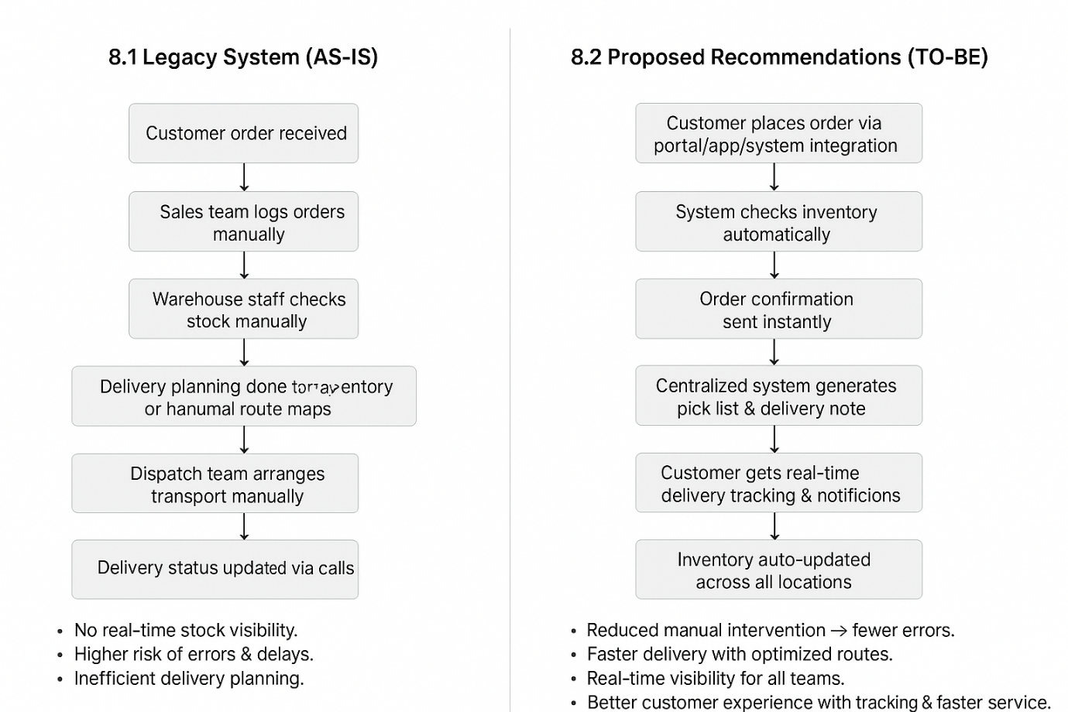

9. Business Requirements

Req ID | Requirement
REQ-001 | Real-time stock level tracking across all warehouses
REQ-002 | Batch tracking with expiry date alerts
REQ-003 | Customer order placement & tracking
REQ-004 | Route optimization considering location & traffic
REQ-005 | Reports for stock, wastage, and delivery performance

10. Appendices

10.1. List of Acronyms
- BRD – Business Requirements Document
- UAT – User Acceptance Testing
- FEFO – First Expiry First Out

10.2. Glossary of Terms
- Route Optimization – Algorithmic calculation of the shortest delivery path.
- Batch Tracking – Monitoring products based on manufacturing batch.

10.3. Related Documents
- AS-IS & TO-BE Process Flows
- Requirement Traceability Matrix (RTM)

11. Process flow diagram :

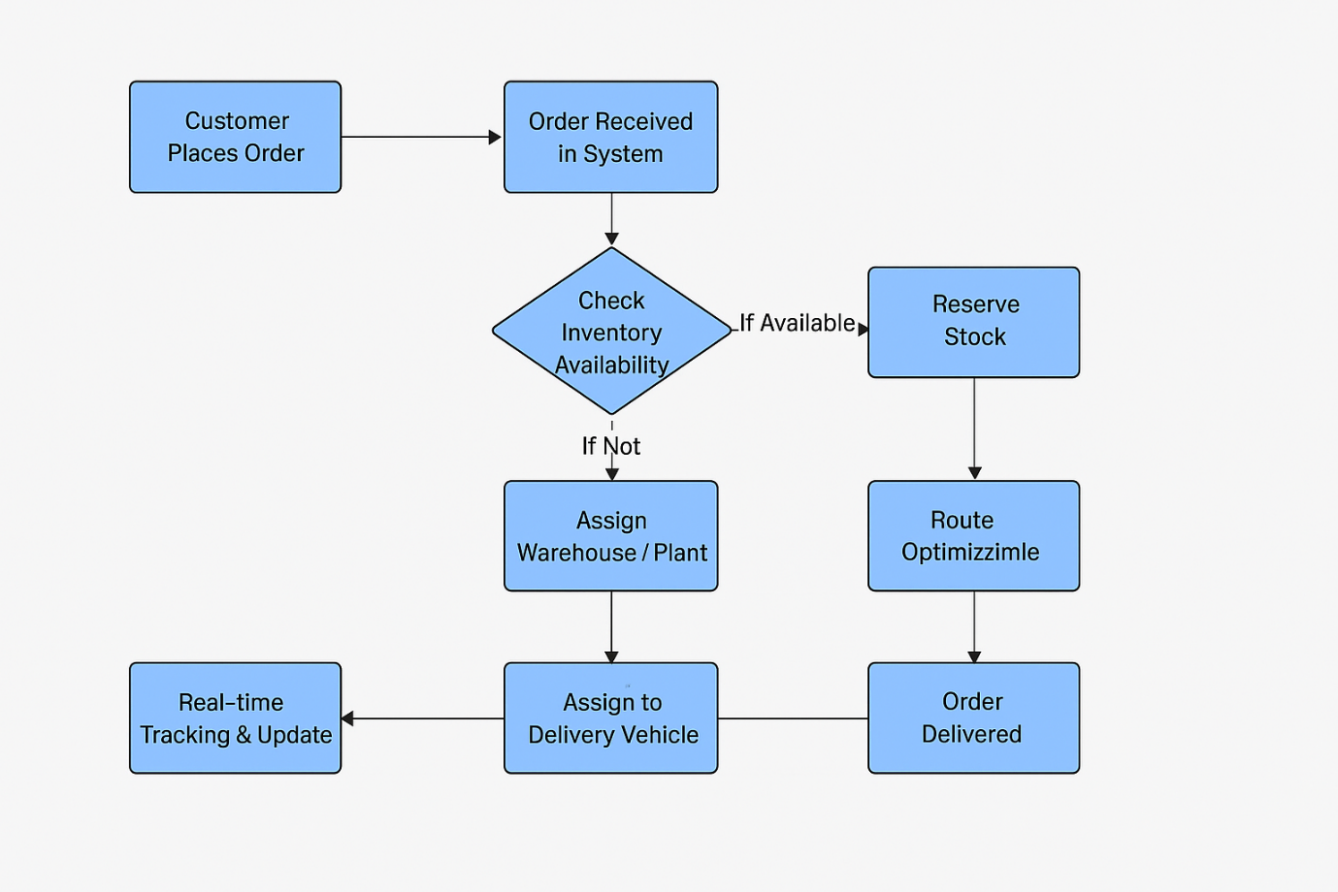

Assignment 2

1. Introduction Letter to Client
Subject: Introduction as Business Analyst – Project Initiation for Online Store Platform
Dear Mr. M.S.Deshmukh,
I hope this message finds you well.
My name is Mugdha Borhade, and I will be serving as the Business Analyst for FreshCart Retail Pvt. Ltd.’s new Online Store Platform project. My primary role will be to work closely with you and your team to understand the business needs, capture requirements, and translate them into clear and actionable specifications for our development and QA teams.
Over the coming days, I will initiate the business understanding phase, during which we will:
- Conduct stakeholder interviews.
- Analyse existing processes and systems (if applicable).
- Define and document business requirements in a structured format.
- Align on project goals, scope, and success criteria.
My aim is to ensure that the final solution aligns perfectly with your business objectives, addresses current challenges, and delivers measurable value.
I look forward to collaborating with you and your team to make this project a success. Please feel free to reach out to me at any time for discussions or clarifications.
Best Regards,
Mugdha Borhade
Business Analyst
borhade.mugdha@tcs.com | 9607857882

2. Brief BRD & SRS – Online Store for FreshCart Retail Pvt. Ltd.

BRD – Online Store
Project: Online Store for FreshCart Retail Pvt. Ltd.
Prepared By: Business Analyst – Mugdha Borhade
Date: 15.08.2025

1. Document Revisions
0.1 | 31-07-2025 | Initial Draft | Mugdha Borhade | Project Lead
1 | 16-08-2025 | Approved Final Document | Mugdha Borhade | Client/PM

2. Approvals
Role | Name | Signature | Date
Client Sponsor | Mr. Ravi Mehta |  | 16-08-2025
Project Manager | Ms. Nisha Kulkarni |  | 16-08-2025
Business Analyst | Mugdha Borhade |  | 16-08-2025

- RACI Chart for This Document
Codes Used:
- R – Responsible
- A – Accountable
- S – Supportive
- C – Consulted
- I – Informed

Task | Client | BA | Dev Team | QA | PM
Requirements Gathering | C | R | I | I | A
Documentation | I | R | S | S | A
Design Validation | C | R | A | S | I
Development | I | C | R | I | A
Testing | I | C | S | R | A
Final Approval & Sign-off | A | C | I | I | R

4. Introduction
FreshCart Retail Pvt. Ltd. is a retail company specializing in fresh groceries, dairy, and organic products. To expand its reach and improve customer satisfaction, the company is planning to launch an Online Store that will enable customers to browse, shop, and get doorstep delivery of products efficiently.

4.1 Business Goals
- Expand market presence via digital commerce.
- Provide seamless online shopping experience.
- Enable efficient delivery and customer satisfaction.
- Centralize inventory & order management.

4.2 Business Objectives
- Launch an e-commerce platform accessible via web & mobile.
- Real-time synchronization of inventory with warehouses.
- Integration with secure payment gateways.
- Enable order tracking and notifications.

4.3 Business Rules
- Customers must register before making purchases.
- Orders above ₹500 qualify for free delivery.
- Payments accepted via Credit/Debit Cards, UPI, NetBanking, Wallets.
- Cancellations allowed before dispatch only.

4.4 Background
FreshCart currently operates only through offline retail outlets. With growing demand for online shopping, the company wants to implement an online store to stay competitive.

4.5 Project Objective
To design and implement a user-friendly, scalable, and secure online platform that manages products, orders, payments, and deliveries in real-time.

4.6 Project Scope
4.6.1 In-Scope Functionality
- User Registration & Login
- Product Browsing, Search & Filter
- Shopping Cart & Wishlist
- Secure Payments Integration
- Order Tracking & Delivery Updates
- Admin Dashboard for Sales, Products, and Inventory
4.6.2 Out-of-Scope Functionality
- International deliveries
- Third-party marketplace integrations
- Loyalty points/reward system (Phase 2 feature)

5. Assumptions
- Customers have internet-enabled devices.
- Inventory data from warehouses is accurate.
- Payment gateways will support required transaction load.

6. Constraints
- Budget and timeline restricted to 6 months.
- Limited in-house technical expertise.
- Must comply with data protection & payment security standards.

7. Risks
Technological Risks – Integration issues with payment gateway, scalability under high traffic.
Skills Risks – Limited expertise in e-commerce implementation.
Political Risks – New government regulations around e-commerce or data privacy.
Business Risks – Customer resistance due to delivery delays or app usability.
Requirements Risks – Changes in product categories, delivery models mid-project.
Other Risks – Dependency on third-party logistics for last-mile delivery.

8. Business Process Overview
8.1 Legacy System (AS-IS)
- All sales happen via physical stores.
- Inventory managed manually at each outlet.
- No centralized visibility.
8.2 Proposed Recommendations (TO-BE)
- Centralized e-commerce system.
- Automated stock updates & dashboards.
- AI-driven delivery route optimization.
- Seamless customer ordering experience.
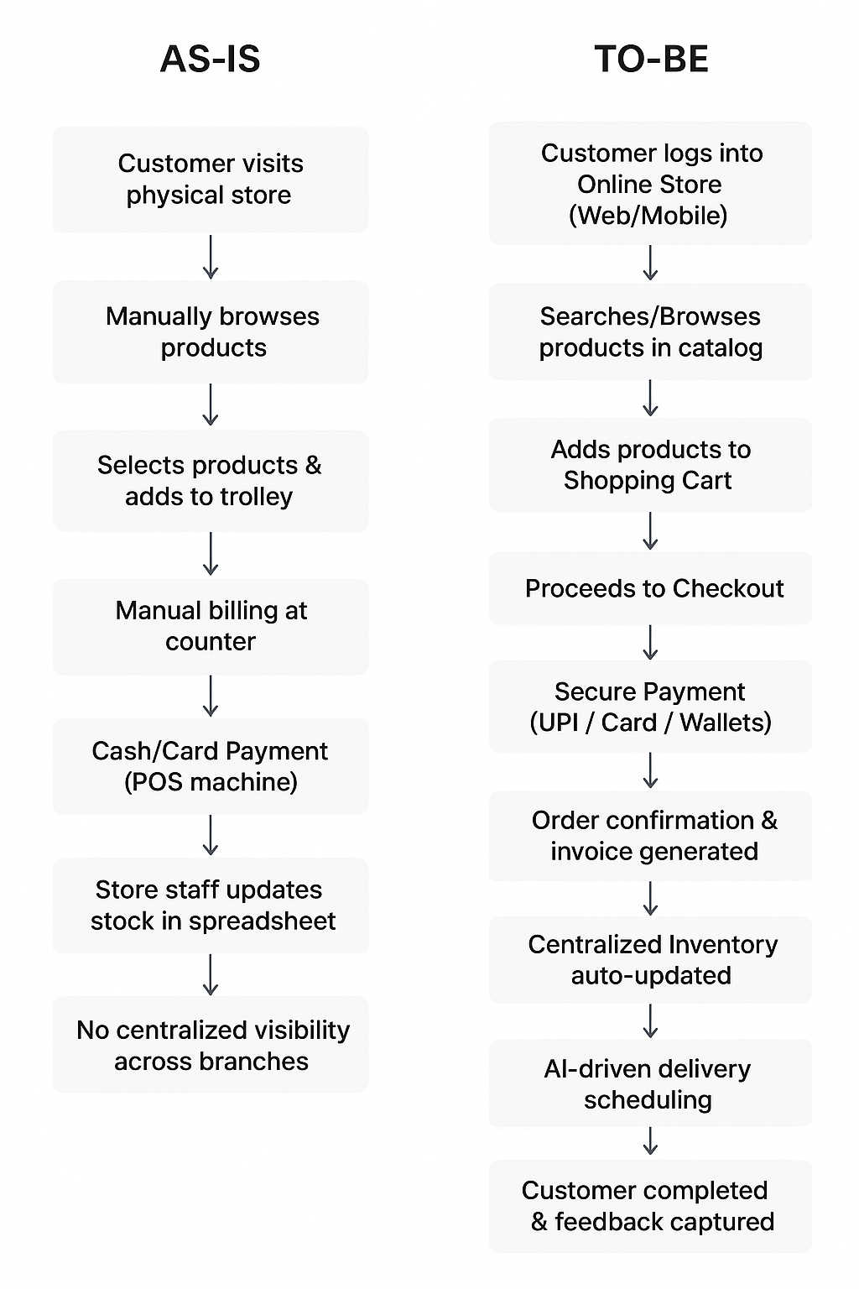

9. Business Requirements
- Customers must be able to register/login securely.
- Customers can browse and search products easily.
- Shopping cart & checkout should be intuitive.
- Secure multi-payment options must be available.
- Customers can track orders in real-time.
- Admin users can manage inventory, orders, and reports centrally.

10. Appendices
10.1 List of Acronyms
- BA – Business Analyst
- PM – Project Manager
- UI – User Interface
- DB – Database
10.2 Glossary of Terms
- E-commerce: Online system for buying/selling goods.
- Inventory: Stock of goods available for sale.
- Payment Gateway: Service to process online payments.
10.3 Related Documents
- Project Charter
- High-Level System Architecture Diagram
- Functional Requirement Documents (FRD)

SRS – Online Store

1. Introduction

1.1 Purpose
The purpose of this document is to define the functional and non-functional requirements for the FreshCart Online Store. The system aims to enable customers to browse, purchase, and get deliveries of grocery and fresh products online, while ensuring accurate inventory tracking and smooth operations.

1.2 Scope
- Online platform for browsing and purchasing grocery and fresh products.
- Centralized inventory management across multiple warehouses.
- Secure payment gateway integration.
- AI-driven delivery route optimization.
- Customer self-service portal with order tracking and feedback.

1.3 Definitions, Acronyms, and Abbreviations
- UI – User Interface
- DBMS – Database Management System
- SKU – Stock Keeping Unit
- OTP – One-Time Password

1.4 References
- BRD for FreshCart Online Store (Version 1.0).
- Industry standards for e-commerce security (PCI-DSS, GDPR).

2. Overall Description

2.1 Product Perspective
The online store will replace the manual in-store shopping process with a centralized e-commerce platform accessible via web and mobile.

2.2 Product Functions
- Customer registration & login.
- Product catalogue browsing & search.
- Cart management & checkout.
- Payment gateway integration.
- Inventory auto-update on order placement.
- Order confirmation, invoice generation.
- Delivery scheduling & real-time tracking.

2.3 User Classes & Characteristics
- Customer: End-users purchasing products.
- Admin: Manages inventory, products, and user accounts.
- Delivery Staff: Access to assigned delivery routes & orders.
- Support Staff: Handles order issues, refunds, and escalations.

2.4 Constraints
- System must support 24x7 availability.
- Must comply with data privacy and payment security standards.
- Mobile-friendly responsive UI.

2.5 Assumptions & Dependencies
- Customers will have internet access.
- Payment gateways (UPI, Wallet, Credit/Debit Card) will be integrated via third-party APIs.
- Delivery is dependent on logistics partner availability.

3. Specific Requirements

3.1 Functional Requirements
- User Management
  - Customers can register/login using email, mobile, or social login.
  - Password reset using OTP/email verification.
- Product Management
  - Admin can add/update/delete products with details (SKU, price, category, stock).
  - Customers can view/search/filter products.
- Shopping Cart & Checkout
  - Customers can add/remove/update items in cart.
  - Checkout with multiple payment options.
- Order Management
  - System generates unique Order ID for each purchase.
  - Order confirmation sent via email/SMS.
  - Customers can track order status in real-time.
- Inventory Management
  - Stock automatically updated upon order placement.
  - Low-stock alerts for admin.
- Delivery Management
  - AI-driven route optimization for delivery staff.
  - Delivery status updated (Out for delivery → Delivered).
- Customer Support
  - Ticketing system for complaints/refunds.
  - Order history and re-order option.

3.2 Non-Functional Requirements
- Performance: System should handle 10,000 concurrent users.
- Security: Data encryption, OTP authentication, secure payment compliance.
- Scalability: Support future addition of new warehouses & delivery zones.
- Usability: Simple, intuitive UI for web & mobile.
- Reliability: 99.9% uptime.

4. System Models
- ERD (Entity Relationship Diagram) connecting Customer, Product, Order, Payment, Inventory.
- Use Case Diagrams for Customer (shopping), Admin (inventory), and Delivery Staff.

3. ERD – Support Ticket / Ticketing Life Cycle
Entities & Attributes:
- User
  - User_ID (PK)
  - Name
  - Email
  - Phone
- Ticket
  - Ticket_ID (PK)
  - User_ID (FK)
  - Category_ID (FK)
  - Priority_ID (FK)
  - Status_ID (FK)
  - Subject
  - Description
  - Created_Date
  - Closed_Date
- Category
  - Category_ID (PK)
  - Category_Name (Order Issue, Payment Issue, Product Query, Technical Issue)
- Priority
  - Priority_ID (PK)
  - Priority_Level (Low, Medium, High, Urgent)
- Status
  - Status_ID (PK)
  - Status_Name (Open, In Progress, Resolved, Closed)
- Agent
  - Agent_ID (PK)
  - Name
  - Email
- Ticket_History
  - History_ID (PK)
  - Ticket_ID (FK)
  - Updated_By (User_ID / Agent_ID)
  - Old_Status
  - New_Status
  - Update_Date
Relationships:
- A User can create many Tickets.
- A Ticket belongs to one Category, has one Priority, and has one Status at a time.
- A Ticket is assigned to one Agent.
- A Ticket can have many Ticket_History records.

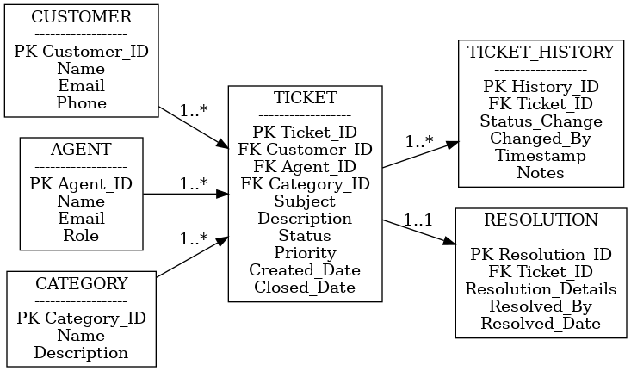

4.User story of shopping from ecommerce

User Story ID | As a (Role) | I want to (Goal) | So that (Benefit) | BV | CP | Acceptance Criteria
US001 | Customer | Search for products using keywords | I can quickly find the product I need | 9 | 5 | • Search should return relevant results within 3 seconds • Search must handle misspellings/synonyms • No-results page should display suggestions
US002 | Customer | Filter products by category, price, and rating | I can refine my search and save time | 8 | 4 | • Filters should work in combination (e.g., price + rating) • Results must refresh dynamically • System must show the number of items after filters applied
US003 | Customer | View detailed product description, price, and reviews | I can make informed purchase decisions | 10 | 3 | • Product page should show name, price, stock status, images, reviews • Multiple product images must be supported • Customer reviews must include ratings and comments
US004 | Customer | Add products to cart | I can collect items before purchasing | 9 | 3 | • Add-to-cart button must be visible on product and listing pages • Cart should update in real-time • Confirmation message should display after adding
US005 | Customer | Modify cart (add/remove items, change quantity) | I can manage what I want to purchase | 8 | 4 | • Users must be able to increase/decrease quantity • Cart total should recalculate instantly • Removed items should not persist after refresh
US006 | Customer | Checkout with multiple payment options | I can pay using my preferred method | 10 | 6 | • Payment gateway must support cards, UPI, wallets, COD • Invalid payment must show proper error message • Successful payment should redirect to confirmation page • Transaction must be logged securely
US007 | Customer | Track my order status | I know when to expect my delivery | 9 | 4 | • System must display real-time status ("Placed → Shipped → Delivered") • Tracking number should link to courier site • Notifications must trigger when status changes
US008 | Customer | Receive order confirmation and updates via email/SMS | I stay informed about my purchase | 7 | 3 | • Confirmation email/SMS must trigger within 1 minute • Status updates must send automatically • Message should include order ID and delivery estimate
US009 | Customer | Save multiple delivery addresses | I can choose quickly during checkout | 6 | 3 | • Users must be able to add/edit/delete addresses • System must allow setting a default address • Address selection must appear at checkout
US010 | Customer | Write product reviews after purchase | I can share my experience and help others | 6 | 4 | • Review option should unlock only after delivery • Reviews must support text + rating stars • Admin should be able to moderate inappropriate reviews
US011 | Admin | Manage product catalog (add, edit, delete items) | I can keep inventory updated | 8 | 5 | • Admin should be able to add/edit/delete product details • System must validate mandatory fields (name, price, stock) • Changes must reflect in customer portal instantly
US012 | Admin | View sales and customer reports | I can make business decisions | 7 | 5 | • Reports should include sales trends, top products, user activity • Data must be exportable (CSV/Excel) • Dashboard should refresh daily with updated data
US013 | Customer | Save products to a wishlist | I can revisit and buy them later | 7 | 3 | • "Add to Wishlist" button should be available on product pages • Wishlist must be accessible from customer profile • Items in wishlist must not expire unless deleted
US014 | Customer | Apply discount codes or coupons at checkout | I can save money on purchases | 8 | 4 | • Coupon field must validate format and expiry • Discount should be applied instantly to cart total • System should reject expired/invalid coupons with error message • One coupon per order rule should be enforced
US015 | Admin | Manage customer support tickets | I can resolve customer queries quickly | 7 | 5 | • Admin must be able to view all open/closed tickets • Tickets must include status, priority, and customer details • System should notify customers when ticket is updated/resolved

