Document 6-
Please prepare a use case diagram, activity diagram and a use case specification document.

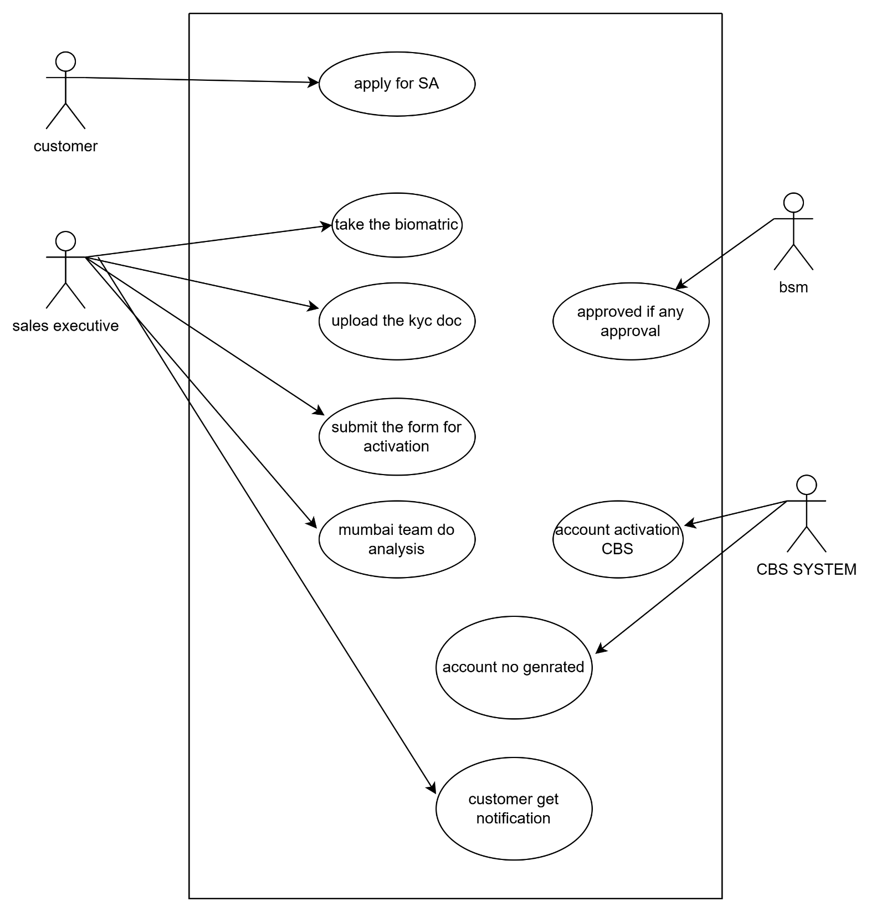

ACTIVITY DIAGRAM:-

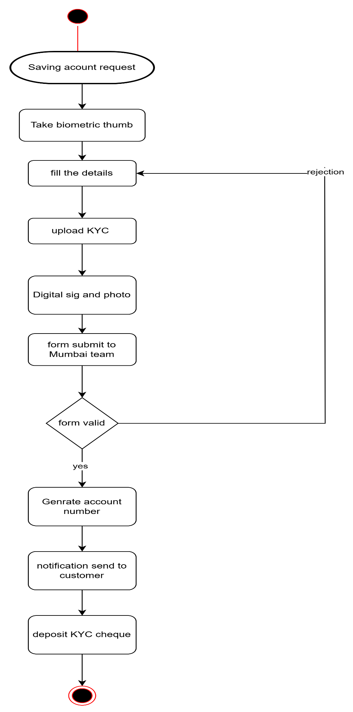
USE CASE SPECIFICATION DOCUMENT:-
Use Case Name: | Saving Account Activation
Use Case Description: | This use case outlines the process of activating a savings account. The customer initiates a request, and the Sales Executive collects and submits the required data. The Branch Sales Manager validates the application, and upon approval, the Core Banking System activates the account.
Actors | Primary Actors:  - Customer – Initiates the request for a new account  - Sales Executive/Agent – Captures and submits customer data  Secondary Actors:  - Branch Sales Manager (BSM) – Validates and approves and rejects application  - Core Banking System (CBS) – Performs the final activation and notification
Basic Flow: | - Customer approaches for a savings account.  - Sales Executive captures personal details and uploads KYC documents.  - Sales Executive submits the application to the BSM.  - BSM reviews and validates the application.  - If approved, CBS activates the account.  - System notifies the customer via SMS/email.
Alternate Flow: | - BSM reviews application and finds errors or incomplete data.  - Application is rejected and sent back to Sales Executive for corrections  - Sales Executive re-submits the corrected application  .
Exceptional Flows: | - Network failure during submission.  - Document upload fails due to format or size issues.  - CBS is offline or temporarily unavailable.  - Customer cancels request mid-process.
Pre-Conditions: | - Customer provides valid identification and KYC documents.  - Sales Executive is logged into the system.  - Internet and internal systems are functional.
Post-Conditions: | - Account is either successfully activated or marked as rejected.  - Customer and Sales Executive are informed of the status.
Assumptions | - All actors are trained in their responsibilities.  - KYC compliance is up-to-date and aligned with regulations.  - Required hardware ( tablet/scanner) is available and functional
Constraints | - System must comply with RBI/KYC guidelines.  - Activation should be completed within defined SLA (24–48 hours).  - Document file size and type must meet specifications.
Dependencies | - Availability of CBS and document verification module.  - Dependency on mobile/email infrastructure for notifications.  - Coordination between field and branch teams.
Inputs and Outputs: | Inputs:  - Customer personal data  - KYC documents (eg PAN, Aadhaar)  - Photograph and signature  Outputs:  - Account number (if successful)  - Activation confirmation message  - Rejection reason (if applicable)
Business Rules: | - Customer must be 18 years or older.  - PAN and Aadhaar must be validated.  - One savings account per customer per branch is allowed.  - Minimum initial deposit must be made (if applicable).
Miscellaneous Information: | - Process can be monitored using a dashboard.  - All transactions are logged for audit and compliance.  - The use case may be integrated with mobile onboarding in future versions.

Document 7- Screens and pages

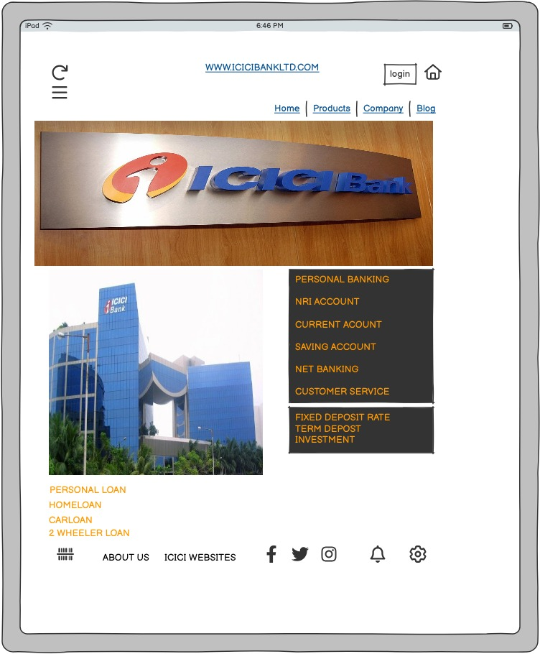

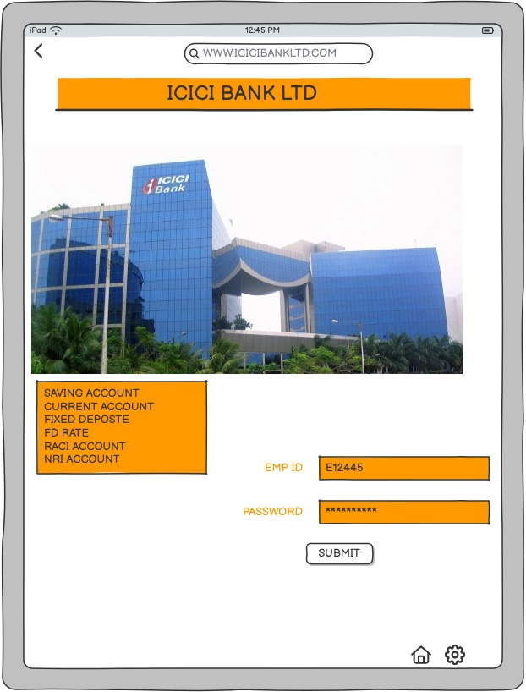

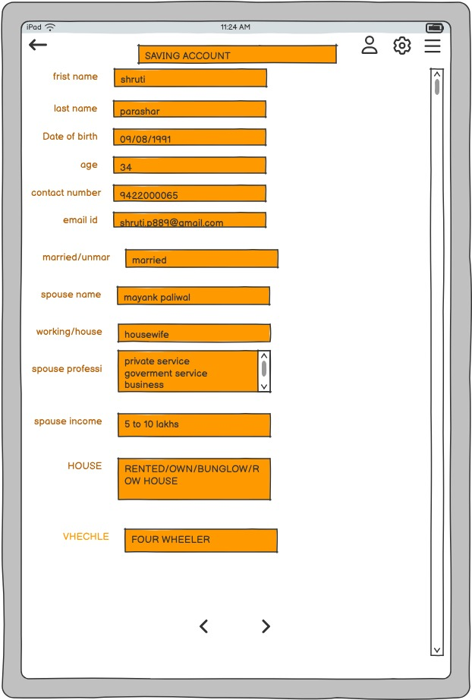

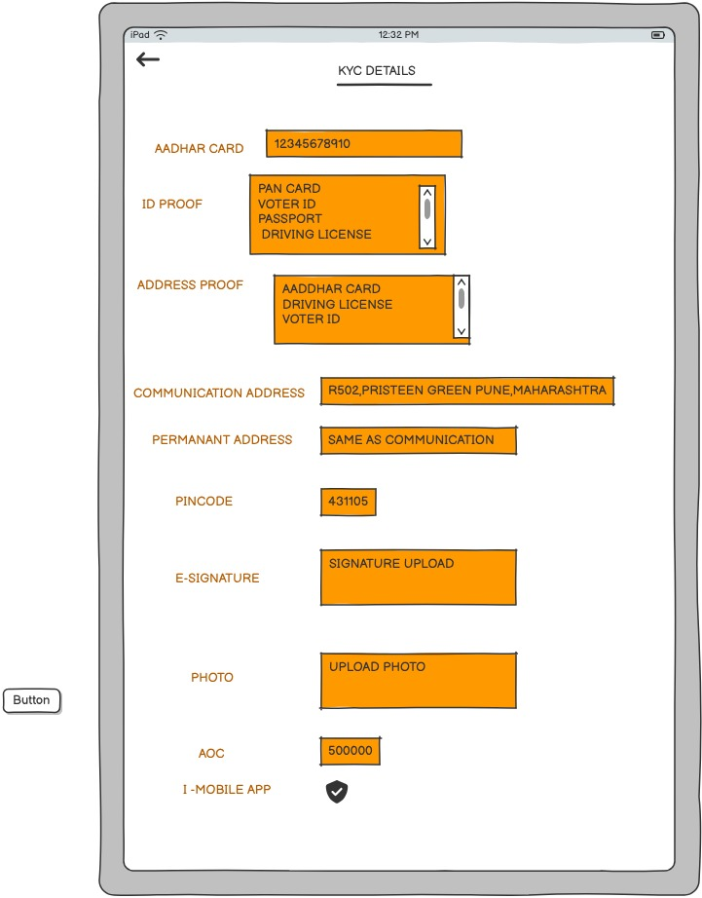

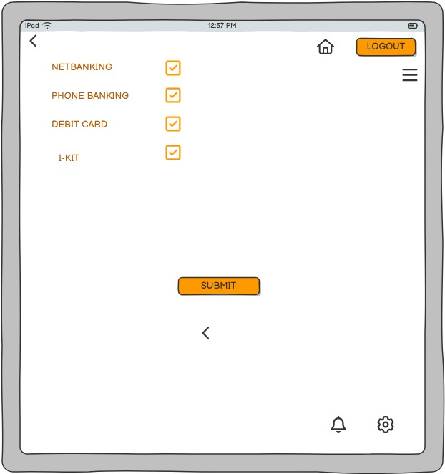

Document 8- Tools-Visio and Axure
Write a paragraph on your experience using Visio and Axure for the project
Answer:
As a Business Analyst on the banking domain project, I extensively used Microsoft Visio and Axure RP to enhance clarity and communication throughout the project lifecycle. With Visio, I created detailed UML diagrams such as use case, activity, and sequence diagrams to visually represent system workflows like savings account activation, KYC validation, and transaction processing. These diagrams helped bridge the gap between business and technical teams, ensuring everyone had a unified understanding of the requirements. In parallel, I used Axure to design interactive wireframes and prototypes for core banking modules, which allowed stakeholders to visualize the end-to-end user journey and provide early feedback. This was particularly effective in refining user interface requirements and avoiding rework during development. Together, these tools played a crucial role in validating requirements, facilitating JAD sessions, and ensuring a smooth transition from design to development in the Waterfall methodology.

Document 9- BA experience

Requirement Gathering:-
- Conducted stakeholder meetings with bank managers, operations teams, and compliance officers to gather detailed requirements.
- Utilized the Moscow technique to prioritize requirements based on business needs (account activation, KYC updates, transaction monitoring).
- Handled client-side availability constraints by identifying backup SPOCs (Single Points of Contact) and gathering inputs within timelines.
- Used the FURPS model to validate requirements ensuring functionality, usability, reliability, performance, and supportability.
- Identified duplicate requirements common in legacy banking systems and eliminated them for clarity.
- Developed prototypes to refine requirements, especially for customer onboarding and savings account workflows.
Requirement Analysis:-
- Translated business requirements into UML diagrams,
- Use Case Diagrams for processes like Open Savings Account and KYC Validation
- Activity Diagrams for workflows such as Account Activation through Branch vs Online
- Facilitated walkthrough sessions with developers and testers to explain workflows incorporated feedback where applicable.
- Business Requirements Specification (BRS)
- Requirements Specification (SRS) tailored for technical teams

Design:-
- Used finalized use cases to derive functional test cases, ensuring end-to-end coverage (account rejection due to incomplete KYC).
- Collaborated with the bank’s IT team and third-party vendors to review solution design documents.
- Created both positive and negative test scenarios (invalid PAN, duplicate account requests).
- Prepared test data reflecting real-time banking conditions (interest rates, branch codes).
- Maintained the Requirements Traceability Matrix (RTM) to ensure each business requirement had corresponding design and test coverage.

Development:-
- Facilitated JAD (Joint Application Development) sessions between bank's IT department and vendor development teams.
- Clarified domain-specific queries during development, such as regulatory compliance (RBI mandates) and data encryption requirements.
- Addressed conflicts by conducting one-on-one discussions with dissenting developers to align understanding and expectations.
- Ensured adherence to approved diagrams and SRS during code development.
- Organized regular meetings shared recordings and notes with absent stakeholders to maintain alignment.

Testing:-
- Supported QA team in developing test cases and scenarios based on use cases (e.g., dormant account handling, nominee update).
- Performed system testing and sanity checks on core banking modules.
- Liaised with client-side testers to obtain test data and coordinate UAT (User Acceptance Testing)
- Continuously updated the RTM to reflect test coverage and issue resolution status.
- Collected formal signoff from business stakeholder’s post-UAT completion.

Deployment:-
- Submitted finalized RTM to the project manager for inclusion in the project closure report.
- Coordinated with internal trainers to prepare End User Manuals for banking staff (account opening officers, branch managers).
- Scheduled and ensured participation in training sessions, addressing queries related to new features or compliance updates.
- Post-deployment, ensured stakeholders had access to proper documentation and support contacts.

