Agile Final Project – WeInvest Wealth Management Enhancement

Document 1: Definition of Done (DoD)
As per Agile Extension to the BABOK® Guide v2, the Definition of Done (DOD) is a clear and shared understanding within the Scrum Team of what it means for a backlog item to be considered “complete.”
It ensures that all team members have a common standard of quality, prevents ambiguity, and guarantees that each increment meets business, technical, and customer expectations.
In the WeInvest Agile Project, the Definition of Done is applicable at three levels:
- User Story Level: For development and testing of specific features.
- Sprint Level: For integrated increments delivered during a sprint.
- Release Level: For production-ready deployments.
Definition of Done – Checklist
# | Checklist Item | Description / Criteria
1 | Produced code for presumed functionalities | Code implementing all acceptance criteria has been developed and committed to the repository.
2 | Assumptions of User Story met | All preconditions and user story expectations are validated and satisfied.
3 | Project builds without errors | The solution builds successfully in CI/CD without compilation or dependency issues.
4 | Unit tests written and passing | Unit tests created for core logic, achieving at least 80% coverage and all tests pass.
5 | Project deployed on test environment identical to production | The feature is deployed in a QA/staging environment mirroring production configuration.
6 | Cross-device and browser tests passed | UI verified across major browsers and devices as per project requirements.
7 | Feature approved by UX designer | The implemented UI aligns with approved design mockups and UX flow.
8 | QA performed and issues resolved | Quality Assurance team tests completed; all major and critical defects fixed.
9 | Feature tested against acceptance criteria | Functionality verified against user story acceptance conditions to ensure completeness.
10 | Feature approved by Product Owner | Product Owner validates that the story meets business and user needs.
11 | Refactoring completed | Any redundant or inefficient code refactored for maintainability and performance.
12 | Configuration and build changes documented | All new configurations, dependencies, or build steps are clearly documented.
13 | Documentation updated | User manuals, API docs, and system guides updated to reflect new changes.
14 | Peer Code Review performed | Code reviewed and approved by at least one other developer to ensure quality and standards.

Document 2: Product Vision – WeInvest Platform Enhancement
Scrum Project Name: | WeInvest – Digital Wealth Platform Automation & Enhancement
Venue: | Hybrid – Office & Microsoft Teams
Date:10 January 2025 | Start time:10:00 AM | End time:4:00 PM | Duration:6 Hours
Client: | WeInvest / XYZ Pvt. Ltd.
Stakeholder list: | Product Owner, Business Analyst, Compliance Head, Operations Lead, IT Manager, DevOps Engineer, Vendor Partners (KYC, Market Data, Analytics)
Scrum Team
Scrum Master: | Nikhil Sharma
Product owner: | Alex Fernandez
Scrum Developer 1: | Priya Nair (Backend Developer)
Scrum Developer 2: | Rajesh Verma (Frontend Developer)
Scrum Developer 3: | Kiran Patil (API Developer)
Scrum Developer 4: | Sneha Joshi (QA Engineer)
Scrum Developer 5: | Ritesh Menon (DevOps Engineer)

Target Group | Needs | Product | Value
Which market segment does the product address? Wealth management, mutual funds, and digital investment platforms. | What problem does the product solve? Manual onboarding (KYC), delayed trades, inconsistent data, and limited analytics. | What product is it? A modernized, API-driven wealth management system with automation and analytics. I | How is the product going to benefit the company? Reduce manual effort by 40%, improve accuracy and compliance.
Who are the target users and customers? Retail investors, financial advisors, and operations staff. | Which benefit does it provide? Real-time execution, 70% automation, improved compliance, and faster customer onboarding. | What makes it desirable and special? Real-time integrations, auto-rebalancing, seamless onboarding, and reliable analytics. | What are the business goals? Increase operational efficiency, scalability, and customer satisfaction.
 |  | is it feasible to develop the product? Yes, using Agile sprints, CI/CD pipelines, and API integrations with vendor systems. | What is the business model? Subscription-based service for investors and commission on transactions.

Document 3: User Stories

User Story No | Tasks | Priority | Value Statement | BV | CP | Acceptance Criteria
US001.1 | UI form creation, field validation, data encryption | High | As a new investor, I want to enter and upload my KYC details online so that I can start onboarding without paperwork. | 10 | 3 | User can input PAN/Aadhaar; mandatory fields validated; data stored securely; user gets confirmation message.
US001.2 | API setup, mapping, error handling, testing | High | As the system, I want to integrate with the KYC vendor API so that I can automatically verify investor data. | 9 | 5 | API returns valid response; successful verification updates status; failed response logged; response time <10s.
US001.3 | UI status screen, logic binding, testing | Medium | As a user, I want to view my KYC verification status on my dashboard so that I know when my account is ready. | 8 | 3 | Status shows Approved/Pending/Rejected; auto-refresh; rejection reason tooltip; syncs instantly.
US002.1 | Trade API creation, validation, confirmation testing | High | As an operations user, I want to execute Buy orders instantly so that trades are processed without vendor dependency. | 9 | 5 | Order executes successfully <3s; confirmation ID generated; fund validation; retry logic implemented.
US002.2 | Backend trade logic, validation, testing | High | As an investor, I want to sell my holdings easily so that I can withdraw funds quickly. | 9 | 5 | Sell reduces portfolio units; confirmation displayed; transaction history updated; error handled gracefully.
US002.3 | Logging framework, error mapping, testing | Medium | As an admin, I want every trade and error recorded so that I can audit transactions accurately. | 8 | 4 | All trades logged with timestamp; failed trades logged separately; retry count visible; export to Excel.
US003.1 | API configuration, refresh cycle setup | Medium | As an investor, I want real-time market data so that I can track my portfolio accurately. | 8 | 4 | Market feed refreshes every 60s; fallback feed works; prices visible; logs maintained.
US003.2 | Chart integration, data binding | Medium | As a user, I want to compare my portfolio performance with benchmarks so that I can assess returns. | 7 | 3 | Benchmark line displayed; filter by time; accuracy verified; graph loads in 2s.
US003.3 | Cache storage, backup API setup | Medium | As a system, I want cached market data so that the dashboard continues to work even if API fails. | 7 | 4 | Cached data refreshed hourly; alerts on failure; fallback data displayed; no data older than 24h.
US004.1 | API configuration, data mapping | Medium | As the system, I want to automatically fetch corporate action data so that portfolio updates happen in real time. | 7 | 5 | Dividend/split/bonus data retrieved daily; failed entries retried; action list visible in admin panel.
US004.2 | Update logic, testing, database sync | Medium | As an operations user, I want the portfolio NAV to auto-adjust for corporate actions so that manual updates are avoided. | 7 | 6 | NAV adjusted within 1 hour; adjustment logs stored; dashboard reflects new value; manual override possible.
US004.3 | Notification trigger, email integration | Low | As an investor, I want alerts for dividends and bonuses so that I stay informed about portfolio changes. | 6 | 3 | Email/SMS sent after event; notification visible in inbox; duplicate alerts prevented.
US005.1 | UI design, backend queries, charting | High | As a wealth manager, I want to see overall performance metrics so that I can take data-driven decisions. | 8 | 4 | Dashboard shows profit/loss, CAGR; filters for time; charts load under 3s; refresh every 5min.
US005.2 | Comparison logic, visualization | Medium | As an investor, I want to compare portfolios across categories so that I can identify the best performers. | 7 | 5 | Multi-portfolio selection; comparison chart; filter by date; differences highlighted visually.
US005.3 | Export module, formatting, validation | Medium | As an investor, I want to download my portfolio report so that I can maintain offline records. | 6 | 3 | PDF/Excel generated <10s; data matches dashboard; timestamped; custom date range available.
US005.4 | ML model integration, testing, reporting | Low | As a product owner, I want AI-driven insights so that I can deliver better investment recommendations. | 5 | 5 | AI analyzes past performance; predictions on dashboard; refresh weekly; >85% accuracy.

Document 4: Agile Product Owner Experience

Role of Product Owner in the WeInvest Agile Project
The Product Owner (PO) plays a crucial role as the bridge between stakeholders and the Scrum team, ensuring that business needs are accurately translated into product functionality.
In the WeInvest project, the PO combines domain expertise in digital wealth management with agile practices to deliver value-driven increments aligned with business goals and market expectations.
Responsibilities of the Product Owner
Responsibility Area | Key Activities
Market Analysis | • Analyze the current digital investment landscape and customer expectations.
Market Analysis | • Identify market gaps and demand for automation in e-KYC, trading, and analytics.
Market Analysis | • Study competitor platforms and available market tools to define product uniqueness.
Enterprise Analysis | • Conduct due diligence on the WeInvest platform’s business potential.
Enterprise Analysis | • Evaluate ROI and business feasibility.
Enterprise Analysis | • Collaborate with finance and strategy teams for opportunity assessment.
Product Vision & Roadmap | • Define clear product vision to simplify investments and enhance customer experience.
Product Vision & Roadmap | • Prepare high-level roadmap including core features, releases, and sprint milestones.
Product Vision & Roadmap | • Align roadmap with market needs and stakeholder goals.
Managing Product Features | • Engage with stakeholders to gather feature expectations.
Managing Product Features | • Prioritize Epics, Stories, and Features based on ROI, criticality, and user impact.
Managing Product Features | • Balance customer demand and technical feasibility.
Managing Product Backlog | • Create, update, and refine the product backlog in JIRA.
Managing Product Backlog | • Prioritize user stories according to business value (BV) and complexity points (CP).
Managing Product Backlog | • Continuously reprioritize based on sprint feedback and stakeholder input.
Managing Overall Iteration Progress | • Review sprint progress and velocity regularly.
Managing Overall Iteration Progress | • Reprioritize stories if required based on changing priorities.
Managing Overall Iteration Progress | • Participate in sprint retrospectives with Business Analysts and Scrum Master to identify improvement areas.

Key Learnings as a Product Owner
Meeting / Concept |  |  | Experience / Learning
Sprint Planning Meeting |  |  | Learned to define sprint goals, select backlog items, and ensure realistic commitments based on team velocity.
Daily Scrum Meeting |  |  | Monitored daily progress, identified blockers early, and aligned team efforts toward sprint objectives.
Sprint Review Meeting |  |  | Demonstrated completed stories to stakeholders, gathered actionable feedback, and adjusted upcoming priorities.
Sprint Retrospective Meeting |  |  | Collaborated with the team to reflect on what went well, what didn’t, and defined process improvements for future sprints.
Backlog Refinement Meeting |  |  | Reviewed and clarified user stories, ensured acceptance criteria completeness, and estimated BV & CP with the team.
Acceptance Criteria Definition |  |  | Ensured every story had measurable acceptance criteria aligned with business goals.
BV (Business Value) & CP (Complexity Points) |  |  | Balanced value and effort to optimize sprint planning and maximize ROI for each iteration.
 | User Story Creation and Management
 | Element | Description
 | Story No. | A unique identifier for each story (e.g., US001, US002).
 | Tasks | Clear, actionable technical or functional subtasks required to complete the story.
 | Priority | Assigned as High / Medium / Low based on business impact.
 | Value Statement Format | As a [user role], I want [goal] so that [benefit].
 | Acceptance Criteria | Specific measurable outcomes confirming the story meets expectations.
 | BV & CP Values | Used to balance business importance with development complexity for sprint selection.

Summary :
The Product Owner ensures that every sprint delivers maximum business value, maintains stakeholder satisfaction, and keeps the product aligned with long-term goals.
Through this project, the PO gained hands-on experience in:
- Sprint ceremonies and backlog refinement.
- Prioritizing and estimating features using BV & CP.
- Communicating effectively between technical and business teams.
- Maintaining transparency, quality, and value in every increment.

Document 5 – Product and Sprint Backlog & Burndown Charts

Product Backlog
User Story ID | User Story | Tasks | Priority | BV | CP | Sprint
US001.1 | Capture KYC Data | UI form creation, validation, encryption | High | 10 | 3 | Sprint 1
US001.2 | KYC API Integration | API setup, mapping, error handling | High | 9 | 5 | Sprint 1
US001.3 | KYC Status Display | UI dashboard status, testing | Medium | 8 | 3 | Sprint 1
US002.1 | Buy API Integration | API development, validation, confirmation | High | 9 | 5 | Sprint 2
US002.2 | Sell API Integration | Backend logic, transaction updates | High | 9 | 5 | Sprint 2
US002.3 | Trade Logging & Error Handling | Logging framework, retry mechanism | Medium | 8 | 4 | Sprint 2
US003.1 | Live Market Feed | API configuration, auto-refresh | Medium | 8 | 4 | Sprint 3
US003.2 | Benchmark Comparison | Chart integration, data binding | Medium | 7 | 3 | Sprint 3
US003.3 | Data Caching & Backup | Cache setup, backup feed | Medium | 7 | 4 | Sprint 3
US004.1 | Corporate Action Data Fetch | API configuration, data mapping | Medium | 7 | 5 | Sprint 4
US004.2 | Portfolio Auto-Update | NAV adjustment logic, testing | Medium | 7 | 6 | Sprint 4
US004.3 | Notifications | Trigger setup, email integration | Low | 6 | 3 | Sprint 4
US005.1 | Analytics Dashboard | UI design, backend queries | High | 8 | 4 | Sprint 5
US005.2 | Portfolio Comparison Tool | Visualization, filters | Medium | 7 | 5 | Sprint 5
US005.3 | Downloadable Reports | Export module, formatting | Medium | 6 | 3 | Sprint 5

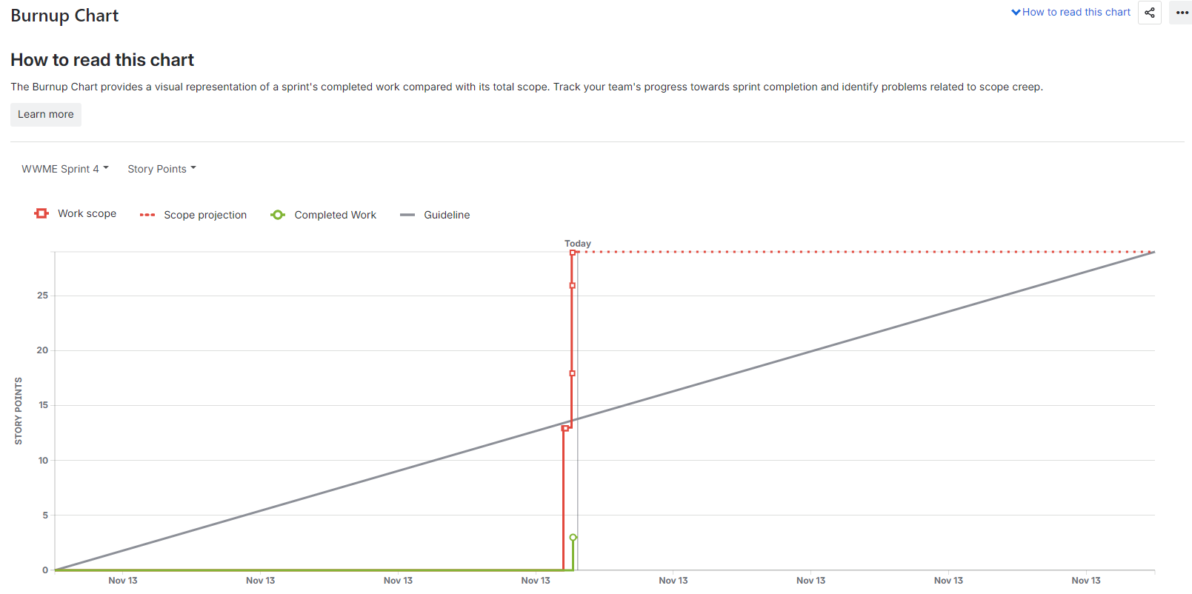

Sprint Backlog
User Story ID | User Story | Tasks | Owner | Status | Estimated Effort (hrs)
US001.1 | Capture KYC Data | UI form, validation, testing | Priya (Frontend) | Completed | 12
US001.2 | KYC API Integration | API setup, error mapping | Kiran (API Dev) | Completed | 16
US001.3 | KYC Status Display | Dashboard status logic | Rajesh (Frontend) | In Progress | 10
US002.1 | Buy API Integration | API creation, testing | Kiran (API Dev) | In Progress | 14
US002.2 | Sell API Integration | Backend logic | Sneha (QA) | Planned | 12
US002.3 | Trade Logging & Error Handling | Logging, retry setup | Ritesh (DevOps) | Planned | 10
US003.1 | Live Market Feed | Market API integration | Kiran (API Dev) | Completed | 14
US003.2 | Benchmark Comparison | Chart UI | Priya (Frontend) | In Progress | 10
US004.1 | Corporate Action Data Fetch | API setup | Kiran (API Dev) | Planned | 12
US004.2 | Portfolio Auto-Update | NAV update logic | Sneha (QA) | Planned | 14
US005.1 | Analytics Dashboard | Performance charts | Rajesh (Frontend) | Planned | 16
US005.3 | Downloadable Reports | Export PDF/Excel | Ritesh (DevOps) | Planned | 10

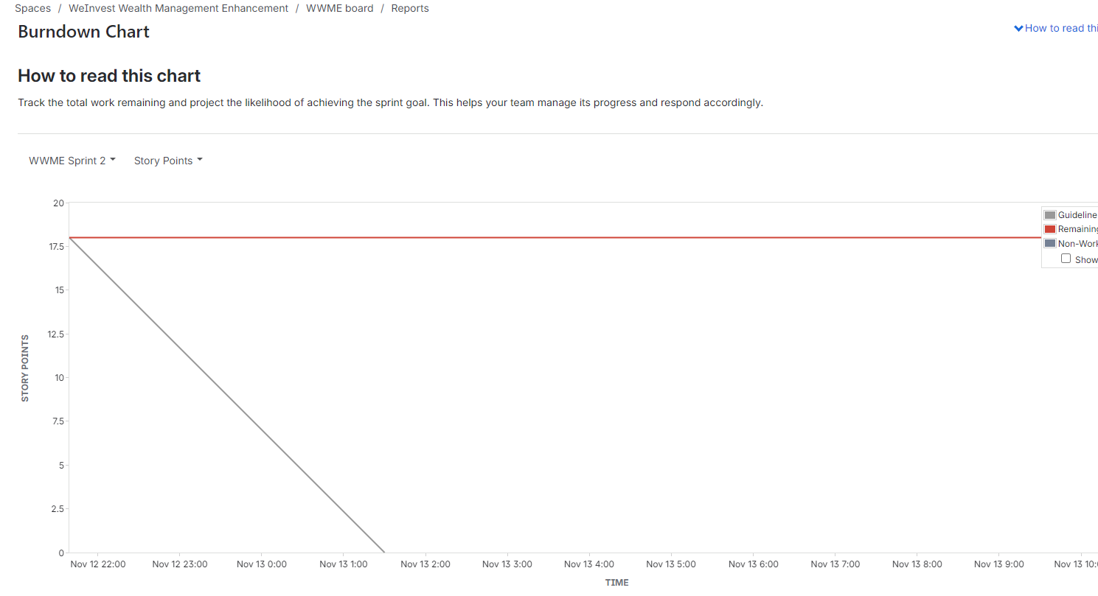
Document 6:Sprintmeetings

Meeting Type 1: Sprint Planning meeting

Date | 06-Jan-25
Time | 10:00 AM – 12:00 PM
Location | Hybrid (WeInvest Office, Mumbai + Microsoft Teams)
Prepared By | Nikhil Sharma (Scrum Master)
Agenda Topics
Topic | Presenter | Time allotted
Sprint Overview & Objectives | Product Owner (Alex) | 10 mins
Review Product Backlog | Scrum Master (Nikhil) | 15 mins
Identify Sprint Goals & Priorities | Scrum Team | 20 mins
Task Breakdown & Estimation | Developers | 25 mins
Assign Tasks & Confirm Ownership | Scrum Master | 10 mins
Define “Done” Criteria & Review Risks | QA & DevOps | 10 mins
Q&A and Closure | Scrum Master | 10 mins
Other Information
Observers | Business Analyst (Optional), Compliance Lead
Resources | JIRA Board, Teams Meeting Link, Sprint Backlog Excel Sheet
Special Notes | Sprint capacity estimated at 60 hours. Ensure all developers update task estimates before end of day.
Meeting Type 2: Sprint Review Meeting

Date | 20-Jan-25
Time | 3:00 PM – 4:00 PM
Location | WeInvest Office – Conference Room B / Microsoft Teams
Prepared By | Nikhil Sharma (Scrum Master)
Attendees | Product Owner – Alex Fernandez
Attendees | Scrum Master – Nikhil Sharma
Attendees | Developers – Priya Nair, Rajesh Verma, Kiran Patil, Sneha Joshi, Ritesh Menon
Attendees | Stakeholders – Operations Head, Compliance Lead

Sprint Status |  |  | Things to Demo | Quick Updates |  | What’s Next
Sprint Goal:Complete automated e-KYC and Buy/Sell API modules. |  |  | Automated e-KYC Workflow -Priya (Frontend) | • API latency improved from 8s → 3s. |  | • Start Sprint 2 focusing on Market Data Integration and Benchmark Comparison.
Planned User Stories :6 |  |  | KYC API Integration with Vendor -Kiran (API Developer) | • Validation errors reduced by 40%. |  | • Add caching layer for reliability.
Completed :5 (83% completion) |  |  | Buy/Sell Order Execution Flow -Rajesh (Frontend) | • Integration test cases automated. |  | • Plan Sprint Planning meeting on 22 Jan 2025.
In Progress :1 (KYC dashboard testing pending) |  |  | Trade Logging Dashboard -Ritesh (DevOps) | • UAT feedback incorporated for smoother user flow.
Overall Status :On Track ✅
 | Meeting Type 3: Sprint Retrospective Meeting
 | Date | 21-Jan-25
 | Time | 10:00 AM – 11:00 AM
 | Location | Microsoft Teams / WeInvest Office – Project Room 2
 | Prepared By | Nikhil Sharma (Scrum Master)
 | Attendees | Product Owner – Alex Fernandez
 | Attendees | Scrum Master – Nikhil Sharma
 | Attendees | Developers – Priya Nair, Rajesh Verma, Kiran Patil, Sneha Joshi, Ritesh Menon

Agenda | What Went Well | What Didn’t Go Well | Questions | Reference
Discuss sprint outcomes, identify process improvements, and agree on action items for the next sprint. | • Team collaboration was excellent — daily scrums on time. | • Some dependency delays from external KYC vendor. | • How can we better handle third-party API dependencies? | Sprint 1 Reports, JIRA Backlog, Burndown Chart Summary, Sprint Review Notes.
 | • KYC API integration completed ahead of schedule. | • Limited buffer time for regression testing. | • Should we allocate a dedicated QA resource per sprint?
 | • Improved testing cycle with fewer defects. | • Resource overlap between API and UI tasks caused minor delays. | • Can we use mock data to test external APIs before integration?
 | • Stakeholder demo received positive feedback.

Meeting type 4: Daily stand Up Meeting
Question | Name /Role |  | Week “X” (from dd-mm-yyyy to dd-mm-yyyy)
Question | Name /Role |  | Monday | Tuesday | Wednesday | Thursday | Friday | Saturday | Sunday
What did you do yesterday?
What did you do yesterday? | Developer 1 – Priya Nair (Frontend) |  | Completed KYC form UI | Fixed validation errors | Integrated status screen | Peer review with QA | Updated UI per feedback | — | —
What did you do yesterday? | Developer 2 – Kiran Patil (API Developer) |  | Configured Buy API | Added authentication tokens | Linked KYC vendor API | Tested trade execution | Logged API latency improvements | — | —
What did you do yesterday? | Developer 3 – Ritesh Menon (DevOps) |  | Setup CI/CD pipeline | Deployed QA environment | Configured logging for trade API | Monitored server uptime | Released sprint build | — | —
What will you do today?
What will you do today? | Developer 1 – Priya Nair |  | Finalize dashboard UI | Unit test validation form | Review KYC dashboard with team | Prepare demo screens | Update Sprint documentation | — | —
What will you do today? | Developer 2 – Kiran Patil |  | Refactor API endpoints | Integrate error handling | Test Sell API | Create mock test data | Support UAT testing | — | —
What will you do today? | Developer 3 – Ritesh Menon |  | Automate deployment script | Configure monitoring alerts | Validate logs with QA | Backup production data | Prepare deployment notes | — | —
What (if any) is blocking your progress? | Developer 1 – Priya Nair |  | None | API response delay | None | — | — | — | —
What (if any) is blocking your progress? | Developer 2 – Kiran Patil |  | Awaiting API key approval | Vendor API downtime | — | — | — | — | —
What (if any) is blocking your progress? | Developer 3 – Ritesh Menon |  | Missing server access | None | None | — | — | — | —

