Q.1 Identify minimum 20 functional requirements
A. Functional Requirements: Functional requirements refers to a specific behavior function or a process that the system or product must perform inorder to meet the needs of the stakeholder. It breaks down the business requirement into technical specifications. These requirements describe what the system should behave in terms of its operation, process and interactions.
Non Functional requirement defines the quality, attribute and performance that the system needs to meet. This defines as to how the system should perform under certain condition.

Req Id | Req Name | Req Description
FR001 | Login Function | The user should be able to login to the application with their login credentials
FR002 | Upload Products | The Manufactures should be able to upload there products
FR003 | Add description | The manufacturers should be able to add the product description with the product value
FR004 | Search product | The user should be able to search the product
FR005 | Add to cart | The user should be able to add products to the shopping cart to purchase
FR006 | Add to Wishlist | The user should be able to move their product from the cart to the Wishlist and have the option to buy it later
FR007 | Place Order | The user should be able to place order by adding the quantity of the product added in the cart and giving the delivery address
FR008 | Order Confirmation | The user should get a confirmation details which should include product ordered, quantity ordered, Amount and the expected day of receiving the order
FR009 | Payment gateway | Multiple payment gateways should be available for the secured payment
FR010 | Order tracking | User should be able to track the status and the location of their orders
FR011 | Order History | User should be able to view the previous order
FR012 | Customer Support | User should be able to interact with the customer support either through chat, email or phone
FR013 | Rating and reviews | User should be able to provide rating and write their reviews for the product purchase
FR014 | Sharing option | User should be able to share the products through their social medias platform
FR015 | Secure Transaction | The platform should ensure secure transaction by proper encryption
FR016 | Product filter option | The user should be able to filter the product by selecting the option of price range, quantity, brand.
FR017 | Profile settings | User should be able to manage their profile by editing their contact details and address
FR018 | Multiple Payment Gateways | The user should have multiple payment options such as debit card, credit card, UPI
FR019 | Product recommendation | The platform should provide personalized user recommendation based on their browsing historyf3r
FR020 | Save for later option | The user should be able to add the items which they want to purchase later to the add the Wishlist or save later option

NFR001 | Usability | The application should be user friendly
NFR002 | Page loading | The application must load the page in 3 second
NFR003 | Security | The application must ensure secure user authentication
NFR004 | Response | The application should response to the user input within 3 seconds
NFR005 | Representation | The page should have a detailed representation
NFR006 | Auto Readable | The OPT must be auto readable by the system
NFR007 | Time Out | Session time out must be in 3 minutes
NFR008 | Location accuracy | The location must be accurate upto 50 mtrs

Q2.

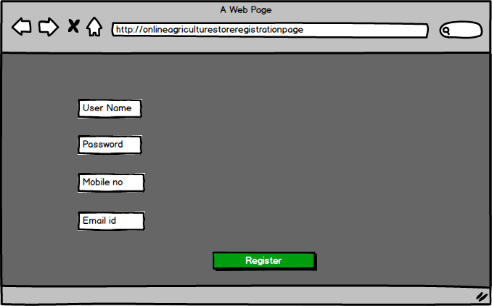
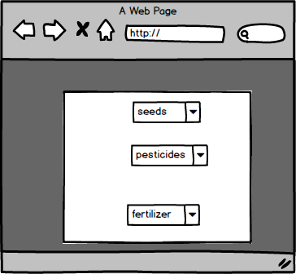

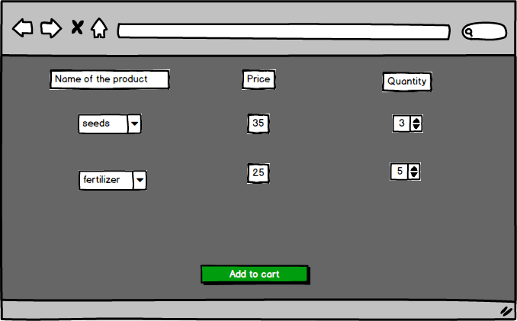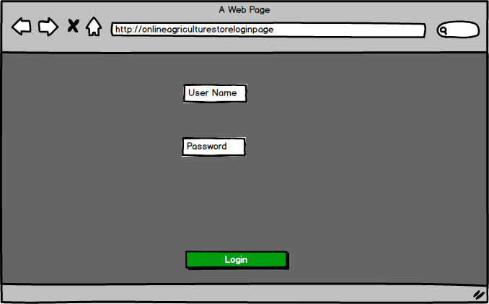

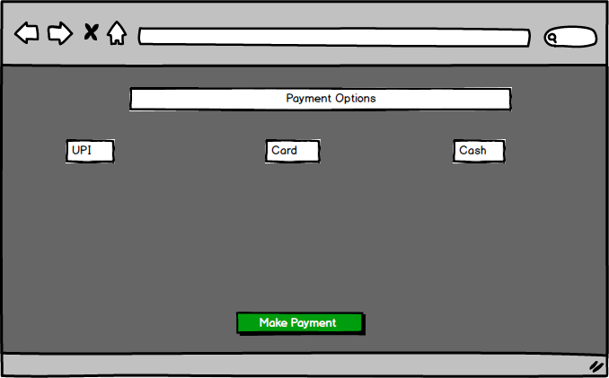

Q3. Make a note of tools
- Business analysis tool is a technique used to prepare a web design or a process flow or a protype which shows how the end product will look after taking into consideration all the requirements gathered for the project. It helps to show the process flow of the system. Tools like MS Visio, Axure, Balsmiq is used to as a business analysis tool.

MS Visio: It is powerful tool used to visually represent and communicate the complex business process, system, workflow and organizational structures. We can prepare flowcharts, data flow diagrams, swimlane diagrams, process flow diagrams, business process modelling.
Balsamiq: This is a wireframing tool used to create a mock-ups and wireframes for websites, apps . It allows us to picture the ideas and concepts thorugh simple drag and drop
Axure RP: this is a prototyping and wireframing tool used by the BA/ UI/UX designer, developer to create interactive, high – fidelity prototype or wireframes for the web application or any digital products.

Q4.
- RTM- Requirement Traceability Matrix is a document that links and track the requirement throughout the project lifecycle to ensure that all the requirement are addressed, tested and delivered. It is used for tracking the functional and non functional requirement . Here we can drag each and every requirement and check if it is completed or not , eg in design phase, in development phase etc. And also track the completion of work in testing phase which includes Unit testing, component testing, system testing and User Acceptance testing(UAT)

REQ ID | REQ Name | Req Description | Design | D1 | T1 | D2 | T2 | D3 | T3 | D4 | T4 | UAT
FR01 | Registration | User should be able to register | Completed | completed | completed | completed | completed | completed | completed | InProgress | incomplete | incomplete
FR02 | Login | User should be able to login | Completed | completed | completed | completed | completed | completed | completed | InProgress | incomplete | incomplete
FR03 | Product upload | User should be able to upload the product and its details | Completed | completed | completed | completed | completed | completed | completed | InProgress | incomplete | incomplete
FR04 | Add to cart | User should be able to add the available products to the cart | Completed | completed | completed | completed | completed | completed | inprogress | InProgress | incomplete | incomplete
FR05 | Make payment | Able to make payment through various modes | Completed | completed | completed | completed | completed | completed | completed | InProgress | incomplete | incomplete
NFR01 | Page loading | The page should not take more than 2 sec | Completed | completed | completed | completed | completed | completed | completed | InProgress | incomplete | incomplete
NFR02 | Response time | The response time for any input received should not be more than 3 sec | Completed | completed | completed | completed | completed | completed | completed | InProgress | incomplete | incomplete
NFR03 | Language support | All language options should be available | Completed | completed | completed | completed | completed | completed | completed | InProgress | incomplete | incomplete
NFR04 | Authentication |  | Completed | completed | completed | completed | completed | completed | completed | InProgress | incomplete | incomplete
NFR05 | Data security | The personal data should be saved properly | Completed | completed | completed | completed | completed | completed | completed | InProgress | incomplete | incomplete

Q5. Prepare test case document

Test case ID | TC001 | Test Case Name | User Registration
Project Id | P001 | Project name | Online agriculture store
PM id | 1234 | PM name | Mr Vandanam
Test strategy Id | 456 | Tester ID | 4545
Test Plan Id | 9898 | Tester Name | Mr. Jason
Test Schedule Id | 4545 | Date of Test | 01-Oct-2025
Scenario | New user should be able to register by providing email id and create password
Link to the page | onlineagristore.com
Pre condition | User should have a valid email id , internet connectivity should be strong, the URL should be working.
Post Condition | User should be able to login successfully after registration with their user id and password.
Input data | Email id, Mobile no, DOB, Name of the user
Expected Behavior | Once the user inputs all his required data he should be able to register himself and “registered Successfully “message should be popped up.
Actual behivour | After registration the user clicks on register button the system pops as user registered
Comment | N/A
Result (Pass/Fail) | Pass

Test case ID | TC002 | Test Case Name | Login
Project Id | P001 | Project name | Online agriculture store
PM id | 1234 | PM name | Mr. Vandanam
Test strategy Id | 456 | Tester ID | 4545
Test Plan Id | 7595 | Tester Name | Miss Alekya
Test Schedule Id | 4545 | Date of Test | 08-Oct-2025
Scenario | Registered user should be able to login using the username and password and captcha
Link to the page | onlineagristore.com
Pre condition | User should be a registered user
Post Condition | Once the registered user inputs the username/ ID , password and captcha he should be able to login successfully and search and buy the required products
Input data | User name/ id, Password and Captcha
Expected Behavior | Once the user inputs all his required data he should be able to register himself and “registered Successfully “message should be popped up.
Actual behivour | After inputing the user anme and password and the captcha the system should pop up login successfully.
Comment | N/A
Result (Pass/Fail) | Pass

Test case ID | TC003 | Test Case Name | Add to cart
Project Id | P001 | Project name | Online agriculture store
PM id | 1234 | PM name | Mr. Vandanam
Test strategy Id | 456 | Tester ID | 4545
Test Plan Id | 8899 | Tester Name | Mr Jason
Test Schedule Id | 4545 | Date of Test | 10-Oct-2025
Scenario | User should be able to add the item to the catr
Link to the page | onlineagristore.com
Pre condition | Products are in stock and add to cart option is enabled
Post Condition | The price and the quantity of the product should be displayed after the products are added to the cart
Input data | Product image, product price, product price
Expected Behavior | After login the user is able to search the required products and add it to his cart for purchase
Actual behivour | After sececting the product and its quantity the user clicks on add to cart option for the purchase
Comment | N/A
Result (Pass/Fail) | Pass

Test case ID | TC004 | Test Case Name | Coupon code apply
Project Id | P001 | Project name | Online agriculture store
PM id | 1234 | PM name | Mr. Vandanam
Test strategy Id | 456 | Tester ID | 4545
Test Plan Id | 7595 | Tester Name | Miss Alekya
Test Schedule Id | 4545 | Date of Test | 12-Oct-2025
Scenario | User should be able to add the coupon code to avail discount in total bill
Link to the page | onlineagristore.com
Pre condition | Coupon code should be valid
Post Condition | Once the user enters the coupon code after adding the required products to the cart he should avail the discount as per the coupon
Input data | Coupon code/ discount code
Expected Behavior | After adding all the required products to the cart, in the checkout page the user will put the coupon code to avail the discount
Actual behivour | After putting the coupon code the user is able to avail discount in the total price of the products purchased.
Comment | N/A
Result (Pass/Fail) | Pass

Test case ID | TC005 | Test Case Name | Payment Page
Project Id | P001 | Project name | Online agriculture store
PM id | 1234 | PM name | Mr. Vandanam
Test strategy Id | 456 | Tester ID | 4545
Test Plan Id | 7595 | Tester Name | Miss Alekya
Test Schedule Id | 4545 | Date of Test | 08-Oct-2025
Scenario | User should be able to do the payment through various options
Link to the page | onlineagristore.com
Pre condition | The required products are added to the cart and total of the payment is calcuated
Post Condition | Redirected to the 3party payment page or COD
Input data | Card details, UPI details, Payment methods
Expected Behavior | User should be able to choose from various payment options such as card, upi, internet banking, COD
Actual behivour | At the payment stage the user can select payment options such as card, upi, COD,
Comment | N/A
Result (Pass/Fail) | Pass

Test case ID | TC006 | Test Case Name | Payment confirmation
Project Id | P001 | Project name | Online agriculture store
PM id | 1234 | PM name | Mr. Vandanam
Test strategy Id | 456 | Tester ID | 4545
Test Plan Id | 7595 | Tester Name | Miss Alekya
Test Schedule Id | 4545 | Date of Test | 14-Oct-2025
Scenario | User should get payment confirmation intimation through email or sms
Link to the page | onlineagristore.com
Pre condition | The payment amount should be debited from the user account
Post Condition | Once the payment is made and after the confirmation emai/ sms the should tbe redirected to the delivery page for tracking the delivery
Input data | Total price and the quantity of the products
Expected Behavior | Once the user makes the payment an automated email/ sms should be sent to the user about the confirmation of the payment
Actual behivour | After making the payment the user gets email/ sms confirmation about the successful compleation of the payment
Comment | N/A
Result (Pass/Fail) | Pass

Test case ID | TC007 | Test Case Name | Order confirmation
Project Id | P001 | Project name | Online agriculture store
PM id | 1234 | PM name | Mr. Vandanam
Test strategy Id | 456 | Tester ID | 4545
Test Plan Id | 7595 | Tester Name | Miss Alekya
Test Schedule Id | 4545 | Date of Test | 08-Oct-2025
Scenario | User should get email or sms foe order confirmation
Link to the page | onlineagristore.com
Pre condition | Payment is successfully made
Post Condition | Order id and tracking details are shared
Input data | Product picture, product price and quantity
Expected Behavior | Once the payment is made the user gets the order confirmation email which includes the order id and tracking details
Actual behivour | After the successful payment the user gets the confirmation email alond with the order id and tracking details, expected date of delivery
Comment | N/A
Result (Pass/Fail) | Pass

Test case ID | TC008 | Test Case Name | Cancel order
Project Id | P001 | Project name | Online agriculture store
PM id | 1234 | PM name | Mr. Vandanam
Test strategy Id | 456 | Tester ID | 4545
Test Plan Id | 7595 | Tester Name | Miss Alekya
Test Schedule Id | 4545 | Date of Test | 08-Oct-2025
Scenario | User should be able to returne any order which he didnot like
Link to the page | onlineagristore.com
Pre condition | User should haveplaced the order and and cancel button is enabled
Post Condition | Order status updated and return is initiated
Input data | Users account details, order id, product details
Expected Behavior | User should be able to cancel the order through order page
Actual behivour | user is able to cancel the order and the refund is been initated
Comment | N/A
Result (Pass/Fail) | Pass

Test case ID | TC009 | Test Case Name | Return the order
Project Id | P001 | Project name | Online agriculture store
PM id | 1234 | PM name | Mr. Vandanam
Test strategy Id | 456 | Tester ID | 4545
Test Plan Id | 7595 | Tester Name | Miss Alekya
Test Schedule Id | 4545 | Date of Test | 08-Oct-2025
Scenario | User should be able to return the order which he don't like
Link to the page | onlineagristore.com
Pre condition | Product is already ordered and the return window is open
Post Condition | Order status is updated and refund is initiated
Input data | Order id, users account details, product id
Expected Behavior | User must be able to return the product from the return order page
Actual behivour | User is able to return the product from return page by using the order id and product id
Comment | N/A
Result (Pass/Fail) | Pass

Test case ID | TC010 | Test Case Name | Session time out
Project Id | P001 | Project name | Online agriculture store
PM id | 1234 | PM name | Mr. Vandanam
Test strategy Id | 456 | Tester ID | 4545
Test Plan Id | 7595 | Tester Name | Miss Alekya
Test Schedule Id | 4545 | Date of Test | 12-Oct-2025
Scenario | Application must be timed out after staying idle for 30 seconds
Link to the page | onlineagristore.com
Pre condition | User should be login and inactive
Post Condition | System should ask for relogin
Input data | User details
Expected Behavior | Application should be session out after been idle for 30 seconds and should ask for re login
Actual behivour | Application gets session out after been idle for 30 seconds and should ask for re login
Comment | N/A
Result (Pass/Fail) | Pass

Q6. Draw database schema and ER diagram
- Database schema is a logical structure that defines how the data is been represented in the database. It includes entity, attributes, constraints like primary key and secondary key
ER diagram is a graphical representation of the database schema. It uses entity attributes and constraints to visually show how the data is connected.
DB schema and ER diagram gives DB design

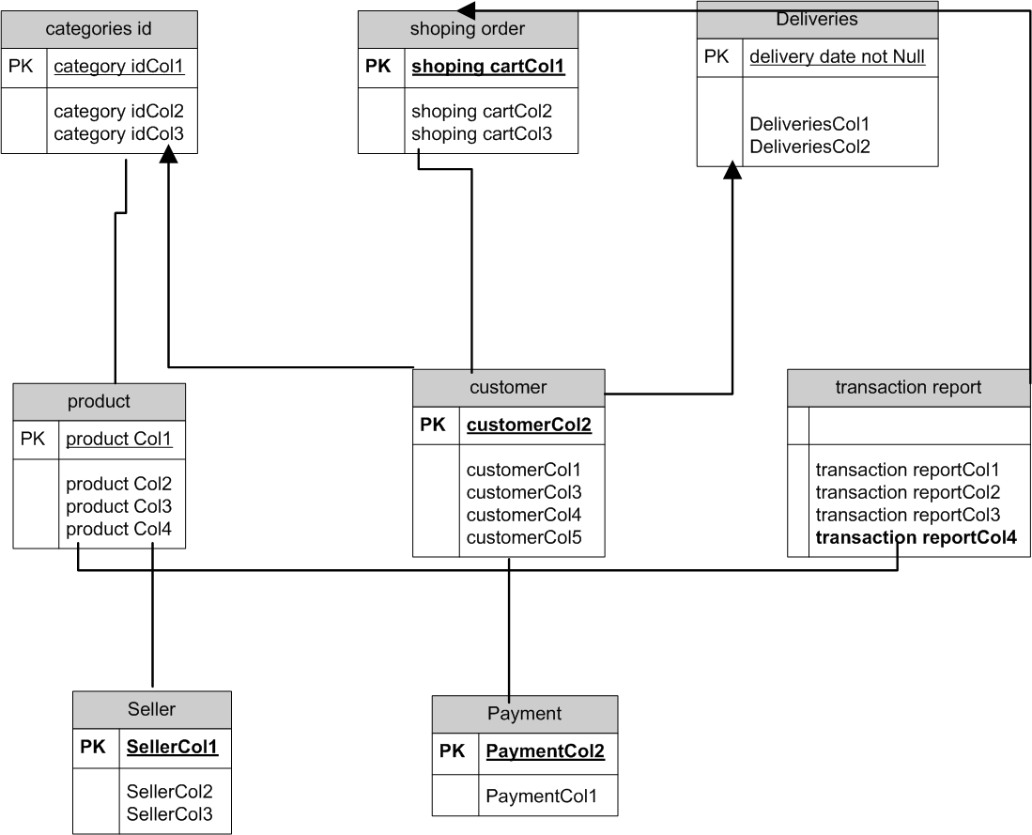

Q7. Data Flow Diagram
- It is a visual representation of the data, which shows how the data is stored, how it is processed within the system and how it is ended. It helps to understand how the design of the data and identify the bottleneck, inefficiency if any

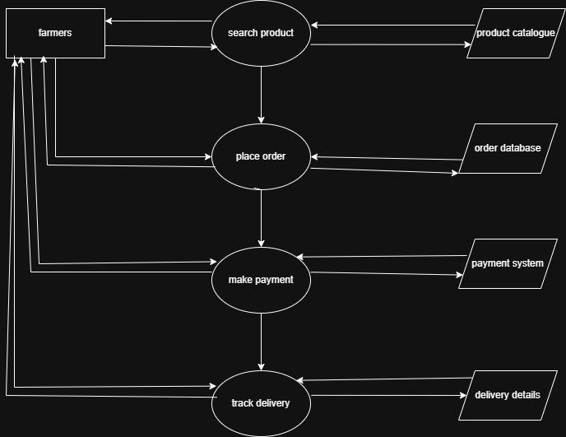

Q.8 how BA should handle the change request.
A. Change request is a formal proposal to alter the system, product or a project.
Change request should be handled in a structured manner so that it doesnot have any negative impact on the scope, time and budget of the project.
Below are the steps involved in change request:
- Change request identification: Identify the change request, document the changes with the specific details of the requested change, the reason of change and the impact of change in the project.
- Change impact analysis: Assess the impact of change in various aspects such as timeline, budget, resources, cost. Evaluate the feasibility of implementing the changes in the project.
- Change evaluation: Review the change request with the key stakeholders, project sponsors and reverent team members.
- Change request prioritization: prioritize based on the urgency and its impact on the project goal. Determine whether the change needs to be done immediately or can be postponed to the future date
- Change approval: Obtain a formal approval from the project sponsor of the change control board and also make sure the all the stakeholders aggree upon the requested changes.
- Change implementation: Incorporate the approved changes into the project plan by the including the changes in the budget, time and resources. communicate the changes to the revelent project team and the stakeholders. Update the project documentation such as requirement, design, and test case
- Change communication: Communicate the approved changes to all the revelant team members, to all the parties, stakeholders and client. Explain clearly about the changes required and all the adjustments in connection to that.
- Change tracking and documentation: track and document all the changes including the approvals and the implementations. Maintain a log or a register and update all the changes to ensure the transparency and accountability throughout the project.
- Change control and monitoring: continuously monitor the implemented changes and its impact on the project plan, scope and timeline. Update the stakeholders about any concerns and issues in the approved changes.
By following these steps project can handle change request.

Q9. Change Request Vs an Enhancement
- Change request is a formal proposal to modify the project process or a system. It occurs at any point of time during the project lifecycle for new requirement, unforeseen issues or for the need of enhancement.
Enhancement refers to improvement or addition made in the project after its initial release. These changes is aimed to increase the software value, performance and functionality based on the customer feedback. Enhancement can be a part of regular software updating or a updating of new version.
As a BA my response for ben’s and kevin’s request will be clasified as enhancement rather than the change request as change request typically involves the modification to existing functionality or requirement and enhancement introduces to new feature that was initially not specified.
In this case the request to allow the farmers to sell or auction their crop yield adds to the new functionality to the application.
To address the enhancement request i would like to follow the standard process for handling new requirement.
- Requirement Gathering: Will meet Ben and Kevin to gather requirements for the new functionality. This involves understanding the new features such as the process to add and manage the crop yeild by the farmers and display the same to the public for the auction.
- Impact analysis: I would analysis the impact of the enhancement on the existing scope, goal, budget and timeline and resources. This will help in determining the feasibility.

- Stakeholder analysis: I would involve the key stakeholders such as the project sponser, the development team and other key personal and take the required inputs for the enhancement.
- Evalutation and prioritization: I will work with the project stakeholders and the development team to evaluate and set priority for the enhancement request. This will consider the impact on project goal, object of the organization and resources.
- Planning and execution: If the enhancement is approved and is feasible i will update the project plan, schedule and cordinate with the development team and the stakeholder for execution of the new feature and ensure proper testing and quality assurance.

Q10. Come up with estimations – How many Manhours required
- Estimation - Estimation in Software Development Life Cycle refers to the process of predicting the resources (time, cost, effort) required to complete asoftware development project or specific tasks within that project. It helps in setting realistic expectation, managing resources efficiently. And evaluate the project feasibility.
Man hour estimation refers to the total amount of human efforts required to complete the software development task or a project. This estimation is required for planning, budgeting and scheduling the project.
Types of the project based on the man hours
- Small Project- Upto 500 man hours
- Medium Project -upto 1000man hours
- Large project-Upto 1500 man hours
Manhours Required = Total hours working per day x Total number of members xTotal numbers of days worked over the specific period.
Number of Working Hours a day = 8 hours
Number of Resources = 12
Time period provided = 18 months = 547 days = 78 weeks (Including Weekends andPublic Holidays)
Assuming Weekends = 156
Assuming Public Holiday= 10
Total = 166
Total working days = 547-166 = 381 working days
Hence, Estimated Manhours = 8 hours * 12 resources * 381 days = 36,576 Manhours required.

Q.11 UAT
A. UAT (user acceptance testing) is a cruicial stage in the SDLC as the user validates the software by testing it in a real world or production like environment. The primary goal of the UAT is that the software meets all the business requirments, functional requirements and is ready to be deployed to the end user.
Below are the stages involved in UAT
- Planning (Prepare for UAT)
In this method blue prints are made for implementing UAT testing for every feature.
Identify key stakeholders, including farmers, suppliers, and business owners.
Review business requirements, ensure critical functionality such as product search, payment method and delivery tracking are included.
- Designing
Here the test case and relaistic datasheets are designed for accurate testing scenario.
Conduct a walkthrough for the critical functions like browsing categories, add the product to cart, tracking details, payment methods.
- UAT Testers:
The testing team consists of end users, who after understanding the test cases do the testing in for critical functionality such as scarching the products, adding to the cart and making the product.
The BA will monitor the progress and take feedback for the missing features of usability issue and log for them for resolving.
- Bug fixing
Whenever bugs are found in UAT the testing team will prioritize and fix the same for error free use
- Sign off
After removing all the bugs the testing team will indicate acceptance of the compleation of all the bugs. Then all the stakeholders comes to a conclusion that the project is ready to go live.

Q.12 Explain project closure document
A. Project closure document also known as closure report is a formal document which signifies the conclusion of the project. It provides details about the project performance, achievements, lesson learnt and any remaining task or any issues. The purpose of this document is to ensure that the project is officially closed, and all the stakeholders have aggred that the project has met its objective.
The project closure documents includes the following:
- Project overview:
Introduction of the project, its scope, its objective and the key stakeholders.
Overview of the project life cycle, including major milestone and phases.
- Project achievement:
This document highlights the key achievements and the deliverables of the project. It outlines the significant milestone of the task which were achived.
- Project timeline and budget:
This includes the project timeline highlighting the start and end date of the project and any major milestone of phase achieved. It also include the project budget including any significant changes.
- Lesson Learnt:
This section includes as to what went well for the project and the areas of improvement. It provides valuable insights for the future projects.
- Quality assurance:
This provides the overview of the testing and validation activity to ensure that the quality is maintained. It also includes the summary of the defects or issues resolved and how it effects the outcome of the project.
- Resource utilization:
This section indicates the utilization of resources. analysis and identify the underutilization or over utilization of the resources and their impact on the project. Recommends optimum resources planning in the future projects.
- Risk Management:
This includes as to how effectively the risk was handled during the project. New risk encountered and lesson learnt to manage the risk for the future project.
- Challenges:
Key obstacles faced during the project and their impact on timeline and delivery. Evaluation of unsolved challenges and their implication on future efforts.
SN | Points to include | Details | Link
1 | Did the client signoff the UAT testing
 | Date of sign off | 10- oct -2025
 | Name of the resources | Mr XYZ
2 | Objective of the project
 | User friendly | Achived
 | Customer satification | ROI in 6 to 12 months
3 | Functionality worked on
 | Secured payment process | achieved
 | categories | achieved
4 | Infrastructure
 | Software installed | achived
 | Licence purchased | achived
5 | Funding
 | Amount approved | 2cr
 | Amount used | 1.98 cr
6 | Overall project information
 | Escalations | 50
 | Customers satification | high
7 | Value to the company
 | Positive/ negative | Positive-90%  Company has gained an edge over the competitor  Increased client

