Waterfall Deliverables- Part 2
Document 6: Use case diagram, activity diagram and a use case specification document.

Use Case diagram shows what system does from the user’s perspective. It highlights actors, use cases and relationships (include, exclude, generalization, association) with them.
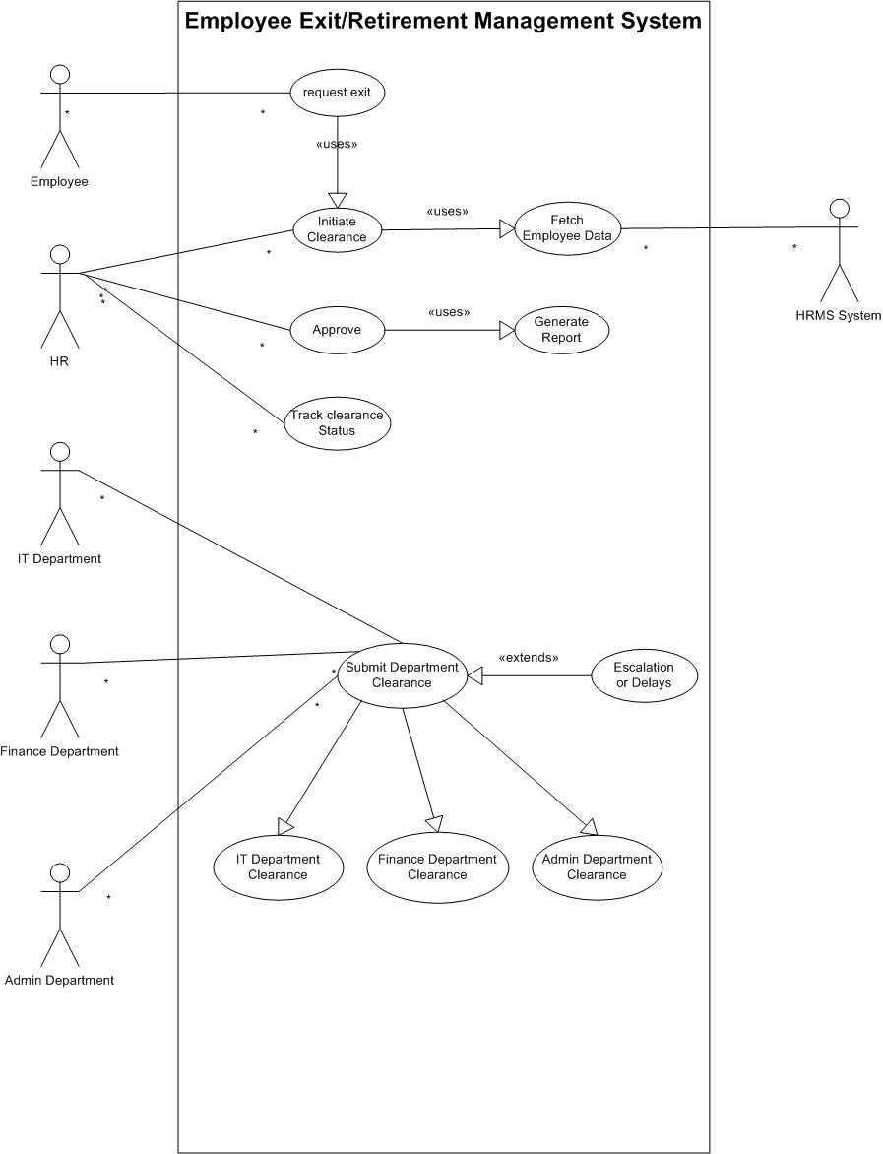
Use case Diagram
Activity diagram shows how the process flows step by step in the system. It is like a workflow chart that explains the order of activities and decisions.
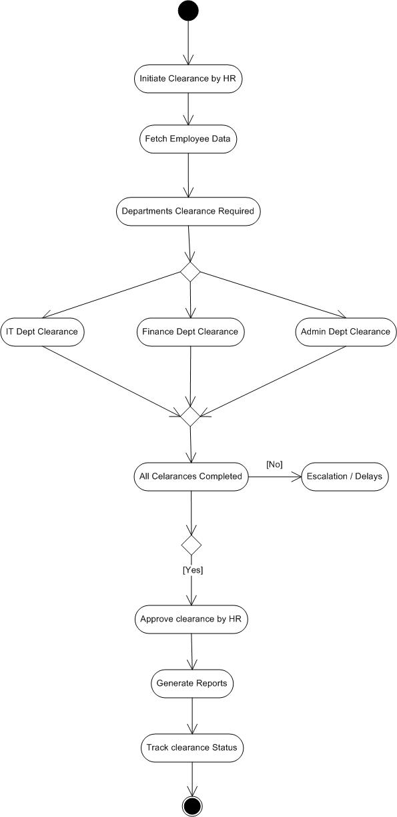
Activity Diagram
Use case Specification Document:

- Use case Name:
Request Exit
- Use case Description
Employee requests exit/retirement
- Actors
- Primary Actors: Employee
- Secondary actors: HRMS system
- Basic Flow
- Employee selects “Request Exit”
- System validates employee record
- Exit request submitted to HR
- Alternate Flow
- Employee cancels request before submission
- Exceptional flow
- Invalid employee status then requests rejected
- Pre- Conditions
- Employee must be active in HRMS
- Post-conditions
- Exit request submitted and sent to HR
- Assumptions
- Employee has access to portal
- Constraints
- Request must include last working date
- Dependencies
- Triggers initiate clearance
- Inputs and Outputs
- Input: Employee ID, exit details
- Output: Exit request acknowledgement
- Business Rules
- Exit request requires minimum 30-day notice
- Miscellaneous Information
- Initial trigger for exit process
- Use Case Name
Fetch Employee Data
- Use case Description
System fetches employee details for HR
- Actors
- Primary Actors: HRMS
- Secondary actors: HR
- Basic Flow
- System retrieves employee records
- Sends data to HR
- Alternate Flow
- Partial data retrieval if some fields missing
- Exceptional flow
- System error retrieving data
- Pre- Conditions
- Employee exists in HRMS
- Post-conditions
- Employee details available to HR
- Assumptions
- Data is up to date
- Constraints
- System downtime may delay fetch
- Dependencies
- Triggered by initial clearance
- Inputs and Outputs
- Input: Employee ID
- Output: Employee data set
- Business Rules
- Data includes department and asset information
- Miscellaneous Information
- Used in clearance workflow

- Use case Name:
Initiate Clearance
- Use case Description
HR initiates clearance after receiving employee’s exit request
- Actors
- Primary Actors: HR
- Secondary actors: Employee, HRMS system
- Basic Flow
- Hr receives exit request
- HR initiates clearance
- System fetches employee data
- Clearance request sent to departments
- Alternate Flow
- HR schedules clearance initiation for future date
- Exceptional flow
- Employee data unavailable
- Pre- Conditions
- Exit request must exist
- Post-conditions
- Clearance workflow started
- Assumptions
- HR has system access
- Constraints
- Clearance initiation must happen before exit date
- Dependencies
- Uses fetch employee data from HRMS system
- Inputs and Outputs
- Input: Employee ID
- Output: Clearance workflow initiated
- Business Rules
- Clearance starts only after HR confirmation
- Miscellaneous Information
- Marks start of department clearances
- Use case name
Generate Report
- Use case Description
System generates clearance report for HR
- Actors
- Primary Actors: HR
- Secondary actors: HRMS System
- Basic Flow
- HR requests clearance report
- System complies clearance data
- Report generated
- Alternate Flow
- HR can choose summary or detailed report
- Exceptional flow
- Missing clearance data
- Pre- Conditions
- Clearance process should exist
- Post-conditions
- Report available for HR
- Assumptions
- Data is accurate
- Constraints
- Report must be exportable in pdf or excel sheet
- Dependencies
- Uses clearance status records
- Inputs and Outputs
- Input: Employee ID
- Output: Clearance report
- Business Rules
- Report includes timestamp
- Miscellaneous Information
- Used for audit

- Use Case Name
Approve
- Use case Description
HR approves final clearance
- Actors
- Primary Actors: HR
- Secondary actors: HRMS System
- Basic Flow
- HR reviews clearance status
- HR approves clearance
- System generates clearance report
- Alternate Flow
- HR requests changes before approval
- Exceptional flow
- Pending clearance in any department
- Pre- Conditions
- All department clearances submitted
- Post-conditions
- Employee gets approval for released officially
- Assumptions
- HR validates all records before approval
- Constraints
- Cannot approve without all clearances
- Dependencies
- Report generation after providing approval
- Inputs and Outputs
- Input: Clearance list sends by each department
- Output: Approval confirmation
- Business Rules
- Approval finalizes exit of an employee
- Miscellaneous Information
- Closure point of exit process

Document 7: Screens and pages
For this project, I have used Axure to design mock-ups for the sysyem. It shows how the system will look and work before actual development.
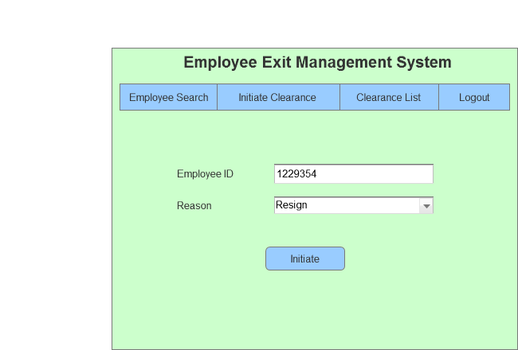
HR Initiate for Employee’s Exit
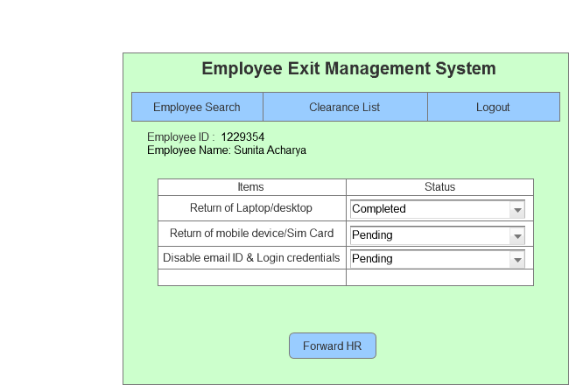
IT Department Checklist
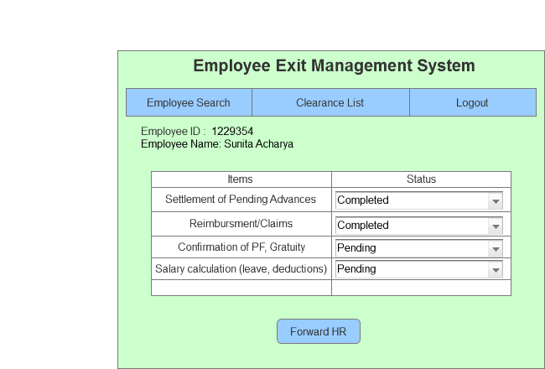
Finance Department Checklist
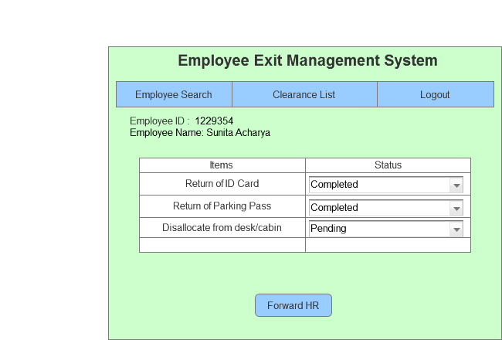
Admin Department Checklist

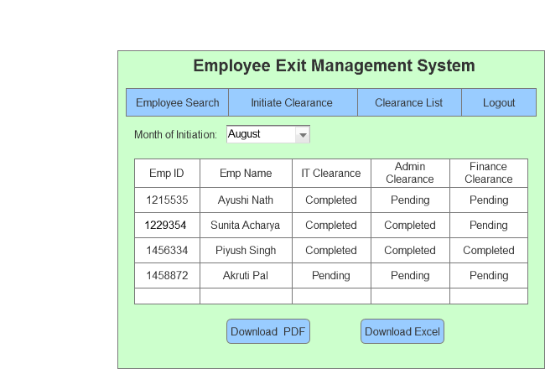
HR Checklist Dashboard
Document 8: Tools-Visio and Axure
In this project, I used MS Visio extensively to create process flow diagrams, use case diagrams and activity diagrams. Visio helped me map out the end-to-end workflow of the employee exit clearance process, define system boundaries and represent interactions between actors and use cases. By visualising activities, decision points and dependencies, I was able to clearly communicate the business logic and system behaviour to stakeholders. The use of Visio ensured that the requirements were well-structured, easy to understand and aligned with the project objectives.
For UI and page design aspect of the project, I used Axure to develop wireframes of the clearance system. Axure allowed me to create page designs that demonstrated how users such as HR, IT department, Finance department and Admin department would look like.
Through this, I was able to showcase the designs in the layout and dashboards, making it easier for stakeholders to visualise the final product before development. This not only improved requirement validation but also reduced ambiguity by providing a clear picture of the system’s look and feel.

Document 9: BA experience
For this enhancement, I have used waterfall model to complete it. My BA experience for Employee Exit/Retirement Management System follows waterfall phases, which are:
Requirement Gathering, Requirement Analysis, Design, Development, Testing, Development.
- Requirement Gathering:
- For requirement gathering, I used elicitation technique which are interviews, workshops, and observation to capture pain points of current clearance workflow and identify gaps.
- I also performed document analysis on existing HR policies, clearance checklist and compliance guidelines to ensure nothing critical was missed.
- Since this project’s stakeholders were from multiple departments, I prepared and circulated questionnaires to gather additional inputs.
- I validated requirements by aligning them with business goals and cross-checking them against the scope to ensure there were no duplicate or contradictory requirements.
- Early prototyping through wireframes was used to clarify screen-level expectations with HR and other departments, which helped refine requirements further.

- Requirement Analysis:
- I prepared use case diagrams, activity diagrams and process flow diagrams (AS-IS) in MS Visio to visualize requirements and ensure all workflows were clearly defined.
- By taking reference from use case diagrams, I made use case specification document where I have provided detailed descriptions of each use cases which includes actors, steps, inputs, outputs, flow etc.
- Stakeholder feedback sessions were organised to review these diagrams. Some changes were suggested by IT team such as Collect It asset should have separate checklist for laptop and mobile, which I incorporated after detailed discussions.
- I prepared the Business Requirement Document (BRD) and Functional Requirement Specification (FRS) for sign-off.
- A Requirement Traceability Matrix (RTM) was also drafted to map each requirement with its corresponding design, development and testing deliverable.

- Design:
- I collaborated with system architect and development team to translate use cases into test scenarios.
- Mock-ups in Axure were created to show the clearance initiation, HR dashboard, HR checklist for approval, IT checklist, Finance and Admin checklist, reporting pages for HR.
- I ensured that both positive and negative test cases were written from the requirements and updated the RTM accordingly.
- I reviewed the design documents with stakeholders to ensure they matched business needs and compliance requirements.

- Development:
- I organised JAD (Join Application Design) sessions with HR and technical team to clarify functional aspects like clearance checklist generation and dashboard reporting.
- Whenever developers had doubts about business rules such as handling escalation if clearance is pending beyond 10 business days, I clarified them with HR heads and updated the documentation.
- I mediated disagreements between technical and functional stakeholders by explaining how certain design decisions directly impact compliance and audit readiness.
- I ensure the team referred to diagrams and requirements documents throughout coding.

- Testing:
- I prepared UAT scenarios from the use cases and clearance workflow.
- I performed high-level validation testing with test data (sample employee records with pending clearances) provided by HR
- I coordinated with testing team, gather information regarding test cases feedback and documented it in a test case scenarios document.
- The RTM was updated with testing status, ensuring each functional requirement (FR001-FR010) was verified.
- I organized User Acceptance Testing (UAT) with HR, IT, Finance, Admin teams capturing issues and ensuring fixes before retesting.
- Once UAT was successful, I coordinated with Project Sponsor to obtain format sign-off.

- Deployment:
- I shared the finalized RTM with the client, attaching it to the project closure document.
- I coordinated the preparation of end user manuals and training sessions for HR, IT, Finance and Admin teams.
- I scheduled and conducted training workshops to ensure smooth adoption of the system.
- I ensured that all stakeholders were present in the final deployment meeting and track progress meeting post go-live.

