Live Project Waterfall Model Documents Part-2/2

Q.1) Use case diagram, activity diagram and a use case specification documents?
Ans.1)

Use Case Specfication document

- Brief decription
This use case describes how an employee from an organisation will use a automation sofwtare solution lnow as Powertrack+ to monitor, control, validate and automate their departmental domain KPI’s

- Actors
Employee
HOD’s
Top level management
Development yeam

- Pre-condition
There must be an active LAN netwrok and mobile accessibility along with system for each employee or user using this knowledge
There must be a facility to for dasboards installation ann an IT team for coordination.

- Basic Flow Events
- The use case begins with an employee or user begins with signing up for accessing the application
- The employee the/n login with employee ID or mobile no and pre defined passowrds
- The user then selects their specific domains i.e Production,store,Purchase,Quality and maintenance
- The user accsess and monitor their Hourlu,daily progress of their KPIs on manufacturing line
- The user then validates and export their data on specific folder for future use.
- The user according to their requirements iniiate and perfform specfic tasks as filling data suchn as production rate, defetcs rates, downtime reports etc.
- Based upon the data employee plan and initiate certain improvements activities as an when required.
- The user them prepare a gantt chart and based on the targets dates and approvals from their HOD.s track theur status.
- After approvals the user perofrm and implement low cost automation solution in plant to increase their OEE
- The user after installation track the progress report and improvement status and send their graphs to HOD.s and top level management.
- The use case ends successfully.

- Alternate flows
- The user could see invalid user details during sign-uo process.
The application will prompt their wrong selection of data
- Wrong Passowrd
The application will send an prompt message in case user enters wrong or invalid passoword
- Wrong domain selection
As specific users from different departement can access only speific domain hence application will send amessage that the user has selected wrong domain
- Inavlid data accessibility
If user inputs any wrong or incorrect data into the domain the application will restrict if it is out of bound data.
- Exporting data
Application will prompt a message if user start exporting data and sending to an unautorize accound or mail any other server.

- Post-condition
The application will prompt a successful sign-up completion when it validates all data are correct
The application will prompt a succssful completeion of project when all the condition in the project domain and work flow are completed after installation and when targets are met.

- Assumption
The data might be incorrect when a wrong input has been given by the user.
The application might not show any fault in case data is manipulated
The application might not log correct or incomplete data in case server is down
The application can fetch worng output if project status are forcefully completed.

- Constraints
Network issue with server domain
Netwrok issue with mobile application
Application support feature on few mobiles

- Inputs & Outputs
Inputs from user such as targets, machine downtime for major & minor level, manpower allocation status, initial rework and bad quality data
Outputs will result in hourly fetching of data sjowing Plan vs actual acjived, level of automation in plant, inventory levels, downtome and energy data on daily basis.

- Business rules
The business rules defines using an digital appliaction process to ensure all the kpi are met in defines duration sucg as to achieve maximum ouput from the organisation and from each employee,track their goals and giebn kpi’s . Hence with this organisation can benfit on various aspects such improved products cost, eliminating high value defecr rates and usage of manpower resulting in reduction in manufacturing cost.

Q.7) Screens & Pages

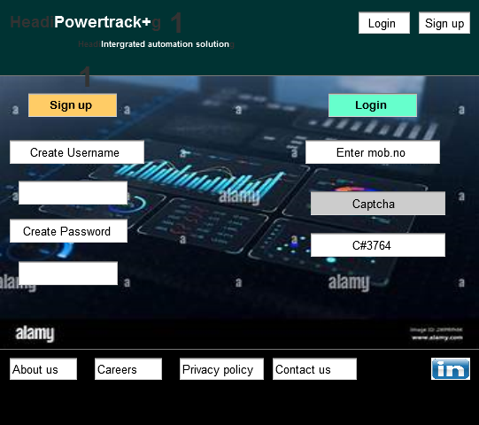

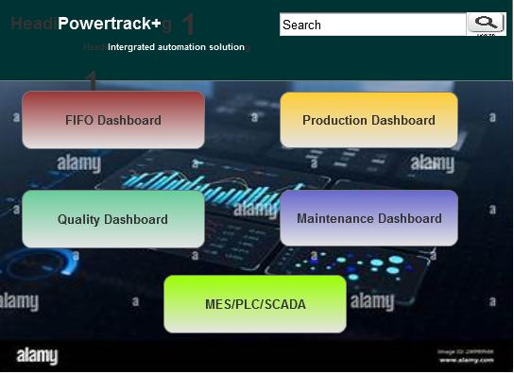

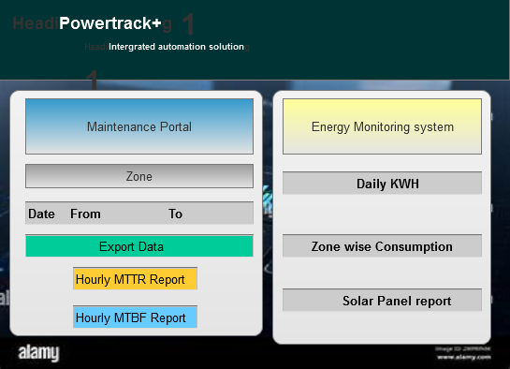

Q.8) Experience using MS Visio and axure?
Ans.8) Using MS visio has been a practical and rewarding experience,The drag and drop interface make it easy to create flowcharts,network diagrams and organisational charts. Its wide range of templates and smart shapes streamlines the process,allowing user to focus more on logic than formatting.It can also integrate with other MS office tools which was appriciable making it more colloborative and smoother experience and more efficient. Visio verstality and professional polish make it valubale tool in any productivity toolkit.

Working with MS azure was a wonderful experience it allows seamless intergration across services,its robust infrasturcuture allows for rapid deployment and management of application wether through virtual machines and app servies. Its detailed monitoring tools provides real time insights and performance optimization.Azure has helped streamline worklows and unlock innovation across projects.

Q.9) BA experience
Ans.9)
Business Analyst (BA) plays a crucial role in the early phases, particularly during requirements gathering and documentation, as changes are difficult to accommodate once development begins. BAs are responsible for defining the business problem, identifying stakeholders, and documenting the desired state

Requirement Gathering:
As a BA We used various req. gathering technique such as brainstorming, Interviews and JAD sessions to acquire all the requirements. We also used prioritisation technique such as MOSCOW to categorize and rank the importance of project requirement.
Client may not be available all the time hence I need to find out the source of contact and collect the information asap.
For validation of req we used FURPS technique.
As a BA we need to remove duplicacy of requirements to avoid redundancy.

Requirement Analysis:
We need to draw UML diagrams to visually describe the requirements.
We also need to draw activity diagrams to describe the process flow.
Communicate the diagrams to the team members
Prepare BRS and SRS document.

Design:
From use case diagram we prepare test case document and test case specification
Coordinate with client for design and solution
Write test cases for both negative and positive test cases.
Prepare RTM to make sure all the requirements has been addressed.

Development:
Organise JAD and brainstorming session to find innovative solution.
Clarifying queries to technical team.
As a BA it is our responsibility to create a healthy environment and to discuss one on one with each team member who are not agreed with the particular solution and to make understand how their action can impact their project.
Conducting regular meeting with technical team and recording the session for other references.

Testing:
Prepare test cases from use cases
Perform high level meeting
Update RTM
Take sign off from client
Prepare client from UAT

Deployment:
Forwarded RTM to client attached with project closure document
Coordinate to submit user manuals
Plan and organize training sessions
Take feedback from the client

