SHIVAM MEHROTRA

Assignment 1
1-Business Requirement Document


<INVENTORY & DELIVERY MANAGEMENT SYSTEM >
<IDMSD001BRDV1D1>
<V1>
<SHIVAM MEHROTRA>

Contents
1. Document Revisions 4
2. Approvals 4
3. RACI Chart for This Document 5
Codes Used in RACI Chart 5
RACI Chart 5
4. Introduction 6
4.1. Business Goals 6
4.2. Business Objectives 6
4.3. Business Rules 6
4.4. Background 6
4.5. Project Objective 6
4.6. Project Scope 6
4.6.1. In Scope Functionality 6
4.6.2. Out Scope Functionality 6
5. Assumptions 7
6. Constraints 7
7. Risks 7
Technological Risks 7
Skills Risks 7
Political Risks 7
Business Risks 7/8
Requirement Risks……………………………………………………………………………………………………………………………………………….8
Other Risks ………………………………………………………………………………………………………………………………………………………… 8
8. Business Process Overview 8
8.1. Legacy System (AS-IS) 8
8.2. Proposed Recommendations (TO-BE) 8
9. Requirements……………………………………………………………………………………………………………………………………………………….9
9.1 Business Requirements
9.2 Functional Requirements
9.3 Non-Functional Requirements
10.Appendices………………………………………………………………………………………………………………………………………………………….9
10.1 List Of Acronyms………………………………………………………………………………………………………………………………………….9
10.2. Glossary Of Terms……………………………………………………………………………………………………………………………….9
10.3. Related Acronyms……………………………………………………………………………………………………………………………….9

Document Revisions
Date | Version Number | Document Changes
022.06.2025 | 0.1 | Initial Draft

Approvals
Role | Name | Title | Signature | Date
Owner of the firm. | Mr.Aman | Owner-Sponser |  | 22.06.2025
Acts as CFO and responsible for managing finances of company. | Mr.Nitin | Finance Head |  | 22.06.2025
Oversees order fulfilment and delivery operations; ensures timely execution. | Mr.Jain | Operation/Delivery Head |  | 22.06.2025
Ensures overall project execution and timely delivery. | Prashant | Delivery Head |  | 22.06.2025
Manages scope, timeline, and coordination of Waterfall phases. | Nikhil | Project Manager |  | 22.06.2025

RACI Chart for This Document
The RACI chart identifies the persons who need to be contacted whenever changes are made to this document. RACI stands for Responsible, Accountable, Consulted, and Informed. These are the main codes that appear in a RACI chart, used here to describe the roles played by team members and stakeholders in the production of the BRD. They are adapted from charts used to assign roles and responsibilities during a project. (RACI can be made for IT side [Project stakeholder] as mentioned above, apart from that, it can also be made for Client side [Business Stakeholder]).
The following describes the full list of codes used in the table:

Codes Used in RACI Chart
R Responsible Responsible for creating this document.
A Accountable Accountable for accuracy of this document
(for example, the project manager)
C Consulted Provides input (such as an interviewee).
I Informed Must be informed of any changes.

RACI Chart
Business Stakeholders
S. No. | Name | Position | BRD | MOCKUP | Test PLAN | Project Plan
1 | Mr.Aman | Owner-Sponsor | A | A | A | A
2 |  | Finance Head | I | I | I | I
  Mr. Nitin
3 | Mr. Sharvil | Operation/  Delivery Head | C | C | C | C
4 | Mr. Kishore | Customer Service Head | I | C | C | I
5 | Mr. Kirti | Sales and Distribution Head | I | C | C | I
6 | Mr. Ranjeet | Plant Managers | I | I | I | I
7 | Mr. Siddharth | Warehouse Manager | I | I | I | I
Project Stakeholders
S.No. | Name | Position | BRD | MOCKUP | Test Plan | Project Plan
1 | Mr. Jain | Delivery Head | C | C | I | C
2 | Mr. Vaibhav | Project Manager | A | C | A | R/A
3 | Mrs. Jaya | Sr. Java Developer | I | I | I | I
4 | Mr. Prashant | Java Developer | I | I | I | I
5 | Mr. Vibhor | Java Developer | I | I | I | I
6 | Mr. Tutu | Network Admin | I |  | I | I
7 | Mr. Rakshit | DB Admin | I |  | I | I
8 | Mr. Rohit | Tester | I |  | R | I
9 | Mr. Vikas | Tester | I |  | C | I
10 | Mr.Shivam | BA | R | R | C | C

Introduction

Business Goals
The goal of the Inventory & Delivery Management System (IDMS) is to efficiently manage inventory across multiple manufacturing plants and warehouses, and to ensure the quickest possible delivery of ice-cream and milk products to customers by automating order allocation and optimizing delivery routes.

Business Objectives
The system will centralize inventory tracking, optimize order fulfillment, and streamline logistics, thereby reducing wastage, improving operational efficiency, and enhancing customer satisfaction and to enable data driven decision making through centralized reporting and analytics.

Business Rules
As a solution tech company we apply industry-best practices and ensured to update the inventory in real time across all allocations, apply FIFO in product dispatching, to auto assign order to nearest warehouse with available stock. We ensure minimum stock alerts are triggered to avoid shortages and provide role based access to the system and delivery timelines must follow service level agreements.
Background
The increasing volume of warehouses, expansion of business and increase in orders has made it challenging for Ice-cream and Milk Products Manufacturing Company to manage real time inventory, timely order fulfillment, managing and controlling wastage of perishable products, poor coordination between Warehouses and manufacturing units. This all has resulted in order delays and decrease in customer satisfaction levels.

Project Objective
To develop and implement Inventory & Delivery Management System to automate real-time inventory visibility and to manage inefficient order fulfillment to ensure timely delivery and eventually increase customer satisfaction and proper management and coordination between manufacturing plants and warehouses across all parts of country.

Project Scope

The project scope covers development and implementation of Inventory & Delivery Management System to meet evolving business across country in e-commerce industry operating across country and facing problems to observed high traffic of orders and to control wastage of products and timely delivery eventually increasing coordination among different manufacturing plants and warehouses across country.
Resources:
People- SME who will provide insights into process involved for Ice-cream and Milk Products Company. Other than this Skilled Developers (Front End and Back End), DB Admin, NW Admin, PM and BA are the people involved behind development of IDMS. Since Waterfall demands thorough documentation, testing, and debugging before deployment, skilled resources are crucial.
Time- As Waterfall model follows sequential approach and the final delivery is done only after the completion of last stage hence Duration of 12 months is required to develop IDMS as we are following Waterfall methodology and its required to complete each stage before moving to another out of which min 15% of the total time will be dedicated to BA for requirement gathering and analysis stage.
Budget- Total of 50 lakhs budget is minimum required as Waterfall model follows sequential structured approach where each phase is fully completed before moving to next which requires skilled resources and careful planning.

In Scope Functionality
- Streamlining and automating inventories and coordination between manufacturing plants and warehouses for efficient management and product tracking and faster delivery.
- Implementing features as per the specifications outlined in the requirement documents.
- Providing maintenance and support services remotely for up to one-year post-implementation.

Out Scope Functionality
The following functionalities are not included in the current phase of the project and may be considered for future enhancements:
- Integration with external courier or logistics service providers is not planned.
- Only English is supported in the current release.

Assumptions
- The following assumptions have been made for the successful execution and delivery of the project:
- All users (warehouse, plant, and admin) will have access to reliable internet to use the web-based application.
- Users will have unique credentials, and authentication will be centrally managed.
- All necessary business inputs, approvals, and feedback will be provided by stakeholders as
- Warehouses and plants are equipped with the necessary hardware (computers, barcode scanners, etc.).
- Business processes like order handling, delivery routing, and inventory control are already documented and agreed upon.
- Requirements once finalized will not undergo major changes during development.
- End-users will be available for training before go-live to ensure smooth adoption.
- Standard security policies and compliance requirements (e.g., data protection) will be followed by default.

Constraints
- Any changes after the requirement finalization will require formal approvals and may impact timelines.
- The accuracy and completeness of lead information depend on users entering valid details.
- The system can integrate only with predefined platforms
- Support and maintenance will be provided for a fixed period (up to 1 year remotely), with additional support requiring a separate agreement.
- Each phase must be completed before progressing to the next, limiting flexibility for mid-phase modifications.
- Reports and dashboards will be based on available system data, and custom reporting may require additional configurations.

Risks
A risk is something that could affect the success or failure of a project. Analyse risks regularly as the project progresses. While you may not be able to avoid every risk, you can limit each risk’s impact on the project by preparing for it beforehand. For each risk, you’ll note the likelihood of its occurrence, the cost to the project if it does occur, and the strategy for handling the risk. Strategies include the following:
Avoid: Do something to eliminate the risk.
Mitigate: Do something to reduce damage if risk materializes.
Transfer: Pass the risk up or out to another entity.
Accept: Do nothing about the risk. Accept the consequences.

Technological Risks
This subsection of “Risk Analysis” specifies new technology issues that could affect the project.
- High traffic or server failures may lead to slow response times or unavailability.
- Poor infrastructure planning may impact scalability and user experience.
- Unplanned outages can disrupt inventory updates and delivery tracking.
- The system may underperform as data volume or number of users increases across locations.

Skills Risks
This subsection of “Risk Analysis” specifies the risk of not getting staff with the required expertise for the project.
- Warehouse or plant staff may not be familiar with using digital inventory systems.
- The company may lack skilled personnel to maintain or troubleshoot the system after go-live.
- Users may face difficulty operating the system efficiently if not trained properly.
- If business analysts or stakeholders lack domain knowledge, key requirements may be missed.

Political Risks
- This subsection of “Risk Analysis” identifies political forces that could derail or affect the project.
- New government policies on food safety, packaging, or distribution may require sudden system updates.
- Changes in transport laws or restrictions between states can affect delivery timelines and routing logic.
- If raw materials or machinery are imported, changes in trade policy may impact operations.
- Shifts in tax regulations could affect pricing, invoicing, and financial reporting modules.

Business Risks
This subsection of “Risk Analysis” describes the business implications if the project is cancelled.
- Difficulty in integrating with external CRMs (e.g., Salesforce) or third-party tools
- Incorrect or outdated inventory data can lead to delivery errors or stock outs.
- Sales teams may resist transitioning from manual processes to the new system.
- Poor data validation processes can impact decision-making.
- Project timelines may slip if stakeholders delay feedback or approvals.
- Warehouse and plant staff may resist switching from manual to digital systems.
- Failure to deliver within agreed timelines may impact customer satisfaction.

Requirements Risks
This subsection of “Risk Analysis” describes the risk that you have not correctly described the requirements. List areas whose requirements were most likely to have been incorrectly captured.
- Missing or vague inputs from stakeholders can lead to functionality gaps or rework.
- Frequent changes in priorities or operations may cause scope creep and delays.
- If expectations are not clearly communicated, the delivered system may not meet actual needs.
- Discovering critical needs late in the project can impact timelines and budget.

Other Risks
In this subsection of “Risk Analysis,” document any other risks not covered in the prior subsections.
- Unexpected changes, delays, or feature creep can lead to overshooting the allocated budget.
- Delays due to technical, resource, or communication issues may impact the overall delivery schedule.
- Migrating historical data from old systems or Excel files may be time-consuming and error-prone.

Business Process Overview
As the business expands for Ice-cream and Milk Products Company, the increasing volume of orders has made it challenging to track stock levels in real time at every warehouses and plants leading to delay in delivery and maximizing perishable stocks. Managers are struggling to track inventory and orders leading to delays in delivery eventually leading to decreased customer satisfaction. Additionally, the lack of a structured and user friendly system results in missed opportunities, and an overall decline in business. Creating Inventory and Delivery Management System can help overcome this situation.

Legacy System (AS-IS)
The current (AS-IS) system in place for managing inventory and deliveries in the company includes a mix of manual, spreadsheet tracking, and basic software tools. These legacy systems have limited integration, and poor real time visibility.

Proposed Recommendations (TO-BE)
The proposed TO-BE system is a centralized, digital platform designed to streamline inventory management and optimize delivery operations across all manufacturing plants and warehouses.

9.Business Requirements
- Ensure real-time visibility of inventory across all locations to support efficient decision-making and stock control.
- Enable accurate tracking of products based on batch numbers and expiry dates to manage perishable goods and reduce waste.
- Automate the allocation of customer orders to the nearest warehouse with available stock to minimize delivery time and cost.
- Prevent out-of-stock situations through minimum stock alerts and proactive replenishment planning.
- Facilitate seamless inter-warehouse transfers with proper tracking and approval mechanisms to balance stock levels.
- Optimize delivery logistics to ensure the fastest and most cost-effective delivery routes.
- Provide real-time tracking and visibility into delivery status for internal teams and customers.
- Enable the manufacturing unit to be automatically notified when product supply is insufficient, allowing timely production.
- Provide automated reporting and analytics on inventory, order fulfilment, and delivery performance for management oversight.
- Ensure secure and role-specific access for users from different departments (admin, warehouse, plant, delivery) to protect data and maintain operational integrity.

Appendices

List of Acronyms

Glossary of Terms

Related Documents

2- Process Flow Diagram for Present AS-IS system
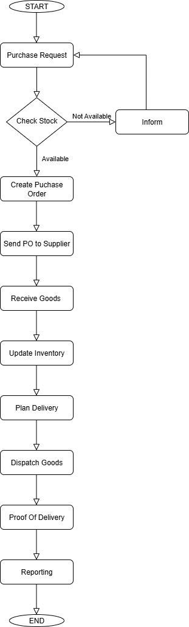
Process Flow Diagram for Proposed TO-BE system
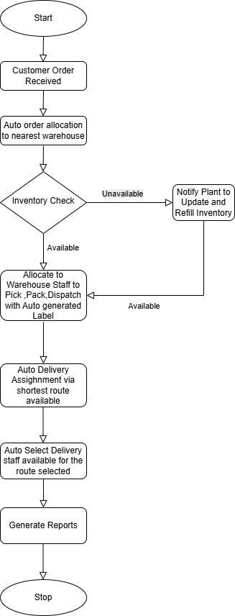
Assignment 2:
1. Write an introduction letter to a client introducing yourself as a business analyst in charge of working with the client and his team to start the business understanding process.
2. Prepare a brief BRD and SRS for a project- Horoscope or Ticketing system or online store.
3. Make an ERD of creating a support ticket/Ticketing life cycle.
4. User story of shopping from ecommerce.

1. Write an introduction letter to a client introducing yourself as a business analyst in charge of working with the client and his team to start the business understanding process.

Answer-
Subject: Introduction as Your Business Analyst Partner
Dear Ice-cream and Milk Products Company,
I hope this message finds you well.
My name is Shivam Mehrotra, and I am pleased to introduce myself as the Business Analyst assigned to collaborate with you and your team. I’ll be your primary point of contact as we begin the business understanding process for your project.
My role is to work closely with you to gain a clear and thorough understanding of your business goals, current processes, and key requirements. This foundational step is critical to ensure that the solutions we deliver align with your strategic objectives and add meaningful value to your organization.
Over the coming days, I will be reaching out to schedule our initial discovery sessions, during which we’ll discuss your priorities, challenges, and expectations in detail. These conversations will help guide the documentation of requirements and ultimately shape the roadmap for the solution ahead.
Please feel free to reach out to me at any time with questions or insights. I’m here to support you throughout this process and ensure a smooth, productive engagement.
Looking forward to working together.
Warm regards,
SHIVAM MEHROTRA
Business Analyst
IDMS TECH

2-Prepare a brief BRD and SRS for a project- Ticketing system.
Answer- BRD and SRS for Ticketing System

SHIVAM MEHROTRA

BRD-Ticketing System

<TICKETING SYSTEM >
<IDMSD001BRDV1D1>
<V1>
<SHIVAM MEHROTRA>

Contents
1. Document Revisions 4
2. Approvals 4
3. RACI Chart for This Document 5
Codes Used in RACI Chart 5
RACI Chart 5
4. Introduction 6
4.1. Business Goals 6
4.2. Business Objectives 6
4.3. Business Rules 6
4.4. Background 6
4.5. Project Objective 6
4.6. Project Scope 6
4.6.1. In Scope Functionality 6
4.6.2. Out Scope Functionality 6
5. Assumptions 7
6. Constraints 7
7. Risks 7
Technological Risks 7
Skills Risks 7
Political Risks 7
Business Risks 7/8
Requirement Risks……………………………………………………………………………………………………………………………………………….8
Other Risks……………………………………………………………………………………………………………………………………… 8
8. Business Process Overview 8
8.1. Legacy System (AS-IS) 8
8.2. Proposed Recommendations (TO-BE) 8
9. Requirements…………………………………………………………………………………………………………………………………………9
9.1 Business Requirements

1.Document Revisions

2.Approvals

Date | Version Number | Document Changes
07.07.2025 | 0.1 | Initial Draft
Role | Name | Title | Signature | Date
Manages the overall system, monitors transactions, handles support, manages users and organizers. Ensures platform reliability and profitability. | Mr. Aman | Admin/Platform Owner |  | 07.07.2025
Oversees Vendors tie-ups and sales operations | Mr. Jain | Distribution Head |  | 07.07.2025
Heads customer service Team assisting users with issues related to bookings, cancellations, refunds, and technical problems. | Prashant | Customer Service Head |  | 07.07.2025

3.RACI Chart for This Document
The RACI chart identifies the persons who need to be contacted whenever changes are made to this document. RACI stands for Responsible, Accountable, Consulted, and Informed. These are the main codes that appear in a RACI chart, used here to describe the roles played by team members and stakeholders in the production of the BRD. They are adapted from charts used to assign roles and responsibilities during a project. (RACI can be made for IT side [Project stakeholder] as mentioned above, apart from that, it can also be made for Client side [Business Stakeholder]).
The following describes the full list of codes used in the table:

Codes Used in RACI Chart
R Responsible Responsible for creating this document.
A Accountable Accountable for accuracy of this document
(for example, the project manager)
C Consulted Provides input (such as an interviewee).
I Informed Must be informed of any changes.

RACI Chart
Business Stakeholders
S. No. | Name | Position | BRD | MOCKUP | Test PLAN | Project Plan
1 | Mr.Aman | Admin/Platform Owner | A | A | A | A
2 | Mr. Jain | Distribution Head | I | I | I | I
3 | Prashant | Customer Service Head | I | C | C | I
Project Stakeholders
S.No. | Name | Position | BRD | MOCKUP | Test Plan | Project Plan
1 | Mr. Jain | Delivery Head | C | C | I | C
2 | Mr. Vaibhav | Project Manager | A | C | A | R/A
3 | Mrs. Jaya | Sr. Java Developer | I | I | I | I
4 | Mr. Prashant | Java Developer | I | I | I | I
5 | Mr. Vibhor | Java Developer | I | I | I | I
6 | Mr. Tutu | Network Admin | I |  | I | I
7 | Mr. Rakshit | DB Admin | I |  | I | I
8 | Mr. Rohit | Tester | I |  | R | I
9 | Mr. Vikas | Tester | I |  | C | I
10 | Mr. Shivam | BA | R | R | C | C

4.Introduction

Business Goals
The goal of the project Ticketing System is to provide a user-friendly digital platform for booking event, movie, or travel tickets, ensuring a seamless experience for customers. The system will enable real-time ticket availability and secure online payments, allowing users to make bookings with confidence. It will also empower event organizers to efficiently manage their events, sales, and reports through a centralized dashboard. By offering instant booking confirmations and dedicated customer support, the platform aims to enhance user satisfaction. Additionally, the system will help reduce manual errors and streamline overall ticketing operations.

Business Objectives

The primary business objectives of the online ticketing system are to simplify the ticket booking process by providing a seamless and intuitive platform where users can easily search, select, and book tickets online.

Business Rules
Users must register and log in to book, cancel, or manage their tickets. Each seat or ticket slot can be booked by only one user to prevent double bookings, and bookings are only confirmed after successful payment. Cancellations are allowed only within the specified time window defined by the event organizer, and each event must have a clearly stated refund policy visible to users before booking. Events created by organizers must be reviewed and approved by the admin before being published, if moderation is enabled. The system will update ticket availability in real time after every booking or cancellation to maintain accuracy.

Background
In recent years, the demand for digital ticketing platforms has grown significantly as users increasingly prefer convenient, contactless, and time-saving booking experiences. Traditional ticket booking methods—such as physical counters or manual processes—are often time-consuming, error-prone, and lack real-time updates. Event organizers and service providers also face challenges in managing ticket sales, tracking availability, and handling customer queries efficiently. To address these gaps, the proposed Online Ticketing System aims to streamline the entire ticketing process by offering a centralized digital platform

Project Objective
The primary objective of this project is to develop a user-friendly, reliable, and scalable online ticketing system that simplifies the ticket booking process for events, movies, travel, and other services. The system will allow users to easily search for available events, select seats, make secure payments, and receive instant booking confirmations. It will also provide event organizers with tools to create and manage events, monitor ticket sales, and generate performance reports. By automating the entire ticketing workflow, the project aims to reduce manual errors, improve customer satisfaction, and enable real-time updates and efficient communication between all stakeholders.

Project Scope
The scope of this project is to develop a web-based online ticketing system that allows users to register, browse events, book tickets, make secure payments, and receive confirmations instantly. The system will also enable organizers to manage events, monitor ticket sales, and process cancellations or refunds. The initial release will focus on desktop and mobile web access, excluding mobile apps and offline booking features.

In Scope Functionality
- User registration, login, and profile management
- Browsing and searching events by category, date, and location
- Real-time ticket availability and seat selection
- Secure online payment and automated booking confirmation
- Email/SMS notifications for booking and cancellations
- Ticket cancellation and refund processing based on organizer policy
- Admin dashboard for event management and reporting
- Organizer access to create, update, and manage their events
- Integration with payment gateway and notification services (email/SMS)
- System access via web browsers (desktop and mobile)

Out Scope Functionality
- Mobile application (Android/iOS)
- Loyalty/reward points system
- Integration with physical ticket kiosks
- Offline bookings or in-person support
- Multilingual support or regional customization

Assumptions
- Users have internet access and valid contact details
- Payment and notification services are functional
- Organizers provide accurate event data
- Admin team is available to manage and support the system
- One language and currency are supported in the initial phase

Constraints
- The project must be completed within a predefined budget, restricting the use of premium third-party tools or advanced features in the initial phase.
- The system must be developed and deployed within a specific timeline, which may limit the number of features included in Phase 1.
- The project must use predefined technologies (e.g., web-based only, no mobile app in Phase 1).
- The platform relies on external services like payment gateways and SMS/email providers, which may affect performance and availability.
- The system will initially support bookings within selected regions only.
- The platform must comply with applicable data protection and digital payment regulations, such as GDPR or local IT laws.

Risks
A risk is something that could affect the success or failure of a project. Analyse risks regularly as the project progresses. While you may not be able to avoid every risk, you can limit each risk’s impact on the project by preparing for it beforehand. For each risk, you’ll note the likelihood of its occurrence, the cost to the project if it does occur, and the strategy for handling the risk. Strategies include the following:
Avoid: Do something to eliminate the risk.
Mitigate: Do something to reduce damage if risk materializes.
Transfer: Pass the risk up or out to another entity.
Accept: Do nothing about the risk. Accept the consequences.

Technological Risks
This subsection of “Risk Analysis” specifies new technology issues that could affect the project.
- Unexpected outages due to server failure or deployment issues may disrupt booking and payment operations.
- Payment gateway, SMS, or email service disruptions could affect ticket confirmations or transactions.
- The platform may be vulnerable to cyberattacks if proper encryption and security protocols are not implemented.
- As user traffic grows, the system may face performance issues if not built to scale efficiently.
- Browser Compatibility Issues: Users on outdated or unsupported browsers may face interface or functionality problems.
- Poor user internet connectivity can result in failed bookings or incomplete transactions.

Skills Risks
This subsection of “Risk Analysis” specifies the risk of not getting staff with the required expertise for the project.
- The project may face delays or quality issues if the development team lacks expertise in required technologies (e.g., Angular, Node.js, payment integrations).
- Poor user interface design could lead to a confusing user experience and reduced customer satisfaction.
- If QA team members lack experience in automation or usability testing, critical bugs might go undetected.
- Improper deployment and infrastructure management may cause downtime or performance issues.
- If a key team member leaves or is unavailable, it may impact project continuity and knowledge transfer.

Political Risks
- Sudden changes in government regulations (e.g., data privacy, digital payments, GST) may require system modifications or compliance updates.
- If the system expands to other regions or countries, differing political or legal environments may impact operations or data handling.
- Government restrictions on internet services, payment gateways, or SMS/email services may disrupt system functionality.
- Changes in digital service taxation or compliance requirements could affect pricing models and financial reporting.
- If the platform integrates with government transportation or cultural event systems, any political changes or delays may impact service availability.

Business Risks
This subsection of “Risk Analysis” describes the business implications if the project is cancelled.
- Users may continue using traditional booking methods or competing platforms, leading to lower-than-expected traffic and revenue.
- The presence of well-established ticketing platforms may reduce market share and slow growth.
- The platform’s income depends heavily on organizers listing events and maintaining active bookings.
- Overpricing or hidden charges may discourage users from completing bookings.
- Disagreements over cancellation policies or refund timelines can damage the platform’s reputation.
- Ticket bookings may vary significantly depending on event seasons or local calendars, affecting revenue consistency.
- Poor customer feedback due to bugs or failed transactions can harm the brand image and user trust.

Requirements Risks
This subsection of “Risk Analysis” describes the risk that you have not correctly described the requirements. List areas whose requirements were most likely to have been incorrectly captured.
- Missing or vague inputs from stakeholders can lead to functionality gaps or rework.
- Frequent changes in priorities or operations may cause scope creep and delays.
- If expectations are not clearly communicated, the delivered system may not meet actual needs.
- Discovering critical needs late in the project can impact timelines and budget.

Other Risks
In this subsection of “Risk Analysis,” document any other risks not covered in the prior subsections.
- Unexpected changes, delays, or feature creep can lead to overshooting the allocated budget.
- Delays due to technical, resource, or communication issues may impact the overall delivery schedule.
- Migrating historical data from old systems or Excel files may be time-consuming and error-prone.

Business Process Overview
The demand for digital ticketing platforms has grown significantly as users increasingly prefer convenient, contactless, and time-saving booking experiences. Traditional ticket booking methods—such as physical counters or manual processes—are often time-consuming, error-prone, and lack real-time updates. Event organizers and service providers also face challenges in managing ticket sales, tracking availability, and handling customer queries efficiently. To address these gaps, the proposed Online Ticketing System aims to streamline the entire ticketing process by offering a centralized digital platform

Legacy System (AS-IS)

The current ticket booking process is manual, time-consuming, and lacks real-time availability or centralized control. Event organizers rely on spreadsheets or offline methods to manage bookings and refunds. This leads to inefficiencies, errors, and poor customer experience.

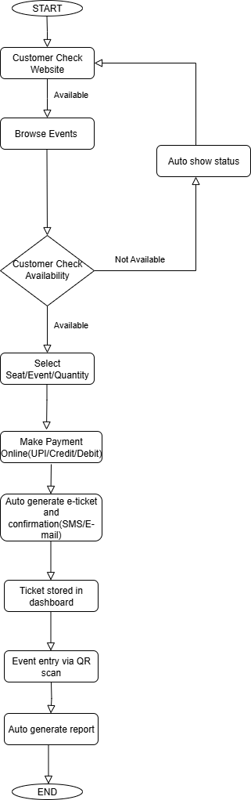

Proposed Recommendations (TO-BE)
Implement a centralized, web-based ticketing system that enables real-time booking, secure online payments, and automated confirmations. Provide dashboards for organizers to manage events and track sales efficiently. Enhance user experience through instant notifications, self-service options, and simplified cancellations or refunds.
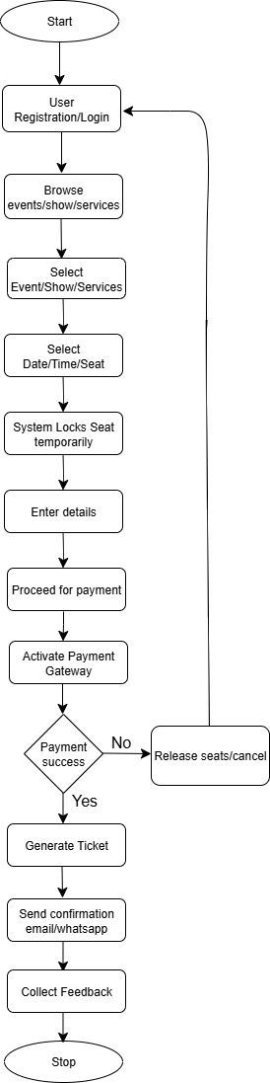

9.Business Requirements
- Users shall be able to search and filter events based on category, date, and location.
- Users shall be able to book tickets and make secure payments via integrated payment gateways.
- Users shall receive instant booking confirmations through email and/or SMS.
- Users shall be able to cancel tickets within the allowed window, and refunds shall be processed based on the organizer’s policy.
- Organizers shall be able to create, update, and manage events, pricing, and ticket inventory through a dedicated dashboard.
- Admins shall have full control over user management, event approvals, and platform-wide settings.
Software Requirements Specification (SRS) for the Online Ticketing System:
- Introduction
  - Purpose
  - Intended Audience
  - Scope
  - Definition
  - Reference
- Overall Description
  - User Interface
  - System Interface
  - Constraints, Assumptions and Dependencies
  - User Characteristics
- System Features & Requirements
  - Functional Requirements
  - Use Cases
  - External Interface Requirements
  - Logical database Requirements
  - Non-functional Requirements
- Deliverables for Approvals

Project Title: Online Ticketing System
Document Version: 1.0
Prepared On: 08-07-2025

1. Introduction

1.1 Purpose
The purpose of this document is to outline the software requirements for an Online Ticketing System that facilitates ticket booking for events, movies, or travel through a centralized web-based platform. It defines the functional and non-functional requirements, system interfaces, and use cases.

1.2 Intended Audience
- Development Team
- Quality Assurance (QA) Team
- Platform Owner / Admin
- Event Organizers
- Stakeholders and Investors

1.3 Scope
This system will allow users to browse events, book tickets, make payments, and receive confirmations. Event organizers can create and manage events, monitor sales, and issue refunds. Admins will oversee operations, reporting, and support. The system will support desktop and mobile web browsers.

1.4 Definitions
- User: A registered customer booking tickets
- Organizer: A person/entity managing events on the platform
- Admin: A user with full system control
- Booking: The process of reserving a ticket
- Cancellation: Process to revoke a booking
- Refund: Return of payment based on cancellation policy

1.5 References
- IEEE Std 830-1998 (Recommended Practice for SRS)
- Payment Gateway API Documentation (e.g., Razorpay, Stripe)
- SMS Gateway API Docs
- GDPR & Local IT Compliance Guidelines

2. Overall Description

2.1 User Interface
- Responsive design for desktop and mobile browsers
- Event listing with filters (date, category, location)
- Seat selection grid (if applicable)
- User dashboard for booking history
- Admin panels for event and sales management

2.2 System Interface
- Payment Gateway Integration
- SMS/Email Notification Services
- Cloud Database (e.g., MySQL/PostgreSQL)

2.3 Constraints, Assumptions, and Dependencies

Constraints:
- Web-only platform in Phase 1 (no mobile app)
- Limited budget and timeline
- Reliance on third-party services (payment, SMS/email)

Assumptions:
- Users have internet access
- Organizers provide accurate event information
- Payment and notification APIs are reliable

Dependencies:
- Hosting infrastructure
- Payment gateway APIs
- SMS/email notification services

2.4 User Characteristics
- General users with basic tech skills
- Organizers with moderate computer literacy
- Admins with technical/system management experience

3. System Features & Requirements

3.1 Functional Requirements

ID | Description
FR-01 | System shall register user and log in to the system
FR-02 | System shall allow to search and filter events
FR-03 | System shall allow to book tickets and make secure payments
FR-04 | The system shall confirm bookings via email/SMS
FR-05 | System shall allow to view and manage booking history
FR-06 | System shall allow cancel bookings as per policy
FR-07 | System shall allow organizers to create, update, and manage events
FR-08 | System shall allow admin to oversee the system and manage disputes
FR-09 | System shall maintain real-time ticket inventory

3.2 Use Case
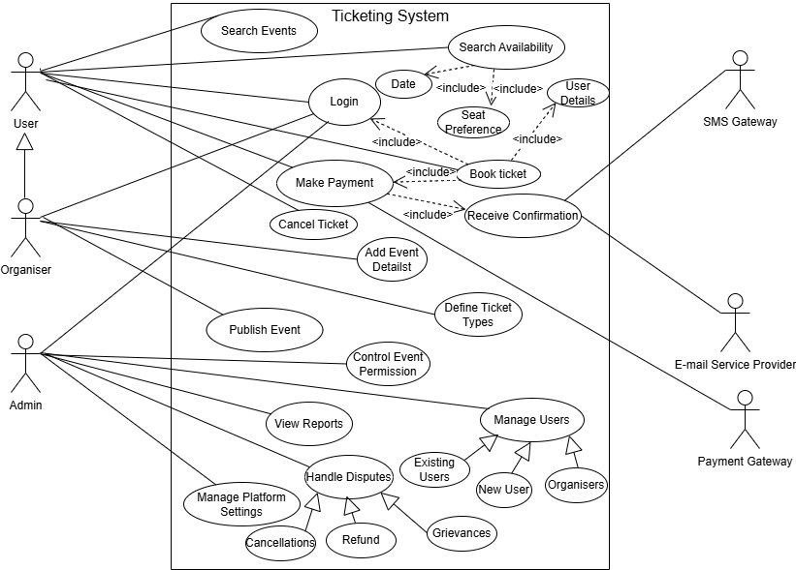

3.3 External Interface Requirements
- Payment Gateway API – To process payments
- SMS Gateway API – For OTPs and confirmations
- Email Service Provider – For booking and cancellation updates

3.4 Logical Database Requirements
User Table: Stores user details, login info
Event Table: Stores event information
Ticket Table: Tracks bookings, seat numbers, status
Transaction Table: Logs payment and refund details
Cancellation Table: Records cancellations and refund status

3.5 Non-functional Requirements

ID | Requirement
NFR-01 | System shall support 1000 concurrent users
NFR-02 | 95% of transactions shall complete within 2 seconds
NFR-03 | System uptime shall be at least 99.9%
NFR-04 | All communications shall be encrypted (HTTPS, TLS)
NFR-05 | The system shall be usable on major web browsers

4. Deliverables for Approvals
- Business Requirement Document (BRD)
- Software Requirements Specification (SRS)
- Wireframes / UI Mockups
- Project Plan with Milestones
- Test Plan and Test Cases
- UAT Sign-off Document

3. Make an ERD of creating a support ticket/Ticketing life cycle.

Answer3-
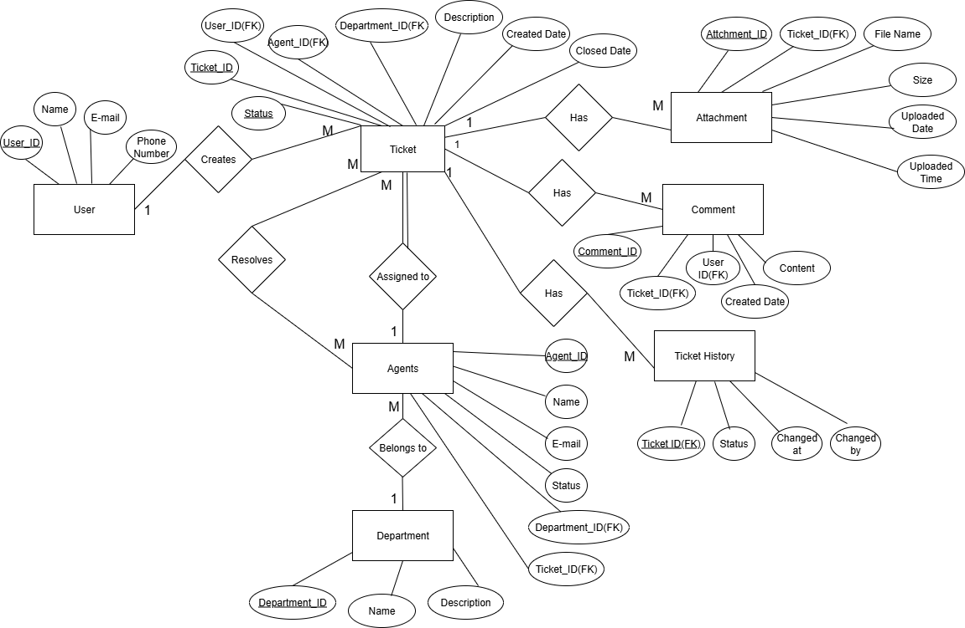

4.User story of shopping from ecommerce.

User Story no. | 1 | Task: | 1 | Priority: | Highest
As a new customer
I want to register and log in to the website
So that I can securely access my account and place orders
BV: | 500$ |  | CP: |  | 5
ACCEPTANCE CRITERIA
User can sign up using email and password.
User receives a verification email.
User can log in with valid credentials.
System shows error messages for invalid login attempts.
Password recovery option is available.

User Story no. | 2 | Task: | 1 | Priority: | Highest
As a shopper,
I want to browse and search for products,
So that I can find items easily.
BV: | 1000$ |  | CP: |  | 5
ACCEPTANCE CRITERIA
User can browse products by category, brand, or trending.
User can use search bar to find products by name or keyword.
Search results display relevant products.
Filters (price, rating, brand) and sort options are available.

User Story no. | 3 | Task: | 1 | Priority: | Highest
As a customer,
I want to view detailed product information,
So that I can make informed purchase decisions.
BV: | 1000$ |  | CP: |  | 5
ACCEPTANCE CRITERIA
Clicking on a product opens its detail page.
Product page shows image gallery, description, specifications, price, availability, and customer reviews.
"Add to Cart" and "Buy Now" buttons are visible

User Story no. | 4 | Task: | 1 | Priority: | Highest
As a customer,
I want to add products to my shopping cart,
So that I can purchase them later.
BV: | 1000$ |  | CP: |  | 5
ACCEPTANCE CRITERIA
User can add one or multiple products to cart.
Confirmation message is shown after adding.
"Cart icon updates with total item count.
Duplicate items update quantity instead of creating new entries.

User Story no. | 5 | Task: | 1 | Priority: | Highest
As a shopper,
I want to update or remove items in my cart,
So that I can finalize my order as needed.
BV: | 500$ |  | CP: |  | 3
ACCEPTANCE CRITERIA
User can increase/decrease item quantities.
User can remove individual items.
"Cart updates totals dynamically.
Cart persists across sessions for logged-in users.

User Story no. | 6 | Task: | 1 | Priority: | Highest
As a logged-in user,
I want to add or select my shipping address,
So that my order can be delivered correctly.
BV: | 1000$ |  | CP: |  | 3
ACCEPTANCE CRITERIA
User can add new addresses with full details (name, address, pincode, mobile).
User can select from saved addresses.
User can edit or delete saved addresses.

User Story no. | 7 | Task: | 1 | Priority: | Highest
As a customer,
I want to complete my purchase with a secure payment,
So that I can successfully place my order.
BV: | 1000$ |  | CP: |  | 3
ACCEPTANCE CRITERIA
User can review order summary before payment.
Payment options include UPI, card, net banking, wallet, and COD.
Successful payment redirects to confirmation page.
Failed payment shows error and retry option.

User Story no. | 8 | Task: | 1 | Priority: | Medium
As a customer,
I want to receive order confirmation after placing an order,
So that I know my order is being processed.
BV: | 500$ |  | CP: |  | 3
ACCEPTANCE CRITERIA
Confirmation page shows order ID, items, total amount, and delivery estimate.
Confirmation email/SMS is sent with order summary.

User Story no. | 9 | Task: |  | Priority: | Medium
As a buyer
I want to track the status of my order,
So that I can know when it will arrive.
BV: | 500$ |  | CP: |  | 3
ACCEPTANCE CRITERIA
User can see real-time status: Confirmed → Packed → Shipped → Out for Delivery → Delivered.
Estimated delivery date is displayed.
Tracking updates appear in "My Orders" section.

User Story no. | 10 | Task: | 1 | Priority: | Medium
As a customer,
I want to return or exchange a product,
So that I can fix issues with my order.
BV: | 500$ |  | CP: |  | 3
ACCEPTANCE CRITERIA
Return/exchange is allowed within the policy window.
User can select reason and upload photos (if required)
Return pickup is scheduled and status is shown.
Refund/exchange confirmation is sent via email/SMS.

User Story no. | 11 | Task: | 1 | Priority: | Medium
As a buyer,
I want to rate and review the product,
So that I can share my experience with others.
BV: | 500$ |  | CP: |  | 3
ACCEPTANCE CRITERIA
Review option is available only after delivery.
User can give star rating (1–5) and write comments.
Reviews are visible on the product page after moderation.

