Question 1 – Functional Requirements - 15 Marks
Identify minimum 20 functional requirements Example : Functional requirement: When an order is fulfilled, the local printer shall print a packing slip. Non-Functional Requirement: Packing slips shall be printed on both sides of 4”x 6” white paper, the standard size for packing slips used by local printers

Req Id | Req Name | Req Description | Priority
FR0001 | Farmer Registration | Farmer should be able to register with the application | 9
FR0002 | Farmer search for products | Farmers should be able to search for available products Fertilizers, seeds, pesticides | 8
FR0003 | Manufacturer Registration | Manufacturers should be able to register with the application | 8
FR0004 | Manufacturer Product Listing | Manufacturers should be able to list their products in the catalogue | 7
FR0005 | Product Details Display | The application should display detailed information about each product, including descriptions, specifications and pricing | 9
FR0006 | Add to Cart | Users should be able to add products to their shopping cart for purchase | 8
FR0007 | Cart Management | Users should be able to view and manage the contents of their shopping cart, including adding or removing products | 8
FR0008 | Wishlist Management | Users should be able to manage their wishlist or buy-later list,including adding or removing products | 7
FR0009 | Multiple Payment Gateways | The platform should integrate with multiple payment gateways to facilitate secure and convenient transactions | 9
FR0010 | Order Placement | Users should be able to place orders for selected products specifying quantity and delivery address | 9
FR0011 | Order Confirmation | Users should receive an order confirmation with details such as order number,products,quantities, total amount, and estimated delivery date | 9
FR0012 | Order Tracking | Users should be able to track the status and location of their orders in real-time | 9
FR0013 | Order History | Users should be able to view their order history, including past orders ,orders details and statuses | 7
FR0014 | Customer Support | Users should have accesses to customer support either through live chat, email or ph for assistance with their orders or enquires. | 8
FR0015 | User Ratings and Reviews | Users should be able to provide ratings and reviews for products they have purchased | 7
FR0016 | Product Recommendations | The platform should provide personalised product recommendations based on user preferences and browsing history | 9
FR0017 | Social Sharing | Users should have the option to share products or their purchase experience on social media platforms | 7
FR0018 | Secure Transactions | The platforms should ensure secure transactions by implementing appropriate encryption and security measures | 9
FR00019 | Product Filtering | Users should be able to filter products based on various criteria such as price range, brand or product type | 8

FR 00020 | Account Management | Users should be able to manage their account settings, including profile information, password changes and email preferences | 7

Question 2–Minimum 5 page designs - 15 Marks Make wireframe and prototypes
Make wireframe and prototypes

Login Page

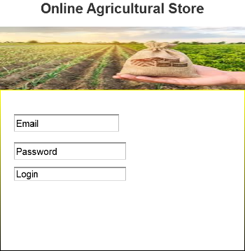
Registration Page
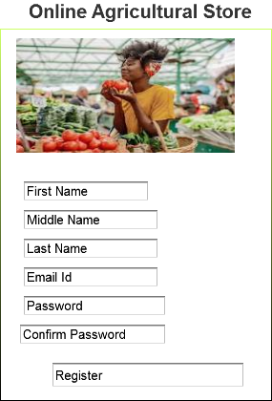

Payment Page
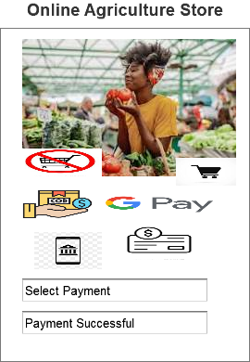

5)Category Page
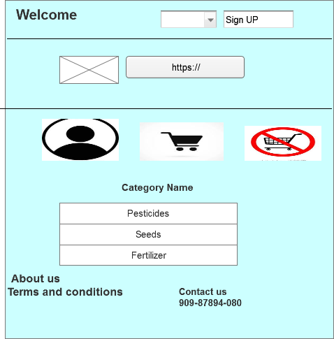

Question 3 – Tools (Visio, Balsamiq) - 15 Marks Make a note of the Tools, which you are using for above concepts
- MS Visio: It’s a popular tool for creating diagrams, flowcharts, and wireframes. It offers a wide range of templates and shapes to create visual representations of processes and systems.
- Balsamiq: It’s a wireframing tool that allows you to create low-fidelity wireframes quickly. It has a simple and intuitive interface, making it easy to sketch out ideas and concepts.
- Axure RP: It’s a powerful prototyping & wireframing tool that enables you to create interactive and dynamic prototypes. It offers advanced features for creating complex interactions and user flows.
- Mockups:Its web-based design tool that provides a comprehensive set of features for wireframing and prototyping. It allows you to create interactive wireframes and prototypes with a user-friendly interface.
These tools can assist you in visualizing and prototyping your design concepts effectively .Its important to explore their features and determine which tool best fits our specific needs and preferences.

Question 4 – RTM - 6 Marks A business analyst’s key responsibilities are to keep track of the requirements and make sure that no requirement is missed.
Mr. Henry and peter have approached you regarding the current status of the project. How will you tackle this situation?
Prepare RTM
Answer:
Req Id | Req Name | Req Description | Design | D1 | T1 | D2 | T2 | D3 | T3 | D4 | T4 | UAT
FR0001 | Farmer Registration | Farmer should be able to register with the application | Y | Y | Y | Y | Y | Y | Y | Y | Y | N
FR0002 | Farmer search for products | Farmers should be able to search for available products Fertilizers, seeds, pesticides | Y | Y | Y | Y | Y | Y | Y | Y | Y | N
FR0003 | No matching product | Farmers should be notified if the searched product not found | Y | Y | Y | Y | Y | Y | Y | N | N | N
FR0004 | Product Section | Farmer should be able to select the product | Y | Y | Y | Y | Y | Y | Y | N | N | N
FR0005 | Out of stock | Farmers should be notified if the product is out of stock | Y | Y | N | N | N | N | N | N | N | N
FR0006 | Filter | Farmers should be able to filter and select the product as per Brands and price | Y | Y | Y | N | N | N | N | N | N | N
FR0007 | Similar products | Farmers should be able to select similar products if the searched product is out of stock | Y | Y | Y | N | N | N | N | N | N | N
FR0008 | Bought together | Once the product is finalised farmer should be suggested with related products as a package with the price | Y | Y | Y | N | N | N | N | N | N | N
FR0009 | Add to cart | Farmer should be able to add the product to the cart for purchase | Y | Y | Y | N | N | N | N | N | N | N
FR0010 | Wishlist | Farmer should have an option to add the product into wishlist | Y | Y | Y | N | N | N | N | N | N | N
FR0011 | Save it later | Farmer should be able to see the option for save it later,to purchase later | Y | Y | Y | N | N | N | N | N | N | N
FR0012 | Delivery Address | Farmer should be able to select the delivery address to deliver the product | Y | Y | Y | N | N | N | N | N | N | N
FR0013 | Payment option | Once the delivery address is selected,Application should show the payment options to the Farmer for purchasing the product | Y | Y | Y | N | N | N | N | N | N | N
FR0014 | Payment Confirmation | Farmer should receive the payment confirmation email and SMS | Y | Y | Y | N | N | N | N | N | N | N
FR0015 | Order Confirmation | Farmer should receive the order confirmation email & SMS | Y | Y | Y | N | N | N | N | N | N | N
FR0016 | Expected Delivery Date | Farmer should also see the Expected Delivery date of the product | Y | Y | Y | N | N | N | N | N | N | N
FR0017 | Track Delivery | Farmer should be able to Cancel/Return/Replace the product | Y | Y | Y | N | N | N | N | N | N | N
FR0018 | Cancel/Return/Replace the product | Farmer should be able to Cancel/return/replace | Y | Y | Y | N | N | N | N | N | N | N
FR00019 | Return Pick up | Farmer should be given pick up date & time for cancel /return | Y | Y | Y | N | N | N | N | N | N | N
FR 00020 | Return Confirmation | Farmer should receive SMS & Email confirmation for Cancellation /Return | Y | Y | Y | N | N | N | N | N | N | N

Req id |  | Req Name |  |  | Req Description |  |  | Design |  | D1 |  | T1 |  | D2 | T2 |  | D3 |  | T3 | D4 |  | T4 |  | UAT
NFR001 |  | Page loading Time |  |  | Each Page load within 2 sec time |  |  | Y |  | Y |  | Y |  | N | N |  | N |  | N | N |  | N |  | N
NFR002 |  | Technical supported system |  |  | Application can be used on any OS (Android/OS) |  |  | Y |  | Y |  | Y |  | Y | Y |  | N |  | N | N |  | N |  | N
NFR003 |  | Time limit for OTP |  |  | OTP time limit should be given maximum of 5 min for login and Registration process |  |  | Y |  | Y |  | Y |  | N | N |  | N |  | N | N |  | N |  | N
NFR004 |  | Logout system |  |  | If the page is not accessed for more 5 min the pageshould log out automatically. |  |  | Y |  | Y |  | Y |  | Y | Y |  | N |  | N | N |  | N |  | N
NFR005 |  | Stock Availibility |  |  | Stock availability should be updated on a real time basis |  |  | Y |  | Y |  | Y |  | N | N |  | N |  | N | N |  | N |  | N
NFR006 |  | SMS & Mail confirmation |  |  | Automated Email & SMS notification should be sent to users |  |  | Y |  | Y |  | Y |  | Y | Y |  | N |  | N | N |  | N |  | N
NFR007 |  | Back up |  |  | All data should be back up automatically |  |  | Y |  | Y |  | Y |  | Y | N |  | N |  | N | N |  | N |  | N
NFR008 |  | Connectivity |  |  | System should be connected with Internet |  |  | Y |  | Y |  | Y |  | Y | Y |  | N |  | N | N |  | N |  | N
NFR009 |  | Stock Alerts |  |  | Seller should receive Stock alert notifications when Stock is reduced, every week |  |  | Y |  | Y |  | Y |  | N | N |  | N |  | N | N |  | N |  | N
NFR010 |  | Net Banking |  |  | Bank account should be active in nature for smooth payment process |  |  | Y |  | Y |  | Y |  | N | N |  | N |  | N | N |  | N |  | N
NFR011 |  | Check Stock |  |  | Once the product is sold,the stock of the product should be reduced |  |  | Y |  | Y |  | Y |  | Y | N |  | N |  | N | N |  | N |  | N
NFR012 |  | Email Address |  |  | Email address should be active to receive Email |  |  | Y |  | Y |  | Y |  | N | N |  | N |  | N | N |  | N |  | N
NFR013 | Taxation system |  | All prodcuts should be including with additional Tax | Y |  | Y | Y |  | N |  | N |  | N |  |  | N |  | N |  |  | N |  | N
NFR014 | Password |  | User should receive Pssword change alert every 30 day | Y |  | Y | Y |  | N |  | N |  | N |  |  | N |  | N |  |  | N |  | N

Question 5 – 10 Test Case Documents - 10 Marks Prepare 10 Test Case Documents

Test Case Id | TC0001 | Test Case Name | User Registration
Project Id | Agri 0213 | Project Name | Online Agriculture Store Project
PM ID | 8838 | PM Name | Mr Vandanam
Test Strategy Id | OAS001 | Tester ID | 67542
Test Plan Id | TOAS01 | Tester Name | Mr Jason
Test Schedule Id | XXX | Date of Test | 10-Oct-24
Scenario |  | To register new user inside Web application using e mail id and creating password
Link to that page |  | www.onlineagristore.com
Preconditions |  | Internet connectivity should be stronger enough,Website URL is working
Post Conditions |  | Registration successful,User able to login into system with username & password
Input Data |  | Email id,Mobile no,Name of the user
Expected Behaviour |  | Once user register using name,mail id/mobile no and create password,System should show user created sucessfully
Actual Behaviour |  | After Entering mandatory fields,if user clicks on register button,then system shows pop up saying ;user created successfully
Comments |  | NA
Result(Pass/Fail) |  | Pass

Test Case Id | TC0002 | Test Case Name | User Login
Project Id | Agri0213 | Project Name | Online Agriculture Store Project
PM Id | 8838 | PM Name | Mr Vandanam
Test Straregy Id | OAS001 | Tester ID | 67542
Test Plan Id | T0AS01 | Tester Name | Miss Alekya
Test Schedule Id | xxx | Date of Test | 12-Oct-2024
Scenario |  | To login registered user using username and password
Link to that page |  | www.onlineagristore.com
Preconditions |  | User is already registered
Post Condition |  | Login Sucessful,User is able to search for the required products
Input Data |  | Username,password,Capcha
Expected Behaviour |  | User Enter Username and Password along with captcha to login and system shows login sucessfully
Actual Behaviour |  | After Entering Username,password and Captcha,if user clicks on”Login” Button,then system shows pop up saying ‘login Sucessfully”
Comments |  | NA

Test Case Id | TC0003 | Test Case Name | Add To cart
Project Id | Agri0213 | Project Name | Online Agriculture Store
PM id | 8838 | PM Name | Mr Vandanam
Test Strategy Id | OAS001 | Tester ID | 67542
Test Plan Id | TOAS01 | Tester Name | Mr Jason
Test Schedule Id | xxx | Date of Test | 15-Oct-2024
Scenario | User should e able to add selected products to cart
Link to that page | www.onlineagristore.com
Preconditions | Products are aviable in inventory and add to cart is enabled
Post Conditions | Total prices will be shown,Payment option would be shown
Input Data | Product id,Product pictures,Product prices
Expected Behaviour | Once login,User will search products on the basis of requirements,and he must be able to add products in the cart for purchase

Test Case Id | TC0004 | Test Case Name | Coupon Code apply
Project Id | Agri0213 | Project Name | Online Agriculture Store
PM id | 8838 | PM Name | Mr Vandanam
Test Strategy Id | OAS001 | Tester ID | 67542
Test Plan Id | TOAS01 | Tester Name | Miss Alekya
Test Schedule Id | XXX | Date of Test | 17- Oct-2024
Scenario |  | User should be able to add coupon code at the checkout time to avail discount
Link to that page |  | www.onlineagristore.com
Preconditions |  | Coupon code must be valid
Post Condition |  | Total price will be adjusted as per coupon code
Input Data |  | Coupon codes,Discount codes
Expected Behaviour |  | At the time of checkout,User must be able to enter coupon code to get the discount on total bill
Actual Behaviour |  | After adding to cart User puts coupon code and gets siscount on total prices of the product
Comments |  | NA

Test Case Id | TC0005 | Test Case Name | Payment
Project Id | Agri0213 | Project Name | Online Agriculture Store Project
PM Id | 8838 | PM Name | Mr Vandanam
Test Strategy Id | OAS001 | Tester Id | 67542
Test Plan Id | TOAS01 | Tester Name | Mr Jason
Test Schedule | xxx | Date of Test | 19-Oct-24
Scenario |  | User must be able to choose payments option and do the payment
Link to that page |  | www.onlineagristore.com
Preconditions |  | Products added to cart and Total price is calculated
Postconditions |  | Redirected to 3rd party app or COD option
Input Data |  | Card details,UPI details Payment method
Expected Behavior |  | Use should be able to choose payment option from Net Banking ,UPI or cash on delivery
Actual Behaviour |  | At the payment stage user is able to select options from Net Banking,card Payments UPI or cash on delivery
Results |  | NA
Results |  | Pass

Test Case Id | TC0006 | Test Case Name | Payment Confirmation
Project Id | Agri0213 | Project Name | Online Agriculture Store Project
PM ID | 8838 | PM Name | Mr Vandanam
Test strategy Id | OAS001 | Tester Id | 67542
Test Plan Id | TOAS01 | Tester Name | Miss Alekya
Test Schedule Id | xxx | Date of Test | 21-Oct-24
Scenario |  | User should get payment confirmation message in phone or mail
Link to that page |  | www.onlineagristore.com
Preconditions |  | Payments is sucessful
Postcondition |  | Redirected to order confirmation page and expected delivery date
Input Data |  | Payment id,Total Price
Expected Behaviour |  | Once payments are done and amount deducted from the user’s ac,user should get text or mail confirmation for payment
Actual Behaviour |  | After payment,User gets payments successful confirmation message or mail that payment has been successfully processed
Comments |  | NA

Test Case Id | TC0007 | Test Case Name | Order Confirmation
Project Id | Agri0213 | Project Name | Online Agriculture Store
PM ID | 8838 | PM Name | Online Agriculture Store Project
Test Strategy Id | OAS001 | Tester Id | 67542
Test Plan Id | TOAS01 | Tester Name | Mr Jason
Test Schedule Id | xxx | Date of Test | 24-Oct-24
Scenario |  | User should get text or mail for order confirmation
Link to that page |  | www.onlineagristore.com
Precondition |  | Payment is sucessful
Post Condition |  | Trcaking of order is enabled
Input Data |  | Product id,Product pictures,Product Prices
Expected Behaviour |  | Once payments are done,User should get order confirmation containing order Id,and expected delivery date
Actual Behaviour |  | After payments done,User should get order confirmation containing order Id and expected delivery date
Comments |  | NA
Results |  | Pass

Test Case Id | TC 0008 | Test Case Name | Cancel order
Project Id | Agri 0213 | Project Name | Online Agriculture Store Project
PM id | 8838 | PM Name | Mr Vandanam
Test Strategy Id | OAS001 | Tester Name | Miss Aleky
Test Schedule Id | XXX | Date of Test | 27-oct-24
Scenario |  | User should be able to cancel wrong order
Link to that page |  | www.onlineagristore.com
Preconditions |  | Product already ordered,Cancel window is open
Post Condition |  | Order status is updated,Refund initiated
Input Data |  | User ac details,Order Id ,Product id
Expected Behaviour |  | User should be able to cancel the order or orders done by mistake from cancel order page
Actual Behaviour |  | User is able to cancel the order from cancel order page from the menu
Comments |  | NA
Results |  | Pass

Test Case Id | TC0009 | Test Case Name | Return of the order
Project ID | Agri0213 | Project Name | Online Agriculture Store Project
PM Id | 8838 | PM Name | Mr Vandanam
Test Strategy Id | OAS001 | Tester ID | 67542
Test Plan Id | XXX | Date of Test | 24-oct24

Scenario | User should be able to return any order which they did nt like
Link to that page | www.onlineagristore.com
Precondition | Product already ordered,Return window is open
Postcondition | Order status is updated,Refund initiated
Input Data | Product Id,Order Id,User Details
Expected Behaviour | User can return the order from the return order page with the help of order id and product id.

Test Case ID | TC0010 | Test Case Name | Session out timing
Project ID | Agri0213 | Project Name | Online Agriculture Store Project
PM ID | 8838 | PM Name | Mr Vandanam
Test Strategy Id | OAS001 | Tester Id | 67542
Test Plan Id | TOAS01 | Tester Name | Miss Alekya
Test Schedule Id | XXX | Date of Test | 3-Nov-24
Scenario |  | Application must be automatically session out afterstaying idle
Links to that Page |  | www.onlineagristore.com
Preconditions |  | User is logged in and inactive
Postconditions |  | System should ask for re-login
Input Data |  | Product id,Order id,User Details
Expected Behaviour |  | Application must be session out after being idle for 30 seconds and should ask for login again
Actual Behaviour |  | Application must be session out after being idle for 30 seconds and should ask for login again
Comments |  | NA
rESULTS |  | Pass

Question 6 – DB Design – 8 Marks After the requirements are thoroughly explained to the entire project team by business analyst, the Database architects have decided to do the database design and also to represent the in-flow and out-flow of data. Draw database schema and ER diagram
Ans: DB Schema is a blueprint that outlines the structure of the database, including its tables,fields,relationships,constraints and other characteristics
Entity Relationship Diagram- It’s a visual representation of the relationships between entities in database. It depicts the entities(tables), attributes(properties/fields) and relationship between them.
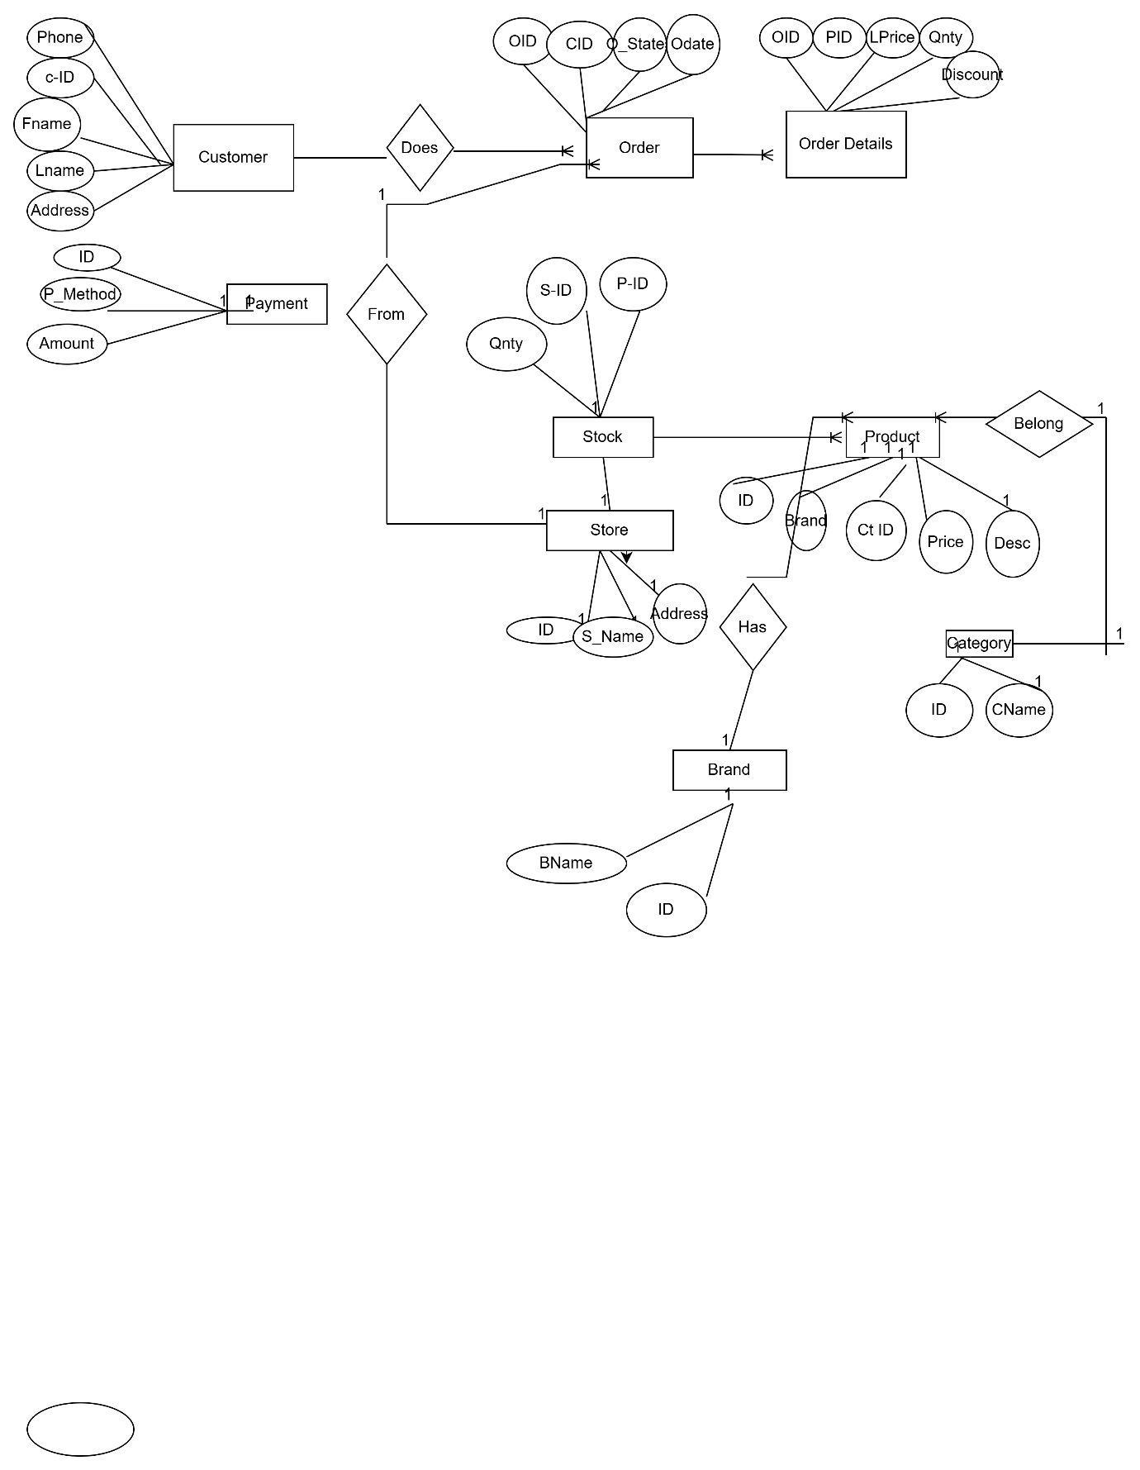
Question 7 – Data Flow Diagram - 3 Marks
What is a data flow diagram? Draw a data flow diagram to represent the in-flow and out-flow of data when a Farmer is placing an order for the product
Answer: A Data Flow Diagram (DFD) is a graphical representation of the flow of data within a system. It shows how data moves from one part of the system to another and how data is transformed, stored and utilized within the system. DFDS are widely used in systems analysis and design to visualize data processes and the way information is handled, stored and transmitted between different system components.

Question 8 – Change Request - 10 Marks Due to change in the Government Taxation structure . We should change the Tax structure How do you handle change requests in a project?
A change request are when a Stakeholder,either a client or an internal team or department ,requests a change to the processes or deliverables that had already been decided upon in the project scope.
In this scenario The change request has come up due to change in the Govt Taxation structure.As a BA I would analyze the request and clarify the stakeholders exactly what the request is asking us to do in the Online Agriculture Product Store.I would 1st do the Feasibility Test,to check how feasible it is to change the current ongoing project with the new change request.
- Change Request Identiication:Identify & document the change request, including the specific details of the requested change, the reason for the change, and its potential impact on the project.
- Change Impact Analysis: Assess the impact of the change on various aspects of the project, such as scope,timeline,cost,resources and risks. Evaluate feasibility and implications of implementing the change.
- Change Evaluation: Review the change request with key stake holders, including project sponsors, clients, and relevant team members. Discuss the potential benefits, risks and trade-offs associated with e change. Consider the project’s objectives, constraints and priorities in the evaluation process.
- Change Prioritization:Prioritize the change request based on its urgency,impact,and alingnment withproject goals.Determine whether the change is critical and must be implemented immediately or can be schedules fr a future phase or release.
- Change Approval:Obtain formal approval from the appropriate stakeholders such as project sponsors or change control boards.Ensure that all stakeholders are in agreement regarding the change and its implications.
- Change Implementation : Incorporate the approved change into the project plan,including any necessary adjustments to the scope,schedule,budget or resources. Communicate the change to the project team and other relevant stakeholders. Update project documentation, such as requirements ,design and test plans to reflect the approved change.
- Change Communication:Communicate the approved change to all relevant parties,including team members,clients and other stakeholders.Clearly explain the reasons for the change,its impact on the project and any adjustments to expectations or deliverables.
- Change Tracking & documentation: Track and document all approved changes,including the rationale,approvals, and implementedmodifications. Maintain a change log or change register to ensure transparency and accountability throughout the project.
- Change Control and Monitoring:Continuouslu monitor the impact of implemented changes on the projects progress,risks and quality.Miantain open lines of communication with stakeholders to address any concerns or issues related to the approved changes,Monitor the project’s overall alignment with the revised scope,timeline and objectives.

Question 9 – Change Request Vs an Enhancement - 5 Marks
As the project is in process, Ben and Kevin have contacted you. The reason is to inform you that they want the Farmers to sell their crop yields through this application i.e. Farmers should be able to add their crop yields or products and display to general public and should be able to sell them. They also want to introduce Auction system for their Crop yields. As a BA, what will be your response? Is this a change request or an enhancement???

The request from Ben and Kevin is an enhancement request, as they want to add another feature in the online store,which will also help the farmers to sell the yields directly in the online store ,apart from buying products.Hence my response would a positive response to them.
Therefore as a BA I should analyse the request and provide a project plan,requirement,design and testing plans for the request.I must prepare an enhancement request.
Question 10 – Estimations - 6 Marks Come up with estimations – How many Manhours required
Total hrs per day* Total number of members* Total numbers of das worked over the specific period
Number of working hrs a day=8 hrs
Number of resources=12
The period provided=18 months=547 days=78 Weeks(including weekends and public holiday)
Assuming weekends =156
Assuming public holidays =10
Total=166
547-166=381 working days
Hence Estimated Manhours=8 hrs*12 resources * 381 days=35576 hrs required

Question 11 – UAT – 6 Marks Project has finally completed all the stages i.e., design, development, testing etc. Now, it is the roleof a business analyst to contact the client for testing of the final product and have to successfully complete it. How are you going to handle this situation? And once it is done, what will be the process to close the project? Explain UAT Acceptance process
Answer:User Acceptance Testing (UAT) is a phase in the software development life cycle where the users of the Online Agriculture Product Store participate in validating that if meets their needs.As a BA I will verify all the validations prior to design the UAT test cases,which will cover the functionality of the product,System environment ,any possible defects which could arise and how to deal with these defects.
Steps for UAT
1)Analysis of Business Requirements: One of the most important activities in the UAT is toidentify and develop test scenarios.These test scenarios are derived from the following documents:
i) Business Use Cases
ii) Process Flow Diagrams
iii) Business Requirements Documents(BRD)
iv) System Requirements Specification(SRS)
2) Creation of UAT Plan: the UAT test plan outlines the strategy that will be used to verify and ensure an application meets its business requirements. It documents entry and exit criteria for UAT,Test scenarios and test cases approach and timelines of testing.
3)Identify Test Scenario and Test Cases:Identify the test scenarios with respect to high-level business process and create test cases with clear test steps.Test cases should sufficiently cover most of the UAT scenarios, Business Use Cases are input for creating the test cases.
4)Preparation of Test Data:Its best advised to use live data for UAT.Data should be scrambled for privacy and security reasons,Tester should be familiar with the database flow.
5) Run and record the results:Execute test cases and report bus if any.Re-test bugs one fixed.Test Management tools can be used for execution.
6)Confirmation Business Objectives met:BA or UAT testers needs to send a sign off mail after the UAT testing.After sign off,the product is good to go for production.Deliverables for UAT testing are Test Plan,UAT scenario and Test Cases,Test results and Defect Log.

Question 12 – Project Closure Document - 6 Marks Explain Project closure document.
Project Closure Document - A Project Closure Document is a formal document that signifies the conclusion of a project. It provides a detailed summary of the project’s performance, achievements, lessons learned, and any remaining task or issues. The document typically includes the following sections:
- Project Ocerview:This Section provides an overview of the project,cluding its objectives,Scope and stakeholders involved.It summarizes the project’s purpose and sets the context for the closure report
- Project Achievements:Here,the document highlights the key achievements and deliverables of the project.It outlines the successful completion ofmilestones,tasks and any significant accomplishments that were achieved.
- Project Timeline and Budget:This section provides an overviewof the project timeline,highlighting the start and end dates ,major phases and milestones.It also includes information on the project’s budget,including any significant deiations or changes.
- Lesson Learned:The lesson learned section reflects on the project’s successes and challenges.It cludes a comprehensive analysis of what worked well and what could have been improved.It highlights valuable insights and recommendations for future projects.
- Stakeholder Fedback:This section gathers feedback from key stakeholders involved in the project.It includes their opinions ,suggestions, and any cencerns they may have expressed.This feedback helps in assessing the overall satisfaction and identifying areas for improvement.
- Risks and Issues:The closure document discusses the risks and issues encountered throughout the project.It outlines the actions taken to mitigate these risks and resolve any issues that arose during the project’s lifecycle.
- Project Performance:This section evaluates the project’s performance against the defined objectives and success criteria.It assesses factors such as scope ,adherence,timeline adherence,budget performance,quality of deliverables and customer satisfaction
- Project Sign-off-The closure document includes formal sign -off or approval from key stakeholders,indicating their acceptance and satidfaction with the project’s outcomes.This signifies the official closure of the project.
- Project Documentation:This section provides an overview of the project documentation,including the list of dicuments produced,their location,and accessibility for future reference.
- Next Steps and Recommendations:The closure document outlines any recommended actions or next steps following the project’s closure.It may include suggestions for further improvements,additional tasks or follow up activities.

