Aamir S
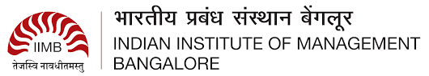
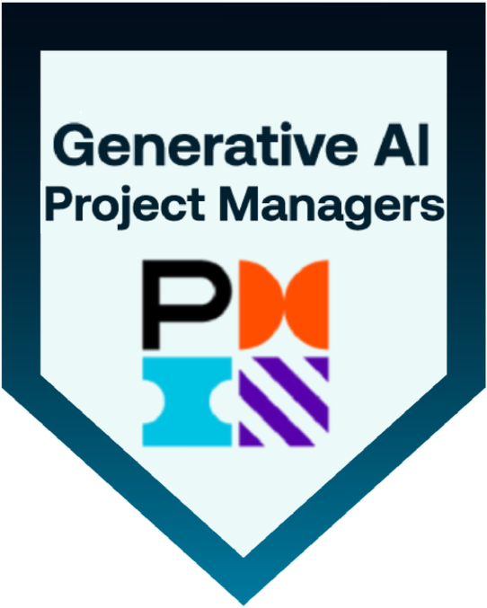
Sr. Business Analyst
saifleader001@gmail.com
M: +91-9966577563
Linkedin
PROFESSIONAL SUMMARY

- Sr Business Analyst with 7 years of experience, delivering data-driven solutions and driving strategic initiatives.
- Expert in business process design, requirement gathering, UAT, and digital transformation.
- Proven success in stakeholder engagement, cross-functional collaboration, and aligning business objectives.
- Skilled in project management, market analysis, and strategic planning to drive performance.
- Configured and optimized ServiceNow ITSM, ITOM, and HRSD modules to enhance HIPAA-compliant service delivery for Revenue Cycle Management (RCM)
Achievements
- Best Employee Award for the years 2020 & 2021 at Arla Foods for consistently reducing the manual tasks by up to 30%.
- Got a Silver Award from Google Inc. along with a Certificate of Excellence for the best productivity as a lead of a Navigation Project-2012.
Core Competencies:
- Business Process Reengineering, KPI Tracking, Stakeholder Analysis, Change Management, User Training, Risk Analysis, Business Case Development, Data Modeling, UAT Planning, Agile Ceremonies, Requirements Elicitation, Workflow Optimization
Skills & Tools:
Programming Languages | Python, SQL.
Software Methodologies | Agile, Scrum, SDLC, Waterfall.
Databases | Oracle, MS SQL Server, PostgreSQL, MySQL
Operating Systems | Windows, Linux, Unix, macOS
Data Visualization Tools | Power BI, Tableau, Airtable
UI/UX Design & Prototyping Tools | Balsamiq, MS Visio, Axure RP, Figma, Adobe XD, Zephyr
Packages | MS SharePoint, MS Office, Airtable
Project Management & Collaboration Tools | Jira, Confluence

Certifications:
Certified Generative Overview for Project Managers by PMI.

PROFESSIONAL EXPERIENCE
Client: Axia Women’s Health, Voorhees, New Jersey | Employer: Amvotech Solutions Inc, Hyderabad, India
Role: Sr. Business Analyst June 2022- July 2024
Responsibilities:
- Conducted ServiceNow-centric business analysis initiatives to identify and document functional requirements for ITSM modules, including Incident, Change, Problem, and Knowledge Management.
- Collaborated with teams to design and optimize claims processing workflows, including 837P/I claim generation, 835 remittance advice integration, and denial management logic within healthcare platforms.
- Ensured compliance with HIPAA standards while enhancing claims adjudication accuracy and reducing turnaround time by automating touchpoints in the claim lifecycle from charge capture to payment posting.
- Acted as a bridge between development and billing operations to reduce claim rejections, integrating logic for ICD-10, CPT, and HCPCS validation before claim submission.
- Conducted detailed assessments of current-state ITSM processes and designed optimized workflows leveraging ServiceNow’s Flow Designer and Workflow Editor.
- Designed Data Flow Diagrams (DFDs), Entity Relationship Diagrams (ERDs), and web page mock-ups using modeling tools.
- Created a Traceability Matrix to maintain the Traceability of the requirements.
- Used MS Project Gantt charts to create the different modules of the project.
- Supported integration efforts between ServiceNow HRSD and third-party HR systems.
- Conducted requirements elicitation using interviews, focus groups, surveys, and observation techniques to gather high-quality functional and non-functional requirements.
- Worked with the QA team for designing Test Plan and Test Cases for the User Acceptance testing (UAT) using Quality Center.
- Led business process reengineering initiatives using Lean principles to improve operational efficiency and reduce cycle time by 30%.
- Used MS Visio for Process modelling and Business Process flow diagrams & SQL commands on Tableau to get the live data from various data platforms like Snowflake & MS SQL.
- Prepared Functional Specification Documentation (FSD) and communicated these to the stakeholders.
- Built real-time analytics dashboards in Power BI to measure ITSM performance metrics, including MTTR, SLA adherence, and service satisfaction scores.

Arla Foods, Riyadh, KSA. Oct 2019 - May 2022
Role: Sr Business Analyst
Responsibilities
- Led end-to-end business analysis for inventory and supply chain management applications, supporting Arla’s dairy operations across procurement, storage, and distribution.
- Performed stakeholder analysis to align cross-functional needs and priorities, contributing to process optimization and system improvements, including enhancements in Salesforce Service Cloud.
- Conducted on-site workshops and walk-throughs at processing plants and warehouses to identify digitalization opportunities in raw material tracking, stock movement, and shelf-life reporting.
- Authored user stories, wireframes, and process flows supporting Power Apps-based inventory tracking systems integrated with SAP, ServiceNow, and Salesforce.
- Collaborated with product managers and UI/UX teams to design mobile-first interfaces aligned with warehouse operations, incorporating barcode scanner compatibility and Salesforce Mobile App considerations.
- Created low- and high-fidelity prototypes using Figma and Balsamiq to validate user journeys and functional specifications.
- Designed Tableau and ServiceNow dashboards to monitor stock levels, order cycles, and fulfillment KPIs.
- Led JAD sessions and implemented requirement traceability matrices (RTM), using MoSCoW prioritization to ensure delivery of high-impact features.
- Conducted UAT and documented business rules, user manuals, and training materials for end users across SAP, Power Apps, and Salesforce platforms, including validation of Apex-triggered automation logic and exception handling to ensure alignment with business processes.
- Partnered with development teams to define user interactions and data bindings for Lightning Web Components (LWC), ensuring component behavior aligned with business use cases such as live stock visibility, barcode scanning, and mobile warehouse operations.

Dr. Mamdooh Ashy Hospitals, Jeddah, Kingdom of Saudi Arabia. August 2017 - Sept 2019
Role: Business Analyst
Responsibilities:
- Facilitated end-to-end business analysis by preparing BRDs, FSDs, and RTMs; gathered cross-functional requirements through interviews, workshops, and observations across HR, IT, and operations teams.
- Ensured regulatory compliance by aligning EMR system enhancements with Saudi Ministry of Health (MOH) standards; conducted gap analyses and coordinated with key stakeholders to meet functional requirements.
- Led process modeling and solution design using Lucidchart and Visio to create BPMN diagrams and mockups for new features and system improvements.
- Performed impact analysis and risk assessments to evaluate enhancement feasibility, prioritize business initiatives, and support decision-making.
- Provided post-deployment support, including root cause analysis, issue resolution, and hypercare for HRSD and non-HR ServiceNow modules through JAD sessions and ongoing stakeholder coordination.

Wathba International Company Ltd, Jeddah, Kingdom of Saudi Arabia. June 2014 - July 2017
Role: Asst. Manager
Responsibilities:
- Led cross-functional teams to plan, execute, and monitor IT service delivery and trade operations, ensuring timely execution of import/export processes, compliance with international trade regulations, and alignment with service-level agreements (SLAs).
- Managed vendor coordination, customs clearance documentation, shipping schedules, and ERP-based inventory systems, supported data integrations for Wathba merger with Ashy Group of Companies.
- Reduced operational delays by 20% through automation and process optimization.
- Integrated WooCommerce with backend systems for real-time order and inventory sync.
- Connected ZKTeco fingerprint system to MS SQL Server for automated reporting.

Client: Google Inc., Hyderabad, India, Employer: GlobalLogic May 2011-May 2014
Role: Sr. Analyst/Team Lead, Content Engineering
Responsibilities:
- Tested front-end Maps interfaces and internal tools for Google Maps Local Data Operations to ensure GIS data accuracy and performance.
- Supported quality control and documentation for GIS content and linear road segments, ensuring consistency across platforms.
- Led data quality initiatives by monitoring KPIs, resolving navigation and routing issues, and collaborating with product teams to enhance map accuracy.
- Created ad-hoc reports and dashboards using Excel, VB Script, and Macros to support data-driven decisions at the managerial level.
- Coordinated with vendors to validate third-party geospatial data and contributed to Maps program execution and innovation.
Education
- Post Graduate Level Program- Strategic Management from IIM Bangalore. -(2024-2025)
- Masters of Computer Applications -(MCA) from JNTU Kakinada. - (2008-2011)

