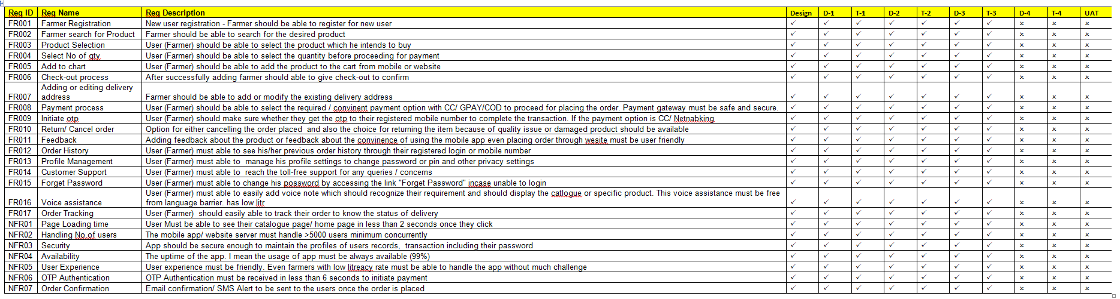

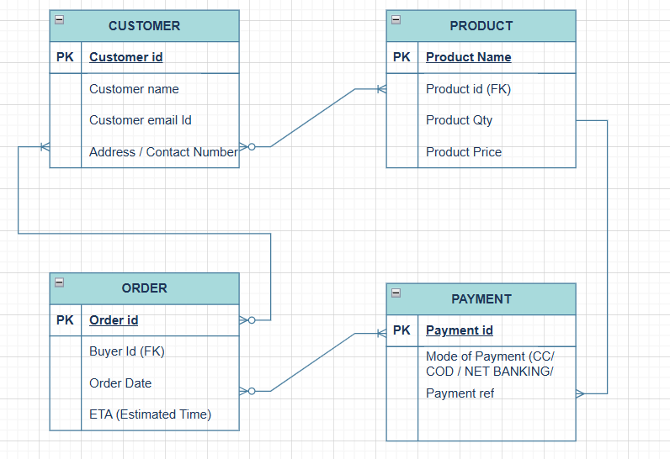

If this project needs to be completed in 12 Months or less than 12 Months (11-12 Months)
No of working Days in a week | 5
No of working hours per day | 8
Total No of working days in a month | 21
Total No of current team strength | 9
This overall hours is excluding of all public holidays / client off  Which comes around 10 Months | 1512 hr

Note – Multiply the Total no days in a month * Total No of working hours * Team strength

Efficiency % | Team | Hours
25% | BA | 378
30% | DEVELOPER team | 453.6
35% | TESTERS | 529.2
10% | UI/UX | 151.2
 |  | 1512

Responsibility (TASK) | Role | How Much it takes (Man hours)
- Connecting with client  - Requerment Gathering  - Documenting BRD & FRD & RTM | - Business Analyst | 378 Hours (25%)

Responsibility (TASK) | Role | How Much it takes (Man hours)
- Thoroughly review the Software Requirements Specification  - Get clarification on challenging/ complex requirements from Business Analysts  - Assess technical feasibility of requirements.  - Coding and designing | Developer | 453.6 Hours (30%)

Responsibility (TASK) | Role | How Much it takes (Man hours)
- Conduct user research (interviews, surveys, contextual inquiry) to understand needs, pain points, and goals.  - Collaborate with Business Analysts/Product Owners to ensure requirements reflect user needs.  - Wireframe & Prototype / designing | UI/ UX Team | 151 Hours (10%)

Responsibility (TASK) | Role | How Much it takes (Man hours)
- Code Quality & Stability  - Automation  - Identifying defects and Non functional needs and addressing that with development team | Testers | 529.2 Hours (35%)

