CAPSTONE PROJECT-1 AAKANKSHA DHOTE
Q.1- Identify Business Process Model for Online Agriculture Store – (Goal, Inputs, Resources, Outputs, Activities, Value created to the end Customer)

Business Process Model
Date: 18-10-25

Goal:
Bridge the gap between buyers(farmers) and availability of agricultural products directly from manufacturers. The farmers should be able to get the products with many and better options, with better quality and authentic brands combined reasonable prices.
The website should be easy to use for users, in different languages and easy features. Adept with instruction manual for new users.

Input Resources:
- Warehouse
- Software systems
- Office space
- Customer data
- Marketing campaigns
- Trained personnel

Activities:
- Provide excellent customer service
- Partner with leading brands
- Streamline order and delivery processes
- Conduct regular performance reviews

Outputs:
- Increased sales revenue
- Improved operational efficiency
- Enhanced customer loyalty

Values:
- Wide product range
- Customer satisfaction
- Reliability and trust
- Continuous improvement

Q.2 SWOT - Mr Karthik is doing SWOT analysis before he accepts this project. What Aspects he Should consider as Strengths, as Weaknesses, as Opportunity and as Threats.
For the Online Agriculture Product Store, the main aim is to help farmers in remote areas easily buy fertilizers, seeds, and pesticides directly from manufacturers through an online platform. Below is the SWOT analysis for the project:
Strengths:
The biggest strength of this project is that it connects farmers and manufacturing companies directly, removing the need for middlemen. It’s also a CSR-based initiative, so it has a positive social impact. The company already has a capable team—developers, testers, PM, and BA—which will help in smooth execution. Since the app will be built using Java, it will be reliable and scalable.
Weaknesses:
Many farmers still don’t have good internet access or are not very comfortable using digital applications, which can become a challenge. Managing deliveries in rural areas may also be difficult. The budget is fixed at ₹2 crores, so we might have to limit some advanced features in the first release.
Opportunities:
If this platform works well, it can be expanded later to include other agricultural products, tools, and even government-linked schemes. The data collected from farmers’ buying patterns can also be used to improve supply and demand planning. There’s also scope to build a mobile version or add regional language support to reach more farmers. We can also connect NGOs with the platform for better understanding of farmers’ issue.
Threats:
There’s always a risk from other agri-tech companies offering similar services. Also, since we are dealing with customer data, security and privacy will be important concerns. Local dealers might feel threatened by the platform. Lastly, poor connectivity in remote villages can affect adoption.

Mr Karthik is trying to do feasibility study on doing this project in Technology (Java), Please help him with points (HW SW Trained Resources Budget Time frame) to consider in feasibility Study.

Q.3- Feasibility Study Mr Karthik is trying to do feasibility study on doing this project in Technology (Java), Please help him with points (HW SW Trained Resources Budget Time frame) to consider in feasibility Study
Mr. Karthik is planning to develop this project using Java technology, so he needs to check a few important areas before starting.
Hardware: The company should have proper servers, computers with good processing power, and reliable internet to host and test the application.
Software: Java JDK, Eclipse/IntelliJ IDE, a database like MySQL or Oracle, and testing tools such as Selenium will be required.
Trained Resources: Skilled Java developers, testers, a database admin, and a business analyst are already available in APT IT Solutions, which makes development easier.
Budget: The total approved budget is ₹2 crores, which should cover development, testing, hardware setup, and minor maintenance costs.
Time Frame: The project is planned for 18 months, which is sufficient for design, development, testing, and deployment phases.
Overall, the project is technically and financially feasible with the available team and resources.
Q.4- GAP ANALYSIS
At present, farmers in remote areas are facing problems in buying fertilizers, seeds, and pesticides. They depend on local shops, where prices are high and product availability is limited. This is the AS-IS process.
In the TO-BE process, the new online agriculture store will allow farmers to directly connect with manufacturers and place orders online. This will reduce costs, save time, and ensure genuine product delivery.
So, the main gap lies in the lack of accessibility, transparency, and convenience, which the new system aims to bridge through a digital platform.
Category | Current Situation (AS-IS) | Future Vision (TO-BE)
Platform | There isn’t a proper platform that connects buyers and sellers directly. | Build an easy-to-use platform that bridges the gap between buyers and sellers.
Internet Connectivity | Poor internet connectivity makes it hard for users to access services smoothly. | The platform will be designed to work well even with low or unstable internet connections.
Product Range | Farmers currently have very few options to choose from. | They’ll get access to a wide range of products from different brands in one place.
Product Availability | Many times, required products are not available when needed. | Products will be easily available through better stock and vendor management.
Pricing | Prices are high and there are hardly any discounts. | The platform will offer better deals and discounts, making products more affordable.
Product Selection | Farmers can’t easily find products that suit their specific crop or soil type. | They’ll be able to filter and choose products based on crop type, soil, and other useful features.
Knowledge & Guidance | There’s limited awareness about which product fits which need. | The platform will also provide helpful information and recommendations to guide farmers.

Q.5 List down different risk factors that may be involved (BA Risks And process/Project Risks.
- Sudden change requests from clients
- Stakeholder conflict over requirements
- Due to budget constraints, few features might be dropped
- Budget might increase for testing /development tools
- May need more resources testing /development tools
- Planned sprint might get delayed due to change requests from clients
- Low compatibility in web or mobile application version of the store
- Bugs/virus/cyber threats
- Farmers might find the app difficult initialy
- Defect/issues count increase

Q.6 RACI
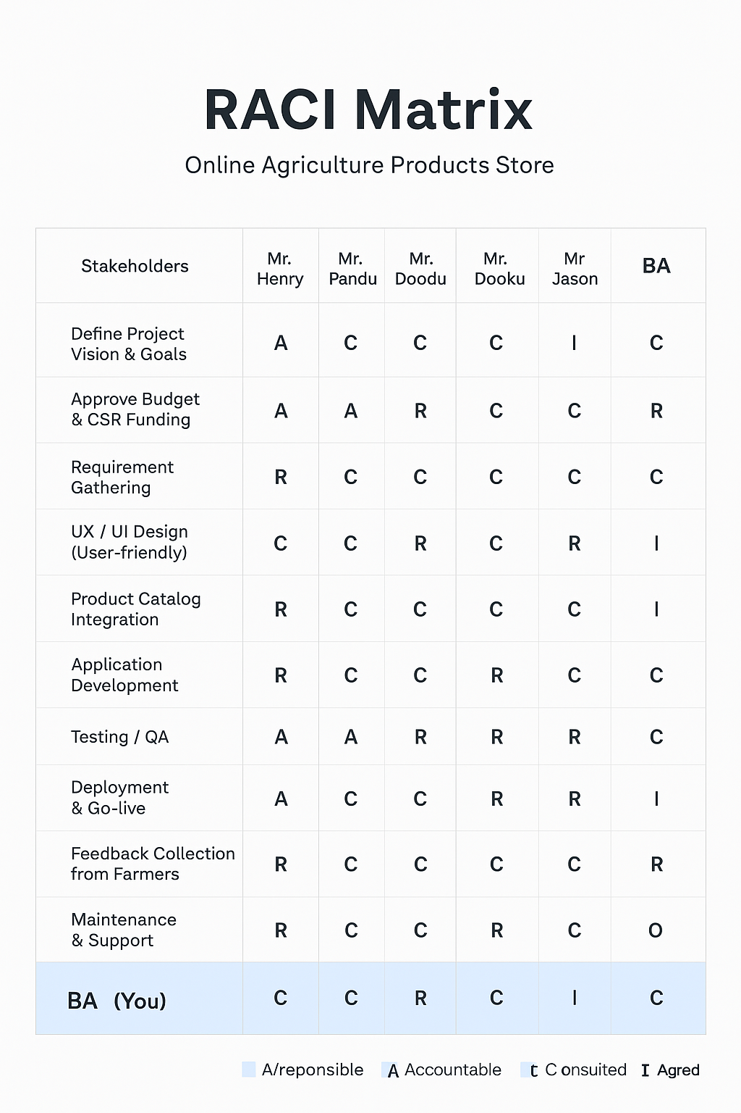
Q.7 BUSINESS CASE DOCUMENT
Project Title: Online Agriculture Product Store
Purpose:
The main aim of this project is to help farmers in remote areas easily buy fertilizers, seeds, and pesticides directly from manufacturers through an online platform. This will make the process faster, cheaper, and more transparent.
Business Need:
Farmers are facing difficulties in getting quality agricultural products at fair prices due to lack of accessibility and middlemen involvement. An online system will solve these issues by connecting farmers and manufacturers directly.
Benefits:
- Farmers can buy products anytime and from anywhere.
- Prices will be more competitive since middlemen are removed.
- Manufacturers can reach a wider customer base.
- Digital records will improve tracking and transparency.
Cost and Budget:
Estimated cost of the project is ₹2 crores, funded under CSR initiative.
Timeline:
The project duration is 18 months, including development, testing, and implementation.
Risks:
Internet connectivity issues in rural areas and lack of digital awareness among farmers may affect adoption.
Conclusion:
This project is socially beneficial and financially feasible. It supports rural development and promotes digital agriculture across regions.

Q.8 Mr Karthik explained to Mr. Henry about SDLC. And four methodologies like Sequential Iterative Evolutionary and Agile. Please share your thoughts and clarity on Methodologies
Mr. Karthik explained to the committee about the four main SDLC methodologies – Sequential, Iterative, Evolutionary, and Agile. Here’s how I understand them:
The Sequential methodology is more of a step-by-step process. You finish one phase completely before moving to the next. It’s simple to follow but doesn’t give much room for changes once a stage is done.
The Iterative methodology allows you to build the project in smaller parts. After each round, you can take feedback, fix issues, and improve it. It’s a more practical approach when things can change along the way.
The Evolutionary methodology is kind of similar, but here the system keeps growing with every version. You start with a basic model and keep adding features based on user needs and feedback. It’s great when the client is not 100% sure of all requirements at the beginning.
Finally, the Agile methodology focuses on teamwork and quick results. The work is divided into small sprints, and after each sprint, feedback is taken to make improvements. It’s flexible, fast, and ensures that the client stays involved throughout the process.
In my opinion, for this online agriculture project, something like Agile or Evolutionary would work best because we’re dealing with new users (farmers), and their requirements may change as they start using the platform.
Q.9 They discussed models in SDLC like waterfall RUP Spiral and Scrum . You put forth your understanding on these models When the APT IT SOLUTIONS company got the project to make this online agriculture product store, there is a difference of opinion between a couple of SMEs and the project team regarding which methodology would be more suitable for this project. SMEs are stressing on using the V model and the project team is leaning more onto the side of waterfall model. As a business analyst, which methodology do you think would be better for this project?
Since this project involves farmers and requires a reliable, user-friendly system, the V-Model will help in verifying requirements and maintaining quality throughout the process. It ensures fewer defects, better testing, and more confidence before the final launch. In SDLC, there are different models used based on project needs and client expectations.
The Waterfall model is a simple step-by-step process where each phase is completed before the next begins. It’s easy to understand but doesn’t allow changes once a phase is done.
The RUP (Rational Unified Process) model divides the project into phases – inception, elaboration, construction, and transition. It’s iterative and helps manage risks and changes effectively.
The Spiral model focuses on risk management and refinement. It combines iterative development with prototyping, making it suitable for large or high-risk projects.
The Scrum model is part of Agile methodology. It divides work into short sprints, encourages teamwork, and allows continuous feedback, making it flexible and fast-paced.
In this project, there’s a difference of opinion between SMEs and the project team. SMEs prefer the V-Model, while the team supports Waterfall. As a Business Analyst, I would recommend the V-Model because it ensures proper validation and testing at every stage.
Q.10 Write down the differences between waterfall model and V model
The Waterfall Model and the V-Model are both traditional SDLC approaches, but they differ mainly in how testing and development are planned and executed.
In the Waterfall Model, all phases follow one after another — requirements, design, development, testing, and deployment. Testing starts only after development is finished, which sometimes leads to late detection of errors. It’s simple but not flexible when changes are needed.
In the V-Model, every development phase has a matching testing phase planned in parallel. For example, requirement gathering is matched with user acceptance testing, and design is linked with system testing. This ensures verification and validation happen throughout the process.
Key Differences:
- Waterfall is linear, while V-Model is a verification and validation-based model.
- In Waterfall, testing happens after development; in V-Model, testing is planned alongside every stage.
- V-Model focuses more on quality and early defect detection.
For this agriculture project, V-Model is a better choice because it ensures proper testing and quality checks at each step, which is crucial for a user-friendly and reliable system for farmers.
Q.11 As a BA, state your reason for choosing one model for this project
As a Business Analyst, I would choose the V-Model for this project. The main reason is that this model allows testing and validation to happen alongside every development phase. Since this project is meant for farmers, who are new to technology, the application must be very user-friendly and error-free.
The V-Model helps ensure that every requirement is verified and validated early, which reduces the chances of defects later. It also maintains transparency between the development and testing teams. With a fixed budget and timeline, this approach provides better control and quality assurance throughout the project.
So, the V-Model fits best for this online agriculture store because it ensures accuracy, quality, and smooth implementation.
Q.12 GANTT CHART
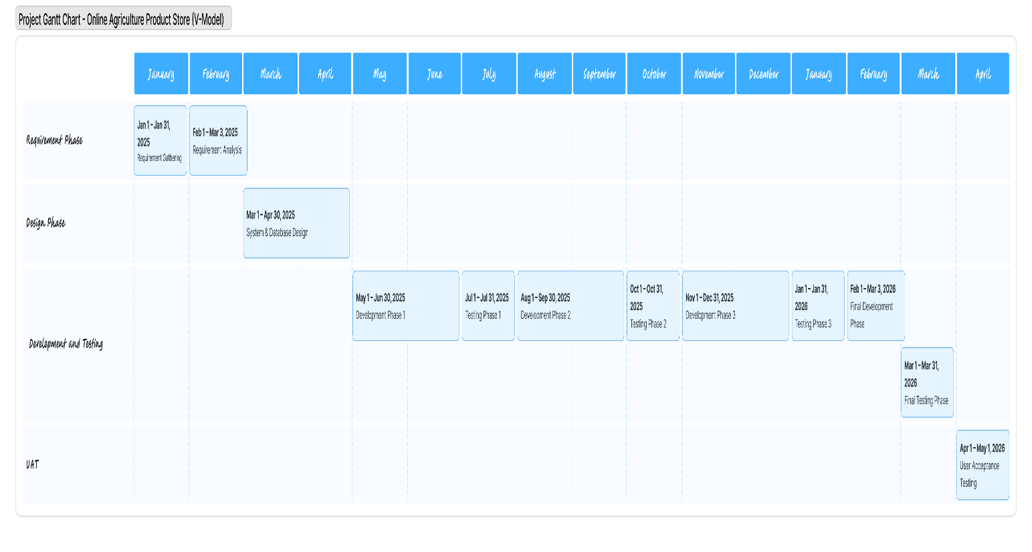

Q.13 Explain the difference between Fixed Bid and Billing projects
Fixed bid and billing projects are basically two different ways of charging for work. In a fixed bid project, the client and the vendor agree on a set price upfront for the whole project. It doesn’t matter if the work ends up taking more time than expected—the price stays the same. This works well when the requirements are clear from the start, but the vendor takes on most of the risk.
On the other hand, in a billing or time-and-material project, the client pays for the actual hours or effort spent. The cost can go up if the project takes longer, but it gives the client flexibility to make changes along the way. Basically, the client bears more risk here, but it’s ideal for projects where the scope isn’t fully defined at the beginning.
Q.14 Preparer Timesheets of a BA in various stages of SDLC -
agangadhar.coepd@gmail.com

1. Design Phase – BA Timesheet
Task | Description | Estimated Hours/Days
Requirement Validation | Review and confirm gathered requirements with stakeholders | 3 Days
Prepare SRS & BRD | Create detailed Software Requirement Specification and Business Requirement Document | 5 Days
Conduct Review Meetings | Discuss documents with PM and technical team | 2 Days
Prepare Process Diagrams | Develop flowcharts and BPMN models | 2 Days
Sign-off | Get final approval on requirements | 1 Day

2. Development Phase – BA Timesheet
Task | Description | Estimated Hours/Days
Clarify Requirements | Support developers by clarifying business rules | 3 Days
Change Requests Handling | Record and analyze change requests (if any) | 2 Days
Review Functional Design | Verify that design aligns with requirements | 2 Days
Participate in Stand-ups | Daily communication with team to track progress | 1 Day

3. Testing Phase – BA Timesheet
Task | Description | Estimated Hours/Days
Prepare Test Scenarios | Help QA team in preparing test cases based on requirements | 3 Days
Requirement Traceability Matrix (RTM) | Ensure all requirements are covered in testing | 2 Days
Review Defects | Analyze and validate raised defects | 2 Days
Participate in Testing Reviews | Discuss test results with QA and development teams | 1 Day

4. UAT (User Acceptance Testing) Phase – BA Timesheet
Task | Description | Estimated Hours/Days
Prepare UAT Plan | Identify UAT scenarios and acceptance criteria | 2 Days
Coordinate with Users | Guide farmers or users during UAT sessions | 2 Days
Collect Feedback | Document user feedback and improvement points | 2 Days
Final Sign-off | Get approval from stakeholders after UAT completion | 1 Day

5. Deployment & Implementation Phase – BA Timesheet
Task | Description | Estimated Hours/Days
Support Go-Live | Coordinate with technical team during deployment | 2 Days
Prepare User Manuals | Create user guides and training materials | 3 Days
Conduct Training Sessions | Train end-users (farmers, suppliers, admins) | 2 Days
Post-Implementation Review | Gather feedback and note lessons learned | 1 Day

