Capstone Project1 – Part -1

- Identify Business Process Model for Online Agriculture Store – (Goal, Inputs, Resources, Outputs, Activities, Value created to the end Customer)

Answer:
Goals- Henry decided to make online agriculture product store, to provide farmers, gardeners, and easy access to high-quality agricultural products and services through online platform. This includes everything from seeds, fertilizers, tools, and machinery to crop protection products, gardening supplies, and farm management software. Henry also thought that, he wanted to expand the market, increase customers to buy the products and educate the customers like service support.

Inputs: Agriculture products easy to purchase, inputs need to provide to farmers, they have need to understand the product and display the cost of the products, supplier details for each item, customer data, Secure payment gateways, courier services, Trained personnel to handle queries, complaints, and support, Software. Farmers can contact directly to manufacturing product companies.

Resources: Warehouse where the products will be deliver to the farmers through online purchase, where the transactions take place. Social media, search engine optimization (SEO), email marketing, paid ads. Physical storage for inventory management, Systems to manage transactions securely.

Output: Farmers can purchase any agriculture product from online without facing any problems. Orders shipped to the customers, including agricultural products like tools, seeds, fertilizers, and equipment. quality products, and support, ositive experiences due to efficient service. Reviews and ratings from customers that help improve future offerings. Collected customer data for further optimization of marketing, inventory, and sales strategies. Collected customer data for further optimization of marketing, inventory, and sales strategies. It should be a user friendly.

Activities: Selecting, ordering, and receiving agricultural products from suppliers, Updating product listings, maintaining user interface (UI) and user experience (UX), and troubleshooting issues, Running campaigns to raise awareness, promotions, and discounts for attracting customers, Processing customer orders, including order verification and payment processing, Picking, packing, and shipping the products to the customer, Handling inquiries, returns, refunds, and troubleshooting, Coordinating with third-party logistics providers to ensure timely delivery.

Value created to the end Customer:
Farmers satisfaction easy to buy product from app and Customers should align with their needs and expectations
Access to a wide variety of agricultural products from the comfort of home, saving time and travel expenses. No need to visit any agriculture stores. Shop from anywhere at any time.
Access to multiple brands/products.
- Mr Karthik is doing SWOT analysis before he accepts this project. What Aspects he Should consider as Strengths, as Weaknesses, as Opportunity and as Threats.
Mr. Karthik as he evaluates whether to accept the Online Agriculture Store project. This analysis helps identify internal and external factors that could impact the project's success.
SWOT:
Strengths:
These are advantages Mr. Karthik and his team may already have that would benefit the project
Strong network of agricultural suppliers or contacts. Understanding of agriculture domain and rural market needs. Skilled and motivated team members available. Access to required tools, technologies, or infrastructure. Past experience with similar projects
Weaknesses:
Lack of experience, Limited experience in the project domain or technology, limited resources, limited time, Limited experience in the project domain or technology, If budgeting is tight or externally controlled.
Opportunities:
These are external chances for growth, success, or competitive advantage. Opportunity to build a long-term relationship with a new or expanding client. Chance to learn or apply new tools or technologies. To collaborate with other vendors or experts. Rising demand for the project’s outcomes.

Threats:
External risks or challenges that could negatively impact the project.
Other fertilizer company products competitions, products cost may decrease due to government change. Tight timelines or milestones, budget cuts, Risk of financial constraints during the project, using unfamiliar technologies, Other vendors competing for the same client.
- Mr Karthik is trying to do feasibility study on doing this project in Technology (Java), Please help him with points (HW SW Trained Resources Budget Time frame) to consider in feasibility Study.
Based on the online app or mobile app. It has to show all the company product with price and label. So that farmers can easy to identify the product they want. Payment option should be UPI, networking or cash on delivery, they have to mention the product delivery date and time.
- Hardware requirement:
- Servers
- Development machines
- Network Infrastructure
- Backup and storage
- Software requirements:
- Development tools
- Framework and Libraries
- Database
- Testing tool
- Trained Resources:
- Required skill sets
- Training needs
- Budget
- 2crores INR
- Cost components
- Typical budget range
- Time frame:
- 18 Months
Activity | BA Role | Estimated effort (Hr's/week)
Requirement gathering workshops | Conduct meetings with farmers, committee and SMEs | 28-30 weeks
Requirement analysis | Analysis and document functional and non-functional requirements | 15-18 weeks
Use case /User story creation | Create use cases, user stories, acceptance criteria | 15 weeks
Requirement traceability matrix (RTM) | Prepare RTM for mapping requirements to design | 9 weeks
Review sessions | Validate requirements with stakeholders | 6 weeks
Total weekly effort | 80- 84 hrs

- Mr Karthik must submit Gap Analysis to Mr Henry to convince to initiate this project. What points (compare AS-IS existing process with TO-BE future Process) to showcase in the GAP Analysis.
AS-IS= Current State
TO-BE= Future State
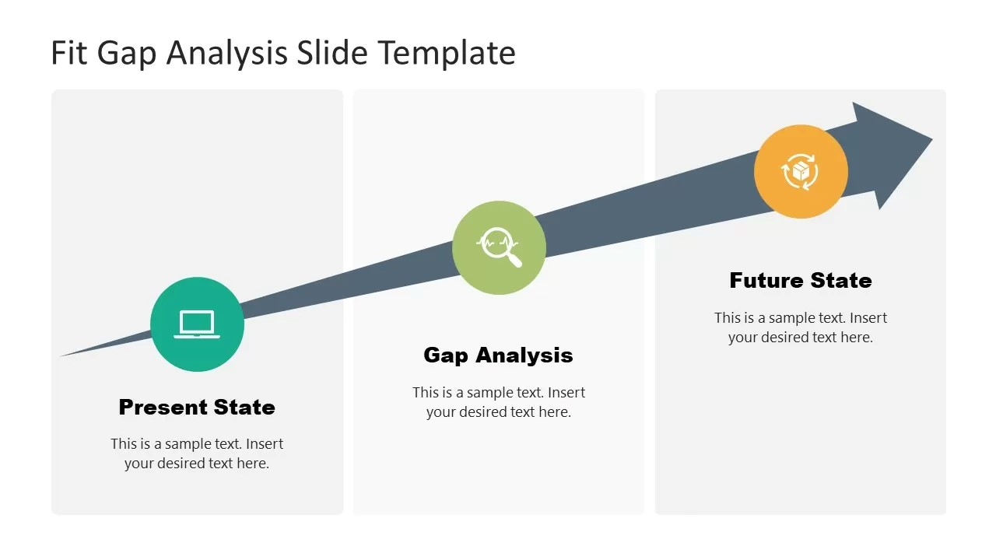

To identify gaps between the current system (AS-IS) and the proposed Java-based solution (TO-BE), and demonstrate how the new technology will improve efficiency, scalability, and business outcomes.
Area | AS-IS (Existing process) | TO-BE (Future process using Java) | GAP identified/ Benefits)
Technology | Legacy system (e.g., Excel-based/manual, or old tech stack like VB/.NET/PHP) | Java-based modular architecture using Spring Boot | Outdated technology replaced with scalable, secure, and modern Java framework
Integration | Minimal or no integration between modules | RESTful API-based seamless integration with other systems | Reduces manual data transfer and errors
Data Management | Manual entry, data duplication, inconsistent reporting | Centralized database (MySQL/PostgreSQL) with automated validations | Enhances data accuracy and real-time analytics
Security | Weak security controls and outdated authentication | Java security features (Spring Security, JWT, encryption) | Strengthened application security and compliance
Maintenance | High maintenance costs, dependency on few skilled people | Standardized Java frameworks with broad developer community | Reduces maintenance costs and resource dependency
Deployment | Manual or on premise only | Automated CI/CD pipelines with cloud deployment (AWS/Azure) | Faster updates and reliable deployment process
Customer Satisfaction | Average | High (real-time, user-friendly system) | Better engagement

The GAP analysis shows significant opportunities for improvement in efficiency, scalability, integration, and security by moving from the current (AS-IS) system to the proposed (TO-BE) Java-based solution.
Implementing the project will:
- Enhance operational performance
- Reduce long-term costs
- Support business growth and innovation

- List down different risk factors that may be involved (BA Risks and process/Project Risks)

list of risk factors Mr. Karthik should consider in his feasibility or planning document, covering both Business Analysis (BA) risks and Project/Process risks — especially relevant to a Java-based project.
Business Analysis (BA) Risks
These risks arise during the requirements gathering, analysis, and validation phases of the project.
Category | Risk Factor | Description / Example | Possible Mitigation
Requirements Elicitation Risk | Incomplete or unclear requirements | Stakeholders may not fully express their needs or use vague terms. | Conduct multiple stakeholder interviews and workshops; create use cases and prototypes.
Stakeholder Risk | Lack of stakeholder engagement | Stakeholders unavailable or uninterested in requirement sessions | Identify key stakeholders early; schedule regular reviews.
Scope Creep | Continuous addition of new requirements | Business users may request new features mid-way | Define and freeze scope; establish change control process
Requirements Validation Risk | Misalignment between business needs and documented requirements | Analysts may interpret requirements incorrectly. | Validate requirements through user walkthroughs and sign-offs
Business Process Understanding Risk | Inadequate understanding of current (AS-IS) processes | Analysts may overlook dependencies or bottlenecks | Map and document all AS-IS and TO-BE processes thoroughly
Data Quality Risk | Inaccurate or inconsistent data in current system | Poor data may impact migration to Java platform. | Implement data cleansing and validation prior to migration.
Regulatory / Compliance Risk | Failure to meet industry or legal standards | Missing compliance requirements in the new system. | Engage compliance officers during requirement phase.
Technology Fit Risk | Business needs not fully met by chosen technology | Java solution may not align with legacy systems | Perform technical feasibility and POC (proof of concept).

Projects risks
These risks arise during the development, testing, deployment, and post-implementation phases.
Category | Risk Factor | Description / Example | Possible Mitigation
Resource Risk | Lack of skilled Java developers or testers | Existing team may not have required technical skills | Provide training or hire experienced Java professionals
Schedule Risk | Delays in deliverables | Overestimation of productivity or unforeseen issues. | Use realistic time estimates and agile tracking (Scrum)
Budget Risk | Cost overruns | Scope changes or unexpected infrastructure costs. | Maintain strict change control; review cost plan regularly
Infrastructure Risk | Insufficient hardware/network resources | Servers may not support new workloads | Upgrade infrastructure; perform load testing.
Quality Risk | Defects discovered late in testing | Incomplete unit/integration testing. | Implement automated testing (JUnit, Selenium).
Security Risk | Vulnerabilities in code or configuration | Weak authentication or poor data handling | Use Spring Security, code reviews, and penetration testing.
Communication Risk | Miscommunication between teams | BA, Dev, and QA teams not aligned | Regular stand-up meetings, progress reviews, and documentation.
Post-Implementation Risk | System downtime or performance issues after go-live | Poor monitoring or unoptimized configuration | Establish monitoring tools (Prometheus, ELK stack) and support plan

- Perform stakeholder analysis (RACI Matrix) to find out the key stakeholders who can take Decisions and Who are the influencers

Role | Stakeholders | RACI
Sponsor | Henry | A
Project Manager | Vandanam | R
Financial head | Pandu | C
Project Coordinator | Dooku | R
Delivery head | Karthik | A
Java Developers | Sr. Juhi | C
Java Developers | Teyson | C
Java Developers | Lucie | C
Java Developers | Tucker | C
Java Developers | Bravo | C
Business Analyst | Srujan | R
Network Admin | Mike | C
Database admin | John | C
Testers | Jason | C
Testers | Alekya | C

Activity / Deliverable | Mr. Henry (Sponsor) | Mr. Karthik (Project Manager / BA) | IT Manager | Dev Team Lead | QA Lead | End Users | Finance Dept
Project Approval & Funding | A | C | C | I | I | I | C
Feasibility Study & Gap Analysis | C | R/A | C | I | I | C | I
Technology Selection (Java) | A | R | C | C | I | I | I
Requirement Gathering | I | R/A | C | C | C | C | I
System Design & Architecture | I | C | A | R | I | I | I
Development & Coding | I | C | C | R/A | I | I | I
Testing & Quality Assurance | I | C | C | C | R/A | C | I
Deployment & Implementation | I | A | R | R | C | C | I
Training & User Adoption | I | R | C | I | C | A | I
Budget Control | A | C | I | I | I | I | R
Project Review & Closure | A | R | C | C | C | C | C
- Early engagement: Align with Mr. Henry and PM early for approvals.
- Continuous communication: Use weekly status updates and dashboards.
- Feedback loops: Include end users during UAT and pilot rollout.
- Conflict resolution: Escalate critical issues to Sponsor promptly.
- Help Mr Karthik to prepare a business case document
Why is this project initiated: To make easy online purchase to buy any agriculture product by the farmers.
What are the current problems (AS-IS): Farmers are facing many problems for purchasing the products from the agriculture store. They have to travel from one place to another place, time taking process. High maintenance costs and limited technical support. Lack of knowledge on the product. Data duplication and inconsistent reporting. Security and compliance risks due to outdated technology.
With this project how many problems could be resolved: Yes, many problems can resolve by the project, farmers can buy from online, products will be home delivery or door delivery, no need to travel to local stores, time saving. They come to know how to pay the products. So that every farmer can purchase from online and also increases the profits for the company.
What are the resources required: Sponsor, Project manager, BA, budget head, project coordinator, testers, developers, designers, IT department, stakeholders.
How much organisation change is required to adopt this technology: API IT solutions has to make from the existing application and by referring that application, they will include new options in the new application. They can make process change, technology infrastructure, easy to navigate or easy to understand the application in a local language. Need government approval and need to follow the company policies.

What is the time frame to recover ROI:
- Initial investment cost (higher investment → longer payback).
- Operational savings (more automation → faster recovery).
- Adoption speed (faster user adoption → quicker ROI).
- Maintenance efficiency (lower ongoing costs → higher net benefit).
For Mr. Karthik’s Java-based project, assuming steady cost savings, the ROI recovery time frame is about 18 months, after which the project starts yielding direct financial and operational benefits.

- The committee of Mr. Henry, Mr. Pandu, Mr. Dooku and Mr. Karthik are having a discussion on project development approach. Mr. Karthik explained to Mr. Henry about SDLC and four methodologies like Sequential, Iterative, Evolutionary and Agile. Please share your thoughts and clarify on methodologies.
SDLC is the structured process used to plan, design, develop, test, and deploy a software product.
It ensures that software is delivered systematically, efficiently, and with quality to meet business requirements.
Typical SDLC Phases:
- Requirement Gathering & Analysis
- System Design
- Development (Coding)
- Testing
- Deployment
- Maintenance & Support
SDLC Methodologies
Different organizations use different development approaches (methodologies) depending on project complexity, risk, and flexibility required.
Below are the four main methodologies Mr. Karthik referred to:
Sequential Model (Waterfall Model):
Concept: Each phase is completed step-by-step in sequence, moving to the next only after the previous one is finished.
Characteristics:
- Linear and structured approach.
- Easy to manage and document.
- Changes are difficult once development starts.

Best suited for:
- Projects with clear, stable requirements.
- Example: Government systems, banking modules with fixed regulations.
Advantages:
- Simple and easy to understand.
- Works well for small, well-defined projects.
Limitations:
- Not flexible to changes.
- Issues found late in testing phase can be costly.
Iterative Model:
Concept: The project is divided into small parts (iterations), each producing a working version of the software.
Each iteration includes design → develop → test, and feedback is used for improvement.
Characteristics:
- Focuses on repeated cycles (iterations).
- Each cycle builds on the previous one.
Best suited for:
- Projects where requirements are partially known and evolve with feedback.
Advantages:
- Early working versions available for review.
- Easier to manage changes between iterations.
Limitations:
- Requires good planning and feedback control.
- Repeated iterations may increase cost or time if not managed.

Evolutionary Model:
Concept: The system is developed in stages, evolving over time as user feedback is incorporated.
It emphasizes continuous refinement until the final product is ready.
Examples of Evolutionary Models:
- Prototyping Model (build a prototype to clarify requirements)
- Spiral Model (combines iterative and risk management approach)
Best suited for:
- Large or high-risk projects where requirements are unclear at the beginning.
Advantages:
- Users see progress early and can provide feedback.
- Reduces risk by tackling it in phases.
Limitations:
- Difficult to manage multiple evolving versions.
- Continuous user involvement is required.
Agile Model:
Concept: Agile is an adaptive and collaborative approach where work is divided into short sprints (2–4 weeks), and each sprint delivers a working software increment.
Core Principles (from Agile Manifesto):
- Customer collaboration over contract negotiation.
- Responding to change over following a plan.
- Working software over documentation.
- Individuals and interactions over processes and tools.
Examples of Agile frameworks:
- Scrum, Kanban, Extreme Programming (XP).
Best suited for:
- Dynamic projects with frequent changes in requirements.
- Environments that value speed, flexibility, and user feedback.

Advantages:
- Quick delivery of usable features.
- Encourages stakeholder involvement.
- Adapts well to change.
Limitations:
- Requires experienced team and constant collaboration.
- Harder to estimate cost and time precisely.
- They discussed models in SDLC like waterfall RUP Spiral and Scrum . You put forth your understanding on these models When the APT IT SOLUTIONS company got the project to make this online agriculture product store, there is a difference of opinion between a couple of SMEs and the project team regarding which methodology would be more suitable for this project. SMEs are stressing on using the V model and the project team is leaning more onto the side of waterfall model. As a business analyst, which methodology do you think would be better for this project?

This is a classic case for a Business Analyst (BA) to analyze and justify the right SDLC (Software Development Life Cycle) model for the project.

Waterfall model:
Linear, sequential approach where each phase (Requirements → Design → Development → Testing → Deployment) must be completed before moving to the next.
Projects with well-defined, stable requirements.
Simple, easy to manage; clear documentation.
Inflexible — changes are costly once project starts.

V-Model (Verification & Validation):
An extension of Waterfall; each development phase has a corresponding testing phase. Testing is planned parallel to development.
Projects requiring high quality and validation (like banking, healthcare)
Emphasizes testing and quality assurance early.
Still rigid; changes after design are difficult.

RUP (Rational Unified Process):
Iterative model focusing on architecture and risk reduction. Divided into 4 phases: Inception, Elaboration, Construction, Transition.
Medium to large projects needing flexibility but with structure.
Manages risks early; iterative.
Requires skilled team; can be heavy on documentation.

Spiral Model:
Combines iterative development with risk management. Each loop (iteration) involves planning, risk analysis, engineering, and evaluation.
High-risk, large, complex projects.
Early risk identification and prototyping.
Expensive and time-consuming.

Scrum (Agile):
Iterative and incremental approach; product developed in short sprints with continuous feedback.
Projects with evolving or unclear requirements.
Flexible; promotes collaboration and customer involvement.
Needs strong coordination and stakeholder availability.
APT IT Solutions has received a project to develop an Online Agriculture Product Store — likely an e-commerce platform that allows farmers and customers to buy/sell agricultural products online.
Such a project involves:
- Dynamic requirements (new product categories, pricing, delivery models).
- Continuous feedback from SMEs (Subject Matter Experts) and users.
- Integration with payment gateways, logistics APIs, etc.
- User experience and performance optimization.
The Debate:
- SMEs prefer the V-Model because they want strict validation and clear documentation (probably due to quality and compliance needs).
- The project team prefers the Waterfall Model because it’s linear and easier to manage for a first release.
As the Business Analyst, your role is to evaluate which model best aligns with the project nature and business goals.
Analysis of Suitability:
Evaluation Criteria | V-Model | Waterfall Model
Requirements Stability | Works if requirements are stable | Works if requirements are frozen early
Customer Involvement | Limited until testing phase | Limited throughout
Testing and Quality Assurance | Strong focus – validation at every stage | Testing happens only after development
Flexibility for Change | Low – difficult after design freeze | Low – even harder after coding starts
Project Size / Complexity | Suitable for medium to large, safety-critical systems | Suitable for small, predictable projects
Risk Handling | Moderate (early test design helps) | Low (risks found late)
Time to Market | Longer | Slightly shorter
Reusability / Future Enhancements | Limited | Limited

BA Recommendation:
Recommended Model: V-Model (Verification & Validation Model)
BA should justify why we use V model:
- Quality and Validation are Critical:
The online agriculture store will handle transactions, payments, customer data, and possibly government or supplier integrations, requiring strong validation and testing discipline.
- Alignment with SME Expectations:
SMEs emphasize validation at every stage — the V-model ensures testing is planned alongside each phase, ensuring their domain expertise is incorporated in validation activities.
- Early Defect Detection:
Since test plans are prepared in parallel with design and requirement documents, defects are identified early, saving rework time later.
- Suitable for Structured Teams:
APT IT Solutions, if operating with clear role segregation (BA, Developer, Tester), can efficiently implement the V-Model’s phase-based structure.
- Better Traceability:
Each deliverable (requirement, design, test case) is mapped and verified, which ensures compliance and accountability — especially useful for audit or review purposes.
Alternative consideration:
If later stages of the project demand continuous enhancements (new features, integrations, seasonal offers) after go-live, the team can transition to Agile (Scrum) for post-launch iterations.
Thus:
- Initial development: V-Model (for strong validation and quality assurance)
- Post-launch maintenance & enhancement: Agile/Scrum (for flexibility)
Final Conclusion:
As a Business Analyst, I recommend adopting the V-Model for this project’s initial development phase because it ensures:
- High-quality output through early testing and validation,
- Clear mapping of requirements to test cases,
- Alignment with SME expectations on quality and verification,
- Controlled project scope and documentation.
However, once the product stabilizes, future updates can follow an Agile (Scrum) approach for continuous improvement.
- 20Write down the differences between waterfall model and V model.

Difference Between Waterfall Model and V-Model
Aspect | Waterfall Model | V-Model (Verification & Validation Model)
Definition | A linear sequential model where each phase follows the previous one step by step. | An extension of the Waterfall model that emphasizes verification and validation activities in parallel.
Process Flow | The process flows downward like a waterfall, from requirements to maintenance. | The process forms a ‘V’ shape, where each development phase has a corresponding testing phase.
Focus | Focuses mainly on development activities. | Focuses on both development and testing activities simultaneously.
Testing Approach | Testing is done after the development phase is complete | Testing starts early, alongside the development phases (verification at each stage).
Relationship Between Phases | Phases are executed one after another, no backward movement allowed. | Every development phase has a corresponding test phase mapped to it.
Error Detection | Errors are detected late in the cycle, during testing. | Errors can be detected early, reducing rework
Verification and Validation | Verification and validation are done after implementation | Verification and validation are done in parallel with development.
Risk Handling | High risk — since defects found late are costly to fix. | Lower risk — defects found early in corresponding test stages.
Customer Involvement | Customer is involved only at the beginning and end | Customer involvement is more throughout the lifecycle for reviews and validations.
Maintenance | Maintenance phase occurs after product delivery | Maintenance still exists, but issues are minimized due to early testing.
Suitable For | Projects with clear, fixed requirements and low risk of change. | Projects that require high reliability and strict quality control (e.g., healthcare, aerospace, banking).
Example Domains | Simple or short-term projects (e.g., small business applications). | Safety-critical systems (e.g., medical devices, defence software).
- Waterfall Model: Sequential and simple; testing happens after all development is done.
- V-Model: Enhanced version of Waterfall; emphasizes early testing and quality assurance by validating each development stage.

Example: Waterfall model-
Requirements Gathering- design- coding- testing- deployment- maintenance.
V- Model:
Requirement – Acceptance testing.
System design – System testing.
Architecture – Integration testing.
Module design – Unit testing.
Implementation

- As a BA, state your reason for choosing one model for this project
As a Business Analyst (BA), here’s how you could justify the choice of the V-Model (Verification and Validation model) for your project — clearly and professionally
Reason for Choosing the V-Model for This Project
Clear and Structured Approach
- The V-Model follows a well-defined, sequential process, making it easy to plan, monitor, and control.
- Each development phase has a corresponding testing phase, ensuring thorough validation of requirements.
Strong Emphasis on Quality and Testing
- Testing is planned in parallel with development, meaning test cases are prepared right from the requirement stage.
- This reduces the chances of missing defects and ensures early defect detection, improving overall product quality.

Best Fit for Stable and Well-Defined Requirements
- Since the project requirements are clearly understood and unlikely to change frequently, the V-Model provides a reliable framework to implement them with minimal rework.
Easy Traceability Between Requirements and Tests
- The model ensures traceability from requirements to test cases, which helps verify that every requirement is properly implemented and tested.
Transparency for Stakeholders
- The V-Model provides clear documentation and milestones, allowing stakeholders such as Mr. Henry, Mr. Pandu, and Mr. Dooku to track progress easily and validate deliverables at each stage.
Lower Risk of Late-Stage Failures
- Since testing begins early and continues throughout development, issues are identified and resolved before deployment, minimizing costly post-release fixes.
Regulatory or Quality-Critical Environment (if applicable)
- For projects that require compliance, auditability, or strict quality control (e.g., finance, healthcare, government systems), the V-Model provides the necessary documentation and traceability.

I chose the V-Model because it provides a highly structured and quality-focused development approach, ensuring each requirement is verified and validated systematically. Given that our project requirements are stable and quality assurance is a top priority, the V-Model ensures precision, transparency, and reduced project risk

- The Committee of Mr. Henry, Mr Pandu, and Mr Dooku discussed with Mr Karthik and finalised on the V Model approach (RG, RA, Design, D1, T1, D2, T2, D3, T3, D4, T4 and UAT) Mr Vandanam is mapped as a PM to this project. He studies this Project and Prepares a Gantt chart with V Model (RG, RA, Design, D1, T1, D2, T2, D3, T3, D4, T4 and UAT) as development process and the Resources are PM, BA, Java Developers, testers, DB Admin, NW Admin.

Mr. Henry, Mr. Pandu, and Mr. Dooku — and Mr. Karthik, the team finalized the V-Model as the development methodology for the project.
Mr. Vandanam has been assigned as the Project Manager (PM) to oversee project execution.
V model following stages:
- RG – Requirement gathering
- RA- Requirement Analysis
- Design- System and Architecture design
- D1- Development Phase 1
- T1- Testing Phase 1
- Development Phase 2
- Testing Phase 2
- Development Phase 3
- Testing Phase 3
- Development Phase 4
- Testing Phase 4
- UAT- User Acceptance Testing.

Role:
Project Manager (Mr. Vandanam)
Responsibilities:
Project planning, tracking, coordination, risk management, and communication with stakeholders.
Role:
Business Analyst (Mr. Karthik)
Responsibilities:
Requirement gathering, analysis, preparing BRD/SRS, supporting validation and UAT
Role:
Java Developers
Responsibilities:
Coding, unit testing, and fixing defects across D1–D4 phases.

Role:
Testers
Responsibilities:
Preparing test cases, executing test plans for T1–T4 and UAT, defect tracking.
Role:
Database (DB) Administrator
Responsibilities:
Database design, optimization, backups, and data security.
Role:
Network (NW) Administrator
Responsibilities:
Ensuring server connectivity, deployment environment setup, and security configuration .
- Each Development phase (D1–D4) has a corresponding Testing phase (T1–T4) to ensure validation at every stage.
- The V-shape structure ensures verification and validation are aligned with requirements.
- PM (Mr. Vandanam) monitors progress through milestones in the Gantt Chart, ensuring on-time delivery.
- UAT serves as the final validation phase before deployment.

Gantt chart:
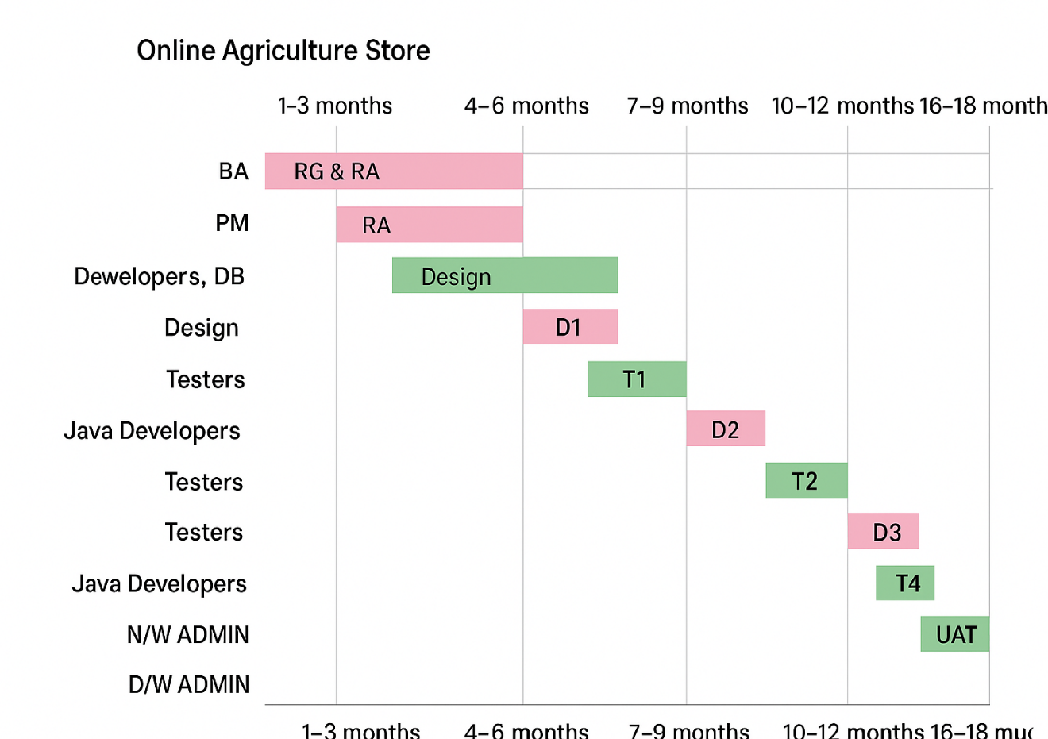

Responsibilities | Resources | 1-3 months | 4-6 months | 7-9 months | 10-12 months | 13-15 months | 16-18 months
BA | RG & RA | 2 months
PM | RA | 2 months
BA, Developers, DB Admin, NW Admin. Dependency on RA | Design |  | 2 months
Java Developers, DB Admin | D1 |  | 1 month
Testers | T1 |  |  | 1 month
Java Developers, DB Admin | D2 |  |  | 2 months
Testers | T2 |  |  |  | 1 month
Java Developers, DB Admin | D3 |  |  |  | 1 month
Testers | T3 |  |  |  |  | 2 month
Java Developers, DB Admin | D4 |  |  |  |  | 1 month
Testers | T4 |  |  |  |  |  | 2 months
BA, Testers, Users | UAT |  |  |  |  |  | 1 month
 | N/W ADMIN
 | D/W ADMIN

- Explain the difference between Fixed Bid and Billing projects
Business Analyst–style explanation of the difference between a Fixed Bid model and a Billing model, specifically in the context of an Online Agriculture Products Store project.
In an Online Agriculture Products Store project, the development team is tasked with building and maintaining a web-based or mobile platform for selling seeds, fertilizers, tools, and other farm-related products.
The type of pricing and engagement model chosen Fixed Bid or Billing (Time & Material) will determine how the client pays and how the project is managed.
Fixed bid model:
Fixed Bid (Fixed Price) model, the project cost, scope, and timeline are agreed upon upfront. The vendor commits to delivering the agreed features within a defined budget and schedule.
The client wants an online platform for farmers to browse, buy, and pay for seeds and fertilizers online with delivery tracking.
The requirements are fixed — product catalogue, cart, payment gateway, and farmer registration module.
The total cost is agreed at ₹10,00,000 with a 6-month timeline.
Vendor delivers the entire system for that price, regardless of actual hours spent.

Billing (Time and material) model:
In a Billing model, also known as the Time and Material (T&M) approach, the client pays based on actual effort, hours, or resources used.
The client starts with a simple seed-ordering system but later decides to add features like real-time crop disease alerts, farmer chat support, and dynamic pricing based on location.
Since requirements evolve, the vendor bills the client monthly or hourly for the team’s effort — say ₹1,200 per hour for developers, ₹800 for testers, etc.
The final cost depends on the actual work completed.
Scope, budget, timeline, risk, change request, best suited for stable and well defined requirements.
As a Business Analyst, I would recommend the Fixed Bid model if the Online Agriculture Products Store has clearly defined scope and limited customization.
However, if the client expects continuous enhancements such as integration with weather APIs, crop advisory tools, or farmer networks, the Billing (T&M) model would be more suitable for flexibility and scalability.

- Preparer Timesheets of a BA in various stages of SDLC.
- Design Timesheet of a BA
- Development Timesheet of a BA
- Testing Timesheet of a BA
- UAT Timesheet of a BA
- Deployment n Implementation Timesheet of a BA
Phase / SDLC Stage | Task Description | Activity Details | Hours Spent | Deliverables / Output
Requirement Gathering (RG) | Conduct stakeholder meetings | Elicited requirements from farmers, suppliers, and buyers | 120 hrs | Meeting notes, Requirement summary
Requirement Analysis (RA) | Prepare Business Requirement Document (BRD) | Drafted BRD based on collected requirements | 180 hrs | BRD v1.0
Design (D1) | Prepare Use Case diagrams & Process Flows | Created diagrams using UML | 360 hrs | Use Case diagrams
Test Planning (T1) | Create Requirement Traceability Matrix (RTM) | Linked BRD to test cases | 440 hrs | RTM v1.0
Design Review (D2) | Review UI Wireframes with stakeholders | Reviewed mock-ups for online product listing | 360 hrs | Approved Wireframes
Testing Support (T2) | Support QA team in preparing test cases | Clarified functional requirements | 430 hrs | Functional clarification log
Design Refinement (D3) | Update process flow post feedback | Revised diagrams | 340 hrs | Updated process flow diagrams
UAT (T3) | Conduct User Acceptance Testing | Collected feedback from users | 430 hrs | UAT feedback report
Deployment Support (D4) | Verify post-deployment changes | Ensured requirements implemented | 218 hrs | BA sign-off report
Post Implementation (T4) | Conduct Post-implementation Review | Captured lessons learned | 290 hrs | PIR Document

