Waterfall Project2 – Part -2/2-Virtual coding Lab Platform- CodeBuddy
Document 6- Please prepare a use case diagram, activity diagram and a use case specification document.
Here is the Use case Specification Document-
- Use case Name User Registration (Student/Faculty)
- Use case Description -This use case allows new users (students or faculty) to register & Login into the CodeBuddy application by providing personal and institutional details.
- Actors- Primary Actor: Student / Faculty, Secondary Actor: System.
- Basic Flow - 1 User selects the “Register” option from the login screen.
2. System displays a registration form.
3. User enters personal details (name, email, phone, etc.).
4. User selects role: Student or Faculty.
5. User provides institutional ID / employee ID.
6. User sets password and confirms it.
7. User submits the form.
8. System validates the inputs.
9. If valid, system creates account and displays a success message.
10. User is redirected to the login page.
11.User enters Login details.

- ALTERNATE FLOW - A1: If the email ID is already registered, show a warning and request login.
A2: If required fields are missing, prompt the user to fill them.

- Exceptional flows - E1: System encounters server error – display "Try again later".
E2: Invalid email or password format – display error message.

- Pre- Conditions - User is not already registered.
- Registration feature is available and active

- post-conditions - User account is created.
- User can now log in with registered credentials.

- Assumptions - User has a valid institutional ID.
- Internet connectivity is available.

- Constraints - Password must be at least 8 characters.
- Email must be unique.
Registration is allowed only with institute domain emails.

- Dependencies - Functional mail server for verification.
- Access to institutional database for ID validation.

- Inputs and Outputs - Inputs: Name, Email, Phone, Role, Institute ID, Password.
Outputs: Account Created Confirmation / Error Message

- Business Rules- - Only authorized institutional users can register.
- A user must select their role accurately.
- Duplicate registration not allowed.
- Miscellaneous
Information - Role-based permissions are assigned after registration.
- Faculty accounts may require approval by admin.
---------------------------------------------------------------------------------------------------------------
Use case Diagram

Activity Diagram
- Registration & Login -User selection
- View Tutorials
- Coding Practice
- Submit the assignment
- Track progress
- Faculty Review
- Admin-Manage User

Document 7- Screens and pages
1. Home Page
- Welcome message: “Welcome to Code Buddy – Learn. Code. Grow.”
- Navigation bar: Home | Login | Register | About | Contact
- Buttons: “Start Coding”, “View Tutorials”, “Login/Register”
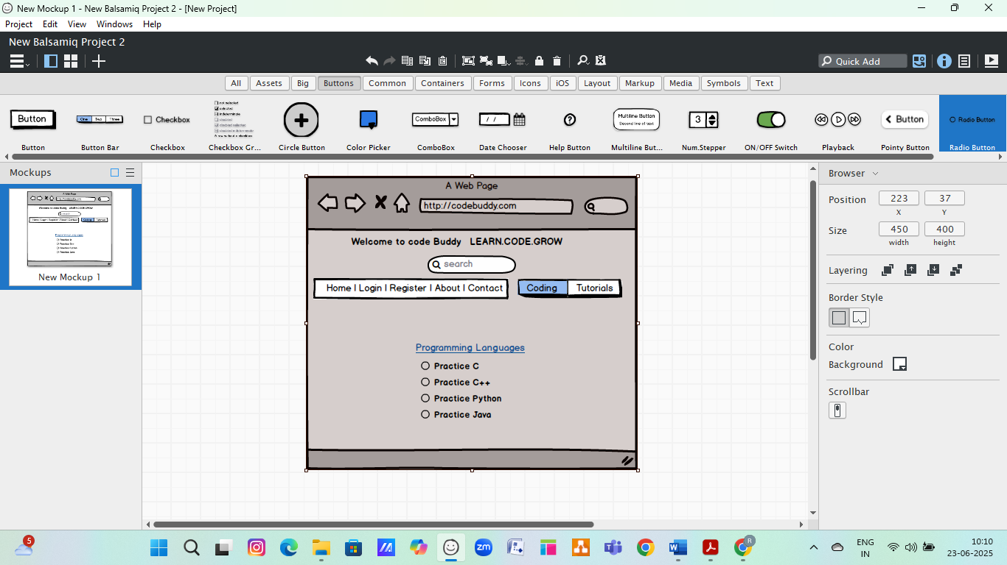

2. Login Page
- Fields:
  - Email
  - Password
- Buttons:
  - Login
  - Forgot Password
  - Register (link to registration page)

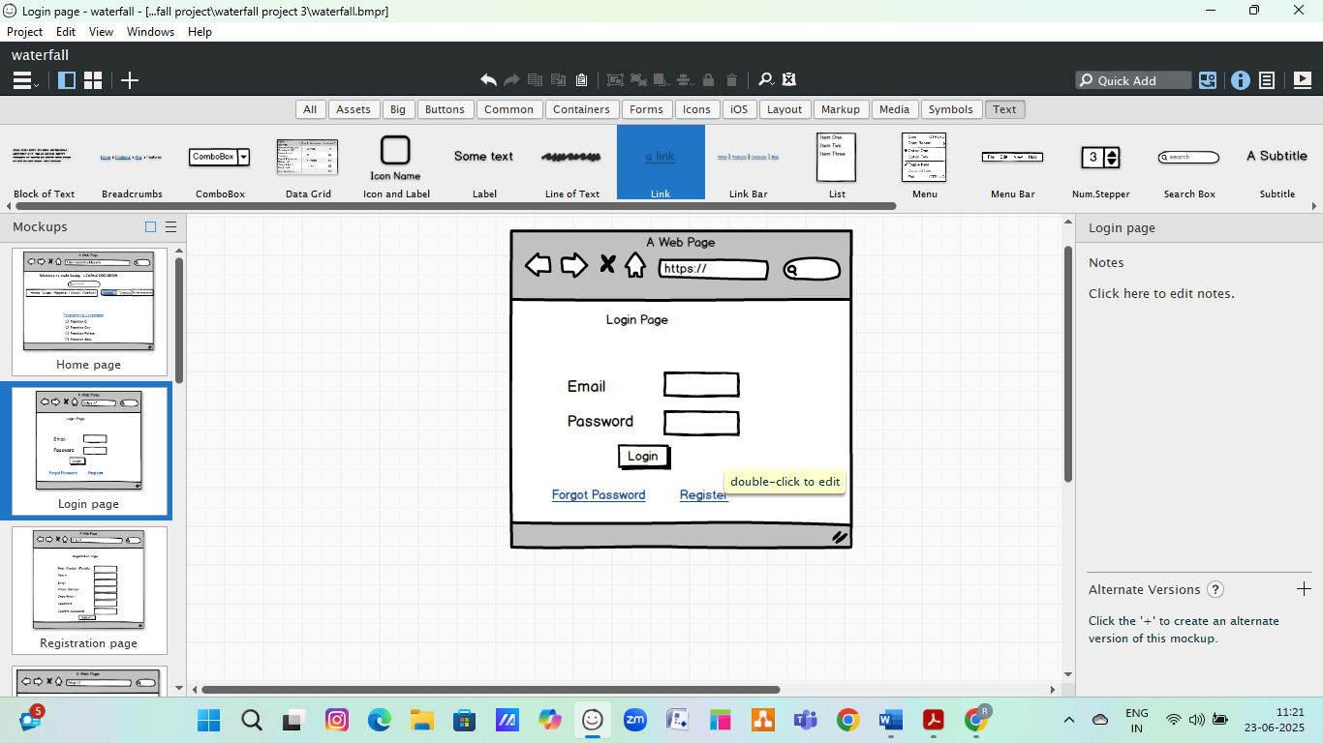
3. Registration Page
- Role selection: Student / Faculty
- Fields:
  - Full Name
  - Email ID
  - Mobile Number
  - Department
  - Password and Confirm Password
- Button: Register
- Message: “Account successfully created. Please login.”
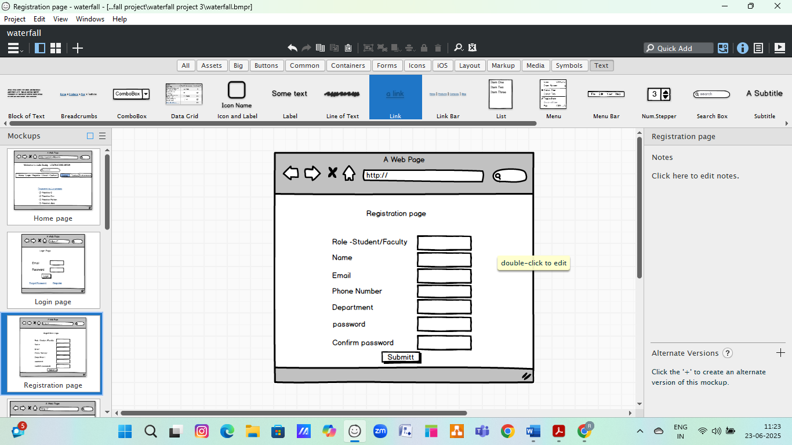

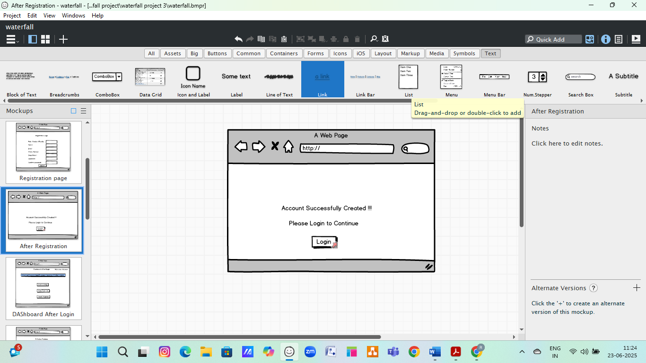

4. Dashboard (after Login)
- Welcome, <Name>
- Navigation:
  - Practice Problems
  - View Progress
  - Tutorials
  - Profile
  - Logout
- Buttons for:
  - "Start Coding"
  - "View Tutorials"
  - "Track Progress"

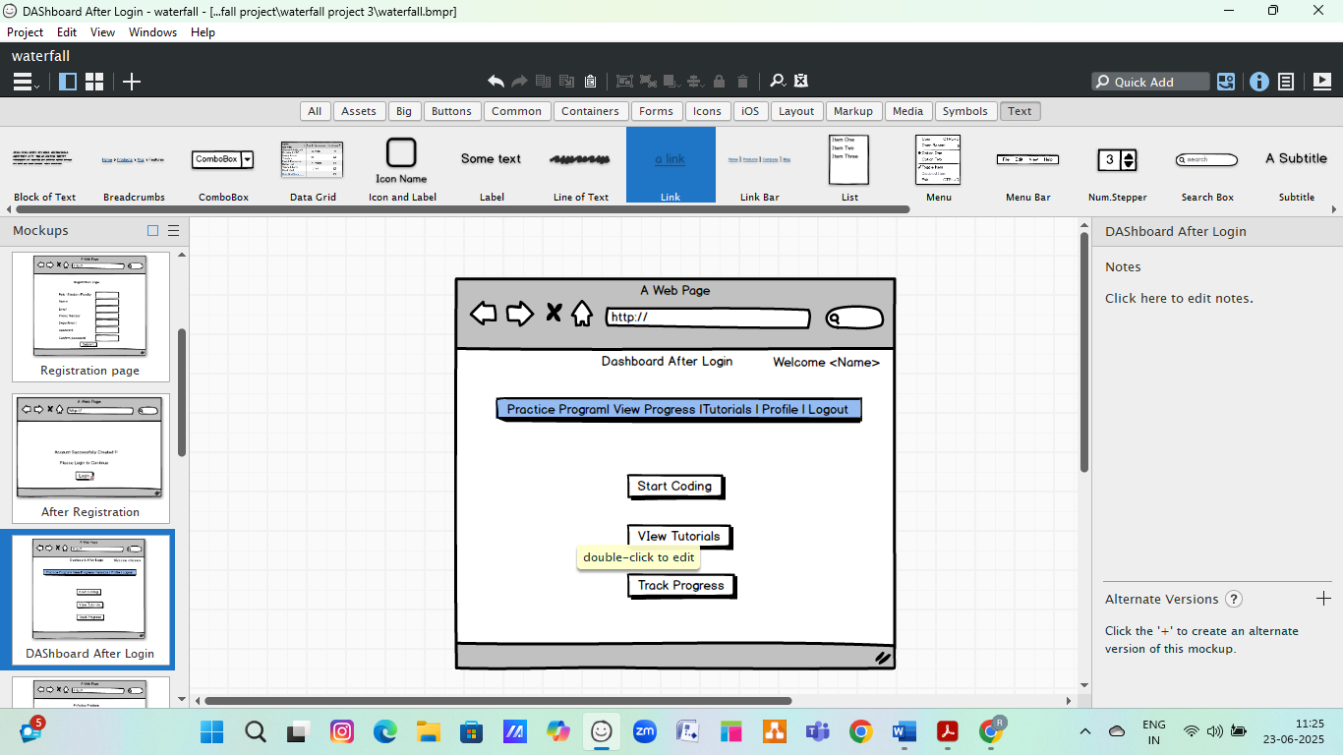

5. Practice Problem Page
- Dropdown to select language: C / C++ / Java / Python
- Select Topic: Loops / Functions / Arrays etc.
- Coding area (IDE-style panel)
- Buttons: Run | Submit | Clear
- Output console area
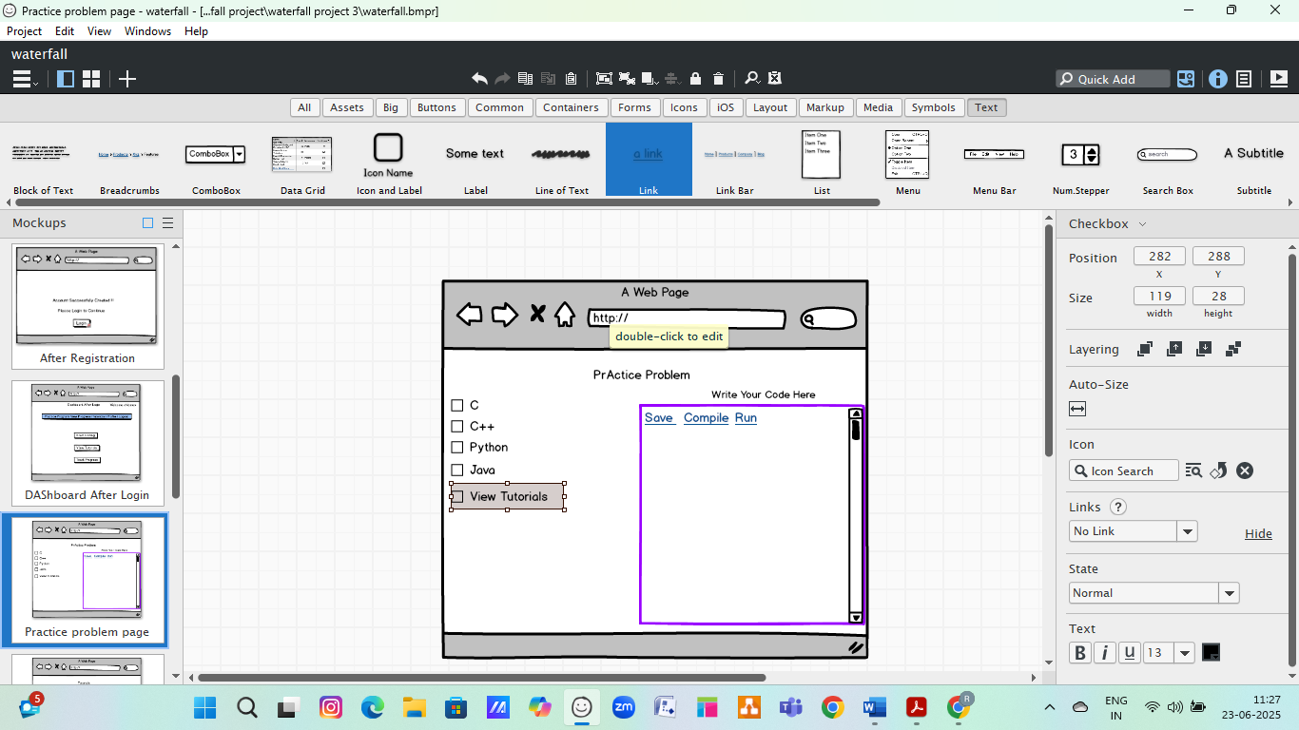

6. View Tutorial Page
- Tabs: Text Tutorials | Video Tutorials
- Categories: Beginner / Intermediate / Advanced
- Example:
  - “Intro to Loops”
  - “JavaScript Basics”
  - “C++ Arrays Explained”
- Buttons: Watch Now / Read
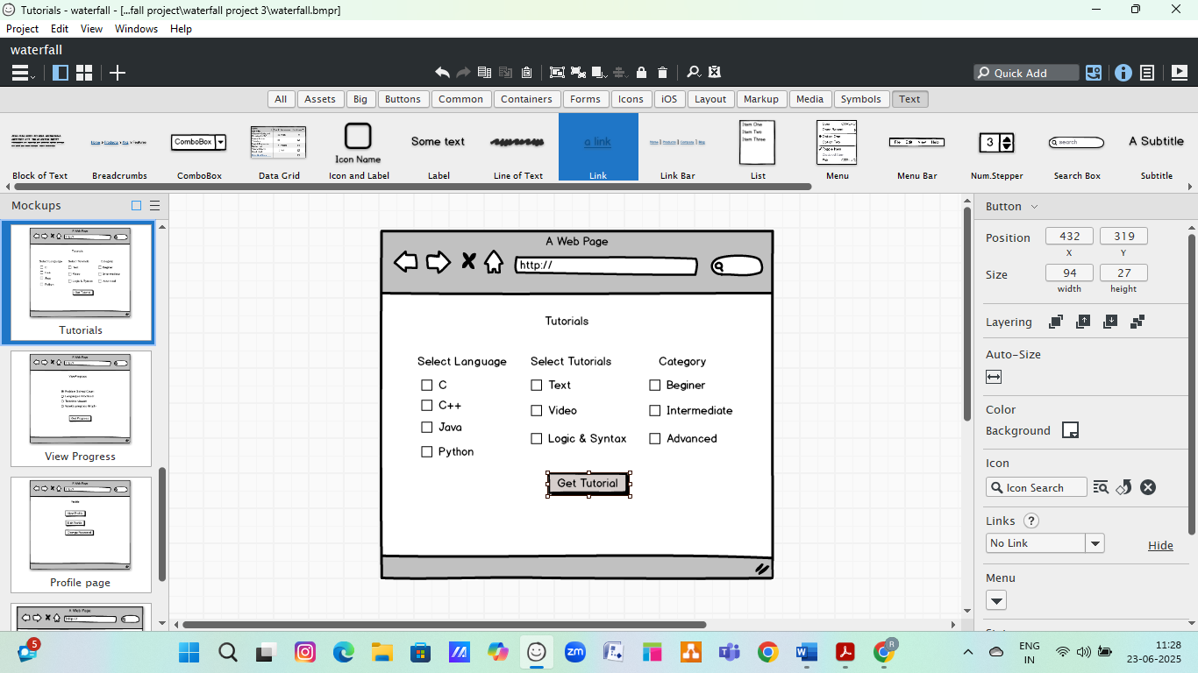

7. View Progress Page
- Table view or chart:
  - Problem solved count
  - Languages practiced
  - Weekly/Monthly graph
- Feedback/suggestions panel
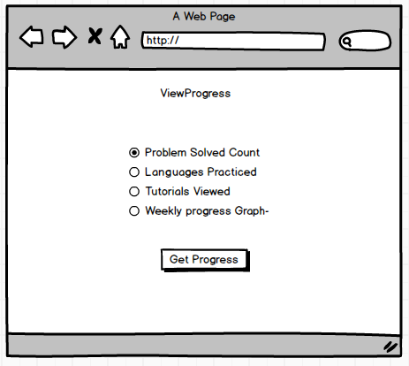

8. Profile Page
- View/edit profile info
- Change password
- View login history
- Role: Student / Faculty
- 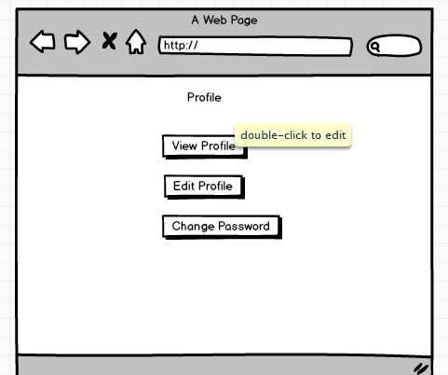

9. Logout Page
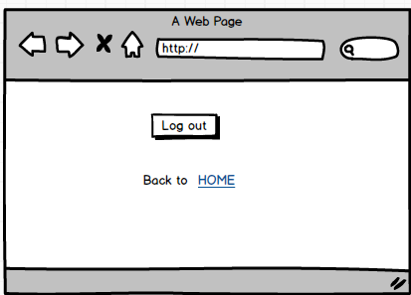

Document 8- Tools-Visio and Axure
During this project, I utilized Microsoft Visio for designing the use case and activity diagrams, which helped in visually representing the system’s flow and user interactions. Visio’s drag-and-drop interface made it easy to create structured and professional-quality diagrams, ensuring clear communication of the system architecture and user flows.
Balsamiq was used to design UI wireframes and screen mockups. It allowed the team to simulate the layout and structure of key screens such as the Home Page, Login Page, Registration Page, Practice Module, and Result Console of the CodeBuddy platform. Balsamiq's low-fidelity wireframing approach kept the focus on functionality and user experience during the early design phase. It was a valuable tool for validating requirements and gathering feedback from users.

Document 9- BA experience
My experience as BA in following phases:
1. Requirement Gathering Phase
- Techniques Used:
To collect and prioritize requirements effectively, I used the MoSCoW technique (Must have, Should have, Could have, Won’t have). This helped the team distinguish between essential and non-essential features early on.
- Stakeholder Coordination:
During this phase, the client was unavailable for a certain period. As the BA, it was my responsibility to identify alternative points of contact from the client’s side, such as faculty coordinators and IT staff, to continue the requirement collection process without delay.
- Validation of Requirements:
Once requirements were collected, I validated them using the FURPS model, which stands for Functionality, Usability, Reliability, Performance, and Supportability. This ensured that the requirements met quality standards and aligned with project goals.
- Handling Redundant Requirements:
During review sessions, I noticed multiple duplicate or overlapping requirements. I collaborated with stakeholders and technical teams to eliminate these repetitions and consolidate related features, ensuring clarity and reducing development effort.
- Prototyping for Clarity:
To help stakeholders visualize the system, I used prototyping techniques such as wireframes and mockups (created using Balsamiq). This helped refine ambiguous requirements and gather more specific feedback.

2. Requirement Analysis Phase
- UML Diagramming:
I created UML diagrams such as use case diagrams and activity diagrams to visually represent the system’s functional requirements. These diagrams helped all stakeholders understand how users would interact with the system and how different components function.
- Process Flow Visualization:
Activity diagrams were used to map out the step-by-step workflows, especially for critical features like registration, login, and coding practice. This helped in clearly conveying the logical sequence of actions.
- Team Collaboration:
Once the diagrams were prepared, I presented them to the development team for review. Some team members had different interpretations or suggestions. As a BA, I facilitated discussions, gathered feedback, and made necessary updates to ensure all perspectives were considered and the final documentation was agreed upon.
- Document Preparation:
Based on the analyzed and validated requirements, I prepared key deliverables including the Business Requirement Specification (BRS) and the Software Requirement Specification (SRS). These documents served as formal references for both the client and the development team.
3. Design Phase
- Test Case Preparation:
I derived test cases directly from the use case diagrams, ensuring both positive and negative scenarios were covered. Writing detailed negative test cases helped anticipate how the system should behave under invalid or unexpected inputs.
- Client Communication:
I discussed the design documents and solution proposals with the client to verify if the design met their expectations. Based on feedback, updates were made to align with their vision.
- Thoroughness:
I paid close attention to ensure no test case was missed, as even a single missed case could affect the integrity of system functionality in later stages.
- Test Data Preparation:
Relevant test data was generated based on real-time student/faculty registration and coding exercise examples. This was essential to simulate actual user scenarios during testing.
- RTM Updates:
I updated the Requirement Traceability Matrix (RTM) to map each requirement with corresponding test cases and design components. This ensured full coverage and helped trace issues back to original requirements if needed.

4. Development Phase
- JAD Sessions (Joint Application Development):
I organized JAD sessions involving the development team, testers, and business stakeholders to ensure everyone was aligned on the functional design and expected outcomes.
- Clarifying Queries:
As development progressed, the technical team often had queries related to logic, flow, or business rules. I resolved these by referring to documented requirements, diagrams, or by reaching out to the client for further clarification.
- Team Conflict Management:
Some team members initially disagreed on certain concepts or were reluctant to participate in collaborative discussions. I handled such situations by conducting one-on-one meetings, explaining the impact of collaboration on project success, and fostering a positive team environment.
- Reference Diagrams:
Use case and activity diagrams created earlier were frequently referred to during unit-level coding, ensuring that development aligned with approved workflows and expectations.
- Meetings and Communication:
Regular meetings were scheduled with both the technical team and the client. At times, not all team members were available. I ensured meeting recordings were shared, and followed up with individual discussions to keep everyone informed and on track.
5. Testing Phase
- Test Case Preparation:
I prepared test cases based on the finalized use cases and ensured they covered all functional and non-functional requirements.
- High-Level Testing:
I performed high-level testing alongside the QA team to verify the major workflows like user registration, login, practice problems, and tutorial access were functioning correctly.
- Test Data Management:
To simulate real-world usage, I coordinated with the client to get realistic test data, which was then used during both internal and client testing phases.
- RTM Updates:
I kept the Requirement Traceability Matrix (RTM) updated to confirm that each requirement had a corresponding test case, and to ensure complete test coverage.
- Client Sign-Off:
Once internal testing was complete, I conducted a walkthrough of the testing results and got the formal sign-off from the client, confirming that their requirements were met.
- UAT Preparation:
I also played a key role in preparing the client team for User Acceptance Testing (UAT) by briefing them, sharing UAT test cases, test data, and guiding them through the system usage so they could validate the solution independently.

6. Deployment Phase
- RTM Handover:
I forwarded the Requirement Traceability Matrix (RTM) to the client as a part of the project closure documentation, ensuring that all requirements were traceable.
- User Manual Coordination:
As a BA i worked with the documentation team and developers to create and finalize end-user manuals. These guides included screenshots and instructions to help users navigate the CodeBuddy platform.
- Training Sessions:
To support adoption, I planned and organized training sessions for both students and faculty. I made sure that the training covered all key features—such as registration, login, coding exercises, and accessing tutorials.
- Attendance Management:
I ensured that all intended users were notified and able to attend the training sessions. In cases where users couldn’t attend live sessions, recordings and support materials were shared for later reference.

