Assignment 1
- BRD

Business Requirement Document (BRD)
Project Name: Inventory and Delivery Management System
Prepared By: Devina Singh
Date: 23rd September 2025

Contents
1. Document Revisions...................................................................................................3
2. Approvals...................................................................................................................4
3. RASCI Chart for This Document ..............................................................................4
Codes Used in RASCI Chart......................................................................................4
RASCI Chart...............................................................................................................4
4. Introduction................................................................................................................5
4.1. Business Goals ...................................................................................................5
4.2. Business Objectives.............................................................................................5
4.3. Business Rules....................................................................................................5
4.4. Background..........................................................................................................5
4.5. Project Objective..................................................................................................6
4.6. Project Scope ......................................................................................................6
4.6.1. In Scope Functionality ....................................................................................6
4.6.2. Out Scope Functionality .................................................................................6
5. Assumptions ..............................................................................................................6

6. Constraints................................................................................................................ 7 Risks...............................................................................................................................7
Technological Risks...................................................................................................7
Skills Risks.................................................................................................................7
Political Risks.............................................................................................................7
Business Risks...........................................................................................................7
Requirements Risks ...................................................................................................7
Other Risks..................................................................................................................7
8. Business Process Overview......................................................................................7
8.1. Legacy System (AS-IS).......................................................................................7
8.2. Proposed Recommendations (TO-BE) ...............................................................7
9. Business Requirements.............................................................................................8
10. Development Plan…………………………………………………………………………9
11. Resource Plan……………………………………………………………………………..9
12. Appendices...............................................................................................................9
12.1. List of Acronyms................................................................................................9
12.2. Glossary of Terms.............................................................................................9
12.3. Related Documents ..........................................................................................9

- Document Revision:

Revision Number | Date | Author | Description of Changes | Reviewer | Approval Date
0.1 | 27/07/25 | Mr Vandanam | Initial draft of the project documentation | XYZ | 28/07/25
0.2 | 4/08/25 | Mr Vandanam | Added project objectives and success criteria | XYZ | 5/08/25
0.3 | 14/08/25 | Mr Vandanam | Included stakeholder analysis and elicitation technique | XYZ | 15/08/25
0.4 | 22/08/25 | Mr Vandanam | Completed functional requirement and requirement traceability matrix | XYZ | 23/08/25
0.5 | 1/09/25 | Mr Vandanam | Updated priority status in requirement traceability matrix | XYZ | 2/09/25
0.6 | 11/09/25 | Mr Vandanam | Added detailed business requirements | XYZ | 12/19/25
0.7 | 18/09/25 | Mr Vandanam | Incorporated appendices and finalised document | XYZ | 19/09/25
0.8 | 25/09/25 | Mr Vandanam | Final review and formatting adjustment | XYZ | 26/09/25

2. Approvals

Role | Name | Signature | Date
Project Sponsor | Mrs Seema Rathore | [ signature ] | 1/08/25
Business Owner | Mr Deepak rathore | [ signature ] | 1/08/25
Project Manager | Mr Vandanam | [ signature ] | 2/08/25
Business Analysts | Miss Devina singh | [ signature ] | 4/04/25
Technical Lead | Monika kumara | [ signature ] | 7/0825
Quality Assurance Lead | Suman Choudhary | [ signature ] | 7/08/25
Stakeholder Representative | Ankita Get | [ signature ] | 8/08/25
It Department Head | Alka kanodia | [ signature ] | 8/08/25

- RASCI chart for this document
Codes used in RASCI chart
- R: Responsible
- A: Accountable
- s: supportive
- C: consulted
- I: informed

Stakeholders | Responsible  (R) | Accountable (A) | Supportive(s) | Consulted  (C) | Informed  (I)
Warehouse manager | R | A |  | C | I
Operation Manager | R | A |  | C | I
IT Department | R |  | S | C | I
Warehouse staff |  |  | S
Customers(Retailers/Distributers) |  |  |  |  | I
Project manager | R | A |  | C
Business analysts | R |  |  | C
designer | R
Testers | R
trainers | R

4. Introduction:
4.1. Business Goal:
To develop a software solution that manages inventory across manufacturing plants and warehouses and ensure the quickest possible delivery of ice cream and milk products to the customers. The Proposed system will focus on two primary goals: efficient inventory management and quickest delivery to customers by achieving these goals company aims to enhance operational efficiency, minimise waste and improve customer satisfaction.
4.2. Business Objectives:
- Stock Control: Streamline inventory tracking across manufacturing plants and warehouses
- Stock and Expiry management: Automated alerts for low stocks or nearing expiry dates
- Reorder management: Enable real-time stock visibility and demand forecasting
- Route Optimization: Optimize delivery routes for fastest customer service
- Delivery Monitoring: Real time delivery order for both internal staff and customers
- Reduce Wastage: reduce wastage and improve cold chain logistics
- Improved Customer Satisfaction: Improve customer satisfaction through quick and timely delivery.
4.3. Business Rule:
- Inventory must be updated when you receive order, dispatch order and do adjustments.
- Order should only be fulfilled if the inventory is available and meets the required self-life criteria
- Delivery routes must be prioritised with less cost of transportation
- Immediate delivery of customer priority orders
- Automated purchase should be triggered depending on warehouse stock availability.
4.4. Background:
Ice cream and milk products are part of the highly perishable dairy sector, the products require cold chain logistics, precise inventory tracking, and rapid distribution to maintain quality and meet consumer expectations. To address these issues inventory management and delivery system will be developed which aims to automatically control the stock availability, manage the reorder, expiry management route optimization and monitor delivery thereby doing fastest delivery and achieving customer satisfaction.

4.5. Project objective:
- Improve operational efficiency: reduce manual handling by streamlining warehouse workflows in apps.
- Demand forecasting: use historical data, stock availability and seasonal trends to predict the demand.
- Automated Replenishment: triggering restocks based on minimum stock threshold and expiry date.
- Real time tracking: GPS enabled tracking for live updates, across manufacturing and warehouse unit for updates.
- Accelerated delivery: GPS enabled logistic tool to fastest and minimum cost delivery.
- Centralised platform for managing order, inventory and logistics.

4.6. Project Scope:
4.6.1. In Scope Functionality:
- Inventory tracking at both warehouse and manufacturing plant
- Order management and allocation
- Delivery route optimization
- Analytics and reporting dashboards

4.6.2. Out Scope Functionality:
- Manufacturing process management
- Customer relationship management.
- No customization outside predefined features

5. Assumptions:
- All warehouse and manufacturing plants have internet access.
- Delivery vehicle should have GPS system attached for route optimization.
- Data regarding traffic and weather is available from external sources.

6. Constraints:
- Budget limitation may restrict the scope of features
- Project timeline must align with company’s peak season schedule

7. Risks:
Technological risks:
- Integration with existing system
- System scalability with increasing demand
Skill risks:
- Ensuring project manager and developers have experience in handling large scale projects.
Political Risks:
- Change in government policies
- Potential vendor lock in with third party tool
Requirement Risks:
- Incomplete or evolving requirement from stakeholder
Business Risks:
- Downtime during system rollout
- Customer dissatisfaction due to transition delays

8. Business process Overview:

8.1. Legacy System (As-IS):
Retailers and Distributers visit the warehouse

Manual Inventory management OR by isolated system

Manual order allocation

Order confirm

Route Optimization based on experience

Higher cost and slower delivery

Customer receive the order

8.2. Proposed Recommendation (TO-BE):
Customer (Distributers/retailers) Places order online

Order route management

Inventory levels check

Order fulfilment

Route optimization

Fast delivery and reduced operational cost

Improved customer satisfactions and fastest delivery

9. Business Requirements:

Req ID | Requirements | Description | Priority
BR001 | Order management | The system must automatically allocate order based on location and inventory, check stock availability and assign orders to appropriate warehouse for picking and packing. | High
BR002 | Priority | The system should be able to priorities the order based on their order quantity. | High
BR003 | Real time tracking | The system should be able to track inventory across all location based on real time. | High
BR004 | Notification and alerts | The system should provide notifications and alerts for perishable items. | Medium
BR005 | Expiry management | The system should be able monitor products based on their expiry date and provide alerts for their sale or disposal. | High
BR006 | Delivery optimization | The system should suggest optimal delivery route considering traffic and distance. | High
BR007 | Report generation | The system should be able to generate reports on stock levels, delivery efficiency and order fulfillment. | Medium
BR008 | Responsive UI | The system should have a responsive user interface with easy to use feature. | High
BR009 | Security | The system must implement robust security measures to protect sensitive business data. | High
BR010 | Performance | The system should be able to handle high volumes of order and data without slowdown. | Medium
BR011 | Scalability | The system should be able to scale with the company’s growth. | High
BR012 | Notifications and alerts | The system should provide notifications and alerts for important deadlines and tasks requiring attention | Medium

10. Development Plan:
Phase | Duration | Work
Requirement Gathering | 2 weeks | Detailed requirement gathering workshop, interviews with clients, Documentation
Design | 4 weeks | System architect design
Development | 8 weeks | Backend, Frontend integration
Testing | 3 weeks | Unit testing, System testing, UAT
Deployment | 2 weeks | System deployment
Training and support | 2 weeks | User manual , Training sessions

11. Resource Plan:
Role | Number | Responsibility
Project Manager | 1 | Maintaining timeline and coordination among team
Business Analysts | 1 | Requirement gathering , client liaisons
Backend developers | 2 | Database , APIs
Front end developers | 2 | UX/UI
QA engineers | 1 | Testing
DevOps Engineer | 1 | Deployment and monitoring

12. Appendices
1. Glossary of Terms
2. Abbreviations Used
2. Process Flow Diagram

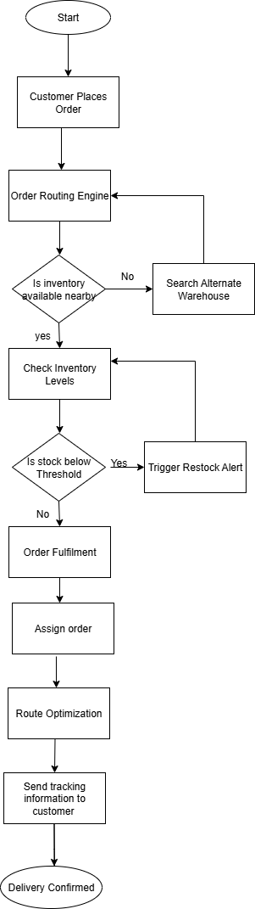
Assignment 2:

- Introduction letter.

Subject: Introduction as your Business Analysts Partner.

Dear [client Name],
I hope this message finds you well. My name is Devina Singh and I am happy to introduce that I will be dedicated Business Analyst for this project. With your visions of maintaining inventory and ensuring quickest delivery of your products my role will be to closely work with you and your team to transform these goals into software solutions.

I am excited to collaborate with you and your team to understand your current process, their challenges and what you aspire from this application. Your insights will be helpful for identifying key requirements and ensure the solution we build align perfectly with your goal.
Thank you for giving opportunity, looking forward to discuss your expectations and gather requirement. Please let me know a convenient time to discuss further.

Warm Regards,
Devina Singh
Business Analysts
XYZ Company
63757558

- Prepare a brief BRD (Business requirement Document) and SRS (Software Requirement Specification) for online store application.

Business Requirement Document (BRD)
Project Name: Online Store Application
Prepared By: Devina Singh
Date: 23rd September 2025

Contents
1. Document Revisions...................................................................................................14
2. Approvals...................................................................................................................14
3. RASCI Chart for This Document ..............................................................................15
Codes Used in RASCI Chart......................................................................................15
RASCI Chart...............................................................................................................15
4. Introduction................................................................................................................15
4.1. Business Goals ...................................................................................................15
4.2. Business Objectives.............................................................................................15
4.3. Business Rules....................................................................................................16
4.4. Background..........................................................................................................16
4.5. Project Objective..................................................................................................16
4.6. Project Scope ......................................................................................................16
4.6.1. In Scope Functionality ....................................................................................16
4.6.2. Out Scope Functionality .................................................................................17
5. Assumptions ..............................................................................................................17

6. Constraints................................................................................................................17
Risks..............................................................................................................................17
Technological Risks...................................................................................................17
Skills Risks.................................................................................................................17
Political Risks.............................................................................................................17
Business Risks...........................................................................................................17
Requirements Risks ...................................................................................................17
8. Business Process Overview.....................................................................................18
8.1. Legacy System (AS-IS).......................................................................................18
8.2. Proposed Recommendations (TO-BE) ...............................................................18
9. Business Requirements.............................................................................................18
10. Appendices...............................................................................................................19
10.1. List of Acronyms................................................................................................19
10.2. Glossary of Terms.............................................................................................19
10.3. Related Documents ..........................................................................................19

- Document revisions:

Revision Number | Date | Author | Description of Changes | Reviewer | Approval Date
0.1 | 27/07/25 | Mr Ajay | Initial draft of the requirement gathering | XYZ | 28/07/25
0.2 | 4/08/25 | Mr Ajay | Made changes in the requirement gathering | XYZ | 5/08/25
0.3 | 14/08/25 | Mr Ajay | Update RACI | XYZ | 15/08/25
0.4 | 22/08/25 | Mr Ajay | Changed the use case diagram | XYZ | 23/08/25
0.5 | 25/09/25 | Mr Ajay | Updated RTM | XYZ | 26/09/25

2. Approvals

Role | Name | Signature | Date
Project Sponsor | Mrs Seema Rathore | [ signature ] | 1/08/25
Business Owner | Mr Deepak rathore | [ signature ] | 1/08/25
Project Manager | Mr Vandanam | [ signature ] | 2/08/25
Business Analysts | Miss Devina singh | [ signature ] | 4/04/25
Technical Lead | Monika kumara | [ signature ] | 7/0825
Quality Assurance Lead | Suman Choudhary | [ signature ] | 7/08/25
Stakeholder Representative | Ankita Get | [ signature ] | 8/08/25
It Department Head | Alka kanodia | [ signature ] | 8/08/25

3. RASCI chart for this document
Codes used in RASCI chart
- R: Responsible
- A: Accountable
- S: support
- C: consulted
- I: informed

Stakeholders | Responsible  (R) | Accountable (A) | Support(s) | Consulted  (C) | Informed  (I)
Project sponsor |  |  |  | C | I
Business owner |  |  |  | C | I
Online Admin | R | A |  | C | I
Product listing manager | R |  |  | C | I
Store staff |  |  | S
IT Department | R |  | S | C | I
Project manager | R | A
Business analysts | R
designer | R
Testers | R
trainers | R

4. Introduction:
4.1. Business Goal:
To build user friendly and scalable online store application which will provide a seamless shopping experience by generating revenue and expanding its market reach thereby increasing customer accessibility and satisfaction.

4.2. Business Objectives:
- Customer engagement: making online store will engage more customers from different regions
- User friendly interface: Developing a customer friendly interface for mobile, desktops and tablets.
- Sales and Revenue growth: Making the sales online and delivering it to customer in minimum time
- Market reach: Integrating with different social media platform for increasing the reach.
- Automatic management: integrate inventory and order fulfilment.
- Data and security: secure payment gateways and customer details.
4.3. Business Rule:
- Product cannot be listed for sale if the stock quantity is zero.
- To view application user must be registered.
- Customers can add, view and update from their shopping cart.
4.4. Background:
The internet growth and change in customer behaviour demands a user friendly application for seamless, convenient and personnel shopping experiences. Most of the customer prefer buying online rather than using traditional shopping method. Online application will help the business owner to streamline product selling online, payment will be done online and also the help them to grow their business by making it online.

4.5. Project objective:
- Increased customer reach: Customers from different area will be able buy products online, search them.
- Enhancing customer Experience: by creating user friendly and responsive design.
- Expanding business: By transforming it into online store.
- Streamlining operations: for business owners through real time inventory tracking, order processing and delivering.
- Data security: customer data will be secured
- Real time delivery tracking: customers will be able to track their orders.
- Secure payment gateway: Encrypted transactions via different payment options.

4.6. Project Scope:
4.6.1. In Scope Functionality
- User authentication: Secure login and role based access control for admin and customers.
- Product catalogue: brow sable and searchable listening
- Shopping cart: customer able to add or remove items.
- Search functionality: customer able to search or filter products.
- Management tool: for updating inventory
- Delivery Tracking: real time tracking of the order delivered.
- Secure payment Integration: with different payment options.
- Dashboard: admin control panel for managing products, orders and user.

4.6.2. Out Scope Functionality:
- Cash on delivery option for customers.
- Manufacturing and supply chain management.
- No customization outside predefined features.

- Assumptions:
- Website will accept the order from India only.
- Price of the products will be in rupees.
- Admin will manage the product catalogue.
- Constraints:
- Timeline and budget of the project.
- Trainings
7. Risks:
Technological risks:
- System downtime while handling user load
- Problems connecting with system gateways, inventory system or third party APIs

Skill risks:
- Lack of training of employees regarding use of system.

Political Risks:
- new tax rules or import export bans impact the supply of product

Requirement Risks:
- Improper requirement gathering or changing requirements.
- User expectations if deliverables aren’t aligned with user need.
Business Risks:
- Market competition from existing or new ones.
- Customer trust may impact due to poor service or data breach.

8. Business process Overview:
Legacy System (As-IS):
Customer visit store

Browse product

Manually selection of product

Product handed to customer

Limited staff and late offer reach to customer

Proposed Recommendation (TO-BE):

Login to online store

Browse and filter products

Add product to shopping cart

Get offer or discounts

Make online payment (UPI, Net banking, card)

Product delivered and improve customer satisfactions

9. Business Requirements:
Req ID | Requirements | Description | Priority
BR001 | User registration and authentication | Customers must be able to create accounts log in securely and manage their profile including password recovery. | High
BR002 | Product catalogue management | Admin should be able to update, categorize and remove product. | High
BR003 | Product description management | Each product should include details like name, description, price, image, stock status and variants. | High
BR004 | Order management system | Admin should be able to manage incoming orders , update status and handle cancellation and return  Customer should be able to place order, view history | High
BR005 | Delivery tracking system | Customer and admin both should be able to track delivery of order in real time | High
BR006 | Add cart functionality | Customer should be able to add items to cart, change their quantities and be able to proceed to checkout | Medium
BR007 | Inventory management | Stock levels tracking, automatic update after purchase and alerts for low inventory. | High
BR008 | Search filter | Search tool for customer to find product quickly based on price, category, brand, ratings. | Medium
BR009 | dashboard | For admin to sales, inventory trends , customer interest and market performance | Medium
BR010 | Responsive UI | The system should have a responsive user interface that works on desktop, tablets and smartphones | High
BR011 | Scalability | The system should be designed to handle increased user loads and data volume | High
BR012 | User feedback | The system should include user feedback to continuously improve the system | Medium

10. Appendices
1. Glossary of Terms
2. Abbreviations Used
3. Related Documents

[Client Name]
[Online shopping application]
Software Requirement Specifications
[23 September 2025]

Versions | Date of revision | Revised by | Reviewed By | Approved by | Reasons for revision
1.0 | 28/07/25 | Ajay mehra | Devina singh | Mr Vandanam | Initial draft created
2.0 | 7/08/25 | Suman choudhary | Devina singh | Mr Vandanam | Suggestion implemented
3.0 | 16/08/25 | Ajay mehra | Pramilla singh | Mr Vandanam | Added Functional Requirement for admin panel
4.0 | 25/08/25 | Suman choudhary | Pramilla singh | Mr Vandanam | Updated non-functional requirements
5.0 | 21/09/25 | Ajay mehra | Pramilla singh | Mr Vandanam | Incorporated client feedback

Table of Contents

  - Introduction…………………………………………………………………………..22

  - Overview………………………………………………………………………………22

  - Acronyms and definition…………………………………………………………….22

  - Operational Requirements…………………………………………………………..22

  - Reference………………………………………………………………………………23

  - Design and Implementation constraints……………………………………………23

  - Assumed factors that could affect the requirement stated in the SRS…………23
2.0 System overview……………………………………………………………………..23
2.1 Current system………………………………………………………………………..23
2.2 Proposed system…………………………………………………………………….24
2.3 Benefits of the Proposed System………………………………………………….24
3.0 UI Requirements……………………………………………………………………..24
3.1 Project Contents’…………………………………………………………………….25
4.0 Other parameters……………………………………………………………………..25
4.1 Acceptance…………………………………………………………………………….25

Introduction:

  - Overview
The system that is described by this document is online store application which is designed for seamless and user friendly interaction for customers.
Through this application customers can browse, manage and purchase product online. An online store can work 24/7 showcasing your product listening, taking orders and building lasting customers without the need of full sales team or retail locations. the key feature includes user ( customer and admin) registration and authentication, product listing with their price, stock status, filtering option and images of product, shopping cart where customer can add product for buying, get discounts, different payment options to buy. Through order management system order will be tracked in real time, automated order confirmation will be there. Customer will be able to filter out product of their interest through search option. Admin will have their dashboards to manage inventory, handle customer and apply promotions for products and also for customer interaction there will be review system, customer helpline will be there.

  - Acronyms and definition

Term | Description
SLA (Service Level Agreement) | It is a formal agreement made between service provider and service recipient. It will define the rules that will govern the relationship.
HTTP ( Hypertext transfer protocol) | It is transaction oriented protocol client/server protocol for browsers and web servers.
EJB (Enterprise Java Beans) | It provide framework for developing large scale enterprise application.
TCP/IP (Transmission control protocol/internet protocols) | It is used to connect host on internet
JAVA EE ( JAVA enterprise edition) | Set of specifications for developing and deploying large scale network application.

  - Operational Requirements

    - Software Requirements

- The system should support modern browsers like google chrome, Mozilla Firefox
- utilises relational database management MySQL for database
- The system shall be compatible with windows, macOS, Linux for on premises deployment.

    - Hardware Requirements

- RAM should be or greater than 8 GB
- The video devices should support graphics
- The processor should be greater than 400 MHz
- users require devices like desktop, tablet, mobile with internet connectivity to access the system

  - References

Book references: JAVA complete reference 13th edition
Web references: Wikipedia, Techcanvas

  - Design and Implementation Constraints

- Time and budget: Additional feature or changes in the feature and functionalities described in document may require changing in time and costing estimation of the project development
- Some User may find it difficult to access the application

  - Assumed factors that could affect the requirements stated in the SRS

- Cloud hosting providers :Availability and price change affect the deployment of project
- Shipping and logistic APIs: accurate delivery tracking and rate calculation depend on these services

2.0 System Overview
2.1 Current System
The current store is operated offline which require customer to come to store for product purchase, limited product variety is there requiring more effort and time from customer. Moreover in traditional method of selling more space is required, more staff and payment facilities are limited. Customers get less benefits in terms of offers as they notified late.so here the store is getting online to address all these issues.

2.2 Proposed System
The proposed system will help the customer to get access of the online store from anywhere and anytime, they can get alerts about their interest of products, discounts offered. The current system allows the customer filter product, save product and pay online. Get the delivery done at doorstep.

2.3 Benefits of the proposed system
- The system will expand market reach beyond physical location making it accessible to people from different geographical locations
- It will reduce cost of operation through automation of the online.
- It will enhance customer experience because of its availability for 24/7
- Provide valuable insights through analytics

  - UI requirements

- The application should be user friendly.
- Easy shopping online from anywhere on different interfaces mobile, desktop and tablet
- Secure registration and profile management facilities for customer
- Strategic data and graph for administration to get the latest trend of customers and popular product
- Admin should be able to avail brand catalogue facility
- Admin and customer should be able to track the shipped product
- Provide information about products in categories
- User can add a product in wish list and get notified when product is available
- Feedback mechanism so that customer can give feedback
- Adequate payment getaway
- Data security so that customer data remain secure
- Secure payment gateways
- 24/7 Availability
- Better component design to get better performance at peak
- Integration with different social media platform for website promotion

3.1 Project Contents
In this project mainly 2 projects are used
- Admin module
- Update information
- Honest transaction
2. Customer module
- Do shopping
- Add products to wish list
4.0 Other parameters
4.1 Acceptance : The client will review and accept the application when prototypes , application with user manual and installation guide will be received.

- Make an ERD (ENTITY RELATIONSHIP DIAGRAM) of creating a support ticket /ticketing life cycle.

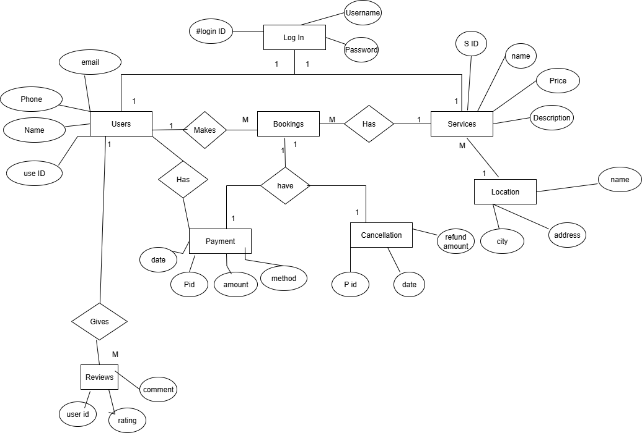

- User story of shopping from e commerce

User story no: 1 | Task:2 |  | Priority: Highest
Value Statement:
As a customer
I want to register to application
So that I can login to the application
BV: 200 |  | CP:5
Acceptance Criteria:
User must provide valid email address and phone number

User story no:2 | Task:2 |  | Priority: Highest
Value Statement:
As a customer
I want to login to E-cart application
So that I can order the product
BV: 500 |  | CP:3
Acceptance Criteria:
System should display Login page
User should enter correct email and password

User story no:3 | Task:3 |  | Priority: Highest
Value Statement:
As an admin
I want to login to the e cart application
So that I can manage customers, orders.
BV:200 |  | CP:5
Acceptance Criteria:
System should display Login page
User should enter correct email and password

User story no:4 | Task:2 |  | Priority: Highest
Value Statement:
As a customer
I want to login
so that I can add products to my shopping cart
BV:500 |  | CP:5
Acceptance Criteria:
User must be logged in
Add to cart button display by system
Ability to update quantity

User story no:5 | Task:3 |  | Priority: Highest
Value Statement:
As a customer
I want to login
So that I can search product of my interest
BV:200 |  | CP:5
Acceptance Criteria:
System should show a functional search button
Customer should be able to search based on price ,brand , product name

User story no:6 | Task:4 |  | Priority: Highest
Value Statement:
As a customer
I want to checkout
So that I can pay for my orders
BV:500 |  | CP:5
Acceptance Criteria:
User should have products in cart
Accurate total price of product should be calculated
Seamless payment process with confirmation

User story no:7 | Task:2 |  | Priority: Medium
Value Statement:
As a customer
I want to login
So that I can track my order status
BV: 500 |  | CP:5
Acceptance Criteria:
Customer can view current status of their order
Status updates are displayed in real time

User story no:8 | Task:2 |  | Priority: Medium
Value Statement:
As a customer
I want to login
So that I can give review about the product I purchased
BV:200 |  | CP:5
Acceptance Criteria:
System should display review your purchase option to customer
Customer can give ratings or add comment and picture about their order

User story no:9 | Task:3 |  | Priority: Medium
Value Statement:
As an admin
I want to provide user id to sales team
So that they can use the application
BV:200 |  | CP:2
Acceptance Criteria:
Admin must be authenticated before this.
Sales person should have valid mail id and phone numbers

User story no:10 | Task:3 |  | Priority: Highest
Value Statement:
As a vendor
I want to login
So that I can I can add my products
BV:500 |  | CP:2
Acceptance Criteria:

User story no:11 | Task:2 |  | Priority: Highest
Value Statement:
As a vendor
I want to get order alerts from customer
So that I can prepare order from customer
BV:500 |  | CP:5
Acceptance Criteria:
Vendor must have verified account with valid credentials
Vendor must agree to platform terms and condition

User story no:12 | Task:3 |  | Priority: Medium
Value Statement:
As a vendor
I want to see the feedback page of my product
So that I can improve the quality of my product
BV:500 |  | CP:2
Acceptance Criteria:
Vendor must have authenticated account
Vendor must be able to see only feedback for his products

User story no:13 | Task:1 |  | Priority: lowest
Value Statement:
As a vendor
I want to get message from customer if they want to gift wrap the product
So that I can pack according to customer demand
BV:200 |  | CP:2
Acceptance Criteria:
Gift wrap option should be displayed to user during checkout
It should be displayed only if vendor give permission to gift wrap
Additional price should be displayed for gift wrap

User story no:14 | Task:3 |  | Priority: Medium
Value Statement:
As a business owner I want to know the user traffic to the website
So that I can improve the feature

BV:200 |  | CP:2
Acceptance Criteria:
Application should be integrated with analytics tool
Tracking must be GDPR-compliant and respect user privacy

User story no:15 | Task:2 |  | Priority: Medium
Value Statement:
As a business owner
I want to know the payment method used by customer
So that I can give a secure payment method
BV:200 |  | CP:5
Acceptance Criteria:
All transaction must record payment method used
Business owner should have access to dashboard showing reports about payment method used

User story no:16 | Task:2 |  | Priority: Highest
Value Statement:
As an admin
I want to download the invoice
So that I can give invoice to the seller or buyer
BV:500 |  | CP:5
Acceptance Criteria:
Admin must be logged in
Admin must have permission to access order and invoice data

User story no:17 | Task:1 |  | Priority: Medium
Value Statement:
As an admin
I want to logout
So that no one can access my account
BV:200 |  | CP:3
Acceptance Criteria:
Admin must be logged in
System should show logout button

User story no:18 | Task:4 |  | Priority: Medium
Value Statement:
As a admin
I want to display discounts on various product
So that customer get attracted
BV:200 |  | CP:3
Acceptance Criteria:
Admin must be logged in
Admin must have permission to manage product pricing and promotion
Admin can set the discount and start and end date of discount

