A company is having manufacturing plants and warehouses in various parts of the country. They manufacture ice-cream and milk products. They want to build software to achieve two goals.
- Manage the inventory
- Quickest delivery to the customers

Assignment 1:
- Please make a BRD which can be presented to the client along with complete development and resource plan.

Business Requirements Document –

Executive Summary –

The client manufactures ice-cream and milk products with multiple plants and warehouses across the country. The business needs a software solution to: 1) manage inventory effectively across manufacturing plants and warehouses; and 2) ensure quickest delivery to customers while maintaining product freshness and minimizing waste.
Project objectives:
- Centralized inventory visibility (real-time stock levels by SKU, location, batch/lot, expiry).
- Automated replenishment & production triggers.
- Route-optimized deliveries (shortest time plus cold-chain compliance).
- Integrations with POS, existing ERP, and third-party logistics (3PL).
- Reporting, alerts, and compliance (expiry, recalls, temperature excursions).

Success metrics:
- Reduce stockouts by 60% within 6 months.
- Reduce per-delivery transit time by 20% in first year.
- Reduce spoilage/wastage by 30% in first year.

Stakeholders
- Executive Sponsor: Head of Supply Chain
- Product Owner: Operations Manager
- Operations: Plant Managers, Warehouse Managers, Fleet Manager
- IT: Infrastructure & Integration Team
- Sales & Customer Support
- Third-Party Logistics Providers (3PL)
- End Customers

Scope (In-scope)
- Inventory module: SKU master, batch & expiry tracking, stock ledger, FIFO/FEFO support
- Warehouse management: receiving, put away, picking, packing, mobile scanning
- Manufacturing interface: production orders, yields, ingredient usage
- Order management: order intake, allocation, backorder management
- Delivery optimization: route planning, delivery windows, vehicle capacity, temperature constraints
- Mobile app for drivers: manifests, POD (proof of delivery), temperature logging, returns
- Integrations: ERP, POS, payment gateway (if retail), GPS telematics, weather API
- Reporting & dashboards: inventory KPIs, deliveries, SLA, spoilage

Out of scope
- New manufacturing equipment controls
- Direct-to-consumer marketing platform (beyond order capture)

Functional Requirements
- FR1: Maintain SKU master with attributes (perishable flag, shelf-life, storage temp).
- FR2: Capture batch/lot number and expiry on receipt.
- FR3: Real-time stock view across all locations.
- FR4: Support automated replenishment rules (min/max, safety stock, EOQ suggestions).
- FR5: Allocate inventory to orders using FEFO.
- FR6: Create pick lists and packing lists; support barcode scanning.
- FR7: Integrate with route optimization engine to produce driver manifests.
- FR8: Mobile app for drivers to capture POD (photo/signature) and log temperature/time.
- FR9: Alerts for near-expiry, temperature excursions, low stock, delayed delivery.

Non-functional Requirements
- NFR1: Availability: 99.9% SLA for core modules.
- NFR2: Performance: Orders allocation <= 2s; inventory query <= 300ms.
- NFR3: Security: Role-based access, encrypted data at-rest/in-transit, audit logs.
- NFR4: Scalability: Support growth to 100+ warehouses and 1,000+ SKUs initial, extendable.
- NFR5: Compliance: Data retention and food-safety traceability.

Constraints & Assumptions
- Client will provide SKU master and historical sales/pick/receipt data for initial setup.
- GPS & telematics devices available on most vehicles; mobile data coverage expected.
- Cold-chain sensors will be provided/integrated later (phased).

High Level Risks
- Data quality in legacy systems delaying cutover.
- Network coverage causing delayed updates from remote vehicles.
- Change management resistance from operations staff.

Development & Resource Plan
Delivery approach
Agile delivery using 2-week sprints. Phased rollout:
- Phase 0 (2 wks): Discovery, data collection & environment setup
- Phase 1 (8 wks): Core Inventory & Warehouse Management (WMS) MVP
- Phase 2 (8 wks): Order Management + Allocation + FEFO
- Phase 3 (6 wks): Delivery Optimization & Driver Mobile App
- Phase 4 (4 wks): Integrations (ERP, POS, GPS) & Reporting
- Phase 5 (4 wks): UAT, training, pilot rollout
- Phase 6 (ongoing): Production hardening, handover, support
Total estimated delivery: ~6 months to pilot (assuming timely inputs).

Team & roles
- Product Owner (Client-side): 0.5 FTE
- Business Analyst (Sulu / Implementation BA): 1 FTE
- Scrum Master/Delivery Manager: 1 FTE
- Solution Architect: 0.5–1 FTE during design and integrations
- Backend Developers (API, integration): 3 FTE
- Frontend Developers (web + dashboards): 2 FTE
- Mobile Developers (Android/iOS or cross-platform): 2 FTE
- QA/Test Engineers: 2 FTE
- DevOps/Cloud Engineer: 1 FTE
- Data Engineer (ETL & reporting): 1 FTE
- UX Designer: 0.5 FTE (early design)
- Technical Writer / Training: 0.5 FTE

Tooling & tech stack
- Cloud: AWS / Azure
- Backend: Node.js / Java Spring Boot
- Database: PostgreSQL (primary), Redis (cache)
- Message Bus: Kafka / RabbitMQ for events
- Mobile: React Native or Flutter
- Route Optimization: integrate Google OR-Tools or commercial TMS
- CI/CD: GitHub Actions / Azure DevOps
- Monitoring: Prometheus + Grafana / Cloud native

Estimated effort (story points / person-months)
A rough estimate: 20–25 person-months for initial 6-month delivery (team ramping up). Detailed estimation will follow after discovery.

Budget considerations
- Implementation labour: depends on location/rates — provide options: in-house vs offshore. Detailed costing to be provided after scoping.
- Licensing: route optimizer, maps, telematics, optional WMS modules.
- Hardware: barcode scanners, mobile devices, possible temperature sensors.

Deployment & Rollout Plan
- Sandbox & QA environments provisioned in cloud.
- Pilot rollout at one plant + one warehouse for 4 weeks.
- Phased rollouts to other locations in 2–4 week waves.
- Training: super-user workshops + SOP documentation + recorded e-learning.

2. Prepare process flow diagram using your imagination.
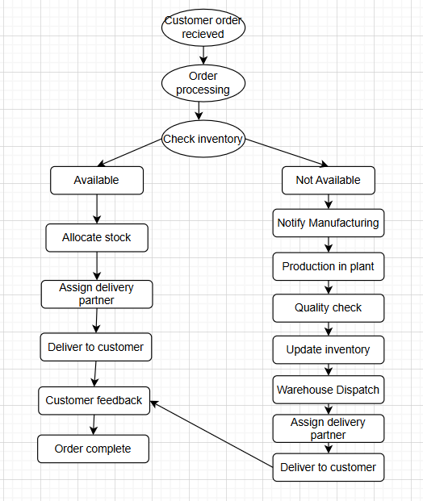

Assignment 2:
1. Write an introduction letter to a client introducing yourself as a business analyst in charge of working with the client and his team to start the business understanding process.
Subject: Introduction — Business Analyst (Nahid) for Inventory & Delivery Project
Dear Sachin,
My name is Nahid Anjum and I will be the Business Analyst assigned to work with you and your team on the Inventory Management & Quick Delivery initiative. I appreciate the opportunity to partner with you on this important transformation that will help reduce spoilage, improve delivery times, and bring centralized visibility to your operations.
Over the next weeks I will:
1) lead the business-understanding workshops with stakeholders
2) document requirements (BRD/SRS) and process flows
3) help prioritize features for a pragmatic MVP
4) coordinate user acceptance testing and training. I bring experience in supply-chain implementations, WMS, and logistics integrations and will act as the bridge between operations and the technical team.
To start, I propose we schedule a 90-minute discovery workshop with Operations, IT, and Sales to review current processes, data sources, and pain points. Please let me know your available times next week. I look forward to collaborating closely with you and your team.
Warm regards,
Nahidd Anjum
Business Analyst

2. Prepare a brief BRD and SRS for a project- Horoscope or Ticketing system or online store.

Brief BRD
Objective: Build an online storefront for retail customers to order ice-cream and milk products for home delivery.
Key features: Product catalog, search & filtering, cart & checkout, payments, order tracking, delivery scheduling, promotions & coupons, user accounts, ratings & reviews, inventory sync with warehouses, admin portal.
Target users: Consumers, Admins, Warehouse pickers, Delivery drivers.
Constraints: Delivery temperature requirements, perishable SKUs, delivery windows.
SRS
Functional Requirements
- User registration & authentication (email, mobile OTP).
- Product catalog with categories, SKU details, images, nutrition info.
- Search with autocomplete, filters (flavour, pack-size, expiry window).
- Cart management and checkout with address validation.
- Payment gateway integration (card, UPI, wallets), and COD support.
- Order confirmation, status updates, and live tracking.
- Returns & refunds (perishable-specific rules).
- Admin portal: product management, price & promo management, order management.

Non-functional
- Page load <= 2s on mobile 4G.
- Support 10k concurrent users (scalable cloud).
- PCI-DSS adherence for payment.

Data model : Users, Addresses, Products, SKUs, Inventory by Location, Orders, Order Items, Payments, Deliveries, Returns.
Acceptance Criteria (example):
- Customer can place an order and receive confirmation within 2 minutes.
- Inventory allocated at order placement and reflected in warehouse picking queue.

3. Make an ERD of creating a support ticket/Ticketing life cycle.

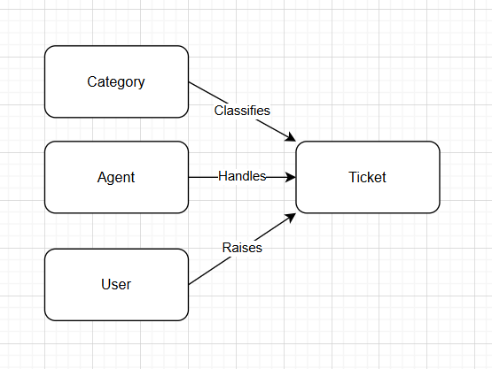
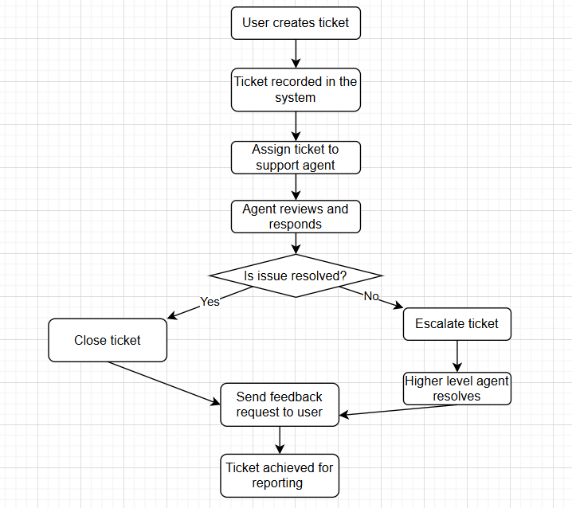

4. User story of shopping from ecommerce.

User Story: 1 | Tasks: User Registration |  | Priority: High
Value statement: As a new user, I want to register using my email or phone number so that I can securely log in to the store.
BV: 100 |  | CP: 5
Acceptance criteria:
- User can register with valid email/phone.
- Verification link/OTP must be sent.
- Registration is confirmed upon successful validation.

User Story: 2 | Tasks: User Login |  | Priority: High
Value statement: As a registered user, I want to log in using my credentials so that I can access my account.
BV: 80 |  | CP: 3
Acceptance criteria:
- Valid credentials allow access.
- Invalid login shows error message.
- Session should be created after login.

User Story: 3 | Tasks: Product Browsing |  | Priority: High
Value statement: As a shopper, I want to browse products by category so that I can easily find what I need.
BV: 200 |  | CP: 8
Acceptance criteria:
- Products are displayed by selected category.
- Page numbers and filters available.
- Product images and prices are visible.

User Story: 4 | Tasks: Product Search |  | Priority: High
Value statement: As a user, I want to search for products by name or keyword so that I can quickly find specific items.
BV: 150 |  | CP: 6
Acceptance criteria:
- Search returns relevant results.
- Handles spelling variations

User Story: 5 | Tasks: Product Details View |  | Priority: High
Value statement: As a user, I want to see detailed product information so that I can make informed decisions.
BV: 100 |  | CP: 4
Acceptance criteria:
- Shows product images, price, specs, reviews.
- “Add to Cart” button visible.

User Story: 6 | Tasks: Add to Cart |  | Priority: High
Value statement: As a user, I want to add products to my cart so that I can purchase them later.
BV: 200 |  | CP: 5
Acceptance criteria:
- Product added successfully.
- Cart updates instantly.

User Story: 7 | Tasks: Update or Remove Cart Items |  | Priority: High
Value statement: As a user, I want to modify or remove items in my cart so that I can control my purchase list.
BV: 150 |  | CP: 6
Acceptance criteria:
- Quantities can be changed.
- Items can be deleted.
- Total cost updates correctly.

User Story: 8 | Tasks: Apply Discount Code |  | Priority: Medium
Value statement: As a user, I want to apply coupon code to my order so that I can avail discounts.
BV: 80 |  | CP: 4
Acceptance criteria:
- Valid coupon reduces total amount.
- Invalid code shows error.

User Story: 9 | Tasks: Checkout |  | Priority: High
Value statement: As a user, I want to check out my cart items so that I can make a purchase.
BV: 300 |  | CP: 10
Acceptance criteria:
- Checkout collects address and payment.
- Order confirmation shown after success.

User Story: 10 | Tasks: Multiple Payment Options |  | Priority: High
Value statement: As a buyer, I want to choose from multiple payment methods so that I can pay conveniently.
BV: 250 |  | CP: 8
Acceptance criteria:
- Support credit card, UPI, COD.
- Show success/failure messages.

User Story: 11 | Tasks: Order Confirmation |  | Priority: High
Value statement: As a user, I want to receive order confirmation so that I know my order was successful.
BV: 100 |  | CP: 3
Acceptance criteria:
- Confirmation screen + email/SMS notification.

User Story: 12 | Tasks: Order Tracking |  | Priority: High
Value statement: As a user, I want to track my orders so that I know the delivery status.
BV: 150 |  | CP: 7
Acceptance criteria:
- Order tracking page displays status and estimated delivery.

User Story: 13 | Tasks: Product Reviews |  | Priority: Medium
Value statement: As a user, I want to rate and review products so that others can see my feedback.
BV: 100 |  | CP: 5
Acceptance criteria:
- Users can post, edit, and delete reviews.

User Story: 14 | Tasks: Wishlist Management |  | Priority: Medium
Value statement: As a user, I want to save products to my wishlist so that I can purchase them later.
BV: 100 |  | CP: 4
Acceptance criteria:
- User can add/remove wishlist items.

User Story: 15 | Tasks: Profile Management |  | Priority: Medium
Value statement: As a user, I want to manage my profile details so that I can keep my account updated.
BV: 80 |  | CP: 4
Acceptance criteria:
- Users can edit name, address, password.

User Story: 16 | Tasks: Notification Alerts |  | Priority: Medium
Value statement: As a user, I want to receive notifications for order updates so that I stay informed.
BV: 120 |  | CP: 5
Acceptance criteria:
- Notifications for shipping, cancellation, delivery.

User Story: 17 | Tasks: Admin Product Management |  | Priority: High
Value statement: As an admin, I want to add, update, or remove products so that the catalog remains current.
BV: 300 |  | CP: 9
Acceptance criteria:
- Admin can CRUD products.

User Story: 18 | Tasks: Inventory Management |  | Priority: High
Value statement: As an admin, I want to monitor stock levels so that I can avoid out-of-stock issues.
BV: 200 |  | CP: 7
Acceptance criteria:
- Low stock alerts generated.
- Inventory auto-decreases after sale.

User Story: 19 | Tasks: Return/Refund Process |  | Priority: Medium
Value statement: As a customer, I want to request returns or refunds so that I can resolve order issues.
BV: 120 |  | CP: 6
Acceptance criteria:
- Returns allowed within 7 days.
- Refund confirmation notification sent.

User Story: 20 | Tasks: Customer Support Chat |  | Priority: Medium
Value statement: As a user, I want to chat with support for order help so that my queries are quickly resolved.
BV: 250 |  | CP: 8
Acceptance criteria:
- Real-time chat between user and support agent.
- Chat history saved in ticket system.

