A customer can make a payment either by Card or by Wallet or by Cash or by Net banking.

Question 1 – Draw a Use Case Diagram:

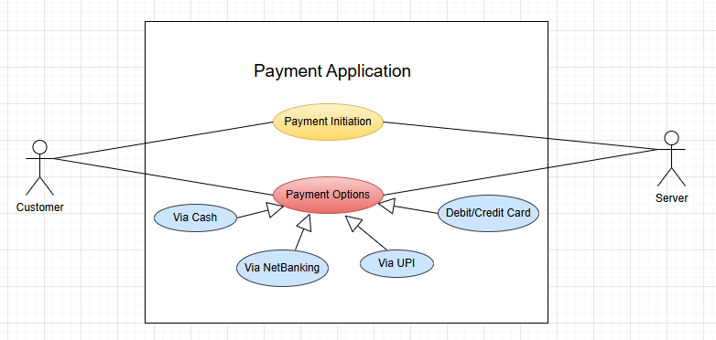
- Use Case diagram shows how external user interacts with the system
- Customer is primary actor and Server is secondary actor
- Customer initiate the payment process.
- Payment options have ‘Generalization’ relationship i.e. kind of. So any one payment mode is used by Customer.

Question 2 –: Derive Boundary Classes, Controller classes, Entity Classes

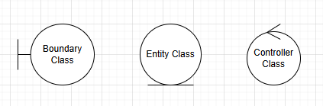

- Boundary Class
  - This is used to handle interactions between System and external Actor.
  - All use cases can be a Boundary class.
  - Examples – PaymentOptionBoundary, CardPaymentBoundary, CashPaymentBoundary, NetBankingPaymentBoundary etc.
- Controller Class
  - It acts as intermediates between Boundary and Entity class.
  - Examples – PaymentinitaitedController, CardPaymentController, CashPaymentController, NetBankingPaymentController etc.
- Entity Class
  - It represents the Core data and business logic of the application.
  - All actors from use case diagram are Entity class.
  - Example – Customer, Payment, Card, Wallet, Server

Question 3 – Place these classes on a three tier Architecture

- 3-tier architecture has three layers i.e. User, Business logic and Data
- All Boundary classes goes under User layer
- All Controller classes goes under Business Logic layer
- All Entity classes goes under Data layer

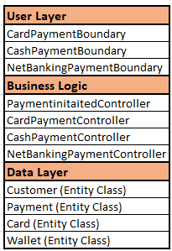

Question 4 – Explain Domain Model for Customer making payment through Net Banking

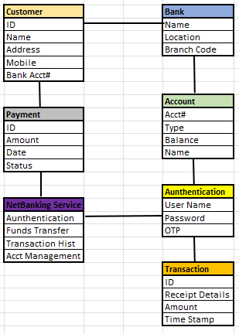

- Domain model is a representation that define Structure, Relationship and Behaviour of entities from Database for some specific scenario.
- Domain model is very similar to entity relationship diagram.
- Multiple tables are connected together to establish a relationship among them.
- Customer is connected to Bank where he/she has account.
- Customer is connected to Payment because he/she needs to initiate the payment transaction.
- Payment is connected to NetBanking since the payment is done vis Net Banking service.
- Bank is connected to Account because Customer has account in that Bank.
- Authentication needs to happen by 2 entities. First is the Customer Bank Account and second is transaction authentication using OTP. Hence this entity is connected from both.
- Once Authentication is complete then only transaction will happen.
- This all above explanation about which tables are connected in what way, is called as Domain Model.

Question 5 - Draw a sequence diagram for payment done by Customer Net Banking

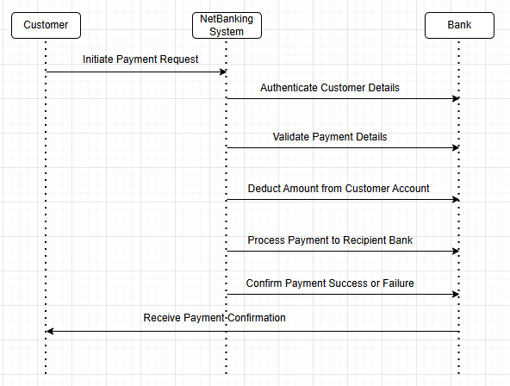

- Sequence Diagram shows how data is flowing in the system in sequential manner.
- It helps BA to understand who are the actors and what processes are followed and in what sequence.

Question 6 - Explain Conceptual Model for this Case

- Conceptual model is very similar to Domain model
- This model talks about relationship between Customer, NetBanking and Payment
- It helps in visualizing the overall structure and flow of the Payment system
- Key elements:
  - Entities – Customer, NetBanking, Bank
  - Attributes – CustomerID, Name, Email, Phone#, NetBanking User ID, Password etc
  - Relationship – Customer initiates the payment etc

Question 7 – What is MVC architecture? Explain MVC rules to derive classes from use case diagram and guidelines to place classes in 3-tier architecture.

- MVC stands for Model View Controller
- It is a framework that separates the application into three main logical components i.e. Model, View and Controller.
- View – It represents UI layer of the application. It shows data received from Model to user and get user inputs to pass on to Controller. It does not contain any application logic.
- Model – It represents the data layer of the application. It add/update/retrieve the data from database.
- Controller – It acts as interface between Model and View. It receives user inputs from View and Translates them into actions to be performed on Model. It contains the business/application logic. It coordinates how Model and View interact.

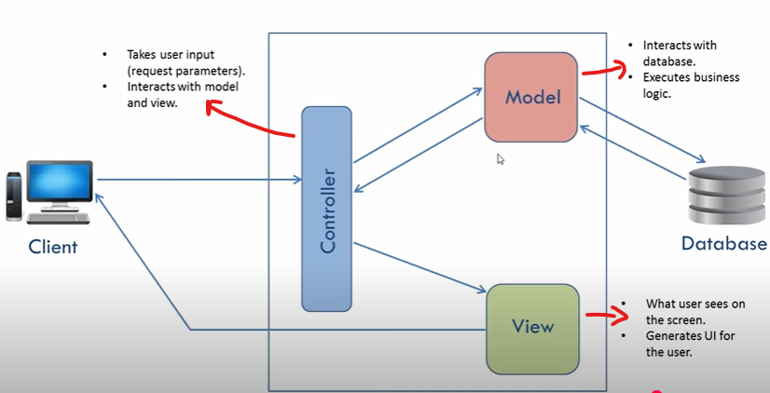

- MVC architecture rules:
  - Combination of one actor and use case results in one Boundary class. Combination of two actors and use case results in two Boundary classes etc.
  - All Views are Boundary class
  - Every Use case is Controller class
  - All Models are Entity class. Each actor result in Entity class.

- Guidelines to place classes in 3-tier architecture
  - Place all Entity classes in DB layer
  - Place Primary actor associated Boundary class to Application layer
  - Place Controller class in Application layer
  - Place Reusability components in Business logic layer

Question 8. Explain BA contributions in project (Waterfall Model – all Stages)

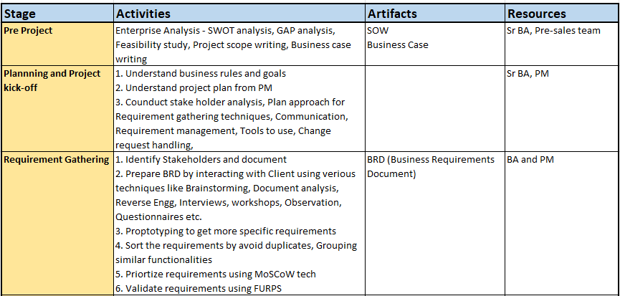
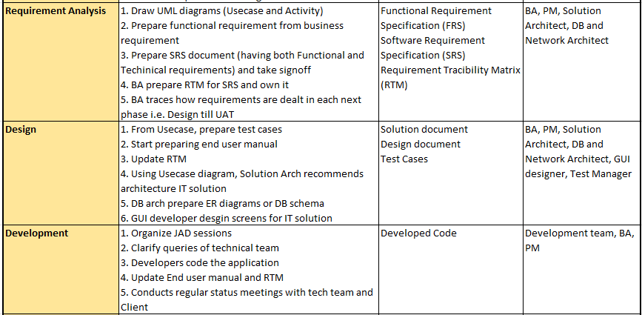
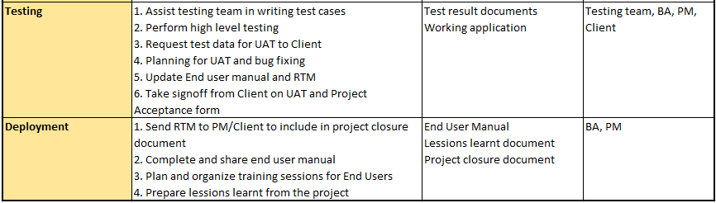

Question 9 - What is conflict management? Explain using Thomas – Kilmann technique

Conflict Management is a process of resolving the conflicts/disagreements between individuals or groups.
Below are the 5 steps for Conflict Management:
- Recognize the existence of Conflict
- Actively listen to concerns of all parties involved
- Check all the possible solutions for Conflict
- Work towards collaborative solution that meet needs of everyone

The Thomas-Kilmann technique help individuals to understand their preferred conflict-handling style and provide insight into each mode.
- Competing – High Assertiveness and Low Cooperativeness – “Only one can win, and it has to be me”.
- Avoiding - Low Assertiveness and Low Cooperativeness – “Uh, can we talk about this tomorrow?”
- Collaborating - High Assertiveness and High Cooperativeness – “I think we both can get what we want”
- Accommodating - Low Assertiveness and High Cooperativeness – “Ok ok …let’s just do it your way”
- Compromising - Medium Assertiveness and Medium Cooperativeness – “Can we find out some middle way for this?”

Question 10 - List down the reasons for project failure

Below are some common reasons for project failures:
- Improper requirement gathering – Requirements are not detail enough or not as per user expectations.
- Frequent changes in the requirements – Too many and very frequent changes in the requirements that lose the project track.
- Lack of stake holders’ involvement – Stakeholders like Users, Product manager, BA, PM etc are not with the team regularly.
- Lack of executive support – Required support from Organization is not there.
- Unrealistic expectations – Budgets or Estimations are very tight
- Improper planning – Planning meetings are not conducted. Backlog is not maintained etc.
- Lack of communication – Communication is not good within team or between team and stakeholders
- Technical challenges – Technical stack does not support the desired functionality. Selecting inappropriate technologies can lead to integration issues and performance problems.
- Resource constraints – Team members are not experienced enough or on long PTO during project life cycle or team size is very small compared to desired size
- Conflicts among stakeholders for project goal or functionality
- Improper Testing – The test cases or Testing done is not aligned with requirements
- Political Conflicts - Internal conflicts and power struggles can negatively impact project morale and productivity.

Question 11 - List the Challenges faced in projects for BA

Below are some common Challenges faced by BAs in projects:
- Ambiguous or Changing requirements - This is a significant hurdle, as unclear or frequently changing requirements can lead to misunderstandings, rework, and missed deadlines.
- Stakeholder Management - Balancing the needs and expectations of diverse stakeholders with conflicting priorities, can be challenging.
- Lack of Stakeholder involvement – Less Stakeholder involvement may result into unclear requirements, wrong priorities, no feedback etc.
- Unclear project objectives – If project objectives are not clear then it is difficult for BA to gather the requirements in detail and prioritize them.
- Managing Conflicts and Negotiations – Conflicting needs and expectations of stakeholders with conflicting priorities …and not ready for Negotiations.
- Communication Gap - Miscommunication between stakeholders and the project team, or within the team itself, can create significant problems, leading to incomplete or inaccurate requirements.
- Time and Resource constraints - Time, budget, and staffing constraints can limit the ability of BAs to gather and analyse information effectively, impacting the quality of their work.
- Resistance to change - Stakeholders may resist new processes or technologies, creating obstacles for the BA to implement necessary changes.
- Lack of Domain Knowledge - When BAs are assigned to projects outside their area of expertise, it can be challenging to understand the business needs and develop effective solutions.
- Data Quality Issues - Incomplete, inconsistent, or inaccurate data can affect the BA's ability to perform thorough analysis and make informed decisions.

Question 12 - Write about Document Naming Standards

- Each and every document from the project must be named in certain standard way.
- Every document must follow standard naming pattern
- Naming standard is a systematic approach to assign unique identifier to various project documents.
- Project documents can’t be named randomly.
- Document naming standard – [Project ID]_[Document Type] V [x] D [y].ext
- Examples of GOOD naming – Prj01_BRD_V1_D0.doc, P005_REQ_V2_D1.xls
- Examples of BAD naming - "Project_Plan.docx", "Requirements_Final.docx", "MeetingNotes.docx"
- It helps team to easily locate and identify the document belongs to which project and for what purpose.
- A good standard will ensure that files are easily identifiable, organized, and retrievable, even when shared or moved.

Question 13 - What are the Do’s and Don’ts of a Business analyst

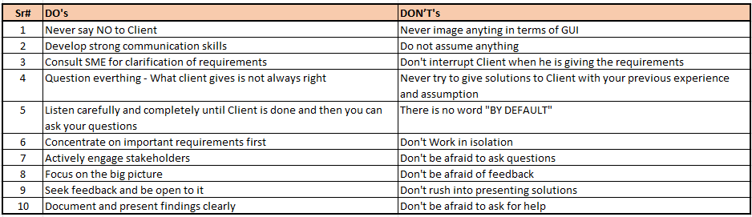

Question 14 - Write the difference between packages and sub-systems

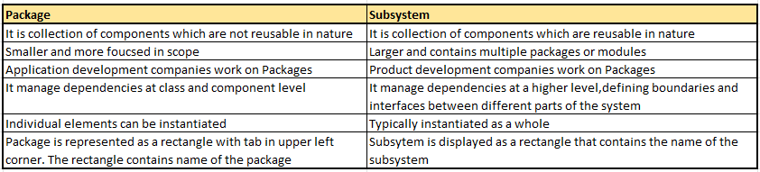

Question 15 – What is camel-casing and explain where it will be used

- Camel-casing is the unique way of naming the entities in Computer programming
- It is the naming convention used in Computer programming.
- It is used for naming variables, functions and identifiers
- In Camel-casing, the first word starts with lower case and each subsequent word starts with uppercase. Also there is no space between the words.
- Example – camelCaseExample, addTwoNumbers(), dayOfWeek, avgEmployeeSalary, calculateTotalPrice
- By using Camel-casing, developers can create more meaningful and readable names.
- It helps in maintaining consistency in codebase and also helps the developers to understand the purpose of the variable/function.
- It is mainly used in sequence diagrams
- The name "camel case" comes from the resemblance of the capital letters to the humps of a camel
- Camel case is widely used in programming languages like JavaScript, Java, and C# for naming variables, functions, and methods.
- It improves readability by visually separating words within a long identifier.

Question 16 - Illustrate Development server and what are the accesses does business analyst has.

- A development server is a dedicated environment or server that is used during software development process.
- It is kind of temporary storage of data and code.
- It provides platform for developers to build, test and debug their application…. before deploying it to production server.
- The development server usually replicates the target production server environment to ensure the compatibility and correct testing.
- Once application functionality looks correct in Development server, it gets moved to further servers like QA/UAT server etc.
- Since development server is mainly meant for development team, BA do not have any exclusive access to it. Usually below access are given for BAs:
  - Read-Only access – Only view
  - Collaborative access – Group access
  - Limited configuration access

Question 17 - What is Data Mapping

- Data Mapping is a process of establishing a relationship between data elements from two or more data sources.
- It defines how data from one source corresponds or transform into data from other source.
- The purpose of data mapping is to endure that data can be accurately and effectively convert between different systems/database/formats.
- Data Mapping involves below steps:
  - Identify source data elements
  - Determine their meaning and structure
  - Find the corresponding target data elements for mapping
- Data mapping is like a guide/map that shows how data in one place corresponds to data in another place.
- Data mapping is done when you are moving the data between different systems or database to ensure that data stays consistent and accurate.
- Data mapping can also help standardize data by ensuring that different systems use the same format and structure for similar information, improving data consistency and reducing errors.
- Examples of data mapping
  - Data Migration: When migrating data from an old system to a new one, data mapping defines how data from the old system's fields should be placed into the corresponding fields of the new system.
  - Data Integration: When integrating data from different sources, data mapping links related data elements from each source to create a unified view of the data.

Question 18 - What is API. Explain how you would use API integration in the case of your application Date format is dd-mm-yyyy and it is accepting some data from Other Application from US whose Date Format is mm-dd-yyyy

- API stands for Application Programming Interface
- It is set of rules/protocols that allow different applications to communicate/interact with each other.
- API is a channel, using which two applications can exchange the data…without needing to know the internal workings of the other application.
- Example - Imagine a restaurant. The waiter (API) takes your order (request) from you (one application) and relays it to the kitchen (another application). The kitchen then prepares the food (performs the action) and the waiter brings the food back to you (returns the response).
- How APIs Work (Example):
  - Request - A user initiates an action in an application, such as searching for a product or requesting a flight booking.
  - API Call - The application sends a request to the relevant API, specifying what information is needed or what action should be performed.
  - Processing - The API processes the request, potentially interacting with a database, another service, or a remote system.
  - Response - The API returns a response to the application, which could be data, a confirmation, or an error message.
  - Display/Use - The application then uses the received information or result to update its interface or perform other tasks.
- Benefits of APIs:
  - Increased Efficiency - APIs enable developers to reuse existing functionality and services, reducing development time and effort
  - Improved Interoperability - APIs facilitate communication and data exchange between different software systems, regardless of their underlying technologies.
  - Enhanced Functionality - APIs allow applications to access a wide range of services and data, expanding their capabilities
  - APIs enable faster development, increased efficiency, and the ability to use existing functionalities of other systems.
- Steps to use API for date format handling:
  - Establish API communication – Set up API communication between the applications.
  - Data formatting - When sending the data from my application to US application, convert the date from dd/mm/yyyy format to mm/dd/yyyy format. This can be done by dividing the date into individual mm,dd,yyyy fields and then re-arrange them.
  - Data Parsing – When data is received from US application to my application, the received date needs to be parsed to convert format from mm/dd/yyyy to dd/mm/yyyy. Again, this can be done by dividing the date into individual mm,dd,yyyy fields and then re-arrange them.
  - Data Validation – Perform the date validation to confirm that the date is still valid after format conversion. Check edge cases like mm=13, dd=32 etc and handle those exceptions.

