Question 1 – Audits - 5 Marks 4 Quarterly Audits are planned Q1, Q2, Q3, Q4 for this Project What is your knowledge on how these Audits will happen for a BA?
Answer:
An audit is a systemic process reviewing or examining the project's processes, outcomes, and performance against predefined objectives, criteria, or standards.
The Audits can be of 2 types.
- Internal – This is conducted by the internal employees of the organization by forming an Audit committee to improve operational efficiency, risk management, and internal controls.
- External – This is conducted by Independent third-party firms or Governing bodies to provide an independent opinion on the fairness and accuracy of a company's financial statements.
Audits can happen for each quarter or once in a year. BA involvement in the Audits can be seen below.

Quarter | Activity | BA in Audit Process
Q1 | Requirements Gathering | Provide, collect and document stakeholder requirements documents like BRD, FRD etc.
Q1 | Stakeholder Analysis | Identify and analyze stakeholders' needs and expectations.
Q1 | Feasibility Study | Assess technical and financial feasibility of proposed solutions with the Auditor
Q1 | Business Requirements Document (BRD) | Review a comprehensive BRD for stakeholder sign-off.
Q2 | Requirements Validation | Review requirements with stakeholders for accuracy.
Q2 | Use Case Development | Review developed use cases and user stories.
Q2 | Prototyping | Review initial prototypes or wireframes for feedback.
Q2 | Change Request Management | Review document and changes to requirements.
Q3 | Requirements Traceability | Review audit compliances of all requirements are traceable throughout SDLC phases.
Q3 | Impact Analysis | Review impact of changes on project scope and timelines.
Q3 | Risk Assessment | Review risks documents related to the requirements.
Q3 | User Acceptance Criteria | Review defined criteria for user acceptance testing (UAT).
Q4 | Performance Review | Review effectiveness of business analysis activities.
Q4 | Lessons Learned | Review lessons learned from the business analysis process.
Q4 | Stakeholder Feedback | Review feedback documents from stakeholders on the requirements process.
Q4 | Process Improvement Recommendations | Suggest improvements based on audit findings.

Question 2 – BA Approach Strategy - 6 Marks
Write BA Approach strategy (As a business analyst, what are the steps that you would need to follow to complete a project – What Elicitation Techniques to apply, how to do Stakeholder Analysis RACI/ILS, What Documents to Write, What process to follow to Sign off on the Documents, How to take Approvals from the Client, What Communication Channels to establish n implement, How to Handle Change Requests, How to update the progress of the project to the Stakeholders, How to take signoff on the UAT- Client Project Acceptance Form )

Answer:
As a business analyst, the steps that I would follow to complete a project are
- Initiation, Planning, Execution, Monitoring and Controlling, Closure.

Elicitation Techniques that can be applied for effective requirements gathering are
- Brainstorming: We will conduct sessions where participants can share their ideas openly, fostering creativity without criticism. The goal is to generate a diverse range of ideas quickly.
- Interviews: One-on-one interviews will be conducted with each stakeholder to capture detailed requirements essential for project completion.
- Workshops/Focused groups: Focused workshops will bring together key stakeholders and subject matter experts (SMEs) for collaborative planning, analysis, design, scoping, and requirements elicitation. These sessions will also facilitate discussions on new features and help reach consensus on critical topics.
- Surveys/Questionnaires: Surveys will be distributed to stakeholders and SMEs, containing a mix of open and closed-ended questions to gather insights on desired products, work practices, and behavioral attitudes.

Stake holder Analysis:

Responsible | Accountable | Consulted | Informed
MR. Henry (Sponsor)  Mr. Karthik (Delivery Head)  Mr. Pandu (Financial Head) | Mr. Vandanam (PM)  Ms. Juhi (Senior Java Developer)  Mr. Teyson, Ms. Lucie, Mr. Tucker, Mr. Bravo (Java Developers)  Mr. Jason, Ms. Alekya (Testers) | Peter  Kevin  Ben  Mr. Mike (Network Admin)  Mr. John (DB Admin)  Mr. Dooku (Project coordinator) | Farmers  Manufacturers

Documents:

- Project Requirements Document
- Project Feasibility Study document
- Stakeholder Analysis (RACI)
- Business Requirements Document (BRD)
- Functional Requirements Specification (FRS)
- System Requirements Specification (SRS)

Process to get Documents Sign off:

I will schedule a Meeting with the sponsor/stakeholders and explain him that all the necessary documentation is ready. I will share him the documents via email and would inform him to review them and give us the sign off with physical signatures via email to proceed with the next steps. The Project Requirements Document, BRD, FRS/SRS would be shared with the sponsor for signoff.

Approvals from the Client:
Obtain the client's approval on the project deliverables, budget, timeline, and approach. Ensure that the client's expectations are aligned with the project's goals and objectives.

Communication Channels:
I will establish the following communication channels:
- Video Conferencing: Used for Gathering Requirements with stakeholders.
- Phone Calls: For discussions or clarifications
- Emails: For Scheduling meetings, confirmations and approvals.

Change Requests:
Change Requests can be effectively managed when
- I Understand the scope of the change request.
- Check if the scope is incorporated by assessing the feasibility study.
- Discussing with the project manager for the estimations and time
- Getting approvals form sponsor/stakeholders on budget and time to implement change.
- Communicate with the internal team members on the change requirements and make sure they are incorporated with in accepted timelines.

Update the progress of the project to the Stakeholders:
Keeping the stakeholders informed about the project's progress through regular status reports, and progress meetings. Highlight any risks or issues that need to be addressed. Provide regular progress updates to the stakeholders and seek their feedback.

Signoff on the UAT- Client Project Acceptance Form:
Conducting User Acceptance Testing (UAT) to validate the project's deliverables. Helping the clients by giving short trainings to understand the system before commencing of UAT. Obtain sign-off from the client on the UAT results and the Project Acceptance Form. Ensure that the project meets the client's expectations and requirements.

Question 3 – 3-Tier Architecture - 5 Marks
Answer:
Three-tier architecture is a software architecture that consists of three layers:
- Application layer [ Screens, Pages, Validations on page, company specific logo, functionality]
- Business logic layer [All Re-Usable components, frequently changing components, Rules etc, Eg: Printer, Payment’s gateway, mail servers]
- Database layer [Data base components connecting to database]
Application Layer: The application layer is the top layer of the architecture and is responsible for presenting the user interface to the end-users. It is also known as the user interface layer or the client layer. This layer handles the interaction between the user and the system.

Business Logic Layer: The Business logic layer is the middle layer of the architecture and contains the business logic of the system. It is also known as the logic layer or the server layer. This layer manages the application logic, data validation, and data processing. It communicates with the application layer and the database layer.

Database Layer: The database layer is the bottom layer of the architecture and is responsible for managing the data storage and retrieval. It is also known as the data layer or the server layer. This layer is responsible for storing and retrieving data from a database management system (DBMS). The database layer provides an interface for the application layer to access and manipulate data.
Question 4 – BA Approach Strategy for Framing Questions – 10 Marks
Answer:
5W 1H-
- Who is the Client?
- Who are the users?
- What is the organization structure?
- What is the approval process in the company?
- Who will benefit from this project?
- Where will the product be deployed?
- How much is the Budget?
- What is the Project and what are the objectives?
- What is the Timeline for the project?
- Why are the clients developing this product?
- What is the current process farmers are adopting for purchase of fertilizers, Seeds, Pesticides?
- How manufacture can be able to upload the new products into application?
- What things we should keep in Filter when farmer search product such as price, brand, delivery time and category etc.
- When the application can be used?
- How many users can use the application at a time?
- What things are most suitable for user to log in the application by email or mobile number?
- Where the provision for the guest user to be provided for using the application?

SMART:
Ensure that questions are Specific, Measurable, Achievable, Relevant, and Time- bound
To effectively clarify requirements and gather actionable information, it's essential to frame questions that are Specific, Measurable, Achievable, Relevant, and Time-bound (SMART). Confirming that each requirement meets the SMART criteria before acceptance for development will enhance project clarity and focus.
- Specific: Ensure each question addresses a clear element of the project.
- Measurable: Formulate questions that can be quantified and counted.
- Action-Oriented: Craft questions that encourage the creation of new or enhanced features.
- Relevant: Identify which features are most important to the customer.
- Time-bound: Establish a timeline to help prioritize requirements.
We can ensure that the questions we ask lead to clear, actionable, and measurable responses that support the overall project goals.

RACI Matrix:
The RACI Matrix is an essential tool for clarifying roles and responsibilities within a project, fostering accountability and collaboration among team members. It categorizes participants as follows:
- Responsible: These are the individuals who carry out the tasks needed to achieve project objectives. They are directly accountable for executing the work or making decisions. This group typically includes project team members such as project managers, business analysts, and developers.
- Accountable: This person is ultimately responsible for the overall success of the task. They ensure that the work is completed accurately and meets the necessary standards. The accountable individual holds the final decision-making authority.
- Consulted: These stakeholders provide valuable feedback and insights throughout the project. Their input is sought through two-way communication, helping to guide decisions and enhance project outcomes.
- Informed: This group consists of individuals who need to be kept updated on project progress. While they do not participate in decision-making or provide feedback, it is important to keep them informed about developments and outcomes.

3-Tier Architecture:
The 3-Tier Architecture is a structured framework that separates an application in 3 layers:
Application Layer:
- What specific user interfaces (UIs) need to be developed?
- What functionalities should the UI provide to the end-users?
- Are there any company-specific branding or design requirements for the presentation layer?
- What types of input validation are necessary to ensure data integrity?
- How will user feedback be collected and incorporated into the design?

Business Logic Layer:
- What core business rules and logic need to be implemented?
- Are there existing reusable components that can be integrated into this layer?
- What compliance and regulatory requirements must be considered?
- How frequently do the business processes change, and how should the architecture accommodate these changes?
- Who will be responsible for maintaining and updating the business logic

Data Layer:
- What types of data will be stored, and what is the expected volume?
- What database management system (DBMS) will be used, and why?
- What operations (insert, update, delete) will be required on the data?
- What security measures need to be in place to protect the data?
- How will data backup and recovery be handled?

Use Cases:
This is a high-level diagram and Base for all diagrams. The focus of this diagram will be on “how external Interfaces” (End Users, support Systems, Special Databases and internet connectivity to third party) will be interacting with the proposed IT System.
- What type of product we will deliver?
- Where is the location we will deliver the application?
- When should be the process be completed?
- Who all are responsible for doing this?
- Why this product will be used?
- How will we deliver this project?

Use Case Specs:
- Who are the Primary and Secondary actors?
- What are the Actor Goals?
- What are the main Tasks or functions that are performed by the Actor?
- What information does the actor desire from the system?

Activity Diagrams:
Activity diagrams are visual representations that depict a sequence of actions or the flow of control within a system, like data flow diagrams. Essentially, they serve as flowcharts that illustrate the progression from one activity to another, with each activity representing an operation within the system.

Purpose of Activity Diagrams:
Illustrate Activity Flow: They provide a clear depiction of how activities are interconnected within the system.
Detail Sequence of Activities: Activity diagrams describe the order in which actions occur, facilitating understanding of the overall process.
Show Parallel and Concurrent Flows: These diagrams can also represent parallel, branched, and concurrent flows, capturing the complexity of system interactions.

Types of Models:
Conceptual Model: A high-level representation of the system's structure and behavior. Data Model: Focuses on the organization and relationships of data elements within the system.
Physical Model: Details the physical implementation of the system, including hardware and software specifications.

Page Designs:
Creating mock-ups and wireframes of the application's user interface is essential for gaining insights into user needs and preferences. These visual representations help to:
Clarify Layout and Functionality: Mock-ups and wireframes provide a clear structure for the application, allowing stakeholders to visualize how users will interact with different elements.
Enhance User Experience: By illustrating design concepts, these tools enable designers to identify potential usability issues early in the development process.
Facilitate Feedback: Sharing these designs with users and stake holders invites valuable feedback, ensuring that the final product aligns with user expectations and requirements.

Question 5 – Elicitation Techniques - 6 Marks
Answer:
As a Business Analyst, employing various elicitation techniques is crucial for gathering requirements and insights from stakeholders. Here are some commonly used techniques:

- Brainstorming: Brainstorming is used in identifying all possible solutions to problems and simplifies the detail of opportunities. It casts a broad net, determining various discreet possibilities. Prioritization of such possibilities is vital to locate needles in haystack. It consists of 3 stages
- Prepare for Brainstorming
- Conduct Brainstorming session
- Wrap-up the brainstorming

- Document Analysis: Document Analysis is an important gathering technique. Evaluating the documentation of a present system can assist when making AS-IS process documents and also when driving the gap analysis for scoping of the migration projects.
A. Prepare for Document Analysis: Evaluate which existing system and business documentation are relevant and appropriate to be studied.
B. Analyze the documents: Study the material and identify relevant business details. Document business details as well as questions for follow-up with subject matter experts.
C. Post Document Analysis wrap-up: Review and confirm the selected details with subject matter experts. Obtain answers to follow-up questions.

- Reverse engineering: Reverse engineering is an elicitation technique that can extract implemented requirements from the software code. There are two general categories of reverse engineering:
- Black Box Reverse Engineering: The system/product is studied without examining its internal structure.
- White Box Reverse Engineering: The inner workings of the system/product are studied.

- Focus Groups: A focus group is a means to elicit ideas and attitudes about a specific product, service or opportunity in an interactive group environment. The participants share their impressions, preferences and needs, guided by a moderator. A focus group typically has 6-12 attendees. It may be necessary to invite twice as many individuals in order to allow for no-shows. If many people need to participate, it may be necessary to run more than one focus group. The topic of the focus group will influence who should be recruited. If the topic is a new product, it is likely that existing users (experts and novices) should be included. There are pros and cons that should be considered when using homogeneous vs. heterogeneous composition. Homogeneous - individuals with similar characteristics. Caution: Differing perspectives will not be shared. Possible solution: conduct separate sessions for different homogeneous groups. Heterogeneous - individuals with diverse backgrounds, perspectives. Caution: Individuals may self-censor if not comfortable with others' background resulting in lower quality of data collected.

- Observation: Observing, shadowing users or even doing part of their job, can provide information of existing processes, inputs and outputs. There are two basic approaches for the observation technique:

- Passive / invisible. In this approach, the business analyst observes the subject matter expert working through the business routine but does not ask questions. The business analyst writes notes about what he/she sees, but otherwise stays out of the way, as if he/she was invisible. The business analyst waits until the entire process has been completed before asking any questions. The business analyst should observe the business process multiple times to ensure he/she understands how the process works today and why it works the way it does.
- Active / visible. In this approach, while the business analyst observes the current process and takes notes, he/she may dialog with the worker. When the business analyst has questions as to why something is being done as it is, he/she asks the questions right away, even if it breaks the routine of the person being observed. In this approach, the business analyst might even participate in the work to gain an immediate appreciation for how the current process works.

- Workshop: Workshops can comprise 6-10 or more users/ stakeholders, working together to identify requirements. A Requirements Workshop is a structured way to capture requirements. A workshop may be used to scope, discover, define, prioritize and reach closure on requirements for the target system.
- Prepare for the Requirements Workshop: Clarify the stake holder's needs, and the purpose of the workshop. Identify critical stakeholders who should participate in the workshop. Define the workshop's agenda. Conduct pre-workshop interviews with attendees.
- Co Conduct/Run the Requirements Workshop: Elicit, analyze and document requirements., Obtain consensus on conflicting views. Establish a professional and objective tone for the meeting. Introduce the goals and agenda for the meeting. Manage the meeting and keep the team on track. Ensure that all stakeholders participate and have their input heard.
- Post Requirements Workshop wrap-up done by Facilitator: Follow up on any open action items that were recorded at the workshop. Complete the documentation and distribute it to the workshop attendees and the sponsor.
- JAD (Joint Application Development) Requirements Workshop: The Joint Application Development (JAD) technique is an extended, facilitated workshop. It involves collaboration between stakeholders and systems analysts to identify needs or requirements in a concentrated and focused effort.
JAD Process Steps includes:
- Define Session: Define the purpose, scope, and objectives of the JAD session, selecting the JAD team, invite and obtain commitment to attend sessions from the appropriate stakeholders, and schedule the session.
- Research Product: Become more familiar with the product or service, gather preliminary e information, obtaining any models.
- Prepare: Prepare any visual aids, developing a realistic agenda, training the recorder, and preparing the meeting room.
- Conduct Session: Follow agenda to gather and document the project needs and requirements. It is important to ensure all participants are given equal treatment during the process.
- Draft the Documents: Prepare the formal documents. The information captured in the JAD session is further refined through analysis efforts, open questions or issues discovered through the sessions are resolved, and the final document is returned to stakeholders for review and validation.

- Interviews: An interview is a systematic approach to elicit information from a person or group of people in an informal or formal setting by talking to the person - the interviewee, asking relevant questions and documenting the responses.

- Prototyping: Creating visual representations or interactive models of proposed solutions facilitates feedback, validates requirements, and enhances stakeholder understanding.

- Mockups are nice because they help the business representatives or clients visualize the functionality of the system. This can be a big advantage to help analysts and stakeholders identify problems early on. However, if introduced too soon in the process the natural tendency is for the business reps/clients to try and be screen designers. Instead of stating that the system shall support "x", they are beginning saying that they need a dropdown to capture "y" and a button to do "z". The client is not a UI designer; in fact, few business analysts truly are, so this can lead to a screen design which does not have an appropriate emphasis on usability. Similarly, specifying the controls needed on a screen detracts from the true requirements of the system and often results in an inadequate level of discussion around why a system must support certain functionality.
- When requirements are captured in screen mockups with no supporting requirements list, it becomes impossible to know whether an early screen design decision was made because it supports a necessary requirement or if it was made for some other reason. How can the analyst and developers know whether they can eliminate or alter the screen feature without losing an important requirement. Questions like, "Do we really need to have the control on this screen, or can we capture the data at a later point in the process?" becomes unanswerable without going back to the original stakeholders. And, on complex projects no one stakeholder may be able to answer the question.
- Screen mockups alone cannot capture the flow through the system. Often analysts will accompany screen mockups with a written description of what happens when certain buttons are clicked or when certain values are entered within a field or dropdown. These descriptions are helpful, but they fall short of describing the end-to-end processes that the system must support. Further document such as process flows or use cases are required, but often overlooked when too much emphasis is place on screen mockups during the requirements gathering process. While analysts and stakeholders who are involved in the screen mockup process may have a basic understanding of the processes supported, developers and testers will not.

- Questionnaires and Surveys: Questionnaires can be useful for obtaining limited system requirements details from users / stakeholders, who have a minor input or are geographically remote. The design of the questionnaire (whether off line or web based) and types of questions are important and can influence the answers, so care is needed.

- Use Case specs: Describing interactions between users and the system illustrates how the system should behave and what actions it should support.
Every Use case will have its own use case Description 1. Use case Name 2. Use case Description 3. Actors a. Primary Actors b. Secondary actors 4. Basic Flow 5. ALTERNATE FLOW 6. Exceptional flows 7. Pre- Conditions Document or Use case Specification. 8. Post- conditions 9. Assumptions 10. Constraints 11. Dependencies 12. Inputs and Outputs - 13. Business Rules 14. Miscellaneous Information

These elicitation techniques offer various approaches to engage stakeholders effectively, gather their insights, and understand their requirements. The choice of techniques depends on the project's nature, stakeholders' availability, and the information needed. Business analysts often combine these methods to ensure comprehensive requirement gathering.

Question 6 – This project Elicitation Techniques - 5 Marks

Answer:
Prototyping: Creating visual representations or interactive models of proposed solutions facilitates feedback, validates requirements, and enhances stakeholder understanding.

- Mockups are nice because they help the business representatives or clients visualize the functionality of the system. This can be a big advantage to help analysts and stakeholders identify problems early on. However, if introduced too soon in the process the natural tendency is for the business reps/clients to try and be screen designers. Instead of stating that the system shall support "x", they are beginning saying that they need a dropdown to capture "y" and a button to do "z". The client is not a UI designer; in fact, few business analysts truly are, so this can lead to a screen design which does not have an appropriate emphasis on usability. Similarly, specifying the controls needed on a screen detracts from the true requirements of the system and often results in an inadequate level of discussion around why a system must support certain functionality.
- When requirements are captured in screen mockups with no supporting requirements list, it becomes impossible to know whether an early screen design decision was made because it supports a necessary requirement or if it was made for some other reason. How can the analyst and developers know whether they can eliminate or alter the screen feature without losing an important requirement. Questions like, "Do we really need to have the control on this screen, or can we capture the data at a later point in the process?" becomes unanswerable without going back to the original stakeholders. And, on complex projects no one stakeholder may be able to answer the question.
- Screen mockups alone cannot capture the flow through the system. Often analysts will accompany screen mockups with a written description of what happens when certain buttons are clicked or when certain values are entered within a field or dropdown. These descriptions are helpful, but they fall short of describing the end-to-end processes that the system must support. Further document such as process flows or use cases are required, but often overlooked when too much emphasis is place on screen mockups during the requirements gathering process. While analysts and stakeholders who are involved in the screen mockup process may have a basic understanding of the processes supported, developers and testers will not.

Use Case Specs: Use case specifications can be used to capture the functional requirements of the system, by defining the various use cases that the system will need to support. This technique can be used to gather requirements related to the interactions between users and the system, as well as the various system functions and features.
Describing interactions between users and the system illustrates how the system should behave and what actions it should support.
Every Use case will have its own use case Description 1. Use case Name 2. Use case Description 3. Actors a. Primary Actors b. Secondary actors 4. Basic Flow 5. ALTERNATE FLOW 6. Exceptional flows 7. Pre- Conditions Document or Use case Specification. 8. Post- conditions 9. Assumptions 10. Constraints 11. Dependencies 12. Inputs and Outputs - 13. Business Rules 14. Miscellaneous Information

Document Analysis: Document Analysis is an important gathering technique. Evaluating the documentation of a present system can assist when making AS-IS process documents and also when driving the gap analysis for scoping of the migration projects.
A. Prepare for Document Analysis: Evaluate which existing system and business documentation are relevant and appropriate to be studied.
B. Analyze the documents: Study the material and identify relevant business details. Document business details as well as questions for follow-up with subject matter experts.
C. Post Document Analysis wrap-up: Review and confirm the selected details with subject matter experts. Obtain answers to follow-up questions.

Brainstorming: Brainstorming is used in identifying all possible solutions to problems and simplifies the detail of opportunities. It casts a broad net, determining various discreet possibilities. Prioritization of such possibilities is vital to locate needles in haystack. It consists of 3 stages
- Prepare for Brainstorming
- Conduct Brainstorming session
- Wrap-up the brainstorming

Justification for usage of elicitation techniques: The Prototyping technique can be used in this project because it allows for quick feedback from stakeholders and can help ensure that the final product meets their needs. The Use Case Specs technique can be used to capture the functional requirements of the system, which is important for any software development project. The Document Analysis technique can be used to review existing documentation related to the project, which can provide valuable insights into the requirements. Finally, Brainstorming can be used to generate new ideas and requirements for the system, which can be particularly useful in a dynamic and evolving project such as this one.

Question 7 – 10 Business Requirements- 10 Marks

Answer:

Req ID | Requirement Description
BR001 | Application should have User friendly Interface
BR002 | Sign up: Farmers and Manufactures need to register to access all the application features
BR003 | Log in: Farmers and Manufactures need to login by giving email id and password
BR004 | Product Upload: Manufactures should be able to add the products in to the products catalogue page
BR005 | Product View and Selection: Farmers should be able to search the products from the product catalogue and can add the products to the cart
BR006 | Wishlist: Farmers can select the required products and save them in the Wishlist page
BR007 | Product order & Confirmation: Farmers can order the selected products from the cart, once the order is placed and payment is completed the order confirmation email should be sent to farmer
BR008 | Order Tracking: Farmers should be able to track their orders once they are placed.
BR009 | Cancellation and Returns: Farmers should be able to cancel or return products if they are not satisfied.
BR010 | Payment gateway: An easy-to-use payment gateway should be available, offering options such as cash on delivery (COD), credit/debit cards, and UPI to enhance the user experience.
BR011 | Data Security: The platform must ensure the security of farmers' personal information, including payment details, by implementing robust security measures and encryption protocols.
BR012 | Performance & Scalability: The Application should run fast and smoothly, also the application should handle large data.

Question 8 –Assumptions- 5 Marks

Answer:
- The Project is designed for Farmers and Farming Products Manufactures and there should be any other products which are not related to farmers.
- The Application should run on mobile, laptop and desktop devices.
- There could be strong security features while login into the application like Mobile OTP or email Authentications
- The Farmers data and their financial transaction details should not be stored.
- There should be a customer support to help farmers and manufactures when needed.
- The Delivery Tracking system could be helpful for both farmers and manufacturers to have transparency.

Question 9 – This project Requirements Priority - 8 Marks

Answer:

Req ID | Req Name | Requirement Description | Priority
BR001 | User Interface | Application should have User friendly Interface | 8
BR002 | User Registration | Sign up: Farmers and Manufactures need to register to access all the application features | 10
BR003 | User Login | Log in: Farmers and Manufactures need to login by giving email id and password | 10
BR004 | Product upload | Product Upload: Manufactures should be able to add the products in to the products catalogue page | 9
BR005 | Product Search & Add to cart | Product View and Selection: Farmers should be able to search the products from the product catalogue and can add the products to the cart | 9
BR006 | Wishlist | Wishlist: Farmers can select the required products and save them in the Wishlist page | 5
BR007 | Order & Payment | Product order & Confirmation: Farmers can order the selected products from the cart, once the order is placed and payment is completed the order confirmation email should be sent to farmer | 10
BR008 | Order Tracking | Order Tracking: Farmers should be able to track their orders once they are placed. | 7
BR009 | Order Cancellation/ Return | Cancellation and Returns: Farmers should be able to cancel or return products if they are not satisfied. | 6
BR010 | Payment Gateway | Payment gateway: An easy-to-use payment gateway should be available, offering options such as cash on delivery (COD), credit/debit cards, and UPI to enhance the user experience. | 8
BR011 | Security & Privacy | Data Security: The platform must ensure the security of farmers' personal information, including payment details, by implementing robust security measures and encryption protocols. | 10
BR012 | Performance & Scalability: | Performance & Scalability: The Application should run fast and smoothly, also the application should handle large data. | 7

Question 10 – Use Case Diagram - 10 Marks
Answer:

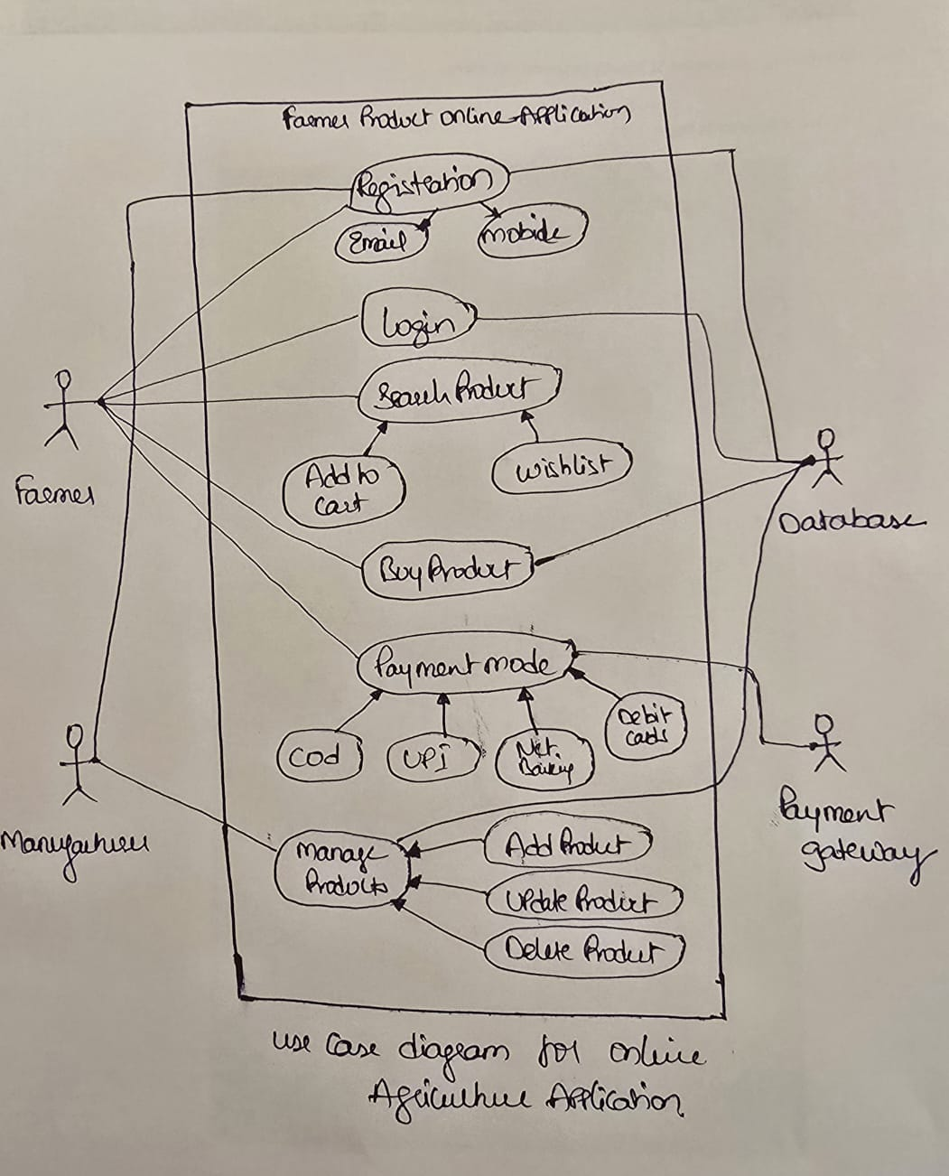

Question 11 – (minimum 5) Use Case Specs - 15 Marks

Use Case Specification | Details
Use Case ID | 1
Use Case Name | User Registering in the Application
Brief Description | This Use Case Describes how a user registers in a online Agriculture store Application
Actors | 1. Farmers  2. Manufacturer  3. Data Base/Admin
Pre-Conditions | There should be an active Internet connection.  User should have a Laptop/Mobile.  User must have an active Email address & active mobile number.
Basic Flow | User clicks in Register button and initiates registration by entering personal details: Name, Address, Mobile number, and Email ID.  Application offers to send OTP to mobile for verification.  User requests OTP to be sent.  User enters received OTP.  Application confirms OTP verification.  User validation is performed.  Application confirms successful user creation.  Use case ends.
Alternate Flow | Invalid OTP: If the incorrect OTP is entered, the app displays: "Please enter the correct OTP."  Mobile Number Already Used: If the entered mobile number is already registered, the app displays: "Mobile number is already in use. Please enter a different mobile number."  Email Address Already Used: If the entered email is already registered, the app displays: "Email address is already in use. Please enter a different email address." User ID Not Available: If the User ID is already taken, the app displays: "User ID already used. Please enter another User ID."  Server Issue: If the server is down, the app displays: "Server busy. Please try again later."
Post Condition | Successful Completion: User ID has been successfully created. Details are updated in the log and Database accordingly.
Supplemental Requirements | The application shall maintain a log, including date and time, of all complete and incomplete transactions

Use Case Specification | Details
Use Case ID | 2
Use Case Name | User Login in the Application
Brief Description | This Use Case Describes how a user Login in a online Agriculture store Application
Actors | 1. Farmers  2. Manufacturers  3.Data Base/Admin
Pre-Conditions | There should be an active Internet connection.  User should have a Laptop/Mobile.  User must have a Valid Email id/ username & password
Basic Flow | User clicks on Login button and initiates Login by entering Valid Email Id/username & Password  User validation is performed.  Application confirms successful login into the application.  Use case ends.
Alternate Flow | Incorrect Password: If the incorrect password is entered, the app displays: "Please enter correct password or click forget password to reset the password"  Incorrect Username: If the incorrect username is entered, the app displays. " Please enter valid username"  Server Issue: If the server is down, the app displays: "Server busy. Please try again later."
Post Condition | Successful Completion: User has been successfully logged into the Application.
Supplemental Requirements | The application shall maintain a log, including date and time, of all complete and incomplete transactions

Use Case Specification | Details
Use Case ID | 3
Use Case Name | User Browse, Select, add to cart the products in the Application
Brief Description | This Use Case Describes how a user Browse, Select & Add the products to the cart in an online Agriculture store Application
Actors | 1. Farmers  2. Data Base/Admin
Pre-Conditions | There should be an active Internet connection.  User should have a Laptop/Mobile.
Basic Flow | User clicks on products Catalogue button  user would be able to view the available products and search for the required product  user would be able to select the product and add them to the cart  Use case ends.
Alternate Flow | Product unavailable: If the user searches with specific product details that are not matching the products available then application displays " Product unavailable"
Post Condition | Successful Completion: User can search for products and add them to the cart
Supplemental Requirements | The application shall maintain a log, including date and time, of all complete and incomplete transactions

Use Case Specification | Details
Use Case ID | 4
Use Case Name | User Making Payment for the Order Placed
Brief Description | This use case describes how the user goes through the payment process after product selection
Actors | 1. Farmers  2. Data Base/Admin  3. Payments Gateway
Pre-Conditions | There should be an active Internet connection.  Farmer should have a Laptop/Mobile.  User should have an active Bank account.
Basic Flow | User Log into the application  User validation is performed.  User selects the products, add them to cart and click on order  User can see the payments gateway link to complete the transaction  User enter the correct CC/DB card / UPI/ Net Banking Details and completes the payment.  use case ends
Alternate Flow | Incorrect Card Details: If the user enters incorrect card details, the user receives an SMS from the bank about payment failure. Display message: "Payment not completed."  Incorrect OTP: If the user enters incorrect OTP, display message: "Payment declined. Incorrect OTP entered."  Server Busy: If payment doesn’t complete due to server issues, display message: "Payment not completed. Server busy. Please try again."
Post Condition | Successful Completion: Payment is completed, and the order is placed successfully.
Supplemental Requirements | The application shall maintain a log, including date and time, of all complete and incomplete transactions

Use Case Specification | Details
Use Case ID | 5
Use Case Name | Track the order
Brief Description | This use case describes how the user can track the placed orders
Actors | 1. Farmers  2. Data Base/Admin
Pre-Conditions | There should be an active Internet connection.  Farmer should have a Laptop/Mobile.
Basic Flow | User Log into the application  User validation is performed.  User clicks on order history button  User Select the active order that needs to be tracked  User would be able to see where the order has reached and an estimated time of delivery  User would be able to call customer care or initiate a chat for any further query or concern  use case ends
Alternate Flow | User selects Inactive order: application displays " Please select an active order to track"
Post Condition | Successful Completion: user can be able to track the order
Supplemental Requirements | The application shall maintain a log, including date and time, of all complete and incomplete transactions

Question 12 – (minimum 5) Activity Diagrams - 15 Marks

- Registration Page:

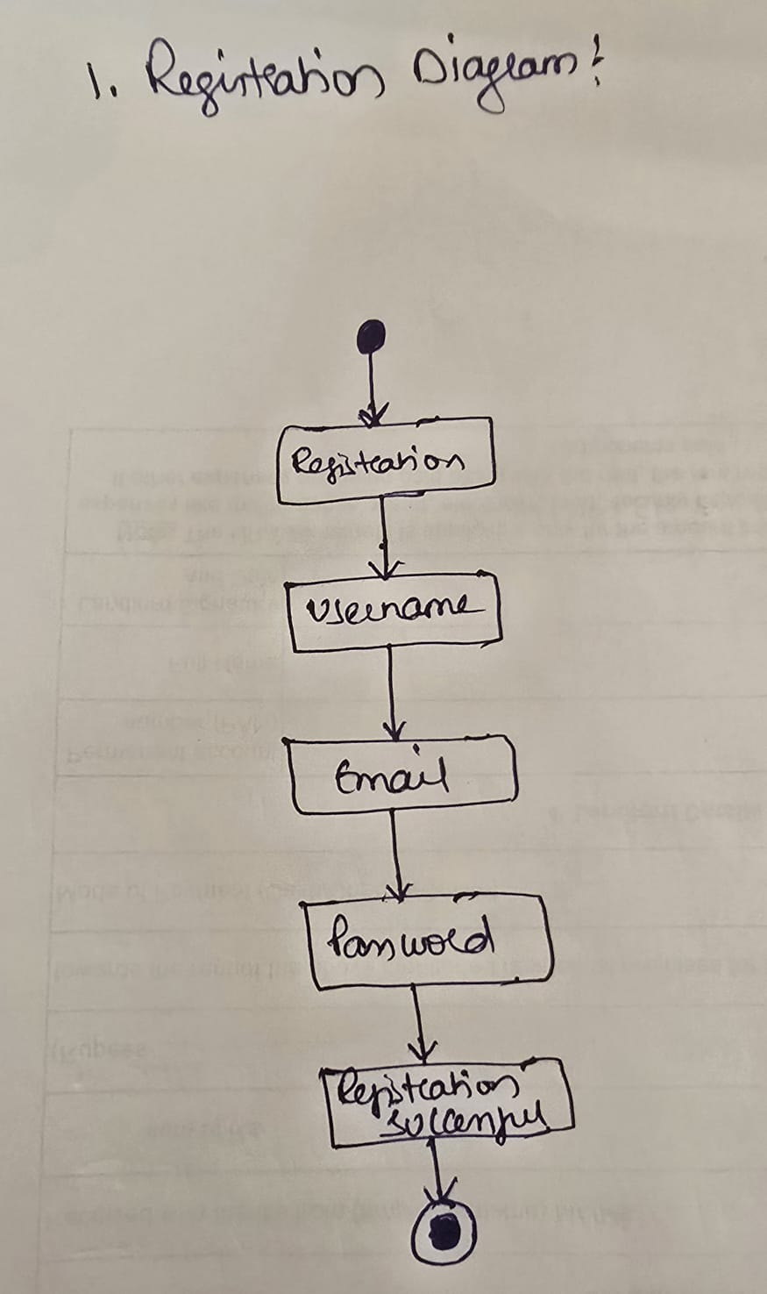

- Login page:

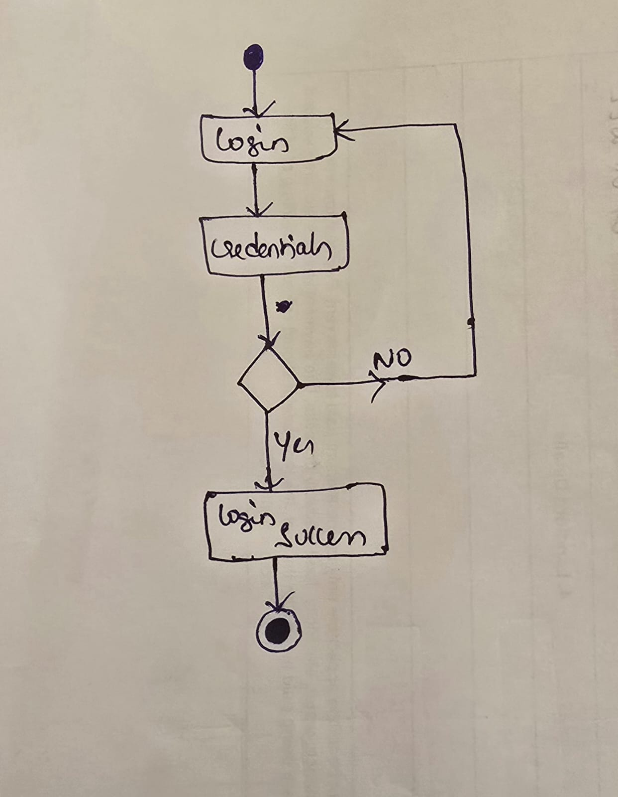

- Order Page:

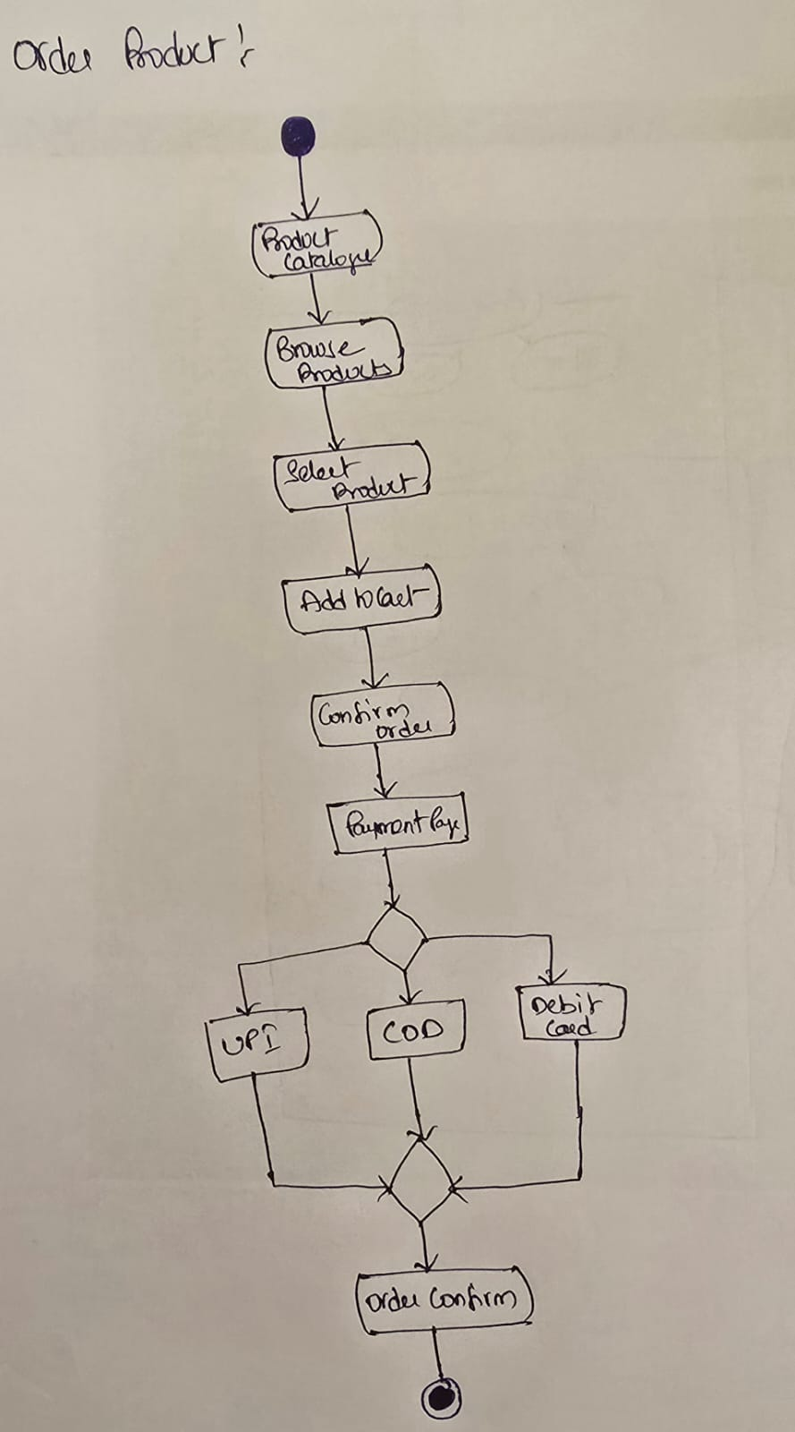

- Cancellation Page:

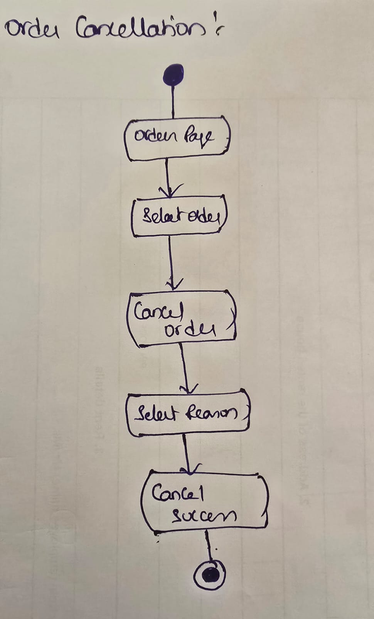

- Manufacturer Adding, updating, Deleting Products.

