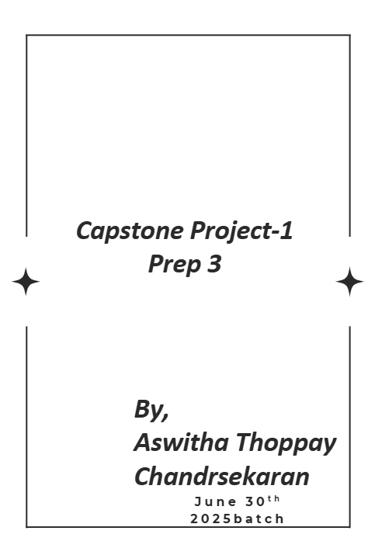

Online Agriculture Products Store
Mr. Henry, after being successful as a businessman and has become one of the wealthiest persons in the city. Now, Mr. Henry wants to help others to fulfil their dreams. One day, Mr. Henry went to meet his childhood friends Peter, Kevin and Ben. They live in a remote village and do farming. Mr. Henry asked his friends if they are facing any difficulties in their day-to-day work.
Peter told Mr. Henry that he is facing difficulties in procuring fertilizers which are very important for farm. Kevin said that he is also facing the same problem in-case of buying seeds for farming certain crops. Ben raised his concern on lack of pesticides which could help in greatly reducing pests in crops.
After listening to all his friends’ problems, Mr. Henry thought that this is a crucial problem faced not only by his friends but also by so many other farmers. So, Mr. Henry decided to make an online agriculture product store to facilitate remote area farmers to buy agriculture products. Through this Online Web / mobile Application, Farmers and Companies (Fertilizers, seeds and pesticides manufacturing Companies) can communicate directly with each other.

The main purpose to build this online store is to facilitate farmers to buy seeds, pesticides, and fertilizers from anywhere through internet connectivity. Since new users are involved, Application should be user friendly.

This new application should be able to accept the product (fertilizers, seeds, pesticides) details from the manufacturers and should be able to display them to the Farmers. Farmers will browse through these products and select the products what they need and request to buy them and deliver them to farmers location.

Mr. Henry has given this project through his Company SOONY. In SOONY Company, Mr Pandu is Financial Head and Mr Dooku is Project Coordinator. Mr. Henry , Mr Pandu , and Mr Dooku formed one Committee and gave this project to APT IT SOLUTIONS company for Budget 2 Crores INR and
18 months Duration under CSR initiative. Peter, Kevin and Ben are helping the Committee and can be considered as Stakeholders share requirements for the Project.
Mr Karthik is the Delivery Head in APT IT SOLUTIONS company and he reached out to Mr Henry through his connects and Bagged this project. APT IT SOLUTIONS company have Talent pool Available for this Project. Mr Vandanam is project Manager, Ms. Juhi is Senior Java Developer, Mr Teyson, Ms Lucie, Mr Tucker, Mr Bravo are Java Developers. Network Admin is Mr Mike and DB Admin is John. Mr Jason and Ms Alekya are the Tester. And you joined this team as a BA.
Your Team

Project Manager - Mr Vandanam
Senior Java Developer - Ms. Juhi
Java Developers - Mr Teyson, Ms Lucie, Mr Tucker, Mr Bravo Network Admin - Mr Mike
DB Admin - Mr John.
Testers - Mr Jason and Ms Alekya
BA - You
Fertilizers, seeds, pesticides details from the manufacturers and should be able to display them to the Farmers.
To gather the business requirements from the client, you went to SOONY and met Mr. Henry. When Mr. Henry was asked about the project and what are they expecting from the project, Mr. Henry stated that he is expecting to have a login for all its users (fertilizers, seeds, pesticides manufacturers and Farmers) , a product catalog of fertilizers, seeds, pesticides, a search option to search for products, payment process, and delivery tracking.
After doing the stakeholder analysis, you have found out that Peter, Kevin, Ben are the key stakeholders and you have scheduled an appointment to meet them. After meeting with them and trying to gather the stakeholder requirements, Kevin said that, a Farmer should be able to browse through the products catalog once they visit the website and need to have a search option so that they can search for any product they need. Peter said that, if a farmer wants to buy any product or add them to buy-later list, they need to login first using their email id and password. If it is a new user, then they can create a new account by submitting their email ID and creating a secure password. Ben added saying that, Farmers needs to have an easy-to-use payment gateway which should include cash-on-delivery (COD), Credit/Debit card and UPI options so that
the user’s experience should be better. Kevin mentioned that, a user gets an email confirmation regarding their order status. A delivery tracker to track the whereabouts of their order.
Identify Business Requirements (which includes Stakeholder Requirements)
BR001 – Farmers should be able to search for available products in fertilizers, seeds, pesticides
BR002 – Manufacturers should be able to upload and display their products in the application Make suitable Assumptions and identify at least 10 Business Requirements.
List your assumptions
Give Priority 1 to 10 numbers ( 1 being low priority – 10 being high priority) to these Requirements after discussions with the stakeholders

Req ID | Req Name | Req Description | Priority
BR001 | Farmer Search for Products | Farmers should be able to search for available products in fertilizers, seeds, pesticides | 8
BR002 | Manufacturers upload their Products | Manufacturers should be able to upload and display their products in the application | 8

Once the requirements are finalized, as a business analyst, one of the major roles is to act as a liaison between the client and the project team. To gather the requirements correctly from the client side and then to deliver those requirements to the project team in a way they understand.
To make the project team understand the requirements, you need to convert those requirements into UML diagrams and screen mock-ups.
You will draw use case diagram Prepare use case specs for all use cases
And you will all Activity diagrams required

Question 1 – Functional Requirements - 15 Marks
Identify minimum 20 functional requirements
Example :
Functional requirement: When an order is fulfilled, the local printer shall print a packing slip.
Non-Functional Requirement: Packing slips shall be printed on both sides of 4”x 6” white paper, the standard size for packing slips used by local printers.
Req ID | Req Name | Req Description | Priority
FR0001 | Farmer Registration | Farmers should be able to register with the application | 8
FR0002 | Farmer Search for Products | Farmers should be able to search for available products in fertilizers, seeds, pesticides | 8
NFR0101 | Page Loading Time | Each Page should load within 2 seconds time | 9
NFR0102 | WCAG 2.1. | The system must meet Web Content Accessibility Guidelines WCAG 2.1. | 8

Functional requirement:
It defines the specific behaviors, functions or operations of a system. They describe what system should do, outlining the necessary tasks, action or activities it must perform to achieve the objectives.
It also defines what need to be done from the system perspective in order to achieve the business requirement.
Req ID | Req Name | Req Description | Priority
FR0001 | User Registration | Users should be able to register with the application | 8
FR0002 | User Search for Products | Users should be able to search for available products in fertilizers, seeds, pesticides | 8
FR0003 | Secure Login | Users should be able to securely log in using Email/Password or Mobile/OTP | 10
FR0004 | New User Registration | New users should be able to register with Email, Phone, and Password | 10
FR0005 | Add to cart | Users should be able to add products to the cart | 9
FR0006 | Add to Buy later | Users should be able to save items for buy-later(wish list) | 8
FR0007 | Payment Gateway Integration | Users should be able to make payments via COD, Card, UPI, Wallet | 10
FR0008 | Order Confirmation Email/SMS | Users should receive order confirmation via Email/SMS | 8
FR0009 | Delivery Tracking | Users should be able to track delivery status of orders | 8
FR0010 | Inventory Updates | Manufacturers should be able to update product stock and pricing | 9

Non-Functional Requirement
Non functional requirements will describe the qualities and attributes of a system focusing on how the system performs rater than specific behavior or functions
NFR0101 | Page Loading Time | Each Page should load within 2 seconds time | 9
NFR0102 | WCAG 2.1. | The system must meet Web Content Accessibility Guidelines WCAG 2.1. | 8
NFR0103 | Usability | The application should have an intuitive and user-friendly interface. | 9
NFR0104 | Performance | The application must load pages within 3 seconds. | 10
NFR0105 | Compatibility | The application should be compatible with major web browsers. | 8
NFR0106 | Availability | The application should maintain 99.9% uptime. | 10
NFR0107 | Scalability | The system should handle up to 10,000 concurrent users without performance degradation. | 9
NFR0108 | Maintainability | The application should allow easy maintenance and updates with minimal downtime. | 8
NFR0109 | Reliability | The system should recover from failures within 1 minute without data loss. | 8
NFR0110 | Data Backup | The system should perform automatic daily backups and support quick restoration of data. | 7

Question 2–Minimum 5 page designs - 15 Marks
Make wireframe and prototypes
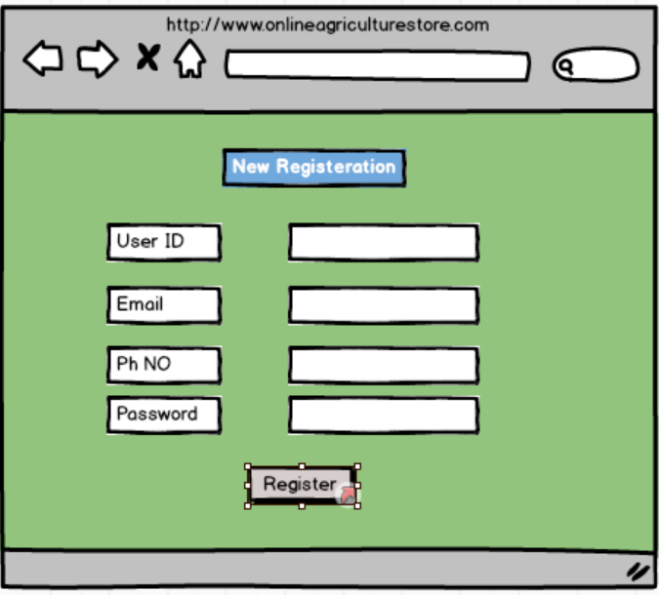
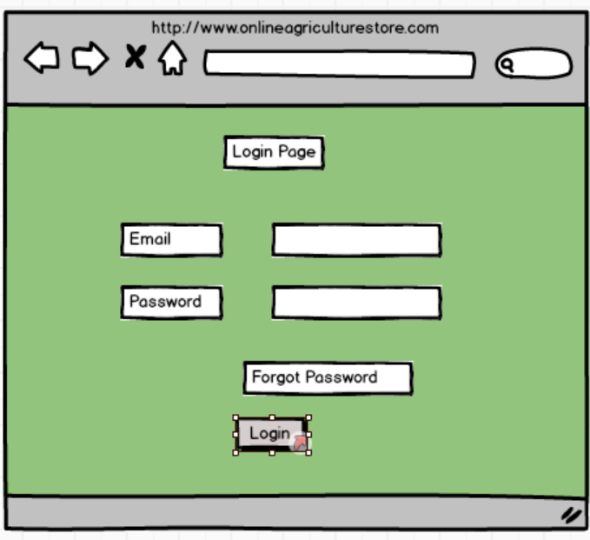
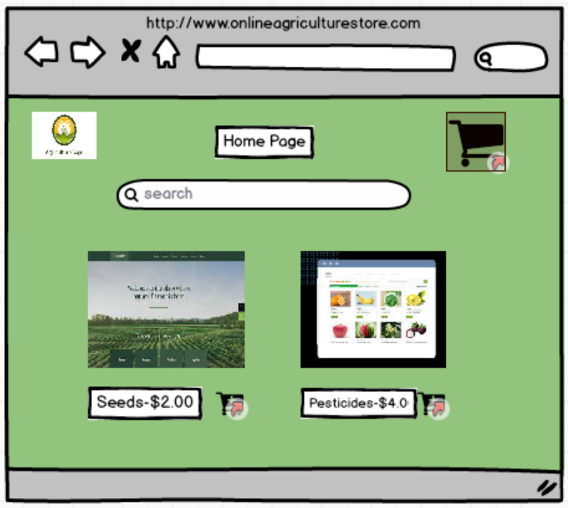
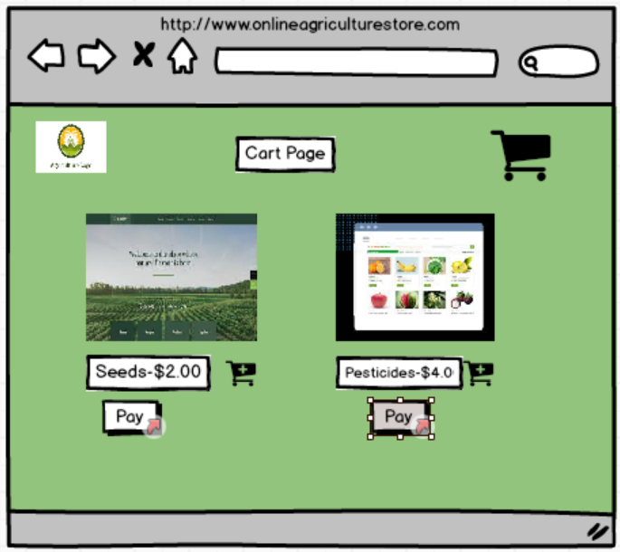
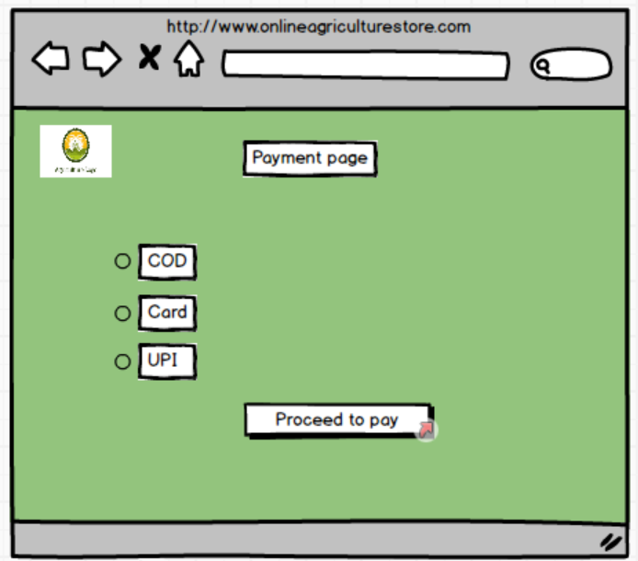
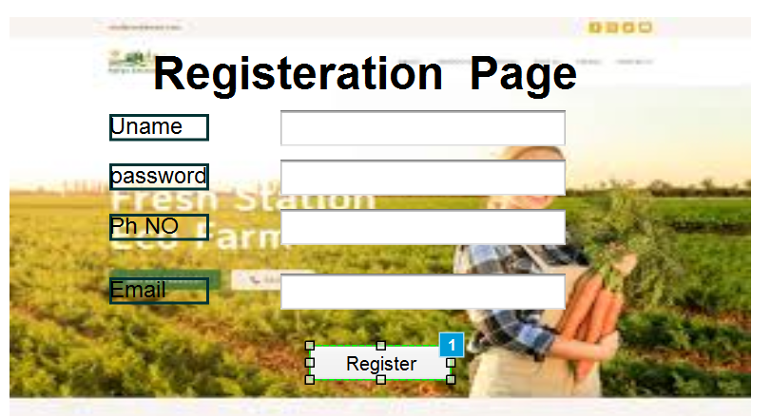
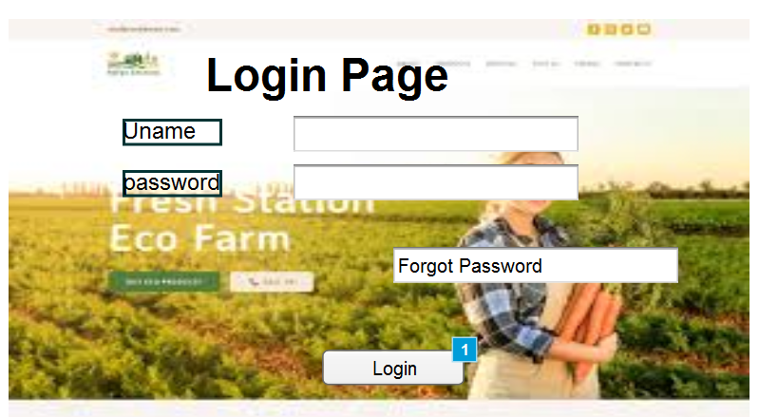
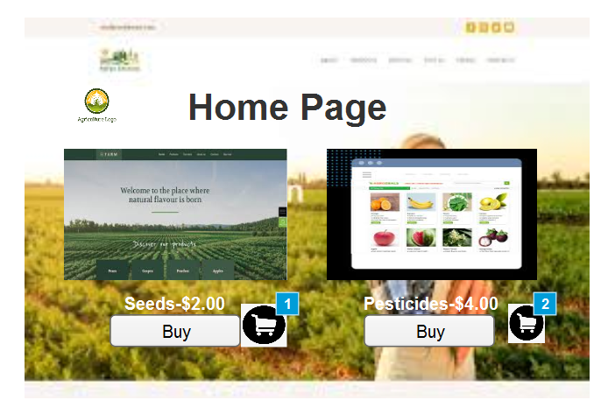
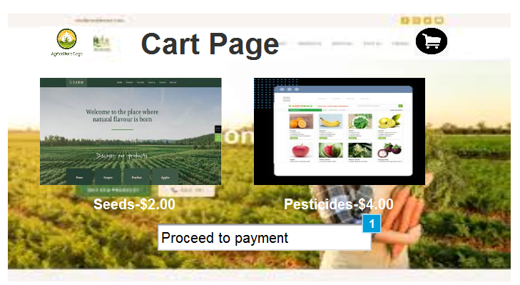
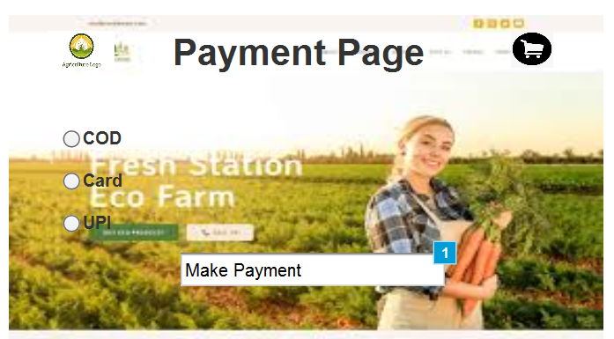

Question 3 – Tools (Visio, Balsamiq) - 15 Marks
Make a note of the Tools, which you are using for above concepts
Microsoft Visio is a Used for creating UML diagrams, flowcharts, activity diagrams, and use case diagrams.
Good for visual representation of complex processes and system workflows.
Balasmiq Is a rapid wireframing tool used for creating the mockups and prototypes of user interfaces.
It will help us creating the blueprint of the future without any color and functionality. It is static in nature. Wireframes are designed by BA or UX design team.
- It is a simple tool to learn and use
- More affordable one time fee
- More focused on creating static images and exporting them in formats such as PNG and PDF.
Axure is more advanced prototyping tool used to create high fidelity interactive wireframes and protoypes for web and mobile applications. It’s the replica of the future systems which is meant to simulate user interactions. Prototype takes more time to develop. It is developed by the development team and the BA. Its dynamic in nature. It might not require for all the projects.
It helps the stakeholder to get the feel of the future system and we can capture their feedback during the session.
- More advanced tool
- Requires more time to learn
- Allows teams to work on the same project simultaneously share design manage changes and comments more efficiently
- Subscription based pricing model
- Supports wide range of output formats, including HTML, CSS

Question 4 – RTM - 6 Marks
A business analyst’s key responsibilities are to keep track of the requirements and make sure that no requirement is missed.
Mr. Henry and peter have approached you regarding the current status of the project. How will you tackle this situation?
Prepare RTM

Req ID | Req Name | Req Description | Design | D1 | T1 | …… | T4 | UAT
FR0001 | Farmer Registration | Farmers should be able to register with the application
FR0002 | Farmer Search for Products | Farmers should be able to search for available products in fertilizers, seeds, pesticides
NFR0101 | Page Loading Time | Each Page should load within 2 seconds time
NFR0102 | WCAG 2.1. | The system must meet Web Content Accessibility Guidelines WCAG 2.1.

RTM is Requirement Traceability Matrix. It is the document helped to track the requirements throughout the lifecycle of the project ensuring that no requirements are overlooked. Any requirements that has been gathered will be inputted in this document where the requirements are tracked. The RTM ensures that every requirement (FR – Functional Requirement / NFR – Non-Functional Requirement) is mapped to design, development, test cases, and UAT. This way, no requirement is missed, and you can confidently report the project status.
Req ID | Req Name | Req Description | Design | D1 | T1 | D2 | T2 | D3 | T3 | D4 | T4 | UT(Unit Testing) | CT(Component Testing) | ST(System Testing) | UAT
FR0001 | User Registration | Users should be able to register with the application | ✔ | ✔ | ✔ |  |  |  |  |  |  | ✔ | ✔ | ✔ | ✔
FR0002 | User Search for Products | Users should be able to search for available products in fertilizers, seeds, pesticides | ✔ | ✔ | ✔ | ✔ |  |  |  |  |  | ✔ | ✔ |  | ✔
FR0003 | Secure Login | Users should be able to securely log in using Email/Password or Mobile/OTP | ✔ | ✔ | ✔ | ✔ |  | ✔ |  |  |  | ✔ | ✔ | ✔ | ✔
FR0004 | New User Registration | New users should be able to register with Email, Phone, and Password | ✔ | ✔ |  | ✔ | ✔ |  |  |  |  | ✔ | ✔ |  | ✔
FR0005 | Add to Cart | Users should be able to add products to the cart | ✔ | ✔ | ✔ |  |  | ✔ |  |  |  | ✔ |  | ✔ | ✔
FR0006 | Add to Buy Later | Users should be able to save items for buy-later (wish list) | ✔ |  | ✔ |  | ✔ |  |  |  |  | ✔ |  | ✔
FR0007 | Payment Gateway Integration | Users should be able to make payments via COD, Card, UPI, Wallet | ✔ | ✔ | ✔ | ✔ |  | ✔ | ✔ |  |  | ✔ | ✔ | ✔ | ✔
FR0008 | Order Confirmation Email/SMS | Users should receive order confirmation via Email/SMS | ✔ |  | ✔ |  |  | ✔ |  |  |  | ✔ | ✔ |  | ✔
FR0009 | Delivery Tracking | Users should be able to track delivery status of orders | ✔ | ✔ | ✔ |  |  |  |  |  |  | ✔ | ✔
FR0010 | Inventory Updates | Manufacturers should be able to update product stock and pricing | ✔ | ✔ | ✔ |  | ✔ |  |  |  |  | ✔ | ✔ | ✔ | ✔

Req ID | Req Name | Req Description | Design | D1 | T1 | D2 | T2 | D3 | T3 | D4 | T4 | UT | CT | ST | UAT
NFR0101 | Page Loading Time | Each Page should load within 2 seconds time | ✔ | ✔ | ✔ |  |  |  |  |  |  | ✔ | ✔ | ✔ | ✔
NFR0102 | WCAG 2.1 | The system must meet Web Content Accessibility Guidelines WCAG 2.1 | ✔ | ✔ |  |  | ✔ |  |  |  |  | ✔ | ✔ | ✔ | ✔
NFR0103 | Usability | The application should have an intuitive and user-friendly interface. | ✔ | ✔ | ✔ |  |  |  |  |  |  | ✔ | ✔ | ✔ | ✔
NFR0104 | Performance | The application must load pages within 3 seconds. | ✔ | ✔ | ✔ | ✔ |  |  |  |  |  | ✔ | ✔ | ✔ | ✔
NFR0105 | Compatibility | The application should be compatible with major web browsers. | ✔ |  | ✔ |  | ✔ |  |  |  |  | ✔ | ✔ | ✔
NFR0106 | Availability | The application should maintain 99.9% uptime. | ✔ | ✔ |  | ✔ |  |  |  |  |  | ✔ | ✔ | ✔ | ✔
NFR0107 | Scalability | The system should handle up to 10,000 concurrent users without performance degradation. | ✔ | ✔ | ✔ |  |  | ✔ |  |  |  | ✔ | ✔ | ✔ | ✔
NFR0108 | Maintainability | The application should allow easy maintenance and updates with minimal downtime. | ✔ |  | ✔ |  | ✔ |  |  |  |  | ✔ | ✔ |  | ✔
NFR0109 | Reliability | The system should recover from failures within 1 minute without data loss. | ✔ | ✔ |  | ✔ |  |  |  |  |  | ✔ | ✔ | ✔ | ✔
NFR0110 | Data Backup | The system should perform automatic daily backups and support quick restoration of data. | ✔ | ✔ |  |  | ✔ |  |  |  |  | ✔ | ✔ | ✔ | ✔

Question 5 – 10 Test Case Documents - 10 Marks
Prepare 10 Test Case Documents
A test case document is a detailed document outlined by testers to ensure that a software application or system is working as expected

Test Case 1
Test case ID | Project ID | Project Name |  | PM ID |  | PM Name |  | Test strategy ID |  | Tester ID | Tester Name | Test plan ID | Test schedule ID | Date of Test
TC-REG-001 | OAPS-001 | Online Agriculture Products Store |  | PM-VDN |  | Mr. Vandanam |  | TS-CORE-REG |  | QA-01 | Jason / Alekya | TP-REG-01 | SCH-REG-S1 | //_____
Scenario | New User Registration with Email, Phone, Username, Password, and OTP validation
Link to that page
Input Data | Set 1: Valid Data  Name: Peter  Phone: 9876543210  Email: peter@farm.com  Username: peterF  Password: Agri@1234  OTP: Valid |  | Set 2: Duplicate Email |  | Set 3 Weak Password |  | Set 4 Invalid Phone |  | Set 5 OTP Expired
Expected Behavior | Account created successfully, redirected to Login, welcome email sent |  | System shows “Email already exists – login or reset password.” |  | Inline error: “Follow password policy (8+ chars, letters, special char).” |  | Inline error: “Enter valid 10-digit number.” |  | Error: “OTP expired.” Show Resend OTP option
Actual Behavior | Account created, redirected to login, welcome email delivered |  | Error displayed correctly: “Email already exists” |  | Error shown: “Password too weak” |  | Validation error shown: “Invalid phone number” |  | OTP expired message shown, resend option enabled
Comments | Works as expected |  | User guided to Login page |  | Policy enforcement correct |  | Correctly blocks invalid input |  | User able to request new OTP
Results | Pass |  | Pass |  | Pass |  | Pass |  | Pass

Test Case 2
Test case ID | Project ID | Project Name |  | PM ID |  | PM Name |  | Test strategy ID |  | Tester ID | Tester Name | Test plan ID | Test schedule ID | Date of Test
TC-SRCH-001 | OAPS-002 | Online Agriculture Products Store |  | PM-VDN |  | Mr. Vandanam |  | TS-CORE-SRCH |  | QA-02 | Jason / Alekya | TP-SRCH-01 | SCH-SRCH-S1 | //_____
Scenario | User searches for products in categories (fertilizers, seeds, pesticides) with filters and keywords.
Link to that page
Input Data | Set 1: Search for “Fertilizer” |  | Set 2: Apply filter “Price < $50” |  | Set 3: Invalid keyword “abcxyz” |  | Set 4: Search “Seeds” + apply multiple filters (brand + rating) |  | Set 5: Check search logs (system)
Expected Behavior | System displays all fertilizers with details, pricing, and availability |  | System filters results and shows only products under $50 |  | System shows “No results found. Try alternate keywords.” |  | Results narrowed to seeds matching brand and rating |  | System logs search query for analytics
Actual Behavior | Fertilizer list displayed with stock, price, description |  | Correct filtered products displayed |  | Error message shown: “No products found” |  | Correct seed list shown with filters applied |  | Logs captured successfully in backend
Comments | Works as expected |  | Filter works correctly |  | User guided to retry |  | Multiple filters working |  | Logs stored for analytics
Results | Pass |  | Pass |  | Pass |  | Pass |  | Pass

Test Case 3
Test case ID | Project ID | Project Name |  | PM ID |  | PM Name |  | Test strategy ID |  | Tester ID | Tester Name | Test plan ID | Test schedule ID | Date of Test
TC-LOGIN-001 | OAPS-003 | Online Agriculture Products Store |  | PM-VDN |  | Mr. Vandanam |  | TS-CORE-LOGIN |  | QA-03 | Jason / Alekya | TP-LOGIN-01 | SCH-LOGIN-S1 | //_____
Scenario | Secure login using either Email + Password or Mobile + OTP
Link to that page
Input Data | Set 1: Valid Email + Password |  | Set 2: Invalid Password |  | Set 3: Unregistered Email |  |  |  | Set 5: Wrong OTP
  Set 4: Valid Mobile + OTP
Expected Behavior | User logged in successfully, redirected to dashboard |  | Error message: “Incorrect password.” Retry allowed; lock after N attempts |  | Error: “Email not found.” Suggest Register or Forgot Password |  | User logged in successfully after OTP validation |  | Error: “Invalid OTP.” Allow retry
Actual Behavior |  |  | Error displayed as expected |  | Error shown correctly |  | OTP accepted, login success |  | Error shown, retry enabled
  Login success, redirected
Comments | Works as expected |  | Lockout rules applied |  | User guided to Register |  | OTP system working fine |  | Retry works properly
Results | Pass |  | Pass |  | Pass |  | Pass |  | Pass

Test Case 4
Test case ID | Project ID | Project Name |  | PM ID |  | PM Name |  | Test strategy ID |  | Tester ID | Tester Name | Test plan ID | Test schedule ID | Date of Test
TC-CART-001 | OAPS-004 | Online Agriculture Products Store |  | PM-VDN |  | Mr. Vandanam |  | TS-CORE-CART |  | QA-04 | Jason / Alekya | TP-CART-01 | SCH-CART-S1 | //_____
Scenario | Farmer adds items to the cart, updates quantities, removes products, and moves items between cart and buy-later list.
Link to that page
Input Data | Set 1: Add a single product (Fertilizer, Qty 1) |  | Set 2: Add multiple products (Seed, Pesticide) |  | Set 3: Update quantity (increase qty from 1 → 3) |  | Set 4: Remove product |  | Set 5: Add to Buy-Later
Expected Behavior | Product added to cart, cart shows item, price, and total |  | All items added to cart with correct totals |  | Cart updates subtotal, tax, and total accordingly |  | Product removed, totals adjusted |  | Product saved in Buy-Later list, removed from active cart
Actual Behavior | Item displayed with correct price and total |  | All items displayed with correct totals |  | Quantity updated, totals recalculated |  | Item removed, total updated |  | Item displayed in Buy-Later, not in cart
Comments | Works as expected |  | Cart supports multiple products |  | Correct calculations |  | Deletion works correctly |  | Buy-Later feature works
Results | Pass |  | Pass |  | Pass |  | Pass |  | Pass

Test Case 5
Test case ID | Project ID | Project Name |  | PM ID |  | PM Name |  | Test strategy ID |  | Tester ID | Tester Name | Test plan ID | Test schedule ID | Date of Test
TC-BL-001 | OAPS-005 | Online Agriculture Products Store |  | PM-VDN |  | Mr. Vandanam |  | TS-CORE-BL |  | QA-05 | Jason / Alekya | TP-BL-01 | SCH-BL-S1 | //_____
Scenario | Farmer saves products to the Buy Later (Wishlist) list and manages items between Buy Later and Cart.
Link to that page
Input Data | Set 1: Add a product to Buy Later |  | Set 2: Add multiple products |  | Set 3: Move item from Buy Later → Cart |  | Set 4: Move item from Cart → Buy Later |  | Set 5: Remove item from Buy Later
Expected Behavior | Product saved in Buy Later list; not visible in cart |  | All items stored in Buy Later list with details |  | Item removed from Buy Later and added to Cart |  | Item removed from Cart and added to Buy Later |  | Product removed, list updated
Actual Behavior | Product saved successfully |  | Multiple items listed correctly |  | Transfer worked correctly |  | Transfer worked correctly |  | Item removed successfully
Comments | Works as expected |  | List supports multiple entries |  | Synchronization works |  | Works in both directions |  | Works as expected
Results | Pass |  | Pass |  | Pass |  | Pass |  | Pass

Test Case 6
Test case ID | Project ID | Project Name |  | PM ID |  | PM Name |  | Test strategy ID |  | Tester ID | Tester Name | Test plan ID | Test schedule ID | Date of Test
TC-PAY-001 | OAPS-006 | Online Agriculture Products Store |  | PM-VDN |  | Mr. Vandanam |  | TS-CORE-PAY |  | QA-06 | Jason / Alekya | TP-PAY-01 | SCH-PAY-S1 | //_____
Scenario | Process payment at checkout using COD, Card, UPI, or Wallet, handle success/failure, and update order accordingly.
Link to that page
Input Data | Set 1: COD – eligible pincode & amount |  | Set 2: Card – valid card + 3DS success |  | Set 3: Card – wrong 3DS/OTP |  | Set 4: UPI – collect request approved |  | Set 5: UPI – timeout/pending
Expected Behavior | Order confirmed with status “COD – payment on delivery” |  | Payment authorized/captured; order placed; receipt sent |  | Show “Authentication failed”; allow retry or change method |  | Payment success; order placed; receipt generated |  | Show “Pending/Timed out”; allow refresh/resend or change method
Actual Behavior | COD accepted; order placed with COD tag |  | Payment success; order confirmed; email sent |  | Auth failed; retry offered |  | UPI success callback received; order confirmed |  | Pending shown; user switched to card
Comments | Eligibility rules applied |  | Eligibility rules applied |  | Proper failure handling |  | PSP integration OK |  | Correct pending handling
Results | Pass |  | Pass |  | Pass |  | Pass |  | Pass

Test Case 7
Test case ID | Project ID | Project Name |  | PM ID |  | PM Name |  | Test strategy ID |  | Tester ID | Tester Name | Test plan ID | Test schedule ID | Date of Test
TC-MANU-001 | OAPS-007 | Online Agriculture Products Store |  | PM-VDN |  | Mr. Vandanam |  | TS-CORE-MANU |  | QA-07 | Jason / Alekya | TP-MANU-01 | SCH-MANU-S1 | //_____
Scenario | Manufacturer/Admin manages product catalog: upload new items, update stock and prices, view reports, and handle inventory consistency
Link to that page
Input Data | Set 1: Add new product (valid data: name, category, price, stock) |  | Set 2: Add product with missing fields (no price) |  | Set 3: Update stock quantity (increase stock by 50) |  | Set 4: Update product price |  | Set 5: Upload invalid image format
Expected Behavior | Product added successfully; visible in catalog for farmers |  | Inline error: “Price required” |  | Inventory updated; reflected in farmer search results |  | New price displayed to farmers; old cached price invalidated |  | rror: “Unsupported file type”
Actual Behavior | Product added and listed |  | Error displayed |  | Stock updated correctly |  | Price updated; cache cleared |  | Error shown
Comments | Works as expected |  | Validation correct |  | Sync Works |  | Correct pricing flow |  | Restriction Enforced
Results | Pass |  | Pass |  | Pass |  | Pass |  | Pass

Test Case 8
Test case ID | Project ID | Project Name |  | PM ID |  | PM Name |  | Test strategy ID |  | Tester ID | Tester Name | Test plan ID | Test schedule ID | Date of Test
TC-BANK-001 | OAPS-008 | Online Agriculture Products Store |  | PM-VDN |  | Mr. Vandanam |  | TS-CORE-BANK |  | QA-08 | Jason / Alekya | TP-BANK-01 | SCH-BANK-S1 | //_____
Scenario | System integrates with Bank Gateway for payment authorization, fund capture, refunds, and transaction reconciliation.
Link to that page
Input Data | Set 1: Valid debit card payment |  | Set 2: Invalid card number |  | Set 3: Insufficient funds |  | Set 4: Bank OTP success (3DSecure) |  | Set 5: Bank OTP failure
Expected Behavior | Bank authorizes payment; system confirms order; receipt issued |  | Bank declines with “Invalid card details.” System shows error |  | Bank returns “Insufficient balance.” Order not placed |  | OTP verified, transaction approved |  | OTP incorrect; transaction declined
Actual Behavior | Payment approved, order confirmed |  | Error displayed correctly |  | Error shown, no order created |  | OTP entered, payment success |  | Error shown, retry allowed
Comments | Works as expected |  | Validation correct |  | Prevents overdraft |  | 3DS flow works |  | Security intact
Results | Pass |  | Pass |  | Pass |  | Pass |  | Pass

Test Case 9
Test case ID | Project ID | Project Name |  | PM ID |  | PM Name |  | Test strategy ID |  | Tester ID | Tester Name | Test plan ID | Test schedule ID | Date of Test
TC-PAY-SUCCESS-001 | OAPS-009 | Online Agriculture Products Store |  | PM-VDN |  | Mr. Vandanam |  | TS-CORE-PAY |  | QA-06 | Jason / Alekya | TP-PAY-01 | SCH-PAY-S1 | //_____
Scenario | Confirm that successful payments (COD, Card, UPI, Wallet) correctly create the order, record the transaction, generate invoice/receipt, decrement stock, and send confirmations.
Link to that page
Input Data | Set 1: COD – eligible pincode & amount |  | Set 2: Card – valid card + 3DS success |  | Set 3: UPI – collect approved |  | Set 4: Wallet – sufficient balance |  | Set 5: Saved card token – success
Expected Behavior | Order placed with status “COD – payment on delivery”; confirmation email/SMS sent; stock decremented |  | Gateway returns success; system captures/authorizes; order Confirmed; receipt/invoice generated; email sent |  | PSP callback success; order Confirmed; receipt generated; email/SMS sent |  | Wallet approves; order Confirmed; receipt generated; stock decremented |  | Tokenized payment success; order Confirmed; PCI-safe logs; email sent
Actual Behavior | Order created with COD tag; confirmation sent; stock updated |  | Payment success; order confirmed; invoice generated; email delivered |  | UPI success received; order confirmed; notifications sent |  | Wallet success; order confirmed; stock updated |  | Token charge success; order confirmed; logs redacted
Comments | COD happy path |  | End-to-end card success |  | UPI happy path |  | Wallet happy path |  | Tokenization working
Results | PASS |  | Pass |  | Pass |  | Pass |  | Pass

Test Case 10
Test case ID | Project ID | Project Name |  | PM ID |  | PM Name |  | Test strategy ID |  | Tester ID | Tester Name | Test plan ID | Test schedule ID | Date of Test
TC-DEL-001 | OAPS-010 | Online Agriculture Products Store |  | PM-VDN |  | Mr. Vandanam |  | TS-CORE-DEL |  | QA-09 | Jason / Alekya | TP-DEL-01 | SCH-DEL-S1 | //_____
Scenario | Farmer tracks delivery status of placed orders (processing → dispatched → in transit → delivered) through the portal/app.
Link to that page
Input Data | Set 1: Order in Processing state |  | Set 2: Order Dispatched |  | Set 3: Order In Transit |  | Set 4: Order Delivered |  | Set 5: Order with Invalid Tracking ID
Expected Behavior | System shows status = “Processing” with estimated dispatch date |  | System shows status = “Processing” with estimated dispatch date |  | Tracking page shows live updates from courier |  | System shows “Delivered” with date/time stamp |  | Error: “Tracking unavailable, please contact support.
Actual Behavior | Processing status displayed correctly |  | Courier details shown with tracking link |  | Status updates visible correctly |  | Delivered status shown with confirmation |  | Error displayed correctly
Comments | Initial state verified |  | Integration working |  | Real-time updates syncing |  | Flow completed successfully |  | Invalid handled gracefully
Results | Pass |  | Pass |  | Pass |  | Pass |  | Pass

Question 6 – DB Design – 8 Marks
After the requirements are thoroughly explained to the entire project team by business analyst, the Database architects have decided to do the database design and also to represent the in-flow and out-flow of data.
Draw database schema and ER diagram
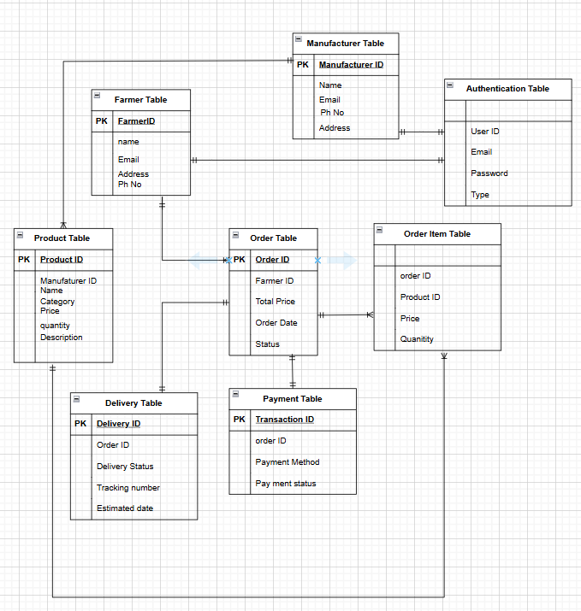

Question 7 – Data Flow Diagram - 3 Marks
What is a data flow diagram? Draw a data flow diagram to represent the in-flow and out-flow of data when a Farmer is placing an order for the product.
- A Data Flow Diagram shows how data moves inside a system.
- It explains the input, process, storage, and output of data.
- It helps to find mistakes or bottlenecks in the system.
- DFD makes it easy to explain system requirements to stakeholders.

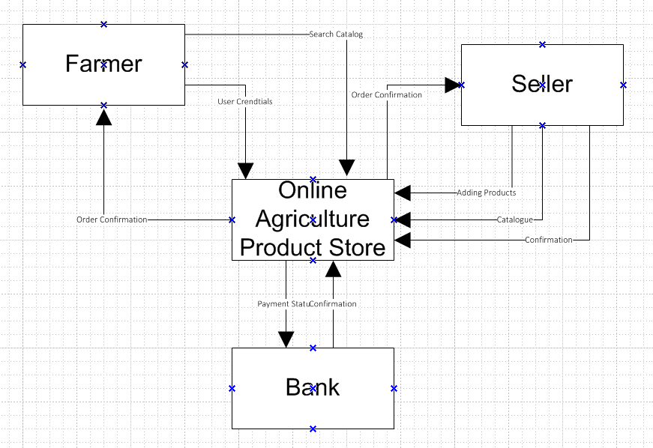

Question 8 – Change Request - 10 Marks
Due to change in the Government Taxation structure . we should change the Tax structure How do you handle change requests in a project?
In this case, the change request arises because of a Government Taxation structure update. As a Business Analyst (BA), I would first review the request and ensure all stakeholders clearly understand what changes are required in the Online Agriculture Product Store system. Normally, I would perform a feasibility study to check effort and impact whether there will be change in the project timeline, budget and scope, but since this is a government-mandated change, feasibility is not optional — it must be implemented.
To handle this change, I would follow these steps:
- Document the Change Request – clearly define what tax changes need to be applied.
- Gather Supporting Materials – refer to updated government taxation policies and rules.
- Assess Scope Impact – confirm that this is an outside scope change, so it will affect budget, schedule, and testing timelines.
- Classify the Change – BA and PM should agree this is a major change since it’s mandated by law.
- Approval Workflow – fill the Change Request Form and obtain PM and Sponsor approvals.
- Team Communication – ensure all developers, testers, and finance-related teams know this is a high-priority request.
- Engage Change Control Board (CCB) – present the request to CCB to recommend actions and updates.
- Update Deliverables – once approved, update system modules, documentation, tax calculation logic, and test cases.

Question 9 – Change Request Vs an Enhancement - 5 Marks
As the project is in process, Ben and Kevin have contacted you. The reason is to inform you that they want the Farmers to sell their crop yields through this application i.e. Farmers should be able to add their crop yields or products and display to general public and should be able to sell them. They also want to introduce Auction system for their Crop yields. As a BA, what will be your response?
Is this a change request or an enhancement???
Clarify the Nature of the Request
The new feature where Farmers can sell their crop yields directly and introduce an Auction system is not just a small tweak. It is an enhancement, because it introduces a new functionality to the existing system, expanding its scope beyond the original requirements.
Change Request vs Enhancement
- Change Request (CR): A modification to something already agreed or built (e.g., update tax structure, fix login flow).
- Enhancement: A new feature that adds value but was not in the original scope (e.g., adding Auction).
- In this case, Auction and selling crop yields = Enhancement.
Feasibility Study
I would conduct a feasibility analysis covering:
- Benefits: Farmers get a direct marketplace, increased transparency, competitive pricing via auctions.
- Costs: Development cost (UI for auction listing, backend bidding logic, payment integration), hosting/transactional costs, ongoing maintenance.
- Risks: Higher complexity, need for secure transactions, system performance under heavy bidding load.
- Timeline impact: May extend delivery schedule depending on scope.
Next Steps
- Document this enhancement request.
- Prioritize it with stakeholders (Ben and Kevin).
- Present cost-benefit analysis to the sponsor and Change Control Board.
- If approved, integrate it into the project plan as an enhancement feature.

Question 10 – Estimations - 6 Marks
Come up with estimations – How many Manhours required
Man-Hours Estimation for Online Agriculture Project
Role | M1–M3Req & Analysis | M4–M5Design | M6–M12Development | M13–M15QA & UAT | M16–M18Deploy & M&O | Total Hrs
PM – Vandanam | 120 | 80 | 280 | 120 | 120 | 720
BA –Aswitha | 320 | 160 | 240 | 120 | 120 | 960
Sr. Dev – Juhi | 0 | 80 | 880 | 240 | 240 | 1,440
Java Devs (Teyson, Lucie, Tucker, Bravo – 1.5 FTE) | 0 | 120 | 3,120 | 600 | 480 | 4,320
DB Admin – John | 80 | 80 | 200 | 60 | 60 | 480
Network Admin – Mike | 60 | 60 | 120 | 60 | 60 | 360
Testers – Jason & Alekya | 0 | 0 | 640 | 960 | 640 | 2,240
TOTAL Hrs / Phase | 580 | 580 | 5,480 | 2,160 | 1,720 | 10,520

Role | Hours | Rate (₹/hr) | Cost (₹)
Project Manager (Vandanam) | 720 | 2,000 | 1,440,000
Business Analyst-Aswitha | 960 | 1,500 | 1,440,000
Sr. Java Developer (Juhi) | 1,440 | 1,800 | 2,592,000
Java Developers (1.5 FTE total) | 4,320 | 1,600 | 6,912,000
DB Admin (John) | 480 | 1,800 | 864,000
Network Admin (Mike) | 360 | 1,600 | 576,000
Testers (Jason & Alekya) | 2,240 | 1,200 | 2,688,000
Grand Total | 10,520 | — | ₹15,512,000 (~₹1.55 Cr)

Question 11 – UAT – 6 Marks
Project has finally completed all the stages i.e., design, development, testing etc. Now, it is the roleof a business analyst to contact the client for testing of the final product and have to successfully complete it. How are you going to handle this situation? And once it is done, what will be the process to close the project?
Explain UAT Acceptance process
As the Business Analyst, once the project has completed design, development, and testing, I will initiate User Acceptance Testing (UAT) with the client to validate that the final product meets their requirements.
The process will be:
- Planning – Share UAT scope, timelines, and test standards with the client, ensuring all features to be validated are agreed upon.
- Designing – Provide well-documented test cases that cover all possible real-world scenarios.
- UAT Testers – Involve client representatives and actual end-users as testers. They will execute test cases and validate system functionalities.
- Bug Fixing – Any defects identified during UAT will be logged, prioritized, and addressed by the development team. The fixed modules will be retested.
- Sign-Off – Once all critical issues are resolved and the client confirms satisfaction, the UAT team signs off, meaning the software is approved for production use.
Project Closure Process
After UAT sign-off, the steps to close the project include:
- Formal Acceptance – Obtain written confirmation from the client that deliverables meet the agreed requirements.
- Handover & Documentation – Transfer system documentation, user manuals, and training material to the client.
- Deployment Support – Assist in go-live activities, ensuring smooth transition to production.
- Lessons Learned & Closure Report – Document project learnings, challenges, and successes for future reference.
- Final Sign-Off – Project sponsor/client signs the closure document, officially marking the project as completed.

Question 12 – Project Closure Document - 6 Marks
Explain Project closure document
S.No | Points to Include | Details | Reference Link
1 | Did the client sign off on the UAT Testing | Yes – Signed off on 15th Sept 2025 by Mr. Henry | Business Scope Document.docx
2 | Objectives of the Project | - User friendliness: Achieved - Customer satisfaction: High, ROI expected within 6 months - More categories: Implemented (fertilizers, seeds, pesticides, tools)
3 | Functionalities Worked On | - Secure payment processing (COD, Card, UPI, Wallet): Achieved - Farmer & Manufacturer registration: Achieved - Product browsing/search: Achieved - Cart & Buy-Later: Achieved - Delivery tracking: Achieved
4 | Infrastructure | - Application hosted on secured cloud server: Achieved - Database schema & backup in place: Achieved - Required laptops & software licenses: Procured
5 | Funding | Amount Approved: ₹2 Crores  Amount Used: ₹1.55 Crores (~77.5% of budget) | Finance Breakdown.docx
6 | Overall Project Information | - Escalations: 35 (all resolved) - Customer Satisfaction: High – Project Duration-36,576 resource hours estimated → optimized to 10,520 actual allocated hours.
7 | Value to the Company | Positive – 95% - Company gained edge over competitors - Farmers & manufacturers onboarded - Increased client base & revenue - Employees trained - New pipeline project confirmed

