Capstone Project Prep 1 Part 2
Question 1 – Audits - 5 Marks
4 Quarterly Audits are planned Q1 , Q2, Q3, Q4 for this Project What is your
knowledge on how these Audits will happen for a BA ?
Answer:
Audit:Audit is the verification of various activities as compared to department standards to ensure dept. is running as per specified standards.

Project Audit:
Project Audit is for verification of activities done by BA,Project Audit is formal review of given project based on standards.

Purpose of Quaterly Audits:
- To fix gaps, issues & risks in BA process & documentation.
- To cross check activities compiled with internal standards or external regulations.
- To ensure project align with Business Goals , stakeholder expectations
- Ensure requirements are tracked , documented & validated

Review Done in Q1 Audit
1 | To ensure BA understands company Goals
2 | To understand the Current Situation of Project
3 | Check Stakeholders requirements are properly gathered
4 | Stakeholder Analysis is done & requirements are prioritized
5 | Proper Elicitation technique is used for Requirements gathering
6 | Work planning is done & understood by all team members

Review Done in Q2 Audit
1 | Business Analyst has to prepare Use Case Diagram & Activity Diagram
2 | To verify documents prepared like Requirements Traceability Matrix(RTM),Business Process Module (BPM) to ensure all requirements are properly understand
3 | Are Business Requirements are finalized & sign done on Documents like RTM

Review Done in Q3 Audit
1 | Business Analyst has to prepare Brainstorming/JAD session with Development team
2 | Are all Requirements are clearly understand by Development Team
3 | Is Business Analyst is updating stakeholder regarding Progress of Project
4 | Are Timelines for all stages are prepared & submit by Business Analyst

Review Done in Q4 Audit
1 | BA is preparing Test Plan for Software testing
2 | Test Data send to client
3 | Is Business Analyst Testing Team assisting Testing product
4 | Is User Manual prepared for software testing
5 | Business Analyst preparing client for User Acceptance Testing
6 | Assist Delivery Manager to implement Project
7 | Are all users are trained & End User manual handover
8 | Sign Off on UAT & after complete implementation done
9 | Document all Timesheets of all stages like Requirement Elicitation, Design, Development, User Acceptance Testing, Software Handover

Question 2 – BA Approach Strategy - 6 Marks
Before the Project is going to Kick Start, The Committee asked Mr Karthik to submit BA Approach
Strategy
Write BA Approach strategy (As a business analyst, what are the steps that you would need to
follow to complete a project – What Elicitation Techniques to apply, how to do Stakeholder Analysis
RACI/ILS, What Documents to Write, What process to follow to Sign off on the Documents, How to
take Approvals from the Client, What Communication Channels to establish n implement, How to
Handle Change Requests, How to update the progress of the project to the Stakeholders, How to
take signoff on the UAT- Client Project Acceptance Form )
Your Team
Project Manager - Mr Vandanam Senior
Java Developer - Ms. Juhi
Java Developers – Mr.Teyson, Ms Lucie, Mr Tucker, Mr Bravo
Network Admin - Mr Mike
DB Admin - Mr John.
Testers - Mr Jason and Ms Alekya
BA - You
Answer:
Business Analyst is plan leads by BA about how the activities will be executed
Business Approach includes following steps:
- Elicitation technique 2. Stakeholder Analysis 3. Documents to write 4. Sign off Document
- Taking approval 6. Communication channels 7. Change request

- BA use technique for Requirement gathering
- Resources for Project & their Roles & Responsibilities
- To identify each stakeholder & ensures stakeholder engagement during project.
- Requirement traceability to review requirement process & approval cycle
- Change management approach to requirement & agreed deliverables

As a Business Analyst following are the steps which needs to followed to complete a project:
- Elicitation Technique to apply:BDRFOWJIPQU
There are several elicitation techniques like
- Brainstorming B. Document Analysis C. Reverse Engineering D. Focus Group
E. Observation F. Workshop G. Joint Application Development
H. Interview I. Prototyping J. Questionnaire & Surveys K. Use case specification
Out of above techniques we are using following Elicitation Techniques:
- Brainstorming: In this we conduct meeting session with all participants in which new ideas are gathered
Without any criticism & in all perspectives.
- Interview: In this technique we take interview of stakeholders to elicit the requirements
- Workshops: Arranging workshops with key stakeholders & SME’s
These will be for Planning, Analysis, Design, Scoping, Requirement Elicitation, Modelling
This Elicitation technique also generate new ideas for new features of products
- Questionnaire: We will send Questionnaires to all stakeholders to gather the requirements, also extract
Information about desired product, work practices & additional product requirements
- Stakeholder Analysis:
- To identify the stakeholders & that are directly/indirectly impacted by change & analyse information got from stakeholder
1 | Project Manager | Mr Vandanam Senior
2 | Sr. Java Developer | Ms. Juhi
3 | Java Developers | Mr.Teyson, Ms Lucie, Mr Tucker, Mr Bravo
4 | Network Admin | Mr Mike
5 | DB Admin | Mr John
6 | Testers | Mr Jason and Ms Alekya
7 | BA | Self
- External Stakeholder:

Primary Stakeholder Sponsored | Mr. Henry
Financial Head | Mr. Pandu
Project co-coordinator | Mr. Dooku
Key Stakeholder | Me. Peter, Kevin, Ben
Internal Stakeholders | Mr Vandanam Senior, Ms. Juhi, Mr.Teyson, Ms Lucie, Mr Tucker, Mr Bravo, Mr Mike,  Mr John, Mr Jason and Ms Alekya
Indirect Stakeholders | Suppliers, Farmers, Delivery Persons

- Priotizing Stakeholder:
RACI Matrix R-Responsible, A-Accountable, C-Consulted, I-Informed

 | PM | BA | DH | Sr. Developer | Developers | Testers | Project Sponsor | Key Stakeholder
 | Vandanam | Self | Karthik | Juhi | Teyson/Lucie/  Tucker/Bravo | Jeson/  Alekya | Henry | Peter/Kevin/Ben
Requirements Gathering | A | R | --- | --- | A | --- | A | C
Requirement Analysis | I | R | --- | --- | --- | --- | --- | ---
Development | R | C | --- | C/A | R | --- | A | ---
Testing | R | I | --- | I | --- | R | --- | ---
Implementation | I | A | R | I | --- | --- | --- | ---
UAT | R | C | --- | --- | --- | --- | I | ---

Summary of RACI Matrix:
Responsible:
(Self,Karthik,Vandanam):BA(RG/RA),PM(Developer/Testing/UAT),DH(Implementation)
Accountable: (Self,Henry,Vandanam,Juhi):Sponsor(RG/Development),BA(Implementation),PM(RG),Sr.Developer(Development),Developers(RG),
Consulted:
(Self,Peter/Kevin/Ben,Juhi):BA(Development/UAT),Key Stakeholder(RG),Sr.Developer(Development)
Informed:
(Self, Vandanam, Juhi, Henry): BA(Testing),PM(RG/Implementation),Sr.Developer(Testing/Implementation),Sponsor(UAT)

- Documents to write:
- Stakeholder Analysis Document (RACI)
- Business Requirement Document (BRD)
- Functional Requirement Specification/Functional Specification Document (FRS/FSD)
- System Requirement Specification/System Requirement Document (SRS/SRD)

- Signing Off Documents:
Sign off above Document is necessary as BA
- Project Vision Document-
E-Mail: Sponsor, Functional Head (FH),Project Manager (PM)
- Business Requirement Document (BRD):
E-Mail: Sponsor
- FRS/FSD,SRS/SRD:
E-Mail: Sponsor, CC: Functional Head (FH),Project Manager (PM)

- Taking Approvals:
Send Mail to respective Stakeholder, Call & take Sign-off from respective Stakeholders
as approval on documents

- Communication channel to establish & implement
As a BA, I would take following communication channels for Requirement Gathering, Brainstorming
On various stages
- Face-Face communication
- Video Conference
- Phone Call
- E-Mail

- How to handle change request:
As a BA following points to consider while change request
- Receive and Document the Change Request
- Acknowledge the Request
- Analyze the Change
- Document the Analysis
- Facilitate Approval Process
- Update Project Artifacts
- Communicate to All Stakeholders
- Track and Monitor the Change

- Updating the progress of Project
As a BA we update Project status as
- Understand Stakeholder needs
Stakeholder might be interest to review the project target vs actual date
- Pro-actively listen to your stakeholder concerns
Stakeholder may share details about risk/issue about project. These requirements should be addressed
- Develop & Execute communication plan
This study includes interest level of stakeholders how the project affects & ability of stakeholder to influence others

After understanding the Key area we can communicate with stakeholder by following
- Weekly, As per defined frequency status reports
- Develop follow-up meeting with actively involved stakeholder
- Online communication to communicate regular progress

- Signing off on UAT-Client Project Acceptance Form:

Project Sign-Off Sheet
Meeting Dt.: 18/5/2025
Project Goals
- To facilitate farmers to buy seeds, pesticides, fertilizers from any location online through internet connectivity.
Project Manager: Mr. Vandanam | Sponsor: Mr. Henry
Start Dt. Of Project: 01/4/2025 | Planned Budget: INR 2 Crores
Planned Completion Dt.: 01/12/2026 | Actual Budget: 1.8 Crores
Variance in Budget:0.2 Crores
Duration: 18 Months
Day past the planned completion Dt.: 01/12/2026
Project Deliverables
All the desired deliverables are fulfilled while implementing this project
Prepared By  Business Analyst | Verified By  Project Manager | Approved By  Sponsor
Remark:

Question 3 – 3-Tier Architecture - 5 Marks
Technical Team have assembled to discuss on the Project approach and have finalized to follow 3-tier
Architecture for this project.
Explain and illustrate 3-tier architecture?
Answer:
3 Tier Architecture is hierarchical software architecture with Three distinct phases
3 Tier architecture comprises of following:
- Application Layer
- Business Logic Layer
- Data Layer

Main job of architecture is to enable software applications to efficiently & quickly respond to user requests or inputs

Application Layer:
Graphical user interface like screens & pages, validates on pages, organization specific business logic will be on application layer

Business Logic Layer:
All reusable components (logic pertaining to industry) frequently changing components ,Governing body rules and regulations, compliances should go the middle layer
Ex.: Printer, Payment Gateways, Mail services, RBI Rules for Banks, IRDA Rules for insurance etc.

Data Base Layer: Data Base components connecting to databases will be at Data Layer
Database like product, client, address, Phone Nos., Quality & Quantity details

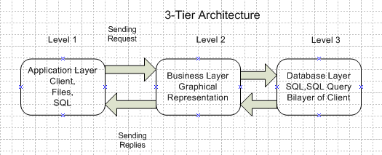

Question 4 – BA Approach Strategy for Framing Questions – 10 Marks
Business Analyst should keep What points in his/her mind before he frames a Question to ask to
the Stakeholder
( 5W 1H – SMART – RACI – 3 Tier Architecture – Use Cases, Use case Specs, Activity
Diagrams, Models, Page designs)
Answer:
Framing Questions:
- 5W1H
- Why: Why client is developing this project
- What: What is the project & what are the objectives
What: What is budget & timeline of project
- When: When project will start & implemented
- Where: Where will be project will deployed
- Who: Who are the customers & stakeholders for this project
- How: How much is the Budget of this project
- SMART Questions:
S: Specific: By narrowing the Questions let specific requirement will be traced in Questions
M: Measurable: The Questions are to be measurable means Quantified & countable
A: Actions Oriented: Does the Question creates new actions & new features
R: Relevant: Does the Question identify which relevant features are required by customer
T: Time bound: Questions will implicate the exact time period when customers need the project
- RACI:
-Responsible: The person is responsible to getting the project done as per set time limit in Gantt chart &
Responsible for performing activity like Requirement Gathering, Analysis, UAT & Implementation
Project Manager or Business Analyst are Responsible particularly for above rasks
-Accountable: Person Responsible to complete the work through & ensure work is suitable are accountable .
-Consulted: These are people with whom team members & PM/BA should communicate for feedback & input.
It is two way communication.
-Informed:
These are people keep informed during progress of project. These may be owners, client & key stakeholders need not
Be consulted or part of decision making.

- 3-Tier Architecture:
-Application/Presentation Layer:
The layer consists of screens, laptops, displays, validation on page, logic or function
-Business Logic Layer: These are SOP, Standards, guidelines, governing body rules, regulations,
Compliances that are all reusable & frequently changing components
-Data Layer: This Data base Management system that stores, edit, delete & update the product,
Client, delivery related data.
- Use Cases:
5W1H: Questionnaire for Use Cases
Why: Why this product will be used
What: What type of product is delivered
When: When the ordering/delivery/payment process will be completed
Where: Where the product is to be delivered
Who: Who are responsible for delivery of product
How: How delivery agent will deliver this product
- Use Case Specification:
Who: Who are Primary & Secondary actors
What: What are activities & Goals of particular actors
What: What is expected by actor from that particular tasks
- Activity Diagram:
Activity Diagrams represents the flow of activities in accordance with time, it represent visual representation of activities in process Flow chart.
The activity can be described as operation of system.
Purpose of Activity Diagram represented:
- How the one activity interlinked with other activity
- Sequence of each activity
- Different options used like Branch & Merge, Parallel, Fork & Join, Activities visual representation
- Model:
By preparing below Model , we can communicate for framing Questions:
- Conceptual Model
- Data Model
- Physical Model

Question 5 – Elicitation Techniques - 6 Marks
As a Business Analyst, What Elicitation Techniques you are aware of? ( BDRFOWJIPQU)
- Brainstorming:
In Brainstorming multiple users, team members subject matter experts take participate to generate more ideas & share information about particular topic.
- Document Analysis:
BA refers existing & previous documents to get more in depth requirements about the project.
BA refers existing documentation for identifying changes in existing documentation. Documents such as pre-existing project plans, system specification, process documentation, market research, customer feedback, system specification, user manuals, MOM are verified by BA
- Reverse Engineering:
In this Elicitation techniques the old or existing system/software is examined in reverse order how it is developed.
This Elicitation technique extracts requirements that are already implemented by working on previous system.
There are two types of Reverse Engg. Techniques
- Black Box Reverse Engineering:
The system / software is studied without examining its internal structures like function or composition of software.
- White Box Reverse Engineering:
The inner configuration of system is studied in this technique like coding, analysis & understanding
- Focus Group:
This Group consists of subject matter experts for project, when information required for project then Project Co-coordinator/BA consults with Focus group.
- Observation:
Observation is Elicitation technique in which BA can observe how actually process is takes place on practical or how user does their job by working in their work environment.
- Workshops:
Workshop comprises group of users or stakeholder working together to identify requirements workshops are used
To scope , discover, defined and prioritize requirements for proposed system.
- Joint Application Development(JAD):
JAD is structured meeting for discussions that involves End users, SME’s, PMs.
This is used to define, clarify and complete requirements.
- Interviews: This is most common technique used for Elicitation in which BA conducts one to one interview with stakeholders & directs Questions.
- Prototyping:
In this model or prototype of software is build to discuss with client how the model works prototypes can be used to create Mockup sites & describe processes using diagrams.
- Questionnaire & Surveys:
A set of Questionnaires is given to stakeholder to Quantify their thoughts.
Questions should be based on high priority risks. It requires remind to participate once the survey is done & Questionnaire is given.
- Use Case Specification:
This techniques gives text & pictures to provide better understanding of requirements . This includes actors, use case & Use case diagram.
This Elicitation given what is to do but not give how to do.

Question 6 – This project Elicitation Techniques - 5 Marks
Which Elicitation Techniques can be used in this Project and Justify your selection of Elicitation Techniques?
Prototyping
Use case Specs
Document Analysis
Brainstorming
Answer:
- Prototyping:
Prototyping means sharing ideas of Project implementation with stakeholders. First all ideas to be collected & arranging idea to get feasibility of product & software across farmers.
- Use Case Specification:
Use case given better understanding of text & pictures for Flow of process & this technique gives how the requirements are fulfilled in system & shows interactions between actor & systems
- Document Analysis:
Existing & previous documents are analyzed for this project to get better idea of current practices,
Identify gaps & take actions on these gaps.
So this technique will be also effective Elicitation technique for this project.
- Brainstorming:
This Elicitation technique can give several ideas & using these ideas we can have best solution for implementation .
This Technique includes 10-12 persons to get Good numbers of ideas from use & stakeholder.

Question 7 – 10 Business Requirements- 10 Marks
Make suitable Assumptions and identify at least 10 Business Requirements.
Req.ID | Requirement Description
BR001 | Farmers should be able to search for available products of category Fertilizers, Seeds, Pesticides
BR002 | Manufactures should be able to upload and display their products in application
BR003 | Farmers should be able to login in portal by entering E-mail & password
BR004 | Farmers should able to update their address ,Login ID, Password on portal
BR005 | Farmers should able to add products in their Wish list & Review all items later
BR006 | Farmers should able to pay by G-Pay wallet, Card, Cash, Pay later of COD
BR007 | Manufacturers should get notify about new requirements from portal automatically
BR008 | Manufacturers should get payment after products delivered to farmers immediately
BR009 | Farmers should able to cancel the order/return the products if they don't need product & get refund amount
BR010 | Farmers should get E-Mail & phone confirmation about order placed & delivered

Question 8 –Assumptions- 5 Marks
List your assumptions
Assumption 1 | Farmers should have good computer,laptop,internet connection
Assumption 2 | Farmers & Manifacturers should have own E-Mail ID,Mobile
Assumption 3 | Farmers should have own Bank Account with online payment mode for UPI,Card,Wallet
Assumption 4 | Application should have price comparision option
Assumption 5 | Farmers should update their address for online product delivery
Assumption 6 | Farmers shold speak with CRM regarding product query

Question 9 – This project Requirements Priority - 8 Marks
Req.ID | Requirement Name | Requirement Description | Priority
BR001 | Farmers Search for Products | Farmers should be able to search for available products of category Fertilisers,Seeds,Pesticides | 9
BR002 | Manufacturing upload their products | Manufactures should be able to upload and display their products in application | 8
BR003 | User Name & Password | Farmers should be able to login in portal by entering E-mail & password | 8
BR004 | User Details | Farmers should able to update their address ,Login ID, Password on portal | 9
BR005 | Browing product catalogue | Farmers should able to add products in their Wish list & Review all items later | 7
BR006 | Payment Gateway | Farmers should able to pay by G-Pay wallet, Card, Cash, Pay later of COD | 9
BR007 | Notifications | Manufacturers should get notify about new requirements from portal automatically | 7
BR008 | Payment delivered | Manufacturers should get payment after products delivered to farmers immediately | 9
BR009 | Cancel/Return | Farmers should able to cancel the order/return the products if they don't need product & get refund amount | 9
BR010 | Order tracking | Farmers should get E-Mail & phone confirmation about order placed & delivered | 7

Question 10 – Use Case Diagram - 10 MarksDraw use case diagram

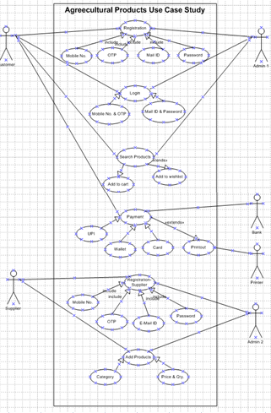

Question 11 – (minimum 5) Use Case Specs - 15 Marks
Prepare use case specs for all use cases

- User Registering in Online Application
Use Case Specification-User Registration
Document Title | User Registration with User Details
Document Owner | Business Analyst
Status | In process
Date | 01.05.25
Brief Description | This Use case describes how a user register in online Farmers Platform of Agricultural Farm Products
Actors | - Farmers  - Admin
Pre-Condition | - Farmers should have online platform accessible Laptop, Computer,Mobile  - Valid Internet Connection
Basic Flow | - Use Case begins with Registration of Farmers & Login  - Use Authentication performed  - Customer search for Agricultural Products  - Application displays multiple products  - User selects the suitable products  - Farmers add the product in wishlist & cart  - Farmers pays the cost of Product by Cash/Wallet/G-Pay/COD  - Products are delivered to Farmers locators  - Framers receives payment & delivery status by Mobile & E-mail
Alternate Flow | - If User login ID/Password forgotten then Forget password option displays  - If Product not available system displays “Product Not Available” & shows alternate products  - If connection disconnects then message should be shown “Internet Connection Error”  - Payment not done then “Order Payment Failure”
Post Conditions | Upon Successfully Transaction:  Products/Seeds/Pesticides/Fertilizers are successfully delivered  Failure condition: Payment unsuccessful leads to failure conditions
Supplemental Requirements | - Application shall include communication details of Customer relationship Manager  - All transactions history should be saved in application

2.User Registry on Portal
Use Case Specification-User Registration
Document Title | User Registering with user details
Document Owner | Business Analyst
Status | In process
Date | 07.05.25
Brief Description | This Use case describes how Farmers are Registering themselves on portal
Actors | - Farmers  - Admin
Pre-Condition | - Farmers should have online platform accessible Laptop, Computer,Mobile  - Valid Internet Connection
Basic Flow | - Farmers click on Registration option in Agricultural Products portal  - Farmers Enter Login ID/Mail ID/Mobile No. for Registering on portal  - OTP receives on Mobile/E Mail ID  - Enter OTP & create password  - Farmers validation performed  - Application displays user created successfully  - Use case Ends
Alternate Flow | - If User enters wrong password then display “Forgotten Password”  - If Wrong OTP Enters then display “OTP Invalid ”  Wrong Login & Mobile No. entered display “Enter Correct E-Mail”/”Enter Correct Mobile No”
Post Conditions | Upon Successfully Transaction: Successful completion of transactions creates User ID & Password  Failure condition: Registration will not be displayed or activate
Supplemental Requirements | - Details updated & Login ID successful  - Login ID & Password will be saved in portal

- Making Payment for Products on Portal
Use Case Specification- Making Payment for Products on Portal
Document Title | Payment Process for Products on Portal
Document Owner | Business Analyst
Status | In process
Date | 10.05.25
Brief Description | This Use case describes how to process payment after the product selection
Actors | - Farmers  - Admin  - Bank
Pre-Condition | - Farmers should have online platform accessible Laptop, Computer, Mobile  - Valid Internet Connection
Basic Flow | - After selection of products user click payment option  - Select Payment option from Card/Cash on Delivery/Wallet/UPI  - After selection of Payment mode fill the details (Login ID/Password)  - Application displays payment completion option  - Farmers / Users get SMS on mail & OTP on Mobile for order placed
Alternate Flow | - If OTP not correctly enters display “OTP Incorrect”  - If Card details entered incorrect display “Incorrect Card Data”  - If Login ID/Password in card display “Password/ID Not correct”  - If Server Busy or No internet connection then display “Error in Internet Connection”
Post Conditions | After successful completion of process payment is completed & order placed
Supplemental Requirements | - The application should maintain history of all complete & incomplete transactions

- Supplier adding & updating products in Portal
Use Case Specification- Supplier adding & updating products on Portal
Document Title | Use case for manufacturing adding products or updating products
Document Owner | Business Analyst
Status | In process
Date | 17.05.25
Brief Description | This Use case describes how supplier/manufacturer adds a product in portal
Actors | - Supplier/Manufacturer  - Admin
Pre-Condition | - Supplier should have laptop/computer/mobile  - Valid internet connectivity
Basic Flow | - After Login on portal supplier ask for OTP & Password  - Enter password & OTP received on Mobile/Mail  - Select the product category & select particular product to add  - Add the product Qty, Specification & cost of product in portal  - Application displays New Product specification, Cost, Qty on portal  - Supplier / Manufacturer receives message or mail on successful transaction  - Use case complete
Alternate Flow | - If Supplier add wrong product in wrong product category then displays “Wrong Product Selected”  - If price Excess entered according to region then display “Wrong Price Entered in Product”
Post Conditions | After successful completion of procedure Product is added in portal for customer selection
Supplemental Requirements | - Portal should save the completed/incomplete transaction history of products

- To cancel the Product & Return/Refund amount
Use Case Specification- To cancel the product & Refund/Return amount on Portal
Document Title | Use case for cancelling products & get refund amount for products in portal
Document Owner | Business Analyst
Status | In process
Date | 24.05.25
Brief Description | This Use case describes how user cancel/return the products at online Agricultural product store
Actors | - Supplier/Manufacturer  - Admin  - Farmers
Pre-Condition | - Farmers/Users should have laptop/computer/mobile  - Valid internet connectivity
Basic Flow | Users / Farmers/Suppliers wants to cancel orders  - Validation for user is done by system  - Select the order that user wants to cancel  - Reason is asked by portal select suitable “Reason”  - Product is displayed with price & Qty that to be concern  - Select product & process concern Message will appear for product pick up & dt.  - Sellers receive order cancellation & pickup product  - Admin issues refund to user  - User gets refund amount  - Use case completes
Alternate Flow | - After the cancellation period is over if user tries to refund the message  “Cancellation period is over” displayed
Post Conditions | User gets refund after cancellation & portal internal data & history is updated
Supplemental Requirements | - The History regarding addition, deletion & refund to be maintained on Portal.

Question 12 – (minimum 5) Activity Diagrams - 15 Marks
- Activity diagrams: Registration Page
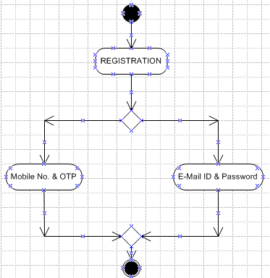

- Activity diagrams: Login Page

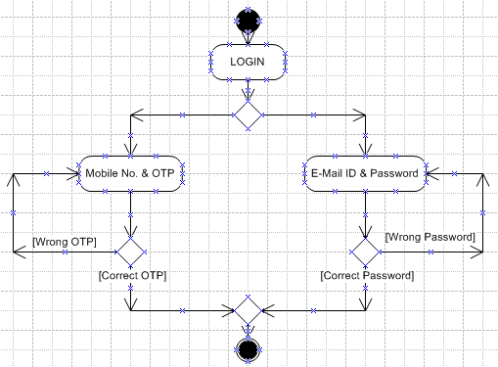

- Activity Diagram: Search Products & Add Products
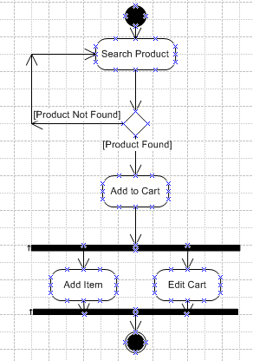
- Activity Diagram: Payment Activity

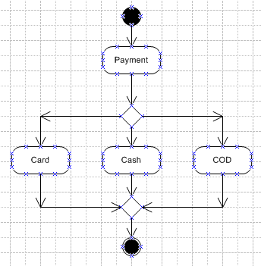

- Activity Diagram: Delivered to Address

