CAPSTONE – 2
Question 1 - 4 Quarterly Audits are planned Q1, Q2, Q3, Q4 for this Project
What is your knowledge on how these Audits will happen for a BA?
Answer:
As a Business Analyst (BA) on this project, I played a crucial role in ensuring that the solution developed meets the requirements and expectations of all stakeholders involved, including Mr. Henry, Peter, Kevin, Ben, and the committee formed by Mr. Henry, Mr. Pandu, and Mr. Dooku. Here's how the quarterly audits might happen for a BA In different phases:
1. Requirement Gathering Phase
Stage | Requirement Gathering (1 Month)
Completed | Completed
Check list | - Meeting minutes documenting discussions with stakeholders.  - Requirement gathering document capturing pain points and stakeholder requirements.  - Stakeholder analysis report including potential user needs.  - Scope statement outlining project objectives and boundaries.  - Budget and timeline overview provided by Mr. Pandu, Mr. Dooku, and the committee.
2. Requirement Analysis Phase
Stage | Requirement Analysis (1 Month)
Completed | Completed
Check list | - Refined requirements document based on stakeholder input.  - Prioritized requirements list with input from stakeholders.  - Risk assessment report identifying potential project risks.  - Technical feasibility analysis in collaboration with the development team.  - Approval documentation from the committee and stakeholders on final requirements.
3. Design Phase
Stage | Design (2 Months)
Completed | Completed
Check list | - Wireframes and prototypes for UI design.  - UI design mockups ensuring user-friendliness.  - Database schema design document for product and user data.  - Cross-platform compatibility analysis report.  - Design review feedback from development and testing teams.
4. Development Phase
Stage | Development (8 - 9 Months)
Completed | In Progress
Check list | - Development environment setup documentation.  - Backend functionalities implementation document.  - Frontend component development plan.  - Payment gateway integration documentation.  - Code review reports ensuring coding standards compliance.
5. Testing Phase
Stage | Testing (4 – 5 Months)
Completed | In progress
Check list | - Test case document covering all application functionalities.  - Unit testing report for individual modules.  - Integration testing plan and results.  - Regression testing documentation after bug fixes or enhancements.  - UAT plan and feedback summary.
6. UAT Testing Phase
Stage | UAT Testing (1 - 2 Months)
Completed | Pending
Check list | - UAT invitation documentation for stakeholders and end-users.  - Training materials provided to users during UAT.  - Issue log documenting identified issues and feedback.  - Compliance report confirming requirements fulfillment.  - Final approval documentation for production deployment.
___________________________________________________________________________
Question 2 - Before the Project is going to Kick Start, The Committee asked Mr Karthik to submit BA Approach Strategy, Write BA Approach strategy (As a business analyst, what are the steps that you would need to follow to complete a project –
- What Elicitation Techniques to apply,
- how to do Stakeholder Analysis RACI/ILS,
- What Documents to Write,
- What process to follow to Sign off on the Documents,
- How to take Approvals from the Client,
- What Communication Channels to establish n implement,
- How to Handle Change Requests, how to update the progress of the project to the Stakeholders,
- How to take signoff on the UAT- Client Project Acceptance Form)
Answer: BA Approach Strategy for the Online Agriculture Product Store Project:
1. Elicitation Techniques:
- Conduct interviews with stakeholders such as Mr. Henry, Peter, Kevin, and Ben to gather their requirements and understand their pain points.
- Use surveys and questionnaires to gather feedback from potential users in remote areas.
- Facilitate focus groups or workshops to brainstorm ideas and gather additional insights from stakeholders.
2. Stakeholder Analysis RACI/ILS:
- Identify key stakeholders, including Mr. Henry, Mr. Pandu, Mr. Dooku, Peter, Kevin, Ben, and the project team.
- Define their roles and responsibilities using a RACI/ILS matrix to ensure clarity and accountability throughout the project.
3. Documents to Write:
- Requirement documentation: Use cases, user stories, and wireframes to capture functional and non-functional requirements.
- Design documents: Architecture diagrams, system design specifications.
- Project plan: Including timelines, milestones, and resource allocation.
4. Sign off on the Documents:
- Conduct review sessions with stakeholders to validate requirements and designs.
- Obtain signoff from stakeholders on requirement documents, design artifacts, and project plan.
5. Approvals from the Client:
- Present project progress and updates to the client through regular status meetings and reports.
- Obtain formal approvals from the client at key milestones, such as completion of requirement analysis, design phase, and development phase.
6. Communication Channels:
- Establish regular communication channels such as weekly status meetings, email updates, and project management tools (e.g., Jira, Microsoft Project) to keep stakeholders informed of project progress.
- Set up a project portal or document repository for easy access to project documentation and updates.
7. Handling Change Requests:
- Implement a change request process to evaluate proposed changes' impact on project scope, timeline, and budget.
- Collaborate with stakeholders to prioritize and assess the feasibility of requested changes before implementing them.
8. Updating Progress to Stakeholders:
- Provide regular progress reports to stakeholders, highlighting key milestones achieved, risks identified, and issues encountered.
- Use visual aids such as Gantt charts or dashboards to illustrate project progress and status effectively.
9. Signoff on the UAT - Client Project Acceptance Form:
- Coordinate user acceptance testing (UAT) activities with the testing team (Mr. Jason and Ms. Alekya) and stakeholders to validate the system meets user requirements.
- Obtain signoff on the UAT-Client Project Acceptance Form from stakeholders to formally acknowledge their satisfaction with the delivered solution.
By following this BA approach strategy, we aim to ensure clear communication, thorough documentation, stakeholder engagement, and effective change management throughout the project lifecycle, ultimately delivering a successful online agriculture product store that meets the needs of farmers and manufacturers.
___________________________________________________________________________
Question 3 – Explain and illustrate 3-tier architecture?
Answer:
1. Presentation Tier (Tier 1):
- This tier represents the user interface and interaction layer. In the case of the agriculture product store, the presentation tier includes the web or mobile application interface that farmers will use to browse and purchase products.
- Components such as HTML/CSS for web pages or UI elements for mobile apps reside in this tier.
- In the development team, Java developers like Ms. Juhi, Mr. Teyson, Ms. Lucie, Mr. Tucker, and Mr. Bravo would be responsible for building and maintaining this tier.
2. Application Tier (Tier 2):
- The application tier, also known as the logic tier or middle tier, handles the business logic and processing of the application. It acts as an intermediary between the presentation and data tiers.
- In the case of the agriculture product store, this tier includes the server-side logic responsible for managing product listings, processing orders, handling user authentication, and facilitating communication between farmers and product manufacturers.
- Components such as server-side Java code or application frameworks like Spring Boot may be used in this tier.
- Java developers like Ms. Juhi, Mr. Teyson, Ms. Lucie, Mr. Tucker, and Mr. Bravo would also contribute to developing and maintaining the application tier.
3. Data Tier (Tier 3):
- The data tier is responsible for managing the storage and retrieval of data used by the application. It typically consists of a database or multiple databases where information such as product details, user accounts, and order history are stored.
- In the case of the agriculture product store, the data tier would store information about fertilizers, seeds, pesticides, farmer profiles, orders, etc.
- Database administrators (DB Admin) like John would be responsible for designing and maintaining the database structure, ensuring data integrity, and optimizing database performance.
- Additionally, network administrators like Mr. Mike would ensure secure and efficient communication between the application tier and the database tier.
___________________________________________________________________________
Question 4: Business Analyst should keep What points in his/her mind before he frames a Question to ask to the Stakeholder (5W 1H – SMART – RACI – 3 Tier Architecture – Use Cases, Use case Specs, Activity Diagrams, Models, Page designs)
Answer:
1. 5W 1H:
- Who: Identify the stakeholders involved in the project, such as farmers, manufacturers, project committee members (Mr. Henry, Mr. Pandu, Mr. Dooku), and the development team.
- What: The need for easy procurement of agricultural products and efficient communication between farmers and manufacturers.
- When: The project was handed over to APT IT SOLUTIONS company under CSR initiative for 18 months duration.
- Where: The project is focused on helping farmers in a remote village.
- Why: Mr. Henry's desire to help farmers and address common agricultural challenges.
- How: The project involves collaboration between SOONY Company, APT IT SOLUTIONS company, and the stakeholders (Peter, Kevin, and Ben).
2. SMART Criteria:
- Specific:
- Objective: To develop an online agricultural product store facilitating farmers' access to fertilizers, seeds, and pesticides.
- Target Audience: Farmers in remote areas facing procurement challenges.
- Deliverables: User-friendly web/mobile application connecting farmers directly with product manufacturers.
- Measurable:
- Metrics: Number of registered farmers on the platform, volume of products sold, user satisfaction ratings, reduction in procurement time for farmers.
- Achievable:
- Feasibility: Utilizing existing technology and expertise within APT IT SOLUTIONS, with a budget of 2 Crores INR and a duration of 18 months.
- Relevant:
- Alignment: Addresses a significant problem faced by farmers, contributing to rural development and fulfilling CSR objectives of SOONY Company.
- Time-bound:
- Deadline: Project completion within 18 months.
- Milestones: Set timelines for development phases, testing, and deployment to ensure timely delivery.
3. RACI Matrix:
- Clarify roles and responsibilities when asking questions, ensuring that stakeholders understand their involvement and contribution to the project.
- Clearly define who is Responsible, Accountable, Consulted, and Informed regarding specific aspects of the project, such as requirements gathering, decision-making, and implementation.
4. 3 Tier Architecture:
- Consider the architectural framework of the project when framing questions, ensuring alignment with the presentation, application, and data tiers.
- Ask stakeholders about their requirements and preferences related to each tier, such as user interface design, business logic, and data storage and retrieval.
5. Use Cases, Use Case Specs, Activity Diagrams, Models, Page Designs:
- Use these artifacts to inform and structure questions to stakeholders, seeking feedback and clarification on specific features, functionalities, and user interactions.
- Validate use cases and activity diagrams with stakeholders to ensure they accurately represent their needs and workflows.
- Discuss page designs and models to gather input on user interface preferences, usability requirements, and visual aesthetics.
___________________________________________________________________________
Question 5 - As a Business Analyst, What Elicitation Techniques you are aware of? (BDRFOWJIPQU)
Answer:
1. Brainstorming:
- Gather stakeholders, including farmers, manufacturers, and project committee members, for collaborative idea generation sessions.
- Encourage open discussion to generate innovative ideas for features, functionalities, and user experiences of the online platform.
2. Document Analysis:
- Review existing documents such as project charters, business plans, and market research reports to understand project objectives, constraints, and industry trends.
- Analyse any relevant documents provided by stakeholders, such as product specifications or regulatory requirements for agricultural products.
3. Requirements Workshops:
- Organize interactive workshops with stakeholders to gather requirements collectively.
- Facilitate discussions and activities to identify stakeholders' needs, priorities, and preferences for the online agriculture product store.
4. Focus Groups:
- Form focus groups consisting of representative stakeholders, such as farmers from different regions and manufacturers of agricultural products.
- Conduct structured discussions to explore specific topics or gather feedback on proposed solutions and prototypes.
5. Observation:
- Observe stakeholders in their natural environment, such as visiting farms or agricultural facilities, to understand their workflows, pain points, and opportunities for improvement.
- Note observations related to how farmers procure agricultural products, manage crops, and interact with suppliers.
6. Workshops:
- Conduct interactive workshops with stakeholders to explore specific topics or address particular aspects of the project, such as user interface design or data management.
- Use hands-on activities and exercises to engage stakeholders and elicit detailed requirements.
7. Interviews:
- Conduct one-on-one interviews with key stakeholders, including Mr. Henry, Peter, Kevin, Ben, and members of the project committee.
- Ask targeted questions to understand their perspectives, goals, challenges, and expectations for the online agriculture product store.
8. Prototyping:
- Develop prototypes or mock-ups of the online platform to visualize proposed solutions and gather feedback from stakeholders.
- Use prototypes to demonstrate key features, user interactions, and workflows, allowing stakeholders to provide input on design and functionality.
9. Questionnaires and Surveys:
- Distribute questionnaires or surveys to a wide range of stakeholders to gather quantitative and qualitative data on their needs, preferences, and satisfaction levels.
- Use survey results to identify common themes, prioritize requirements, and validate proposed solutions.
10. User Stories:
- Collaborate with stakeholders to create user stories that capture specific requirements from the perspective of end users, such as farmers, manufacturers, and administrators.
- Use user stories to prioritize features, define acceptance criteria, and guide development iterations.
___________________________________________________________________________
Question 6 – Which Elicitation Techniques can be used in this Project and Justify your selection of Elicitation Techniques?
Answer:
1. Document Analysis: This technique involves reviewing existing documentation related to the project, such as project charters, business plans, and organizational process assets. In this case, I will analyse any documents provided by Mr. Henry's company SOONY regarding their goals, objectives, and initial project requirements. This will give Me a foundation to understand the project scope and expectations.
2. Brainstorming: Brainstorming sessions with the project team, including stakeholders like Peter, Kevin, and Ben, can be incredibly valuable for generating ideas and gathering requirements. It's a creative process that encourages collaboration and can uncover insights that might not have been apparent initially. Brainstorming can help in identifying features, functionalities, and potential challenges associated with the development of the online agriculture product store.
3. Prototyping: Prototyping involves creating a simplified version of the final product to gather feedback and refine requirements. Given the complexity of the project and the need for user-friendliness emphasized by Mr. Henry, prototyping can be a powerful technique. It allows stakeholders to visualize the proposed solution, provide feedback early in the development process, and ensure that the final product meets their expectations. Prototypes can be especially useful for testing user interfaces and workflows.
Justification:
- Document Analysis: This technique provides a starting point for understanding the project's background, objectives, and initial requirements. By analyzing existing documents, you can gain insights into the context of the project and identify key stakeholders' expectations and goals.
- Brainstorming: Brainstorming sessions allow for creative thinking and idea generation. By involving stakeholders like Peter, Kevin, and Ben, you can gather diverse perspectives and insights into the requirements of the online agriculture product store. Brainstorming also fosters collaboration and can help build consensus among stakeholders.
- Prototyping: Prototyping is essential for validating requirements and ensuring that the final product meets stakeholders' needs and expectations. By creating prototypes, you can visualize the proposed solution and gather feedback early in the development process. This iterative approach helps identify potential issues and refine requirements before investing significant time and resources into development.
___________________________________________________________________________
Question 7 – Identify at least 10 Business Requirements.
Answer:
Business Requirements:
1. BR001: The application should support multi-factor authentication for user login to enhance security.
2. BR002: Farmers should be able to search for available products in fertilizers, seeds, and pesticides. Additionally, farmers should be able to view detailed product descriptions, including ingredients, usage instructions, and product specifications.

3. BR003: Manufacturers must verify their identity and product authenticity before listing products on the platform.
4. BR004: The application should have a user-friendly interface with intuitive navigation to enhance user experience.
5. BR005: Farmers should have the option to save favourite products or create a Wishlist for future reference.
6. BR006: Manufacturers should receive notifications for new orders and manage order fulfilment through the platform.
7. BR007: The application should provide real-time updates on order status, including processing, shipping, and delivery.
8. BR008: Users should have access to a secure and seamless payment gateway that supports multiple payment methods, such as UPI, cash on delivery, and online payment.
9. BR009: The application should provide a feedback mechanism for users to rate products and provide reviews.
10. BR010: The platform should have built-in analytics to track user activity, product popularity, and sales trends for business insights.
___________________________________________________________________________
Question 8 – Make suitable Assumptions (List of Assumptions)
Answer:
Assumptions:
1. Internet Connectivity: It is assumed that farmers and manufacturers have access to stable internet connectivity to use the online agriculture product store effectively.
2. User Accessibility: Users have access to devices like smartphones or computers with internet connectivity to access the online agriculture product store.
3. User Knowledge: Users, including farmers and manufacturers, possess basic knowledge of using internet-based applications and are comfortable with online transactions.
4. Product Availability: It is assumed that manufacturers will update product availability in real-time, ensuring accurate representation of available products in the catalogue.
5. Product Diversity: It is assumed that a diverse range of fertilizers, seeds, and pesticides are available from various manufacturers to populate the product catalogue.
6. Payment Gateway Integration: The payment gateway will be integrated with the application to facilitate secure transactions between users and manufacturers.
7. Delivery Infrastructure: There is an existing delivery infrastructure in place to facilitate the shipping of products from manufacturers to farmers, either through third-party logistics services or dedicated delivery channels.
8. Product Quality Assurance: Manufacturers are responsible for ensuring the quality and authenticity of the products listed on the platform.
9. User Support: There will be provisions for user support, including FAQs, tutorials, and customer service channels, to assist users in navigating the application and resolving issues.
10. Regulatory Compliance: The application will comply with relevant regulations and standards governing agricultural product sales and e-commerce.
11. Legal Compliance: The online agriculture product store complies with relevant laws and regulations governing e-commerce, data protection, and agricultural product sales in the region of operation.
12. Data Privacy and Security: The application will implement robust measures to safeguard user data and ensure privacy and security throughout the platform.
13. Feedback Mechanism: There will be a feedback mechanism in place for users to provide input, suggestions, and complaints about the application's functionality and user experience.
14. Scalability: The platform is designed to handle a potentially large volume of users and transactions, with scalability built into its infrastructure to accommodate future growth.
___________________________________________________________________________
Question 9 – Give Priority 1 to 10 numbers (1 being low priority – 10 being high priority) to these Requirements after discussions with the stakeholders
Answer:
Req. ID | Req. Name | Req. Description | Priority
BR001 | Multi-factor authentication | Enable multi-factor authentication for enhanced login security. | 8
BR002 | Farmer Search for Products | Allow farmers to search and view detailed product descriptions for fertilizers, seeds, and pesticides. | 7
BR003 | Manufacturer verification | Mandate manufacturer verification for listing product authenticity | 10
BR004 | User-friendly interface | Ensure a user-friendly interface with intuitive navigation. | 9
BR005 | Save favourite products/Wishlist | Enable farmers to save favorite products or create a Wishlist. | 6
BR006 | Order notifications for manufacturers | Provide manufacturers with order notifications and management capabilities. | 8
BR007 | Real-time order status updates | Offer real-time updates on order status, including processing, shipping, and delivery. | 10
BR008 | Secure payment gateway | Implement a secure and versatile payment gateway supporting UPI, cash on delivery, and online payments. | 10
BR009 | Feedback mechanism | Incorporate a feedback mechanism for product ratings and reviews. | 7
BR0010 | Analytics for business insights | Include built-in analytics for tracking user activity, product popularity, and sales trends. | 9
___________________________________________________________________________

Question 10 – Use Case Diagram
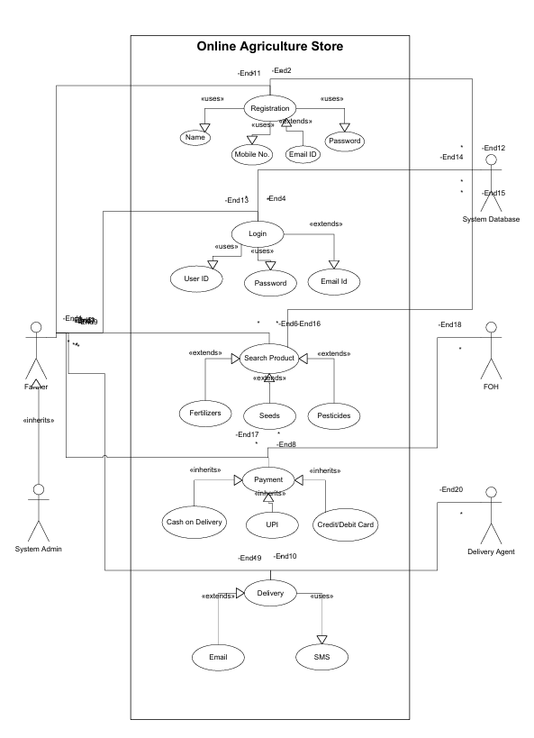
Answer:

___________________________________________________________________________
Question 11 – Prepare use case specs for all use cases
Answer:
1. Register
Use Case ID | UC001
Use Case Name | Register
Created By |  | Last Updated By
Date Created |  | Last Revisions Date
Actor | Farmer And Manufacturer
Description | Users can register for a new account.
Pre-Condition | User should have internet connection.
Post-Condition | User is registered successfully to login into system.
Normal Flow of events/Basic Flow/Happy Path | 1. User clicks on the register/ Sign up option.  2. User Need fill out the registration form with their Name, Mobile No., email and password.  4. The system verifies the info and registers to database.
Alternative Flow | If the user enters invalid credentials, the system prompts them to enter valid credentials.
Exception
Frequency of use | High
2. Login
Use Case ID | UC002
Use Case Name | Login
Created By |  | Last Updated By
Date Created |  | Last Revisions Date
Actor | Farmer And Manufacturer
Description | Users can log in to their existing account.
Pre-Condition | User should be registered into database
Post-Condition | User is logged in to the system.
Normal Flow of events/Basic Flow/Happy Path | 1. User clicks on the login/register option.  2. If the user has an existing account, they enter their email and password.  3. If the user is new, they fill out the registration form with their email and password.  4. The system verifies the credentials and logs the user in or registers them accordingly.
Alternative Flow | If the user enters invalid credentials, the system prompts them to enter valid credentials.
Exception
Frequency of use | High
3. Search product
Use Case ID | UC003
Use Case Name | Search Product
Created By |  | Last Updated By
Date Created |  | Last Revisions Date
Actor | Farmer
Description | The farmer wants to search for products in fertilizers, seeds, and pesticides, and view detailed product descriptions.
Pre-Condition | Farmer is logged into the application.
Post-Condition | Farmer obtains information about desired products.
Normal Flow of events/Basic Flow/Happy Path | 1. Farmer navigates to the search functionality.  2. Farmer enters search query (e.g., fertilizer, seed).  3. System retrieves relevant products and displays them.  4. Farmer selects a product to view detailed description.  5. System displays detailed product information including ingredients, usage instructions, and specifications.
Alternative Flow | If no matching products are found, the system displays a message indicating that no results were found.
Exception | Invalid credentials entered: system prompts user to enter valid credentials.
Frequency of use | High
4. Browse Product
Use Case ID | UC004
Use Case Name | Browser Products
Created By |  | Last Updated By
Date Created |  | Last Revisions Date
Actor | Farmer And Manufacture
Description | Users can browse through the available products in the online agriculture product store.
Pre-Condition | User is logged in (optional).
Post-Condition | User has browsed through the available products, also Farmer obtains information about desired products.
Normal Flow of events/Basic Flow/Happy Path | 1. User navigates to the product catalog.  2. The system displays a list of available products, including their names, images, and prices.  3. User can scroll through the list to view different products.
Alternative Flow | If the user is not logged in:  1. The system displays a message prompting the user to log in or continue browsing as a guest.  2. User can choose to log in or continue as a guest.
Exception | 1. No products available: system displays a message; user can go back or perform another action.  2. Technical issue fetching catalog: system shows an error message; user can refresh or try again later.  3. Difficulty scrolling: system provides navigation controls; user navigates with ease.
Frequency of use | High
5. Wishlist
Use Case ID | UC005
Use Case Name | Add to Wishlist
Created By |  | Last Updated By
Date Created |  | Last Revisions Date
Actor | Farmer
Description | The farmer wants to save favourite products or create a Wishlist for future reference.
Pre-Condition | Farmer is logged into the application.
Post-Condition | Farmer's favourite products are saved for future reference.
Normal Flow of events/Basic Flow/Happy Path | 1. User navigates to the product details page.  2. User clicks on the "Add to Wishlist" button next to the desired product.  3. The system adds the product to the user's Wishlist.
Alternative Flow | If the user is not logged in:  1. The system prompts the user to log in before adding the product to the Wishlist.  2. User logs in with their credentials.  3. The system adds the product to the user's Wishlist.  Saving process fails due to technical issues
Exception | If the user encounters an error while adding the product to the Wishlist:  - The system displays an error message.  - User can try adding the product again or perform another action.
Frequency of use | Medium
6. Checkout
Use Case ID | UC006
Use Case Name | Checkout
Created By |  | Last Updated By
Date Created |  | Last Revisions Date
Actor | Farmer
Description | Farmers can proceed to checkout and complete their purchase.
Pre-Condition | User is logged in and has added products to their shopping cart.
Post-Condition | User has completed the purchase and receives a confirmation of the order.
Normal Flow of events/Basic Flow/Happy Path | 1. User navigates to the shopping cart.  2. User reviews the items in their cart and adjusts quantities if necessary.  3. User clicks on the "Checkout" button.  4. The system prompts the user to enter shipping and payment information.  5. User completes the checkout process.
Alternative Flow | If the user chooses cash on delivery as the payment method:  1. The system skips the prompt for payment information.  2. User confirms the order.  3. The system displays a confirmation message and processes the order for cash on delivery.
Exception | If the user's selected payment method fails:  - The system displays an error message.  - User can choose an alternative payment method or cancel the checkout process.
Frequency of use | High
7. Delivery Tracking
Use Case ID | UC007
Use Case Name | Delivery Tracking
Created By |  | Last Updated By
Date Created |  | Last Revisions Date
Actor | Farmer
Description | Farmers can track the delivery status of their orders.
Pre-Condition | Order should be placed
Post-Condition | User has viewed the delivery status of their order.
Normal Flow of events/Basic Flow/Happy Path | 1. User navigates to the order tracking section.  2. User enters the order ID or selects the order from their order history.  3. The system retrieves the current delivery status of the order and displays it to the user.
Alternative Flow | If the user doesn't have the order ID:  1. The system prompts the user to check their email for the order confirmation.  2. User clicks on the order confirmation email.  3. The system redirects the user to the order tracking section with the order ID pre-filled.
Exception | If the user enters an invalid order ID:  - The system displays an error message.  - User can re-enter the order ID or contact customer support for assistance.
Frequency of use | Medium
___________________________________________________________________________
Question 12 – Activity diagrams
Answer:
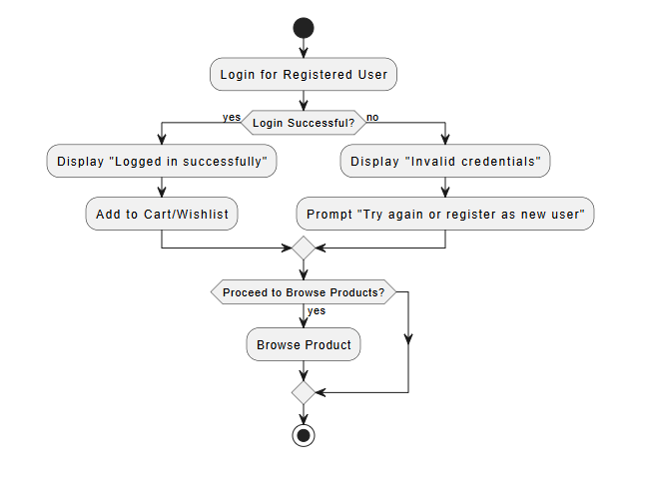
- Registered Login
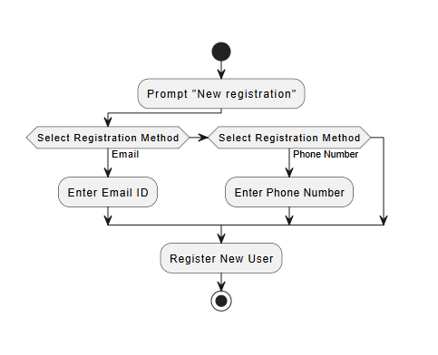
- New Registration

- Search Product
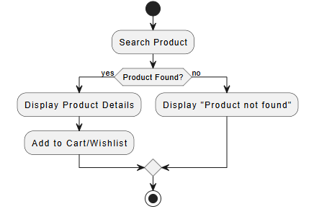
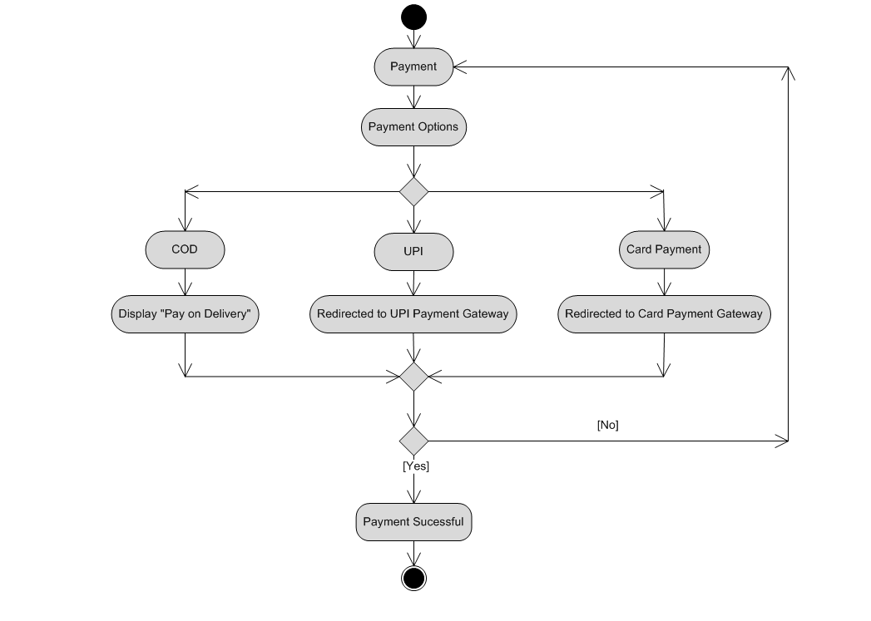
- Payment

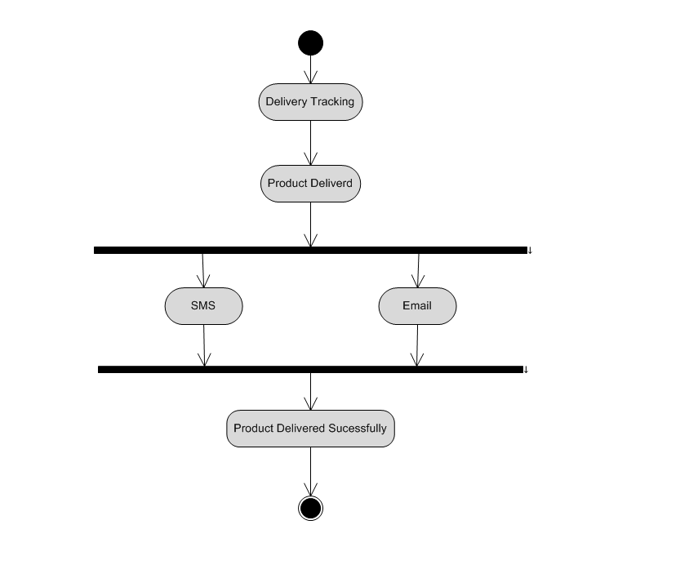
- Delivery Tracking
Mock-up
