AGILE DELIVERABLES PART - 2
PROJECT DELIVERABLES
CENTRAL PROVIDER FILE TOOL (CPF)

DOCUMENT-1 – Definition of Done
The Definition of Done (DOD) checklist ensures that the provider Management tool and central provider tool enhancements meets the quality standards before being considered complete.

Definition of Done (DOD) for the Enhancements –
User story level –
- Requirement and Analysis –
The user story is clearly defined using the standard format:
“As a [provider], I want to [perform payment action], so that [I can easily make secure payments].”
Stakeholders (Providers, Product Owner, Compliance Team) have reviewed and approved the story.
The story is linked to the Product Backlog Item (PBI) or epic for traceability.

- Design and Develop DOD –
The UI/UX design reflects the approved prototype and meets accessibility
The integration with existing payment gateways or provider systems is validated in a dev/test environment.
he API changes, if any, are documented and versioned properly.
- Testing the DOD-
All unit integration and functional test cases are created and executed successfully.
Acceptance Criteria are fully tested and passed.
UAT sign off received from end users or providers representatives.
- Compliance & Performance DoD-
Data transfer and payment transactions comply with PCI DSS, HIPAA, and U.S. data

privacy laws. Error logging and monitoring mechanisms are in place.

Audit trail is captured for payment related actions.
- DoD Enhancements for Website
User Story documentation is updated in the backlog management tool (e.g., Jira, Azure DevOps).
BRD, FSD and process flow diagrams, (AS -IS, TO BE) are updated and reflected the enhancement
- Stake holder and product owner Approval -
Product owner verification whether this enhancement meets the business value and complexity points
All stakeholders take sign off that the enhancement fulfils the purposes.
The user story is marked as Done in Jira
Sprint Level –
QA performance and issues Resolved – Testing team verifies functionality, performance and security issues.
Project Delayed on test Environment identical to production – Features are like production, providers data.
Tests on required devices/browsers passed- Compatibility checks across the browsers/devices.
Feature by UX designers – UI/UX Team approves design consistency.
Refactoring completed- code optimized for performance and readability.
Release Level-
Any configuration or build changes documented- Changes in API, database are properly recorded.
Documentation Updated – User guides, FAQS and technical documentation
Stake holder Approval- Product Owner, Business Team, and mentors meet the expectations.
This DOD ensures that the Enhancements are fully functional, tested and aligned the needs before the release.

Document-2 Product Vision Document
Scrum Project Name | CPF Tool Enhancements and FSPM digital platform
Venue | Online/company office
Date | Start time: | End Time: | Duration:
Client | Cigna
Stake Holder List- | - Providers (Should be able to review the details and receive the payments accurately)  - Users (Responsible for uploading the details, monitoring the provider lists and giving the payment links)  - Admin Team (Manages the Providers tool and documents the Functionality of the platform)  - Product Owner (Defines the requirements and ensures the alignment with the business goals)  - Scrum Team – (Responsible for the development, testing and Deployments)
Scrum Team | - Scrum Master – Anusha  - Product Owner – Sangeetha  - Scrum Developer 1- Akhila  - Scrum Developer 2- Anitha  - Scrum Developer 3- Kalyani  - Scrum Developer 4-Mansi  - Scrum Developer 5- Rachitha

This product Vision Document serves as a foundation for guiding the LMS enhancements through the Agile Scrum Framework, ensuring smooth collaboration between stakeholders and the development team.
Vision – The Vision for this Enhancement of provider Management, Improves the accessibility to providers and enhance the overall provider experiences by providing a centralized platform for tracking providers data, Feedbacks and document managements. This ensures that providers can access to the website and check the details and get their payments accurately and track their progress seamlessly.
Target Groups | Needs | Product | Value
- The product targets the U.S. healthcare payment and provider management segment, focusing on organizations involved in medical billing, provider reimbursements, and hospital/vendor payments.  - Target Users –  - Primary Users like Healthcare providers, Administrative staff.  - Secondary Users -Payers like (Insurance Companies, Clinics)  - System Administrators like Finance and compliance Teams  - Customers | Problem Solved –  • Providers currently face manual, time-consuming payment processes that lead to errors, delays, and compliance risks.  • Lack of digital integration with payer systems causes inefficiency, payment disputes, and poor tracking.  • Manual handling increases administrative costs and reduces productivity. | What Product is it?  • A web-based digital payment platform tailored for healthcare providers in the USA.  • Core features include:  - Secure provider login and authentication  - Payment initiation (credit card, ACH, net banking)  - Invoice viewing and payment history  - Automated email confirmations and notifications  - Real-time dashboards and reporting | How does it benefit the company?  • Strengthens the organization’s digital presence in the U.S. healthcare sector.  • Demonstrates CSR impact by supporting providers and improving healthcare operations.  • Enhances brand reputation as a socially responsible and tech-driven company.  • Reduces operational costs and manual workload for finance teams.
Document -3 User Stories
User Story No: 1 | Tasks:2 |  | Priority: HIGHEST
As a Provider,
I want to login securely to the portal
So that I can access my payment dashboard safely.
BV- 500 |  | CP-5
Acceptance Criteria –
- Given a registered provider, when they enter valid credentials, then the system grants access to the dashboard.
- Given incorrect credentials, when the provider attempts login, then an error message is displayed.
- Given 3 failed attempts, when the provider retries, then their account is temporarily locked for 15 minutes.

User Story No: 2 | Tasks:2 |  | Priority: HIGHEST
As a provider
I want to view my payment status and history
So that I can track pending and completed payments easily.
BV- 200 |  | CP-3
Acceptance Criteria –
• Given a logged-in provider, when they navigate to the dashboard, then all invoices and payment statuses are displayed.
• Given successful payments, when the page loads, then transaction details appear with status "Paid".
• Given unpaid invoices, when displayed, then a “Pay Now” option is visible.

User Story No: 3 | Tasks:2 |  | Priority: HIGHEST
As a Provider,
I want to Make payments online
So that I can settle invoices without paper.
BV- 500 |  | CP-8
Acceptance Criteria –
• Given a provider selects “Pay Now,” when they enter valid payment details, then the transaction processes successfully.
• Given invalid card details, when the payment is submitted, then the system displays an error.
• Given successful payment, when confirmed, then the provider receives a confirmation message and receipt.

User Story No: 4 | Tasks:2 |  | Priority: Medium
As a Provider,
I want to download and receive my payment receipt
So that I can maintain my records
BV- 200 |  | CP-5
Acceptance Criteria –
• Given a successful payment, when completed, then a downloadable PDF receipt is available.
• Given an email ID on file, when the payment completes, then a receipt is automatically emailed to the provider.

User Story No: 5 | Tasks:2 |  | Priority: HIGHEST
As a Provider,
I want to view detailed invoices
So that I can verify charges before making payments.
BV- 100 |  | CP-3
Acceptance Criteria –
• Given a logged-in provider, when they click an invoice, then all line items and due amounts are shown.
• Given invoices are overdue, when viewed, then the due date and penalty (if any) are displayed.

User Story No: 6 | Tasks:2 |  | Priority: HIGHEST
As a Provider,
I want to receive notifications
So that I can stay updated about due dates and confirmations
BV- 200 |  | CP-5
Acceptance Criteria –
• Given an invoice due, when 3 days remain, then a reminder email/SMS is sent.
• Given a successful payment, when completed, then an instant confirmation notification is sent.

User Story No: 7 | Tasks:2 |  | Priority: Medium
As a Provider,
I want to reset my password securely,
So that I can regain access if I forget it
BV- 500 |  | CP-8
Acceptance Criteria –
• Given a provider clicks “Forgot Password,” when they provide a valid email, then a reset link is sent.
• Given an expired link, when used, then the system displays an error message.

User Story No: 8 | Tasks:2 |  | Priority: HIGHEST
As a Provider,
I want to filter my payment history,
So that I can find specific transactions easily.
BV- 200 |  | CP-5
Acceptance Criteria –
• Given a search query, when entered, then matching payments are displayed.
• Given filters by date or amount, when applied, then only relevant transactions appear.

User Story No: 9 | Tasks:2 |  | Priority: LOW
As a Provider,
I want to export my payment reports,
So that I can share or analyze them offline.
BV- 500 |  | CP-8
Acceptance Criteria –
Given payment records, when “Export” is clicked, then data is downloaded in the selected format (PDF).

User Story No: 10 | Tasks:2 |  | Priority: Medium
As a Provider,
I want to ensure the payments are Encrypted,
So that I can check with the system’s security
BV- 200 |  | CP-13
Acceptance Criteria –
• Given a payment in progress, when submitted, then card data is encrypted.
• Given data transmission, when occurring, then HTTPS is used for secure connection.

User Story No: 11 | Tasks:4 |  | Priority: HIGHEST
As a Provider,
I want to verify my identity using OTP,
So that I can Protect my account from unauthorized access.
BV- 500 |  | CP-5
Acceptance Criteria –
• Given MFA enabled, when provider logs in, then an OTP is sent to their registered device.
• Given wrong OTP, when entered, then login is denied.

User Story No: 12 | Tasks:4 |  | Priority: Medium
As a Provider,
I want to see my payment history,
So that I can ensure payment accuracy compliance
BV- 500 |  | CP-5
Acceptance Criteria –
•Given admin login, when accessing dashboard, then payment transactions are listed with filters.
• Given payment discrepancies, when found, then admin can flag and review them.

User Story No: 13 | Tasks:4 |  | Priority: HIGHEST
As a Provider,
I want to take the payment directly from banks,
So that I can reduce my work and manual entry
BV- 200 |  | CP-8
Acceptance Criteria –
- Given bank API integration, when payment is initiated, then funds are transferred automatically.
- Given connection failure, when detected, then system retries or alerts the user.

User Story No: 14 | Tasks:4 |  | Priority: Medium
As a User Provider,
I want to get instant help,
So that I can resolve payment related issues quickly.
BV- 500 |  | CP-5
Acceptance Criteria –
• Given chat is available, when provider opens it, then they can interact with support or a chatbot.
• Given issue is unresolved, when escalated, then it is logged for manual follow-up.

User Story No: 15 | Tasks:4 |  | Priority: HIGHEST
As a User Provider,
I want to use assistive features,
So that I can receive payments without barriers.
BV- 500 |  | CP-13
Acceptance Criteria –
- Given the website, when accessed by screen readers, then all elements are readable.
- Given colour contrast settings, when tested, then text remains visible for visually impaired users.

Document -4 Agile PO Experience.
Agile Product Owner Experience –
The product Owner plays a crucial role in Agile projects by maintaining a clear vision while aligning it with market demand and industry experiences.
My Involvement and Responsibilities –
As the product Owner, I was actively involved in every stage of the Agile Deliverables process, ensuring smooth coordination between stakeholders and the development team.

My Key Responsibilities Included-
Market Analysis –
- Conduct market need and demand analysis to identify gaps and opportunities.

- Study availability of similar products and competitors in the healthcare payment sector.

- Evaluate emerging digital payment trends and user behaviour patterns in the U.S. market.
Enterprise Analysis -
- Perform assess to the market opportunity and potential ROI.

- Collaborate with business stakeholders to ensure the product aligns with the organization’s CSR and strategic goals.

- Analyse regulatory and compliance requirements (HIPAA) relevant to the market.
Product Vision and Roadmap -
- Define a clear product vision that focuses on simplifying and digitizing provider payments.

- Create a product roadmap outlining high-level features, milestones, and delivery timelines.

- Continuously refine the vision based on stakeholder feedback, market trends, and end-user insights.

Managing Product Features -
•Maintain and prioritize the product backlog to reflect current business priorities.
• Reprioritize user stories based on new feedback or changing stakeholder needs.
• Conduct epic and story planning sessions with the Business Analyst and Scrum team.
• Ensure backlog items are clearly defined, estimated, and ready for sprints.
Managing product Backlog -
- Organised and prioritized user stories for development

- Adjusted prioritization based on evolving business needs.

- Planned and managed epics effectively to ensure smooth iterations.
Managing overall Iteration Progress -
- Review sprint progress regularly to ensure development aligns with roadmap goals.

- Participate in sprint planning, review, and retrospectives with the Business Analyst
and Scrum Master.

- Support re-prioritization of sprints or epics when business priorities shift.

- Validate sprint outcomes and ensure deliverables meet the Definition of Done (DoD).

How I conducted and Participated in Meetings –
Sprint Planning Meeting –
- Facilitated discussions on sprint goals and backlog prioritization
- Ensured all user stories were defined with acceptance criteria
- Assigned business value (BV) and Complexity Points (CP) for efficient Backlog management
Daily Scrum Meeting –
- Attend stand -ups to track progress, identify blockers, and provide necessary clarifications.
- Ensured the team was aligned with business Objectives and had clear priorities.
- Addressed issues raised by the development team to prevent delays.
Sprint Review Meeting –
- Led Demonstrations of completed features to stakeholders.
- Gathered feedback and Incorporated necessary changes into the back log.
- Assessed product quality, user experiences, and feature completeness.
Sprint Retrospective Meeting –
- Conducted discussions on what went well and areas for improvement.
- Identified process inefficiencies and suggested workflow optimizations
- Encouraged open feedback to enhance team collaboration and sprint effectiveness
Backlog Refinement Meeting -
- Reprioritized backlog items based on stakeholder feedback and changing requirements.
- Break down epics into smaller, more manageable user stories for future sprints.
- Ensured backlog was continuously refined to meet evolving business needs.

Key Learnings from this Project –
- Through this project, I gained valuable insights into Agile Methodologies and effective sprint management particularly in:
- Creating and Managing user stories effectively.
- Conducting Agile Ceremonies to maximize collaboration and efficiency.
- Prioritizing backlog items based on business Impact.
- Continuously improving team coordination and sprint Execution.
Additional Contributions and Improvements –
- Established a structured approach to backlog management for better workflows and
- efficiency.
- Enhanced stakeholder engagement through structured meetings and clear communications.
- Implemented prioritization techniques to ensure high value features were delivered first.
- The role of the Product Owner in Agile Project is Dynamic and essential in delivering a
- successful product that meets the business objectives while ensuring user satisfaction.
- My Involvement in all agile Ceremonies and backlog management ensured a seamless
- development process and timely delivery of valuable product Enhancements.
Document -5 Product and Sprints Backlog and Product and Sprint Burndown Charts
Product Backlog –
Sprint Burn chart – It is a graphical view of the un remaining work left version the time in the Iteration. A project backlog can be expressed on the vertical axis, while time is indicated on the horizontal axis .
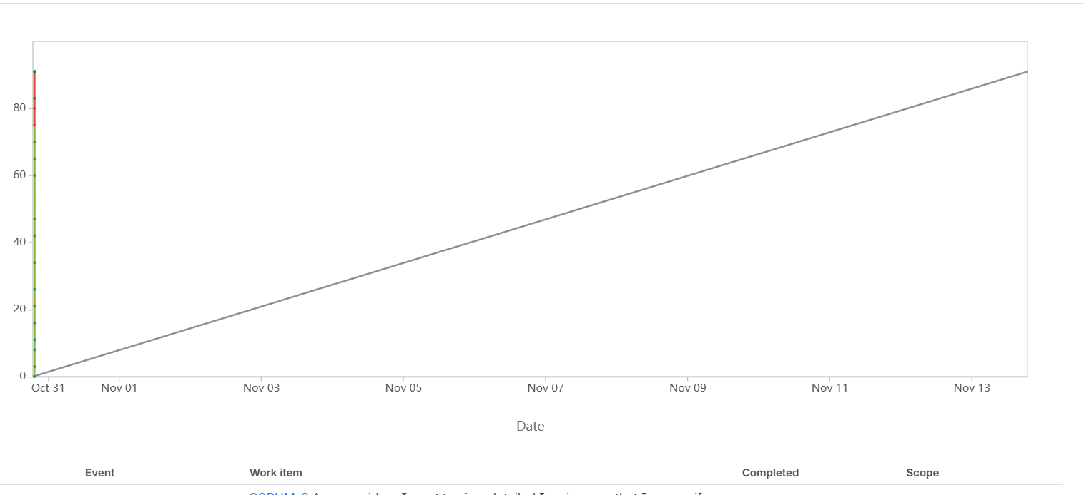

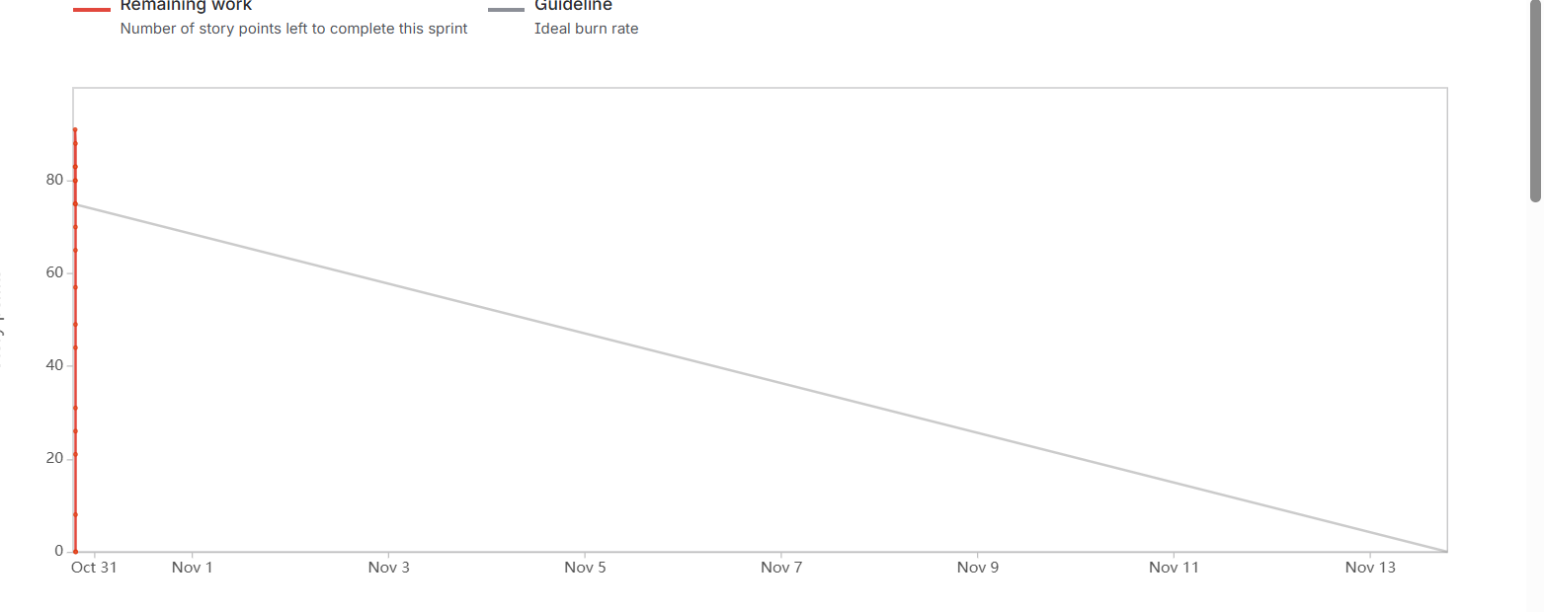

Sprint Burndown Chart – It shows the amount of work remaining in the product Backlog item helps in visualizing whether they are on the track to complete the project within the time.

Document -6 Sprint Meetings.
Meeting Type -1 Sprint Planning Meeting.
Date – 01-11-2025
Time- 10.00 AM -11.30 AM
Location- Conference Room/Virtual Meeting
Prepared by – Sangeetha
Attendees- Product Owner, Scrum Master, Developers, QA, Business Analyst
Agenda Topics -

Topic | Presenter | Time Allotted
Review of backlog Items  Prioritization of Backlog items | Product Owner  Scrum Master | 15mints  10mints

Topic | Presenter | Time Allotted
Sprint Goal Setting  Assigning Task to Team Members  Identifying risks and dependencies  Q& A and Finalization | Business Analyst  Scrum Master  Business Analyst  All | 15mints  20 Mints  20 Mints  10mints

Other Information –
Observers – Stake Holders, Trainers
Resources- Jira Board, Confluence Documentation, Project Backlog
Special Notes - Sprint to focus on Implementing Nurturing Sessions Tab and Documents Tab with core functionalities

Meeting Type -2 Sprint Review Meeting
Date – 02-11-2025
Time- 3.00 -4.30 PM
Location – Conference Room/ Virtual Meeting
Attendees – Product Owner, Scrum Master, Developers, QA, Business Analyst, stake holders

Sprint Review Agenda –

Sprint Status | Things to do Demo | Quick Updates | What’s Next
Completed 100% of the planned enhancements  Documents Tab successfully Implemented | Demo of Providers Digital Platform, Links, View the details, Payment Options  Providers can now view the transactions of their payments and draw them directly from their UPI services | Providers can now access to the portal and collect the payments  Ensuring all the options are available for the providers | Gathering the providers details to refine the features  UI? UX Improvements based on the providers feedbacks

Meeting type -3
Sprint Retrospective Meeting
Date – 02-11-2025
Time- 11.00 AM -12.30 PM
Location- Conference Room/Virtual Meeting
Prepared by -Sangeetha
Attendees- Scrum Team, Business Analyst, QA
Retrospective Agenda –

Discussion Points | Notes
What went well?  What didn’t go well?  Questions?  Reference | Successfully developed provider links, gathered the details, view the details, Documents Tab  Some providers faced issues in accessing the tools and uploading their license numbers  Should we add a search or filter for the providers for the feedback and their transaction history? How can we improve the documents Tab UI for better accessibility?  Jira Backlogs, Git hub repository, Testing reports

Meeting 4- Daily Stand Up Meetings
Question | Name/Role | Week (From 20-10-2025 to 25-10-2025)
Question | Name/Role | Monday | Tuesday | Wednesday | Thursday | Friday | Saturday | Sunday
What did you do yesterday? | Developer-1 | Reviewed backlog items and started working on UI for provider details Tab | Integrated  Session links for first Batch of students | Fixed layout alignment issues reported by testers | Implement  Providers data for feedback functionality | Conducted  Internal testing with QA team | - | -  -  -
 | Developer -2 | Setup database tables for  Storing session attendance | Created queries to fetch session  Feedback | Worked on API Call  Removal and direct database retrieval | Debugged session tracking issues | Refactored SQL queries for  Better performance | - | -  -  -
 | Developer -3 | Add and upload and download functional for hospitals and providers | Conducted UI/UX testing | Fixed minor bugs reported by stake holders | Finalized UI and Submitted for review | Designed the documents tab UI | - | -  -  -
What Will you do today? | Developer-1 | Work on Improving UI responsive  Ness for users | Start working on automated  Test cases  For the  Providers  Feedback module | Implement user role restrictions for feedback submissions | Refactor frontend code for  Performance Improvements | Prepare a demo for stake holders | - | --
 | Developer -2 | Finalize and test providers mechanism | Work on SQL optimization for better data | Implement functional  requirements | Conduct database testing | Review and Finalize database schema | -
 | Developer -3 | Start Inte  Grating document | Improve UI  Navigation Flow based | Add download  Progress | Conduct UX testing | Review the final UI | -

