Capstone Project3– Part -1/2
Question 1. A customer can make a payment either by Card or by Wallet or by Cash or by Net banking. Draw a Use Case Diagram

Answer- 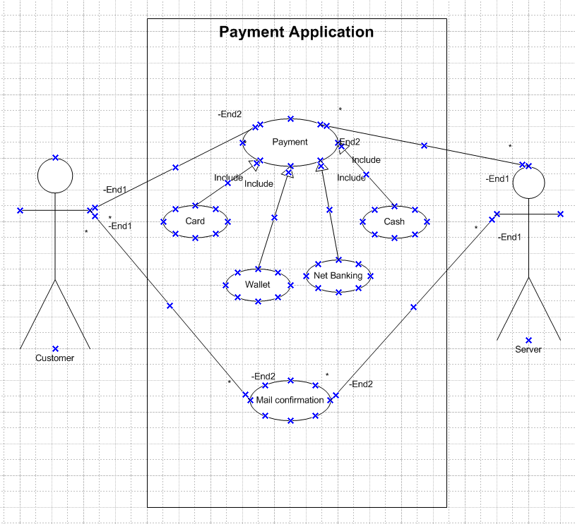

Question 2. Derive Boundary Classes, Controller classes, Entity Classes

Answer- Boundary Classes- This class represents the interaction between an actor and system. They act as a translator which gives out the exact information. The system depends upon the boundary class to communicate. Identifier- Vertical line connected to a circle with a small horizontal line.

Controller classes- The use case will result in a Controller class and manages the flow of information. It act as intermediate between the boundary class and entity class. Identifier- Circle with an arrow.

Entity Classes- It represents the core and business logic of an application. Which actually stores the data of an application. Identifier- A circle attached to a horizontal line in a vertical position.
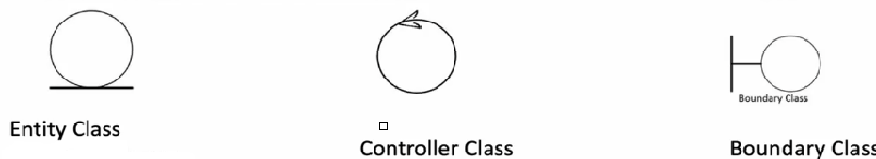

Example-
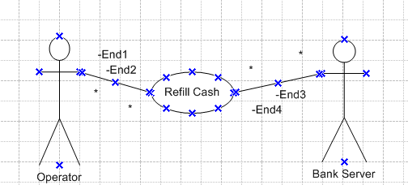

In this the operator fill the cash will be Boundary class.
Refill cash will Controller class.
Operator will be Entity class.
Bank server will be entity class.
Refill cash updated in the bank system will be boundary class.

Question 3. Place these classes on a three tier Architecture

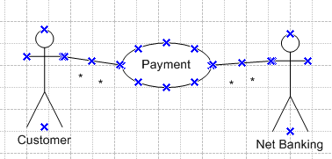
Answer – Let us understand it with an example-
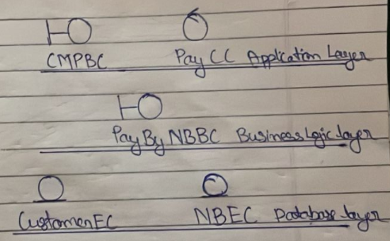
These 2 images illustrates about the MVC-Model View Controller classes. Where a customer is making payment through net-banking.
CMPBC- Customer Making Payment Boundary class and fall under Application Layer.
PayCC- Payment Controller Class will also fall under Application Layer.
PayByNBBC- Payment by Net Banking Boundary Class. Here a 3-party involvement is there and so in that case it will fall under Business Logic Layer.
CustomerEC- Customer Entity Class will fall under Database layer.
NBEC – Net Banking Entity Class will fall under Database layer.

Question 4. Explain Domain Model for Customer making payment through Net Banking

Answer-
Domain Model means each participating class will do an action part. All these classes and their action parts together will achieve one task or functionality.

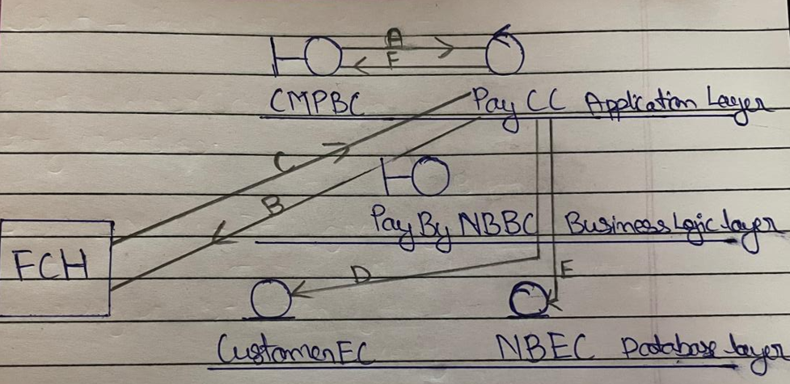
CMPBC- Customer Making Payment Boundary class.
PayCC- Payment Controller Class will.
PayByNBBC- Payment by Net Banking Boundary Class.
CustomerEC- Customer Entity Class.
NBEC – Net Banking Entity Class.

There is a flow of information will goes in systematic way so that the completion of the flow will result in Domain modelling. Here the customer will make the payment by net banking by choosing the option net banking available in the screen of the application (A), after which the Pay CC will add information like amount, purpose etc and pass through the information to PayByNBBC (B). Customer will be redirected to 3-party window where the payment transaction will take place. After the successful transaction that info will be pass on to PayCC (C). Now before PayCC will update its own database first i.e CustomerEC (D) and NBEC (E). After the database is updated the CMPBC will show the transaction details to the customer on the screen (F).

Question 5- Draw a sequence diagram for payment done by Customer Net Banking.

Answer- 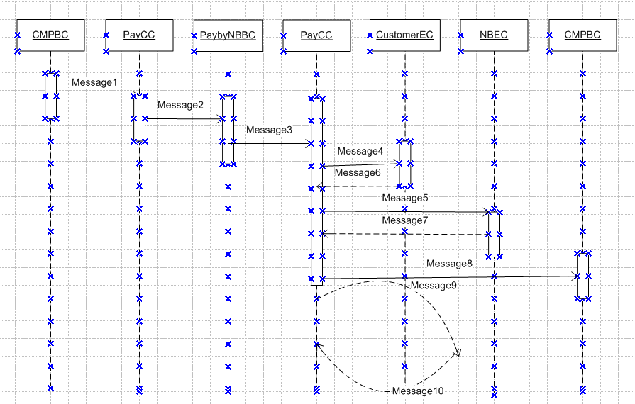
Message 1- customerInitiateNetbankingAndPassonTheInformatioToPaycc
Message 2-addCompanyDetailAndSendToPaybyNBBC
Message 3-updateTrasactionDetailsToPayCC
Message 4-updateTrasactionDetailsToCustomerEC
Message 5- updateTrasactionDetailsToNBEC
Message 8- updateTrasactionDetailsToCMPBC
Message 9-selfCheckAndValidation
Message 10- selfCheckAndValidation

Question 6- Explain Conceptual Model for this Case

Answer- Conceptual model refer to high level representation of system which outline the key element of a function of an application. It provide a clear view of the domain which makes it easier to understand.

In this case for Customer making payment through Net Banking
- Customer initiates payment
- Chooses net banking option
- Completes payment
- Return back to the application page

Question 7- What is MVC architecture? Explain MVC rules to derive classes from use case diagram and guidelines to place classes in 3-tier architecture

Answer- MVC stands for Model View Controller. It is architectural pattern used to develop applications. It separate an application into 3 interconnected components.
Model represents the data of the application in the database. It contains all the business rules and logic. This revolves around the data of the application and known as Entity class.

View represents the presentation of the application. It displays the data which was being provided by the model to the user. Actor speaks to system through boundary authenticating information between boundary and Entity class.

Controller- It act as an intermediate between the boundary and entity class and controls the flow of data. It act as a helping hand and pass on the data with utmost care.

MVC Architecture Rules
- Combination of One Actor and an use case results in one Boundary class.
- Combination of Two Actors and an use case results in two Boundary class.
- Combination of Three Actors and an use case results in three Boundary class and so on…
- Each use case will result in a controller class.
- Each Actor will result in one entity class.

Guidelines
- Place all Entity Class in DB Layer.
- Place Primary Actor associated Boundary Class in Application Layer.
- Place Controller Class in Application Layer.
- If governing Body influence or Reusability is there with any of remaining Boundary Class, place them in Business Logic Layer or else place them in Application Layer.

Question 8- Explain BA contributions in project (Waterfall Model – all Stages)

Answer-
Stage | Activities | Artifacts
Pre-Project | Feasibility study, Enterprise analysis, Market research, Risk analysis, Project scope | Purchase order  Statement of work
Planning & Estimation& Assessment | Stakeholder analysis, BA approach strategy, Plan Budget, understanding business rules and goals. | Stakeholder list
Requirement Gathering | Stakeholder identify and document, Elicitation techniques, Sort the requirements, Prioritize and Validate the requirements | BRD
Requirement Analysis | UML diagrams, Prepare FRS, Confirm req. from client and take sign off, Prepare RTM, Track all the requirement to be taken care off and nothing left behind | FRS, RTM, SSD, SRS
Design | Prepare test cases, communicate with client and drive them towards UAT, update RTM, Collab with designers | HDD/ADD  Solution Document
Coding | JAD sessions, Update RTM, Drive the backend team and client towards UAT | LDD/CDD
Testing | Assist test manager with test cases, Prepare client for UAT, update RTM, Take sign-off from client | UAT sign off
Deployment | Attach RTM with project closure report, plan and organise training sessions for end user, | User training Manuals

Question 9- What is conflict management? Explain using Thomas – Kilmann technique

Answer - Conflict Management refer to the process of resolving disagreement or disputes between groups of people. Its major focus is handle the conflicts in a constructive way.

5 steps to Conflict Management
- Identify the conflict
- Discuss the details
- Agree with the root problem
- Check for every possible solution for the conflict
- Negotiate the solution to avoid the future conflicts.

Thomas Kilmann technique gives us two dimension to manage the conflicts. On Y-axis we have assertiveness the process and domain knowledge and on X-axis we have BA with co-operation.

When Assertiveness is low and co-operation is low the group of people will avoid.
When Assertiveness is high and co-operation is low the group of people will compete.
When Assertiveness is low and co-operation is high the group of people will accommodate.
When Assertiveness is high and co-operation is high the group of people will collaborate.
When Assertiveness is medium and co-operation is medium the group of people will compromise.

As a BA one should derive the discussion that the group of people will conclude the conflicts on collaborate stage or minimum at compromise stage not anywhere else.
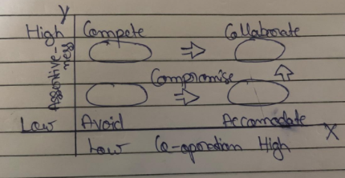

Question 10- List down the reasons for project failure

Answer –
- Improper requirement gathering- Requirements were not gathered correctly which results in delay or failure of project.
- Continuous changes in requirement- Constant changes in the requirement results in poor product.
- Lack of user involvement- At last the product need to be delivered to user, if their involvement is less than the final product will meet the actual parameters.
- Unrealistic exception- Everything has be crystal clear there should be no unrealistic expectations which harm the overall project.
- Improper planning- Proper planning will lead to a successful project.
- Resources constraint- Efficiently use of available resources will help in building a good product otherwise resources constraint will delay the project or could be the reason of failure.
- Scope creep- Project cannot be completed within budget and time.
- Technical challenges- Any hardware or software issue can also result in project failure.

Question 11- List the Challenges faced in projects for BA

Answer –
- Obtaining sign-off on requirement- Taking for approval from the client of requirement documents.
- Change Management with respect to cost and timelines- Sometimes the client changes bring some changes at the later or initial stage of the project because of which the cost and timeline of the project gets impacted.
- Coordination between developers and testers- Maintaining coordination between testers and developers can be a bit challenging as they both are experts in their own field and bring both on the same can be a tough task at times.
- Conducting meetings – Schedule meeting between different group of people can be challenging and bring out the major output from those meeting is also important by addressing all the attendees of the meeting.
- Driving client for UAT completion – Make sure that the client understand the importance of UAT and all outcome UAT should meet the requirement of the client.
- People management- BA work is to act as a helping hand which involves managing people.

Question 12- Write about Document Naming Standards

Answer- Document Naming Standard is important to ensure that all the documents are named correct with systematic approach in order to identify then and use them throughout the development process.

All the document should be named as per the standard-
[Project ID][Document Type]Version[X]Date[Y]

Example- If there is project with Project ID[PROJ890] and currently working with the Function Requirement Document along with the latest version and date on which the document was completed. Then the document can be named as PROJ890-FRD-1.0-2023-04-01

Question 13- What are the Do’s and Don’ts of a Business analyst

Answer-

Do’s | Don’ts
Extract maximum leads to the solution from the client. | Never say NO to the client.
Consult SME in case of doubts. | Never imagine anything in terms of GUI.
One should keep him updated with the markets trends. | Never try to give early solution without any prior experience and assumptions.
Listen to the client first and then ask your queries. | Never give false promises or hopes without consulting with backend team or PM.
Be optimistic and look for the solutions for the problems which all comes in your way. | Don’t be so straightforward with the client, always maintain distance.

Question 14- Write the difference between packages and sub-systems

Answer- Packages- Collection of components which are not re-useable in nature. Application development companies work on Packages. Eg- Twitter.

Sub-systems – Collection of components which are re-usable in nature.
Product development companies work on Sub- system. Eg- Google meet.

Question 15- What is camel-casing and explain where it will be used.

Answer- Camel-casing is format in which naming can be done in a project. Where entire first letter will be lower case and subsequent words first letter should be in upper case. Like a camel hump. Also there should be no gap between the words.

It is used for naming variables, function and identifiers.

Eg- firstName, payBill, customerOrderId.

Question 16- Illustrate Development server and what are the accesses does business analyst has?

Answer- Development server is meant for developers to work upon the application during the development and testing of the application. It has unfinished features and broken code then are meant for developer to rectify before proceeding further.

Tester also test the application in this server and fix the bugs if any before they deploy the application.

The business analyst has limited or view only access of this server as there will certain elements which a BA will not able to understand and will create chaos. A BA can only see and take follow ups in the meeting.

Question 17- What is Data Mapping?

Answer- Data mapping refer to the matching information from one data source to another so that the outcome should be appropriate.

Data mapping act as a bridge between business needs and technical implementation which ensure that when data move from one source to another it should remain accurate and fruitful for the business.

Eg- Entering a patient information from the hand written receipt into hospital portal.

Question 18- What is API. Explain how you would use API integration in the case of your application Date format is dd-mm-yyyy and it is accepting some data from Other Application from US whose Date Format is mm-dd-yyyy

Answer- API stands for Application Programming Interface. It refer to exchange of information between different applications to serve a common goal.

The API should make out to create a function in between the change of information which converts the format from mm-dd-yyyy to dd-mm-yyyy, which will solve the problem of data inconsistency.

