Question 1 – Audits , 4 Quarterly Audits are planned Q1 , Q2, Q3, Q4 for this Project What is your knowledge on how these Audits will happen for a BA ?
Answer: As a Business Analyst (BA), participating in quarterly audits (Q1, Q2, Q3, and Q4) involves a systematic review of project activities, deliverables, and processes.
1. Preparation (Before Each Audit)
- The BA gathers all up-to-date requirement-related documents: BRD (Business Requirements Document), SRS (System Requirements Specification), Use Cases, and other relevant artifacts.
- Change logs, sign-off records, and stakeholder feedback are collected and organized for review.
- Communication with project leads ensures all recent updates and changes are accurately reflected in documentation.
2. Audit Execution (During Each Quarter)
- The auditors (which may include project managers, quality assurance teams, and sometimes external reviewers) schedule sessions with the BA and related team members.
- The documentation is examined for:
  - Completeness and accuracy (are all stakeholder needs captured and tracked?).
  - Traceability (can every requirement be linked from its origin to solution and test cases?).
  - Compliance (does the project comply with internal standards, client expectations, and regulatory rules?).
- The BA participates in discussions, demonstrates how requirements were gathered, prioritized, validated, and handed off, and explains the sign-off and change management processes.
3. Stakeholder Feedback and Gap Analysis
- The audit team may also collect feedback from key stakeholders (e.g., farmers, manufacturers) to confirm that their expectations are being met.
- The audit identifies any variances between the plan and the current state (gaps, risks, or missed requirements) and works with the BA to propose and record corrective actions.
4. Reporting and Follow-up
- After each audit, findings are formally reported.
- The BA helps design and implement action plans where gaps or issues are found.
- The outcomes of audits (strengths, weaknesses, risks) are shared with all relevant project stakeholders, ensuring lessons are learned and improvements are re-communicated for the next quarter.

Question 2 – BA Approach Strategy
Step | Description / Activities | Deliverables / Artifacts | Key Team Members Involved | Notes
1. Initiation & Team Alignment | - Meet committee to understand project goals and expectations.  - Perform stakeholder mapping and assess influence/interest. | Stakeholder Map, Project Objectives Document | Business Analyst (BA), Committee Members | Identify all users – farmers, manufacturers, management, technical leads, testers
2. Requirements Elicitation | - Conduct interviews (individual and group) with stakeholders.  - Organize workshops/focus groups.  - Distribute surveys/questionnaires.  - Analyze existing documents.  - Create prototypes/wireframes for feedback. | Interview Notes, Workshop Minutes, Survey Results, Prototypes/Wireframes | BA, Stakeholders (Farmers, Manufacturers, PM, Developers) | Use mixed methods to cover both functional and non-functional requirements
3. Stakeholder Analysis (RACI & ILS) | - Define roles using RACI matrix: Responsible, Accountable, Consulted, Informed.  - Analyze stakeholder influence and level of support (ILS). | RACI Matrix, ILS Matrix | BA, Project Manager (PM), Technical Leads | Helps clarify responsibility, communication, and approval paths
4. Documentation | - Draft Business Requirements Document (BRD).  - Develop System Requirements Specification (SRS).  - Write Use Cases and User Stories.  - Create process flow diagrams and wireframes.  - Maintain Change Logs. | BRD, SRS, Use Cases, User Stories, Process Flows, Wireframes, Change Logs | BA, PM, Technical Team | Documentation should be clear, detailed, and version-controlled
5. Review & Sign-Off Process | - Circulate requirement drafts among stakeholders.  - Collect feedback through meetings or email.  - Conduct formal sign-off sessions (digital or physical).  - Maintain sign-off records and version history. | Document Review Comments, Signed Approval Sheets | BA, PM, Stakeholders, Client Representatives | Sign-off ensures consensus and readiness to proceed
6. Approvals & Communication | - Establish communication channels: Emails, collaboration tools (Slack/Teams), scheduled meetings.  - Use shared document repositories (Google Drive, SharePoint).  - Track and archive approvals formally. | Communication Plan, Meeting Minutes, Approval Records | BA, PM, All Stakeholders | Effective communication reduces confusion and keeps project on track
7. Change Request Management | - Log all change requests in a dedicated Change Log.  - Assess impact on time, cost, scope, and risk.  - Present changes for stakeholder approval before implementation.  - Update all relevant documents and re-obtain sign-off. | Change Request Forms, Updated Documents, Impact Analyses | BA, PM, Stakeholders | Controlled change management reduces scope creep and misunderstandings
8. Project Progress Updates | - Provide milestone/sprint progress reports.  - Share dashboards with key metrics (e.g., requirements approved, change requests pending).  - Conduct periodic review meetings (weekly/biweekly/monthly). | Status Reports, Dashboards, Meeting Minutes | BA, PM, Technical Team, Client Representatives | Keeps all parties informed and engaged throughout project lifecycle
9. User Acceptance Testing (UAT) & Client Project Acceptance | - Plan and document UAT scenarios with testers and end users.  - Facilitate UAT execution and defect logging.  - Ensure resolution and retesting.  - Collect Client Project Acceptance Form after successful UAT. | UAT Test Scenarios, Defect Logs, Client Acceptance Form | BA, Testers (Jason, Alekya), PM, Client Representatives | Represents formal closure of the BA scope and confirms client satisfaction

Question 3: Explain and illustrate 3-tier architecture?
Answer:
What is 3-Tier Architecture?
3-tier architecture is a classic software design pattern that divides an application into three distinct, independent layers:
- Presentation Tier
  - It is Also called: User Interface layer or Client tier
  - Role: The front-end interface where users interact with the application.
  - Typical technologies: Web browsers (HTML, CSS, JavaScript), mobile apps, desktop interfaces.
  - Example: For an agriculture product store, this could be the website or app where farmers and manufacturers log in, browse products, and place orders.
- Application Tier
  - Also called: Business Logic layer or Middle tier
  - Role: Contains the application’s core logic, rules, calculations, and workflows. It processes user requests, applies business rules (like checking product availability or calculating prices), and communicates between the user interface and the database.
  - Example: Handles actions such as user authentication, order processing, payment validation, and sending notifications.
- Data Tier
  - Also called: Database layer or Storage tier
  - Role: Manages and stores all data—such as user accounts, product listings, order history. Provides database services and ensures data security, integrity, and retrieval.
  - Example: Stores product details, purchase records, user information, order tracking updates.
Illustration of 3-Tier Architecture
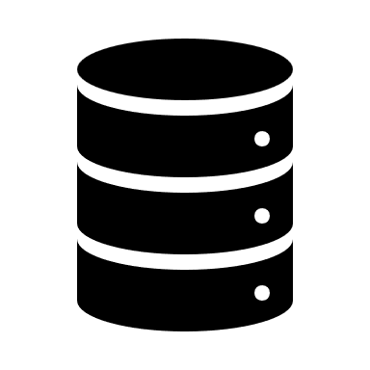



Presentation Application Data

Question 4
Business Analyst should keep What points in his/her mind before he frames a Question to ask to the Stakeholder ( 5W 1H – SMART – RACI – 3 Tier Architecture – Use Cases, Use case Specs, Activity Diagrams,Models, Page designs)
Answer:
1. 5W1H Framework
- Who: Who is involved/affected by this requirement or process?
- What: What is being requested, changed, or solved?
- When: When is this needed, or when does it take place?
- Where: Where will this impact/process occur (location, platform)?
- Why: Why is this important or necessary (business rationale)?
- How: How will this be implemented or performed in practice?
2. SMART Criteria
Make sure each question aims to clarify requirements that are:
- Specific: Focused, clear, and unambiguous.
- Measurable: Can success or completion be measured?
- Achievable: Is it realistic and feasible for the project?
- Relevant: Does it align with project/business goals?
- Time-bound: Is there a timeframe for implementation or delivery?
3. RACI Matrix Consideration
- Clarify roles and responsibilities before questioning:
  - Responsible: Who will be doing the work?
  - Accountable: Who will sign off or own the outcome?
  - Consulted: Who should be consulted for input?
  - Informed: Who needs to be kept in the loop?
- Tailor your questions to the right stakeholders based on their RACI role.
4. 3-Tier Architecture Awareness
- Make sure your questions cover implications for:
  - Presentation Layer: User interfaces or screens.
  - Application (Logic) Layer: Business processes, rules, and flows.
  - Data Layer: Data storage, retrieval, structure, and integrations.
- Frame questions to clarify how a requirement or change will impact each tier, if relevant.
5. Use Cases and Specifications
- Consider if a question should clarify one or more of the following:
  - The user’s goal/scenario (What is the user trying to accomplish?)
  - The actors involved and their interactions with the system.
  - Steps in the process, exceptions, and alternate paths.
- Check if existing use cases/use case specs cover the area in question or if new scenarios need to be elicited.
6. Activity Diagrams, Models, and Visuals
- Think visually: Would the stakeholder benefit from seeing a diagram of the process, workflow, or interaction?
- Use activity diagrams or flowcharts to validate possible questions or highlight unclear hand-offs and responsibilities.
- Prepare to reference or request visuals/models for complex requirements.
7. Page Designs & UI Concerns
- For user interface or experience-related requirements:
  - Ask about user needs/preferences for layout, navigation, labels, and language.
  - Clarify accessibility, mobile responsiveness, and multilingual needs.
Question 5 -As a Business Analyst, What Elicitation Techniques you are aware of?
Answer:
Acronym | Elicitation Technique | Description & Application
B | Brainstorming | A group creativity technique used to generate a wide variety of ideas or solutions in a short period. The BA facilitates sessions with stakeholders to draw out diverse input, solve problems, or identify new opportunities. Ideal when initial ideas are unclear or innovation is needed.
D | Document Analysis | Involves reviewing existing documentation (manuals, reports, previous requirements, process flows, regulations, contracts, etc.) to extract requirements and understand current processes, legacy systems, and organizational context. Useful at the beginning of a project or for gap analysis.
R | Requirements Workshops | Organized, focused meetings where stakeholders, users, and subject matter experts collaborate to define, validate, or prioritize requirements. Workshops encourage consensus, resolve contradictions, and quickly clarify complex points.
F | Focus Groups | A selected group of stakeholders is brought together to discuss needs, perceptions, and expectations about the product or process. The BA facilitates the session to collect collective feedback, uncover preferences, and identify consensus or conflicting viewpoints.
O | Observation | The BA directly observes users performing their work in their natural environment. This reveals unspoken needs, daily challenges, and process nuances that might not surface during interviews or surveys. There are two types: passive (watching) and active (asking questions during the task).
W | Workshops (JAD / Group Sessions) | Joint Application Development (JAD) workshops are a structured form of workshop—bring together cross-functional teams (business, IT, users) for intensive multi-day sessions to analyze requirements, design solutions, or validate business processes.
J | Job Shadowing | The BA follows a user or stakeholder during their workday to observe processes, workflows, and pain points. This technique helps uncover operational needs and gain a hands-on understanding of actual tasks, interactions, and bottlenecks.
I | Interviews | One-on-one or small group conversations with stakeholders to gather detailed information about their needs, goals, challenges, or expectations. Interviews can be structured (set questions), semi-structured (guided with flexibility), or unstructured (open-ended discovery).
P | Prototyping | Creating visual or interactive models (mock-ups, wireframes, sample screens, or system demos) to help stakeholders articulate, clarify, and validate their requirements. Prototypes make abstract ideas concrete and encourage early feedback—especially valuable with non-technical users.
Q | Questionnaires/Surveys | Distributing structured sets of questions to a large or remote group of stakeholders to quickly collect quantitative and qualitative data. Useful for gathering broad opinions, experiences, ranking requirements, or prioritizing features when face-to-face interaction isn’t feasible.
U | User Task Analysis | Breaking down how users perform specific tasks step by step to identify functional requirements, pain points, and potential improvements. May involve mapping user journeys or process flows to visualize and analyze each stage of user interaction and system usage.

Question 6 – Which Elicitation Techniques can be used in this Project and Justify your selection of Elicitation Techniques?

Elicitation Technique | How it's Used in this Project | Justification
Prototyping | Building wireframes or sample versions of key interfaces (e.g., product search, order placement, dashboards) to show stakeholders how the system might look and function. | Farmers and manufacturers may not be familiar with technical jargon; seeing and interacting with sample screens helps them provide practical, early feedback, reducing misunderstandings and costly rework.
Use Case Specifications | Documenting detailed scenarios showing different user interactions, including expected flows and alternate paths (e.g. how a farmer searches for products, places an order, or tracks a delivery). | Clarifies exactly what users and the system will do, ensuring all requirements are captured, edge cases are discussed, and developers have a concrete reference. This reduces ambiguity and aligns expectations.
Document Analysis | Reviewing existing materials (industry reports, competitor platforms, current manual processes, legal requirements, previous projects). | Uncovers baseline requirements, identifies best practices, and ensures the solution does not miss critical functions or compliance needs while reducing redundant effort.
Brainstorming | Facilitating group sessions with stakeholders (farmers, manufacturers, PM, developers) to generate ideas for features, process improvements, or solutions to uncovered problems. | Encourages creative thinking, leverages diverse perspectives, and helps identify features or pain points that isolated interviews might miss, leading to more complete requirements.
Using these techniques together ensures requirements gathering is comprehensive, practical, and tailored to your stakeholders’ abilities—producing better results and fewer misunderstandings throughout the project.

Question 7 -Make suitable Assumptions and identify at least 10 Business Requirements.
Answer:

Req ID | Requirement Description
BR001 | Farmers should be able to browse and search for all available products (fertilizers, seeds, pesticides).
BR002 | Manufacturers should be able to register/login and upload their products (fertilizers, seeds, pesticides) to the catalog.
BR003 | All users (farmers, manufacturers) are required to have a secure login (email and password); new users can easily register and create accounts.
BR004 | The platform must maintain a comprehensive product catalog organized by type (fertilizers, seeds, pesticides), with images and detailed info for each product.
BR005 | Farmers must be able to add products to a “buy later” or wishlist for future consideration (post-login).
BR006 | A search function is provided to allow farmers to quickly find desired products using keywords/filters.
BR007 | The payment gateway must support multiple payment options: Cash on Delivery (COD), Credit/Debit card, and UPI.
BR008 | After placing an order, the farmer receives an automatic email confirmation detailing their purchase and order status.
BR009 | Farmers must have order and delivery tracking functionality to view real-time status and estimated delivery dates.
BR010 | The manufacturer user role can edit or remove previously uploaded products from the catalog after successful login.
BR011 | The application should provide a responsive/mobile-friendly design for convenient access via computers or smartphones.
BR012 | Support for multilingual interface to accommodate users in different regions (if the business expands to broader geographies).
BR013 | The platform should ensure secure encryption for transactions and user authentication to maintain data privacy and integrity.
BR014 | Customer support/helpdesk channel is provided (chat or contact form) for assistance with registration, orders, or payments.

Question 8 – Assumptions
Assumptions
- Users’ Digital Access:
All users, including farmers and manufacturers, have access to internet-connected devices (smartphones, tablets, or computers) to use the online platform.
- User Digital Literacy:
Farmers and manufacturers possess basic digital skills necessary to navigate the website/app, register accounts, and perform transactions.
- Payment Gateway Availability:
The payment gateways integrated (COD, Credit/Debit cards, UPI) are reliable, secure, and widely accepted in the regions targeted by the project.
- Logistics & Delivery Services:
Delivery and logistics partners are available and capable of shipping products to both rural and urban areas where farmers reside.
- Compliance & Regulatory Approvals:
The platform complies with all relevant legal, agricultural, and e-commerce regulations required to sell fertilizers, seeds, and pesticides online.
These assumptions form the foundation for the requirements and the design of the Online Agriculture Products Store.
Question 9 – Requirements Priority
Req ID | Req Name | Req Description | Priority (1-10)
BR001 | Farmer Search for Products | Farmers should be able to search for available products in fertilizers, seeds, pesticides | 8
BR002 | Manufacturers Upload Products | Manufacturers should be able to upload and display their products in the application | 8
BR003 | User Registration & Login | All users (farmers, manufacturers) must register and log in securely before accessing features | 10
BR004 | Product Catalog/Browse | Application must display an organized, browsable product catalog to users | 8
BR005 | Wishlist/Buy-Later | Farmers can add products to a “buy later” or wishlist after logging in | 6
BR006 | Search Functionality | Application provides an efficient keyword/filter search across all catalogues | 8
BR007 | Payment Gateway Integration | Multiple secure payment options: COD, Credit/Debit Card, UPI for seamless checkout | 10
BR008 | Email Order Confirmation | Automatic email confirmation to users upon order placement and status update | 7
BR009 | Order & Delivery Tracking | Real-time delivery/status updates for placed orders | 9
BR010 | Edit/Remove Uploaded Products (Manufacturer) | Manufacturers can edit or remove their own product listings after login | 7
BR011 | Mobile-Responsive Interface | Platform is optimized for both web and mobile device access | 8
BR012 | Multilingual Interface | UI supports multiple regional languages for broader accessibility | 6
BR013 | Data Security & Privacy | End-to-end encryption for user data and financial transactions; privacy compliance | 10
BR014 | Customer Support/Helpdesk | In-app helpdesk or contact form for user support | 7
- Priority 10: Essential for core platform function, security, or compliance (e.g., registration/login, payment, data security).
- Priority 9: Critical for user experience or business operations (e.g., order/delivery tracking).
- Priority 8: Highly important for usability and marketplace viability (e.g., search/browse, product uploads).
- Priority 7: Enhances user engagement and trust (e.g., order confirmations, support, product editing).
- Priority 6: Adds future-proofing or regional reach (e.g., wishlist, multilingual support).

Question 10 – Use Case Diagram
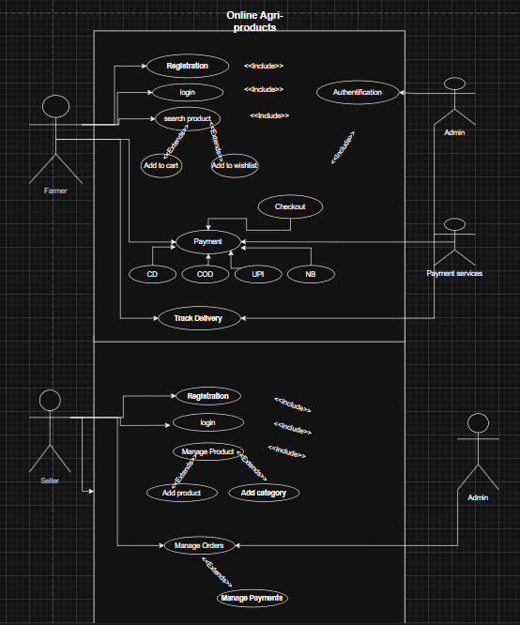

Question 11 – Use Case Specs
Use Case 1: User Registration/Login
Use case Id | 1
Use Case Name | User Registration and Login
Actor(s) | Farmer, Manufacturer
Preconditions | User is not logged in
Postconditions | User is authenticated and granted access to the dashboard
Main Flow | 1. User chooses 'Register' or 'Login'.  2. For registration, user enters email and creates a password.  3. System validates and creates account.  4. For login, user enters credentials.  5. System authenticates and logs user in.
Alternate/Exception Flows | - Registration: If email exists, show error.  - Login: Wrong credentials, prompt for retry or 'Forgot Password'.
Use Case 2: Product Search/Browse
Use case ID | 2
Use Case Name | Product Search and Browse
Actor(s) | Farmer
Preconditions | User is logged in
Postconditions | Product results are displayed to the user
Main Flow | 1. Farmer navigates to catalog or uses search bar.  2. Enters keywords or filters.  3. System fetches and displays relevant products.
Alternate/Exception Flows | - If no products match, system displays 'No Results Found'.
Use Case 3: Product Upload (Manufacturer)
Use case Id | 3
Use Case Name | Product Upload
Actor(s) | Manufacturer
Preconditions | Manufacturer is logged in
Postconditions | New product appears in the catalog
Main Flow | 1. Manufacturer goes to 'Add Product' page.  2. Enters product details (name, type, price, stock).  3. Uploads images.  4. System validates and saves product.  5. Confirmation message delivered.
Alternate/Exception Flows | - If data is invalid/missing, display error and request corrections.
Use Case 4: Place Order and Payment
Use case ID | 4
Use Case Name | Place Order and Make Payment
Actor(s) | Farmer
Preconditions | Farmer is logged in & has items in cart
Postconditions | Order is placed; payment request completed
Main Flow | 1. Farmer reviews cart.  2. Proceeds to checkout.  3. Enters/selects delivery address.  4. Chooses payment type (COD, Card, UPI).  5. Confirms purchase.  6. System records order and sends confirmation email.
Alternate/Exception Flows | - Payment fails: prompt to retry or choose another method.  - Missing address: prompt user to input valid address.
Use Case 5: Order Delivery Tracking
Use case ID | 5
Use Case Name | Order Delivery Tracking
Actor(s) | Farmer
Preconditions | Order has been placed and dispatched
Postconditions | Farmer views real-time order status
Main Flow | 1. Farmer logs into account.  2. Navigates to 'My Orders'.  3. Selects an order.  4. System displays delivery status and estimated delivery date.
Alternate/Exception Flows | - If tracking data unavailable, system displays 'Tracking unavailable, contact support'.

Question 12 – Minimum 5 Activity Diagrams
- User Registration
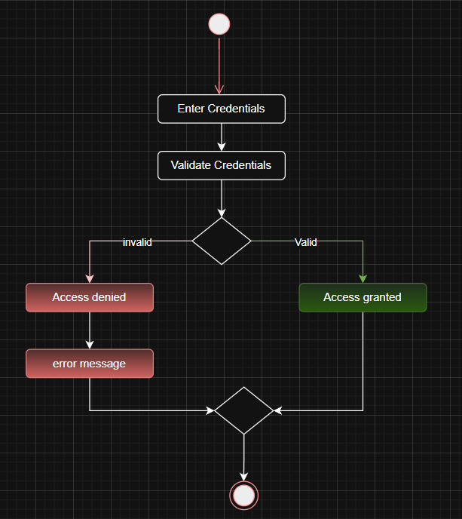
- Product Search
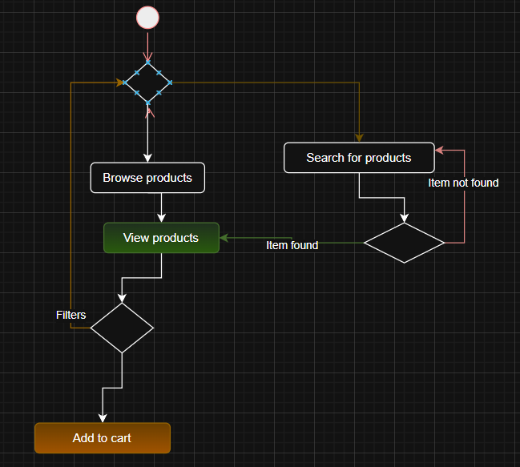
- Upload Product
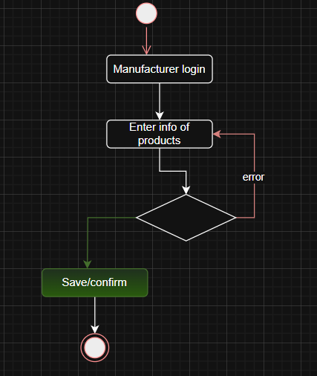
- Place Order
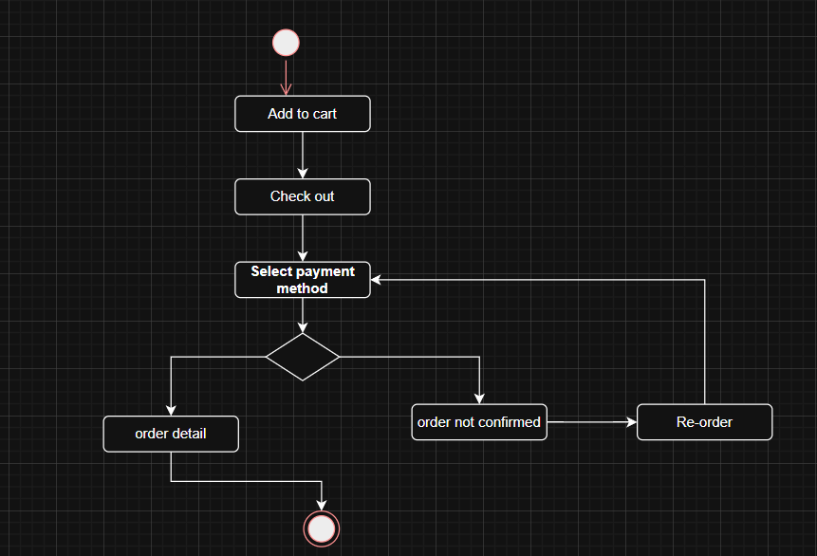
- Payment
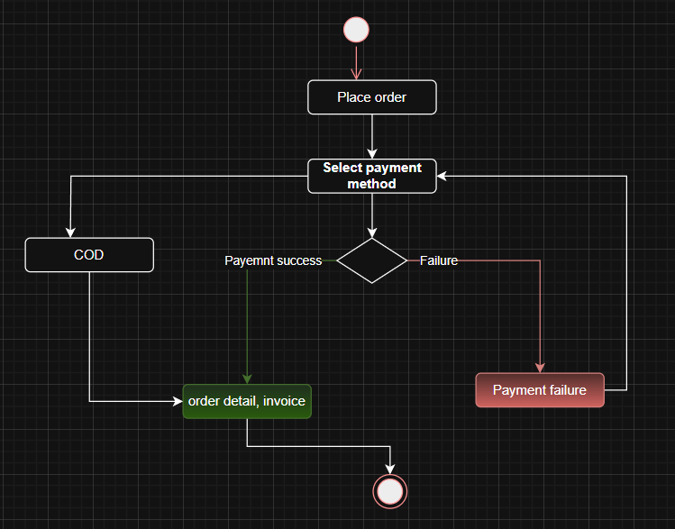
- Order return/cancellation
