Waterfall Model Deliverables Documents – Part -2/2

Document 6- Use Case Diagram, Activity diagram and a Use Case Specification Document
Question 1: Please prepare a use case diagram, activity diagram and a use case specification document.
Answer: Here are use case specifications for the main functionalities in the aerospace system enhancement and integration project. Each use case includes essential details to capture user interaction with the system.

Use Case 1: Submit Aircraft Maintenance Record
Use Case ID | UC-AERO-01
Actors | Maintenance Engineer, System
Description | Records details of aircraft maintenance activities into the system for tracking, audit, and compliance purposes.
Preconditions | - The engineer must be authenticated and assigned to the aircraft.  - The aircraft must be registered in the system.  - The engineer has the appropriate permissions to create work orders.
Trigger | Engineer selects "Submit Maintenance Request" from the maintenance module.
Main Flow | - Engineer logs in.  - Navigates to Maintenance → Submit Request.  - Selects aircraft from dropdown list.  - Fills in form (maintenance type, issue description, urgency, location, date).  - Attaches supporting documents or images.  - Clicks Submit.  - System validates and stores request.  - Generates tracking ID.  - Sends notification to Maintenance Manager.
Post Conditions | - Request is saved in database and visible in dashboards.  - Email/SMS confirmation sent to engineer.
Alternate Flow | - If required fields are missing → system prompts to fill.  - If file format is invalid → prompts correct format.  - If aircraft ID is not found → error message displayed.
Assumptions | - Engineers follow SOPs during entry.  - The aircraft status is active and not decommissioned.
Constraints | - Maintenance logs cannot be edited post submission unless reopened by admin.  - Internet connectivity is required.
Dependencies | - Aircraft registry module.  - User authentication service.
Inputs & Outputs | - Inputs: Maintenance data, images, reports.  - Outputs: Maintenance record ID, confirmation alert.
Business Rules | - All logs must be submitted within 24 hours of maintenance completion.  - Role-based access to aircraft records.
Miscellaneous | - Audit trails are automatically generated.  - SLA countdown begins once request is submitted.

Use Case 2: Initiate Procurement Request
Use Case ID | UC-AERO-02
Actors | Inventory Manager, System
Description | Create a procurement request for parts or equipment needed for operations.
Preconditions | - Manager must be logged in.  - Budget allocation must be available.
Trigger | Manager identifies inventory shortage via system alert.
Main Flow | - Navigate to Procurement module.  - Select part or item from master list.  - Enter quantity and urgency.  - Attach supplier preference if any.  - Submit for department approval.  - System logs request and routes to approver.
Post Conditions | - Request is recorded and routed for approval.  - Procurement team notified if approved.
Alternate Flow | - If item is not in the master list, the system prompts manual entry and flags it for review.  - If no budget is available, system halts the process.
Assumptions | - Inventory data is current.  - Budget allocations are predefined.
Constraints | - Requests over ₹10 lakh must undergo CFO review.  - Max 3 suppliers can be attached per request.
Dependencies | - Vendor database.  - Budget monitoring tool.
Inputs & Outputs | - Inputs: Item name, quantity, priority.  - Outputs: PR number, approval status.
Business Rules | - Approvals are mandatory for purchases above ₹1 lakh.  - Stock validation against minimum threshold before request submission.
Miscellaneous | - SLA for approval process is 48 hours.

Use Case 3: Generate Compliance Report
Use Case ID | UC-AERO-03
Actors | Compliance Officer, System
Description | The compliance officer generates a system-based report to demonstrate adherence to DGCA/FAA/EASA regulations.
Preconditions | - Logged-in user with compliance role  - Historical data available
Trigger | Officer selects “Generate Compliance Report” from the dashboard.
Main Flow | - User logs in  - Chooses report type (maintenance logs, part certifications, audit trail)  - Sets time frame and aircraft ID  - Clicks Generate  - System compiles data, applies filters  - Displays downloadable PDF  - Logs action
Post Conditions | - Report stored for future reference  - Available for export
Alternate Flow | - No data → system alerts “no records found”  - Too large dataset → prompts filter refinement
Assumptions | - Required data is in compliance database  - User knows reporting parameters
Constraints | - Reports limited to 1000 records per file  - Access is read-only
Dependencies | - Audit logging system  - Aircraft maintenance module
Inputs & Outputs | - Inputs: Aircraft ID, report type  - Outputs: Compliance report PDFv
Business Rules | - Reports must be stored for 7 years.  - Only DGCA-approved formats allowed.
Miscellaneous | - Logs every report generation for internal audit.

Use Case 4: Assign User Roles
Use Case ID | UC-AERO-04
Actors | Admin, System
Description | An administrator assigns or revokes system access and permissions based on department and role.
Preconditions | - Admin has logged in  - User exists in HR master
Trigger | Admin accesses User Management → Assign Roles.
Main Flow | - Admin selects user  - Chooses department, role level  - Selects module access  - Clicks Assign  - System updates role matrix  - Logs action
Post Conditions | - Role is updated  - User permissions activated
Alternate Flow | - If user not in master list → error message  - Role already assigned → prompts confirmation for override
Assumptions | - HR system is synced  - Admin follows policy
Constraints | - RBAC rules strictly enforced  - Cannot assign cross-department access
Dependencies | - HR system integration  - Role-based access control module
Inputs & Outputs | - Inputs: User ID, role level  - Outputs: Access confirmation
Business Rules | - Admin can assign max 3 roles per user  - Audit trail must be created for changes
Miscellaneous | - System alerts user via email upon role change.

Use Case 5: Define and Trigger Workflow Automation
Use Case ID | UC-AERO-05
Actors | Business Analyst, System
Description | Design and implement automated workflows for processes like inventory alerts or approval chains.
Preconditions | - Business rules must be finalized.  - System module for workflow exists.
Trigger | Analyst accesses "Workflow Engine".
Main Flow | - Selects process template or creates new.  - Defines triggers (e.g., inventory below 100 units).  - Assigns action (e.g., auto PR generation, email alert).  - Tests the workflow using sandbox.  - Activates the workflow.
Post Conditions | - Automation rule is active.  - Triggers respond to live data.
Alternate Flow | - Test may fail if data dependencies are missing.  - Workflow will not activate without mandatory fields.
Assumptions | - Business processes are stable and validated.
Constraints | - Only one active workflow per process instance.  - Loops and parallel flows limited by system capability.
Dependencies | - Master data setup.  - Integration with affected modules.
Inputs & Outputs | - Inputs: Process name, trigger conditions, actions.  - Outputs: Trigger logs, alerts, automated transactions.
Business Rules | - Each workflow must be linked to a department and approved by the Process Owner.  - Workflow testing is mandatory before go-live.
Miscellaneous | - Workflows can be cloned and version-controlled.

Use Case diagram
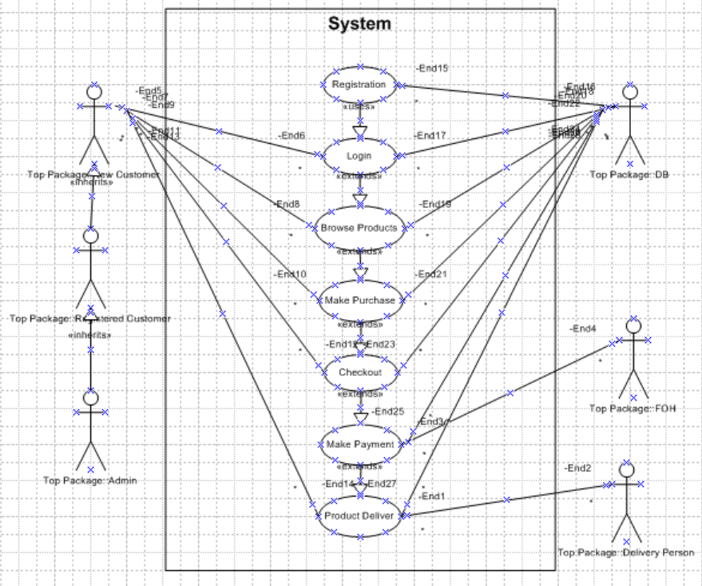
Activity diagram
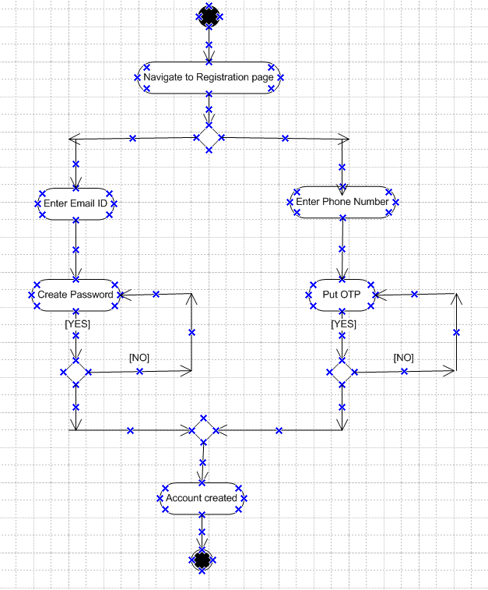
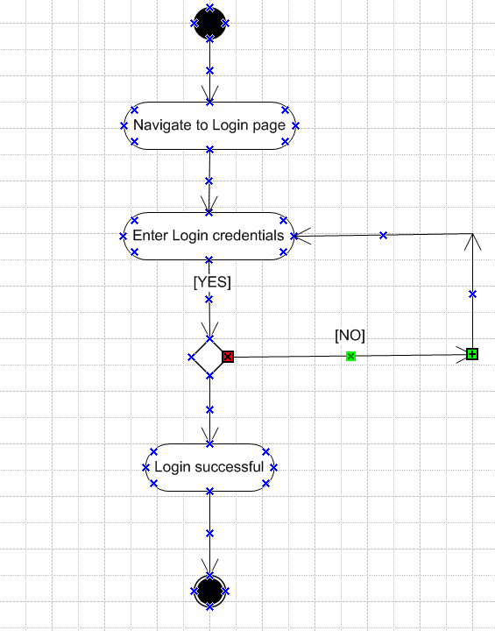
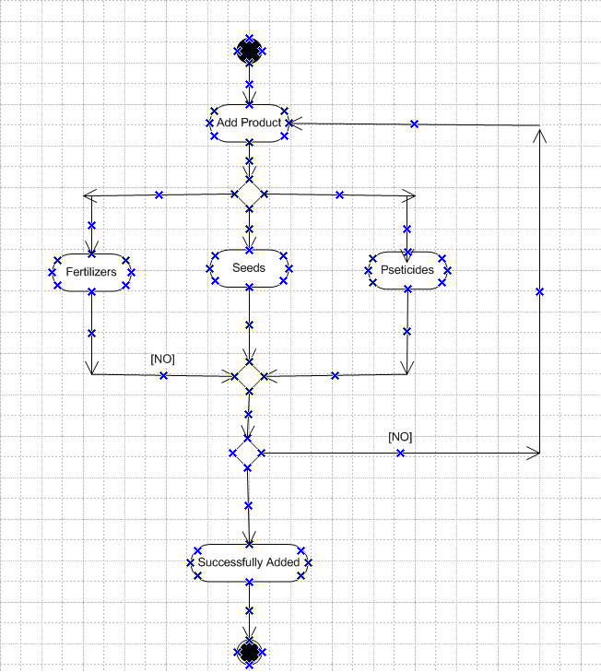
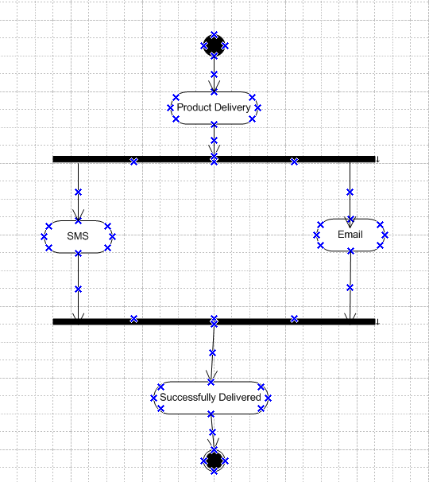
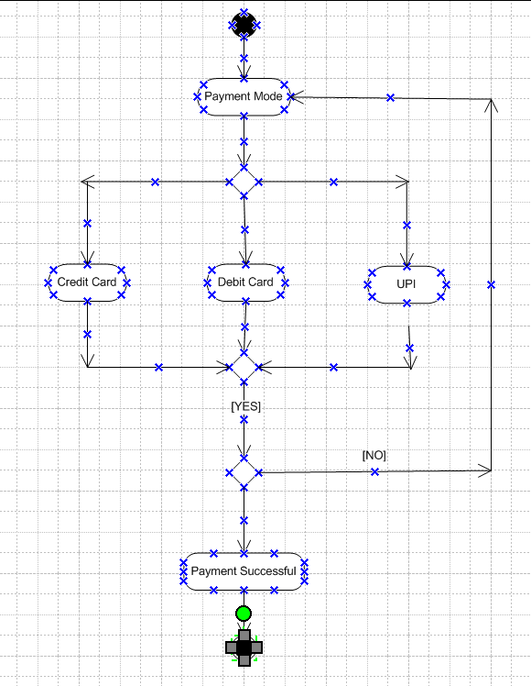

Document 7- Screens and pages
Question 2: Please follow the following steps to create the mock-ups
- Kindly use balsamic or Axure.
- Always start with a home page of an application.
- Take a feature and follow it to the end
- Eg: Home page of SCRUM Foods
- Select Login- Create a login page
- Let’s assume, you want to search a restaurant. Search page- Type the restaurant name and select the dish
- Add to cart page
- Payment page
- Logout page

Answer: Here is my version of the project’s mock-ups.
HOME PAGE
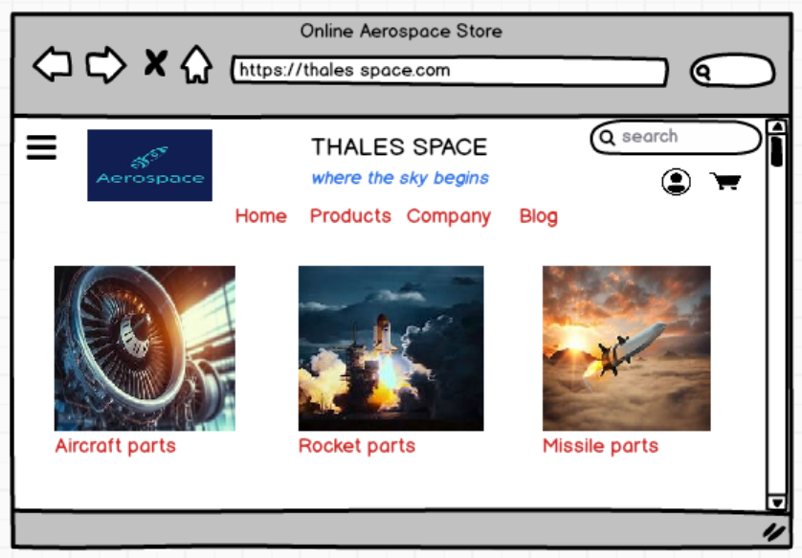
LOGIN PAGE
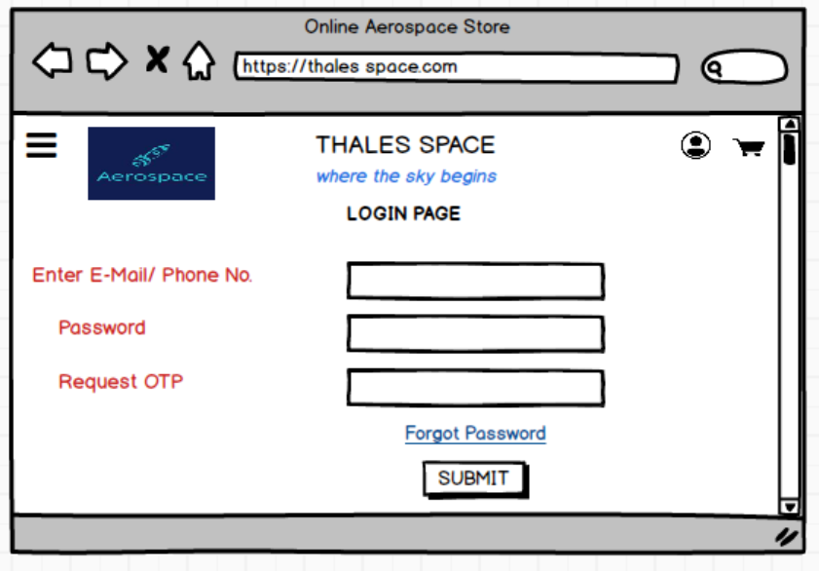
LISTING PAGE
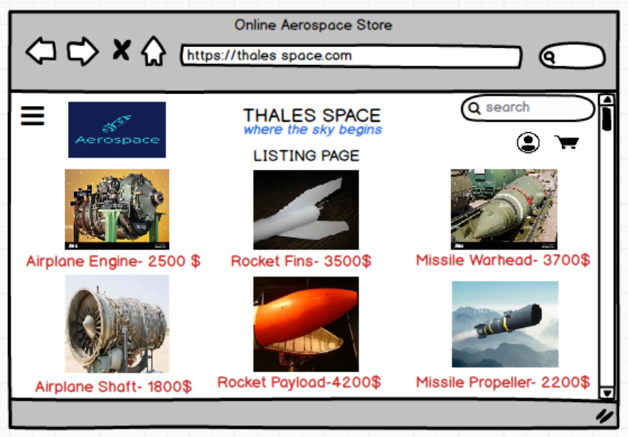
CART PAGE
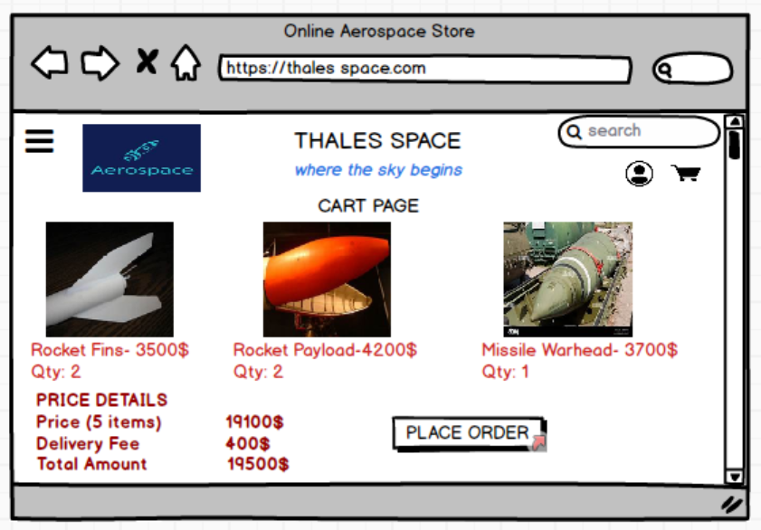
PAYMENT PAGE
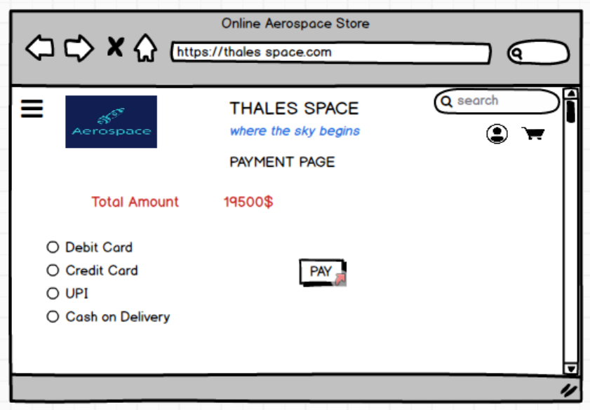
LOGOUT PAGE
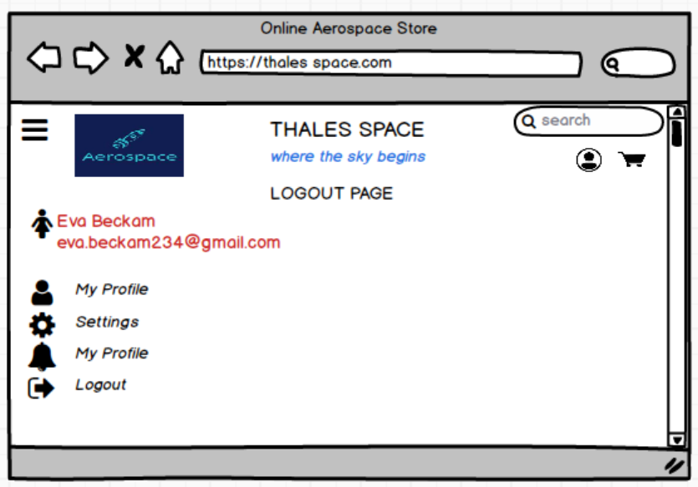

Document 8- Tools-Visio and Axure
Question 3: Write a paragraph on your experience using Visio and Axure for the project.
Answer: As part of the requirements elicitation and validation process for the Aerospace System Enhancement Project, two primary tools were extensively utilized: Microsoft Visio and Axure RP. These tools played a critical role in facilitating stakeholder understanding, aligning technical specifications, and minimizing rework during downstream phases of the Waterfall lifecycle.

As part of the aerospace system enhancement project, I utilized Microsoft Visio extensively to design and document a wide range of process flow diagrams, system architecture overviews, and swim lane workflows. Visio proved to be instrumental in visually articulating complex interdependencies between modules such as aircraft maintenance, procurement, compliance, and reporting. It enabled clear communication between business stakeholders and the technical team by converting textual requirements into easy-to-understand visual representations, which streamlined approvals and reduced ambiguity during requirement sign-off sessions.
In parallel, I leveraged Axure RP to create interactive wireframes and high-fidelity prototypes for the user interfaces of the new IT system. Axure allowed me to simulate real-time interactions like dropdowns, navigation flows, and role-based dashboards, which significantly improved early-stage feedback from end-users and helped reduce rework during the development phase. By integrating logic, conditional flows, and data widgets in Axure, I was able to present a realistic preview of the system to business users before a single line of code was written. Both tools together enhanced the documentation quality, improved stakeholder engagement, and ensured design accuracy throughout the Waterfall-driven development lifecycle.

Document 9- BA experiences
Question 4: Write the experience as a BA in following phases: Requirement Gathering, Requirement Analysis, Design, Development, Testing and Deployment.
Answer: Below is your experience as a Business Analyst in the Requirement Gathering, Analysis, Design, Development, Testing, and Deployment phases:

- Requirement Gathering Phase:
- Conducted stakeholder interviews, workshops, and surveys with cross-functional teams (Operations, Compliance, Engineering).
- Captured detailed business needs, system pain points, and future expectations from the upgraded IT solution.
- Used elicitation techniques such as document analysis, observation, and brainstorming to gather both functional and non-functional requirements.
- Ensured coverage of regulatory requirements (DGCA, FAA) and operational goals specific to the aerospace domain.
- Documented findings in a structured Business Requirements Document (BRD) and facilitated stakeholder review and approval.

- Requirement Analysis Phase:
- Analysed collected requirements for feasibility, consistency, completeness, and alignment with business goals.
- Created and maintained a Requirements Traceability Matrix (RTM) to ensure clear mapping from business needs to technical requirements.
- Collaborated with architects and developers to validate feasibility, integrations, and dependencies with existing ERP/legacy systems.
- Identified and resolved conflicting requirements through impact analysis and joint stakeholder sessions.
- Segregated requirements into functional, non-functional, system, and compliance categories for clarity.

- Design Phase:
- Created wireframes and interactive UI mock-ups using Axure RP for modules like Maintenance Workflow and Vendor Tracking.
- Developed process flow diagrams, swim lanes, and data interaction maps using Microsoft Visio to visualize system behaviour.
- Authored detailed Use Case Specification Documents covering actors, triggers, main flows, alternate flows, and exceptions.
- Collaborated with UX designers and solution architects to ensure user-friendly interface design and logical navigation.
- Ensured that the design adhered to scalability, usability, and compliance requirements.

- Development Phase:
- Acted as a point of contact for the development team for clarifications on business rules and technical requirements.
- Participated in walkthroughs and sprint reviews to validate alignment between developed features and original specifications.
- Reviewed prototypes and database schema for consistency with functional requirements.
- Ensured implementation of key controls such as role-based access, audit logs, and data validation mechanisms.
- Facilitated communication between the business and development teams to avoid scope creep and misunderstanding.

- Testing Phase:
- Worked with the QA team to define detailed test scenarios, test cases, and test scripts based on functional requirements.
- Supported System Integration Testing (SIT) by validating integration points and verifying workflows across modules.
- Led User Acceptance Testing (UAT) by preparing UAT scripts, coordinating testers, and documenting feedback.
- Collaborated in triaging bugs and prioritizing defect resolution with development and QA teams.
- Ensured all compliance checkpoints and data accuracy validations were covered in test execution.

- Deployment Phase:
- Coordinated final approvals and go-live checklists with business sponsors and IT leadership.
- Conducted training sessions for end-users and support staff using training manuals, SOPs, and quick-reference guides.
- Verified successful data migration and performed sanity checks on production environment.
- Monitored early-stage production behaviour, gathered feedback, and supported initial issue triage and resolution.
- Facilitated post-deployment reviews and documented lessons learned for continuous improvement in future phases.

