Q1. What isthe difference between Brainstorming and JAD Sessions? 3 Marks

Feature/Aspect | Brainstorming | JAD Session
Purpose | Generate creative ideas, solutions, or concepts for a specific problem or  project | Gather requirements, define project scope, and streamline communication  among stakeholders
Process/Structure | Open and free-flowing; participants share ideas without immediate  evaluation or criticism | Structured and facilitated; involves guided discussions and predefined  activities
Facilitation | Minimal or informal facilitation; anyone can lead | Led by a trained facilitator who manages the agenda and ensures focused  outcomes
Focus | Quantity and diversity of ideas | Detailed analysis, documentation, and  consensus on system requirements
Duration/Formality | Usually informal and short (often a  few hours) | More formal, can last several days, and  produces documented deliverables

Q 2. Why is Document Analysis one of the compulsory techniques we use in a Project? Justify – 3 Marks

- Document analysis is a crucial technique used in project management because it provides valuable insights, information, and context that are essential for project success.
- Understanding Requirements - contains valuable information about project objectives, scope, and expectations.
- Quality Assurance - documents include quality standards, guidelines, and procedures that define expectations for project deliverables.

Q3. In Which Context we will use Reverse Engineering? - 3 Marks
It is the process of extracting knowledge or design information from anything man -made and re-producing it or re-producing anything based on the extracted information.

There are 2 categories of reverse engineering -
Black box - The system or product is studied without examining its internal structure.
White box - the inner working of the system or product is studied.

Q4. What is the difference between Brainstorming and Focus Groups? - 3 Marks

Aspect | Brainstorming | Focus Groups
Purpose | To generate a wide range of creative  ideas and solutions for a problem | To gather in-depth feedback, opinions, and  attitudes about an idea, product, or process
Structure | Less structured, encourages free-  flowing and spontaneous idea sharing | Highly structured, guided by a skilled  moderator with a discussion guide
Participant  Selection | Open to anyone; no specific criteria  required | Participants are carefully selected based on  relevant characteristics or experiences
Output | List of ideas or solutions, often  recorded for further evaluation | Detailed report or summary of findings, often  organized by themes or questions
Group Size | Can involve any number of  participants | Usually involves 5–12 participants

Q5. Observation Technique – Explain both Active and Passive approaches - 3 Marks

Observation Techniques is commonly used in research and requirements gathering to gather the data by directly observing individuals, processes or systems.

There are two main approaches to observation -
Active Approach - involves direct engagement and interaction with participants. Ask questions, participate in tasks to gain deeper insight.

Passive Approach - involves indirect engagement and don't interact with participants. Observe to gain unaltered natural behavior output.

Q6. How do you conduct the Requirements Workshop- 3 Marks

- Plan and Prepare:
Define clear objectives for the workshop, identify and invite key stakeholders and subject matter experts, and create a detailed agenda. Share relevant background information and documentation with participants before the session to ensure everyone is prepared

Facilitate the Workshop:
Begin with an introduction and icebreakers to foster collaboration. Present the project overview and clarify the purpose of the workshop. Use interactive

techniques like brainstorming, discussions, and process mapping to gather, clarify, and prioritize requirements. Ensure all voices are heard and keep the discussion focused on objectives

Document and Follow Up:
Record all requirements, decisions, and action items discussed. Summarize the workshop outcomes and circulate them to participants for review. Follow up on assigned tasks and schedule additional meetings if needed to address outstanding issues or validate requirements

Q7. In which context, Interview Technique can be conducted by a BA ? How may approaches are there in conducting Interviews? (Structured – Unstructured) Explain them. Explain the difference between Open Ended Questions and Closed ended Questions – 6Marks

Interview Technique conducted by a BA in the following context :
  - Used by a Business Analyst (BA) to gather detailed information, clarify requirements, understand stakeholder needs, or explore problems and solutions directly from individuals or small groups.
  - Applied when in-depth insights are needed from subject matter experts, end
users, sponsors, or other stakeholders.
  - Useful for requirements elicitation, validating existing information, investigating issues, or building rapport with stakeholders

Approaches to Conducting Interviews:
  - Structured Interview: The BA prepares a predetermined set of questions in advance
  - Unstructured Interview: The BA does not have a fixed list of questions;
questions are adapted based on the flow of conversation and interviewee responses
  - Combination Approach: Often, BAs use a mix of both structured and unstructured techniques, starting with prepared questions and adapting as needed during the interview.

Difference Between Open-Ended and Closed-Ended Questions:

    - Open-Ended Questions:
Encourage detailed, descriptive responses and allow the interviewee to explain their thoughts, experiences, or opinions in their own words. Examples: "Can you describe how you use the current system?" or "What challenges do you face in your daily work?"

Closed-Ended Questions:
Require short, specific answers, often “yes” or “no,” or a single piece of
information.
Examples: "Do you use the reporting feature daily?" or "How many users are there in your department?"

Q8. Questionnaire Technique – Where will we use? Give one example - 6 Marks

  - The questionnaire technique is used when a Business Analyst (BA) needs to gather information from a large group of people efficiently, especially when direct interviews or workshops are not practical.
  - It is ideal for collecting standardized data, opinions, or feedback from stakeholders, users, or employees across different locations or departments.
  - Questionnaires help in identifying business goals, understanding current processes, gathering requirements, and pinpointing challenges or areas for improvement.
Example:

  - A BA sends out a questionnaire to all department managers to collect information about their current workflows, the tools they use, and the challenges they face in daily operations.
Sample questions might include:
1) What tools or systems do you use?

Q9. How to Sort the Requirements – Where we will use? Give one example - 5 Marks

  - Sorting requirements is a crucial step in the requirements management process, helping to organize, prioritize, and categorize them for effective analysis and implementation.

  - Sorting is often done during the requirements elicitation and documentation phases of a project. Sorting requirements is essential in project planning and management to ensure the most critical features are delivered first, especially when resources (time, budget, or manpower) are limited. It helps teams focus on high priority needs and align development with business goals.

  - Based on Functional vs. Non-functional Requirements, Priority Sorting, User Role Sorting, and Time Dependency Sorting, we can sort out the requirements.

Q10. Prioritize the Requirements – –Where we will use? Give one example - 5 Marks

Prioritizing requirements is a critical step in the requirements management process, helping teams focus on what is most important for the success of a project. Prioritization is typically done based on factors such as business value, impact, and dependencies.

Use Prioritization Techniques:
Requirements are sorted using techniques like the MoSCoW method (Must have, Should have, Could have, Won’t have), Hundred Dollar Method (stakeholders allocate points or “money” to requirements)

Example:
In a software development project, a BA gathers a list of 30 requirements from stakeholders. Using the MoSCoW method, the team classifies each requirement as
Must have, Should have, Could have, or Won’t have. This ensures that the development team starts with the most essential features (Must haves), followed by important but non-critical ones (Should haves), and leaves optional or future features (Could/Won’t haves) for later.

Q11. Weekly status reporting – How we will drive? 5 Marks

Weekly status report is a summary of all work done during a week and how these activities contributed to the completion of a task or a project, or how each one brings the team closer to the achievement of their targets.
Questions that can be asked in a weekly status report include:
  - What have you been working on recently?

  - What have you accomplished this week?
  - What are your top priorities?
  - What are your challenges going into next week?

Question – 12
Meeting Minutes Document – prepare one Sample?
The meeting of minutes document is a formal written document that summarize the discussion and action taken during the meetings , this is particularly important for tracking the project progress and documenting the decisions and assign responsibilities

Metting of minutes document sample
Meeting title: project 4 weekly status report
Date : July 4, 2025
Time : 10:30 – 11:30
Location : Conference room B4
Facilitator : Naveen
Note taker : Pradeep

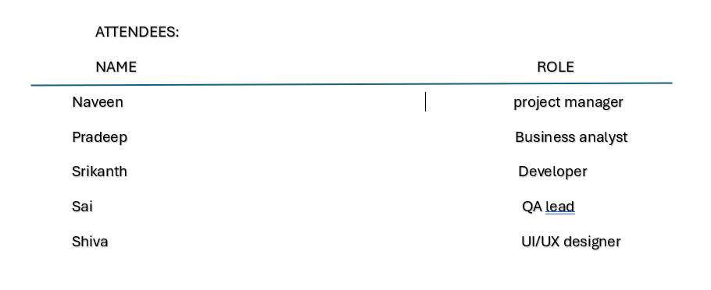
AGENDA :
-Review progress on current sprint
-Discuss blockers and risks
-Upcoming deliverables
-Action items and next steps

Discussion summary
-Sprint planning

Development team completed 6 to 8 planned stories
UI design for feature B is finalized
QA started test planning

-Risks and blockers

API integration delay from external vendor
Potential resource constraints in QA next week due to leave
-Upcoming deliverables

Code freeze for feature A – July 16
Final UX review for feature B – July 17

Decision Made
-Move on developer to support API work temporarily
-Push internal demo to July 22 to allow buffer
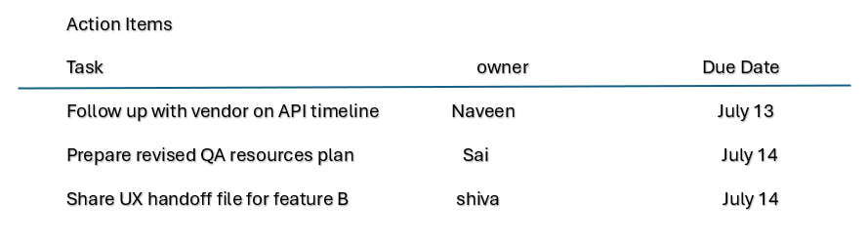
Next meeting
Date – July 19,2025
Time – 10.00 am
Location – Zoom .

Q13. Change Tracker – Document - – prepare one Sample -4 Marks

The Change Tracker document is used by the project team to log and track change requests made throughout the life of the project.
The sample change tracker document
CHANGE ID | DATE RAISED | CHANGE DESCRIPTION | TYPE | REQUESTED BY | IMPACT SUMMARY | STATUS | DECISION | OWNER | TARGET DATA
CHG-001 | 5-jul-25 | Add dark mode  Feature | Scope | Product  Owner | Extra design  Dev time  5days | Under  Review | TBD | Dev  Lead | TBD
Chg-002 | 8-jul-25 | Extend UI review  Deadline by 3  Days | Schedule | UX team  Lead | No major impact on  Over all  Timeline | Approved | Accepted | UX lead | 15- JUL-25
Chg003 | 10-jul-25 | Remove feature c  Due to budget cuts | Scope | Project  Sponsor | Saves 7  Dev days | Approved | Accepted | PM | N/A
Chg004 | 12-jul-25 | QA tester on leave  1 week | Resource | QA  manager | Test cycle  Might  Delayed | Under  Review | TBD | QA lead | TBD

Q14. Difference between Traditional Development Model and Agile Development Models – 8 Marks

S.No. | Traditional Development Model | Agile Development Model
1 | Follow a linear and sequential approach. | Follows an iterative and incremental  approach.
2 | Requirements are fixed at the beginning. | Requirements can change during development.
3 | Customers are involved only at the start and  end. | Customers are involved throughout the  process.
4 | Testing is done after the development phase. | Testing is done continuously in each iteration.
5 | The entire product is delivered at the end of the project. | Working software is delivered after each sprint.
6 | Less flexible to change once development  begins. | Highly flexible and adaptive to changes.
7 | Suitable for small projects with stable requirements. | Suitable for complex projects with evolving needs.
8 | Emphasis on process and tools. | Emphasis on individuals and interactions.

Q15. Explain Brainstorming Technique – Where to use? 5 Marks

- To generate a wide range of creative ideas and solutions for a problem
- Less structured, encourages free-flowing and spontaneous idea sharing
- Open to anyone; no specific criteria required
- List of ideas or solutions, often recorded for further evaluation
- Can involve any number of participants

Q16. What reports Accounts Departments will generate (minimum 5 reports) – 10 Marks

Great question—let’s break it down logically.

For the Employees Loan Management System, the Accounts Department would need to generate several key reports to track, manage, and audit employee loans. Here’s a list of 5 essential reports they could generate:

Loan Disbursement Report

  - Details all loans that have been approved and disbursed within a specific period (e.g., monthly, quarterly).
  - Includes employee name, employee ID, loan amount, disbursement date, and payment method.
  - Purpose: Helps track cash outflow and verify disbursements against approvals.

Loan Repayment Schedule Report
  - Shows upcoming loan repayment installments for all employees.
  - Includes due dates, EMI (Equated Monthly Installments) amounts, and outstanding balances.
  - Purpose: Helps in monitoring expected recoveries and ensuring payroll deductions align with repayment schedules.

Loan Status Summary Report

  - Summary of all loans categorized as: Pending Approval, Approved, Rejected, Active, or Closed.
  - Includes count and total value of loans in each category.
  - Purpose: Gives a snapshot of overall loan portfolio health.

Loan Default/Overdue Report

  - Highlights employees who missed payments or whose repayments are overdue.
  - Includes employee details, overdue amount, and number of missed installments.
  - Purpose: Alerts the accounts team to take corrective action or send reminders.

Loan Interest Income Report

  - Shows total interest income earned from employee loans over a specific period.
  - Includes details of individual loans and cumulative interest.
  - Purpose: For financial planning, tax calculations, and auditing.

- Employee Loan Eligibility Report (shows employees eligible for loans and their limits).
- Rejected Loan Applications Report (with reasons for rejection).
- Loan Write-Off Report (if any loans are written off due to employee separation or other reasons).

Q17. What is the structure of the message/mail communicated from the HR department to the employee in case the Loan is rejected? – 5 Marks
Subject: Notification of Loan Application Status

Dear [Employee Name],

Thank you for applying for a loan through the Employees Loan Management System. We appreciate your trust in utilizing this facility.
After careful review of your application (Loan ID: [Loan ID]), we regret to inform you that your loan request has been rejected due to the following reason(s):

[State the specific reason for rejection, e.g., Not meeting eligibility criteria, Insufficient tenure with the organization, Pending previous loan repayment, etc.]
We encourage you to review the eligibility guidelines and consider reapplying in the future when the criteria are met. If you have any questions regarding this decision or wish to discuss your application further, please feel free to contact the HR department at [HR Email Address] or [HR Phone Number].
We value your contribution to TTS Company and remain committed to supporting our employees wherever possible.

Best regards,
[HR Representative Name]
HR Department TTS Company

Q18. What is the structure of the message/mail communicated from the HR department to the employee in case the Loan is approved? – 5 Marks

Subject: Congratulations! Your Loan Application Has Been Approved

Dear [Employee Name],
We are pleased to inform you that your loan application (Loan ID: [Loan ID]) submitted on [Application Date] has been approved.
Please find below the details of your approved loan:

Loan Amount: [Approved Loan Amount] Interest Rate: [Applicable Interest Rate]% Repayment Period: [Number of Months] months Monthly Installment (EMI): [EMI Amount]
First Deduction Date: [Date]

To proceed, please review the attached Loan Approval Terms and Conditions and the Repayment Schedule. If you agree with the terms, kindly provide your consent by replying to this email or signing the attached agreement by [Deadline Date].
Once we receive your confirmation, the loan amount will be disbursed, and automatic salary deductions will be initiated as per the repayment schedule.
If you have any questions or require further clarification, feel free to contact the HR department at [HR Email Address] or [HR Phone Number].
We appreciate your continued contribution to TTS Company and look forward to supporting you through this initiative.

Best regards,
[HR Representative Name]
HR Department TTS Company

Q19. Design a sample report on the Loans applications Received by the accounts department – 8 Marks
TTS Company – Employees Loan Applications Report Reporting Period: 01-June-2025 to 30-June-2025 Department: Accounts

S  . | Emp ID | Emp Name | Dept | Loan Amount  Requested | Applica tion  Date | Status | Remarks

N
o
1 | TTS0 01 | Ananya Sharma | IT | ₹2,00,000 | 05-  June-  2025 | Approv ed | Disbursement scheduled 10-June-  2025
2 | TTS0 14 | Rajeev Menon | Finan ce | ₹1,50,000 | 07-  June- 2025 | Rejecte d | Insufficient tenure (6 months)
3 | TTS0 25 | Priya Verma | HR | ₹75,000 | 10-  June- 2025 | Approv ed | Awaiting employee consent
4 | TTS0 42 | Arun Kumar | Opera tions | ₹1,00,000 | 15-  June-  2025 | Pendin g  Review | Sent for HR verification
5 | TTS0 56 | Neha Singh | R&D | ₹2,50,000 | 20-  June- 2025 | Rejecte d | Loan eligibility exceeded
6 | TTS0 78 | Vikram Das | Marke ting | ₹1,20,000 | 25-  June- 2025 | Approv ed | Repayment starts 01-July-2025

Q20. Which reporting Tools we will use for generating reports. – 5 Marks

To generate reports for the Employees Loan Management System, the following reporting tools can be used:

Microsoft Power BI

  - For interactive dashboards and visual analytics of loan data.

Tableau
  - To create detailed and visually appealing reports with drill-down capabilities.

SAP Crystal Reports

  - For designing professional, printable financial reports.

Oracle BI Publisher

  - To generate high-volume reports directly from enterprise databases.

Microsoft Excel (with Pivot Tables & Charts)

  - For quick and flexible reporting on loan applications, repayments, and summaries.

