MEDsights (Medical Insight platform) Part 2/2 Evaluation

Document 6- Please prepare a use case diagram, activity diagram and a use case specification document.
Use case diagram:
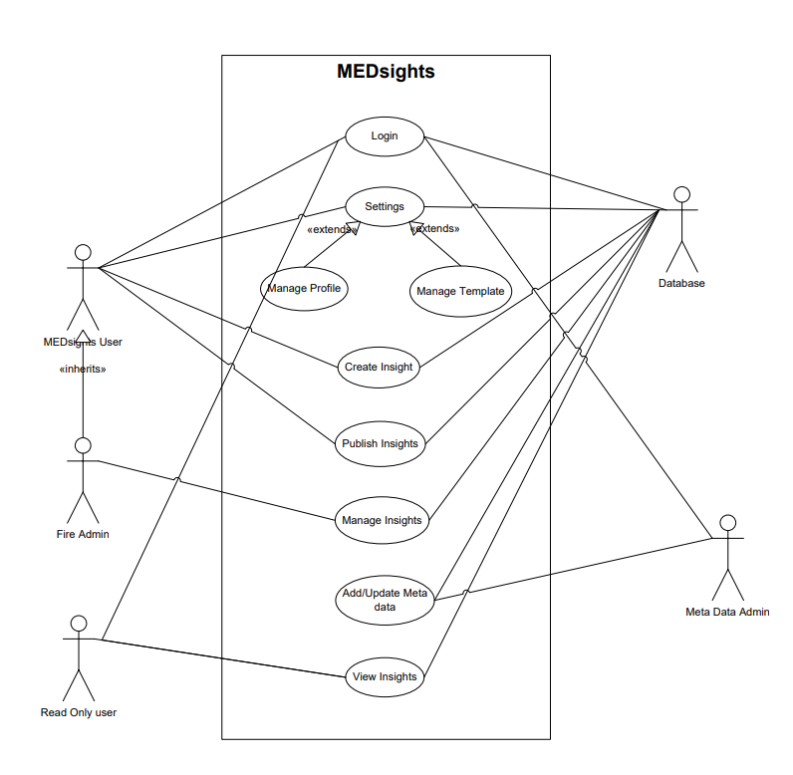

Activity Diagrams:
MEDsights user:
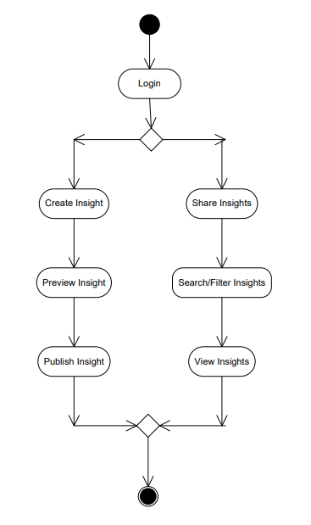
Read only user:
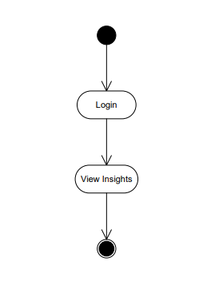

Fire Admin:
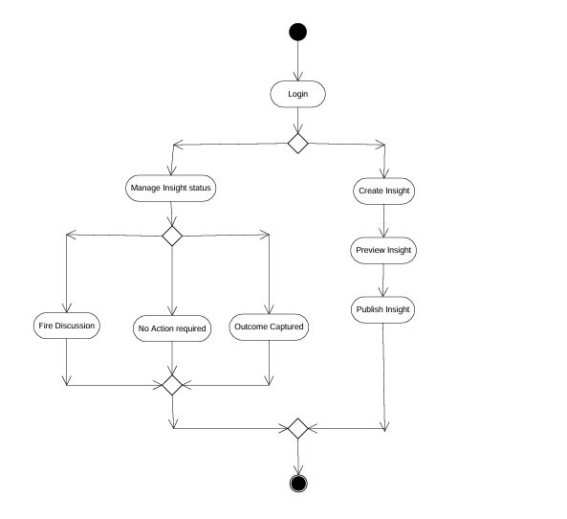
Use case specification document:
User Login:
Use Case Specification | Details
Use case id | USECASE_01
Use case name | User Login
Use case description | This use case describes the login process for users accessing the MEDsights application securely. The system verifies credentials and grants access based on user roles.
Actors | Primary Actors: MEDSights user, Fire Admin, Read only user, Meta data admin  Secondary Actors: DB
Basic Flow | 1. User navigates to the login page.  2. User enters credentials (username/password).  3. System validates credentials against stored records.  4. If valid, user is granted access and redirected to the dashboard.  5. Login success message is displayed.
Alternate Flow | - If authentication fails, the user is prompted to retry or reset the password.  - If multi-factor authentication (MFA) is enabled, user must complete additional verification steps.
Exceptional Flows | - Account lockout due to multiple failed login attempts.  - System downtime prevents login access.
Pre-Conditions | - User must be registered in the system.  - Authentication system must be operational.
Post-Conditions | - User gains access to their account.  - Login activity is logged for audit purposes.
Assumptions | - Users remember their credentials or have access to password recovery options.  - System follows industry-standard authentication protocols.
Constraints | - Limited login attempts before temporary lockout.  - Login must comply with security policies, including strong password requirements.
Dependencies | - Database for storing user credentials.  - Authentication and security module.
Inputs and Outputs | Inputs: Username, password, MFA token (if applicable).  Outputs: Login success/failure message, user dashboard access.
Business Rules | - All users must authenticate before accessing the system.  - Password complexity and expiration policies must be enforced.  - Login failures trigger security alerts after multiple attempts.
Miscellaneous Information | - The system provides login audit logs for security monitoring.  - Support team can assist users with login issues.

Create insight:
Use Case Specification | Details
Use case id | USECASE_02
Use case name | Create Insight
Use case description | This use case describes the process where an End User creates a new insight in the MEDsights application, ensuring insights are properly recorded and available for further analysis.
Actors | Primary Actors: End User, Fire admin  Secondary Actors: DB, Meta data admin
Basic Flow | 1. End User logs into the MEDsights application.  2. End User navigates to the "Create Insight" section.  3. End User enters insight details.  4. System validates the input data.  5. End User submits the insight.  6. System processes the insight and stores it in the database.
Alternate Flow | If validation fails, the system prompts the End User to correct the errors before submission.
Exceptional Flows | - System outage prevents insight creation.  - End User loses connectivity while creating an insight, prompting an automatic save for later retrieval.
Pre-Conditions | - End User must be logged in with appropriate permissions.  - Database must be operational for storing insights.
Post-Conditions | - Insight is successfully saved  - System logs the creation process for audit purposes.
Assumptions | End User follows predefined format guidelines for insights.
Constraints | - Insights must adhere to regulatory standards.  - Limited concurrent submissions to prevent system overload.
Dependencies | Authentication system to verify End User access.
Inputs and Outputs | Inputs: Insight title, description, relevant metadata.  Outputs: Confirmation message, stored insight.
Business Rules | - Only authorized End Users can create insights.  - Insights must align with medical compliance standards.
Miscellaneous Information | - System maintains an audit trail for all insights created.

Template creation:
Use Case Specification | Details
Use Case ID | USECASE_03
Use Case Name | Creating Templates
Use Case Description | This use case describes how users can create, edit, and delete templates in the MEDsights application through the settings option.
Actors | Primary Actors: MEDsights user, Fire Admin  Secondary Actors: Meta Data Admin, DB
Basic Flow | 1. User navigates to the settings option and selects "Templates".  2. User chooses to create a new template.  3. User enters template details and content.  4. System saves the template and makes it available for use.  5. User receives confirmation of template creation.
Alternate Flow | - User selects an existing template to edit and modifies the content.  - System updates and saves the edited template.  - User chooses to delete a template, and the system removes it permanently.
Exceptional Flows | System error prevents saving or updating the template.
Pre-Conditions | - User must have access to template management within the settings.
Post-Conditions | - Newly created templates are available for use.  - Edited templates reflect changes.  - Deleted templates are permanently removed from the system.
Assumptions | - Users require templates for consistent document formatting.
Constraints | - Templates must follow predefined formatting rules.  - Only authorized users can modify or delete templates.
Dependencies | - Database for storing template content.  - Access control module for user permissions.
Inputs and Outputs | Inputs: Template name, content, Meta data field  Outputs: Created templates, confirmation messages
Business Rules | - Users can only edit or delete templates they own.  - Deleted templates cannot be recovered.
Miscellaneous Information | - System maintains logs of template modifications for auditing.

Home page:

Use Case Specification | Details
Use Case ID | USECASE_04
Use Case Name | Home Page Functionality
Use Case Description | This use case describes the functionalities of the Home Page in the MEDsights application. The homepage provides a search bar for users to search insights by name or ID, an insight display section to show results, and a recently viewed section to list previously accessed insights.
Actors | Primary Actors: MEDsights user, Fire Admin, Read only user  Secondary Actors: Meta Data Admin, DB
Basic Flow | 1. User navigates to the home page after login.  2. User enters an insight name or ID in the search bar.  3. System retrieves matching insights based on search criteria.  4. The insight display section presents the search results.  5. User selects an insight to view details.  6. Recently viewed section updates to include the accessed insight.
Alternate Flow | - If no matching insights are found, the system displays a "No results found" message and suggests refining the search.
Exceptional Flows | - System error prevents the search functionality from working.
Pre-Conditions | - User must be logged into the MEDsights application.  - The system must have stored insights available for search.
Post-Conditions | - User successfully retrieves insights based on search input.  - Recently viewed insights list is updated.
Assumptions | The system delivers fast and accurate search results.
Constraints | Recently viewed insights are limited to a predefined number of records.
Dependencies | - Database storing insights data.  - Search indexing and caching mechanism.
Inputs and Outputs | Inputs: Insight name or ID entered by the user  Outputs: List of relevant insights, recently viewed insights section update
Business Rules | - Only accessible insights are displayed based on user roles.  - Recently viewed section maintains a limited history of accessed insights.
Miscellaneous Information | - The homepage is the default landing page after login.

Insights page:
Use Case Specification | Details
Use Case ID | USECASE_05
Use Case Name | Insights Page Functionality
Use Case Description | This use case describes the functionalities of the Insights Page in the MEDsights application, where users can search for insights, apply metadata-based filters, and interact with insight cards using lazy load functionality.
Actors | Primary Actors: MEDsights user, Fire Admin, Read only user  Secondary Actors: Meta Data Admin, DB
Basic Flow | 1. User navigates to the Insights Page.  2. User enters an insight name or ID in the search bar.  3. System retrieves matching insights based on search criteria.  4. Insights are displayed dynamically using lazy load.  5. User applies metadata-based filters from the filter section.  6. System updates the displayed insights based on selected filters.  7. User selects an insight card.  8. System navigates the user to the Insight Detail Page for further analysis.
Alternate Flow | - If no matching insights are found, the system displays a "No results found" message and suggests refining the search.
Exceptional Flows | - System error prevents insights from loading.
Pre-Conditions | - User must be logged into the MEDsights application.  - The system must have stored insights available for search and filtering.
Post-Conditions | - User successfully retrieves insights based on search or filter input.  - User navigates to the Insight Detail Page upon selecting an insight.
Assumptions | The system delivers fast and optimized search results using lazy loading.
Constraints | Filters must align with predefined metadata categories.
Dependencies | - Database storing insights and metadata information.  - Search indexing and caching mechanism.
Inputs and Outputs | Inputs: Insight name, ID, metadata-based filters  Outputs: List of relevant insights, filtered insights, navigation to detail page
Business Rules | - Only accessible insights are displayed based on user roles.  - Lazy load optimizes performance by dynamically loading insights.
Miscellaneous Information | - System logs search and filter activities for optimization and analytics.

Fire admin page:
Use Case Specification | Details
Use Case ID | USECASE_06
Use Case Name | Fire Admin Insight Management
Use Case Description | This use case describes the functionality available to the Fire Admin in the MEDsights application. The Fire Admin can create insights, update the status of insights, filter insights for status updates, and capture discussions and outcomes in the Fire Discussion page.
Actors | Primary Actor: Fire Admin  Secondary Actors: MEDsights user, DB, Meta data admin
Basic Flow | 1. Fire Admin navigates to the Home Page.  2. Fire Admin selects the option to Create Insight.  3. Fire Admin enters relevant details for the insight and submits it.  4. System saves the new insight and makes it available for users.  5. Fire Admin navigates to an insight to update status.  6. Fire Admin selects one of the available statuses: Open, No Action Required, Fire Discussion, Outcome Captured.  7. System updates the insight status accordingly.  8. Fire Admin navigates to the Fire Discussion Page to capture discussion outcomes.
Alternate Flow | - Fire Admin applies filters to view insights based on metadata or status.  - Fire Admin modifies or refines insight details before submission.
Exceptional Flows | - System error prevents insight creation or status updates.  - User lacks permissions to modify insights.
Pre-Conditions | - Fire Admin must be logged into the system.  - Insights must be available for filtering and updating statuses.
Post-Conditions | - New insights are created successfully.  - Insight statuses are updated accurately.  - Discussions and outcomes are recorded in the Fire Discussion Page.
Assumptions | - Fire Admin understands insight creation and management workflows.  - System supports status filtering for efficient insight updates.
Constraints | - Status updates must follow predefined categories.  - Access restrictions apply to insight creation and status modification.
Dependencies | - Database storing insights and discussions.  - Role-based access control for Fire Admin permissions.
Inputs and Outputs | Inputs: Insight details, status update selection, filters  Outputs: Created insights, updated insight status, logged discussion outcomes
Business Rules | - Only Fire Admins can modify status of insights  - System logs all updates for audit and compliance purposes.
Miscellaneous Information | - System tracks Fire Admin activities for reporting and optimization.

Document 7- Screens and pages
Login:
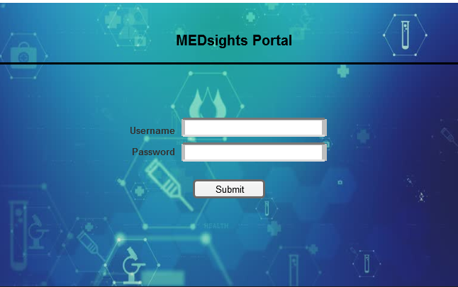

Home:
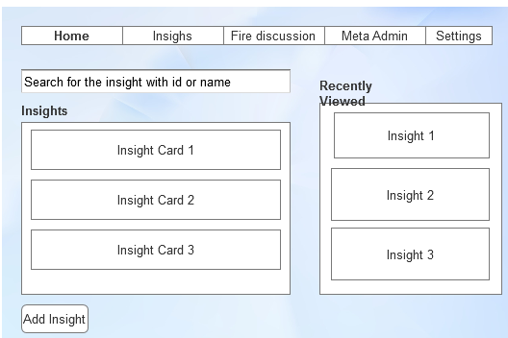

Create Insight:
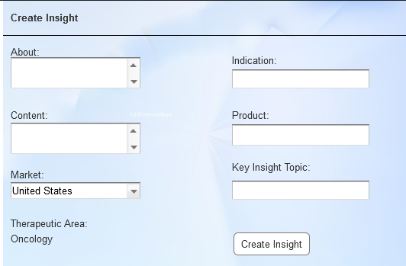

Insights:
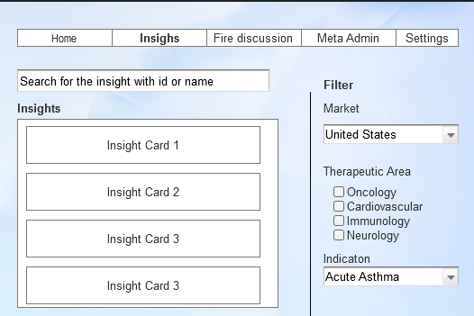

Fire discussion:
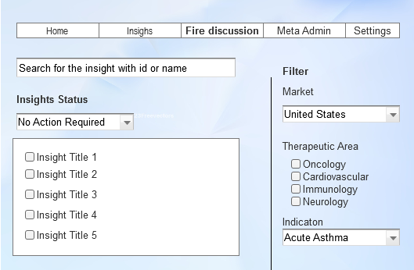
Meta Admin:
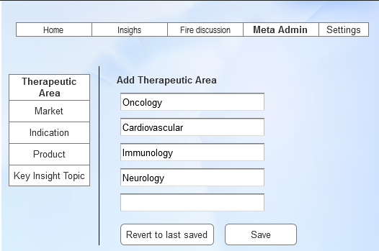

Settings:
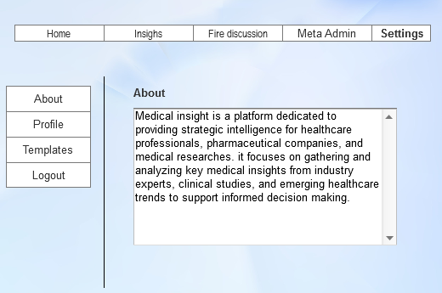

Document 8- Tools-Visio and Axure

Using Visio and Axure for the project was a smooth process because both tools helped in different ways. Visio made it easy to draw clear diagrams, like flowcharts and organizational structures, which helped plan and visualize ideas quickly. It’s great for making structured designs that everyone can understand. Axure, on the other hand, allowed for interactive prototypes, meaning I could create designs that responded to clicks and actions, almost like a real website or app. This helped test ideas before building them fully. Visio was best for simple, static diagrams, while Axure was useful for making interactive designs. Together, they made it easier to plan, design, and test different parts of the project efficiently.
Visio is generally easier to use for basic diagramming, while Axure has a steeper learning curve due to its advanced prototyping features. Visio is great for static diagrams, whereas Axure supports interactive elements, making it ideal for UX/UI design.

Document 9- BA experience

My experience as BA in following phases:
1. Requirement Gathering
This is the starting point of the project, where I collect and understand what the client needs.
- We used the MOSCOW technique to prioritize requirements into four categories: Must have, Should have, Could have, and Won’t have—helping us focus on the most important features.
- During this phase, the client was unavailable, which posed a challenge. As a BA, I had to identify key contacts from the client’s side who could provide essential information quickly.
- Once requirements were gathered, I verified them using the FURPS technique, ensuring that they met Functionality, Usability, Reliability, Performance, and Supportability standards.
- Some requirements were duplicated or repeated, which could lead to confusion. Removing redundant requirements helped streamline the project scope.
- Prototyping was useful in refining requirements. Creating a basic version of the system allowed the client to visualize how things would work, making their expectations clearer.

2. Requirement Analysis
After gathering the requirements, the next step was to analyze them in detail.
- I created UML (Unified Modeling Language) diagrams, which provided a visual representation of how different components would interact. This helped everyone, including developers and testers, to understand the workflow better.
- Activity diagrams were also used to map out process flows and define how different tasks are connected. This made it easier for the team to plan development work.
- Sharing these diagrams with the team sometimes led to disagreements. As a BA, I had to communicate and justify the logic while remaining open to suggestions. Modifications were made based on valuable feedback.
- I prepared two key documents:
  - Business Requirement Specification (BRS) – This document captured all high-level business needs and expectations.
  - Software Requirement Specification (SRS) – A more detailed technical document outlining software functionalities and system behavior.

3. Design
The design phase is critical because it translates requirements into actual system functionality.
- I used use case diagrams to develop test cases that ensured all functionalities were tested thoroughly.
- Regular discussions with the client were necessary to validate the design and solution documents.
- I wrote positive test cases (ensuring expected scenarios work properly) and negative test cases (checking how the system handles incorrect inputs or errors).
- Since missing even a single test case could cause major issues later, I ensured no test cases were overlooked.
- Preparing test data for upcoming testing helped simulate real-world scenarios.
- The Requirements Traceability Matrix (RTM) was consistently updated to ensure that every requirement was accounted for and tested correctly.

4. Development
During development, the focus was on ensuring developers implemented the requirements correctly.
- JAD (Joint Application Development) sessions helped align business and technical perspectives, ensuring smooth development.
- Developers often had queries about specific requirements, and I was responsible for clarifying them.
- Some team members had conflicting views or were hesitant to cooperate in discussions. As a BA, I handled these situations diplomatically, speaking to them individually and explaining the project impact. This helped create a positive and collaborative work environment.
- Reference diagrams were used for coding, ensuring developers had a clear guide on functionality.
- Conducting regular meetings with both technical teams and the client was challenging. When some team members missed meetings, I recorded sessions and later had one-on-one discussions to keep them updated.

5. Testing
Testing ensures the developed system meets requirements and works as expected.
- Test cases were prepared using the use cases defined earlier.
- I performed high-level testing to validate major system functionalities.
- Since realistic test data improves testing accuracy, I requested test data from the client.
- The RTM was continuously updated, tracking requirements and their respective test cases.
- Once testing was successful, client sign-off was obtained, confirming acceptance of the completed system.
- I also worked on preparing the client for User Acceptance Testing (UAT), ensuring they understood how to validate the system from their side.

6. Deployment
Deployment is the final phase, where the system is delivered to the users.
- The RTM was forwarded to the client, attached to the project closure document, ensuring all requirements were met before deployment.
- I coordinated the creation and sharing of end-user manuals, making it easier for users to understand the system.
- Organizing training sessions ensured users were comfortable with the new system before it went live.
- To ensure full participation, I made sure all relevant candidates attended the training, reducing future support issues.

