Capestone 1 -Part 3
Submitted By: Bhavane P
Question 1 – Functional Requirements
A Functional Requirement defines what the system should do—its specific behaviors, features, or functions that deliver value to users and stakeholders.
Req ID | Requirement Name | Requirement Description
FR001 | Farmer Registration | Farmers can register as users with email and password.
FR002 | Manufacturer Registration | Manufacturers can create an account.
FR003 | User Login | Users (Farmer, Manufacturer) can log in to the application.
FR004 | Product Catalog View | Farmers can browse a catalog of all listed products.
FR005 | Product Search | Farmers can search for products by keyword, type, or category.
FR006 | Product Filter | Farmers can filter products by type, brand, price, or availability.
FR007 | Product Details View | Detailed product information and images are accessible.
FR008 | Add to Cart | Farmers can add selected products to their cart.
FR009 | Add to Wishlist | Farmers can save items to a wishlist/buy-later list.
FR010 | Place Order | Farmers can place orders for items in their cart.
FR011 | Payment Processing | System supports payment by COD, Credit/Debit Card, and UPI.
FR012 | Order Confirmation | Farmers receive an email confirmation after order placement.
FR013 | Order Tracking | Farmers can track the delivery status of orders.
FR014 | View Order History | Farmers can view past orders and details.
FR015 | Manufacturer Upload Product | Manufacturers can add new products to the catalog.
FR016 | Edit/Delete Product | Manufacturers can edit or remove their own product listings.
FR017 | Multi-language Support | Users can select from available languages for the interface.
FR018 | Responsive Design | Application displays correctly on mobile and desktop.
FR019 | User Feedback/Support | Users can send support queries or feedback through a form or chat.
FR020 | Password Recovery | Users can recover/reset their account passwords if forgotten.

Non-Functional Requirements (NFRs)
Non-functional requirements describe how well or under what conditions the system performs its functions—covering qualities like speed, security, reliability, usability, and compliance.
NFR ID | Requirement Name | Description
NFR101 | System Reliability | System shall handle failures gracefully and recover without user intervention within 5 minutes.
NFR102 | Maintainability | Code and documentation must be clear and modular, facilitating updates and bug fixes within 2 business days.
NFR103 | Data Privacy | User personal information shall comply with applicable data privacy laws (e.g., GDPR, local regulations).
NFR104 | Load Handling | The system shall support up to 10,000 daily transactions with consistent performance.
NFR105 | Mobile Responsiveness | The application interface must be fully responsive on mobile devices across varying screen sizes.
NFR106 | Logging and Monitoring | All transactions and critical operations must be logged with timestamps for audit and troubleshooting.
NFR107 | Payment Security | Payment processing must comply with PCI DSS standards for handling credit card data.
NFR108 | Transaction Integrity | Order and payment transactions must be atomic; partial updates shall not be saved.
NFR109 | User Support Response Time | Helpdesk support should respond to user inquiries within 24 hours on working days.
NFR110 | Disaster Recovery | The system must have a disaster recovery plan ensuring restoration of service within 4 hours.

Question 34 – Minimum 5 Page Designs
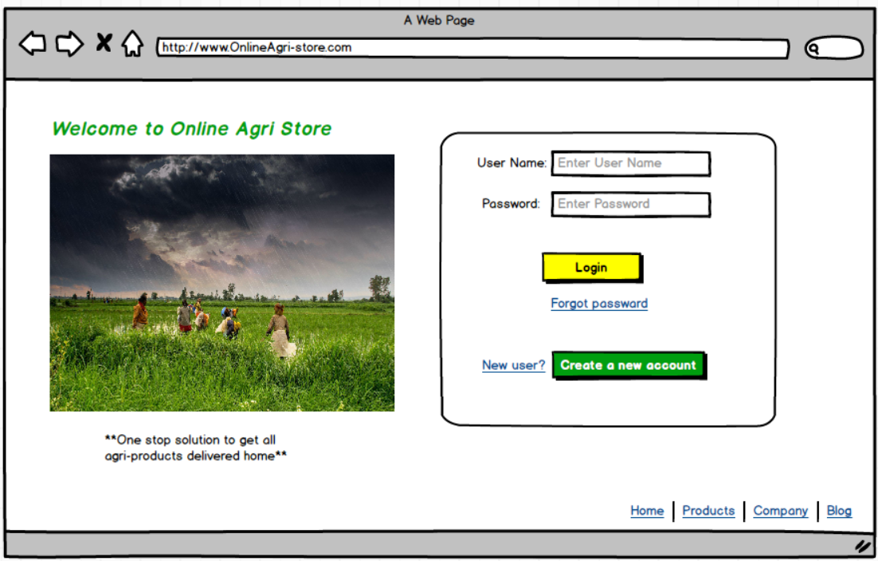
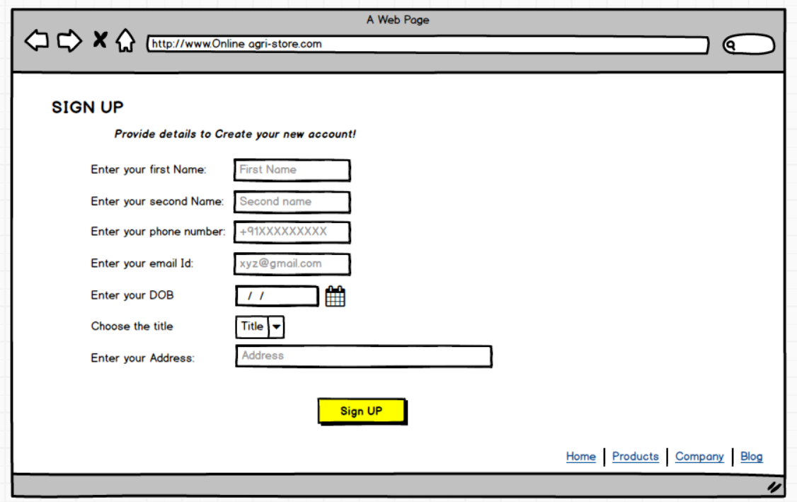
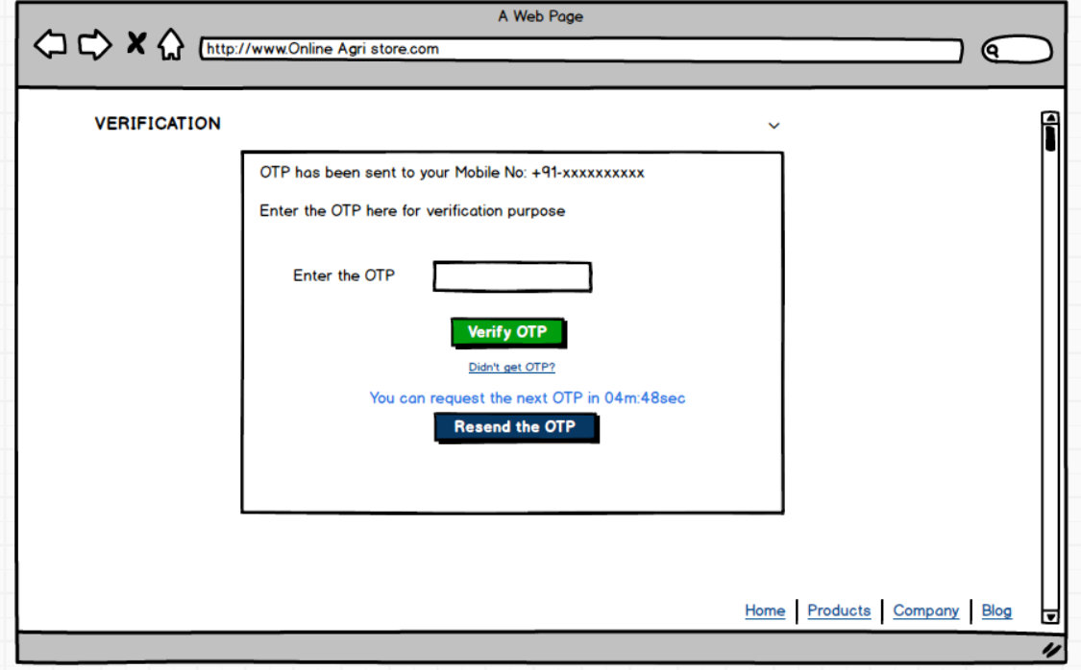
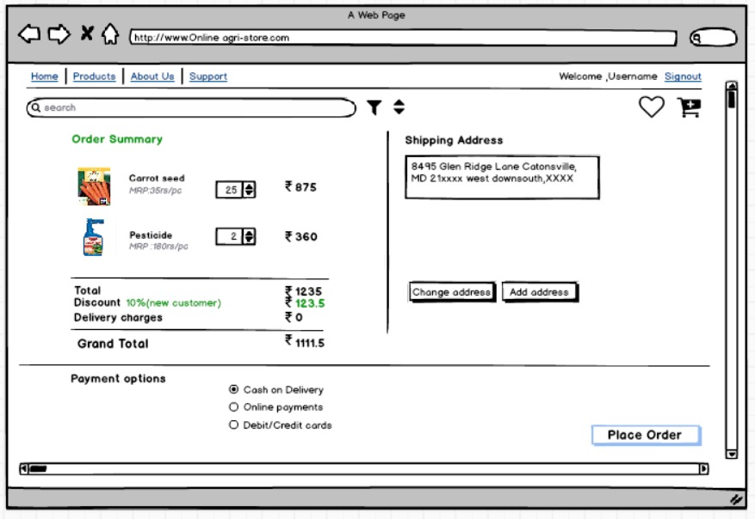
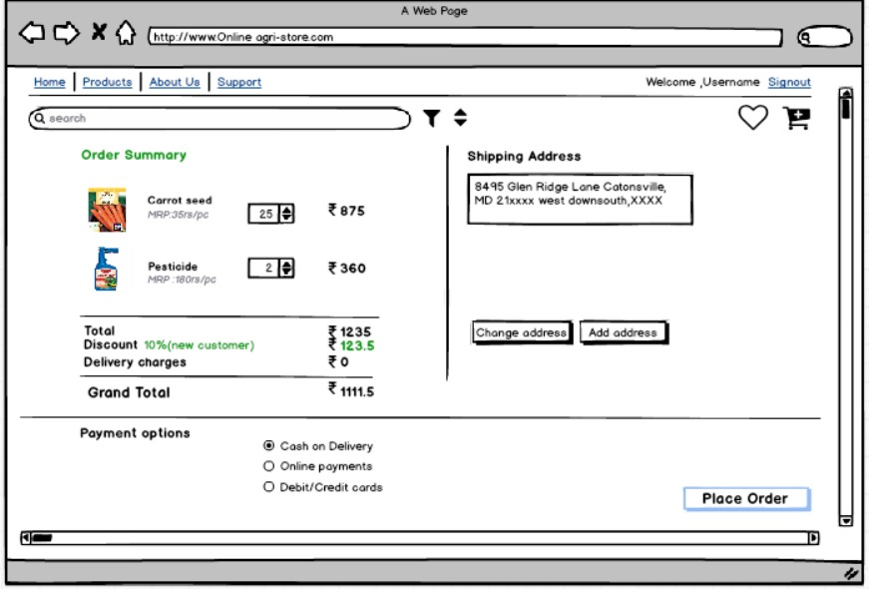
Question 35 – Tools Used: Visio, Balsamiq
- Microsoft Visio
Microsoft Visio is a powerful diagramming tool from Microsoft, widely used for creating flowcharts, organizational charts, data flow diagrams (DFDs), network diagrams, and detailed process maps.
Key Features:
- Large selection of templates and shapes for various diagram types.
- Drag-and-drop interface for easy creation of complex visuals.
- Integration with other Microsoft Office products.
- Useful for formal documentation, system modeling, and sharing visual processes with technical and non-technical stakeholders.
Uses:
Process mapping, system architecture, workflows, business process modeling, and technical documentation.
- Balsamiq
Balsamiq is a rapid wireframing tool focused on creating low-fidelity (sketch-like) UI mockups. It’s known for its “hand-drawn” look that emphasizes structure and content, not detailed design.
Key Features:
- Simple and intuitive drag-and-drop interface.
- Rich library of UI components for quick mockups.
- Encourages feedback and creativity without focusing on polished visuals.
- Fast for brainstorming layouts, app screens, and web pages at early stages.
Uses:
Early-stage ideation, stakeholder workshops, validating ideas quickly, and getting feedback on layouts and workflows before deep design begins.
- Axure RP
Axure RP (Rapid Prototyping) is an advanced wireframing and prototyping tool that allows users to create highly interactive and dynamic prototypes, closely simulating real application behavior.
Key Features:
- Supports logical conditions, clickable components, dynamic content, and data-driven interactions.
- Lets you build functional prototypes with forms, navigation, and user flows.
- Enables user testing and validation of UX before development begins.
- Generates specifications and design notes for developer handover.
Uses:
Creating high-fidelity, interactive prototypes for complex projects, UX testing, demonstrating user journeys, and bridging communication between design, business, and development teams.
Question 36 – RTM (Requirements Traceability Matrix)
Definition:
A Requirements Traceability Matrix (RTM) is a project document that traces and maps user and system requirements through test cases—ensuring every requirement is covered in testing.
Req ID | Req Name | Req Description | Design | DEV1 | TEST1 | DEV2 | TEST2 | DEV3 | TEST3 | DEV4 | TEST4 | UAT
FR101 | User Sign-Up | Both farmers & manufacturers can register with email and password | Y | Y | Y | N | N | N | N | N | N | N
FR102 | Secure Login | Registered users can log in securely with credential checks | Y | Y | Y | N | N | N | N | N | N | N
FR103 | Product Catalog Access | Farmers can view a categorized catalog of all fertilizers, seeds, pesticides | Y | Y | Y | N | N | N | N | N | N | N
FR104 | Advanced Search | Search function with keyword and filter (type, brand, price) | Y | Y | Y | N | N | N | N | N | N | N
FR105 | Add to Cart/Wishlist | Ability to add products to shopping cart or wish/buy-later list | Y | Y | Y | N | N | N | N | N | N | N
FR106 | Order Placement | Farmers can checkout and place orders for in-stock products | Y | Y | Y | N | N | N | N | N | N | N
FR107 | Payment Integration | System supports and processes payments (COD, Card, UPI) | Y | Y | Y | N | N | N | N | N | N | N
FR108 | Email Notification | Users get email upon order placed, shipped, delivered | Y | Y | Y | N | N | N | N | N | N | N
FR109 | Delivery Tracking | Farmer can view real-time status of deliveries/orders | Y | Y | Y | N | N | N | N | N | N | N
FR110 | Manufacturer Upload | Manufacturer can add/edit/delete their product listings | Y | Y | Y | N | N | N | N | N | N | N
FR111 | Multilingual Interface | Application supports regional language switching | Y | Y | Y | N | N | N | N | N | N | N
FR112 | Customer Support | Users can submit feedback or queries in-app | Y | Y | Y | N | N | N | N | N | N | N

Non-Functional Requirements (NFRs) Table
NFR ID | NFR Name | Description | Design | Dev | Test | UAT
NFR001 | Performance | Each page must load within 2 seconds under standard conditions | Y | Y | Y | Y
NFR002 | Scalability | Platform supports at least 5,000 concurrent users | Y | Y | Y | Y
NFR003 | Security | All user data and transactions encrypted via SSL/TLS | Y | Y | Y | Y
NFR004 | Availability | 99.5% monthly uptime | Y | Y | Y | Y
NFR005 | Usability | Users must complete key tasks within 3 clicks | Y | Y | Y | Y
NFR006 | Accessibility | Platform must meet WCAG 2.1 Level AA guidelines | Y | Y | Y | Y
NFR007 | Compatibility | Works on Chrome, Firefox, Safari, Edge latest 2 versions | Y | Y | Y | Y
NFR008 | Backup & Recovery | Daily data backup with RPO < 24 hours | Y | Y | Y | Y
NFR009 | Response Time | Search results returned within 1 second on average | Y | Y | Y | Y
NFR010 | Localization Support | System supports English and regional languages | Y | Y | Y | Y

Question 37 – 10 Test Case Documents
A test case document in software testing is a detailed set of specifications that defines the inputs, execution conditions, testing steps, and expected results for testing a particular feature or aspect of a software application. Its purpose is to verify whether the software behaves correctly according to requirements and to help identify defects or errors systematically.
Test Case ID | Title/Description | Pre-conditions | Test Steps | Test Data | Expected Result | Actual Result | Status | Post-conditions
TC101 | Register new seller and add product | None | 1. Register seller account  2. Login  3. Upload valid product details & image | New seller, sample product data | Product addition successful | Success banner shown | Pass | Home Page
TC102 | Upload product without price | Must be logged in as seller | 1. Upload image/name only  2. Leave price blank | Missing price | Error: "Enter price" | Error message shown | Pass | Remain on page
TC103 | Add product with invalid image type | Must be logged in as seller | 1. Upload non-image (e.g., .doc file) as product image | Invalid file type | Error: "Invalid image format" | Error message shown | Pass | Remain on page
TC104 | Seller reaches upload quota | Seller quota nearly full | 1. Add products until limit  2. Attempt one more | Over quota | Error: "Max product limit" | Error shown | Pass | Remain on page
TC105 | View product after adding | Product has been added | 1. Add product  2. Log out/in  3. Search new product | Recently added product | Product visible in catalog | Product displayed | Pass | Catalog
TC106 | Add product with special characters | Must be logged in as seller | 1. Enter special chars in product name/desc | Name: "@@!!", Desc: "%^&*()" | Fields accept special characters | Product shown with correct data | Pass | Product listed
TC107 | Update product stock | Product exists, logged in | 1. Change stock quantity  2. Save | New stock value | Product stock updated | Success message shown | Pass | Home Page
TC108 | Attempt duplicate product upload | Original product exists | 1. Add product  2. Attempt exact duplicate | Duplicate entry | Error/warning for duplication | Error/warning shown | Pass | Remain on page

Question 38 – DB Design
Data Base designs : A database diagram is a visual representation of the structure and organization of a database. It typically shows tables (or entities), the fields/columns in each table, and the relationships (or connections) between those tables.

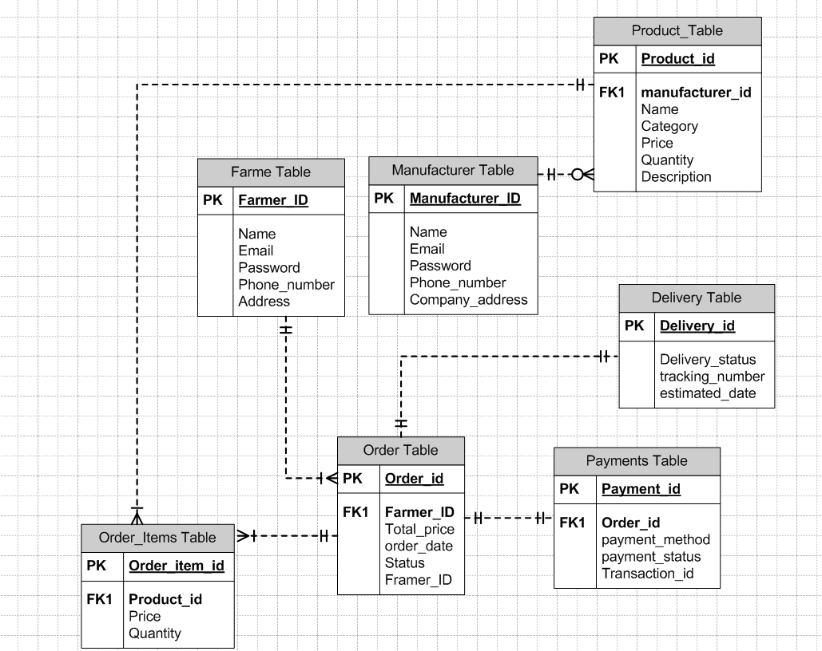

Question 39 – Data Flow Diagram (DFD)
What is a DFD?
A Data Flow Diagram shows how data moves through a system—capturing process steps, data stores, and external actors.
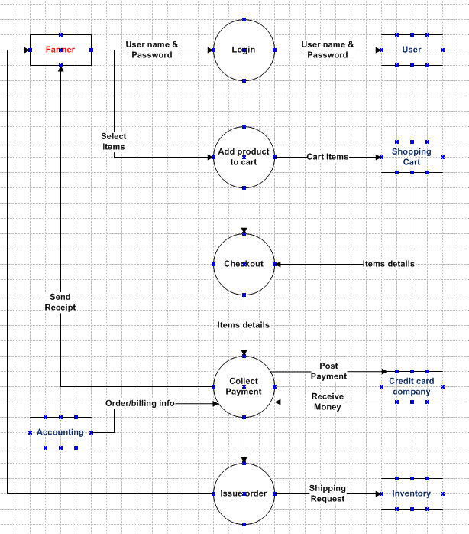
Question 40 – Change Request
Scenario:
There’s been an update in government tax laws, and now your project’s tax structure must be changed.
How should a BA handle this kind of change?
Step | What You Do and Why It Matters
1. Receive Change Request | Formally accept the change (email or form), including who made the request, what needs to change, and why. This ensures transparency and an audit trail.
2. Document the Change | Enter it in the project’s Change Log with all key information (ID, date, summary, who initiated). This keeps your team organized and accountable.
3. Analyze the Impact | Evaluate how updating the tax structure will affect requirements, coding, database, testing, costs, schedule, and who will be affected. This lets you plan realistically and spot risks early.
4. Review & Approve with Stakeholders | Meet with technical leads, the client, and all key stakeholders. Explain the implications, get their input, and secure the green light before acting.
5. Update All Documentation | Revise the BRD, SRS, diagrams, and any training materials, so every document reflects the new tax logic—no confusion later!
6. Implement the Change | Developers and testers make the required updates, following the updated requirements.
7. Test & Validate | Rigorously test to confirm the new tax rules work (correct calculations, compliance, and business behaviour).
8. Communicate to Everyone | Inform all affected users and support staff about what’s changed and if there are any new steps for them. Prevents confusion and support overload.
9. Close the Change Request | Once testing and client review are successful, formally mark the change as “closed” and archive all emails, forms, and approvals for future reference.
Why is this process important?
It ensures you stay compliant, avoid chaotic changes, and keep clients and internal teams confident in the quality and transparency of your work.
Question 41 – Change Request vs. Enhancement
Change Request :
A change request is a formal instruction to adjust something already in the agreed project plan—usually to fix, update, or bring requirements in line with policy or real-world needs. For example, "Due to revised government tax rules, please update all tax calculations in our system."
- When to use:
If the core functionality is already planned or existing, but needs to be corrected, refined, or made compliant.
- Process:
Document the change, analyze what it impacts (features, cost, schedule), get needed approvals, then implement.
Enhancement :
An enhancement is about adding new features or major capabilities that weren’t originally scoped for the system. For instance, "Let’s allow farmers to sell their own crops and add an online auction system for those products." This changes the product from just a marketplace for fertilizers/seeds to a full agri-e-commerce platform for crop sales and auctions.
- When to use:
When stakeholders want new business functionality, user roles, or workflows that substantially extend the project.
- Process:
Conduct new requirement gathering, feasibility studies, budget/schedule planning, and treat as a major upgrade or new project phase.

Scenario Example | Change Request or Enhancement? | Why?
Update tax rates in invoices after new govt. notification | Change Request | It’s a correction/update to existing functionality, keeping the project compliant.
Add auction feature for farmer-sold crops | Enhancement | It’s a new capability, expanding the project’s user base and use cases beyond the original spec.
Question 42 – Estimations: Manhours
How do you estimate overall effort for this kind of project? Here’s an example high-level breakdown:
Activity | Estimated Manhours | Who’s Involved
Requirements Gathering | 20 | You (BA), Stakeholders
Documentation (BRD/SRS) | 16 | BA
UI/Architectural Design | 24 | Developers, BA
Development | 60 | Developers, DB Admin, Network Admin
Testing | 28 | Testers
UAT & Training | 12 | BA, Testers, Client Users
Deployment & Support | 10 | Developers, Admins
Buffer (10%) | 17 | All Team Members
Total | 187 Manhours

Question 43 – UAT Acceptance Process
User Acceptance Testing (UAT) is the final phase of software testing where the actual end users test the system to ensure it meets their business needs and works correctly in real-world scenarios.
How will you, as BA, handle client-side User Acceptance Testing (UAT) and closure?
UAT Handling:
- Kick-off UAT:
  - Schedule UAT sessions with client users.
  - Provide them with clear test scenarios, data, and instructions.
- Support Execution:
  - Be available during UAT to answer questions and help log any issues.
  - Keep track of all feedback, bugs, or enhancement requests.
- Track and Resolve:
  - Work with developers/testers to fix all critical issues raised during UAT.
  - Arrange for retesting as needed.
- Formal Sign-off:
  - Once all tests are passed, collect a signed UAT Acceptance or Client Project Acceptance Form from the client.
Project Closure Process:
- Ensure all deliverables have been provided and agreed upon.
- Conduct a closure meeting to confirm client is satisfied and all business objectives are met.
- Archive all key documentation (BRD, Change Log, UAT forms, emails).
- Formally release project resources and deliver the final “Project Closure Report.”
Question 44 – Project Closure Document
What is a Project Closure Document? Why do you need it?
A Project Closure Document is your project’s “finishing touch.” It formally certifies completion, summarizes what’s been delivered, and captures any final lessons for the team and client. It acts as proof of a job well done, and as a handover for ongoing maintenance/support.
Typical Contents:
Section | What’s in It?
Project Summary | Why you did the project, its original objectives, and what’s been delivered.
Deliverables List | Itemizes all products/services the project provided, showing nothing’s missing.
Approvals/Sign-offs | Signed records (UAT forms, Acceptance emails) showing client satisfaction.
Outstanding Issues | Any open items, risks, or future tasks still pending (if any).
Final Budget/Timeline | Shows how actuals compared to the original plan (time and money).
Lessons Learned | Notes what worked well and what the team could do better next time.
Recommendations | Suggestions for support, maintenance, or version-up if the project continues evolving.
Closure Signatures | Official signatures from key client and project team leaders, confirming closure.
Purpose:
It’s proof that the project has been delivered and accepted, helps wrap up financials and resource allocation, and leaves everyone clear and satisfied about what was achieved.

