Capestone Part 3
Question 1 – Functional Requirements
Req ID | Requirement Name | Requirement Description
FR1001 | User Account Registration | Anyone (farmer or manufacturer) can create an account by providing required details.
FR1002 | User Authentication | All users sign in with secure credentials.
FR1003 | Manufacturer Product Upload | Manufacturers upload product info and images.
FR1004 | Farmer - Catalog Access | Farmers access and view full product catalog.
FR1005 | Product Quick Search | System accepts keywords and returns quick search results.
FR1006 | Category-based Product Filter | Users filter listings by product category (fertilizer, seed, pesticide).
FR1007 | View Product Information | All users view product details including price, stock, and specs.
FR1008 | Add to Cart from Catalog | Farmers add items directly to shopping carts from listings or details page.
FR1009 | Modify Cart Items | Farmers can increase, decrease, or remove items from shopping cart before ordering.
FR1010 | Proceed to Checkout | Initiate purchase process from shopping cart.
FR1011 | Enter/Select Delivery Address | Farmers add or select a stored delivery address for orders.
FR1012 | Payment Option Selection | Application presents COD, card, and UPI payment choices upon checkout.
FR1013 | Payment Gateway Integration | Payment data is securely processed with selected provider.
FR1014 | Order Confirmation/Receipt | System generates an order confirmation screen and receipt email.
FR1015 | Order Status Tracking | Farmers track order status updates and delivery progress online.
FR1016 | Email Notifications | Email updates sent for major order events (placed, shipped, delivered).
FR1017 | Mobile-Friendly UI | Website adapts to users accessing via mobile devices.
FR1018 | Profile Management | Users update personal, contact, and password details post registration.
FR1019 | Wishlist Storage | Farmers add products to wishlist without adding to cart.
FR1020 | Multilingual Interface | Interface can be switched to another local/regional language.

Non-Functional Requirements
NFR ID | Requirement Name | Description
NFR001 | Performance | The system must load each page within 2 seconds under standard network conditions.
NFR002 | Scalability | The platform shall support a minimum of 5,000 concurrent users without performance degradation.
NFR003 | Security | All user data and transactions must be encrypted using industry-standard protocols (e.g., HTTPS, SSL/TLS).
NFR004 | Availability | The application must have an uptime of 99.5% monthly, minimizing downtime for users.
NFR005 | Usability | The user interface should be intuitive and allow users to complete any primary function within 3 clicks.
NFR006 | Accessibility | The system must comply with WCAG 2.1 Level AA guidelines to support users with disabilities.
NFR007 | Compatibility | The application must be compatible with recent versions of major browsers (Chrome, Firefox, Safari, Edge).
NFR008 | Backup and Recovery | Data backup must occur daily with a recovery point objective (RPO) of less than 24 hours.
NFR009 | Response Time | Search queries should return results within 1 second on average.
NFR010 | Localization Support | The system must support multiple languages including English and major regional languages.

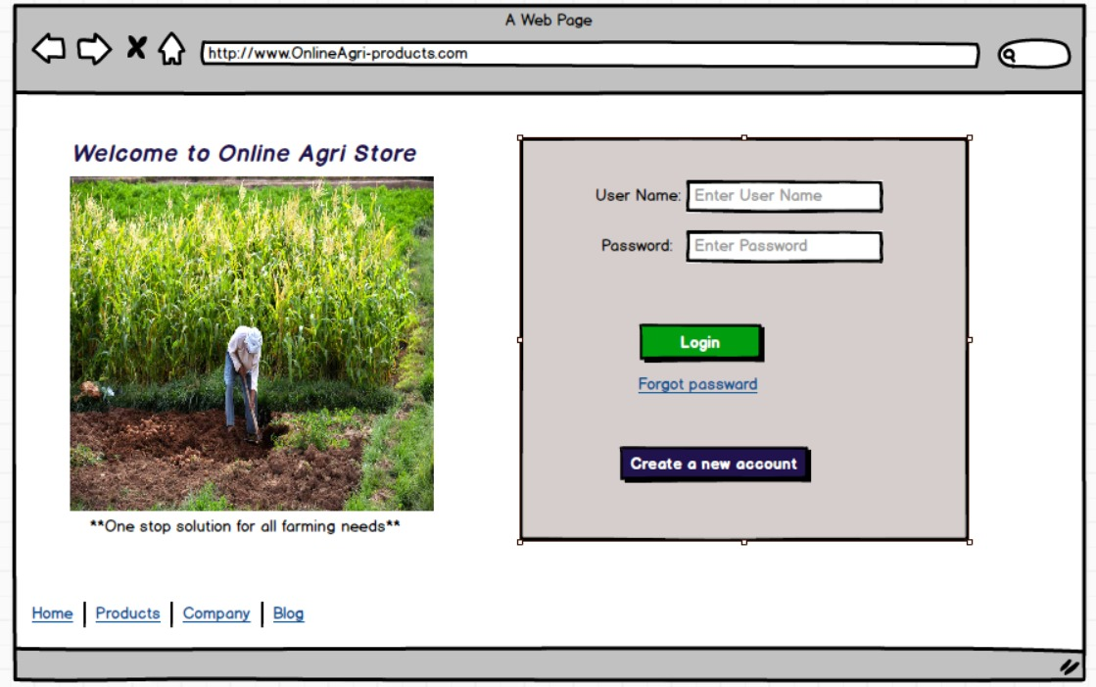
Question 34 – Minimum 5 Page Designs
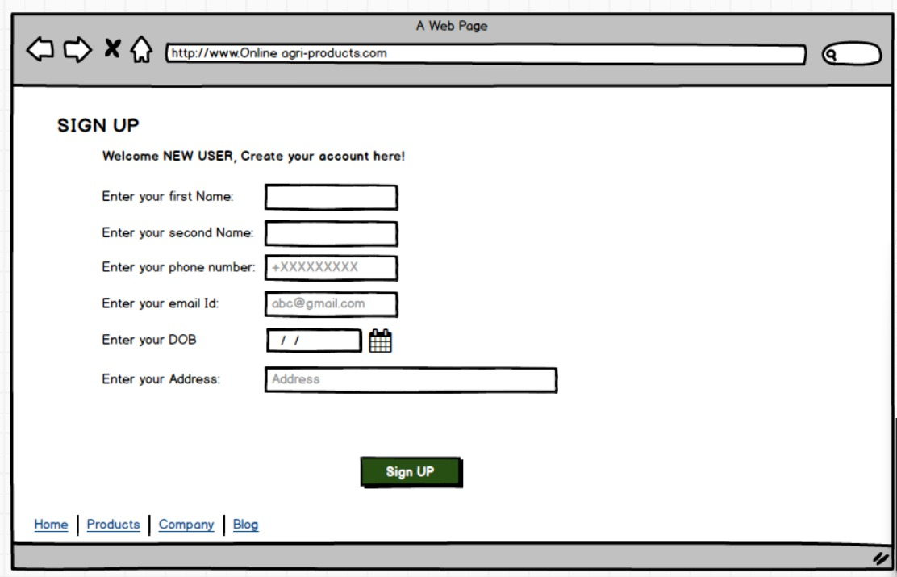
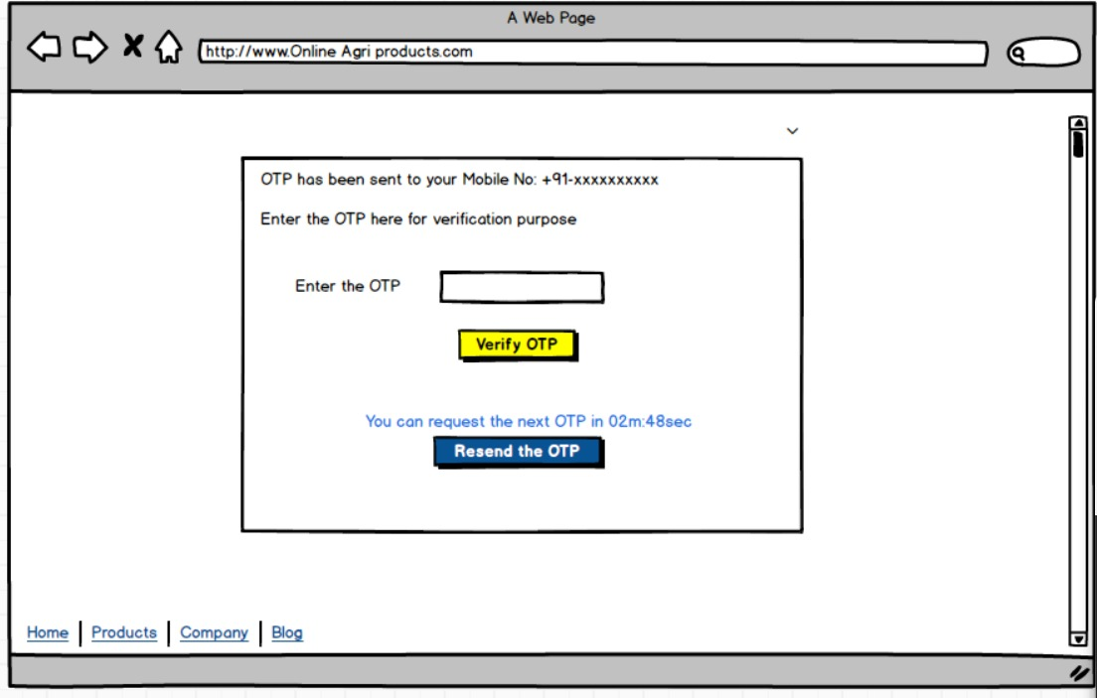
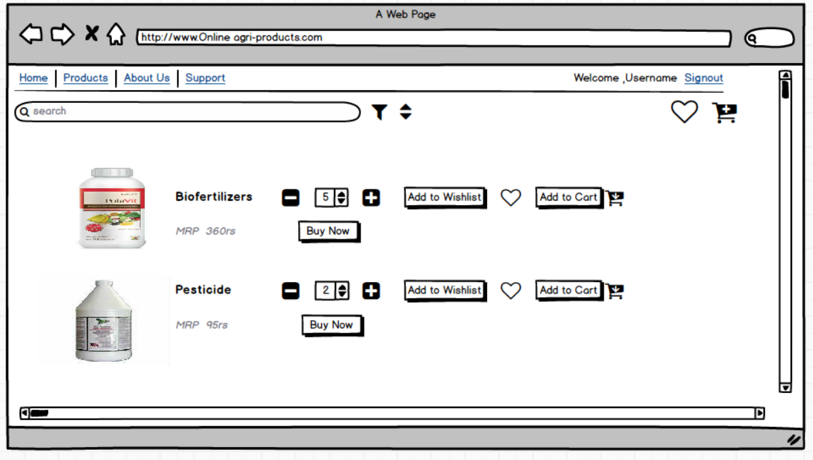
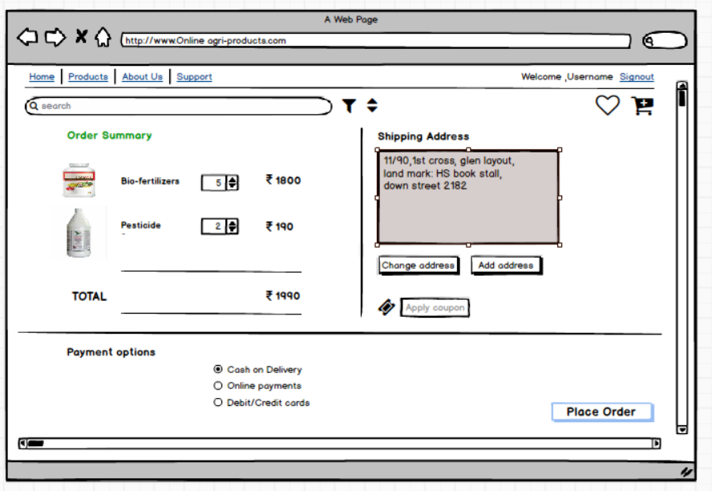
Question 35 – Tools for BA Work

Tool Name | What It Does Well
Microsoft Visio | Visio is a widely-respected application designed for crafting a broad array of diagrams—such as flowcharts, process maps, network diagrams, and organizational charts. It offers drag-and-drop templates, rich shape libraries, and precise alignment tools.
Balsamiq | Balsamiq specializes in turning rough ideas into easy, low-fidelity wireframes quickly. Its interface mimics hand-sketched visuals, fostering creativity and fast feedback without worrying about colors or pixel-perfect details.
Axure RP | Axure RP empowers you to create interactive, dynamic prototypes that simulate real app or website functionality. It supports conditional logic, forms, and clickable elements—going beyond static wireframes.
Mockups (Mockups) | Moqups is a browser-based tool that streamlines the creation of wireframes, mockups, and prototypes in a collaborative setting. Its library of design elements and templates speeds up project delivery.

Question 36 – Requirements Traceability Matrix (RTM)
The RTM traces each requirement to its corresponding test cases, design, and, if needed, user stories, to ensure all are built and tested.
Req ID | Req Name | Req Description | Design | D1 | T1 | D2 | T2 | D3 | T3 | D4 | T4 | UAT
FR001 | Farmer Registration | Farmer should be able to register with the application | Y | Y | Y | N | N | N | N | N | N | N
FR002 | Product Search | Farmer should be able to search for available items | Y | Y | Y | N | N | N | N | N | N | N
FR003 | Login Functionality | Users (farmer/manufacturer) can log in securely | Y | Y | Y | N | N | N | N | N | N | N
FR004 | Product Selection | Farmer can select/add product to cart | Y | Y | Y | N | N | N | N | N | N | N
FR005 | Out of Stock Alert | User notified if item is out of stock | Y | Y | Y | N | N | N | N | N | N | N
FR006 | Apply Filters | Filter products by brand, price, and type | Y | Y | Y | N | N | N | N | N | N | N
FR007 | Wishlist/Buy Later | Farmer can add products to wishlist/buy-later list | Y | Y | Y | N | N | N | N | N | N | N
FR008 | Payment Gateway | Multiple payment methods (COD, UPI, Card) | Y | Y | N | N | N | N | N | N | N | N
FR009 | Order Confirmation | System sends email confirmation for placed orders | Y | Y | N | N | N | N | N | N | N | N
FR010 | Order Tracking | Farmers able to track status of their order | Y | Y | N | N | N | N | N | N | N | N
FR011 | Responsive UI | Application is usable on web and mobile devices | Y | Y | N | N | N | N | N | N | N | N
FR012 | Profile Management | Users can update their profile/address | Y | Y | N | N | N | N | N | N | N | N

NFR ID | NFR Name | Description | Design | Dev | Test | UAT
NFR001 | Performance | Each page must load within 2 seconds under standard conditions | Y | Y | Y | Y
NFR002 | Scalability | Platform supports at least 5,000 concurrent users | Y | Y | Y | N
NFR003 | Security | All user data and transactions encrypted via SSL/TLS | Y | Y | Y | Y
NFR004 | Availability | 99.5% monthly uptime | Y | Y | Y | Y
NFR005 | Usability | Users must complete key tasks within 3 clicks | Y | Y | Y | Y
NFR006 | Accessibility | Platform must meet WCAG 2.1 Level AA guidelines | Y | Y | Y | Y
NFR007 | Compatibility | Works on Chrome, Firefox, Safari, Edge latest 2 versions | Y | Y | Y | N
NFR008 | Backup & Recovery | Daily data backup with RPO < 24 hours | Y | Y | Y | N
NFR009 | Response Time | Search results returned within 1 second on average | Y | Y | Y | Y
NFR010 | Localization Support | System supports English and regional languages | Y | Y | Y | Y
Test Case ID | Title | Test Steps | Test Data | Expected Result | Post-condition | Actual Result | Status
TC001 | Seller adds product within limit | 1. Login as seller  2. Upload product image  3. Enter product name  4. Update product price | Product image, name, valid price | Product added successfully | Home Page | Banner: "Product added Successfully" | Pass
TC002 | Seller uploads duplicate product | 1. Upload identical product image  2. Use same product name/price | Duplicate product info | Duplicate warning displayed | Remain on page | Banner: "Duplicate product" | Pass
TC003 | Product image not uploaded | 1. Attempt to proceed without uploading image | No image | Error: "Please upload image" | Remain on page | Error shown | Pass
TC004 | Product price invalid | 1. Enter negative price/blank price | Negative or blank price | Error: "Invalid price" | Remain on page | Error shown | Pass
TC005 | Product added over max limit | 1. Add products up to system’s max  2. Try adding extra product | Exceeds limit | Error: "Limit reached" | Remain on page | Error shown | Pass
TC006 | Edit existing product | 1. Select product  2. Update description  3. Submit changes | Updated details | Product updated | Home Page | Banner: "Product updated" | Pass
TC007 | Delete product | 1. Select product  2. Delete product  3. Confirm | Product ID | Product removed | Home Page | Product no longer in catalog | Pass
TC008 | Add product with long description | 1. Enter a description >256 characters | Long description | Error: "Description too long" | Remain on page | Error shown | Pass

Question 37 – 10 Test Case Documents

Question 38 – Database Design & ER diagram
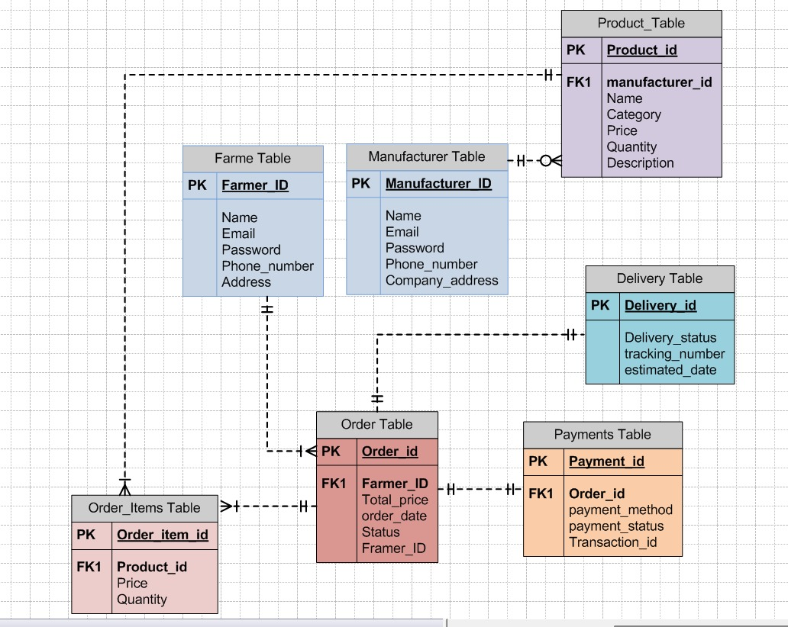

Question 39 – Data Flow Diagram Explanation
What is a Data Flow Diagram (DFD)?
- A DFD graphically represents the flow of data within a system, showing processes, data stores, and external entities.
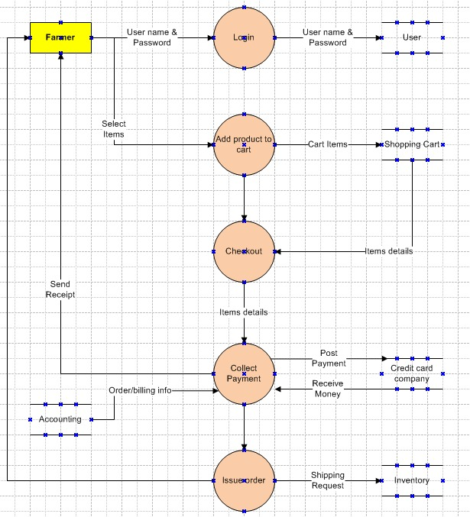

Question 40 – Change Request
Scenario:
Due to a change in government taxation, the tax structure in your system must be updated.
Step | Description
1. Receive Change Request | Record the request formally (Change Request Form or email) with details—who raised it, what is needed, why.
2. Document Change | Log the request in the Change Log with unique ID, description, date, and initiator (e.g., taxation update).
3. Impact Analysis | Assess how this change affects requirements, database, code, test cases, timeline, cost, and stakeholders.
4. Stakeholder Review & Approval | Discuss with key stakeholders, technical leads, and the client. Obtain necessary approvals before proceeding.
5. Update Documentation | Revise requirements (BRD/SRS), design documents, and affected diagrams to reflect the new tax structure.
6. Implement Change | Developers and testers execute the changes as per agreed scope and timeline.
7. Validation & Testing | Test the updated system to ensure correct tax calculation and compliance.
8. Communication | Inform all affected parties (including end-users, support team) of the new tax rules and any process updates.
9. Closure | Once verified, mark the request as closed in the Change Log. Archive all related approvals and communications.
Question 41 – Change Request vs Enhancement
Aspect | Change Request | Enhancement
Definition | A formal request to modify, correct, or update an existing requirement, process, or feature due to external changes or flaws. | A planned addition or improvement that extends the original scope by adding new features or capabilities.
Scope | Usually affects current functionality or fixes issues within the existing system. | Introduces new functionality or significant improvement beyond the original agreed scope.
Example | Updating the tax calculation due to a new government taxation rule. | Adding a feature that lets farmers sell their crop yields and participate in auctions.
Impact | May require minor to moderate changes; limited impact on overall system architecture. | Often involves larger changes with impacts across business logic, UI, and database structures.
Approval Process | Typically quicker, focused on assessing impact and compliance. | May involve detailed feasibility study, budgeting, and planning as a new development phase.
Project Phase | Can happen anytime; often during maintenance or compliance updates. | Usually planned for future releases or major project extensions.
As a Business Analyst, you should:
- Treat Change Requests as updates that need impact analysis, timely approvals, and implementation.
- Treat Enhancements as new project requirements that need detailed requirement gathering, prioritization, and possibly new project phases or releases.!

Question 42 – Estimations: Manhours

Activity | Estimated Manhours | Who Involved
Requirements Gathering | 20 | BA, Stakeholders
Documentation (BRD/SRS) | 15 | BA
Design (UI/Architectural) | 24 | Developers, BA
Development | 60 | Developers, DB Admin, Net Admin
Testing (Unit, Integration) | 26 | Testers
UAT Support & Training | 12 | BA, Testers, Users
Deployment & Support | 10 | Developers, Admins
Buffer (10%) | 15 | All
Total Estimated | 182 Manhours

Question 43 – UAT Acceptance Process
Handling UAT:
- Initiate UAT
  - Contact client stakeholders and organize UAT planning meeting.
  - Share test scenarios, scripts, and environment details with client users.
- Execution
  - Support users as they perform each scenario; answer queries, track issues/bugs.
  - Log all feedback, issues, and defects (with details).
- Issue Resolution
  - Developers/testers fix identified bugs. BA coordinates retesting until all critical issues are resolved.
- Formal Sign-off
  - Once UAT passes, obtain written confirmation from the client in the form of a UAT Sign-off or Client Project Acceptance Form.
Closing the Project:
- Ensure all deliverables are handed over and accepted.
- Conduct a project closure meeting to confirm completion with all stakeholders.
- Archive all project documents (BRD, Change Log, Test Results, UAT forms).
- Release project resources and prepare a closure report.
Question 44 – Project Closure Document
What is it?
- A Project Closure Document formally records the completion of a project, summarizing deliverables, approvals, outstanding items, and lessons learned.
Contents Typically Include:
Section | Description
Project Summary | Overview, key objectives, scope covered
Deliverables List | All items delivered and accepted by the client
Approvals/Sign-offs | Records of acceptance (UAT forms, email confirmations)
Outstanding Issues | Any unresolved items or follow-up actions (if applicable)
Final Budget & Timeline | Review of actuals vs. forecast
Lessons Learned | What worked well, what to improve in future
Recommendations | Suggestions for ongoing maintenance or enhancements
Closure Signatures | Official sign-off from the client, PM, and key stakeholders
Purpose:
- Confirms formal project completion, releases the team, and ensures all steps are documented for audit or future reference.

