liza rani nayak
[Email address]

online agriculture store
Prep 1 Part 3

Question 1 – Functional Requirements
Functional requirements – Function requirements define the specific behaviours , functions , or operation of a system. They describe what the system should do , outlining the necessary tasks , actions , or activities it must perform to achieve its objectives.
Req ID | Req Name | Req description
FR001 | User Registration | Farmer and manufactures should be able to register.
FR002 | Login | Farmer should log in with valid credentials.
FR003 | Product Catalog management | System should display a catalog of products.
FR004 | Search for the products | Farmer should be able to search for available products.
FR005 | Adding products to the cart | Farmer should be able to add the products to the cart.
FR006 | Adding product to the Wishlist | Farmer should be able to add the product to Wishlist
FR007 | Place Order | System should allow farmers to confirm their cart and place an order.
FR008 | Payment with different integration | Farmer should be able to make a payment with different modes.
FR009 | Order tracking | Farmer should be able to track their orders with status update.
FR010 | Inventory management | System should auto-update stock availability when products are purchased.
FR011 | Email/SMS Notification | Farmers should receive order confirmation and status update notifications.
FR012 | Multi language & Devise support | The platform should support multiple language and be compatible with mobile device

Non-functionality requirement – Non- Functionality requirements will describe the quality and attribute of a system, focusing how the system performs rather than specific behaviours and functions.
Req ID | Req Name | Req description
NR001 | Performance | The application must load page within 3 seconds
NR002 | Response time | Search result displayed within 2 seconds
NR003 | Security | Password stored in encrypted format
NR004 | Data privacy | Transactions secured with SSL/TLS
NR005 | Usability | The application should have an intuitive and user friendly
NR006 | Ease to registration | New user should register within 2 minutes
NR007 | Reliability | 99.5% system uptime annually
NR008 | Compatibility | The application should be compatible with major web browser
NR009 | Disaster recovery | Recovery time < 5 minutes after crash
NR010 | Compliance | Follow e-commerce & data privacy regulations
NR011 | Supportability | Logging and error reporting enabled
NR012 | Accessibility | The system must follow Accessibility Guidelines WCAG 2.1.
NR013 | System monitoring | Real time monitoring of system health
NR014 | Customer support availability | 24/7 help desk and chatbot integration

Q3- WIREFRAME
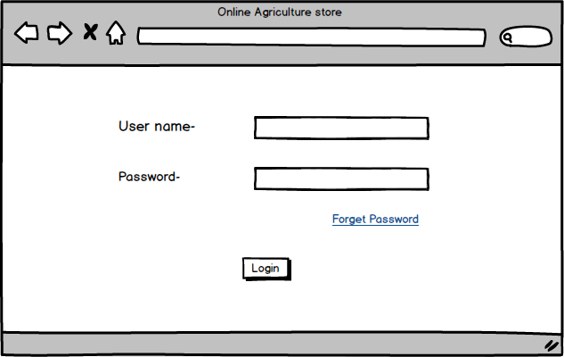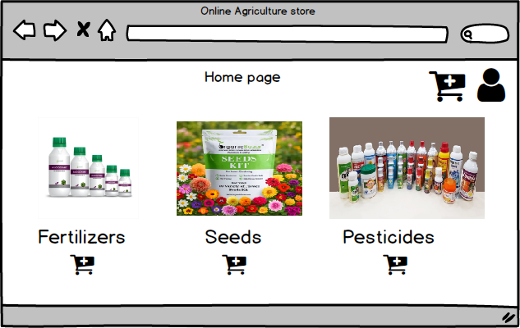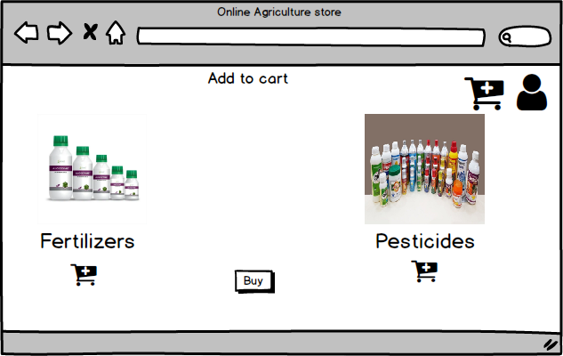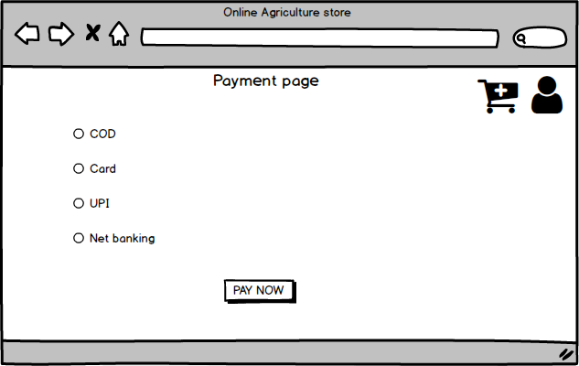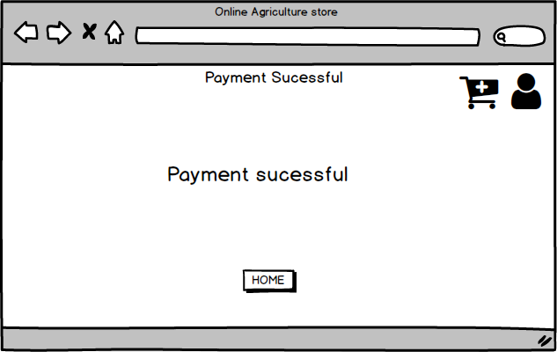

PROTOTYPE
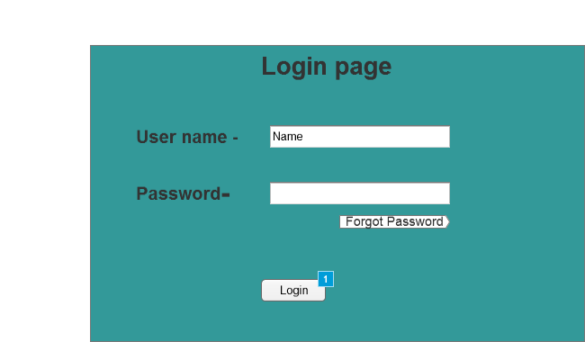
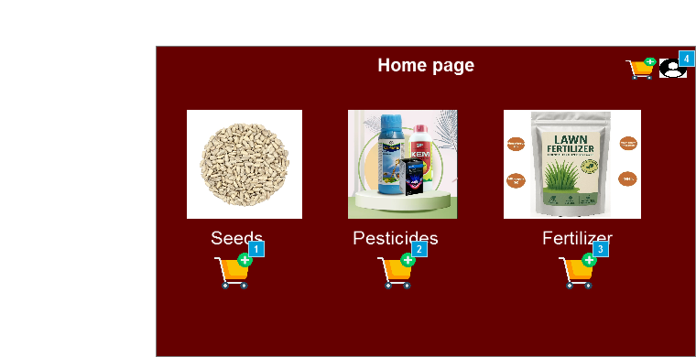
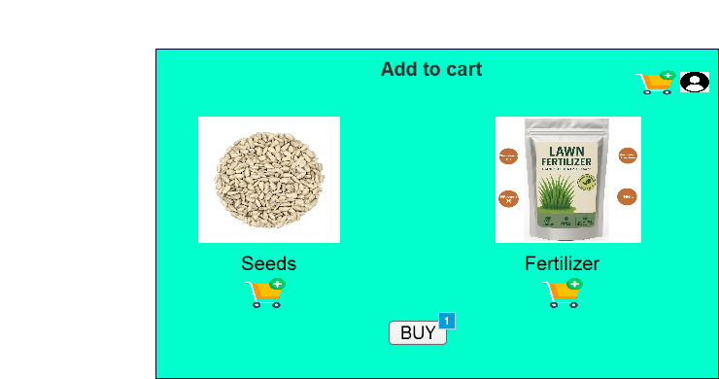
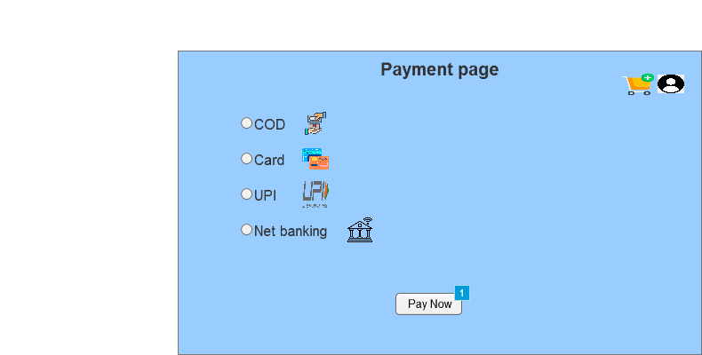

Q3- Tools ( Balsamiq , Visio)
As part of the business analysis process , different tools were used to create diagrams, visual models , and design representations . those tools helped in understanding requirements clearly and communicating ideas effectively.
- Microsoft Visio – Used to create Use Case Diagrams, Activity Diagrams and Flowcharts .
- Helped is visually representing the functional flow , system interactions and business processes.
- Supported clear documentation of relationship between users and the systems.
- Balsamiq- Used to design Wireframes and prototypes for the system .
- Helped visualize the user interface layout and navigation flow before actual development .
- Made it easier to gather feedback from stakeholders and make quick design improvements .
Conclusion – Both tools played a major role in requirement visualization and validation. Visio focused on process representation , while Balsamiq supported design visualization.
Q4- Prepare RTM
RTM(Requirement traceability matrix ) is a document used to track the requirements throughout the project lifecycle , ensuring that they are met and none are overlooked.
Req ID | Req Name | Req Description | Design | Code | UT(unit Testing ) | CT( component testing ) | SIT(System integration testing ) | UAT(User Acceptance Testing )
FR001 | User registration | User should register themselves | completed | Complete | Complete | Complete | Complete | incomplete
FR002 | User login | User should be able to login securely | Completed | Completed | Completed | Completed | Completed | incomplete
FR003 | Search products | User should be able to search products | Complete | Complete | Complete | Complete | Incomplete | Incomplete
FR004 | View product details | User should be able to view detailed info of the product | Complete | Complete | Complete | Complete | Incomplete | Incomplete
FR005 | Add to cart | User should be add selected products to the cart | Complete | Complete | Complete | Incomplete | Incomplete | Complete
FR006 | Place order | User should be able to place an order for selected product | Complete | Complete | Complete | Complete | Incomplete | Incomplete
FR007 | Make payment | User should be able to make secure payment | Complete | Complete | Complete | Complete | Complete | Incomplete
FR008 | Views order history | User should be able to see past orders | Complete | Complete | Complete | Incomplete | Incomplete | Incomplete
FR009 | Update profile | User should be able to update personal details | Complete | Complete | Complete | Complete | Incomplete | Complete
FR010 | Edit Cart | User should be able to update product quantity in the cart | Complete | Complete | Complete | Complete | Complete | Complete
FR011 | Remove from cart | User should be able to remove products from the cart | Complete | Complete | Complete | Complete | Complete | Complete
FRO12 | Logout | User should be able to secure log out | Complete | Complete | Complete | Complete | Complete | Complete
FR013 | Receive order confirmation | User should receive confirmation via Email / SMS | Complete | Complete | Complete | Incomplete | Incomplete | Incomplete
NR014 | Performance | Search results should display within 2 seconds | Complete | Complete | Complete | Complete | Complete | Complete
NR015 | Security | User data and payment details must be encrypted | Complete | Complete | Complete | Complete | Incomplete | Incomplete
NR016 | Availability | System uptime should be at least 99% | Complete | Complete | Complete | Incomplete | Incomplete | Complete
NR017 | Scalability | System should support at least 1000 concurrent users | Complete | Complete | Complete | Complete | Incomplete | Complete
NR018 | Usability | Interface should be user friendly and easy to navigate | Complete | Complete | Complete | Complete | Complete | Complete

Q5-10 Test Case Documents
A test case document is a detailed outline used by testers to ensure that a software application or system is working as expected.
Test case ID | TC001 |  | Test case name | User registration
Project ID | AGRO001 |  | Project name | Online Agriculture Products Store
PM ID | PM100 |  | PM name | Mr. Ramesh Kumar
Test strategy ID | TS001 |  | Tester ID | T001
Test plan ID | TS001 |  | Tester name
Test schedule ID | SCH001 |  | Date of test
Scenario | User registrations
Link to that page
Input data | Step 1 Open registration page | Step2  Enter name , Email , password and contact |  |  | Step 3  Click register
Expected behaviour | User account created confirmation mail sent
Actual behaviour | As expected
Comments | Functional
Results (pass/fail) | Pass

Test case ID | TC002 |  |  | Test case name |  | User login
Project ID | AGRO001 |  |  | Project name |  | Online agriculture products store
PM ID |  |  |  | PM name |  | Mr. Ramesh Kumar
Test strategy ID |  |  |  | Tester ID |  | T002
Test plan ID |  |  |  | Tester name
Test schedule ID |  |  |  | Date of test
Scenario | User login
Link to that page
Input data |  | Step 1  Open login page | Step 2  Enter valid credentials |  | Step 3  Click Login
Expected behaviour |  | Redirected to dashboard
Actual behaviour |  | As expected
Comments |  | Works fine
Results (pass/fail) |  | Pass

Test case ID | TC003 |  | Test case name | Search product
Project ID | AGRO001 |  | Project name | Online agriculture products store
PM ID |  |  | PM name
Test strategy ID |  |  | Tester ID | T003
Test plan ID |  |  | Tester name
Test schedule ID |  |  | Date of test
Scenario | Search product
Link to that page
Input data | Step 1  Go to home page | Step 2  Enter “Organic fertilizer 10 KG” in search bar |  |  | Step 3  Click search
Expected behaviour | Product list displayed
Actual behaviour | As expected
Comments | Accurate results
Results (pass/fail) | Pass

Test case ID |  | TC004 | Test case name |  | Apply Filters
Project ID |  | AGRO001 | Project name |  | Online agriculture products store
PM ID |  |  | PM name
Test strategy ID |  |  | Tester ID |  | T004
Test plan ID |  |  | Tester name
Test schedule ID |  |  | Date of test
Scenario | Apply Filters
Link to that page
Input data | Step 1  Search seeds |  |  | Step 2  Apply filter price 500 |  | Step 3  Click Apply
Expected behaviour | Filtered products appear
Actual behaviour | As expected
Comments | Quick filter
Results (pass/fail) | Pass

c | TC005 | Test case name |  | Add to cart
Project ID | AGRO001 | Project name |  | Online agriculture products store
PM ID |  | PM name
Test strategy ID |  | Tester ID |  | T005
Test plan ID |  | Tester name
Test schedule ID |  | Date of test
Scenario | Add to cart
Link to that page
Input data | Step 1  Select hybrid seeds |  | Step 2  Click add to cart |  | Step 3  View cart
Expected behaviour | Item added to cart
Actual behaviour | As expected
Comments | Cart updated
Results (pass/fail) | Pass

Test case ID | TC006 | Test case name |  | Place order
Project ID | AGRO001 | Project name |  | Online agriculture products store
PM ID |  | PM name
Test strategy ID |  | Tester ID |  | T006
Test plan ID |  | Tester name
Test schedule ID |  | Date of test
Scenario | Place order
Link to that page
Input data | Step 1  Open cart |  | Step 2  Select delivery address |  | Step 3  Click place order
Expected behaviour | Order confirmed
Actual behaviour | As expected
Comments | Confirmation email sent
Results (pass/fail) | Pass

Test case ID | TC007 | Test case name |  | Payment processing
Project ID | AGRO001 | Project name |  | Online agriculture products store
PM ID |  | PM name
Test strategy ID |  | Tester ID |  | T007
Test plan ID |  | Tester name
Test schedule ID |  | Date of test
Scenario | Payment processing
Link to that page
Input data | Step 1  Select pay now |  | Step 2  Enter card or UPI details |  | Step 3  Confirm payment
Expected behaviour | Payment successful
Actual behaviour | As expected
Comments | Payment secure
Results (pass/fail) | Pass

Test case ID | TC008 | Test case name |  | Track order
Project ID | AGRO001 | Project name |  | Online agriculture products store
PM ID |  | PM name
Test strategy ID |  | Tester ID |  | T008
Test plan ID |  | Tester name
Test schedule ID |  | Date of test
Scenario | Track order
Link to that page
Input data | Step 1  Login to account |  | Step 2  Click my orders |  | Step 3  Select order to track
Expected behaviour | Shows delivery status
Actual behaviour | As expected
Comments | Updates live
Results (pass/fail) | Pass

Test case ID | TC009 | Test case name |  | Cancel order
Project ID | AGRO001 | Project name |  | Online agriculture products store
PM ID |  | PM name
Test strategy ID |  | Tester ID |  | T009
Test plan ID |  | Tester name
Test schedule ID |  | Date of test
Scenario | Cancel order
Link to that page
Input data | Step 1  Open my orders |  | Step 2  Click cancel order |  | Step 3  Confirm cancellation
Expected behaviour | Order cancelled , refund initiated
Actual behaviour | As expected
Comments | Works fine
Results (pass/fail) | Pass

Test case ID | TC010 | Test case name |  | Feedback submission
Project ID | AGRO001 | Project name |  | Online agriculture products store
PM ID |  | PM name
Test strategy ID |  | Tester ID |  | T010
Test plan ID |  | Tester name
Test schedule ID |  | Date of test
Scenario | Feedback submission
Link to that page
Input data | Step 1  Open feedback page |  | Step 2  Type comments |  | Step 3  Click submits
Expected behaviour | Feedback saved and acknowledge
Actual behaviour | As expected
Comments | Feedback stored
Results (pass/fail) | Pass
Q6- DB Design
DB Schema is a blue print that outlines the structure of a data base, including its tables, fields , relationships, constraints and other characteristics.
An Entity relationship diagram (ERD) is a visual representation of the relationships between entities and database. It depicts the entities ( such as table ) , attributes (properties of fields ) and relationship between them.
Q7- Draw a Data flow diagram
A data flow diagram (DFD) is a graphical representation of the flow of the data within a system . it visually shows how data moves from one process to another. How its stored and where its ends up.
It helps analysts and designers understand the flow of data within a system, identify potentials bottlenecks or inefficiencies and communicate system requirements to stakeholders.

Q8- Change request
A change request is a formal proposal to after a system , product or project
- Understand the scope of change request and document the change request
- Do the impact analysis – project scope , schedule , budget , resource and risk
- Prioritize change requests based on its urgency , importance , impact or project.
- Seek approval from the project sponsor for the change request
- Communicate the change request and its potential impacts to all relevant stakeholders ,including the project team.
Ex-
If GST changes from 5% to 8%,
• Update all related modules (Product Price, Invoice, Payment Gateway).
• Adjust formulas in backend logic.
• Update database field tax_rate.
• Recalculate and validate all transactions for accuracy.

Q9-Change request VS enhancement
As a Business Analyst, my response to Ben and Kevin’s request would be that this is an Enhancement, not a Change Request.
this request expands the scope of the existing system and adds additional modules, making it an Enhancement rather than a Change Request.
As a Business Analyst, you should document the requirements and work with the development team to determine the feasibility and impact of the new features. You should also consider the potential benefits, risks, and costs associated with the enhancements before making any recommendations to the client.
Q10-Estimation

Manhours represent the total effort of resources required to complete a project
There are three project types based on effort:
• Small Project: up to 500 hours
• Medium Project: up to 1000 hours
• Large Project: up to 1500 hours

Analysis:

As per the Online Agricultural Store case study, the duration of the project is 15-18 months, and the current team size is around 12–15 members, including the Business Analyst, Developers, Testers, and UI Designers.
Hence, this project will fall under the Medium Project category (approximately 1000 manhours).
• Since the existing team members are skilled in e-commerce and agricultural platforms, no external trainers are required.
• The organization already has the necessary tools and technologies (like Visio for diagrams and Balsamiq for wireframes), so no additional infrastructure setup is needed.
• The estimated effort for the enhancement (Farmer product selling + Auction system) will be around 100–150 additional manhours, which can be managed within the current project schedule.
Q11- UAT

Planning:
In this step, Blue Prints are made to implement UAT testing for every feature that needs to test and minimum standards for accepting the rest.
Designing :
Here the Test cases are designed to hide all the possibilities of software packages in a real word environment:
UAT Testers:
A Testing team consists of a end users that meet the criteria for implementing testing.
They should know the test cases to run and understand the functionalities.
Bug Fixing:
Whatever Bugs are found in the UN'T Testing, the development team should work on them and make it software error free.
Sign Off:
After removing all the bugs, the testing team indicates acceptance of the completion of the bugs. In this phase, all the stakeholders come to a conclusion that the software is ready to GO LIVE and sign it off.

12Project closer document
• A project closure document, also known as a project closure report, is a formal document that summarise the key outcomes, lessons learned, and final details of a completed project.
• It serves as a comprehensive record of the project's accomplishments, challenges, and overall performance, providing
relatable insights for stakeholders and future projects
Points to be included in the Project closure document are :
Project Overview
Achievements
Lessons Leamed
Quality Assurance
Resource Utilization
Risk Management
Challenges

S.No | Points to included |  | Details | Reference link
1 | Did the client signed off on the UAT testing |  |  | Business scope document. docx
 | Date of the signoff |  | 9thOct 2025
 | Name of the resources
2 | Objective of the project
 | User friendliness |  | Achieved
 | Customer satisfaction |  | ROI in 6 months
 | More categories |  | Achieved
3 | Functionality worked on
 | Secure payment processing | Achieved
 | Category | Achieved
4 | Infrastructure
 | Software installed | Achieved
 | Laptop purchased | Achieved
5 | Funding |  |  | Finance breakdown.docx
 | Amount approved | Rs. 2 core
 | Amount used | Rs .195 lakhs
6 | Overall project information
 | Escalations | 50
 | Customer stratifications | High
7 | Value of the company
 | Positive / negative | Positive: 90%  -Company has gained an edge over the competitors  -increased clients  -Trained employees  New project in pipeline

