Stage: 4 BA Mock – Case Study
A company is having manufacturing plants and warehouses in various parts of the country. They manufacture ice-cream and milk products. They want to build software to achieve two goals.
• Manage the inventory
• Quickest delivery to the customers
Assignment 1:
- Please make a BRD which can be presented to the client along with complete development and resource plan.
2. Prepare process flow diagram using your imagination.
Solution:
Business Requirement Document: A Business Requirement Document (BRD) is a formal document that defines the business goals, needs, and expectations of a project from the client or stakeholder’s perspective.

1. Introduction
This BRD outlines the business requirements for developing an Inventory and Delivery Management System (IDMS) for a dairy products manufacturing company.
The system aims to streamline inventory management, track stock movements across plants and warehouses, and optimize customer delivery times.
2. Business Objectives
- Achieve real-time inventory visibility across all manufacturing units and warehouses.
- Reduce stock-out and overstock situations.
- Enable fast and efficient delivery routing.
- Improve supply chain efficiency through automation and integration.
- Enhance customer satisfaction through timely delivery.
3. Current Challenges
- Lack of centralized visibility of stock.
- Manual tracking of product expiry and storage conditions.
- Delays in customer order fulfilment.
- Inefficient routing for delivery vehicles.
- Lack of real-time reporting and analytics.

4. Proposed Solution
Develop a centralized ERP-based software system with the following modules:
- Inventory Management
  - Stock tracking by batch, expiry date, and location.
  - Automatic reorder alerts.
  - Integration with manufacturing plants and warehouses.
- Order Management
  - Real-time order placement and tracking.
  - Auto-allocation of warehouse based on customer location.
- Delivery Management
  - Route optimization for delivery vehicles.
  - Integration with GPS for live delivery tracking.
- Reports & Analytics
  - Inventory turnover, wastage reports.
  - Delivery time performance dashboard.
- User Management
  - Role-based access (Admin, Plant Manager, Warehouse Manager, Delivery Executive, etc.)

5. Stakeholders
Stakeholder | Role | Responsibility
Client Management | Sponsor | Approve project scope and budget
Business Analyst | Bridge | Requirement gathering and documentation
Development Team | Developers | Build the software modules
QA Team | Testers | Ensure quality and bug-free product
Operations Manager | End User | Validate business processes

6. Development Plan
Phase | Activity | Duration
Phase 1 | Requirement Gathering & BRD approval | 2 weeks
Phase 2 | UI/UX & Architecture Design | 2 weeks
Phase 3 | Development (Inventory + Delivery Modules) | 6 weeks
Phase 4 | Testing (UAT & Integration) | 2 weeks
Phase 5 | Deployment & Training | 1 week
Total Duration | 13 weeks (3 months approx.)

7. Resource Plan
Role | Responsibility | Count
Business Analyst | Requirement documentation | 1
Project Manager | Project oversight | 1
UI/UX Designer | Interface design | 1
Backend Developer | Database & API | 2
Frontend Developer | UI implementation | 2
QA Engineer | Testing | 1
DevOps | Deployment | 1

Process Flow Diagram:
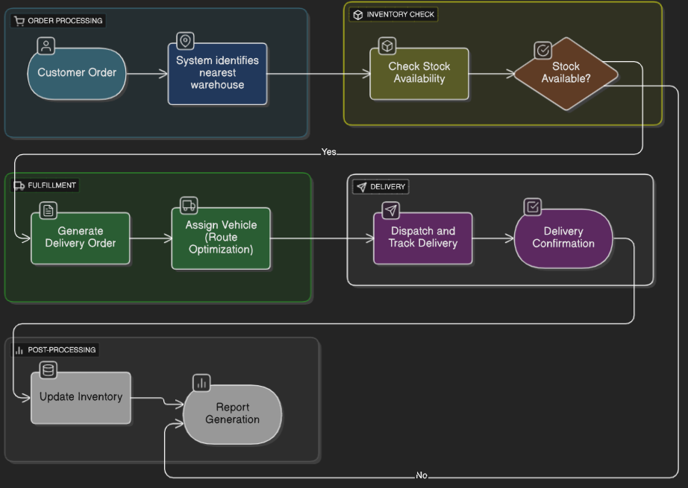
Assignment 2:
Write an introduction letter to a client introducing yourself as a business analyst in charge of working with the client and his team to start the business understanding process.
Solution:
Subject: Introduction – Business Analyst for Your Project
Dear Krishna Dwarkadish,
I hope this message finds you well.
My name is Mayur Shiralkar, and I will be working with you as the Business Analyst for your upcoming project. My role will be to understand your business processes, gather requirements, and ensure that our development aligns with your objectives.
Over the coming days, I will be engaging with you and your team to discuss workflows, challenges, and desired outcomes to build a solution that best fits your operational needs.
Looking forward to a fruitful collaboration.
Thanks & Regards,
Mayur Shiralkar.
Business Analyst, XYZ Techsystems Pvt Ltd.

Prepare a brief BRD and SRS for a project- Horoscope or Ticketing system or online store.
Solution:
Business Requirement Document
Project: Online Store System
Prepared By: Mayur Shiralkar – Business Analyst
Date: 05.10.2025
Version: 1.0

1. Introduction
1.1 Purpose
The purpose of this BRD is to outline the business requirements for developing an Online Store System that enables customers to browse, select, and purchase products online securely and conveniently.
The system will help the business expand its digital presence, increase sales, and enhance customer experience.

1.2 Background
With the growing shift toward eCommerce, businesses must provide an online platform to reach customers directly. This system will serve as a centralized portal for customers to shop and for administrators to manage inventory, sales, and deliveries.
1.3 Objectives
- Provide a seamless shopping experience.
- Manage products, inventory, and orders efficiently.
- Enable secure payments.
- Provide delivery tracking and order history for users.
- Allow admin to monitor and control all operations from one dashboard.

2. Business Scope
In Scope:
- Customer Registration, Login, and Profile Management
- Product Browsing, Filtering, and Searching
- Shopping Cart and Checkout Process
- Online Payment Integration (UPI, Credit/Debit, Wallets)
- Order Tracking and Notifications
- Admin Panel for Product, Order, and User Management

Out of Scope:
- Integration with external logistics providers (Phase 2)
- Multi-language support
- International shipping

3. Stakeholders
Stakeholder | Role | Responsibilities
Client | Business Owner | Approves requirements and validates deliverables
Business Analyst | Bridge between client & dev team | Requirement gathering, documentation
Development Team | Developers | Design and implement system
QA Team | Testers | Validate functionality and performance
End Users | Customers | Use platform to shop online
Admin Users | Internal staff | Manage inventory and orders

4. Business Requirements
ID | Requirement | Description
BR_001 | User Registration | Allow users to sign up and create accounts
BR _002 | User Login | Secure login with authentication
BR _003 | Product Management | Admin can add, edit, or delete products
BR _004 | Product Search & Filter | Customers can search by name or category
BR _005 | Shopping Cart | Add/remove/update items in cart
BR _006 | Checkout | Enter shipping details and payment
BR _007 | Payment Gateway | Integrate secure payment system
BR _008 | Order Tracking | Customers can track order status
BR _009 | Notifications | Send email/SMS confirmation
BR _010 | Reports | Admin can generate sales and order reports

5. Business Process Flow
Step 1: Customer registers and logs in
Step 2: Browses and searches products
Step 3: Adds selected items to the cart
Step 4: Proceeds to checkout
Step 5: Makes payment via secure gateway
Step 6: Receives order confirmation
Step 7: Admin processes and updates delivery status
Step 8: Customer receives delivery and rates product
6. Assumptions
- Internet connection is mandatory.
- Payment gateway API credentials will be provided by the client.
- The application will be deployed on a secure cloud server.

7. Resource and Timeline Plan

Phase | Task | Duration
Phase 1 | Requirement Gathering & BRD Sign-off | 1 week
Phase 2 | UI/UX and Database Design | 1 week
Phase 3 | Development | 4 weeks
Phase 4 | Testing | 2 weeks
Phase 5 | Deployment & Training | 1 week
Total Duration | 9 Weeks

8. Approval
Client Signature: _______________________
Date: _______________________

Software Requirement Specification:

Project: Online Store System
Prepared By: Mayur Shiralkar – Business Analyst
Version: 1.0

1. Introduction
1.1 Purpose
The SRS defines the software requirements for the Online Store System. It outlines system functionalities, interfaces, performance criteria, and design constraints.
1.2 Scope
The system will enable customers to browse, buy, and track orders online while allowing admins to manage products, orders, and users efficiently.
1.3 Intended Audience
- Development Team
- QA Team
- Client & Project Stakeholders

2. System Overview
The Online Store System will have two main user roles:
- Customer: Browse, shop, and track orders.
- Admin: Manage inventory, users, and sales.
The system will be web-based, scalable, and integrated with secure payment gateways.

3. Functional Requirements:
ID | Module | Requirement Description
FR_001 | User Management | Users can register, log in, and manage profiles
FR_002 | Product Catalog | Display list of products with price, stock, and images
FR_003 | Product Search | Search and filter by name, price, or category
FR_004 | Shopping Cart | Add, edit, or remove products from cart
FR_005 | Checkout | Collect shipping and payment details
FR_006 | Payment | Process payment securely via gateway API
FR_007 | Order Management | Track order status and history
FR_008 | Notifications | Send emails/SMS for order events
FR_009 | Reports | Generate daily/monthly sales reports
FR_0010 | Feedback | Customers can rate and review products

4. Non-Functional Requirements
ID | Category | Description
NFR_001 | Performance | System should support 100 concurrent transactions per second.
NFR_002 | Reliability | Automatic data backup every 24 hours.
NFR_003 | Availability | 99.9% system uptime.
NFR_004 | Security | Password encryption, SSL, and role-based access control.
NFR_005 | Usability | Simple, intuitive user interface for all age groups.
NFR_006 | Scalability | Add new categories, products, and users without downtime.
NFR_007 | Maintainability | Modular architecture for easy upgrades.

5. System Interfaces
Interface Type | Description
User Interface | Web application with responsive design
Payment Interface | Integration with Razorpay / Stripe API
Notification Interface | Email/SMS gateway integration
Database Interface | CRUD operations on SQL database

6. Database Design (High-Level Entities)
- Users (UserID, Name, Email, Password, Address, Role)
- Products (ProductID, Name, Price, CategoryID, Stock, Image)
- Orders (OrderID, UserID, TotalAmount, Status, Date)
- OrderDetails (OrderDetailID, OrderID, ProductID, Quantity, Price)
- Category (CategoryID, Name, Description)
- Payment (PaymentID, OrderID, Mode, Status, Date)
- Reviews (ReviewID, ProductID, UserID, Rating, Comments)
7. System Architecture Overview
Client Layer: Web Interface (HTML, CSS, JavaScript)
Application Layer: Business Logic (Node.js / Java / .NET)
Database Layer: MySQL / PostgreSQL
Integration Layer: Payment and Notification APIs
8. Constraints
- Must run on latest web browsers (Chrome, Firefox, Edge).
- Responsive for all devices.
- Database storage capacity: minimum 100 GB.

Make an ERD of creating a support ticket/Ticketing life cycle.
Solution:

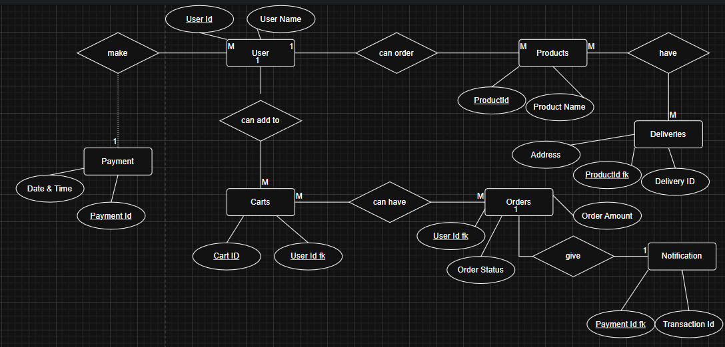

4. User story of shopping from ecommerce.
Solution:

User Story No: 1 Task: 1 Priority: Highest
As a Customer
I want to register in the Online Store
So that I can log in and purchase products.
BV: 500 CP: 2
Acceptance Criteria:
Registration screen with text boxes for Username, Password, Email, Mobile No.
Click on Register Button.
Send successful registration notification to the user.

User Story No: 2 Task: 2 Priority: Highest
As a Customer
I want to log in with my credentials
So that I can access my dashboard.
BV: 400 CP: 2
Acceptance Criteria:
Login form with Username and Password fields.
Validate credentials.
Redirect to dashboard after successful login.

User Story No: 3 Task: 3 Priority: High
As a Customer
I want to view all available products
So that I can browse and choose items to buy.
BV: 600 CP: 3
Acceptance Criteria:
Display product list with name, image, price, and availability.

User Story No: 4 Task: 4 Priority: High
As a Customer
I want to filter products by category
So that I can find items easily.
BV: 400 CP: 3
Acceptance Criteria:
Filter options by category, price range, and rating.

User Story No: 5 Task: 5 Priority: High
As a Customer
I want to search products by name
So that I can quickly locate what I need.
BV: 350 CP: 2
Acceptance Criteria:
Search bar with keyword-based product results.

User Story No: 6 Task: 6 Priority: High
As a Customer
I want to view detailed product information
So that I can make an informed purchase decision.
BV: 500 CP: 3
Acceptance Criteria:
Product detail page with image, description, price, stock, and reviews.

User Story No: 7 Task: 7 Priority: High
As a Customer
I want to add items to my cart
So that I can purchase them later.
BV: 600 CP: 2
Acceptance Criteria:
Add to Cart button, confirmation message, and cart counter update.

User Story No: 8 Task: 8 Priority: High
As a Customer
I want to update or remove items from the cart
So that I can manage my selected products.
BV: 500 CP: 3
Acceptance Criteria:
Edit quantity or delete item options in cart.

User Story No: 9 Task: 9 Priority: High
As a Customer
I want to view my shopping cart
So that I can review selected items before checkout.
BV: 450 CP: 2
Acceptance Criteria:
Cart page showing all items, subtotal, and total amount.

User Story No: 10 Task: 10 Priority: Highest
As a Customer
I want to checkout and make payment
So that I can complete my purchase.
BV: 800 CP: 5
Acceptance Criteria:
Checkout page with address and payment details.
Integration with payment gateway.

User Story No: 11 Task: 11 Priority: Medium
As a Customer
I want to save my shipping address
So that I can reuse it for future orders.
BV: 300 CP: 2
Acceptance Criteria:
Address form with save and edit options.

User Story No: 12 Task: 12 Priority: Medium
As a Customer
I want to view my order confirmation
So that I can verify order details.
BV: 350 CP: 2
Acceptance Criteria:
Display confirmation screen with order number and summary.

User Story No: 12 | Task: 12 |  | Priority: Medium
As a customer
I want to track my order status
So that I know when to expect delivery.
BV: 450 |  | CP: 3
Acceptance Criteria:
Order tracking page with live status updates.

User Story No: 13 | Task: 13 |  | Priority: High
As a customer
I want to receive email notifications for orders
So that I stay informed.
BV: 300 |  | CP: 2
Acceptance Criteria:
Send order placed, shipped, and delivered emails.

User Story No: 14 | Task: 14 |  | Priority: Medium
As a customer
I want to view my previous orders
So that I can reorder products.
BV: 350 |  | CP: 2
Acceptance Criteria:
Order history page showing all past orders.

User Story No: 15 | Task: 15 |  | Priority: Medium
As a customer
I want to cancel an order before dispatch
So that I can modify my decision.
BV: 400 |  | CP: 2
Acceptance Criteria:
Cancel button active before dispatch status.

User Story No: 16 | Task: 16 |  | Priority: Medium
As a customer
I want to rate and review products
So that I can share my feedback.
BV: 450 |  | CP: 3
Acceptance Criteria:
Star rating and comment section per product.

User Story No: 17 | Task: 17 |  | Priority: low
As a customer
I want to view recommended products
So that I can discover similar items.
BV: 300 |  | CP: 2
Acceptance Criteria:
Display suggestions based on purchase history.

User Story No: 18 | Task: 18 |  | Priority: Medium
As a customer
I want to apply discount codes
So that I can get reduced prices.
BV: 500 |  | CP: 4
Acceptance Criteria:
Promo code field with validation and discount calculation.

User Story No: 19 | Task: 19 |  | Priority: Medium
As a customer
I want to add items to Wishlist
So that I can save them for future purchase.
BV: 600 |  | CP: 4
Acceptance Criteria:
Wishlist page with add/remove functionality.

User Story No: 20 | Task: 20 |  | Priority: High
As an Admin
I want to add new products
So that I can update the store inventory.
BV: 600 |  | CP: 4
Acceptance Criteria:
Form for product name, category, price, stock, and image.

User Story No: 21 | Task: 21 |  | Priority: High
As an Admin
I want to edit or delete products
So that I can maintain updated product data.
BV: 400 |  | CP: 2
Acceptance Criteria:
Update and delete buttons on product management screen.

User Story No: 22 | Task: 22 |  | Priority: Medium
As an Admin
I want to view all customer orders
So that I can manage deliveries.
BV: 500 |  | CP: 3
Acceptance Criteria:
Order list with order number, date, and status.

User Story No: 23 | Task: 23 |  | Priority: Medium
As an Admin
I want to view all customer orders
So that I can manage deliveries.
BV: 400 |  | CP: 3
Acceptance Criteria:
Order list with order number, date, and status.

User Story No: 24 | Task: 24 |  | Priority: High
As an Admin
I want to assign orders to delivery partners
So that dispatch is efficient.
BV: 400 |  | CP: 3
Acceptance Criteria:
Assign delivery executive to each order.

User Story No: 25 | Task: 25 |  | Priority: High
I want to update delivery status
So that customers can track progress.
BV: 600 |  | CP: 3
Acceptance Criteria:
Delivery status dropdown: Pending, Shipped, Delivered.

User Story No: 26 | Task: 26 |  | Priority: High
As an Admin
I want to generate sales reports
So that I can analyze business performance
BV: 600 |  | CP: 3
Acceptance Criteria:
Reports by date, category, and revenue.

User Story No: 27 | Task: 27 |  | Priority: High
As an Admin
I want to manage users
So that I can control platform access.
BV: 400 |  | CP: 3
Acceptance Criteria:
Add, edit, block, or delete user profiles

User Story No: 28 | Task: 28 |  | Priority: low
As an Admin
I want to view customer feedback
So that I can improve products.
BV: 300 |  | CP: 2
Acceptance Criteria:
Feedback dashboard linked to product ratings

User Story No: 29 | Task: 29 |  | Priority: low
I want to send promotional emails
So that I can inform users of new offers.
BV: 350 |  | CP: 2
Acceptance Criteria:
Email template system with scheduling.

User Story No: 30 | Task: 30 |  | Priority: Medium
As an Admin
I want to manage categories
So that I can organize products better.
BV: 350 |  | CP: 2
Acceptance Criteria:
Add/edit/delete categories feature.

User Story No: 31 | Task: 31 |  | Priority: High
As a Delivery Partner
I want to register into the system
So that I can receive assigned orders.
BV: 400 |  | CP: 2
Acceptance Criteria:
Registration form with ID, phone, vehicle details.

User Story No: 32 | Task: 32 |  | Priority: Medium
As a Delivery Partner
I want to view assigned deliveries
So that I can plan my route.
BV: 350 |  | CP: 2
Acceptance Criteria:
Dashboard showing delivery list with status.

User Story No: 33 | Task: 33 |  | Priority: Medium
As a Delivery Partner
I want to update delivery status
So that the system reflects real-time progress.
BV: 300 |  | CP: 2
Acceptance Criteria:
Mark orders as Delivered, Returned, or Delayed.

User Story No: 34 | Task: 34 |  | Priority: Medium
As a Delivery Partner
I want to view delivery addresses on a map
So that I can navigate easily.
BV: 350 |  | CP: 2
Acceptance Criteria:
Map integration with route optimization.

User Story No: 35 | Task: 35 |  | Priority: High
As a customer
I want to contact customer support
So that I can resolve issues quickly.
BV: 400 |  | CP: 3
Acceptance Criteria:
Support form and ticket generation

User Story No: 36 | Task: 36 |  | Priority: Medium
As a customer
I want to receive order delivery confirmation SMS
So that I know my order is completed.
BV: 300 |  | CP: 2
Acceptance Criteria:
SMS API integration for status updates.

User Story No: 37 | Task: 37 |  | Priority: Low
As an Admin
I want to view top-selling products
So that I can optimize stock levels.
BV: 350 |  | CP: 3
Acceptance Criteria:
Dashboard chart with product sales ranking.

User Story No: 38 | Task: 38 |  | Priority: Medium
As an Admin
I want to track system errors and logs
So that I can ensure smooth operations.
BV: 400 |  | CP: 3
Acceptance Criteria:
Log viewer with filter and export features.

User Story No: 39 | Task: 39 |  | Priority: High
As a customer
I want a secure payment gateway
So that my transactions are safe.
BV: 700 |  | CP: 4
Acceptance Criteria:
Payment via UPI, card, wallet with encryption.

User Story No: 40 | Task: 40 |  | Priority: High
As a customer
I want to log out of my account
So that I can protect my privacy.
BV: 250 |  | CP: 1
Acceptance Criteria:
Logout button and redirection to login screen.

