Project Title: Agile-Based Healthcare Integration with EHR, RCM, and ServiceNow Platform at Axia Women’s Health
Document 1: Definition of Done
The Definition of Done (DoD) is a shared agreement among Agile team members that outlines the specific conditions a product increment must satisfy to be considered complete. It ensures alignment across stakeholders, provides a benchmark for quality, and minimizes rework.
In Agile and Scrum environments, the DoD applies at various levels such as:
- User Story level (e.g., feature complete and tested)
- Sprint level (e.g., all stories meet DoD)
- Release level (e.g., end-to-end integration, UAT passed)
DoD Criteria (Axia Project Context):
- Code compiled and passes static code checks
- Unit test coverage >= 85%
- Code peer-reviewed and merged
- Feature deployed on a production-simulated test environment
- Passed functional, integration, and regression testing
- UX review conducted and feedback implemented
- Security/privacy compliance checked (HIPAA, HITECH)
- PO validates the acceptance criteria and formally signs off
- Documentation and release notes updated
- No critical/high-priority bugs open
Example: In the Axia Women’s Health project, a ServiceNow “HR Onboarding Story” was marked done only after the onboarding form was tested across browser types, successfully stored data to the CMDB, passed HIPAA-compliance validations, and was approved by both QA and the PO.

Document 2: Product Vision
Vision: To implement an integrated digital healthcare ecosystem at that combines EMR, RCM, and enterprise workflows with ServiceNow ITSM, HRSD, and ITOM modules.
Target Group:
- Market Segment: Women’s healthcare clinics and diagnostic centers.
- Target Users: Physicians, nurses, billing staff, HR staff, and IT support teams.
Needs:
- Problem: Disconnected legacy systems for clinical, IT, and HR operations.
- Solution: Unified agile solution with compliance, automation, and visibility.
- Benefit: Faster workflows, improved data accuracy, audit-readiness, and increased patient/employee satisfaction.
Product:
- Product: Cloud-based digital health and IT operations suite.
- Special Features: FHIR-compliant EMR integrations, real-time dashboards, self-service HR and IT portals.
- Feasibility: Validated through existing ServiceNow and healthcare vendor capabilities.
Value:
- Benefits: Operational efficiency, compliance adherence, faster care delivery.
- Business Goals: Improve service turnaround by 30%, reduce system downtime by 70%, and lower claim rejection rates.
- Model: Subscription-based services and long-term support contracts.

Document 3: User Stories
User story No: AXIA-001 Tasks:
- Configure FHIR interface engine
- Test HL7 message transformation
- Validate EMR integration on test environment Priority: High
Value Statement: As a clinical administrator, I want seamless EMR integration so that patient records auto-update across labs and billing. BV: 9 CP: 5
Acceptance Criteria:
- HL7 messages exchanged in real-time
- EMR interface passes end-to-end test scenarios
- User validation approved by Product Owner

Document 4: Agile PO Experience
The Product Owner (PO) ensures alignment between product vision and stakeholder needs. At Axia, the PO coordinated EMR workflows, ServiceNow customization, and RCM logic.
Key PO Responsibilities in the Axia Project:
- Conducted market and gap analysis for women’s health IT workflows
- Designed roadmap covering ITSM, RCM, and HRSD components
- Maintained prioritized backlog (epics and stories)
- Led sprint planning, reviews, and retrospectives with stakeholders
- Managed requirement reprioritization based on user testing
Example: During Sprint 3, the PO prioritized the automation of denial codes in 835 EDI to reduce billing rejections by 50%.

Document 5: Backlogs & Burndown Charts
Product Backlog: Contains epics for EMR integration, ServiceNow modules, and compliance dashboards. Stories include EDI claim workflows, FHIR endpoints, CMDB design, and patient self-service portals.
User Story ID | User Story | Tasks | Priority | BV (Business Value) | CP (Complexity Points) | Sprint
US001 | As a billing manager, I want automated eligibility checks before appointment so that claim denials are reduced. | - Identify existing eligibility check process - Integrate API with insurance providers - Test validation rules - Create exception reports | High | 8 | 5 | Sprint 1
US002 | As a patient account specialist, I want to flag and categorize denied claims automatically so we can prioritize rework. | - Define denial reason categories - Build logic for claim auto-categorization - Design dashboard filter by denial reason - QA testing | Medium | 6 | 8 | Sprint 2

Sprint Backlog: Pulled from product backlog for 2-week sprints, includes tasks with owners and estimated effort.

User Story ID | User Story | Tasks | Owner | Status | Estimated Effort (hrs)
US001 | As a billing manager, I want automated eligibility checks before appointment so that claim denials are reduced. | - Analyze current process - API integration - Build validation rules - Test with providers | Priya (BA), Raj (Dev) | In Progress | 24
US002 | As a patient account specialist, I want to flag and categorize denied claims automatically so we can prioritize rework. | - Define categories - Set auto-flag rules - UI dashboard filter - QA & feedback loop | Sneha (BA), Arjun (Dev) | Not Started | 28

Product Burndown: Tracks scope reduction as features complete across sprints.
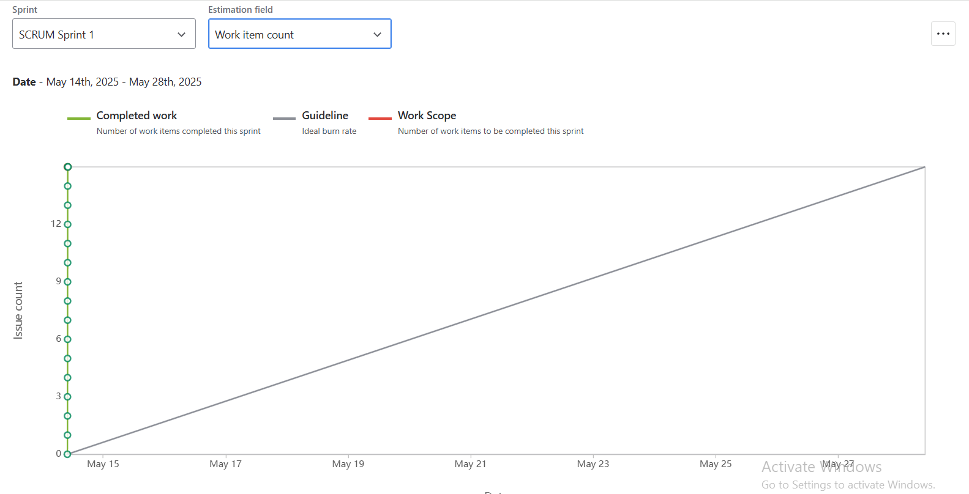

Sprint Burndown: Tracks task progress within a sprint — ideal for daily stand-ups and scrum reviews.
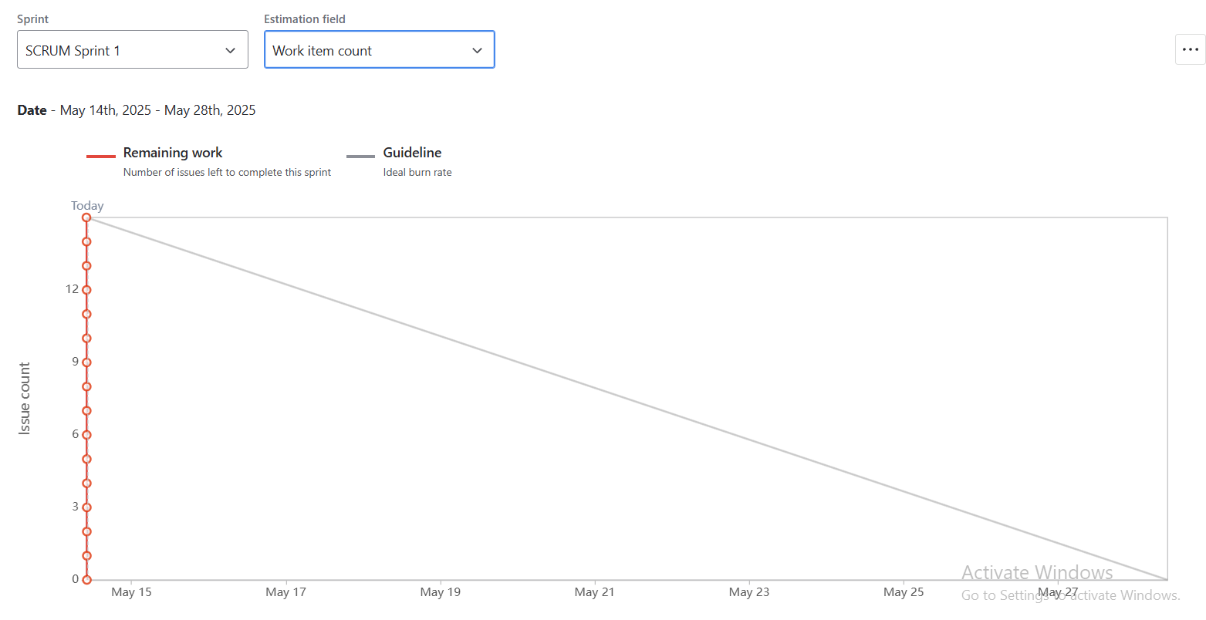
Example: In Sprint 2, burn rate showed 80% completion by Day 7. After reassigning blocked tasks, sprint goal was achieved.
Document 6: Sprint meetings
Meeting Type 1: Sprint Planning meeting
Field | Details
Date | June 20, 2025
Time | 10:00 AM – 11:00 AM EST
Location | Axia WH Conf Room B / Zoom
Prepared By | Anjali Mehra (Product Owner)
Attendees | PO, Scrum Master, Dev Team, QA, Billing Lead

Agenda Topics
Topic | Presenter | Time Allotted
Sprint Goal Overview & Key Deliverables | Product Owner | 10 mins
Review of Sprint Backlog (US001–US003) | Business Analyst | 15 mins
Development Capacity & Task Assignment | Tech Lead | 10 mins

Other Information
Item | Details
Observers | EMR vendor integration consultant (optional)
Resources | Jira board, Velocity chart, Epic roadmap
Special Notes | Ensure ICD-10 compliance impacts are discussed

Meeting Type 2: Sprint review meeting
Field | Details
Date | July 3, 2025
Time | 3:00 PM – 4:00 PM EST
Location | Axia WH Teams Call
Prepared By | Saifullah Aamir
Attendees | PO, QA, Dev Team, Revenue Cycle Manager

Sprint Review Summary
Sprint Status | Things to Demo | Quick Updates | What’s Next
80% Complete (US001 & US002 done) | Eligibility API working liveClaim categorization UI demo | Small delay in US003 UI integration | Begin development of payment posting module
Partial QA pending | Auto-flag denial rules in action | Claims dataset used from live batch | Prepare UAT test cases
Burndown on track | Error logging framework introduced | No major blockers | Move pending tasks to Sprint 3

Meeting Type 3: Sprint retrospective meeting
Field | Details
Date | July 5, 2025
Time | 2:00 PM – 2:45 PM EST
Location | Teams Virtual Meeting
Prepared By | Scrum Master (Rohit Sharma)
Attendees | PO, Devs, QA, Scrum Master

Retrospective Review
Agenda | What Went Well | What Didn’t Go Well | Questions | Reference
Review Sprint 2 outcomes | Smooth eligibility API integration | QA got only 2 days for testing | Can QA be looped in earlier? | Sprint 2 Jira board
Share team feedback | Strong team coordination with PO | Delay in EMR data availability | Who owns EMR dependency communication? | Confluence notes
Action items discussion | Daily standups were efficient | Jira subtasks lacked clear estimates | Can BA add estimates during refinement? | Retrospective board

Meeting Type 4: Daily Stand-up meeting

 | Monday | Tuesday | Wednesday | Thursday | Friday | Saturday | Sunday
Developer 1 (Raj) | Completed eligibility API integration | Code review for US001 | Fixed validation rule issues | Worked on exception report | Deployed to test env | — | —
Developer 2 (Meera) | Created UI wireframes for denial flags | Started front-end for US002 | Built filter component | Connected backend service | Bug fixes | — | —
Developer 3 (Amit) | Created test cases for US001 | Regression testing | Test data prep | Executed test cases | Logged 4 bugs in US002 | — | —

