Assignment 1:
- Please make a BRD which can be presented to the client along with complete development and resource plan.

BRD

PROJECT NAME: Inventory & Delivery software application PROJECT ID: PROJ-1234 -SOF-2025-A01
VERSION ID: Version 1.1.1
Author: Sam Rajan

Contents
- DocumentRevisions. 8
- Approvals. 8
- RASCI Chart for This Document 8
Codes Used in RASCI Chart 9
RASCI Chart 9
- Introduction 9
  - Business Goals. 9
  - Business Objectives. 9
  - Business Rules. 10
  - Background 10
  - Project Objective 10
  - Project Scope 10
    - In Scope Functionality 10
    - Out Scope Functionality 10
- Assumptions 10
- Constraints. 10
- Risks. 10
Technological Risks. 11
Skills Risks. 11
Political Risks. 11
Business Risks. 11
Requirements Risks 11
Other Risks. 11
- Business Process Overview 11
  - Legacy System (AS-IS) 11
  - Proposed Recommendations (TO-BE) 11
- Business Requirements. 11
- Appendices. 12
  - List of Acronyms. 12
  - Glossary of Terms. 12
  - Related Documents 12

Document Revisions

Date | Version Number | Document Changes
20/08/2025 | 0.1 | Initial Draft

Approvals.

Role | Name | Title | Signature | Date
Project
Sponsor
Business
Owner
Project Manager
System
Architect
Development Lead
User
Experience Lead
Quality Lead
Content Lead

- RACI Chart for This Document
The RACI chart identifies the persons who need to be contacted whenever changes are made to this document. RACI stands for responsible, accountable, consulted, and informed. These are the main codes that appear in a RACI chart, used here to describe the roles played by team members and stakeholders in the production of the BRD. They are adapted from charts used to assign roles and responsibilities during a project.( RACI Can be made for IT side[Project stakeholder] as mentioned above, apart from that Can also Be made for Client side[Business Stakeholder]). The following describes the full list of codes used in the table:
Codes Used in RACI Chart
* Authorize Has ultimate signing authority for any changes to the document. R Responsible Responsible for creating this document.

A Accountable for accuracy of this document (for example, the project manager) S Supports Provides supporting services in the production of this document
C Consulted Provides input (such as an interviewee). I Informed Must be informed of any changes.

Project Phase / Task | Project Manager | BA | Developers | Testers | Client/S  .H
Requirements Gathering | A | R | C | C | I
Requirements Documentation  (SRS) | A | R | C | C | I
System Design | A | C | R | C | I
Implementation (Coding) | C | C | R/A | I | I
Unit Testing | C | I | R | A | I
Integration & System Testing | C | C | C | R/A | I
User Acceptance Testing  (UAT) | I | R | C | A | R
Deployment | A | C | R | C | I
Maintenance &  support | A | C | R | R | I

Introduction

  - Business Goal
To improve operational efficiency in managing inventory across plants & warehouses.
To ensure fastest delivery of ice-cream and milk products to customers.

Business Objectives
Implement a centralized inventory management system to track raw materials, finished goods, and stock movement.
Automate order processing and delivery scheduling for quicker turnaround. Reduce wastage of perishable products by demand forecasting.
Provide real-time visibility of stock levels to management and distributors. Integrate system with logistics providers for optimal routing and delivery.

Business Rules

Inventory levels must never drop below safety stock thresholds.
Expiry dates must be tracked; perishable products must be dispatched first (FIFO/LIFO).
Orders placed before 2 PM must be dispatched same day (where stock is available). Each delivery truck must not exceed maximum load capacity.
Warehouses must update stock movements in real time.

Background
Client operates 10 manufacturing plants and 25 warehouses nationwide. Current system is semi-manual using spreadsheets.
Issues faced: stock mismatch, delays in delivery, wastage due to expiry, customer complaints.
Company wants to scale operations with an integrated digital solution.

Project Objective
Build and implement an Inventory & Delivery Management System (IDMS) that integrates:
Manufacturing plants Warehouses Distribution centers
Customer delivery tracking

Project Scope

In-Scope Functionality:
Inventory management (stock in/out, tracking, expiry alerts). Demand forecasting & restoration .
Order management & delivery scheduling. Route optimization for delivery trucks.
Integration with existing ERP/Finance systems. Reporting & dashboards (sales, stock, wastage).

Out Scope Functionality:
HR management modules. Payroll processing.
Direct consumer-facing app (phase 2).
Manufacturing process automation.

Assumptions :
All warehouses have stable internet connectivity. Staff will undergo training before go-live.
Accurate master data will be provided by client.

Constraints:
Budget limit: INR 5 Crores. Timeline: 9 months (3 phases).
Must comply with FSSAI regulations (food safety). System to be multilingual (English + regional).

Risks

Technological Risks
Integration issues with legacy ERP. Data migration errors from Excel sheets. Skills Risks
Warehouse staff may lack IT skills. Need for extensive training.
Political Risks
State transport policies affecting delivery timelines.
Business Risks
Resistance to change from staff used to manual methods. Failure to meet demand spikes in summer season.
Requirements Risks

Frequent changes in delivery policies from management. Misalignment between IT vendor & client expectations.
Other Risks
Power outages at remote warehouses. Hardware failures (barcode scanners, servers).

- Business Process Overview
  - Legacy system Current Process (AS-IS):
Manufacturing plant produces goods, manually recorded in Excel, stock updated at warehouses end of day, distributors call warehouse, orders fulfilled manually, delivery arranged, delivered.

  - Proposed Recommendation (TO-BE):
Manufacturing Plants update stock digitally, real-time visibility in central system, warehouses auto-update, orders placed online, system suggests best warehouse & delivery route, dispatch scheduled, tracking available to customers.
Inventory Management:
The future solution provides centralized, cloud-based inventory tracking, enabling real-time automated updates from all sites. This structure enforces strict FIFO handling and generates proactive alerts for low stock or expiring items, ensuring better inventory accuracy and product freshness.
Order Processing:
A digital order portal will automate workflow, allowing orders to be received and processed centrally. The system will automatically select the best warehouse for fulfillment, based on proximity and stock, and integrate directly with finance and billing for end-to-end efficiency.
Delivery Operations:
Advanced route optimization, supported by mapping APIs, will enable dynamic scheduling that considers order priority, distance, and live traffic conditions. Real- time delivery tracking and customer notifications will enhance transparency and ensure timely delivery completions.
Reporting & Analytics:
Management will gain access to interactive, real-time dashboards for critical performance metrics, comprehensive on-demand and scheduled reports, and advanced trend analysis. This empowers data-driven management and speeds up problem resolution.

- Business Requirements
System must allow real-time inventory tracking across all locations. System must generate alerts for low stock & nearing expiry products. System must allow order placement and delivery scheduling.
System must support route optimization & vehicle load planning. System must integrate with ERP & Finance systems.
System must provide dashboards for management (sales, stock, wastage, delivery times).

- Appendices
Mockups of dashboard screens. Sample workflows.
Proposed project timeline (Gantt chart).

  - List of Acronyms
IDMS – Inventory & Delivery Management System ERP – Enterprise Resource Planning
FIFO – First In, First Out RLS – Row Level Security

  - Glossary of Terms
Inventory – Raw materials, semi-finished & finished goods. Warehouse – Storage unit for distribution.
Route Optimization – Algorithm to find fastest delivery route. Demand Forecasting – Predicting future demand using past data.

  - Related Documents
Request for Proposal (RFP). Current IT Infrastructure Document.
Food Safety Compliance Guidelines.

- Prepare process flow diagram using your imagination.

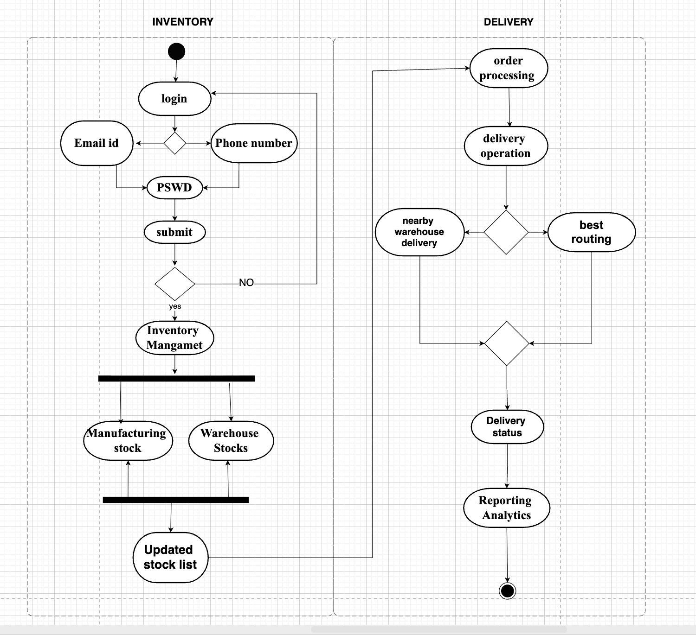

Assignment 2:
- Write an introduction letter to a client introducing yourself as a business analyst in charge of working with the client and his team to start the business understanding process.

Subject: Introduction – Business Analyst for Inventory & Delivery management system project engagement
Dear XYZ,
I hope this message finds you well.

My name is Sam Rajan and I will be working with you as the Business Analyst assigned to your project. My role will be to collaborate closely with you and your team to ensure that we fully understand your business needs, define clear requirements, and translate them into effective solutions that align with your organizational goals.
Over the coming weeks, I will facilitate discussions and workshops to:

  - Understand your business processes, challenges, and objectives.
  - Identify key stakeholders and gather their expectations.
  - Document and prioritize requirements for the project.
  - Ensure alignment between your strategic goals and the solution being developed.
I am committed to ensuring that this engagement runs smoothly and that the final solution not only meets but exceeds your expectations. Please feel free to reach out to me anytime with questions, clarifications, or inputs that you feel will add value to the project.
I look forward to working with you and your team, and I am confident that together we will build a strong foundation for a successful outcome.
Thank you for the opportunity to collaborate with you.

Warm regards, Sam Rajan Business Analyst sfhb company
samrajan1994.sgcs@gmail.com 9876543210

- Prepare a brief BRD and SRS for a project- Horoscope or Ticketing system or online store.
BRD

Ticketing software project
Contents 1.DocumentRevisions. 8
- Approvals. 8
- RASCI Chart for This Document 8
Codes Used in RASCI Chart 9
RASCI Chart 9
- Introduction 9
  - Business Goals. 9
  - Business Objectives. 9
  - Business Rules. 10
  - Background 10
  - Project Objective 10
  - Project Scope 10
    - In Scope Functionality 10
    - Out Scope Functionality 10
- Assumptions 10
- Constraints. 10
- Risks. 10
Technological Risks. 11
Skills Risks. 11
Political Risks. 11
Business Risks. 11
Requirements Risks 11
Other Risks. 11
- Business Process Overview 11
  - Legacy System (AS-IS) 11
  - Proposed Recommendations (TO-BE) 11
- Business Requirements. 11
- Appendices. 12
  - List of Acronyms. 12
  - Glossary of Terms. 12
  - Related Documents 12

- Document Revisions

Date | Version Number | Document Changes
21/08/2025 | 0.1 | Initial Draft

- Approvals.

Role | Name | Title | Signature | Date
Project
Sponsor
Business Owner
Project
Manager
System Architect
Development
Lead
User Experience
Lead
Quality Lead
Content Lead

- RACI Chart for This Document
The RACI chart identifies the persons who need to be contacted whenever changes are made to this document. RACI stands for responsible, accountable, consulted, and informed. These are the main codes that appear in a RACI chart, used here to describe the roles played by team members and stakeholders in the production of the BRD. They are adapted from charts used to assign roles and responsibilities during a project.( RACI Can be made for IT side[Project stakeholder] as mentioned above, apart from that Can also Be made for Client side[Business Stakeholder]). The following describes the full list of codes used in the table:
Codes Used in RACI Chart
* Authorize Has ultimate signing authority for any changes to the document.

R Responsible Responsible for creating this document.
A Accountable for accuracy of this document (for example, the project manager) S Supports Provides supporting services in the production of this document
C Consulted Provides input (such as an interviewee).
I Informed Must be informed of any changes.

Project Phase / Task | Project Manager | BA | Developers | Testers | Client/S.H
Requirements Gathering | A | R | C | C | I
Requirements Documentation (SRS) | A | R | C | C | I
System Design | A | C | R | C | I
Implementation (Coding) | C | C | R/A | I | I
Unit Testing | C | I | R | A | I
Integration & System  Testing | C | C | C | R/A | I
User Acceptance Testing  (UAT) | I | R | C | A | R
Deployment | A | C | R | C | I
Maintenance & support | A | C | R | R | I

- Introduction

  - Business Goal
To develop a centralized online ticketing system that allows customers to search, book, pay for, and manage tickets for events, travel, and entertainment seamlessly.
To provide real-time ticket availability and secure digital transactions.
To reduce operational costs and errors caused by manual ticketing systems.

  - Business Objectives
Improve customer experience through real-time booking confirmation. Provide multiple and secure payment methods.
Enable event organizers/admins to manage ticket inventory and pricing dynamically. Deliver business insights through reports and dashboards.
Ensure scalability to handle high peak-hour traffic.

  - Business Rules
A booking is confirmed only upon successful payment. Cancellation requests are honoured only before event start time.
Refund rules vary by event/vendor policy (e.g., 80% refund if cancelled 24 hrs in advance).
One user can book up to 10 tickets per event.
User must be authenticated (registered) before booking.
Seat allocation (if applicable) is based on availability at booking time.

  - Background
Current ticketing is managed manually or through fragmented systems, leading to: Double-booking issues.
Lack of real-time availability updates.
Customer dissatisfaction due to slow processes.
Businesses are moving towards digital-first solutions for efficiency and scale.

  - Project Objective
Build an end-to-end ticketing platform that supports: User-friendly booking interface.
Payment integration.
Ticket generation and tracking.
Admin management for events and pricing. Analytical reporting for decision -making.

  - Project Scope
    - In-Scope Functionality
User registration, login, profile management. Event search, filtering, and selection.
Booking, cancellation, refund processing.

Payment gateway integration.
Notification system (Email/SMS confirmations). Admin portal (event setup, pricing, reports).
Reporting and analytics dashboards.
    - Out-of-Scope Functionality Offline ticket counter sales. Loyalty/reward point system.
Integration with external travel/event aggregators (Phase 2 consideration).

- Assumptions
Users have internet and smartphone/PC access. Third-party payment APIs are available and reliable. Email/SMS services are available.
Vendors provide updated event/ticket availability data.

- Constraints
Must comply with PCI DSS standards for payment security. System availability: 24x7, 99.9% uptime.
Performance: Handle 10,000+ concurrent users. Limited budget and timeline.

- Risks
Technological Risks
Payment gateway downtime.
High traffic load affecting performance.

Skills Risks
Lack of skilled resources in BI reporting or system integration.

Political Risks
Changes in government regulation of online transactions or digital services.

Business Risks

Competition from established platforms (Bookmyshow ,Ticketmaster). Vendor/event partners not adopting the platform.

Requirements Risks
Unclear requirements from stakeholders. Scope creep due to frequent feature requests. Other Risks
Cybersecurity threats (phishing, hacking). Customer resistance to adopting a new platform.

Business Process Overview
  - AS-IS (Legacy System)
Manual or semi-digital booking. Customers often need to physically visit.
Delays in confirmation and higher risk of double-booking.
  - TO-BE (Proposed System) Fully digital ticketing solution. Real-time availability visibility.
Automated booking, confirmation, and cancellation. Integration with secure payment systems.

Business Requirements
Customers should be able to search and book tickets online. The system must integrate with secure payment gateways.
System must send instant confirmation via email/SMS.
Admin should manage event/ticket creation, pricing, and availability. Dashboards for sales, usage, and cancellations.
System must support refunds and cancellation policies.

Appendices
Sample wireframes.

Sample reports.

List of Acronyms
UAT: User Acceptance Testing
PCI DSS: Payment Card Industry Data Security Standard API: Application Programming Interface

Glossary of Terms
Ticket: A digital proof of booking.
Refund: Amount returned to customer post cancellation. Admin: Authorized user managing events and reports.

Related Documents
Market Research Report – Digital Ticketing Industry. Payment Gateway Integration Documentation.
Customer Journey Mapping Document.

SRS
Software Requirements Specification

for
Ticketing software project

Version 1.0 approved

Prepared by Sam Rajan

XYZ company

21/08/2025

Contents

- Introduction
  - Purpose
    - 1.2. Document Conventions.
    - 1.3 Intended Audience and Reading Suggestions
    - 1.4. Project Scope
    - 1.5. References
- Overall Description
- 2.1. Product Perspective
- 2.2. Product Features
- 2.3. User Classes and Characteristics.
- 2.4. Operating Environment
- 2.5. Design and Implementation Constraints
- 2.6. User Documentation.
- 2.7 Assumptions and Dependencies
- System Features.
- 3.1. System Feature 1
- 3.2. System Feature 2 (and so on)
- External Interface Requirements
- 4.1. User Interfaces
- 4.2. Hardware Interfaces
- 4.3. Software Interfaces
- 4.4. Communications Interfaces.
- Other Nonfunctional Requirements
- 5.1. Performance Requirements ...
- 5.2. Safety Requirements
- 5.3. Security Requirements
- 5.4. Software Quality Attributes.

- Other Requirements Appendix A: Glossary. Appendix B: Analysis Models Appendix C: Issues List

Revision History

Name | Date | Reason For Changes | Version

- Introduction
  - Purpose
The purpose of this document is to define the requirements for the Ticketing System. This system will enable users to book, manage, and cancel tickets for events, travel, or services through a centralized platform. The SRS serves as a foundation for development, testing, and deployment, ensuring all stakeholders have a common
understanding of the system’s capabilities.
  - Document Conventions
This document follows IEEE SRS standards. Headings are numbered hierarchically (e.g., 1, 1.1, 1.1.1), and technical terms are explained in the glossary. System features are described in narrative form and supplemented with references to UML diagrams when required.
  - Intended Audience and Reading Suggestions
The intended audience includes project stakeholders, business analysts, developers, testers, and system administrators. Business users may focus on Sections 1 and 2 for an overview, while technical teams should review Sections 3, 4, and 5 for detailed system and interface requirements.
  - Project Scope

The Ticketing System will provide an online platform for customers to search, book, and manage tickets efficiently. It will support multiple ticket categories (e.g., transport, events) and allow integration with payment gateways. The scope includes customer-facing interfaces, administrative tools for managing inventory and reports, and backend APIs for integration with third-party services.
  - References
IEEE Std 830-1998: IEEE Recommended Practice for Software Requirements Specifications
Business Requirement Document (BRD) – Ticketing System Project UML Diagrams (Use Case, Activity, Sequence) attached in Appendix B

- Overall Description
  - Product Perspective
The Ticketing System is a standalone web and mobile-based application, integrating with external payment gateways, notification services (SMS, email), and third-party APIs for events or transport schedules.
  - Product Features
Key features include user registration, ticket search and booking, secure payments, e-ticket generation, booking history management, cancellation and refunds, and administrative dashboards.
  - User Classes and Characteristics
End Users (Customers): General users with basic technical knowledge who book and manage tickets.
Administrators: Users with higher access to manage ticket inventory, pricing, and reporting.
Support Staff: Users who handle customer issues and refunds.
  - Operating Environment
The system will run on standard web browsers (Chrome, Edge, Firefox) and mobile devices (Android and iOS). The backend will operate on a cloud-hosted environment with scalability support.
  - Design and Implementation Constraints Compliance with GDPR for customer data privacy. PCI DSS compliance for handling payments. Limited bandwidth in some rural customer areas.

  - User Documentation
User guides, FAQs, and in-app tooltips will be provided for customers. Administrators will have access to a more detailed system manual.
  - Assumptions and Dependencies
Reliable internet connectivity for users.
Availability of third-party APIs for payment and event schedules. Dependencies on SMS/email gateways for notifications.

- System Features
  - Ticket Search and Booking
Users can search for tickets by category, location, and date, view availability, and book tickets.
  - Secure Payment and E-Ticket Generation
The system supports multiple payment methods and generates digital tickets with QR codes.
  - Booking Management
Users can view booking history, download tickets, cancel bookings, and request refunds.
  - Administrative Features
Admins can add or update ticket inventory, configure pricing, generate sales reports, and manage refunds.
- External Interface Requirements
  - User Interfaces
Responsive web and mobile interfaces with a simple navigation structure.
  - Hardware Interfaces
Standard laptops, desktops, and mobile devices with internet connectivity.
  - Software Interfaces
Integration with payment gateways, email/SMS APIs, and external scheduling APIs.
  - Communications Interfaces
Secure HTTPS protocols, REST APIs for integration, and real-time notifications.
- Other Nonfunctional Requirements

  - Performance Requirements
The system must handle up to 10,000 concurrent users with less than 2-second response time.
  - Safety Requirements
System must ensure transaction recovery in case of failure and avoid double billing.
  - Security Requirements
Data encryption (AES-256), role-based access control, and secure authentication with multi-factor options.
  - Software Quality Attributes
The system should be scalable, maintainable, and ensure high availability (99.9% uptime).
- Other Requirements
The system should support localization (multi-language, multi-currency) for future expansion.
Appendix A: Glossary
API: Application Programming Interface
PCI DSS: Payment Card Industry Data Security Standard GDPR: General Data Protection Regulation
Appendix B: Analysis Models
UML Use Case Diagram UML Activity Diagram UML Sequence Diagram Appendix C: Issues List
Pending confirmation of refund policy rules from stakeholders. Final selection of third-party payment gateway provider.

- Make an ERD of creating a support ticket/Ticketing life cycle.

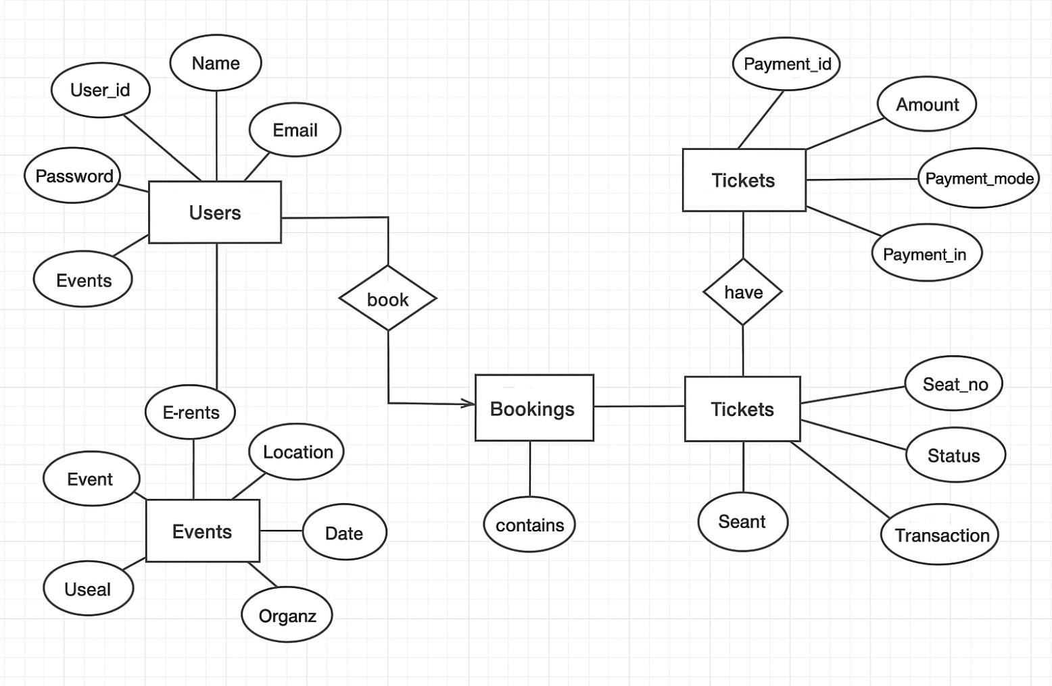

- User story of shopping from ecommerce. Register
User Story No: 1

| Tasks: 2 | Priority: HIGHEST |

AS A CUSTOMER
I WANT TO REGISTER IN THE ECOMMERCE PORTAL SO THAT I CAN PLACE ORDERS
BV: 200
CP: 2
ACCEPTANCE CRITERIA

Registration with Name, Email, Phone, Address, Password Click Register button
Display success notification
Login
User Story No: 2
| Tasks: 2 | Priority: HIGHEST | AS A CUSTOMER
I WANT TO LOGIN TO MY ACCOUNT
SO THAT I CAN ACCESS MY PROFILE AND PURCHASE HISTORY
BV: 200
CP: 1
ACCEPTANCE CRITERIA:

Login with Email/Phone and Password Click Login button
Redirect to homepage on success
Show error for invalid credentials

Reset password
User Story No: 3

| Tasks: 2 | Priority: HIGH |

AS A CUSTOMER
I WANT TO RESET MY PASSWORD
SO THAT I CAN REGAIN ACCESS TO MY ACCOUNT
BV: 200
CP: 2
ACCEPTANCE CRITERIA:
Enter registered email
Receive password reset link Set new password and login
Search
User Story No: 4
| Tasks: 2 | Priority: HIGHEST | AS A CUSTOMER
I WANT TO SEARCH FOR PRODUCTS
SO THAT I CAN FIND ITEMS OF INTEREST
BV: 500
CP: 5
ACCEPTANCE CRITERIA:
Enter keywords in search bar Display matching product list
Show filters and sort by relevance

Filter product
User Story No: 5
| Tasks: 2 | Priority: HIGH | AS A CUSTOMER
I WANT TO FILTER PRODUCTS BY PRICE AND BRAND SO THAT I CAN NARROW MY SEARCH
BV: 100
CP: 2
ACCEPTANCE CRITERIA:
Apply price and brand filters

Show updated product list

Sort product
User Story No: 6
| Tasks: 2 | Priority: MEDIUM | AS A CUSTOMER
I WANT TO SORT PRODUCTS
SO THAT I CAN VIEW ITEMS BY PRICE OR POPULARITY
BV: 500
CP: 2
ACCEPTANCE CRITERIA
Sort options: low to high, high to low, popularity Display sorted items

View product
User Story No: 7
| Tasks: 2 | Priority: HIGH | AS A CUSTOMER
I WANT TO VIEW PRODUCT DETAILS
SO THAT I CAN MAKE AN INFORMED DECISION
BV: 200
CP: 3
ACCEPTANCE CRITERIA
Click product for details page
Show name, images, price, description, specifications, reviews

Add to Cart
User Story No: 8
| Tasks: 2 | Priority: HIGH | AS A CUSTOMER
I WANT TO ADD PRODUCTS TO MY CART
SO THAT I CAN PURCHASE MULTIPLE ITEMS TOGETHER

BV: 200
CP: 1
ACCEPTANCE CRITERIA
Click “Add to Cart”
Product appears in shopping cart Update/remove item option in cart
Update Cart
User Story No: 9
| Tasks: 2 | Priority: MEDIUM | AS A CUSTOMER
I WANT TO UPDATE CART QUANTITIES
SO THAT I CAN BUY THE NEEDED AMOUNTS
BV: 100
CP: 2
ACCEPTANCE CRITERIA
Adjust quantity in cart Total updates accordingly
Remove items from cart

View Cart
User Story No: 10
| Tasks: 2 | Priority: MEDIUM | AS A CUSTOMER
I WANT TO VIEW MY CART SUMMARY SO THAT I CAN REVIEW MY SELECTIONS
BV: 100
CP: 1
ACCEPTANCE CRITERIA
Cart page lists items, quantity, price, total Edit or proceed to checkout options

Checkout
User Story No: 11

| Tasks: 2 | Priority: HIGH |

AS A CUSTOMER
I WANT TO PROCEED TO CHECKOUT SO THAT I CAN PLACE MY ORDER
BV: 200
CP: 2
ACCEPTANCE CRITERIA
Click Checkout
Enter or select delivery details Proceed to payment

Update Address
User Story No: 12
| Tasks: 2 | Priority: MEDIUM | AS A CUSTOMER
I WANT TO SAVE MULTIPLE ADDRESSES SO THAT I CAN FASTER CHECKOUT
BV: 100
CP: 1
ACCEPTANCE CRITERIA
Add, edit, delete addresses Select address during checkout

Select payment method
User Story No: 13

| Tasks: 2 | Priority: HIGH |

AS A CUSTOMER
I WANT TO SELECT A PAYMENT METHOD
SO THAT I CAN CHOOSE UPI, COD OR DEBIT/CREDIT CARD
BV: 500
CP: 8
ACCEPTANCE CRITERIA
Payment options on checkout (UPI, COD, card) Complete payment securely
Confirmation shown post-payment
Coupon code
User Story No: 14
| Tasks: 2 | Priority: MEDIUM | AS A CUSTOMER
I WANT TO ENTER PROMOTION CODES SO THAT I CAN GET DISCOUNTS
BV: 100
CP: 2
ACCEPTANCE CRITERIA
Promo code input at checkout
Valid code applies discount Invalid code shows error

Order confirmation
User Story No: 15

| Tasks: 2 | Priority: HIGH |

AS A CUSTOMER
I WANT TO RECEIVE ORDER CONFIRMATION WITH INVOICE SO THAT I HAVE A RECORD OF MY PURCHASE
BV: 200
CP: 3
ACCEPTANCE CRITERIA
Order confirmed after payment Invoice generated and emailed
Invoice available in account orders

Track order
User Story No: 16
| Tasks: 2 | Priority: MEDIUM | AS A CUSTOMER
I WANT TO TRACK MY ORDER STATUS SO THAT I KNOW WHERE MY ORDER IS
BV: 200
CP: 3
ACCEPTANCE CRITERIA
Order details show current status
Updates as order progresses (processing, shipped, delivered)

Order status
User Story No: 17

| Tasks: 2 | Priority: MEDIUM |

AS A CUSTOMER
I WANT TO RECEIVE ORDER STATUS NOTIFICATIONS SO THAT I AM INFORMED ON DELIVERY
BV: 200
CP: 2
ACCEPTANCE CRITERIA
Notification on dispatch, out for delivery, delivered
Sent by email and/or SMS
View order history
User Story No: 18
| Tasks: 2 | Priority: MEDIUM | AS A CUSTOMER
I WANT TO VIEW ORDER HISTORY
SO THAT I CAN REFERENCE OR REORDER
BV: 100
CP: 1
ACCEPTANCE CRITERIA
List previous orders in account View order details and status
Reorder from past order

Rate & Review
User Story No: 19
| Tasks: 2 | Priority: LOW | AS A CUSTOMER
I WANT TO RATE & REVIEW PRODUCTS SO THAT I CAN SHARE FEEDBACK

BV: 100
CP: 1
ACCEPTANCE CRITERIA
Submit review & rating on purchased products Published and visible on product page

Customer support
User Story No: 20
| Tasks: 2 | Priority: MEDIUM | AS A CUSTOMER
I WANT TO CONTACT CUSTOMER SUPPORT SO THAT I CAN RESOLVE ISSUES
BV: 100
CP: 2
ACCEPTANCE CRITERIA
Access support form/chat
Submit issue, receive ticket/confirmation
Track response or resolution

