CAPSTONE PROJECT – 1- PART 3

Identify minimum 20 functional requirements
Example :
Functional requirement: When an order is fulfilled, the local printer shall print a packing slip.
Non-Functional Requirement: Packing slips shall be printed on both sides of 4”x 6” white paper, the standard size for packing slips used by local printers.
Req ID | Req Name | Req Description | Priority
FR0001 | Farmer Registration | Farmers should be able to register with the application | 8
FR0002 | Farmers Search for Products | Farmers should be able to search for available products in fertilizers, seeds, pesticides | 8
FR0003 | Product Browsing | Farmers can browse product catalog without logging in | 7
FR0004 | Wishlist/Buy Later | Farmers can add products to a Wishlist after logging in | 7
FR0005 | Add to Cart | Farmers can add items to cart before purchasing | 8
FR0006 | Place order | Farmers can place an order after login | 9
FR0007 | Payment Gateway | System should support COD, UPI, Credit/Debit card payments | 9
FR0008 | Order Confirmation Email | Farmers receive an email after successful order placement | 8
FR0009 | Track Order | Farmers can track delivery status of their orders | 8
FR0010 | Manufacturer Registration | Manufacturers can register and create accounts | 8
FR0011 | Manufacturer Product Upload | Manufacturers can upload fertilizers, seeds and pesticides to the system | 9
FR0012 | Login Functionality | Both Farmers and Manufacturers should be able to log in using credentials | 9
FR0013 | Forgot Password | Users should be able to reset password using registered email | 7
FR0014 | Profile Management | Users should be able to update their profile info | 6
FR0015 | Product Sorting and Filtering | Users can sort and filter products based on price, rating, category etc. | 7
FR0016 | Admin Dashboard | Admin should be able to manage users and products | 9
FR0017 | Product Details View | Users can view detailed information about products | 8
FR0018 | Notifications | System should notify users of status updates (email/SMS/ in-app) | 7
FR0019 | Reviews and Ratings | Farmers can provide ratings and reviews for purchased products | 6
FR0020 | Contact support | Users can contact support through an online form | 7

Non-Functional Requirements (NFR)

Req ID | Req Name | Req Description | Priority
NFR0101 | Page Loading Time | Each page should load within 2 seconds | 9
NFR0102 | WCAG 2.1 Compliance | The system must meet Web Content Accessibility Guidelines (WCAG 2.1) | 8
NFR0103 | Uptime Guarantee | Application should ensure 99.9% uptime monthly | 9
NFR0104 | Mobile Responsiveness | The application must be accessible on all modern mobile browsers | 8
NFR0105 | Data Encryption | All data should be encrypted using industry standards | 9
NFR0106 | Scalability | System should scale to support up to 100,000 concurrent users | 7
NFR0107 | Backup Frequency | System should perform full data backups every 12 hours | 7
NFR0108 | Disaster Recovery | System must recover within 5 minutes in case of failure | 9
NFR0109 | Response Time | API response time should not exceed 500ms for 95% of requests | 8
NFR0110 | Multi-Browser Support | Support Chrome, Firefox, Safari, Edge | 6
NFR0111 | Security Compliance | Comply with Top 10 security standards | 9
NFR0112 | Session Timeout | User sessions should auto-expire after 15 minutes of inactivity | 7
NFR0113 | Audit Logging | Log all user activities and system events for auditing purposes | 8
NFR0114 | Memory Usage | Application should not exceed 500MB RAM per container instance | 6
NFR0115 | UI Consistency | All UI components should follow a consistent design system | 6
NFR0116 | Language Support | System should support English and at least one regional language | 6
NFR0117 | Compliance – GDPR | User data should be handled in accordance with GDPR standards | 9
NFR0118 | Search Performance | Product search results should appear within 2 seconds | 7
NFR0119 | Documentation Availability | System features must be documented for end users and developers | 5
NFR0120 | Analytics Dashboard | Admin analytics dashboard should render in under 3 seconds | 6

2Q) Make wireframe and prototypes?
Ans:
Wireframes - A wireframe is a simple, low-fidelity visual layout that shows the basic structure of a webpage or application screen, indicating where elements like buttons, input fields, menus, and images will be placed. It focuses on layout and functionality without involving colors, styles, or detailed design elements, helping the team understand what will appear on each screen and ensuring clarity for developers and testers before actual development begins.

Prototypes - a Prototype is a high-fidelity, interactive model of the application that allows stakeholders to click through screens, simulate navigation, and experience the workflow as if they are using the real system. It helps in visualizing the system flow, identifying improvements in user experience, and gathering feedback from stakeholders before starting development, thereby reducing rework and ensuring the system aligns with user expectations.

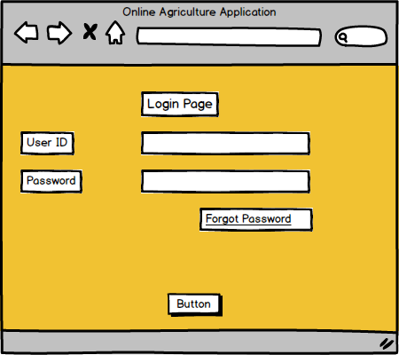

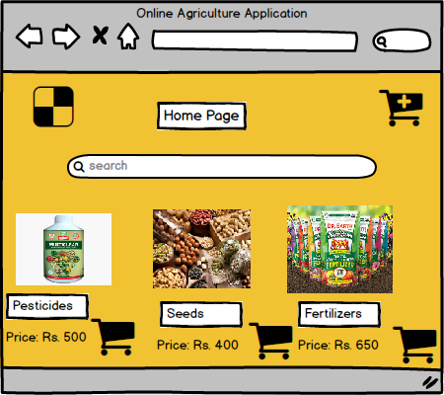

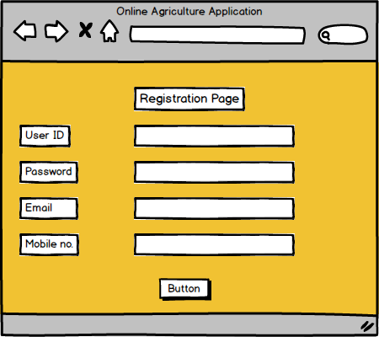

• Wireframes show Login, Registration, Product Catalog, Cart, Payment screens.
• Prototype allows stakeholders (Mr. Henry, Peter, Kevin, Ben) to click through the screens, add products to cart, simulate placing orders, and give feedback before actual coding.

3Q) Make a note of the T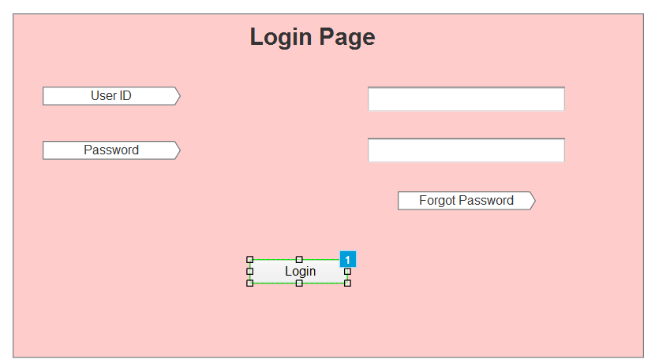
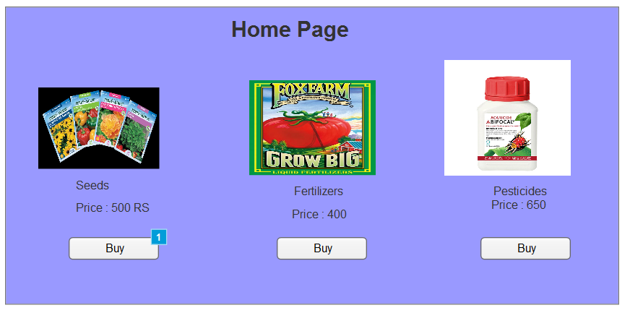

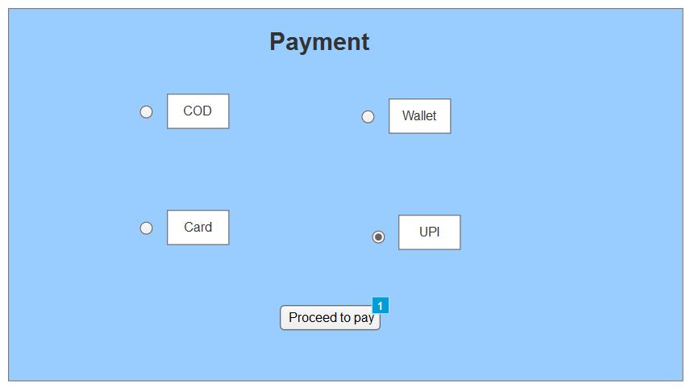

3Q)Make a note of the Tools, which you are using for above concepts.
Ans: During the Software Development Life Cycle (SDLC), especially in the requirements gathering and system design phase, various tools are used to model, visualize, and validate functional and non-functional requirements. Below are the tools I’ve utilized:
- Microsoft Visio :
Purpose:
- Used for creating UML diagrams like Use Case, Activity, Sequence, and Class Diagrams.
- Helps visualize system behavior, data flow, and business processes.
- Also used to create flowcharts for functional logic.
Pros:
- Easy drag-and-drop interface.
- Supports a wide range of diagram types.
- Integrates well with Microsoft Office tools (Word, PowerPoint, Excel).
- Widely used in the industry for formal documentation.
Cons:
- Not ideal for collaborative real-time editing.
- Limited interactive or clickable prototype features.
- More suitable for static diagrams than dynamic or UI-oriented work.

- Axure RP:
Purpose:
- Used to create interactive wireframes and functional mockups for websites and applications.
- Helps simulate real-world system behavior through click-through interactions.
- Supports conditional logic, dynamic content, and adaptive views.
Pros:
- Supports high-fidelity, realistic prototypes.
- Allows simulation of complex logic and workflows.
- Enables annotation and documentation for developers.
- Ideal for stakeholder demonstrations and usability testing
Cons:
- Has a learning curve for new users.
- Heavier application compared to lighter mockup tools.
- May be overkill for simple designs or early-stage concepts.

- Balsamiq :
Purpose:
- Used in early stages of requirement gathering to create sketch-style, low-fidelity wireframes.
- Helps quickly lay out the structure of web pages or app screens.
Pros:
- Very simple and intuitive to use.
- Great for brainstorming and rapid ideation.
- Encourages stakeholder participation without focusing on design details.
- Ideal for quick feedback loops in Agile development.
Cons:
- Limited interactivity (non-clickable).
- Not suitable for presenting polished or final designs.
- Doesn’t support dynamic or responsive behaviors.

4Q) Mr. Henry and peter have approached you regarding the status of the project. How will you tackle this situation?
Ans:
RTM for Functional Requirements:
Req ID | Req Name | Req Description | D1(Design) | T1(Unit Test) | T2(Integration Test) | T3(System Test) | T4(UAT)
FR0001 | Farmer Registration | Farmers should be able to register with the application | Complete | Complete | Complete | Complete | Pending
FR0002 | Farmer Search for Products | Farmers should be able to search for available products | Complete | Complete | Complete | Complete | Pending
FR0003 | Product Browsing | Farmers can browse product catalog without logging in | Complete | Complete | Complete | In Progress | Pending
FR0004 | Wishlist/Buy Later | Farmers can add products to a Wishlist after logging in | Complete | Complete | In Progress | Pending | Pending
FR0005 | Add to Cart | Farmers can add items to cart before purchasing | Complete | Complete | Complete | Complete | Pending
FR0006 | Payment Gateway | System should support COD, UPI, Credit/Debit card payments | Complete | Complete | In Progress | Pending | Pending
RTM for Non-Functional Requirements:
Req ID | Req Name | Req Description | D1(Design) | T1(Unit Test) | T2(Integration Test) | T3(System Test) | T4(UAT)
NFR0101 | Page Loading Time | Each page should load within 2 seconds | Complete | Complete | Complete | In Progress | Pending
NFR0102 | WCAG 2.1 Compliance | System must meet WCAG 2.1 accessibility guidelines | Complete | Complete | In Progress | Pending | Pending
NFR0103 | Uptime Guarantee | Application should ensure 99.9% uptime monthly | Complete | In Progress | Pending | Pending | Pending
NFR0104 | Mobile Responsiveness | Application accessible on all modern mobile browsers | Complete | Complete | In Progress | Pending | Pending
NFR0105 | Data Encryption | All data encrypted using industry standards | Complete | Complete | Complete | In Progress | Pending
NFR0106 | Scalability | System should scale to support up to 100,000 concurrent users | Complete | In Progress | Pending | Pending | Pending

5Q) Prepare 10 Test Case Documents?
Ans:
Test Case ID | TC_FR001 |  | Test Case Name |  | Farmer Registration
Project ID | P_AGRI_001 |  | Project Name |  | Online Agriculture Store
PM ID | PM_101 |  | PM Name |  | Mr. Henry
Test Strategy ID | TS_001 |  | Tester ID |  | T_001
Test Plan ID | TP_001 |  | Tester Name |  | Peter
Test Schedule ID | TSCH_001 |  | Date of Test |  | 30/06/2025
Scenario | Search for Product
Link to that page: Registration Page
Input Data | Set 1: Name=Raj | Set 2: Email=raj@gmail.com |  | Set 3: Password=Test@123 |  | Set 4: Phone = +1-9821345678 | Set 5: Address = 12 Greenfield Village
Expected Behavior | User should be registered and redirected to login page
Actual Behavior | User registered successfully and redirected to login page
Comments | Tested on Chrome and Firefox
Result (Pass/Fail) | Pass

Test Case ID | TC_FR002 |  | Test Case Name |  | Farmer Registration
Project ID | P_AGRI_001 |  | Project Name |  | Online Agriculture Store
PM ID | PM_101 |  | PM Name |  | Mr. Henry
Test Strategy ID | TS_001 |  | Tester ID |  | T_002
Test Plan ID | TP_001 |  | Tester Name |  | Peter
Test Schedule ID | TSCH_002 |  | Date of Test |  | 30/06/2025
Scenario | Farmers logs in with valid credentials
Link to that page: Login Page
Input Data | Set 1: Name=Email=raj@gmail.com | Set 2: Password=Test@123 |  | Set 3: Password=Test@123 |  | Set 4: Phone = +1-9821345678 | Set 5: Address = 12 Greenfield Village
Expected Behavior | User should be logged in and redirected to dashboard
Actual Behavior | User successfully logged in and redirected to dashboard
Comments | Functionality working on mobile and web
Result (Pass/Fail) | Pass

Test Case ID | TC_FR003 |  | Test Case Name |  | Farmer Registration
Project ID | P_AGRI_001 |  | Project Name |  | Online Agriculture Store
PM ID | PM_101 |  | PM Name |  | Mr. Henry
Test Strategy ID | TS_001 |  | Tester ID |  | T_003
Test Plan ID | TP_001 |  | Tester Name |  | Peter
Test Schedule ID | TSCH_003 |  | Date of Test |  | 30/06/2025
Scenario | Farmers searches for products
Link to that page: Product Search Page
Input Data | Set 1: Urea | Set 2: “Cotton Seeds” |  | Set 3: “Organic Pesticide” |  | Set 4: Tractor | Set 5: Irrigation Pipe
Expected Behavior | Product list should display matching items within 2 seconds
Actual Behavior | User successfully logged in and redirected to dashboard
Comments | Search with partial keywords returns relevant results
Result (Pass/Fail) | Pass

Test Case ID | TC_FR004 |  | Test Case Name |  | Add Product to Wishlist
Project ID | P_AGRI_001 |  | Project Name |  | Online Agriculture Store
PM ID | PM_101 |  | PM Name |  | Mr. Henry
Test Strategy ID | TS_001 |  | Tester ID |  | T_004
Test Plan ID | TP_001 |  | Tester Name |  | Peter
Test Schedule ID | TSCH_004 |  | Date of Test |  | 30/06/2025
Scenario | Farmers adds product to wishlist
Link to that page: Product Details Page
Input Data | Set 1: Urea | Set 2: “Seeds” |  | Set 3: “Tractor” |  | Set 4: “Fertilizer” | Set 5: “Sprayer”
Expected Behavior | Products added to Wishlist with success message
Actual Behavior | Wishlist updated correctly for all products
Comments | Wishlist count incremented correctly on each addition
Result (Pass/Fail) | Pass

Test Case ID | TC_FR005 |  | Test Case Name |  | Add Product to Cart
Project ID | P_AGRI_001 |  | Project Name |  | Online Agriculture Store
PM ID | PM_101 |  | PM Name |  | Mr. Henry
Test Strategy ID | TS_001 |  | Tester ID |  | T_005
Test Plan ID | TP_001 |  | Tester Name |  | Peter
Test Schedule ID | TSCH_005 |  | Date of Test |  | 30/06/2025
Scenario | Farmers adds product to cart
Link to that page: Product Details Page
Input Data | Set 1: Urea | Set 2: “Seeds” |  | Set 3: “Fertilizer” |  | Set 4: “Sprayer” | Set 5: “Tractor”
Expected Behavior | Products added to cart successfully
Actual Behavior | Cart updated, quantities reflected correctly
Comments | Search with partial keywords returns relevant results
Result (Pass/Fail) | Pass

Test Case ID | TC_FR006 |  | Test Case Name |  | Place Order
Project ID | P_AGRI_001 |  | Project Name |  | Online Agriculture Store
PM ID | PM_101 |  | PM Name |  | Mr. Henry
Test Strategy ID | TS_001 |  | Tester ID |  | T_006
Test Plan ID | TP_001 |  | Tester Name |  | Peter
Test Schedule ID | TSCH_003 |  | Date of Test |  | 30/06/2025
Scenario | Farmers places order
Link to that page: Checkout Page
Input Data | Set 1: COD | Set 2: UPI |  | Set 3: Debit Card |  | Set 4: Credit Card | Set 5: Net Banking
Expected Behavior | Order placed, order ID generated, redirected to confirmation page.
Actual Behavior | Order placement successful for all payment modes.
Comments | Confirmation email received after order.
Result (Pass/Fail) | Pass

Test Case ID | TC_FR007 |  | Test Case Name |  | Payment Gateway Verification
Project ID | P_AGRI_001 |  | Project Name |  | Online Agriculture Store
PM ID | PM_101 |  | PM Name |  | Mr. Henry
Test Strategy ID | TS_001 |  | Tester ID |  | T_003
Test Plan ID | TP_001 |  | Tester Name |  | Peter
Test Schedule ID | TSCH_007 |  | Date of Test |  | 30/06/2025
Scenario | Verify payment processing
Link to that page: Payment Page
Input Data | Set 1: COD | Set 2: Credit Card |  | Set 3: Debit Card |  | Set 4: UPI | Set 5: Net Banking
Expected Behavior | Payment processed and confirmation shown
Actual Behavior | Payment successful with status update and confirmation screen
Comments | Error displayed correctly for invalid payment details.
Result (Pass/Fail) | Pass

Test Case ID | TC_FR008 |  | Test Case Name |  | Order Confirmation Email
Project ID | P_AGRI_001 |  | Project Name |  | Online Agriculture Store
PM ID | PM_101 |  | PM Name |  | Mr. Henry
Test Strategy ID | TS_001 |  | Tester ID |  | T_008
Test Plan ID | TP_001 |  | Tester Name |  | Peter
Test Schedule ID | TSCH_008 |  | Date of Test |  | 30/06/2025
Scenario | Confirm order email sent
Link to that page: Confirmation Page
Input Data | Set 1: Valid Email | Set 2: Multiple Items |  | Set 3: Single Item |  | Set 4: COD Payment | Set 5: UPI Payment
Expected Behavior | Confirmation email sent with order details
Actual Behavior | Email received within 30 seconds post order placement
Comments | Email formatting and content verified
Result (Pass/Fail) | Pass

Test Case ID | TC_FR009 |  | Test Case Name |  | Track Order
Project ID | P_AGRI_001 |  | Project Name |  | Online Agriculture Store
PM ID | PM_101 |  | PM Name |  | Mr. Henry
Test Strategy ID | TS_001 |  | Tester ID |  | T_009
Test Plan ID | TP_001 |  | Tester Name |  | Peter
Test Schedule ID | TSCH_009 |  | Date of Test |  | 30/06/2025
Scenario | Track order using ID
Link to that page: Track Order Page
Input Data | Set 1: Valid Order ID | Set 2: Delivered Status |  | Set 3: Pending Status |  | Set 4: Cancelled Status | Set 5: In Transit
Expected Behavior | Order displayed correctly
Actual Behavior | Correct status shown for each order scenario
Comments | Edge case with invalid ID returns “Order Not Found” as expected.
Result (Pass/Fail) | Pass

Test Case ID | TC_FR010 |  | Test Case Name |  | Manufacturer Registration
Project ID | P_AGRI_001 |  | Project Name |  | Online Agriculture Store
PM ID | PM_101 |  | PM Name |  | Mr. Henry
Test Strategy ID | TS_001 |  | Tester ID |  | T_010
Test Plan ID | TP_001 |  | Tester Name |  | Peter
Test Schedule ID | TSCH_010 |  | Date of Test |  | 30/06/2025
Scenario | Manufacturer registration
Link to that page: Manufacturer Registration Page
Input Data | Set 1: Name =ABC Agro | Set 2: Email=abc@agro.com |  | Set 3: Password=Agro@123 |  | Set 4: Phone=+1-9263718289 | Set 5: Address=Farm Road, Pune
Expected Behavior | Manufacturer registered, redirected to login page and email received.
Actual Behavior | Registration successful, redirected and email received
Comments | Validated email verification and form validation
Result (Pass/Fail) | Pass

6Q) After the requirements are thoroughly explained to the entire project team by business analyst, the Database architects have decided to do the database design and also to represent the in-flow and out-flow of data – DB Design
Ans: A Database Schema is a structured framework that defines how data is organized in a database, detailing the tables, columns, data types, and the relationships among the tables. It acts like a blueprint for developers and database administrators, ensuring clarity on how data will be stored, retrieved, and managed within the system.
An Entity Relationship (ER) Diagram is a visual representation of this database schema, showcasing entities (tables), their attributes (columns), and the relationships between these entities using symbols like rectangles for entities, ovals for attributes, and diamonds for relationships, often with crow’s foot notation to indicate cardinality (one-to-one, one-to-many, many-to-many).

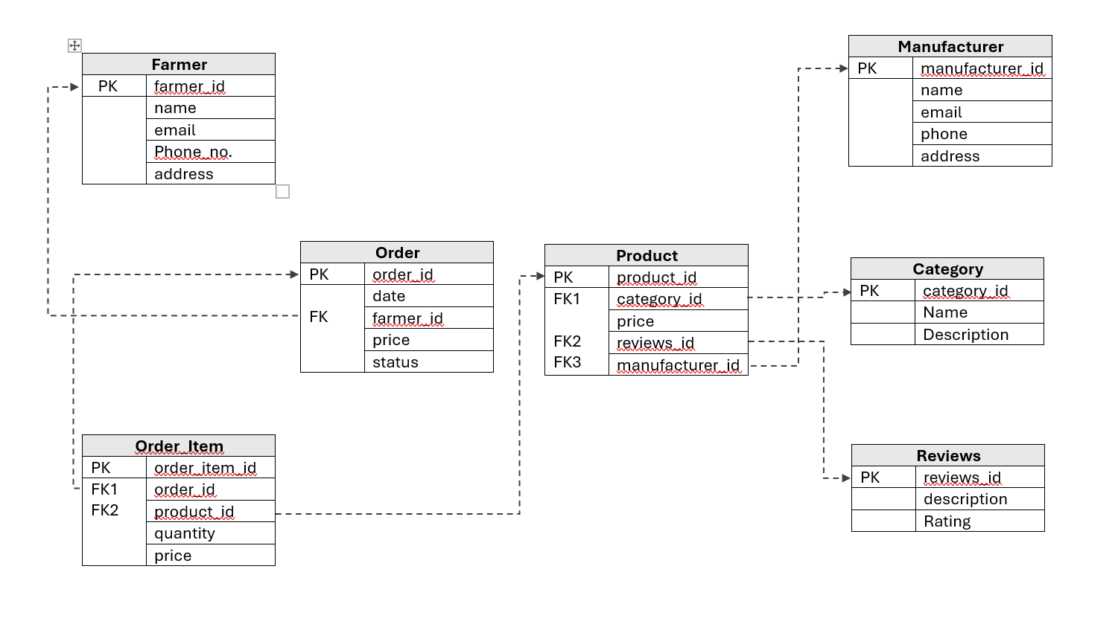
This ER diagram represents a marketplace application where:
- Manufacturers post products.
- Farmers can browse, review, and purchase products.
- Categories and reviews are maintained for better organization and feedback.
Explanation of each table:
1️. Farmer Table
- Primary Key (PK): farmer_id
  - Unique identifier for each farmer.
- Attributes:
  - name, email, phone_no, address.
- Purpose:
  - Stores farmer profiles who use the system to purchase products.
- Relationship:
  - Connected to Order Table using farmer_id as Foreign Key (FK).
- In this table, each farmer can place multiple orders, establishing a one-to-many relationship.
2️. Manufacturer Table
- PK: manufacturer_id
- Attributes:
  - name, email, phone, address.
- Purpose:
  - Stores manufacturer details who upload and sell products.
- Relationship:
  - Connected to Product Table using manufacturer_id as FK.
- In this table, a manufacturer can post multiple products, creating a one-to-many relationship.
3️.Product Table
- PK: product_id
- FK1: category_id → connects to Category table.
- FK2: reviews_id → connects to Reviews table.
- FK3: manufacturer_id → connects to Manufacturer table.
- Attributes:
  - price.
- Purpose:
  - Stores all products available for purchase on the platform.
- Relationships:
  - Belongs to a category.
  - Linked to reviews.
  - Associated with a manufacturer.
In this table, Products are the core of the system, linking categories, manufacturers, and reviews to maintain a structured, scalable product catalog.
4️. Category Table
- PK: category_id
- Attributes:
  - name, description.
- Purpose:
  - Stores product categories (e.g., Seeds, Fertilizers, Tools).
- Relationship:
  - Connected to Product Table.
This table ensures each product is organized under a category for easy filtering and browsing.
5️. Reviews Table
- PK: reviews_id
- Attributes:
  - description, rating.
- Purpose:
  - Stores feedback and ratings provided by farmers on products.
- Relationship:
  - Linked to Product Table using reviews_id.
This table allows maintaining a history of reviews, helping farmers make informed decisions.
6️. Order Table
- PK: order_id
- FK: farmer_id → connects to Farmer table.
- Attributes:
  - date, price, status.
- Purpose:
  - Stores order-level details of purchases made by farmers.
- Relationship:
  - Connected to Farmer Table (each farmer can place many orders).
  - Connected to Order_Item Table (each order can have many items).
The Order Table captures overall transaction details, while individual items are managed in the Order_Item Table.
7️. Order_Item Table
- PK: order_item_id
- FK1: order_id → connects to Order table.
- FK2: product_id → connects to Product table.
- Attributes:
  - quantity, price.
- Purpose:
  - Stores item-level details within an order, including product purchased, quantity, and unit price.
- Relationship:
  - Links orders to products, enabling many-to-many mapping between orders and products (via Order_Item).
In this table, each order can have multiple items, and each item corresponds to a product, allowing detailed tracking of sales.
Relationship Summary :
Farmer → Order (1:M): A farmer can place many orders.
Order → Order_Item (1:M): Each order can have many items.
Order_Item → Product (M:1): Each item corresponds to a product.
Product → Category (M:1): Each product belongs to a category.
Product → Reviews (M:1): Each product can have reviews.
Product → Manufacturer (M:1): Each product is uploaded by a manufacturer.
7Q) What is a data flow diagram? Draw a data flow diagram to represent the in-flow and out-flow of data when a Farmer is placing an order for the product
Ans: Data Flow Diagram – DFD is a graphical representation that shows how data moves within a system displaying Processes(actions performed on data), Data stores(where data is stored), Data flows(movement of data), External entities(people or systems interacting with the system).
It helps visualize inflow and outflow of data clearly for analysis and system design.

8Q) Due to change in the Government Taxation structure we should change the Tax structure How do you handle change requests in a project?
Ans:
Change Request - A change request is a formal proposal to modify the scope, requirements, features, or functionality of a project after the project has started. It is raised when stakeholders identify a new need, correction, or compliance update that was not part of the originally agreed requirements. It ensures that any change is tracked, analyzed for impact on cost, time, and scope, approved by stakeholders, implemented carefully, and tested before deployment.

Handling change requests in a Project:
When there is a change in Government Taxation structure, leading to a tax structure change in the project, Change Request Handling involves the following systematic steps:

Step-by-step process:
1️. Receive & Register the Change Request
Receive the change formally from stakeholders (e.g., tax rate change from 12% to 15% due to GST updates).
Log it in the Change Request Tracker with:
- Request ID
- Description of change
- Reason for change (compliance with government regulations)
- Requested timeline and priority.
2️. Understand & Analyze the Change
Conduct a requirement gathering session with stakeholders, PM, and developers to:
- Understand the exact change in tax logic.
- Identify impacted modules:
  - Order processing
  - Invoice generation
  - Payment calculation
  - Reports
- Identify impacted database tables (e.g., Tax Table, Invoice Table).
3️. Impact Analysis
Work with the technical team to evaluate:
- Effort estimation (developer, tester hours)
- Impact on project timelines and cost
- Dependencies on third-party APIs or payment gateways
Prepare an Impact Analysis Document.
4️. Approval Process
Present the impact analysis to stakeholders for:
- Approval of the change
- Agreement on timeline and cost adjustments if required
- Obtain formal approval (email or signed document).
5️. Update Project Documents
Update:
- SRS, BRD, and RTM with the new tax requirements
- Test case documents for impacted scenarios
- Design documents and data flow diagrams
Communicate changes to development and QA teams.
6️. Implementation
Developers implement the updated tax calculation logic.
Update database (e.g., new tax rates).
Update UI forms if necessary (e.g., invoice display).
7️. Testing
Conduct Unit Testing and System Testing to verify:
- Correct tax calculations at checkout and invoice generation
- Integration with payment gateways
Conduct Regression Testing to ensure existing functionalities are not impacted.
8️. User Acceptance Testing (UAT)
Coordinate with stakeholders to:
- Execute UAT test cases to validate the new tax structure
- Gather feedback and resolve issues
- Confirm compliance with government policies.
9️. Deployment
Schedule and deploy changes to the production environment.
Ensure rollback plans are ready for emergencies.
Inform stakeholders and users about the change if necessary.
10️. Closure of Change Request
Update the Change Log with:
- Change description
- Implementation details
- Testing confirmation
- Approval records
- Closure date
Mark the change request as ‘Closed’ in the tracker.
Summary:
Request → Analyze → Impact Assessment → Approve → Update Docs → Implement → Test → UAT → Deploy → Close.
So, following the above steps provides -
- Ensures government compliance.
- Avoids system disruptions.
- Keeps stakeholders informed.
- Ensures traceable, structured, and low-risk handling of changes.

9Q) As the project is in process, Ben and Kevin have contacted you. The reason is to inform you that they want the Farmers to sell their crop yields through this application i.e. Farmers should be able to add their crop yields or products and display to general public and should be able to sell them. They also want to introduce Auction system for their Crop yields. response?
Is this a change request or an enhancement???
Ans:
This is an Enhancement, not a Change Request.
- A Change Request modifies existing requirements or functionalities due to corrections, compliance, or stakeholder needs (e.g., tax updates).
- An Enhancement introduces new functionalities not originally planned in the initial requirements.
Since selling crop yields and auction systems are new functionalities that expand the scope of the project, they are classified as Enhancements.
If we get Enhancements during the project timeline:
1️. Acknowledge and Document:
- Capture the enhancement request formally from Ben and Kevin.
- Record their expectations clearly for selling and auction features.
2️. Impact Analysis:
- Scope Impact: Addition of crop management and auction modules.
- Time Impact: Additional development, testing, and UAT effort.
- Cost Impact: Potential increase in project budget.
- Technical Impact:
  - New database tables (e.g., Crop_Yield, Auction_Details).
  - Additional UI screens for adding listings, managing bids, and auction dashboards.
  - New API endpoints and business logic.
3️. Stakeholder Discussion:
- Schedule a meeting with Mr. Henry, PM, and stakeholders to:
  - Explain the benefits of the enhancement.
  - Discuss the impact on timeline, resources, and cost.
  - Get alignment on priorities.
4️. Approval Process:
- Seek formal approval from stakeholders for scope, budget, and timeline adjustments.
- Update the Project Plan with revised delivery timelines.
5️. Document Updates:
- Update SRS, RTM, and Design Documents with new requirements and flows.
- Prepare wireframes for farmer product upload and auction modules.
6️. Plan Execution:
- BA will:
  - Write user stories for the enhancement.
  - Work with developers to design and develop the modules.
  - Coordinate testing with test cases prepared for these enhancements.
  - Conduct UAT with Ben, Kevin, and Mr. Henry.
7️. Communication:
- Maintain transparent updates with stakeholders on progress, blockers, and timeline adherence.
This ensures the system evolves to meet stakeholders' evolving needs while maintaining project management discipline during CSR delivery.
10Q) Come up with estimations – How many Manhours required
Ans: Man-hour Estimations for this project:
Project Overview:
- Project Name: Online Agriculture Products Store
- Budget: 2 Crores INR (CSR funded by Mr. Henry’s company)
- Duration: 18 months (540 calendar days)
- Company: APT IT SOLUTIONS
- Team Members: 10
  - Project Manager (Mr. Vandanam)
  - Senior Java Developer (Ms. Juhi)
  - Java Developers (Mr. Teyson, Ms. Lucie, Mr. Tucker, Mr. Bravo)
  - Network Admin (Mr. Mike)
  - DB Admin (Mr. John)
  - Testers (Mr. Jason, Ms. Alekya)
  - Business Analyst (Sadhika)
Calculation Assumptions:
Total Working Days: 396 days (excluding weekends and holidays).
Daily Effort per Resource: 8 hours/day.
Total Manhours (with 10-member team):
396 days × 8 hrs/day × 10 members = 31,680 man-hours
To plan realistically, considering practical resource allocation and buffer, the project uses around:
Total Manhours (Including buffer): 3168 hours (as per structured allocation).

Detailed Phase-wise Estimation:

Project Phase | Estimated Days | Man-Hours (Days x 8hrs)
Requirement Gathering & Analysis (BA + PM) | 14 | 112
UI/UX Design for Registration & Product Display (Senior Dev + Devs) | 12 | 96
Database Architecture & Setup (DB Admin + Senior Dev) | 10 | 80
Development – Farmer Registration (Devs + Senior Dev) | 24 | 192
Development – Product Catalogue & Search (Devs) | 28 | 224
Payment Gateway Integration (Senior Dev + Devs) | 30 | 240
Delivery Tracking Module (Devs) | 14 | 112
Email Notification Integration (Dev + Tester) | 10 | 80
Testing – Unit, Integration, System (Testers + Devs) | 8 | 64
UAT Support and Bug Fixing (Testers + BA + Devs) | 20 | 160
Deployment & Go-Live Support (Network Admin + DB Admin + Senior Dev) | 10 | 80
Project Management & Documentation (PM + BA) | 6 | 48
Buffer for Rework/Unforeseen Issues | 12 | 96
Total | 208 days | 1564 hours

No. of working hours :
- Business Analyst & Project Manager: 200-250 hours (Requirement gathering, UAT, documentation).
- Senior Java Developer: 300-350 hours (Design, supervision, integrations).
- Java Developers: 600-700 hours collectively across modules.
- DB Admin: 80-100 hours (setup, monitoring).
- Network Admin: 40-60 hours (deployment, configurations).
- Testers: 200-250 hours collectively (test cases, UAT, retesting).
Overall Project Estimation:
- The project is large-scale with an estimated 1500-1600 man-hours aligned with an 18-month timeline under the CSR initiative.

- It covers registration/login, catalog/search, payment gateway, delivery tracking, notifications, admin and manufacturer modules.
- This structured estimation helps in resource planning, milestone tracking, and ensuring smooth delivery within budget and timelines.

11Q) Project has finally completed all the stages i.e., design, development, testing etc. Now, it is the role of a business analyst to contact the client for testing of the final product and have to successfully complete it. How are you going to handle this situation? And once it is done, what will be the process to close the project? Explain UAT Acceptance process.
Ans:
UAT: User Acceptance Testing (UAT) is the final phase where actual users (stakeholders) test the system to ensure it meets their business requirements and is ready for Go-Live.
Step-by-Step: How I will handle UAT as a BA
1️) Preparation before UAT:
- Review all BRDs, FRDs, RTM, and test cases to ensure all requirements are mapped to test cases.
- Coordinate with the QA team to ensure system testing and defect fixing are completed before UAT.
- Identify stakeholders (Mr. Henry, Peter, Kevin, Ben) who will participate in UAT.
- Prepare UAT Plan including:
- Scope of UAT
- Features to be tested
- Testing environment details
- Entry and Exit criteria
- Schedule and timelines
2️) UAT Environment Setup:
- Coordinate with DB Admin and Network Admin to prepare a stable UAT environment mirroring production.
- Load sample production-like data for realistic testing.
- Ensure user access credentials for stakeholders are ready.
3️) Test Case Review and Sign-off:
- Prepare UAT Test Cases and User Scenarios based on real-life situations (e.g., Farmer registration, product search, order placement, payment, delivery tracking).
- Share test cases with stakeholders for pre-review, gather feedback, and finalize.
4️) Conduct UAT Sessions:
- Schedule UAT sessions with stakeholders.
- Conduct a kick-off meeting to explain test objectives, tools, and test execution procedures.
- Guide stakeholders on logging test results and reporting issues clearly.
5️) UAT Execution and Issue Tracking:
- Observe stakeholders while they test to note usability issues.
- Collect feedback and defect reports in a structured UAT Issue Tracker.
- Prioritize and assign bugs to the development team for quick resolution.
- Communicate frequently with stakeholders regarding the progress of fixes.
6️) Retesting:
- Once defects are fixed, stakeholders re-test to confirm resolution.
- Validate that critical business flows are working as expected without defects.
7️) UAT Sign-off:
Prepare a UAT Summary Report:
- Test cases executed
- Pass/Fail rates
- Defects logged and resolved
- Pending issues (if any) with mitigation plans
Conduct a sign-off meeting with stakeholders to collect formal written approval that the system meets business needs and is ready for Go-Live.
Project Closure Process as BA:
1️) Project Closure Meeting:
- Conduct a meeting with client (Mr. Henry, stakeholders) and the project team.
- Review deliverables and confirm all scope items are completed.
2️) Documentation:
Prepare a Project Closure Document including:
- Summary of deliverables completed
- UAT sign-off details
- Lessons learned (e.g., what went well, challenges faced, improvements for future)
- Pending items and support handover details
- Maintenance and support contacts
3️) Knowledge Transfer and Handover:
- Provide user manuals, training sessions, and system documentation to the client.
- Ensure support contacts are shared with the client for post-Go-Live assistance.
4️)Official Closure:
- Update project tracking tools with closure status.
- Release project resources formally.
- Send a thank you note to stakeholders and the team for their collaboration.
5️) Go-Live Preparation:
- Inform the client the system is ready for Go-Live.
- Coordinate with the technical team for production deployment scheduling.
- Monitor the system post-Go-Live for initial support.
UAT Acceptance Process:
1️.Planning – Define scope, criteria, and prepare stakeholders.
2️. Designing – Prepare user-centric test cases and scenarios.
3️. Execution – Stakeholders test using prepared cases in a real environment.
4️. Bug Fixing – Dev team fixes issues, retesting by stakeholders.
5️. Sign-Off – Formal approval for Go-Live from stakeholders.
Why this structured process is important:
- Ensures client requirements are verified in real scenarios.
- Builds client confidence before Go-Live.
- Allows the BA to maintain clear communication and transparency.
- Ensures a clean closure without pending issues, maintaining professional delivery standards.
12Q) Explain Project closure document?
Ans: Project Closure Document :
A project closure document (or closure report) is a formal document prepared at the end of a project that:
- Summarizes key outcomes, deliverables, and final details.
- Records lessons learned and challenges faced.
- Confirms the project has met its objectives and is officially closed.
It serves as a comprehensive record of the project’s accomplishments, challenges, and overall performance, providing valuable insights for stakeholders and helping improve future projects.
1️. Purpose of Project Closure Document:
The Project Closure Document marks formal project completion, confirming:
- All project objectives, scope, and deliverables are achieved.
- Stakeholders (Mr. Henry, Peter, Kevin, Ben) formally accept the system.
- Lessons learned, financials, and contracts are documented for reference.
- Smooth transition of the system to the client/operations team for Go-Live.
- Ensures stakeholder satisfaction and formal approval for closure.
2️. Key Components of Project Closure Document:

A. Project Summary -
- Project Name: Online Agriculture Products Store
- Budget: ₹2 Crores INR
- Duration: 18 months (540 days)
- Scope: User registration, product catalog & search, payment gateway, delivery tracking, email notifications, admin & manufacturer modules.
- Client: Mr. Henry, SOONY Company (CSR initiative)
- Vendor: APT IT SOLUTIONS

B. Deliverables and Achievements -
- User registration and login completed for farmers and manufacturers.
- Product catalog with search and filter functionality deployed.
- Payment gateway integrated with COD, UPI, and card payments.
- Delivery tracking and order notifications enabled.
- User manuals and training guides provided to the client.
C. Performance Evaluation Table -
Metric | Planned | Actual | Variance
Timeline(months) | 18 | 17 | -1
Budget (INR Crores) | 2.0 | 1.92 | -0.08
Quality defects | 0 | 3 (fixed) | 0

D. Quality Assurance -
- All modules tested for functionality, performance, and security.
- UAT conducted with Mr. Henry and stakeholders, feedback incorporated.
- Bugs fixed before Go-Live, ensuring a stable release.
E. Resource Utilization -
- Team members utilized:
  - PM, BA, Senior Developer, 4 Developers, 2 Testers, DB Admin, Network Admin
- Resource allocation:
  - Requirements gathering: 14 days
  - UI/UX: 12 days
  - Database setup: 10 days
  - Development: 60+ days across modules
  - Testing & UAT: 30+ days
- Resources efficiently managed to avoid overheads.
F. Risk Management -
- Identified Risks: Delay in payment gateway integration, network security checks.
- Mitigation: Parallel testing and vendor follow-ups.
- Outcome: Managed within timeline and budget.

G. Challenges Faced -
- Remote connectivity challenges with stakeholders (solved with scheduled calls).
- Farmers’ feedback requiring minor UI changes.
- Payment integration debugging delays (resolved within buffer time).
H. Value to the Company -
- Helps SOONY CSR initiatives reach farmers, empowering them digitally.
- Establishes SOONY as a socially responsible leader in agriculture enablement.
I. Final Approval -
- Formal sign-off obtained from Mr. Henry and committee confirming project acceptance.
- System marked Go-Live ready.
- Handover of:
  - Source code repository.
  - User manuals and training documents.
  - Admin credentials and operational workflows.

3️. Closure Activities:
- Project team informed and released from project-specific tasks.
- Closure meeting conducted with stakeholders.
- Project archived in APT IT SOLUTIONS project management system for reference.
- Feedback collected for process improvement.
4️. Conclusion:
The Project Closure Document ensures:
- Transparency and accountability in project delivery.
- Stakeholder satisfaction and formal closure.
- Captures lessons learned and improvements for future projects.
- Enables smooth operational transition and Go-Live readiness.
Points to be included in the Project Closure Document:
- Project Overview – Brief summary of project goals and scope.
- Achievements – Key milestones and deliverable completed.
- Lessons learned – Points for improvement in future projects.
- Quality Assurance – Confirmation of testing and quality checks.
- Resource Utilization – Details of how resources were used.
- Risk Management – Risks faced and how they were managed.
- Challenges – Major issues faced and how they were resolved.
- Client Acceptance – Confirmation that the client has accepted the final product.
This document helps ensure the transparency and accountability and marks the official closure of the project.

