Inventory Management and Delivery System for RS Ice-Cream & Milk Products
Version – 1.0
PRO01BRD01-2852025
Author – Vaibhav Bhagat

Contents
- Document Revisions
- Approvals
- RACI Chart for This Document
RASCI Matrix Chart
- Introduction
  - Business Goals
  - Business Objectives
  - Business Rules
  - Background
  - Project Objective
  - Project Scope
    - In Scope Functionality
    - Out Scope Functionality
- Assumptions
- Constraints
- Risks
Technological Risks
Skills Risks
Political Risks
Business Risks
Requirements Risks
Other Risks
- Business Process Overview
  - Legacy System (AS-IS)
  - Proposed Recommendations (TO-BE)
- Business Requirements
- Development And Resource Plan

Document Revision:

Date | Version Number | Document Changes
28-05-2025 | 0.1 | Initial Draft

Approvals :

Role | Name | Title | Signature | Date
Project Sponsor | Ajith | Business Head
Business Analyst | Vaibhav | Sr. BA
Project Manager | Avinash | PM
System Architect | Shubham | Lead DA
Devlp Lead | Parth | Sr Developer
Tester | Pravin | QA Engineer
User Exp Lead | Ashish | Sr. S/W tester
DB Architect | Vaibhav | DB Architect

RASCI Matrix :

Name | Position | * | R | A | S | C | I
Ajith | Project Sponsor |  | Yes | Yes | Yes | Yes
Vaibhav | Business analyst | Yes | Yes | Yes |  |  | Yes
Avinash | Project Manager | Yes | Yes | Yes |  |  | Yes
Shubham | System Architect |  |  | Yes | Yes
Parth | Devlp Lead |  |  | Yes | Yes
Pravin | Tester |  |  |  |  | Yes
Ashish | User Exp Lead |  |  |  | Yes |  | Yes
Vaibhav | DB Architect |  | Yes | Yes |  |  | Yes

Introduction:

RS ice Cream & Milk Products a leading manufacturer of ice cream and dairy products with a robust network of manufacturing plants and distribution warehouses. The primary focus of the proposed system is twofold: to implement intelligent inventory management and to facilitate the fastest possible delivery to customers. By achieving these objectives, Company aims to significantly boost operational efficiency, minimize product wastage, optimize supply chain workflows, and ultimately enhance customer satisfaction and loyalty. The company currently faces challenges in managing inventory and ensuring timely deliveries due to fragmented systems and lack of visibility across locations. This project aims to address these inefficiencies. This document outlines the requirements and development plan for building software to manage inventory and ensure the quickest delivery of ice cream and milk products across the company's manufacturing plants and warehouses.

Business Objectives:
- Efficient inventory management across manufacturing plants and warehouses.
- Optimize delivery routes and reduce delivery time.
- Real-time monitoring and tracking of stock levels and logistics.
- Improve customer satisfaction through timely deliveries.
Business Objectives:
- Efficient inventory management across manufacturing plants and warehouses.
- Optimize delivery routes and reduce delivery time.
- Real-time monitoring and tracking of stock levels and logistics.
- Improve customer satisfaction through timely deliveries.
- Minimize operational costs through route and stock optimization.
- Ensure compliance with food safety and quality standards.
In-Scope:
- Real-time inventory tracking and management across all manufacturing units and warehouses.
- Automated inventory restocking alerts based on predefined thresholds.
- Delivery route optimization using GPS and real-time traffic data.
- Live delivery tracking system accessible to customers and administrators.
- Customer notification system for order status updates via email and SMS.
- Role-based access control ensuring secure system interactions.
- System performance monitoring with regular reporting dashboards.
- Data security through encryption protocols and regular backups.
- Generation of customizable reports for inventory and logistics.
- Integration with ERP systems for seamless workflow management.
5. Out of Scope:
- Procurement and installation of hardware or IoT devices.
- Management and operations of third-party logistics (3PL) providers.
- Integration with external systems not specified in project requirements.
- Mobile application development (unless specifically requested).
- Customer grievance and complaint management portal.
- In-depth financial auditing or accounting functionalities.
- Employee performance management tools.
Assumptions:
- All required data (e.g., inventory levels, warehouse details) will be provided by the client.
- Adequate IT infrastructure (e.g., servers, networks) will be in place.
- The client will ensure stakeholder availability for requirement validation and approvals.
- Users will undergo training sessions to ensure smooth adoption.
- Third-party service providers (e.g., GPS, payment gateways) will offer consistent services.
- Internet connectivity will remain stable across all warehouses and delivery points.
- Regulatory requirements and compliance details will be clearly communicated.
Constraints:
- Budget and resource limitations must be adhered to.
- Project deadlines must be strictly followed.
- The system must integrate seamlessly with existing ERP and third-party tools.
- Data privacy and security standards must comply with regulatory laws.
- Any significant changes in requirements post-approval may impact timelines and costs.
- Hardware dependencies must be managed externally by the client.
- Real-time system performance is dependent on stable internet and hardware support.

Risks:

Technological Risks
- Integration challenges with legacy systems.

Skills Risks
- Limited technical expertise among staff.

Political Risks
- Resistance to change from internal stakeholders.

Business Risks
- Delay in software implementation may lead to operational inefficiencies.

Requirements Risks
- Unclear or changing requirements may impact development timelines.

Other Risks
- Data security concerns during system migration.

Business Process Overview:
The software will enable seamless inventory and delivery management across multiple manufacturing plants and warehouses. Orders placed by customers will be checked against inventory levels, and delivery routes will be dynamically optimized using GPS and real-time traffic data. Warehouse managers will oversee stock updates and manage alerts for low inventory levels. Delivery agents will receive optimized routes and status updates will be automatically shared with customers. Performance dashboards and analytics will provide actionable insights to stakeholders for continuous improvement.

Business Requirement :

Sr. No. | Business Requirement | Functionality | Description | Priority
BR-01 | Real-time Inventory Tracking | Inventory Management System | Track inventory levels in real-time across all warehouses and manufacturing plants. | High
BR-02 | Automated Restocking Alerts | Inventory Alerts | Trigger notifications when stock reaches predefined thresholds. | High
BR-03 | Multi-Warehouse View | Inventory Dashboard | Display all warehouse stock levels on a consolidated view. | Medium
BR-04 | Dynamic Route Optimization | Delivery Optimization Engine | Optimize delivery routes using GPS, live traffic, and weather data. | High
BR-05 | Live Order Status Updates | Customer Order Tracking | Provide customers with real-time order status updates via email/SMS. | High
BR-06 | Delivery Tracking System | GPS-based Delivery Tracking | Track live location of deliveries for customers and admin users. | High
BR-07 | Actionable Analytics and Reporting | Data Analytics Dashboard | Generate visual dashboards for stock levels, order status, delivery time, and overall performance. | Medium
BR-08 | User Role Management | Role-Based Access Control | Manage user roles and permissions for Admin, Warehouse Managers, Delivery Agents, and Customers. | High
BR-09 | System Alerts for Delays and Anomalies | Alert System | Automated alerts for delayed deliveries or system errors. | Medium
BR-10 | Performance Metrics Reporting | Performance Reporting | Generate reports for management review of key metrics, including fulfillment time and order accuracy. | Medium
BR-11 | Data Security | Encryption and Role-Based Access | Ensure all sensitive data is encrypted and accessible only to authorized users. | High
BR-12 | Customer Notifications | Notification System | Automated customer notifications for order confirmations and estimated delivery times. | High
BR-13 | Stock Transfer Management | Stock Transfer Module | Manage stock transfers between warehouses efficiently. | Medium
BR-14 | Compliance with Regulatory Standards | Compliance Engine | Ensure that the system adheres to food safety and industry standards. | High
BR-15 | Disaster Recovery | Backup and Disaster Recovery System | Implement daily data backups and a disaster recovery plan for business continuity. | Medium
BR-16 | Seamless ERP Integration | Integration with Existing ERP Systems | Facilitate data synchronization with the client's existing ERP solutions. | High
BR-17 | Order Processing Verification | Order Management System | Prevent processing of orders when inventory is insufficient. | High
BR-18 | Delivery Feedback Collection | Feedback and Rating System | Allow customers to provide feedback and ratings after delivery completion. | Low

Development And Resource Plan: ICE CREAM and MILK PRODUCTS Manufacturing Management System
This section outlines the human resources required for the successful development, deployment, and maintenance of the Ice Cream and Milk Products Manufacturing Management System. Each role is critical to achieving the project goals of inventory management and optimized delivery.

No | Phase | Time
1 | Requirements Gathering | 2-3 Weeks
2 | Design | 2-3 Weeks
3 | 3. Development | 12-14 Weeks
4 | Testing | 4-6 Weeks
5 | Deployment & UAT | 2-4 Weeks

Role | Number of Resources | Responsibilities
Project Manager | 1 | - Oversee project planning, execution, and delivery.
Project Manager | 1 | - Manage stakeholder communication and project timelines.
Project Manager | 1 | - Mitigate risks and ensure adherence to budget and scope.
Business Analyst | 1 | - Gather and document business requirements.
Business Analyst | 1 | - Bridge communication between technical and business teams.
Business Analyst | 1 | - Conduct process analysis and suggest improvements.
Developers | 4 | - Design, code, and implement inventory management and delivery optimization modules.
Developers | 4 | - Ensure integration with ERP, GPS, and third-party systems.
Developers | 4 | - Write scalable, secure, and maintainable code.
QA Engineers | 2 | - Develop and execute test plans and cases for functional and non-functional requirements.
QA Engineers | 2 | - Identify and report system defects and work with developers on resolution.
QA Engineers | 2 | - Conduct performance, load, and security testing.
UI/UX Designer | 1 | - Create intuitive user interfaces for web and mobile platforms.
UI/UX Designer | 1 | - Design responsive and user-friendly layouts for warehouse managers, delivery agents, and customers.
Support Engineers | 1 | - Provide technical support post-deployment.
Support Engineers | 1 | - Address end-user issues and system maintenance requests.
System Administrator | 1 | - Manage server infrastructure and ensure 99.9% uptime.
System Administrator | 1 | - Oversee system backups, disaster recovery, and security measures.
Data Analyst | 1 | - Collect, analyze, and report on system data to provide insights on inventory, delivery, and system performance.
Data Analyst | 1 | - Develop performance dashboards for stakeholders.
Integration Specialist | 1 | - Ensure seamless integration with third-party services (e.g., GPS, payment gateways, and ERP systems).
Integration Specialist | 1 | - Troubleshoot and resolve integration issues.
Trainers | 1 | - Conduct user training sessions for warehouse managers, delivery agents, and admin users.
Trainers | 1 | - Develop user manuals and training materials.

Related Documents
- Functional Requirements Document (FRD)
- Requirement Traceability Matrix (RTM)

2. Process Flow Diagram:

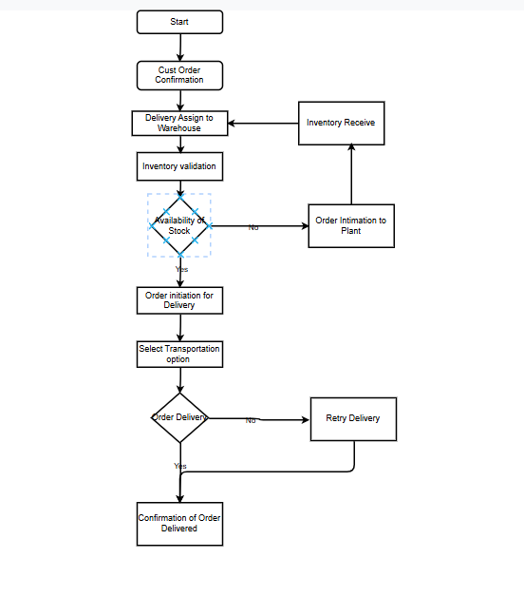

Assignment 2
Introduction Letter to Client

Subject: Introduction as Your Business Analyst for Ice Cream & Milk Product Inventory and Delivery Management Project

Dear ABC,

I hope this message finds you well. It is with great enthusiasm that I introduce myself as your dedicated Business Analyst for the upcoming project aimed at optimizing your inventory management and delivery operations for ice cream and milk products.
With several years of experience managing and delivering business solutions across industries, I am committed to ensuring a seamless collaboration throughout this project. My primary focus will be on understanding your business processes, identifying core challenges, and working closely with your team to deliver a solution tailored to your unique operational needs.
Objectives We Will Work on
- Efficient Inventory Management: Implementing real-time tracking, low-stock alerts, and multi-warehouse views to minimize stock outs and overstock situations.
- Enhanced Delivery Optimization: Utilizing dynamic routing, real-time GPS tracking, and automated customer notifications to ensure timely deliveries.
- Data-Driven Insights: Providing actionable insights and custom reports through advanced data analytics and performance dashboards.

My primary goal is to ensure we gather the right requirements that will translate into a product that supports your goals: efficient inventory management and fast, reliable delivery service. I will be scheduling our initial discovery sessions soon and appreciate your inputs throughout the project lifecycle.

Best regards,
Vaibhav Bhagat
Business Analyst
COEPD Tech
Bhagatvaibhav19@gmail.com
7276793013

Bus On Click
Version – 1.0
BOC01BRD01-29052025
Author – Vaibhav Bhagat

Contents
- Document Revisions
- Approvals
- RACI Chart for This Document
RASCI Matrix Chart
Introduction
- Business Goals
- Business Objectives
- Business Rules
- Background
- Project Objective
- Project Scope
- In Scope Functionality
- Out Scope Functionality
Assumptions
Constraints
Risks
  - Technological Risks
  - Skills Risks
  - Political Risks
  - Business Risks
  - Requirements Risks
  - Other Risks
Business Process Overview
Legacy System (AS-IS)
Proposed Recommendations (TO-BE)
Business Requirements

Document Revision:

Date | Version Number | Document Changes
29-05-2025 | 0.1 | Initial Draft

Approvals :

Role | Name | Title | Signature | Date
Project Sponsor | Rahul | Business Head
Business Analyst | Vaibhav | Sr. BA
Project Manager | Pradip | PM
System Architect | Lalit | Lead DA
Devlp Lead | Vikas | Sr Developer
Tester | Chetan | QA Engineer
User Exp Lead | Gopal | Sr. S/W tester
DB Architect | Pavan | DB Architect

RASCI Matrix :

Name | Position | * | R | A | S | C | I
Rahul | Project Sponsor |  | Yes | Yes | Yes | Yes
Vaibhav | Business analyst | Yes | Yes | Yes |  |  | Yes
Pradip | Project Manager | Yes | Yes | Yes |  |  | Yes
Lalit | System Architect |  |  | Yes | Yes
Vikas | Devlp Lead |  |  | Yes | Yes
Chetan | Tester |  |  |  |  | Yes
Gopal | User Exp Lead |  |  |  | Yes |  | Yes
Pavan | DB Architect |  | Yes | Yes |  |  | Yes

Introduction:

Business Goals:
Defines the high-level business goals the system aims to achieve.
- Minimize customer waiting times to enhance overall user satisfaction and streamline service delivery.
- Optimize payment process performance by reducing loading times and ensuring a seamless transaction experience.
- Reduce server downtime to maintain consistent availability and minimize service disruptions.
- Expand server capacity to improve system stability and prevent performance fluctuations during high-traffic periods.
- Integrate cloud infrastructure to enhance system scalability and significantly improve response times.
- Upgrade payment security protocols to ensure robust protection of customer data and compliance with industry standards.

Business Objectives:
Describes specific objectives that the system should fulfill.
- Implement real-time traceability for seat availability and booking lists to ensure transparency and improve user experience.
- Upgrade GPS tracking capabilities to provide more precise and reliable location data across all routes.
- Deploy accurate live running status updates across all devices and platforms to keep users informed in real time.

Business Rules:
Outlines key business rules governing the system’s behavior.
- No double booking of seats.
- Refunds permitted only as per cancellation policy.
- User registration required for ticket purchase.
- Booking window opens 14 days in advance.

Project Background:
The current booking, payment, and live tracking system for transportation services faces several challenges, including long customer wait times, slow payment processing, unreliable real-time data, and frequent server issues during peak periods. To overcome these issues, the organization is initiating a strategic digital upgrade aimed at enhancing user experience, improving system reliability, and introducing features such as real-time seat traceability, accurate GPS tracking, and scalable infrastructure—guided by clear business goals, objectives, and rules.

Project Objective:
- Automate ticket booking and reservation management.
- Provide real-time updates on movie schedules and seat availability.
- Integrate multiple payment options for seamless transactions.
- Enhance customer experience through personalized recommendations.

Project Scope:
This project encompasses the enhancement of the existing management system with a focus on improving user experience, operational efficiency, and system reliability. Key scope areas include implementing real-time seat availability and booking traceability, optimizing the payment process, upgrading GPS tracking capabilities, expanding server capacity, integrating cloud infrastructure, and enforcing critical business rules. The solution will be deployed across all supported platforms to ensure seamless access to live running status and secure payment functionalities.

In-Scope Functionality:
- Real-time seat availability and booking traceability
- Optimization of payment process speed and reliability
- Integration of cloud infrastructure to improve scalability and performance
- Server capacity expansion to reduce downtime and fluctuations
- Enhanced GPS tracking for accurate live status
- Cross-platform support for live running status updates
- Upgraded payment security protocols
- Enforcement of booking rules (e.g., no double booking, cancellation policies, booking window)

Out-of-Scope Functionality:
- Changes to fare structure or pricing strategy
- Integration with third-party travel aggregator platforms
- Development of mobile applications (if not part of core web platform)
- Marketing or promotional campaign implementations
- In-vehicle hardware upgrades unrelated to GPS tracking

Assumptions:
- Users have stable internet connections to support real-time features and updates.
- Integration with third-party services (e.g., payment gateways, cloud platforms) will be technically feasible.
- Adequate funding and resources will be available to complete the project as planned.
- Users and staff will adapt to and adopt new system features with proper training and support.
- Existing system data can be migrated to the upgraded infrastructure without significant data loss or integrity issues.

Constraints:
- Project must be delivered within a fixed budget and timeline.
- System upgrades must comply with applicable data protection and payment security regulations.
- Legacy system architecture may limit integration flexibility or performance enhancements.
- Server downtime for upgrades must be minimal to avoid disrupting service.
- All features must be compatible across multiple user devices and platforms (e.g., Android, iOS, web).

Risk:
1. Technological Risks
- System Integration Challenges – Compatibility issues with legacy systems or third-party services.
- Data Migration Failures – Risk of data loss or corruption during system transition.
- Cyber security Threats – Potential vulnerabilities during or after upgrades, especially in payment and user data modules.
- Performance Bottlenecks – New features may introduce latency or overload existing infrastructure if not optimized.
- Platform Compatibility Issues – Risk of inconsistent performance across different user devices and operating systems.

2. Business Risks
- Budget Overruns – Costs may exceed initial estimates due to unforeseen technical or resource challenges.
- Delayed Delivery – Project may miss key deadlines, affecting business operations or stakeholder confidence.
- Low User Adoption – End users may resist adopting the new system due to lack of familiarity or perceived complexity.
- Revenue Loss During Transition – Service interruptions or system downtime could lead to temporary loss of revenue.
- Misalignment with Business Needs – Features developed may not fully align with evolving business requirements.

- Political / Regulatory Risks
- Policy Changes – Government regulations around data privacy, transport operations, or digital payments may change mid-project.
- Compliance Violations – Risk of non-compliance with local or international regulations (e.g., GDPR, PCI-DSS).
- Licensing Restrictions – Use of third-party platforms or technologies may be affected by regional legal limitations.

4. Operational Risks
- Staff Training Delays – Insufficient or delayed training may lead to errors or inefficient use of the new system.
- Vendor Reliability – Dependency on third-party service providers or consultants may pose delivery and quality risks.
- System Downtime – Scheduled or unscheduled outages may impact service continuity.

Business Process Overview:

Business Process Overview describes the end-to-end process flow of Bus On Click Organisations current operations, highlighting the legacy (AS-IS) system used for manufacturing, inventory management, and delivery. Understanding the AS-IS process is critical in identifying gaps, inefficiencies, and areas of improvement for the proposed solution.
Legacy System (AS-IS State):

Customer Experience:
- Long waiting times during booking and payment processes.
- Lack of real-time seat availability and booking transparency.
- Inconsistent or delayed live running status updates.

System Performance:
- High payment loading time and occasional transaction failures.
- Frequent server down time and performance fluctuations under high traffic.
- Limited server capacity leading to slow response times.

Infrastructure and Security:
- No cloud infrastructure to handle scaling demands.
- Basic GPS tracking with limited accuracy.
- Security measures for payment processes require enhancement.

Operational Constraints:
- Manual intervention required in tracking and seat management.
- Minimal automation or integration across platforms and devices.
- Booking policies are in place but not fully supported by system automation (e.g., cancellation and refund policies).

Proposed Solutions (TO-BE State):

Enhanced Customer Experience:
- Significantly reduced customer waiting times due to optimized booking and payment workflows.
- Full implementation of real-time seat availability and booking traceability.
- Accurate, real-time live running status accessible across all platforms and devices.

Improved System Performance:
- Streamlined and faster payment processing with minimal loading times.
- Robust server infrastructure with expanded capacity and minimized downtime.
- Seamless scalability through integration of cloud-based systems.

Modernized Infrastructure and Security:
- Upgraded GPS tracking for real-time precision and reliability.
- Enhanced security protocols to safeguard payment processes and customer data.
- Automated enforcement of business rules, including booking policies, registration, and refund guidelines.

Compliance and Governance:
Enforcement of key business rules:
- No double booking of seats.
- Refunds only as per cancellation policy.
- Mandatory user registration before ticket purchase.
- Booking window opens 14 days in advance.

Business Requirements:

BR_ID | Requirement Name | Requirement Description | Priority
BR01 | Real Time Tracking | Implement accurate and reliable GPS tracking to provide customers and operators with real-time vehicle location and ETA updates. | High
BR02 | Live Seat Availability Display | Enable dynamic and real-time seat inventory updates to allow customers to view and book available seats instantly. | High
BR03 | Faster and Secure Payment Processing | Integrate with modern, secure payment gateways to reduce transaction processing times and support multiple payment modes (UPI, cards, wallets, etc.). | High
BR04 | System Scalability during Peak hours | Upgrade infrastructure to handle high traffic volumes and concurrent user activity without performance degradation or downtime. | High
BR05 | Reduced Customer Waiting time | Optimize booking workflows and vehicle dispatch processes to minimize delays and improve overall service delivery speed. | High
BR06 | Improved System Stability | Migrate to a more resilient cloud-based server architecture to reduce downtime and ensure consistent system performance. | High
BR07 | User-Friendly Booking Interface | Redesign the user interface for both web and mobile platforms to make booking, payment, and tracking seamless and intuitive. | Medium
BR08 | Automated Notifications and Alters | Implement real-time SMS/email/push notifications for key updates like booking confirmation, payment success, delays, and arrival alerts. | Medium
BR09 | Advance Reporting and Analytics | Provide dashboards and reports for business users to analyze usage patterns, performance metrics, customer feedback, and financial transactions. | Low
BR10 | Compliance and Data Security | Ensure the upgraded system complies with relevant data protection regulations and includes robust access control and encryption for sensitive information. | High

Appendices:

List of Acronyms:
- API – Application Programming Interface
- RTM – Requirements Traceability Matrix
- BR – Business requirement
- NFR – Non-Functional Requirement
- FR – Functional Requirement

Software Requirement Specifications:

Project Name | Bus On Click
Customer Name | Sangitam Travels
Project Version | Version 0.1
Project Sponsor | Sangitam Travels
Project Manager | Pradip
Project Initiation Date | 07/08/2025

Overview of project:-
The Bus on Click bus ticket booking project aims to develop an online platform that allows users to search Buses on different routes across Maharashtra, book tickets, make payments, and manage travel plans efficiently. It is designed to improve user experience by offering a fast, reliable, and secure way to handle railway reservations. This project modernizes traditional booking processes and supports high user traffic nationwide.

Purpose of this project:-
The purpose of this project is to design and develop a comprehensive Ticketing System that allows users to raise support tickets, ensures efficient ticket management, tracks issue resolution, and enhances customer satisfaction through faster turnaround and feedback collection. The purpose of this document is to define the Software Requirements Specification (SRS) for the Bus on Click bus ticket booking project will provide a seamless and efficient way for customers to browse, book, and manage Bus tickets online while ensuring smooth operations for Bus administrators. The system will include web and mobile-based platforms with real-time updates on Bus routes and schedules and seat availability.

Product Scope:-
The product scope of the The Bus on Click bus ticket booking project encompasses the development of a comprehensive digital platform enabling users to search train schedules, verify seat availability, perform ticket bookings, and process secure payments. The system will facilitate user account management, ticket cancellations, and automated refund handling, while ensuring compliance with industry standards for security and data integrity. Key functionalities include real-time booking confirmation through SMS/E-mail notifications and e-ticket generation. Furthermore, the platform will support administrative capabilities for managing train schedules, transaction records, and system performance analytics.

1. Business Goals
The primary goals of the Bus On Click Project are:
- Enable seamless movie ticket booking through an intuitive online platform.
- Automate theater management processes such as seat allocation and schedule updates.
- Enhance customer engagement with loyalty programs, personalized recommendations, and notifications.
- Provide data-driven insights through sales analytics, customer behavior analysis, and performance reporting.

2. Business Objectives
- Ensure real-time Buses and seat availability tracking to prevent overbooking.
- Implement secure payment gateways for hassle-free transactions.
- Provide multiple access platforms (web and mobile applications).
- Offer personalized movie recommendations based on customer preferences.
- Automate refund and rescheduling policies in line with company guidelines.
- Generate real-time reports and analytics to help business decision-making.

- In-Scope Functionality
- Online Bus Ticket search and browsing.

- Seat selection based on availability.
- Secure online payment integration.
- Automated ticket booking confirmation via email/SMS.
- Bus schedule and seat management for admins.
- Dynamic pricing based on demand.
- Customer loyalty programs and promotional offers.
- Mobile app and web platform support.
- Real-time booking status tracking.
- Out-of-Scope Functionality
- In-app tied up Hotel and rest room updation.
- Third-party advertisement integration.
- Assumptions
- Users will have stable internet access for seamless booking.
- The system will support both Android and iOS platforms.
- Secure payment processing with encryption will be implemented.
- The system will handle peak booking periods without performance issues.
- Customers will provide valid credentials for authentication.

Requirement Traceability Matrix:
Req ID | Requirement name | Description | Design | D1 | T1 | D2 | T2 | UAT
BR001 | Real Time Tracking | Implement accurate and reliable GPS tracking to provide customers and operators with real-time vehicle location and ETA updates. | Yes | Yes | Yes | Yes | Yes | Yes
BR002 | Live Seat Availability Display | Enable dynamic and real-time seat inventory updates to allow customers to view and book available seats instantly. | Yes | Yes | Yes | Yes | Yes | Yes
BR003 | Faster and Secure Payment Processing | Integrate with modern, secure payment gateways to reduce transaction processing times and support multiple payment modes (UPI, cards, wallets, etc.). | Yes | Yes | Yes | Yes | Yes | Yes
BR004 | System Scalability during Peak hours | Upgrade infrastructure to handle high traffic volumes and concurrent user activity without performance degradation or downtime. | Yes | Yes | Yes | Yes | Yes | Yes
BR005 | Reduced Customer Waiting time | Optimize booking workflows and vehicle dispatch processes to minimize delays and improve overall service delivery speed. | Yes | Yes | Yes | Yes | Yes | Yes
BR006 | Improved System Stability | Migrate to a more resilient cloud-based server architecture to reduce downtime and ensure consistent system performance. | Yes | Yes | Yes | Yes | Yes | Yes
BR007 | User-Friendly Booking Interface | Redesign the user interface for both web and mobile platforms to make booking, payment, and tracking seamless and intuitive. | Yes | Yes | Yes | Yes | Yes | Yes
BR008 | Automated Notifications and Alters | Implement real-time SMS/email/push notifications for key updates like booking confirmation, payment success, delays, and arrival alerts. | Yes | Yes | Yes | Yes | Yes | Yes
BR009 | Advance Reporting and Analytics | Provide dashboards and reports for business users to analyze usage patterns, performance metrics, customer feedback, and financial transactions. | Yes | Yes | Yes | Yes | Yes | Yes
BR010 | Compliance and Data Security | Ensure the upgraded system complies with relevant data protection regulations and includes robust access control and encryption for sensitive information. | Yes | Yes | Yes | Yes | Yes | Yes

Functional Requirement:

Req. ID | Req. name | Req. description | Priority
FR-001 | User Authentication and Account Management | The system must allow users to create accounts, log in securely, and manage their account details such as personal information, preferences, and password. | 10
FR-002 | Buses Search by Routes, Destination, Date | Users should be able to search for available trains by specifying source station, destination station, and travel date. | 10
FR-003 | View Seat Availability | The system should display seat availability for selected Bus, including information on types of bus (e.g., AC Sleeper Non AC Sleeper, Seater) and seat types (e.g., window, aisle). | 10
FR-004 | Booking with Class and Quota Options | Users can choose the Buses type (Sleeper, Seater) and select a booking type (ladies, senior citizens, etc.) before confirming the booking. | 9
FR-005 | Payment Gateway Integration | The system must integrate with multiple payment gateways (e.g., debit/credit card, UPI, digital wallets) to process payments securely. | 10
FR-006 | Ticket Download and Receipt | After a successful booking, the user must be able to download an electronic ticket (E-Ticket) and a receipt, which will be sent via email or SMS as well. | 8
FR-007 | Ticket Cancellation and Refund | Users can cancel their tickets and apply for a refund, with the system automatically processing refund requests based on cancellation policies. | 8
FR-008 | View Ticket Details | Users should be able to view the details of their tickets, including train details, seat assignment, and booking status. | 9
FR-009 | Reservation Confirmation Email/SMS | The system must send confirmation emails or SMS with booking details once a ticket is successfully booked. | 8
FR-010 | Multiple Passenger Booking | Users should be able to book tickets for multiple passengers in a single transaction by entering their details collectively. | 7
FR-011 | Bus Schedule Viewing | The system should allow users to view the train schedule, including departure and arrival times, intermediate stops, and delays. | 8
FR-012 | User Profile Management | The system must allow users to manage and update their profiles, including contact details and preferences. | 7
FR-013 | Payment Confirmation Notification | After payment is processed, the system should send a confirmation of the transaction to the user, indicating whether it was successful or failed. | 9
FR-014 | Booking History | Users should be able to view their past booking history, including past tickets, cancellations, and payment status. | 8
FR-015 | Real-Time Bus Status Updates | The system should provide real-time updates about Bus delays, cancellations, and arrivals/departures. | 10
FR-016 | Mobile-Friendly Interface | The ticketing system should be fully accessible and optimized for mobile devices (iOS and Android). | 9
FR-017 | Seat Preferences (e.g., lower berth) | Users should be able to choose seat preferences such as lower berth, upper berth, or window seat, based on availability. | 7
FR-018 | Special Discounts (Senior Citizen, etc.) | The system should apply applicable discounts based on user details (e.g., senior citizens, students) during booking. | 8
FR-019 | Multi-Language Support | The system should offer multi-language support, including English, Hindi, and other regional languages. | 7
FR-020 | Payment Processing | The system shall allow users to make payments using multiple methods such as credit/debit cards, UPI, and net banking, and confirm the payment status in real-time before ticket confirmation. | 10

Non-Functional Requirement:

Req. ID | Req. name | Req. description | Priority
NFR-001 | System Availability | The ticketing system should have a minimum uptime of 99.9%, ensuring high availability for users at all times. | 10
NFR-002 | System Scalability | The system should be able to scale up to handle 1 million concurrent users during peak demand periods, such as holidays and festivals. | 10
NFR-003 | Security | All payment transactions must comply with security standards & user data should be encrypted using secure protocols. | 10
NFR-004 | Performance | The system must load all pages and complete ticket booking processes within 2-3 seconds for a seamless user experience. | 9
NFR-005 | Compatibility | The system must be compatible with all major web browsers like Chrome, Firefox, Safari, Edge and mobile platforms iOS, Android. | 9
NFR-006 | Data Backup and Recovery | The system must include regular backups and a disaster recovery plan to ensure no loss of data in case of system failure. | 9
NFR-007 | Compliance with Regulations | The system must adhere to local regulations such as data privacy laws like GDPR in case of international users, or India's Personal Data Protection Bill. | 9
NFR-008 | Usability | The user interface should be intuitive, with a simple design, easy navigation, and user-friendly instructions for booking, payment, and cancellations. | 9
NFR-009 | Load Handling | The system must be able to handle up to 100,000 concurrent transactions without performance degradation during peak times like booking during festivals. | 9
NFR-010 | Support for Mobile Platforms | The system must be responsive, with mobile apps for iOS and Android that allow users to search, book, and manage tickets directly from their mobile devices. | 9

Use Case Diagram:
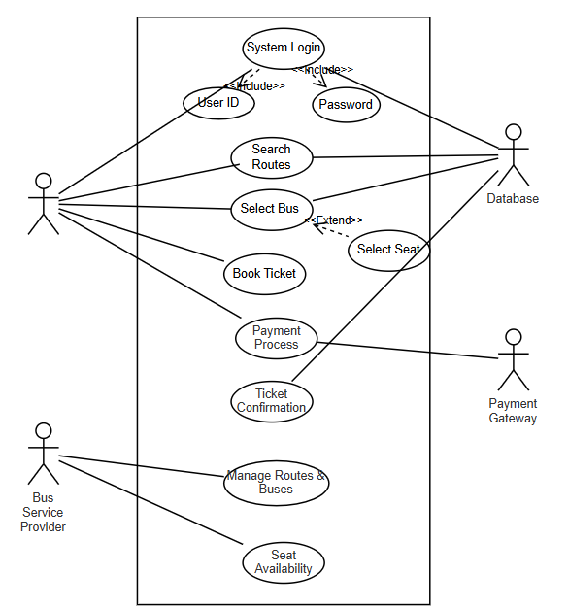
UseCase ID | UC001
UseCase Name | User Login
Actors | Customer
Description | This use case allows a customer login to the system thorugh User ID and password
Precondition | The user must be registered to application
Postcondition | • The Application is Connected with network and operational.
Basic Flow | 1. The user login thorugh user id password
Basic Flow | 2. The system prompts the user to enter search criteria (e.g. routes, date, location).
Basic Flow | 3. The user enters the criteria and submits the request.
Basic Flow | 4. The system retrieves and displays available routes and buses.
Alternative Flow | If user is not able to login then redirected to forgot password
Exceptions | The Application detects invalid or incomplete Customer Profile details.
Frequency of use | High
Assumptions | User profiles database is regularly updated.

UseCase ID | UC002
UseCase Name | Select Buses and Seats
Actors | Customers
Description | This use case allows customers to select Bus and choose available seats for booking.
Precondition | The user must have selected a Routes.
Postcondition | The selected Bus and seats are reserved for the user.
Basic Flow | 1. The user selects a Routes and navigates to the Bus & seat selection page.
Basic Flow | 2. The system displays available buses and seats.
Basic Flow | 3. The user selects a Bus and preferred seats.
 | 4. The system confirms the selection and proceeds to the payment page.
Alternative Flow | If selected seats are taken, the system prompts the user to choose other seats.
Exceptions | Technical issues in seat availability updates.
Frequency of use | High
Assumptions | Real-time seat availability updates are accurate.

UseCase ID | UC003
UseCase Name | Receive Digital Ticket
Actors | Customer, Notification System
Description | This use case ensures the customer receives a digital ticket after successful booking.
Precondition | The user must have completed the payment process.
Postcondition | The user receives a digital ticket via email/SMS.
Basic Flow | 1. The system generates a digital ticket after successful payment.
Basic Flow | 2. The system sends the ticket to the user's registered email/SMS.
Basic Flow | 3. The user receives and verifies the ticket.
Alternative Flow | If the email is incorrect, the user can request a resend.
Exceptions | Email delivery failure due to server issues.
Frequency of use | High
Assumptions | The system integrates with a reliable email/SMS provider.

UseCase ID | UC004
UseCase Name | Manage Routes and Buses Listings
Actors | Services Provider Admin
Description | This use case allows the Service provider to add, update, or remove movies from the system.
Precondition | The admin must be logged into the system.
Postcondition | The Buses and Routes database is updated.
Basic Flow | 1. The admin navigates to the Buses and Routes management page.
Basic Flow | 2. The system displays current available Routes and buses.
Basic Flow | 3. The admin selects to add, update, or remove routes and buses.
Basic Flow | 4. The system processes the request and updates the database.
Alternative Flow | If Routes and buses details are incorrect, the admin is prompted to correct them.
Exceptions | Database connection failure.
Frequency of use | Medium
Assumptions | Admins have the required permissions.

Activity Diagram:

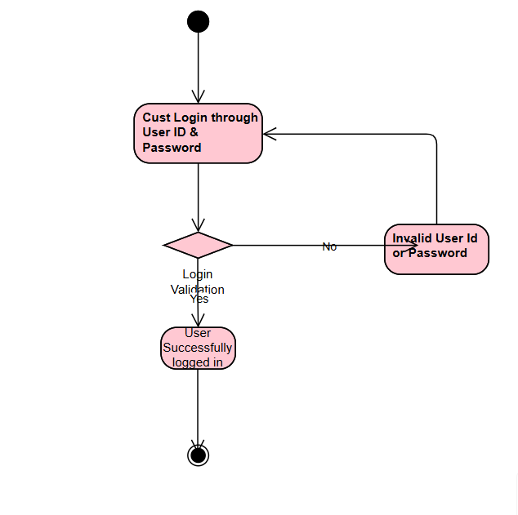

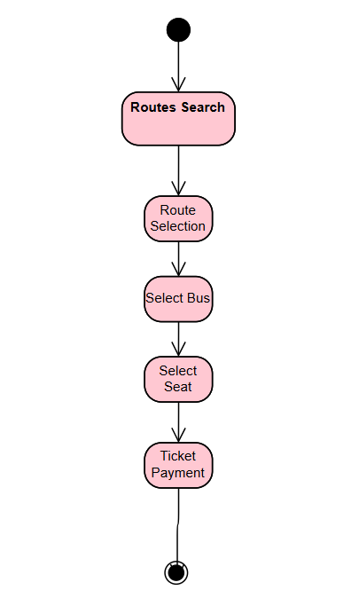

ERD :
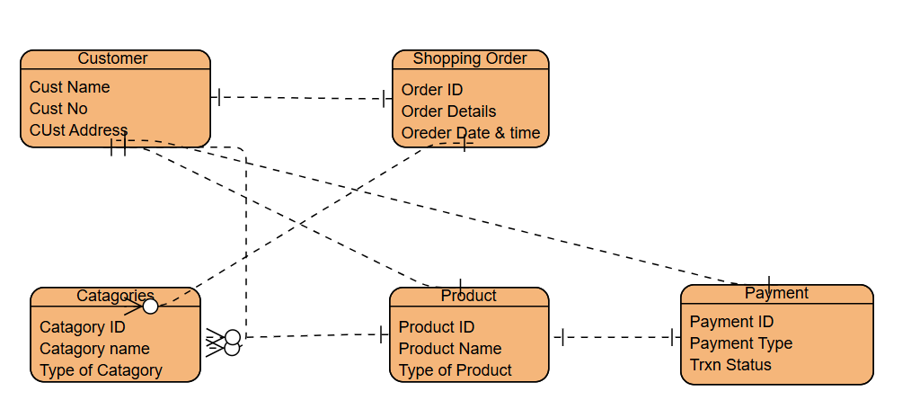

User Story of Shopping from E-commerce:

User Story ID. 1 | Tasks: 3 | Priority: Highest
As a new user, I want to register an account on the platform so that I can access personalized recommendations and place orders.
BV: 500 | CP: 05
Acceptance criteria:
User can register using email, phone number, or social media accounts.
The user must receive a verification email or SMS.
The user is prompted to complete their profile after registration.

User Story ID. 2 | Tasks: 3 | Priority: Highest
As a registered user, I want to log in to my account so that I can view my past orders and preferences.
BV: 500 | CP: 03
Acceptance criteria:
User can log in using email, phone number, or social media accounts.
If the login details are incorrect, an error message is shown.
User is redirected to the homepage upon successful login.

User Story ID. 3 | Tasks: 2 | Priority: Highest
As a user, I want to recover my forgotten password so that I can log in again.
BV: 200 | CP: 05
Acceptance criteria:
User can request a password reset email/SMS.
The link in the email/SMS should redirect the user to a page to reset the password.
The new password must be validated before being updated.

User Story ID. 4 | Tasks: 4 | Priority: Highest
As a user, I want to browse products by categories so that I can find the items I need.
BV: 200 | CP: 08
Acceptance criteria:
Products are categorized (e.g., Men, Women, Kids, Electronics).
Users can navigate through sub-categories.
The user can see product images, names, and prices.

User Story ID. 5 | Tasks: 3 | Priority: Medium
As a user, I want to search for products by name or filter so that I can quickly find what I am looking for.
BV: 200 | CP: 05
Acceptance criteria:
The search bar should show suggestions as the user types.
Search results are relevant to the query.
Users can filter search results based on price, brand, color, and size.

User Story ID. 6 | Tasks: 5 | Priority: Highest
As a user, I want to view detailed information about a product so that I can make an informed purchase decision.
BV: 500 | CP: 08
Acceptance criteria:
The product page should display images, price, description, size options, and color options.
Users should be able to read reviews and ratings.
Availability and stock status should be visible.

User Story ID. 7 | Tasks: 4 | Priority: Highest
As a user, I want to add products to my shopping cart so that I can purchase multiple items at once.
BV: 500 | CP: 05
Acceptance criteria:
The user can add multiple items to the cart.
The cart icon should show the number of items added.
A confirmation message should appear when an item is added.

User Story ID. 8 | Tasks: 5 | Priority: Highest
As a user, I want to view the contents of my shopping cart so that I can review my order before checkout.
BV: 200 | CP: 08
Acceptance criteria:
The user can see all added items, including product name, price, quantity, and total price.
Users can remove or change quantities of items in the cart.
Users can see estimated shipping fees and taxes.

User Story ID. 9 | Tasks: 4 | Priority: Highest
As a user, I want to proceed to checkout so that I can complete my purchase.
BV: 500 | CP: 05
Acceptance criteria:
User can view and edit their shipping address, payment method, and order summary.
The "Proceed to Checkout" button should be prominent.
Users can see the total cost before confirming the order.

User Story ID. 10 | Tasks: 3 | Priority: Highest
As a user, I want to apply a discount code so that I can receive a discount on my order.
BV: 200 | CP: 05
Acceptance criteria:
The discount code field should be visible at checkout.
The discount should be applied correctly after entering the valid code.
Invalid codes should show an error message.

User Story ID. 11 | Tasks: 5 | Priority: Highest
As a user, I want to choose a payment method so that I can pay for my order.
BV: 200 | CP: 08
Acceptance criteria:
The platform should support multiple payment methods (credit card, debit card, UPI, wallet, COD).
Payment should be processed securely.
The user should see a confirmation page after payment is successful.

User Story ID. 12 | Tasks: 3 | Priority: Highest
As a user, I want to receive an order confirmation after I complete the payment so that I know my purchase is successful.
BV: 200 | CP: 05
Acceptance criteria:
The user should receive a confirmation email/SMS.
The confirmation page should display the order ID, summary, and estimated delivery date.

User Story ID. 13 | Tasks: 5 | Priority: Medium
As a user, I want to track my order so that I can know its status and expected delivery time.
BV: 200 | CP: 08
Acceptance criteria:
The user can track the order from the order history section.
The tracking page shows real-time status updates, such as "Dispatched," "In Transit," and "Out for Delivery."
Delivery time should be accurate.

User Story ID. 14 | Tasks: 3 | Priority: Medium
As a user, I want to leave a review for a product I purchased so that I can share my experience with others.
BV: 200 | CP: 05
Acceptance criteria:
The user can rate the product from 1 to 5 stars.
The user can write a review with text.
Reviews are displayed on the product page.

User Story ID. 15 | Tasks: 3 | Priority: Medium
As a user, I want to view a size guide so that I can choose the right size for clothing or shoes.
BV: 500 | CP: 05
Acceptance criteria:
A size guide link is provided on the product page.
The size guide shows measurements for different sizes.
The guide is easy to understand.

User Story ID. 16 | Tasks: 5 | Priority: Highest
As a user, I want to receive product recommendations based on my previous purchases or browsing history.
BV: 200 | CP: 08
Acceptance criteria:
The recommendations are personalized based on user behavior.
Recommended products are shown on the homepage or product detail page.
Users can click to view more recommendations.

User Story ID. 17 | Tasks: 8 | Priority: Medium
As a user, I want to save items for later so that I can purchase them at another time.
BV: 200 | CP: 05
Acceptance criteria:
The user can click “Save for Later” on items in the cart.
Saved items are stored in a separate list.
Users can move items back to the cart.

User Story ID. 18 | Tasks: 3 | Priority: Low
As a user, I want to add items to my wishlist so that I can track items I may want to purchase in the future.
BV: 200 | CP: 05
Acceptance criteria:
Users can add products to a wishlist from the product page.
Users can view and remove items from the wishlist.
Wishlist items are saved for future visits.

User Story ID. 19 | Tasks: 5 | Priority: Highest
As a user, I want to filter products by brand so that I can narrow down my choices.
BV: 200 | CP: 08
Acceptance criteria:
The user can select multiple brands from the filter options.
Products are filtered to show only those from the selected brands.
The applied filters are displayed on the screen.

User Story ID. 20 | Tasks: 3 | Priority: Highest
As a user, I want to sort products by price, popularity, or ratings so that I can find the best products easily.
BV: 500 | CP: 05
Acceptance criteria:
Sorting options like “Price Low to High,” “Best Selling,” and “Top Rated” should be available.
The sorting should be applied immediately and reflect on the product list.
Users can clear the sort and view products by default.

User Story ID. 21 | Tasks: 5 | Priority: Low
As a user, I want to cancel my order before it is shipped so that I can avoid receiving unwanted products.
BV: 500 | CP: 08
Acceptance criteria:
The user can cancel the order if the status is “Pending” or “Processing.”
The user is notified if cancellation is successful.
The amount paid should be refunded after cancellation.

User Story ID. 22 | Tasks: 4 | Priority: Highest
As a user, I want to initiate a return or exchange for a product if it doesn’t meet my expectations.
BV: 500 | CP: 08
Acceptance criteria:
Users can initiate a return/exchange within a specific period (e.g., 30 days).
The user can select the reason for return or exchange.
A refund or replacement is processed based on the return policy.

User Story ID. 23 | Tasks: 3 | Priority: Medium
As a user, I want to select a shipping option during checkout so that I can choose the most convenient delivery method.
BV: 200 | CP: 05
Acceptance criteria:
The user can select between standard and expedited shipping.
The estimated delivery date should be shown for each shipping option.
The cost for each shipping option should be displayed.

User Story ID. 24 | Tasks: 3 | Priority: Medium
As a user, I want to add, edit, or remove delivery addresses so that I can have my products shipped to the correct location.
BV: 100 | CP: 05
Acceptance criteria:
Users can add multiple delivery addresses to their profile.
Users can select a default delivery address.
Users can edit or delete existing addresses.

User Story ID. 25 | Tasks: 5 | Priority: Low
As a user, I want to purchase and redeem gift cards so that I can gift credit to others.
BV: 100 | CP: 08
Acceptance criteria:
Users can select the gift card value and add it to the cart.
Users can redeem gift cards at checkout.
The system should validate and apply the gift card amount to the total order.

