Business Requirements Document (BRD)
Project Name: Inventory Management and Delivery Optimization System for Dairy Products
Project ID: IM-DO -2025
Version ID: v1.0
Author: Roopshree Shelke, Business Analyst

Contents
1. Document Revisions
2. Approvals
3. RASCI Chart for This Document
4. Introduction
4.1. Business Goals
4.2. Business Objectives
4.3. Business Rules
4.4. Background
4.5. Project Objective
4.6. Project Scope
4.6.1. In Scope Functionality
4.6.2. Out Scope Functionality
5. Assumptions
6. Constraints
7. Risks
8. Business Process Overview
8.1. Legacy System (AS-IS)
8.2. Proposed Recommendations (TO-BE)
9. Business Requirements
10. Plans
10.1. Development Plan
10.2. Resource Plan
11. Appendices
11.1. List of Acronyms
11.2. Glossary of Terms
11.3. Related Documents

1. Document Revisions
Date | Version | Author | Document Change
24-Jul-2025 | 1.0 | Roopshree Shelke | Initial Draft Created

2. Approvals
Name | Designation | Signature | Date
George Christou | Project Sponsor
Shashi Shah | Project Manager
Arushi Singh | Solution Architect

3. RASCI Chart for This Document
The RASCI chart provides a clear delineation of roles and responsibilities across key stakeholders involved in this project. It ensures that every activity ranging from requirement gathering and documentation to system design and implementation is owned, reviewed, and supported by the appropriate personnel. For instance, the Business Analyst is responsible (R) for requirements gathering, while the Project Manager is accountable (A) for major decisions and overall project coordination. Developers are primarily responsible for the technical building, while QA is responsible for testing. The client is consulted or informed depending on the stage. This matrix helps streamline communication, reduce ambiguity, and accelerate decision-making throughout the lifecycle of the project.

Codes used in RASCI Document
R | Responsible | Responsible for creating this document
A | Accountable | Accountable for accuracy of this document
S | Support | Provides supporting services in the production of this document
C | Consulted | Provides input such as interview.
I | Informed | Must be informed of any change

RACI Chart
Activity | BA | PM | DEV | QA | Client
Requirements Gathering | R | A |  |  | C
Document Preparation | R | A |  |  | I
Review & Approval | S | A |  |  | A
Design of TO-BE System | C | A | R |  | I
Implementation & Testing | I | A | R | R | C

4. Introduction

4.1. Business Goals
To enhance operational efficiency and customer satisfaction by centralizing inventory and logistics operations across manufacturing plants and warehouses.

4.2. Business Objectives
- Manage inventory in real time across all locations.
- Optimize delivery by routing orders from nearest warehouse.
- Automate alerts for restocking and expiry management.

4.3. Business Rules
- All inventory updates must be time-stamped
- Delivery must not exceed 24 hours from order placement
- Expired items must not be shipped

4.4. Background
The client operates multiple manufacturing plants and warehouses across the country. Currently, the operations are semi-manual with no centralized tracking, resulting in stockouts, delayed deliveries, and wastage.

4.5. Project Objective
The primary objective of the project is to build an integrated software system that eliminates manual inefficiencies in inventory and delivery processes for dairy products. The solution will track inventory levels across manufacturing plants and warehouses, automate delivery routing based on real-time stock and customer location, and ensure product quality and availability. The system is expected to reduce delivery times, minimize waste, and increase operational transparency.
Develop a software system that automates inventory tracking and streamlines the delivery process using location intelligence.

4.6. Project Scope
The scope of this project encompasses the design, development, and implementation of a comprehensive backend system for managing inventory and deliveries. The solution will integrate core modules such as inventory updates, order processing, delivery route optimization, and role-based dashboards. While the project focuses on back-office automation and logistics efficiency, it intentionally excludes customer-facing interfaces or payment systems, assuming these are handled separately.

In Scope Functionality
The solution will include the development of core modules that directly support inventory and logistics operations. These include the Inventory Management Module for real-time stock updates, an Order Management Module to handle order lifecycles, a Geo-routing Engine for assigning optimal delivery sources, detailed Dashboards for monitoring activities, and secure Role-based Access Control to ensure the right access levels across users. The following functionalities will be delivered as part of the current project:
- Inventory Management Module
- Order Management Module
- Geo-routing Engine
- Dashboard and Reporting Tools
- Role-based Access Control.

4.6.2 Out Scope Functionality
This project will not include any components related to payment gateway integration, e-commerce or customer-facing platforms. Features such as customer feedback collection, online tracking interfaces, or loyalty programs are also considered out of scope, as the primary goal is to enable backend efficiency within the organization. The following items are not included in the scope of the current project:
- Payment gateway integration
- Direct customer-facing frontend

5. Assumption
This project is based on several foundational assumptions that are expected to hold true throughout the lifecycle:
- It is assumed that all participating warehouse and plant facilities are equipped with basic digital infrastructure, including computing systems and internet access, enabling integration with the centralized system.
- The client is assumed to have an in-house delivery fleet, thereby reducing reliance on third-party logistics and simplifying routing logic.
- Stable internet connectivity is expected at all operational locations to ensure real-time data sync, though provisions for offline access will be discussed.
- Furthermore, the availability of historical and operational data from existing systems is presumed to support system initialization and data migration during implementation.

6. Constraints
Despite a focused approach to execution, certain limitations may affect the scope, timeline, or implementation quality . The following constraints have been identified for the successful execution of the project:
- Remote warehouse or plant locations may have limited internet bandwidth, which could impede real-time data transmission, necessitating the need for robust offline-first architecture.
- Offline data synchronization, therefore, becomes a technical requirement rather than a feature.
- Additionally, the project must be completed within a stringent 12-week timeline, which compresses testing and user training into a tight schedule.
- Budgetary constraints further limit the expansion of the scope, team size, or post-deployment enhancements during the initial release phase.
- These constraints demand disciplined project management and prioritization.

7. Risk
Risks present uncertainties that could impact the project’s success, and proactive identification helps in mitigation planning. Below is a breakdown of categorized risks

Technological Risk
- Legacy System Integration: Integration with outdated or undocumented legacy systems may pose compatibility and stability challenges.
- Go-Live Infrastructure Downtime: Inadequate server capacity or infrastructure gaps might cause service interruptions during deployment.

Skills Risk
- Staff Capability: Operational staff in plants may lack sufficient digital literacy, resulting in extended onboarding or errors in data input.
- Resource Availability: Shortage of experienced developers with domain-specific expertise could delay module development or reduce code quality

Political Risk
- Resistance to Adoption: Long-standing manual workflows may be deeply embedded, leading to hesitation or pushback from end-users during rollout.
- Internal Alignment Issues: Cross-functional teams (IT, logistics, operations) may have conflicting priorities that affect coordination and approvals.
Business Risk
- Missed SLAs: Any delay in order processing or delivery due to system issues could impact customer satisfaction and lead to contractual penalties.
- Process Overhaul Disruption: Rapid change in operational flow could temporarily destabilize existing business routines and KPIs.

Requirement Risk
- Scope Drift: Evolving or unclear business requirements can lead to mid-project changes, resulting in rework and timeline breaches.
- Documentation Gaps: Insufficient documentation from the client side could hinder accurate requirement analysis and system design.

Other Risk
- Weather Events: Unpredictable climate conditions such as floods or heavy rains may affect transportation and power at warehouses.
- Power Reliability: Remote locations may face intermittent electricity supply, impacting system availability and requiring UPS backup or solar solutions.

8. Business Process Overview
The business currently follows a fragmented and semi-manual operational model across its inventory and delivery systems. The lack of centralized visibility results in inefficiencies like stock discrepancies, delayed deliveries, and manual coordination over phone calls or spreadsheets. To address these issues, a streamlined digital process is being proposed. The business transformation process will shift the current model from decentralized, reactive operations to a centralized, proactive, and data-driven environment. The new system will provide role-specific access, automated alerts, real-time inventory updates, and integration with geo-location tools to optimize delivery assignments and ensure seamless tracking.

8.1. Legacy System (AS-IS)
The legacy setup includes manual stock entry at individual locations using spreadsheets or paper logs, which leads to delays in updating the central inventory system. Orders are coordinated through informal communication channels like phone calls or emails, often causing errors or missed deliveries. There is minimal reporting or analytics, making it difficult for management to monitor performance or forecast demand accurately. The lack of standardization across warehouses also results in inconsistent practices, further reducing operational efficiency.
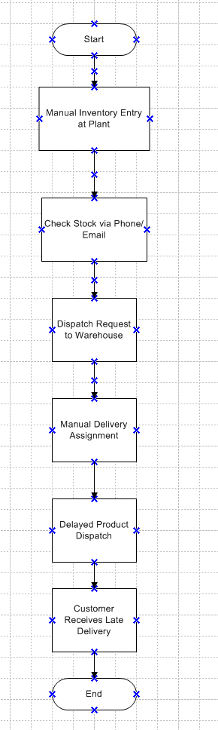

8.2. Proposed Recommendations (TO-BE)
The proposed system aims to establish a centralized and automated platform that integrates inventory and logistics functions. The new solution will enable real-time synchronization of stock levels across all locations, provide predictive alerts for low or expired inventory, and route orders to the nearest warehouse automatically using a geo-routing engine. Managers will gain access to intelligent dashboards that visualize operational metrics, improving decision-making. Furthermore, the system will feature role-based access control, audit trails, and scalability to support future enhancements or integrations with customer-facing systems.
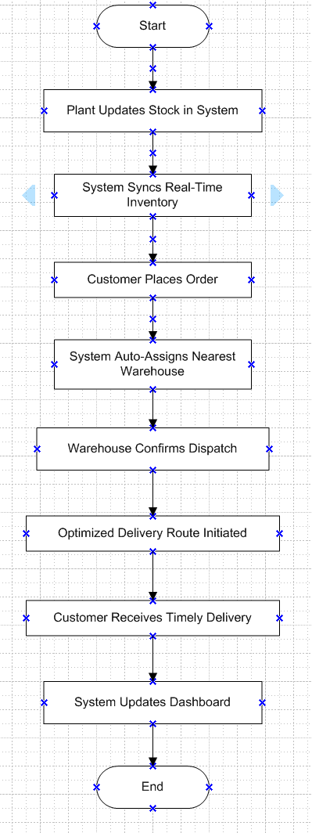

9. Business Requirements
The core business requirements focus on eliminating inefficiencies in the current processes and enabling intelligent decision-making.
- The system must allow inventory updates directly from plant interfaces.
- Support automatic alerts for low or expired stock.
- It include an intuitive order capture module.
- It should be capable of assigning delivery routes based on the geographic location of the customer and stock availability.
- Additionally, the solution must present stakeholders with customizable dashboards for monitoring KPIs.
- It enforce strict access control and audit logs for security and compliance.
- These requirements form the backbone of a robust, scalable, and future-ready logistics platform tailored to the organization’s dairy product distribution model.

10. Plans

10.1. Development Plan

Phase | Duration | Key Deliverables
Phase 1: Requirement Analysis | Week 1-2 | Finalized BRD and Functional Requirements
Phase 2: System Design | Week 3-4 | UI Wireframes, DB Schema, Architecture Blueprint
Phase 3: Core Development | Week 5-8 | Inventory & Order Management Modules
Phase 4: Geo-routing & Delivery Engine | Week 9-10 | Delivery Logic Integration, Routing rules
Phase 5: Testing & QA | Week 11-12 | Unit, Integration & UAT
Phase 6: Go-Live & Training | Week 13 | Deployment, User Training & Handover

10.2. Resources Plan

Role | Count | Responsibility
Project Manager | 1 | Overall coordination and delivery
Business Analyst | 1 | Requirement gathering and validation
UI/UX Designer | 2 | User interface wireframes and design
Backend Developer | 3 | Core logic and database/API development
Frontend Developer | 2 | Interface for dashboard and access
QA Engineer | 3 | Functional and regression testing

11. Appendice

11.1. List of Acronyms
- SLA: Service Level Agreement
- BRD: Business Requirements Document

11.2 Glossary of Terms
- Inventory: Stock of finished goods in plant/warehouse
- Geo-routing: Assigning delivery based on customer location

11.3 Related Documents
- Functional specification document.
- Technical Feasibility Report
- System Design Document
- Project plan

Process flow diagram using your imagination:

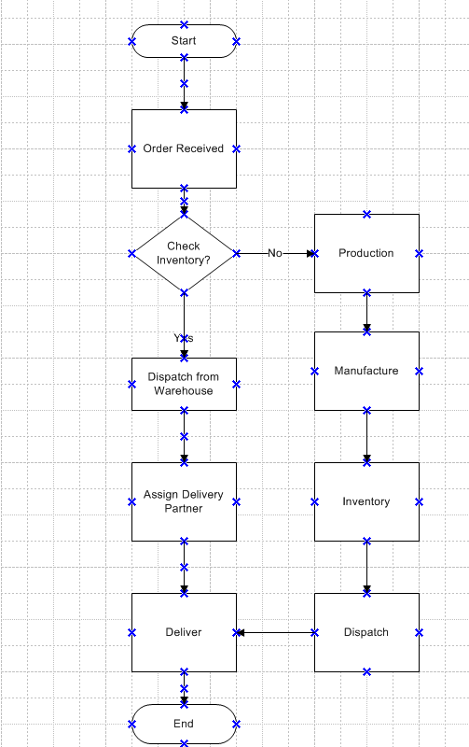

Assignment 2:
1. Write an introduction letter to a client introducing yourself as a business analyst in charge of working with the client and his team to start the business understanding process.
Subject: Introduction – Business Analyst Assigned to Your Project
Dear Client,
I hope this message finds you well.
My name is Roopshree, and I am pleased to introduce myself as the Business Analyst assigned to work with you and your team on the upcoming project involving Inventory Management & Quick Delivery Optimization.
As your primary point of contact from the business analysis side, I will be responsible for understanding your current processes, identifying gaps, and gathering detailed requirements that align with your business goals. My focus will be to ensure that the solution we design together is practical, efficient, and tailored to your unique needs.
Over the coming days, I will initiate a series of discussions to:
- Understand your business objectives and key challenges
- Capture current (AS-IS) processes and pain points
- Collaborate with stakeholders to define the desired (TO-BE) state
- Document requirements to support our development and delivery teams
Your insights will be invaluable, and I look forward to working closely with your team to ensure a smooth and transparent process throughout the project.
Please feel free to reach out to me directly with any questions, suggestions, or clarifications. I will be scheduling our initial business discovery meeting shortly and will share the details with you soon.
Looking forward to a productive and successful collaboration.
Warm regards,
Roopshree Shelke,
Business Analyst

2. Prepare a brief BRD and SRS for a project- Horoscope or Ticketing system or online store.

BUSINESS REQUIREMENTS DOCUMENT (BRD)
Project Name: Ticketing System
Prepared by: Roopshree Shelke
Date: 24 July 2025

The Ticketing System project aims to develop a centralized platform for managing tickets raised by users. These may be related to support issues, service requests, or event access. The system will improve response time, track resolution progress, and provide analytics.

2. Business Goals
- Provide a single platform for users to raise and track tickets
- Assign tickets efficiently to relevant teams or agents
- Improve customer satisfaction through timely resolution
- Provide transparency and traceability of requests
- Generate reports for performance and service tracking

3. Project Scope
3.1. In Scope:
- Ticket creation via portal/email/API
- Auto assignment and manual assignment
- Ticket status tracking (Open, In Progress, Closed, Escalated)
- User, Agent, and Admin roles
- Notifications and alerts
- Reporting and dashboard
3.2. Out of Scope:
- Voice support integration
- Multi-language support in v1
- External CRM integration in v1

4. Stakeholders
- Business Owner
- IT Support Team
- End Users (Employees or Customers)
- Product Development Team

5. Assumptions
- Users will have internet access.
- All users will be onboarded with proper roles and permissions.
6. Constraints
- Initial version must go live in 6 weeks.
- Hosted on client's internal cloud infrastructure.
7. Risks
- Delays in stakeholder inputs.
- Incomplete requirement understanding.
- Lack of trained support agents initially.
8. Business Requirements
- The ticketing system must enable users to easily raise support requests or service issues through a web portal, including key details such as subject, category, and description.
- Once submitted, tickets should be automatically assigned to appropriate agents based on predefined business rules, such as issue type or department.
- The system must allow agents to manage their assigned tickets by updating status, adding comments, and marking them as resolved.
- Administrators should be able to view and manage all tickets across the system, including the ability to reassign, escalate, or close tickets when needed.
- Automated notifications via email or SMS should be triggered at key points in the ticket lifecycle, such as ticket creation, assignment, resolution, or escalation.
- Finally, the system should offer reporting and dashboard capabilities to allow managers to track metrics like ticket volumes, resolution time, SLA compliance, and agent performance.

Software Requirements Specification (SRS)
Project: Support Ticketing System
Prepared by: Roopshree SHelke
Date: 24 July 2025

1. Introduction

1.1 Purpose
This SRS defines the functional and non-functional requirements for a Support Ticketing System to manage internal/external support requests, from ticket creation to resolution.

1.2 Scope
The system allows users to raise support tickets, assigns them to appropriate departments/agents, tracks their status, and ensures timely resolution. It includes features such as ticket logging, status updates, comments, prioritization, assignment, and reporting.

1.3 Definitions, Acronyms, Abbreviations
SLA: Service Level Agreement
UI: User Interface
Ticket: A logged issue/request from a user

2. Overall Description

2.1 Product Perspective
This is a standalone web application that integrates with user authentication services and email/SMS notifications.

2.2 Product Functions
The application allows users to register/login, raise support tickets, assign and track tickets, and enables agents/admins to update status, communicate, and generate reports.

2.3 User Characteristics
Admin: Full access to manage users and tickets.
Agent: Handles assigned tickets.
User: Can submit and track their own tickets.

2.4 Constraints
• Web browser–based (Chrome, Firefox supported)
• Data must be stored in a secure, encrypted format
• SLA time for high-priority tickets: 4 hours

2.5 Assumptions & Dependencies
• Users will have basic knowledge of submitting forms online
• Email/SMS gateway access will be provided by the client

3. Functional Requirements
ID | Description
FR001 | Users must be able to register/login securely
FR002 | Users can raise new tickets with subject, description, priority, department
FR003 | System auto-assigns ticket to appropriate agent or queue
FR004 | Agents can update status and add internal/external comments
FR005 | System sends email/SMS notifications for ticket status updates
FR006 | Admin can view all tickets and filter by user, department, SLA status
FR007 | Tickets can have attachments (PDF, image) with size limit (e.g., 5MB)

4. External Interface Requirements

4.1 User Interfaces
• Login/Register screen
• Ticket submission form
• Dashboard for Users and Agents
• Admin analytics panel

4.2 Software Interfaces
• Email service for notifications
• SMS API for alerts
• Database (e.g., MySQL or PostgreSQL)

5. Non-Functional Requirements

Category | Requirement
Performance | System must handle up to 500 concurrent users
Availability | 99.5% uptime required
Security | Data encryption at rest and in transit; 2FA for agents
Scalability | Must support additional departments and ticket types as needed
Usability | Intuitive interface for non-technical users

6. Appendices
The Support Ticketing System is designed to streamline the way issues and service requests are reported, managed, and resolved within the organization. It establishes a structured workflow that ensures timely resolution, clear accountability, and visibility across all support activities. By digitizing this process, the system aims to enhance operational efficiency, enforce service level compliance, and provide a seamless experience for users and support agents alike.

6.1 Legacy System (AS-IS)
In the current environment, the support process is manual and lacks centralized oversight. Users typically raise issues through informal channels such as emails, phone calls, or messaging apps. These requests are managed inconsistently by support staff, often using spreadsheets or personal notes, which introduces significant room for human error. There is no formal ticketing mechanism, which means issues may go untracked, follow-ups are often missed, and there is no way to measure or enforce service level agreements (SLAs). Moreover, support managers lack visibility into agent performance, ticket backlogs, and common issue trends, making it difficult to drive service improvements or plan resources effectively.
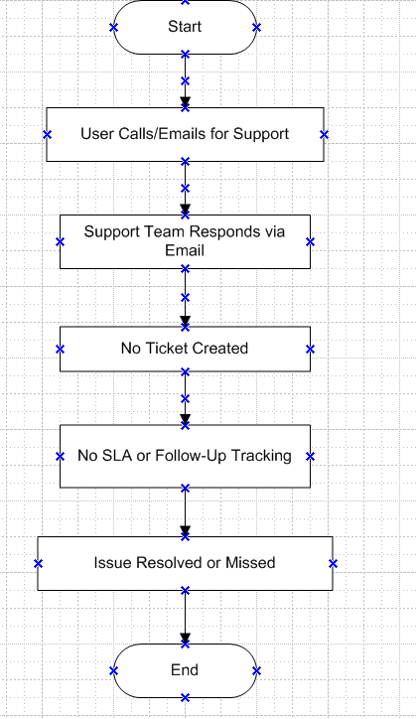

6.2 Proposed Recommendations (TO-BE)
The proposed Support Ticketing System introduces a centralized, digital platform for managing support requests end-to-end. Users will submit tickets via a web portal or mobile interface, selecting categories and priority levels that help route the request to the appropriate support agent or department automatically. Each ticket will follow a defined lifecycle open, in progress, resolved, and closed enabling all parties to track its progress in real time. Built-in SLA monitoring will ensure that tickets are handled within agreed timelines, and automated notifications will keep users updated on changes in status. Agents can collaborate on tickets using comments and attachments, while managers will benefit from detailed dashboards displaying performance metrics, open ticket volume, SLA compliance, and recurring issues. This shift to an automated, transparent, and scalable system will significantly reduce resolution times, improve user satisfaction, and provide a solid foundation for continuous service improvement
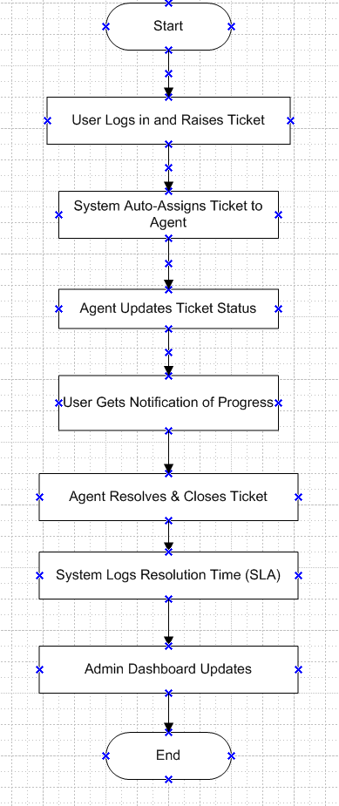

7. Appendices
A. Glossary
B. Use Case Diagram (optional)
C. ERD (Entity Relationship Diagram)

3. Make an ERD of creating a support ticket/Ticketing life cycle.
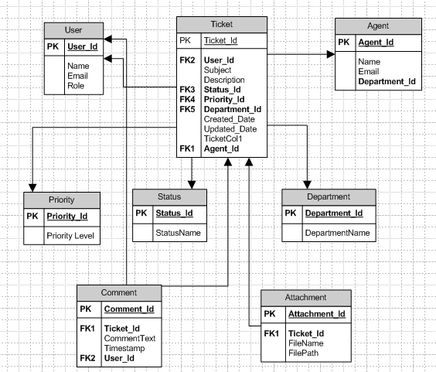

4. User story of shopping from ecommerce
User Story- 01 | Task- 1 |  | Priority- High
As a customer
I want to register an account
So that I can shop and track my orders
BV- 50 |  | CP- 02
Acceptance Criteria:
1. User can register with name, email, mobile, and password.
2. Required fields should be validated.
User Story- 02 | Task- 2 |  | Priority- High
As a customer
I want to log into my account
So that I can access my saved preferences
BV- 40 |  | CP- 03
Acceptance Criteria:
1. User must provide valid email/mobile and password.
2. Error message for incorrect credentials..

User Story- 03 | Task- 03 |  | Priority- High
As a customer
I want to browse products by category
So that I can explore product types easily
BV- 50 |  | CP- 03
Acceptance Criteria:
1. Search should support keyword and category list must be clickable..
2. Display relevant results based on input.

User Story- 04 | Task- 04 |  | Priority- High
As a customer
I want to search for products
So that I can quickly find what I need
BV- 60 |  | CP- 05
Acceptance Criteria:
1. Search supports keywords and filters.
2. Display results accurately.

User Story- 05 | Task- 05 |  | Priority- High
As a customer
I want to add products to wishlist.
So that I can save them for later
BV- 60 |  | CP- 05
Acceptance Criteria:
1. Each product has a wishlist button.
2. User can view wishlist later.

User Story- 06 | Task- 01 |  | Priority- High
As a customer
I want to add products to cart
So that I can buy them later
BV- 70 |  | CP- 05
Acceptance Criteria:
1. Clicking add-to-cart adds the product.
2. Cart updates reflect instantly.

User Story- 07 | Task- 02 |  | Priority- High
As a customer
I want to view and edit cart
So that I can manage my selected items
BV- 80 |  | CP- 05
Acceptance Criteria:
1. Cart shows name, qty, price.
2. User can update quantity or remove.

User Story- 08 | Task- 03 |  | Priority- High
As a customer
I want to apply promo codes
So that I can reduce my order cost
BV- 50 |  | CP- 03
Acceptance Criteria:
1. Promo field accepts valid codes.
2. Show discounted amount.

User Story- 09 | Task- 04 |  | Priority- High
As a customer
I want to checkout securely
So that I can complete my purchase
BV- 70 |  | CP- 08
Acceptance Criteria:
1. Checkout shows summary.
2. Requires address and payment.

User Story- 10 | Task- 03 |  | Priority- High
As a customer
I want to make payment
So that I can finalize my purchase
BV- 90 |  | CP- 08
Acceptance Criteria:
1. Multiple payment options.
2. Confirm payment success.

User Story- 11 | Task- 02 |  | Priority- Medium
As a customer
I want to track orders
So that I know my delivery status
BV- 60 |  | CP- 05
Acceptance Criteria:
1. Tracking shows shipped, out for delivery.
2. Show estimated date.

User Story- 12 | Task- 03 |  | Priority- Medium
As a customer
I want to review past orders
So that I can check history
BV- 50 |  | CP- 05
Acceptance Criteria:
1. List orders by date.
2. Show details on click.

User Story- 13 | Task- 02 |  | Priority- Medium
As a customer
I want to receive email updates
So that I stay informed
BV- 40 |  | CP- 05
Acceptance Criteria:
1. Send emails on order and shipping.
2. Includes order summary.

User Story- 14 | Task- 04 |  | Priority- Medium
As a customer
I want to repeat previous order
So that I save time
BV- 70 |  | CP- 05
Acceptance Criteria:
1. ‘Repeat Order’ button available.
2. Add all items to cart.

User Story- 15 | Task- 03 |  | Priority- Medium
As a customer
I want to contact customer support
So that I get help in case needed
BV- 40 |  | CP- 05
Acceptance Criteria:
1. Support form or chat available.
2. Responses within 24 hrs.

User Story- 16 | Task- 03 |  | Priority- Medium
As a customer
I want to rate and review products
So that I share my experience
BV- 30 |  | CP- 05
Acceptance Criteria:
1. Allow star ratings.
2. User can write a review.

User Story- 17 | Task- 03 |  | Priority- Medium
As a customer
I want to manage my account info
So that I can update details
BV- 70 |  | CP- 08
Acceptance Criteria:
1. Edit profile info securely.
2. Changes require OTP/email verification

User Story- 18 | Task- 03 |  | Priority- Medium
As a customer
I want to save multiple addresses
So that I can use them during checkout
BV- 60 |  | CP- 03
Acceptance Criteria:
1. Allow adding, editing, deleting addresses.
2. Mark default address

User Story- 19 | Task- 04 |  | Priority- Medium
As a customer
I want to receive invoice
So that I keep records
BV- 30 |  | CP- 02
Acceptance Criteria:
1. Invoice sent after order.
2. Downloadable from profile.

User Story- 20 | Task- 05 |  | Priority- Medium
As a customer
I want to apply discount coupons
So that I can reduce the total cost
BV- 100 |  | CP- 05
Acceptance Criteria:
1. Coupon code field is available at checkout.
2. Validation and discount applied automatically.

User Story- 21 | Task- 02 |  | Priority- Medium
As a customer
I want to register an account
So that I can shop and track my orders
BV- 100 |  | CP- 02
Acceptance Criteria:
1. User can register with name, email, mobile, and password.
2. Required fields should be validated.

User Story- 22 | Task- 03 |  | Priority- Medium
As a customer
I want to log into my account
So that I can access my saved preferences
BV- 20 |  | CP- 02
Acceptance Criteria:
1. User must provide valid email/mobile and password.
2. Error message for incorrect credentials.

User Story- 23 | Task- 03 |  | Priority- Medium
As a customer
I want to search for products
So that I can quickly find what I need
BV- 40 |  | CP- 05
Acceptance Criteria:
1. Search should support keyword and category filtering.
2. Display relevant results based on input.

User Story- 24 | Task- 02 |  | Priority- Medium
As a customer
I want to add items to cart
So that I can prepare for checkout
BV- 100 |  | CP- 05
Acceptance Criteria:
1. User can add available products to cart.
2. Cart updates with quantity and subtotal.

User Story- 25 | Task- 04 |  | Priority- Medium
As a customer
I want to view my cart
So that I can see my selected items
BV- 60 |  | CP- 08
Acceptance Criteria:
1. Cart displays product name, price, and quantity.
2. User can update or remove items.

User Story- 26 | Task- 02 |  | Priority- Medium
As a customer
I want to place an order
So that I can complete my purchase
BV- 40 |  | CP- 03
Acceptance Criteria:
1. User can proceed to checkout from cart.
2. Order summary shown before confirmation.

User Story- 27 | Task- 04 |  | Priority- Medium
As a customer
I want to make payment
So that I can pay securely
BV- 500 |  | CP- 03
Acceptance Criteria:
1. Multiple payment options are supported.
2. Confirmation shown on successful payment.

User Story- 28 | Task- 03 |  | Priority- Medium
As a customer
I want to track my order
So that I can know the delivery status
BV- 60 |  | CP- 08
Acceptance Criteria:
1. Order history shows order ID and current status.
2. Tracking link provided post-dispatch.

User Story- 29 | Task- 04 |  | Priority- Medium
As a customer
I want to save delivery addresses
So that I can checkout faster next time
BV- 500 |  | CP- 05
Acceptance Criteria:
1. User can add/edit/delete multiple addresses.
2. One address can be marked as default.

User Story- 30 | Task- 05 |  | Priority- Medium
As a customer
I want to schedule delivery
So that I receive at my convenience
BV- 60 |  | CP- 05
Acceptance Criteria:
1. Allow selecting delivery slot.
2. Confirm preferred date/time.

User Story- 31 | Task- 02 |  | Priority- Low
As a customer
I want to cancel an order
So that I change my mind
BV- 70 |  | CP- 02
Acceptance Criteria:
1. Allow cancellation if not shipped.
2. Send cancellation confirmation.

User Story- 32 | Task- 03 |  | Priority- Low
As a customer
I want to browse deals & offers
So that I save money
BV- 500 |  | CP- 03
Acceptance Criteria:
1. Dedicated page for offers.
2. Filter by discount type.

User Story- 33 | Task- 03 |  | Priority- Low
As a customer
I want to subscribe
So that I stay updated
BV- 80 |  | CP- 03
Acceptance Criteria:
1. Email opt-in option.
2. Send weekly deals.

User Story- 34 | Task- 04 |  | Priority- Low
As a customer
I want to earn loyalty points
So that I benefit from shopping
BV- 30 |  | CP- 03
Acceptance Criteria:
1. Points per purchase.
2. View balance in profile.

User Story- 35 | Task- 01 |  | Priority- Low
As a customer
I want to use loyalty points
So that I redeem them
BV- 100 |  | CP- 02
Acceptance Criteria:
1. Apply points during checkout.
2. Show updated total.

User Story- 36 | Task- 02 |  | Priority- Low
As a customer
I want to receive SMS alerts
So that I stay informed
BV- 40 |  | CP- 03
Acceptance Criteria:
1. Send SMS for key updates.
2. Opt-in from settings.

User Story- 37 | Task- 03 |  | Priority- Low
As a customer
I want to enable 2 Factor Authentication
So that I secure my account
BV- 70 |  | CP- 03
Acceptance Criteria:
1. Option to enable OTP-based login.
2. Prompt when logging in.

User Story- 38 | Task- 04 |  | Priority- Low
As a customer
I want to change password
So that I protect my account
BV- 60 |  | CP- 02
Acceptance Criteria:
1. Update from profile.
2. Requires current password.

User Story- 39 | Task- 02 |  | Priority- Low
As a customer
I want to delete my account
So that I control my data
BV- 500 |  | CP- 03
Acceptance Criteria:
1. Request permanent deletion.
2. Prompt final confirmation.

User Story- 40 | Task- 01 |  | Priority- Low
As a customer
I want to report an issue
So that I alert the team
BV- 500 |  | CP- 03
Acceptance Criteria:
1. Allow reporting broken links or bugs.
2. Support team receives report.

