Waterfall Deliverables – Part -2/2
Project Name – Job Diva – An Application Tracking System

Document 6 - Please prepare a use case diagram, activity diagram and a use case specification document.

Use case diagram –
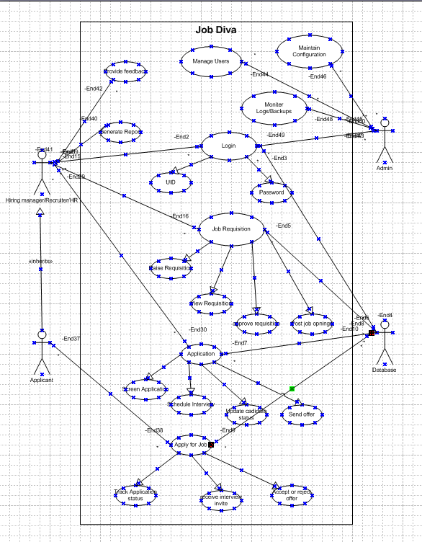

Activity diagram –
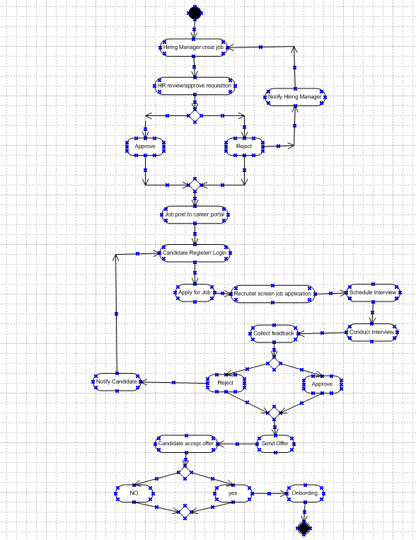

Use Case Specification Document –
- Use Case – Login
Use case Name | Login
Use case Description | This use case describes the process through which users (candidates, HR staff, recruiters, or hiring managers) securely log into the Applicant Tracking System using valid credentials to access their personalized dashboards and functionalities.
Actors | Primary Actors - System User (e.g., Candidate, HR Admin, Hiring Manager)  Secondary Actor - Authentication System & Database Server
Basic Flow | - User navigates to the ATS login page  - User enters a valid username/email and password.  - System validates the credentials.  - Upon successful validation, the user is authenticated.  - System redirects the user to their appropriate dashboard based on role.
ALTERNATE FLOW | - User clicks on “Login with SSO” (e.g., Google, Microsoft).  - User is redirected to the external identity provider.  - After successful authentication, user is redirected back to ATS.  - ATS maps the authenticated identity and loads the appropriate user dashboard.
Exceptional flows | User enters incorrect username or password.  System shows an error message: "Invalid username or password."  User can try again or use "Forgot Password."
Pre- Conditions | User must have an active account in the ATS.  User must have access to the login URL.
post-conditions | User is successfully logged in and redirected to their dashboard.  Session is created and maintained for the logged-in user.
Assumptions | Users remember their credentials or can reset them.  Role-based redirection logic is properly configured.
Constraints | Password complexity requirements are enforced.  Session timeout policies are applied (e.g., 15 mins of inactivity).
Dependencies | User credential database  Network connectivity
Inputs and Outputs | Input – User id and Password  Output - Access to user-specific dashboard
Business Rules | Password must meet minimum complexity  After 5 failed attempts, account is locked for 30 minutes.
Miscellaneous Information | CAPTCHA may be added after repeated failed logins.  Audit logs may be retained for compliance (e.g., GDPR)

- Use Case – Job Requisition Creation
Use case Name | Job Requisition Creation
Use case Description | This use case describes how a Hiring Manager initiates a job requisition in the ATS to request the creation and approval of a new job opening. The requisition captures key job details like title, department, skills, budget, and location, and routes it for approval.
Actors | Primary Actor - Hiring Manager  Secondary Actor - HR Reviewer / Approver, Recruiter and Department Head / Finance Team
Basic Flow | - Hiring Manager logs into the ATS  - Navigates to "Create Job Requisition" section  - Fills in required fields (job title, department, location, description, budget, skills, etc.)  - Submits the requisition for approval.  - System validates inputs and sends the requisition to designated approvers (e.g., HR, Finance)  - Approvers review and approve/reject with comments.  - Once approved, system flags the job requisition as “Approved” and notifies the recruiter.  - Recruiter proceeds to post the job.
ALTERNATE FLOW | - Hiring Manager chooses to save the requisition as a draft.  - System stores data and allows later retrieval for editing and submission.
Exceptional flows | Any approver can reject the requisition with comments.  System notifies the Hiring Manager, who can edit and resubmit.
Pre- Conditions | User has valid credentials and proper role permissions to create requisitions.  Job requisition form is configured in the ATS.  Approval hierarchy is defined in the system.
post-conditions | Requisition is created, stored, and (if approved) moves to the "Job Posting" stage.  Notifications are sent to relevant stakeholders (recruiter, HR).
Assumptions | The organization has pre-defined workflows for requisition approvals.  Budget and headcount validations are integrated into the system.
Constraints | Only users with the “Hiring Manager” role can create requisitions.  Budget fields must be validated against internal budget rules.
Dependencies | Role-based access control  Approval workflow configuration
Inputs and Outputs | Input - Job Title, Department, Location, Job Description, Skills etc  Output - Created job requisition (in Draft/Submitted/Approved/Rejected state) and Notification to approvers
Business Rules | Each requisition must be approved before posting.  Mandatory fields (Job Title, Description, Budget, Department, etc.) must be filled.  One active requisition per job position code (to avoid duplicates).
Miscellaneous Information | Requisition templates can be predefined for standard roles.  Requisition status should be visible to all involved stakeholders.  System should allow comments or attachments with requisition.

- Use Case – Interview Scheduling
Use case Name | Interview Scheduling
Use case Description | This use case describes how a recruiter or HR user schedules interviews for shortlisted candidates using the ATS. The system coordinates between interviewers and candidates to find suitable time slots, sends notifications, and tracks interview details.
Actors | Primary Actor - Recruiter / HR Executive  Secondary Actor – Candidate, Interviewer / Panel Members, Calendar System (e.g., Outlook/Google Calendar)
Basic Flow | - Recruiter logs into the ATS and accesses the list of shortlisted candidates.  - Selects a candidate and clicks on “Schedule Interview.”  - Selects interview type (e.g., phone, virtual, in-person).  - Adds interviewer(s), preferred date/time slots, location/link.  - System checks interviewer availability (via calendar integration).  - Sends interview invite to interviewer(s) and candidate.  - Candidate confirms the proposed schedule (if required).  - Interview is scheduled and recorded in ATS.  - Notifications and calendar invites are sent to all participants.  - Interview status is updated (Scheduled).
ALTERNATE FLOW | Candidate Self-Scheduling  - System sends an email link to the candidate with available time slots.  - Candidate selects a convenient time.  - System confirms and updates interview schedule.
Exceptional flows | Interviewer Not Available - System cannot find a common available time. Recruiter is prompted to choose a different time slot or interviewer.
Pre- Conditions | Candidate must be shortlisted and in the interview stage.  Recruiter and interviewers must have appropriate system access.  Interviewers' availability must be defined or integrated with calendar.
post-conditions | Interview schedule is recorded and visible to stakeholders.  Calendar invites and email notifications are sent.  Interview stage is updated in the candidate profile.
Assumptions | All participants are available within a common window.  Candidate and interviewers have access to email and calendars.
Constraints | Only authorized users can schedule interviews.  Time zone conflicts must be managed manually if not automated.
Dependencies | Integrated calendar system (e.g., Outlook/Google).  Video conferencing system (for virtual interviews).
Inputs and Outputs | Input - Candidate ID / Profile, Interview type and mode, Date and time options, Meeting location or link  Output - Interview schedule confirmation, Calendar invites, Email notifications to all, Status update in ATS
Business Rules | Only shortlisted candidates can be scheduled for interviews.  Mandatory fields (interviewers, time, candidate) must be filled.
Miscellaneous Information | System should allow re-scheduling and cancellations  Reminder notifications should be sent 24 hours and 1 hour before interviews.

- Use Case – Offer Letter Generation
Use case Name | Offer Letter Generation
Use case Description | This use case defines the process in which a recruiter or HR personnel generates and issues an offer letter to a selected candidate through the ATS after the final interview and selection. It includes generation, review, approval, and dispatch of the offer.
Actors | Primary Actor - HR Executive / Recruiter  Secondary Actor – Candidate, Hiring Manager (for validation/approval), Compensation/Finance Team
Basic Flow | - Recruiter logs into the ATS and navigates to the selected candidate's profile.  - Selects the “Generate Offer Letter” option.  - Chooses the appropriate offer template (based on role, level, region).  - Fills in necessary details such as compensation, joining date, job title, location, etc.  - Submits the offer for internal approval  - Hiring Manager or HR Head reviews and approves the offer.  - System generates the finalized offer letter (PDF or DOC format).  - Offer letter is emailed to the candidate via the ATS.  - Candidate receives and views the offer letter through the candidate portal or email.  - System logs the offer status as “Sent.”
ALTERNATE FLOW | Custom Offer Letter Upload  Recruiter can upload a manually prepared and signed offer letter to the candidate’s profile instead of generating it within the system.
Exceptional flows | Missing Required Fields - Recruiter forgets to enter compensation or joining date. System displays an error and prevents proceeding until completed.
Pre- Conditions | Candidate must have completed the interview process and marked as “Selected.”  Offer templates and approval workflows must be configured in the ATS.  HR/recruiter must have proper access rights to generate offers.
post-conditions | Offer letter is generated and shared with the candidate.  Candidate status is updated to “Offer Sent.”
Assumptions | Offer templates are pre-defined and customizable.  Candidates have access to view offer letters via email or portal.
Constraints | ATS may have limited formatting support for complex offer documents.  Approval turnaround time may delay offer generation.
Dependencies | Offer letter templates repository  Approval workflow engine  Email notification system
Inputs and Outputs | Input - Candidate profile, Compensation details, joining date, Job title & location, Offer template  Output - Generated offer letter (PDF/DOC), Email notification to candidate, System update: Offer Sent
Business Rules | Offer letter must follow company-approved templates and legal language.  Only users with required roles can generate and send offer letters.
Miscellaneous Information | ATS should allow offer letter versioning and tracking.  System should auto-send reminders to candidates if no response in X days.  Offer letter must be stored securely and accessible in the candidate profile.
Document 7 – Screen and Pages
- Login
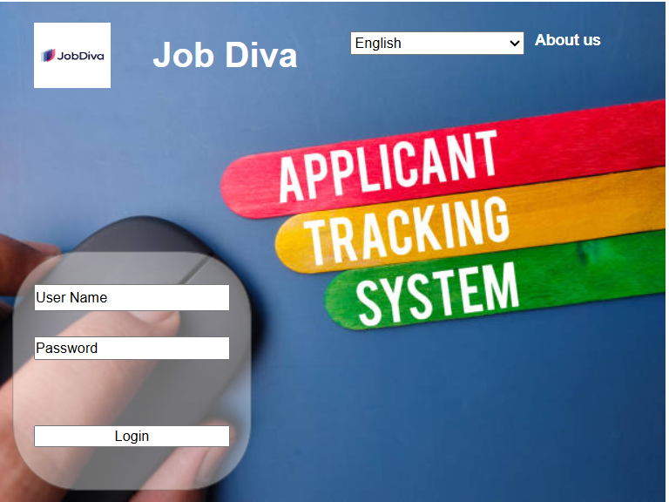
- Job requisition creation
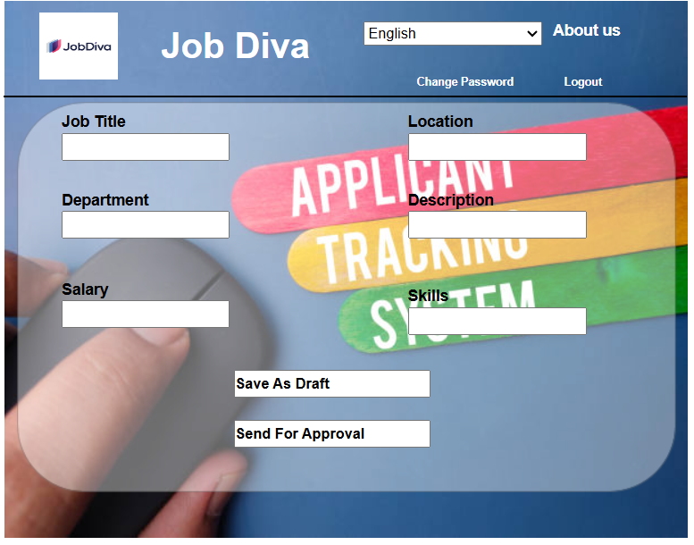

- Approval from HR/Departmental Head
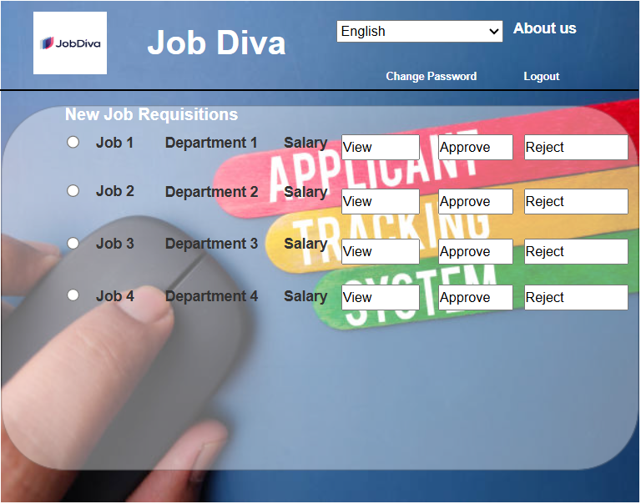

- Mark Active to Approved Requisition
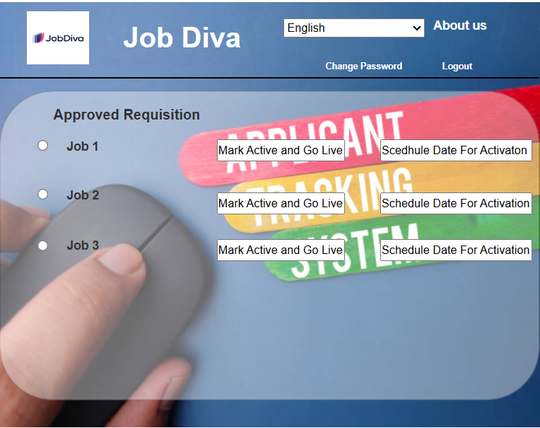

- Logout
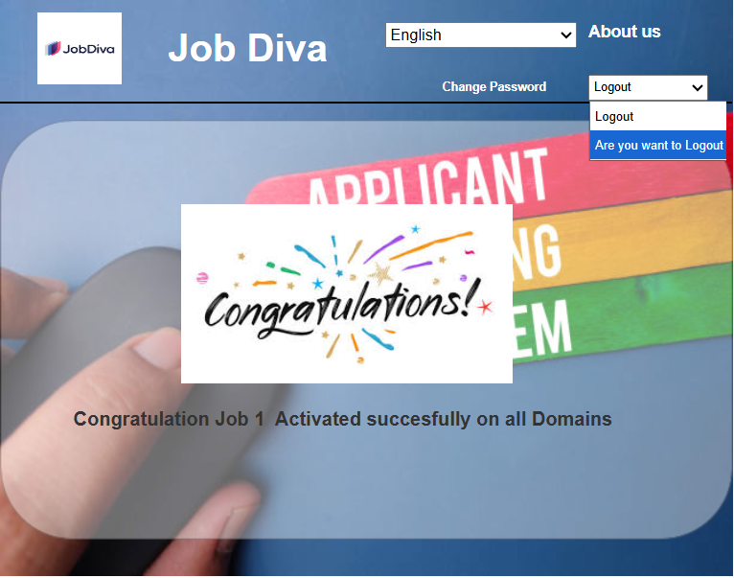

Document 8 – Tools – Visio and Axure
Write a paragraph on your experience using Visio and Axure for the project

I leveraged Microsoft Visio and Axure RP extensively throughout the ATS project to support clear communication and efficient design validation. Using Visio, I created detailed Business process flow diagrams, Activity Diagrams, and use case diagrams to map out the recruitment lifecycle and stakeholder interactions. This helped align business and technical teams early in the project.
In parallel, I used Axure RP to build interactive wireframes and clickable prototypes of key ATS screens like job requisition creation, and interview scheduling. These prototypes allowed stakeholders to visualize and validate user journeys before development began, significantly reducing rework and enhancing stakeholder engagement. Both tools played a critical role in bridging gaps between business requirements and functional design.

Document 9 – BA Experience
My Experience as BA in Following Phase:
- Requirements Gathering: I played a pivotal role throughout the project lifecycle. During the Requirement Gathering phase, I conducted stakeholder interviews, workshops, and document analysis to elicit business needs, ensuring alignment with recruitment objectives.
- To gather requirements, we used MOSCOW technique.
- Client is not available for some period during this phase. So as a BA i need to source out point of contacts from his side and get the information ASAP.
- I validate the requirements using FURPS technique
- There are many requirements which are duplicated or repeated. We need to remove them immediately
- Prototyping is used to give more specific requirements

- Requirement Analysis: In the Requirement Analysis phase, I translated business inputs into detailed functional and non-functional requirements, developed use cases, and process models, and collaborated with SMEs to validate scope and feasibility.
- We need to draw UML diagrams to visually describe the requirements
- Activity diagrams also used to describe the process flow
- Communicate the diagrams to team. Some team members might not agree with them and might make changes. As a BA we need to consider the points and make modifications
- Prepare BRS and SRS

- Design: Moving into the Design phase, I worked closely with UX designers and solution architects to review wireframes, workflows, and system Mock-ups—providing traceability back to requirements and ensuring that user expectations were clearly represented.
- From the use case diagrams, we prepare test cases
- Communicate with client on design and solution documents
- Write negative test cases as well along with positive test cases.
- Do not miss a single test case. It might have huge impact on project development in later stages
- Prepare test data for testing
- Update RTM. This is just as we need to make sure that all the requirements are met

- Development: During Development, I supported the technical team by clarifying requirements, prioritizing requirement, and participating in smooth implementation.
- Organized JAD sessions
- Clarifying queries of tech team during coding
- There might be some team members who doesn't agree with the concept or who doesn’t cooperate during JAD sessions. As a BA i handle the situation gently and had one on one discussion with them. Explained how their actions are going to affect the project. Setup healthy environment within the team.
- Referred diagrams to code the Unit
- Conduct regular meetings with technical team and client which is challenging. Some team members might not be available for the meeting. Recording the session and providing that to missed one and having one to one discussion later with that missed person is all i need to do

- Testing: In the Testing phase, I was involved in reviewing test cases, validating user scenarios, and leading UAT sessions with business stakeholders to confirm the system met its intended goals.
- Prepare test cases from use cases
- Perform high level testing
- Test data is requested by BA from client
- Updated RTM
- Take signoff from client
- Prepare client for UAT

- Deployment: Finally, during Deployment, I helped coordinate release readiness, conducted training sessions, prepared user guides, and supported post-launch issue triaging to ensure a seamless transition to the live environment. This end-to-end involvement ensured that business value was delivered at every stage of the project.
- Forwarded RTM to client which should be attached to project closure document
- Coordinates to complete and share end user manuals
- Plans and organizes training sessions
- Make sure all the candidates attend the meeting

