Capstone Project1 – Part -2

Online Agriculture Products Store
- Question 1 – Audits - 5 Marks.
4 Quarterly Audits are planned Q1, Q2, Q3, Q4 for this Project What is your knowledge on how these Audits will happen for a BA?
Answer 1:
In Q1 Auditor will check the following details:
Stage | Requirement Gathering Phase
Status | Completed
Checklist | BRD template
 | Elicitation results report
 | Duplicate requirements report
 | Grouping of functionalities/features- Client signoff
In Q2 Auditor will check the following details:
Stage | Requirement Analysis Phase
Status | Completed
Checklist | UML Diagrams
 | Business to Functional Requirements mapping
 | Client Signoff
 | RTM Document version control
In Q3 Auditor will check the following details:
Stage | Design Phase
Status | Completed
Checklist | Utilization of Tools
 | Documented evidence on client communication.
 | Stakeholder MOM
In Q4 Auditor will check the following details:
Stage | Development Phase
Status | Completed
Checklist | Creating detailed checklist of requirement
 | Creating timeline and task with list of deliverables and deadlines
 | Meeting with Project development team.

- Question 2 – BA Approach Strategy - 6 Marks
Before the Project is going to Kick Start, The Committee asked Mr Karthik to submit BA Approach Strategy. Write BA Approach strategy (As a business analyst, what are the steps that you would need to follow to complete a project – What Elicitation Techniques to apply, how to do Stakeholder Analysis RACI/ILS, What Documents to Write, What process to follow to Sign off on the Documents, How to take Approvals from the Client, What Communication Channels to establish n implement, How to Handle Change Requests, How to update the progress of the project to the Stakeholders, How to take signoff on the UAT- Client Project Acceptance Form )
Your Team
Project Manager - Mr Vandanam Senior Java Developer - Ms. Juhi
Java Developers - Mr Teyson, Ms Lucie, Mr Tucker, Mr Bravo Network Admin - Mr Mike
DB Admin - Mr John.

Technical Team have assembled to discuss on the Project approach and have finalised to follow 3-tier architecture for this project.
Answer 2: BA Approach Strategy: As a business analyst, the following steps can be followed to complete the project and ensure effective communication and collaboration with stakeholders:
[A] Elicitation Techniques to apply – There are several Elicitation techniques to be used to elicit the requirement, however for this project, we are going to use the below Elicitation techniques.
1. Brainstorming – We are going to arrange sessions, where participants are allowed to provide inputs without criticism, discussion, or evaluation. The goal is to be creative and gather as many ideas as possible in a short period of time.
2. Interviews – We will be interviewing every Stakeholder to elicit the requirements needed to complete the project.
3. Workshops – We are going to arrange workshops, which will be a focused event and will be attended by Key Stakeholders and SMEs. The purpose of these workshops will be for Planning, Analysis, Design, Scoping, Requirements elicitation, Modelling, or combination of any of these. This elicitation technique will also be used for generating ideas for new features of the products, to reach consensus on a topic and to review requirements and design.
4. Surveys or Questionnaire – There will be Surveys or Questionnaires sent to all the stakeholders and SMEs, which will include multiple ranges of open and closed ended questions, which will extract the information about the desired product, work practices and behavioural attitudes etc.
[B] Stakeholder Analysis – Stakeholder Analysis involves Identifying the Stakeholders who will be directly or indirectly impacted by the change and analysing the information once collected.
- Identifying Stakeholders:
- Internal Stakeholders
        - Project Manager – Mr. Vandanam
        - Senior Java Developer - Ms. Juhi
        - Java Developers – Mr. Teyson, Ms Lucie, Mr Tucker, Mr Bravo
        - Network Admin – Mr. Mike
        - DB Admin – Mr. John
        - Testers – Mr. Jason and Ms. Alekya
        - BA – Mr. Sourabh Bhattacharya
- External Stakeholders –
        - Project Sponsor - Mr. Henry
        - Financial Head – Mr. Pandu
        - Project Coordinator – Mr. Dooku
        - Key stakeholders - Peter, Kevin and Ben
- Prioritizing Stakeholders: RACI Matrix –
Tasks | Mr.Henry  (Project sponsor) | Peter,Kevin,Ben (Key Stakeholders) | Mr.Karthik (Delivery Head) | Mr.Vandanam (Project Manager) | Ms juhi (Senior java Developer) | Teyson, Lucie, Tucker,Bravo (Java Developers) | Mr Jason and Ms Alekya (Tester) | Kirti Raheja (BA)
Requirement Gathering |  | C |  | A/I |  |  |  | R
Requirement Analysis |  |  |  | I |  |  |  | R
Development |  |  |  | R/A | A/C | R
Testing |  |  |  | I | I |  | R | I
Implementation |  |  | R | I |  |  |  | R
UAT | I |  |  | R/A |  |  |  | I
[C] Documents to write-
- Project vision Document.
- Business Analysis Plan – Stakeholder Analysis Document (RACI)
- Business Requirements Document.
- Functional requirement specification (FRS)/ Functional Specification Document (FSD)
- System requirement specification (SRS)/ System Requirement Document (SRD)

[D] Signing off on the Documents- Once the above-mentioned documents are prepared, as a BA, I will take the sign off on the above documents via Emails and Physical sign off as well from the respective Stakeholders.
- Project Vision Document – Email to – Project Sponsor and CC – Financial Head, Project Coordinator and Project Manager.
- Business Requirement Document – Project Sponsor (Email and Physical).
- FRS/FSD & SRS/SRD – Email to - Project Sponsor and CC - Financial Head, Project Coordinator and Project Manager.
[E] Taking Approvals - While taking approval for all the above documents, I will call the respective Stakeholders and send them an Email with the details.
[F] Communication Channels to establish and implement - As a BA, I would prefer the below communication channels:
- Face to Face communication – for Requirement Gathering stage. For example, Interviews with Stakeholders.
- Video conferencing - This communication is also used when the Stakeholder is at a different location.
- Phone calls – This communication is used for setting up meetings with Stakeholders and for taking approvals.
- Emails – This communication is used for setting up meetings with Stakeholders and for taking approvals.
[G] How to handle Change request- As a BA I would handle the Change request by understanding the below steps.
- Understanding the Scope of Change.
- Determining the Scope of Incorporating the Change request.
- Understanding the Feasibility of the Change request.
- Taking the approval for the Change.
- Communicating and Implementing the Change.
[H] Updating the progress of the project- Provide regular progress updates to stakeholders, including the project manager, technical team, and committee members. This can be done through status reports, dashboards, and meetings to ensure transparency and keep stakeholders informed.
- Understand stakeholder needs.
- Proactively listen to your stakeholders' concerns.
- Develop and execute a communication plan.
- Utilize online collaboration tools to share regular progress.
- Send out weekly or bi-weekly status reports.
- [I] Signing off on the UAT- Client Project Acceptance Form- Define a process for User Acceptance Testing (UAT) where the client tests the system and provides feedback.
- To finish up the project sign off process, write a small report to other stakeholders or executives. Briefly describe how closely the project adhered to the initial project plan, what risks or issues occurred and whether the project was a success in general.

Project Sign-off Sheet
Version Date: **/**/****
Project Name: Online Agriculture Product Store
Project Goals:
1. To provide online agriculture facility to farmers, to help farmer with online product store.
2. New application should be able to accept the product (fertilizers, seeds, pesticides) details from the manufacturers and should be able to display them to the Farmers.
3. To facilitate farmers to buy seeds, pesticides, and fertilizers from anywhere through internet connectivity.
Project Manager- Mr. Vandanam | Sponsor - Mr. Henry
Start Date:01st Feb 2024 | Planned Budget: INR 2 Crores
Planned Completion Date: 18th Aug 2026 | Actual Budget:
Actual Completion Date: | Variance:
Variance:
Duration: 18 months
Days Past the Planned Completion Date:
Project Deliverables
By signing this document, I acknowledge that I have delivered all the stated deliverables at the agreed quality levels.  Project Manager Signature  Date: **/**/**** | By signing this document, I acknowledge that I have received all the stated deliverables at the agreed quality levels.  Sponsor Signature:  Date: **/**/****
Remarks

Question 3 – 3-Tier Architecture - 5 Marks
Explain and illustrate 3-tier architecture?
Answer 3: Three-tier architecture, also known as multi-tier architecture, is a software design pattern that divides an application into three interconnected layers: presentation layer, business logic layer, and data storage layer. This architecture separates the concerns of user interface, business processing, and data management, allowing for scalability, modularity, and maintainability of the application.
Presentation Layer: This layer is also called Client layer and is responsible for accepting inputs or requests from the user and displaying data for the user in a user-friendly format. It accepts inputs and sends their inputs or request to the business logic layer.
Business Layer: This layer is also called Business Logic Layer and helps define solutions to complex business problems. It acts as a middle layer between the client and the database server which are used to exchange partially processed data.
Database Layer: In this layer the data or information is stored. This layer performs operations like insert, update and delete to connect with the database.
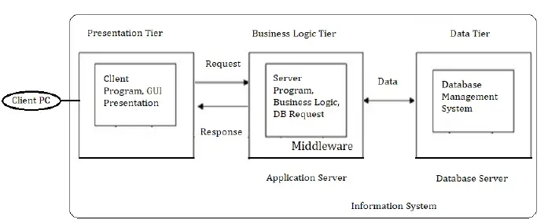
Presentation Layer | All user interface will be visible on the screen in the Client layer, Ex: Application Name, Login username and password, Product list, New user registration, New arrivals etc.
Business Layer | Reusable components or changing rules and regulations are included in the Business Logic layer, Ex: GST, Multiple payment options etc.
Database Layer | Storage place for all the information related to Products, Client credentials etc. Ex: Product price, Quality, Quantity, Client details etc.

Question 4 – BA Approach Strategy for Framing Questions – 10 Marks
Business Analyst should keep What points in his/her mind before he frames a Question to ask to the Stakeholder
(5W 1H – SMART – RACI – 3 Tier Architecture – Use Cases, Use case Specs, Activity Diagrams, Models, Page designs)

Answer 4:
Following questions are framing by me with keeping in mind all prospective of(Where, What, Who, When, How and other)
5W 1H-
- What is the Project and what are the objectives?
- What is the Timeline for the project?
- Who is the Client and Who are the users?
- Who will benefit from this project?
- Where will the product be deployed?
- How much is the Budget?
- Why are the clients developing this product?

Other Questions-
- What is the current process farmers are adopting for purchase of fertilizers, Seeds, Pesticides?
- After opening of the URL what things are shown on the First page?
- How manufacture can be able to upload the new products in to application?
- What things we should keep in Filter when farmer search product such as price, brand, delivery time and category etc.
- When the application can be used?
- How many users can use the application at a time?
- What things are most suitable for user to log in the application by email or mobile number?
- Can we also allow guest user to use the application?
SMART Criteria-
Frame questions that are Specific, Measurable, Achievable, Relevant, and Time-bound. SMART questions help to clarify requirements, gather specific information, and ensure that the responses are actionable and measurable.
SMART - Confirm the requirement is SMART before accepting it for development.
- Specific - Narrowing the questions, so let every single question at least include one element that you can get from it.
- Measurable – The questions are better to be quantified and countable.
- Action Oriented – Does the question influence creation of different or new feature packages.
- Relevant – Does the question identify which features are most required from the customer?
- Time bound – Does it let you or your customer decide priority in a specific time frame.
RACI Matrix
- Responsible –The person who does the work to achieve the task. They have responsibility for getting the work done or decision made. The persons responsible are typically working-level project team members, such as the project manager, business analyst and developers.
- Accountable – The people who is responsible for the correct and through completion of the task. They are responsible for ensuring the work is complete and suitable.
- Consulted – People from whom feedback and input should be solicited. They are going to provide information for the project and with whom there can be two-way communication.
- Informed – People kept informed of progress by keeping them in loop. These individuals do not have to be consulted or be a part of the decision making.
3 Tier Architecture-
- Presentation layer - This layer display screens, pages, validation on page, company specific logic, functionally.
- Business logic layer - In a business logic layer all reusable components, frequently changing components, governing body rules, regulation, compliance.
- Data layer - In this layer the data or information is stored. This layer performs operations like insert, update and delete to connect with the database.
Use Cases-
- What type of product we will deliver?
- Where is the location we will deliver the application?
- When should be the process be completed?
- Who all are responsible for doing this?
- Why this product will be used?
- How will we deliver this project?
Use Case Specs-
- Who are the Primary and Secondary actors?
- What are the Actor Goals?
- What are the main Tasks or functions that are performed by the Actor?
- What information does the actor desire from the system?
Activity Diagrams – Activity diagrams are visual representations of a series of actions or flow of control in a System similar to a Data flow diagram. It is basically a flowchart to represent the flow from one activity to another activity. The activity can be described as an operation of the system.
Purpose of an activity diagram can be described as –
- Draw the activity flow of a system.
- Describe the sequence from one activity to another.
- Describe the parallel, branched, and concurrent flow of the system.
Models-
- Conceptual Model
- Data Model
- Physical Model
By considering these points, you can frame well-thought-out questions that elicit the necessary information from stakeholders, leading to a clearer understanding of requirements and project expectations.

Question 5 – Elicitation Techniques - 6 Marks
As a Business Analyst, What Elicitation Techniques you are aware of? (BDRFOWJIPQU)
Answer 5:
As a Business Analyst, there are several elicitation techniques that can be used together requirements and insights from stakeholders. Here are some commonly used elicitation techniques:
      - Brainstorming: A group technique used to generate ideas and gather input from stakeholders. It encourages open and creative thinking to explore potential solutions or identify requirements.
      - Document Analysis: Reviewing existing documentation, such as business plans, process flows, and user manuals, to extract relevant information and identify gaps or areas for improvement.
      - Requirements Workshops: Conducting facilitated sessions with stakeholders together requirements, clarify doubts, resolve conflicts, and ensure collaboration among participants.
      - Interviews: One-on-one or group discussions with stakeholders to gather detailed information, understand their perspectives, and uncover specific requirements.
      - Focus Groups: Gathering a selected group of stakeholders to discuss specific topics or areas of interest. The group dynamics encourage interaction and exchange of ideas, providing valuable insights.
      - Observation: Actively observing stakeholders' work environment, processes, and activities to gain a deeper understanding of their needs, challenges, and workflows.
      - Document Analysis: Analyzing existing documents, reports, and documentation related to the project or domain to extract relevant information.This technique helps in understanding the current state and identifying gaps.
      - Questionnaires and Surveys: Distributing structured questionnaires or surveys to stakeholders to gather quantitative or qualitative data and opinions on specific topics or requirements.
      - User Stories: Capturing requirements from the user's perspective in a concise narrative format, focusing on the user's goals, actions, and expected outcomes.
      - Prototyping: Creating a visual representation or interactive model of the proposed solution to gather feedback, validate requirements, and facilitate stakeholder understanding.
      - Use Cases: Describing interactions between actors (users) and the system to illustrate how the system should behave and what actions it should support.These elicitation techniques provide various approaches to engage stakeholders, gather their insights, and understand their requirements effectively. The choice of technique(s) depends on the project's nature, stakeholders' availability, and the information needed. Business analysts often employ a combination of these techniques to ensure comprehensive requirement gathering.
Question 6 – This project Elicitation Techniques - 5 Marks
Which Elicitation Techniques can be used in this Project and Justify your selection of Elicitation Techniques?
Fertilizers, seeds, pesticides details from the manufacturers and should be able to display them to the Farmers.
To gather the business requirements from the client, you went to SOONY and met Mr. Henry. When Mr. Henry was asked about the project and what are they expecting from the project, Mr. Henry stated that he is expecting to have a login for all its users (fertilizers, seeds, pesticides manufacturers and Farmers), a product catalog of fertilizers, seeds, pesticides, a search option to search for products, payment process, and delivery tracking.
After doing the stakeholder analysis, you have found out that Peter, Kevin, Ben are the key stakeholders and you have scheduled an appointment to meet them. After meeting with them and trying to gather the stakeholder requirements, Kevin said that, a Farmer should be able to browse through the products catalog once they visit the website and need to have a search option so that they can search for any product they need. Peter said that, if a farmer wants to buy any product or add them to buy-later list, they need to login
first using their email id and password. If it is a new user, then they can create a new account by submitting their email ID and creating a secure password. Ben added saying that, Farmers needs to have an easy-to-use payment gateway which should include cash-on-delivery (COD), Credit/Debit card and UPI options so that the user’s experience should be better. Kevin mentioned that, a user gets an email confirmation regarding their order status. A delivery tracker to track the whereabouts of their order.

Identify Business Requirements (which includes Stakeholder Requirements)
BR001 – Farmers should be able to search for available products in fertilizers, seeds, pesticides BR002 – Manufacturers should be able to upload and display their products in the application
Answer 6:
For this Project, I would prefer to use the below Elicitation techniques.
- Brainstorming: By using this Technique, we can extract several ideas to make the Online store more useful for farmers and other users. Once we have these ideas, we can analyse and select the best ideas to implement. Brainstorming is effective with group of 8 to 12 people it helps to get the good number of ideas from user and stakeholders.

- Prototype: Prototyping is a visual technique, where we can create a representation of any ideas and allow us to test our ideas directly with the users before developing into a fully-fledged product. For this project, I would draw down the idea in a paper and share it with the stakeholders. Being a completely new project in the market, for which there are no details or documents available, I would use this technique to find the feasibility of the project, before spending money on the project.

- Use case specs: This technique is a combination of text and pictures which will provide me a better understanding of the requirements. This technique shows the behaviour of the system and help to capture the requirement of the system. These diagrams also identify the interactions between the system and its actors.

By employing these elicitation techniques, the project team can gather a range of requirements, validate them through feedback and discussions, and ensure that the online agriculture product store addresses the needs of the farmers effectively.

Question 7 – 10 Business Requirements- 10 Marks
Make suitable Assumptions and identify at least 10 Business Requirements.
Answer 7:
- BR001- All users (manufacturers and Farmers) should be able to sign up easily on the system.
- BR002- All users (manufacturers and Farmers) should be able to log in by submitting their email ID and password.
- BR003 - Farmers should be able to search for available products in fertilizers, seeds, pesticides.
- BR004 - Manufacturers should be able to upload and display their products.
- BR005 - Once the user’s login to the portal, they should be able to update their address details, to make sure the delivery happens to their requested address only.
- BR006 - Farmers should be able to browse through the Product catalogues once they visit the website.
- BR007 - Farmers should have the Buy Now option if they want to purchase the product immediately.
- BR008 - Farmers can have a Save for Later or Wish list option, if they want to buy any product later.
- BR009 - Farmers needs to have an easy-to-use payment gateway which should include cash-on delivery (COD), Credit/Debit card and UPI options so that the user’s experience should be better.
- BR010 - Farmers should get an email confirmation regarding their order status.
- BR011 - Farmers should be able to track their order, once placed.
- BR012 - Farmers should be able to cancel or return the product, if not happy with it.
- BR013 - Farmers should have an option to rate the Product, Delivery and Overall experience.
- BR014 - The online store should be optimized for mobile devices, allowing farmers to access and use the platform seamlessly on smartphones and tablets
- BR015 - The platform should ensure the security of farmers' personal information, including their payment details, by implementing robust security measures and using encryption protocols.

Question 8 –Assumptions- 5 Marks
List your assumptions
Answer 8:
- The online agriculture product store will primarily cater to farmers and companies involved in the manufacturing of fertilizers, seeds, and pesticides.
- The store will operate as a web and mobile application to provide accessibility to users.
- Users should either have Laptop or Desktop or Mobile.
- They should have an active Email address.
- They should have an active Bank account with active payment modes, like Credit/Debit card, UPI payments or mobile banking facility etc.
- They also should have an active registered mobile number to receive OTPs to pay for the product and accept delivery.
- The store will require a user login system for manufacturers and farmers to access different functionalities.
- A product catalogue will be available, featuring detailed information about fertilizers, seeds, and pesticides, including pricing and manufacturer details.
- Users will have the ability to search for specific products within the catalogue.
- Farmers will need to create an account using their email ID and password to make purchases or add products to a buy-later list. New users can create a new account by providing their email ID and creating a secure password.
- The payment gateway will support multiple options, including cash-on-delivery (COD), credit/debit card, and UPI (Unified Payments Interface), for a convenient user experience.
- Users will receive email confirmations regarding their order status, providing details about their orders.
- The platform will include a delivery tracker feature to allow users to track the progress and location of their orders.
- The application should have Chat facility to speak to any customer service querying for any product, they want to buy.

Question 9 – This project Requirements Priority - 8 Marks
Give Priority 1 to 10 numbers ( 1 being low priority – 10 being high priority) to these Requirements after discussions with the stakeholders

Req ID | Req Name | Req Description | Priority
BR001 | Farmer Search for Products | Farmers should be able to search for available products in fertilizers, seeds, pesticides | 8
BR002 | Manufacturers upload their Products | Manufacturers should be able to upload and display their products in the application | 8

Once the requirements are finalized, as a business analyst, one of the major roles is to act as a liaison between the client and the project team. To gather the requirements correctly from the client side and then to deliver those requirements to the project team in a way they understand.
To make the project team understand the requirements, you need to convert those requirements into UML diagrams and screen mock-ups.
Answer 9:
Req ID | Requirement Description | Priority
BR001 | All users (manufacturers and Farmers) should be able to sign up easily on the system. | 9
BR002 | All users (manufacturers and Farmers) should be able to log in by submitting their email ID and password. | 9
BR003 | Farmers should be able to search for available products in fertilizers, seeds, pesticides. | 8
BR004 | Manufacturers should be able to upload and display their products. | 8
BR005 | Once the user’s login to the portal, they should be able to update their address details, to make sure the delivery happens to their requested address only. | 7
BR006 | Farmers should be able to browse through the Product catalogues once they visit the website. | 6
BR007 | Farmers should have the Buy Now option if they want to purchase the product immediately. | 9
BR008 | Farmers can have a Save for Later or Wish list option, if they want to buy any product later. | 8
BR009 | Farmers need to have an easy-to-use payment gateway which should include cash-on delivery (COD), Credit/Debit card and UPI options so that the user’s experience should be better. | 10
BR010 | Farmers should get an email confirmation regarding their order status. | 6
BR011 | Farmers should be able to track their order, once placed. | 9
BR012 | Farmers should be able to cancel or return the product, if not happy with it. | 7
BR013 | Farmers should have an option to rate the Product, Delivery and Overall experience. | 6
BR014 | The online store should be optimized for mobile devices, allowing farmers to access and use the platform seamlessly on smartphones and tablets | 7
BR015 | The platform should ensure the security of farmers' personal information, including their payment details, by implementing robust security measures and using encryption protocols. | 8

Question 10 – Use Case Diagram - 10 Marks
Draw use case diagram

Answer 10:

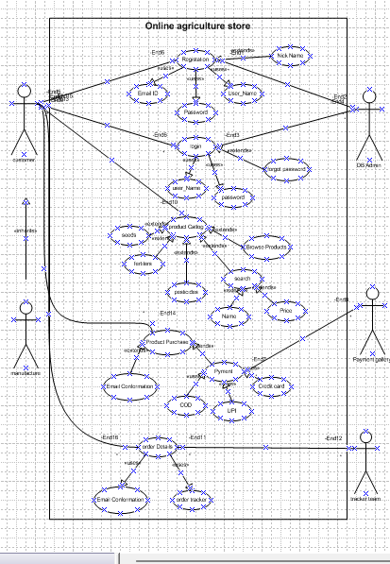

Question 11 – (minimum 5) Use Case Specs - 15 Marks
Prepare use case specs for all use cases
Answer 11:

Use Case ID | UC001
Use Case Name | This use case shows How the user can buy Agriculture product from this application.
Created by | MR ABC | Last Updated by | 04-Apr-23
Date Created | 25-Mar-  23 | Last Revision Date | 01-Apr-23
Actor | Customers/Farmers
Description | Describing how page should respond if there is no internet
Pre-condition | Farmers is having an active internet connection
Post-condition | Success -Farmers can place the order successfully. Failure -Farmers unable to Login/ logs are updates accordingly.
Normal Flow of events/ Basic Flow/ Happy Path | - The use case starts when Farmers do the registration with valid email ID and then Login with ID and password.  - Use case validate the user is performed.  - Then farmers can view products; add to card and place the order.
Alternative Flow | Invalid User; Wrong account ID; Wrong password; No successful authentication Via mobile number or email Id
Exceptions | If internet connection lost during activity, then display "Check your internet connection"
Frequency of Use | High
Assumptions | It is assumed that customer is registered and has computer Knowledge

Use Case ID | UC002
Use Case Name | This use case shows how farmers can register on the app.
Created by | MR ABC | Last Updated by | 05-Apr-23
Date Created | 26-Mar-  23 | Last Revision  Date | 02-Apr-23
Actor | Customers/Farmers
Description | Describing how page should respond if they do not put OTP for registration
Pre-condition | Farmers is having an active internet connection
Post-condition | Success -Farmers can register successfully. Failure -Farmers unable to register are updated  accordingly.
Normal Flow of events/ Basic Flow/ Happy Path | - The use case starts when Farmers do the registration with valid email ID and then Login with ID and password.  - Then farmers can register using OTP.
Alternative Flow | Incorrect OTP, No successful authentication Via mobile number or email Id
Exceptions | If internet connection lost during activity, then display "Check your internet connection"
Frequency of Use | High
Assumptions | It is assumed that customer has an email ID and mobile phone for authentication.

 | Use Case ID | UC003
 | Use Case Name | This use case shows how sellers can upload new products on the app.
 | Created by | MR ABC |  | Last Updated by |  | 06-Apr-23
 | Date Created | 27-Mar-23 |  | Last Revision Date |  | 03-Apr-23
 | Actor | Sellers/Dealers
 | Description | Describing how to upload new product details.
 | Pre-condition | Sellers have basic technical knowledge & internet connection.
 | Post-condition | Success -Sellers can upload product description successfully.  Failure - Sellers unable to upload products accordingly.
 | Normal Flow of events/ Basic Flow/ Happy Path | The use case starts when seller’s login with valid email ID and then Login with ID and password.  Then sellers can login using OTP. Sellers then upload the products.
 | Alternative Flow | Sellers can login using OTP  Sellers can upload products using history details.
 | Exceptions | If internet connection lost during activity, then display "Check your internet connection"
 | Frequency of Use | High
 | Assumptions | It is assumed that sellers have details about their products.
 | Use Case ID | UC004
 | Use Case Name | This use case shows how farmers can add products to cart.
Created by |  |  | MR ABC |  | Last Updated by |  | 07-Apr-23
Date Created |  |  | 28-Mar-23 |  | Last Revision Date |  | 04-Apr-23
Actor |  |  | Farmers/Customers
Description |  |  | Describing how to purchase products.
Pre-condition |  |  | Farmers have basic technical knowledge & internet connection.
Post-condition |  |  | Success -Farmers can add products to cart successfully.  Failure - Farmers unable to add products to cart.
Normal Flow of events/ Basic Flow/ Happy Path |  |  | Farmers search for desired products and browse the catalogue.  Farmers then select desired quantity and no of items.  Farmers add product to cart.
Alternative Flow |  |  | Farmers can Wishlist the product and then add it to cart. Farmers can directly add products from their past purchase and make similar purchase.
Exceptions |  |  | If internet connection lost during activity, then display "Check your internet connection"
Frequency of Use |  |  | High
Assumptions |  |  | It is assumed that Farmers have basic browsing knowledge of products.

Use Case ID | UC005
Use Case Name | This use case shows how farmers can initiate return and refund.
Created by | MR ABC | Last Updated by | 08-Apr-23
Date Created | 29-Mar-23 | Last Revision Date | 05-Apr-23
Actor | Farmers/Customers
Description | Describing how to initiate refund and return
Pre-condition | Farmers have basic technical knowledge & internet connection.
Post-condition | Success -Farmers can initiate return & refund.  Failure - Farmers unable initiate refund and return.
Normal Flow of events/ Basic Flow/ Happy Path | Farmers go to purchase history and initiate return.  Farmers then select reason for return and agree to T&C for the same.  Farmers select mode and medium of refund.
Alternative Flow | Farmers can get refund added to their account wallet.
Exceptions | If internet connection lost during activity, then display "Check your internet connection"
Frequency of Use | High
Assumptions | It is assumed that Farmers have basic browsing knowledge of products.

Question 12 – (minimum 5) Activity Diagrams - 15 Marks
Activity diagrams
Answer 12:
Login Page:
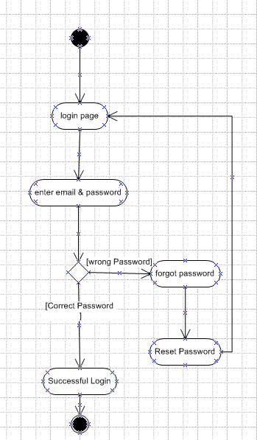

Payment:
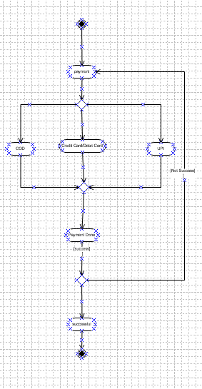
Order Status:
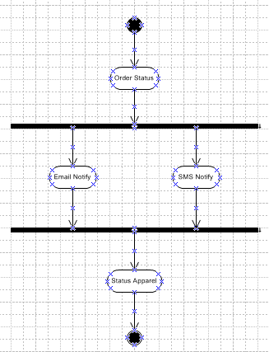
Search for Products:
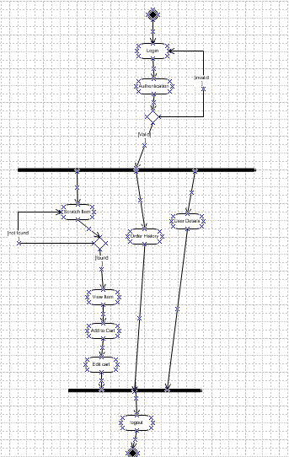
Products:
