CAPSTONE PREP 1 PART 2
PROJECT ON AGRICULTURAL ONLINE PRODUCTS STORE
QUESTION NO .1
AUDITS: QUATERLY AUDITS ARE PLANNED Q1, Q2, Q3, Q4 FOR THIS PROJECT. WHAT IS YOUR KNOWLEDGE ON HOW THESE AUDITS WILL HAPPEN FOE A BA?

ANSWER: QUARTER 1 REQUIREMENT GATHERING PHASE.

STAGE | QUARTER 1 AUDIT REPORT  (REQUIREMEMENT GATHERING PHASE)
COMPLETED | 10 WEEKS (WEEK 1 TO WEEK 10)
CHECK LIST | BRD Template
CHECK LIST | Elicitation results report
CHECK LIST | Duplicate Requirements report
CHECK LIST | Grouping of functionalities /features, client sign off
CHECK LIST | Email communications -To, CC, BCC

In this beginning stage of the project the quarterly audits are done based on the phases.
The first stage of the project is Requirement Gathering, in this phase we usually prepare various types of reports and mention in how many weeks or days the first phase is happening. We also have checklist where certain reports and results are obtained like BRD, Elicitation results, Emails.

QUARTER 2 REQUIREMENT ANALYSIS PHASE.

STAGE | QUARTER 2 AUDIT REPORT  (REQUIREMENT ANALYSIS PHASE)
COMPLETED | WEEK (16 TO 24 )7 WEEKS
CHECK LIST | UML Diagrams
CHECK LIST | Business to functional Requirements mappings.
CHECK LIST | Client sign off documents.
CHECK LIST | RTM Document version control.
CHECK LIST | Email communications -To, CC, BCC.

The second stage is Requirement Analysis phase where the requirements which are collected are analyzed using various diagrams like UML, RTM Documents and the communications through E-mails.

QUARTER -3 DESIGN PHASE.

STAGE | QUARTER 3 AUDIT REPORT  DESIGNING PHASE
COMPLETED  CHECKLIST | WEEK (24 TO 37) 7 WEEKS.
COMPLETED  CHECKLIST | Utilization of tools.
COMPLETED  CHECKLIST | Documented evidence on client communications.
COMPLETED  CHECKLIST | Stakeholders MOM
COMPLETED  CHECKLIST | Email Communications. -To, CC, BCC.

The third stage is Designing Phase where the time taken is 7 weeks.

And the usage of tools and stakeholder’s meeting’s and MOM are done in Designing phase.

QUARTER 4 AUDIT REPORTS.

STAGE | QUARTER 4 AUDIT REPORT  DEVELOPMENT PHASE .
COMPLETED | WEEK (40 TO 60 )20 WEEKS
CHECKLIST | JAD Sessions report.
CHECKLIST | End user manual preparation report.
CHECKLIST | Business Analyst and Developer MOM.
CHECKLIST | Email Communications – TO, CC, BCC.

In this Audit report stage, there are 20 weeks to run this Development phase.

There are few sessions like JAD and preparing of MOM of developers and business analyst.

user manual report is also done in this phase.

QUARTER 5 -AUDIT REPORTS.

STAGE | QUARTER 5 AUDIT REPORT.  TESTING
COMPLETED  CHECKLIST | WEEK (58 TO WEEK 78 )20 WEEKS.  TEST CASE SUMARY  TRAINING REPORTS TO END USERS.  LESSONS LEARNT DOCUMENTS.  EMAIL COMMUNICATIONS -TO, CC, BCC.

In this testing phase the business analyst and testers are involved. Here test
case summary and

reports to end users and Email communications are done. If they are any
errors again, they are sent to bug fix.

Question 2-
BA approach strategy
Before the project is going to kickstart, the committee asked MR. Karthik to submit BA approach
strategy?
Answer –
We have many Elicitation Techniques to apply used to gather requirements. Some of
them are Brain storming, Document Analysis, Workshops, Focus Groups,
Observations etc.

How to do Stake Holder Analysis in RCM: Stake Holder Analysis can be done by
using RACI Matrix involves in identifying stakeholders& defining their roles and
responsibilities within a project.

What Documents to write:
BRD, FRD, Use Case documentation, Test Case Document.

What process to follow to sign off on the document:
Sign off to be taken on SRS as this is the primary and important document.
Sign off can be taken by using E-Mail confirmation from client.

How to take approvals from the client:
Establishing a formal meeting with the clients to keep them informed and get
continuous feedbacks.

What Communications channels to establish and Implement:
Regular meetings, Bi weekly sprint reviews, monthly stakeholder update

How to handle change Requests:
Change request form, Do impact analysis, Approval process, Documentation.

How to update the progress of the project to the stake holders:
Weekly status reports, Monthly Review Meetings are done to update the progress of
the project.

How to take sign off on the UAT client project:
Acceptance Form: UAT preparation, conduct UAT, Fix Issues, Acceptance Form,
Final Review Meetings, Obtain Sign Off.

Question -3 Three tier Architecture and Explain it?

Answer- 3 Tier Architecture.

- Application Layer.

- Business Logic Layer.

- Database Layer.

- Application Layer -The top most layer of the architecture is also known as

“Presentation Layer “. It handles user interface IT components such as

Screens, Pages.

Example – E- Commerce Websites.

- Business Logic Layer- Middle layer of Architecture acts as an intermediary

between the presentation layer and the data storage layer. This layer contains

the core logic of the application.

Example – Printer, Payment Gateways.

- Database Layer -Bottom most layer of the architecture responsible for storing

and retrieving data.

Example – My SQL, Oracle database.

QUESTION 4 – Approach strategy for framing questions –

Answer – 1) The 5WH Frame work is a useful tool for gathering information and

understanding a situation by answering the questions about who, what, when, where

why and how?

2- The SMART technique can help in creating questions

(Specific, Measurable, Attainable, Relevant, Time Bound)

3- RACI charts help to define and clarify roles and responsibilities within a team by

outlining who is responsible, consulted, informative for each task.

4- UML is a standardized way of diagramming and modelling software system to aid

in design, development, communication between team members.

QUESTION 5 – What are the Elicitation Techniques?

Answer – Elicitation Techniques- These are the techniques used to gather the
information which are used in IT Companies to engage with the stake holders.
As a business analyst the elicitation techniques I’m aware of:

- Brain Storming – Brain Storming can be done either Individually or in groups

The ideas collected can be reviewed and analyzed. It can come up with very

innovative ideas & requirements.

- Document Analysis – Document Analysis could be a lot of information and

easy to transfer to a new system requirements document. It can have

documentation about your current system which can provide some of the

inputs for the new system requirements.

- Reverse Engineering – Where the Software for an existing system has little

or outdated documentation and it is necessary to understand what the

system does actually. It can extract implemented requirements from the

software code. (Solution to Problem). They are two general categories of

Reverse Engineering.

- Black Box Reverse Engineering.

- White Box Reverse Engineering.

Black box Reverse Engineering – The product is studied without examining its
internal structure.
White box Reverse Engineering -The Inner workings of the system/product
are studied.
- Focus Groups – A focus group is a means to elicit if the ideas and

attitudes about a specific product, service or opportunity in an interactive

group environment. The participants share their impressions, needs and

guided. There are pros /cons that should be considered when using:

Homogeneous VS Heterogeneous.

Homogeneous – Individuals with similar characteristics

Heterogeneous – Individuals with diverse back grounds, perspectives.

- Observation -Observing users or even doing part of their job can provide

information of existing processes inputs and outputs.

There are two basic approach for observation Techniques:

1)Active

2)Passive

Active: In this approach, the BA observes the current process and take notes

He /She may dialog with the worker. He /She asks the questions right away.

Passive: In this approach, the BA observes the SME working through the

business routine but does not ask the questions directly.

- Workshops: Workshops on compromise 6-10 or more users working together

to identify requirements. They are faster than the group interviews for

obtaining requirements, particularly for common or system wide requirements.

Process: 1) Prepare for the requirements workshop
2)Run the requirements tool.
3) Post Requirements workshop wrap up done by Facilitator.

- JAD (Joint Application Development): Define sessions, Defining the purpose,

Scope and Objectives of the JAD sessions selecting the JAD Team, invite and

obtain commitments to attend the sessions from the appropriate stake holders

and scheduling the sessions. It is important to obtain management

commitment to support the process and identify the appropriate stake holders.

- Interviews: An interview is a systematic approach to elicit information from a

person or group of people in an informal or formal setting by talking to the

person, asking relevant questions and documenting the responses.

- Prototyping: Capturing the requirements from the clients using the logos

colures etc.

- Questionnaire: Questionnaires can be useful for obtaining limited systems

requirements detail from users /stake holders, who have a minor input or

geographically remote.

10) Use Case specs: A Use Case Specification is a detailed textual description of
how a user or actor interacts with the systems to achieve a specific goal.

Question 6 – Which Elicitation Techniques can be used in this project?

Answer – The Elicitation Techniques used in this project are:
- Interviews

- Workshops

- Prototyping.

- Interviews: Farmers, suppliers, and stake holders have unique

needs. (Delivering time lines, Payments).

Example- Knowing about the farmers what challenges they face when selling.
- Workshops – Brings Multiple stakeholders together like (Farmers, IT

Teams, CSR Board).

- Prototyping -Many farmers don’t understand technical documents

but can easily give feedback on a visual prototype of online stores.

Identifying Business Requirements including stake holders’ requirements -

- Providing an online platform for farmers to directly sell

agricultural products to consumers and retailers.

- Eliminate middle people to ensure farmers fair prices.

- Enable market reach for farmers in remote places.

- Ensuring secure payment gateways.

Stake holder Requirements

- MR. Henry (CSR Project Sponsor)
- Ensuring project aligns with CSR goals.
  - Cost effective solution within 2 CR budget.
- Completion within 18 months timeline.

- Mr. Pandu (Farmer Representative)
                - Easy Onboarding for farmers with minimal technical skills.
                - Local language support for product listings.
                - Transparent pricing systems without hidden charges.
                - Timely Payment for farmers.

- Peter (Project Manager)
                - Clear project scope and miles stones.
                - Risk Mitigation strategies.
                - Smooth Execution with defined roles. (RACI Matrix)
4) Kevin (Technical Lead /Developers)
            - Availability of trained JAVA resources.
            - Proper requirement clarity to avoid rework
            - Stable Infrastructures.
5) Ben (Tester / QA Lead)
              - Well documented test cases.
              - Availability of UAT testers.
              - Proper test Environment set up before Deployment.
6) End Users -
              - Easy Browsage of products.
              - Secure Checkout and Payment Process.
Customer Support Channel.

Question 7 -10 Business Requirements –Identify at least 10 Business
Requirements.

- Online Market place creation: Developing a secure online store for farmers

to sell products directly.

- Farmer Onboarding and Registration: Providing simple registration with

KYC verifications.

- Product Catalog and Management: Enables farmers to upload products

details (Name, price, Quantity,)

- Secure Payment Gateways Integration: Supports UPI, Cards, Net

Banking’s and ensure farmers to receive pay outs within a period.

- Order and Inventory Management: Automate order tracking, Stock

Availability and updates for farmers and customers.

- Logistics and Delivery Integration: Partners with logistics providers for

delivering tracking’s and integrations into the platform.
- Multi Language Support -Ensuring accessibility on mobile devices and

availability of local languages options.

- Customer Support and Feedback System- Providing a support channel for

farmers and buyers to resolve queries.

- Data Security and Compliances: Ensuring Compliances with data privacy

Regulations, Secures storage of farmer.
- Analytics and Reporting: Generating reports on sales farmer earnings, and
CSR impact for stake holders.
Question 8 – Assumptions

- The project budget is fixed at 2 cr under CSR Initiative.

- The project must be completed within an 18 months’ time lines.

3) The platform will be developed using JAVA Technology as decided.

4)Farmers from remote areas are the primary users of the system.

5) Farmers may have limited digital literacy so the platform must be

simple to use.

- Internet connectivity in rural areas maybe limited, Hence the

system should be user friendly.

7) Farmers must receive timely payments after product sale is done.

Question -9 This Project Requirements Priority.
Give Priority 1 to 10 numbers (1 Being Low Priority -10 Being Priority
these Requirements after discussions with the stake holders.

Requirement  ID | Requirement Name | Description | Priority
BR 001 | User search for the products | Users Should be able to search for the available products. | 1
BR 002 | Users create login | Users should be able to create login if he is a new user. | 2
BR 003 | Users browse through products | Users should be able to browse through the available products. | 3
BR 004 | Email Confirmation | Users should get Email Confirmation for their order | 4
BR 005 | Payment Gateway | All the payments methods should be available (Credit /Debit /UPI/COD) | 5
BR 006 | Manufacture can add products in the product catalog | Manufacturer’s must be able to add the products and also should be able to display the products. | 6
BR 007 | Add to Cart option | Users must be able to add the products in the Cart. | 7
BR 008 | Product Delivery Tracking | Users must be able to track the delivery of the product. | 8
BR 009 | Product Info | Users should get the Product Information. | 9
BR 10 | Product Delivery on Time | Users Must be able to get the Delivery of the Product on Time. | 10
Hence, the above table shows the sequence of the Requirements for the Agricultural Online Delivery of the products from priorities 1 to 10.

Question 10 – Draw a Use Case Diagram.
Use Case Diagram- A Use Case Diagram is a Visual Representation of the
interactions between users (Actors) and a system.
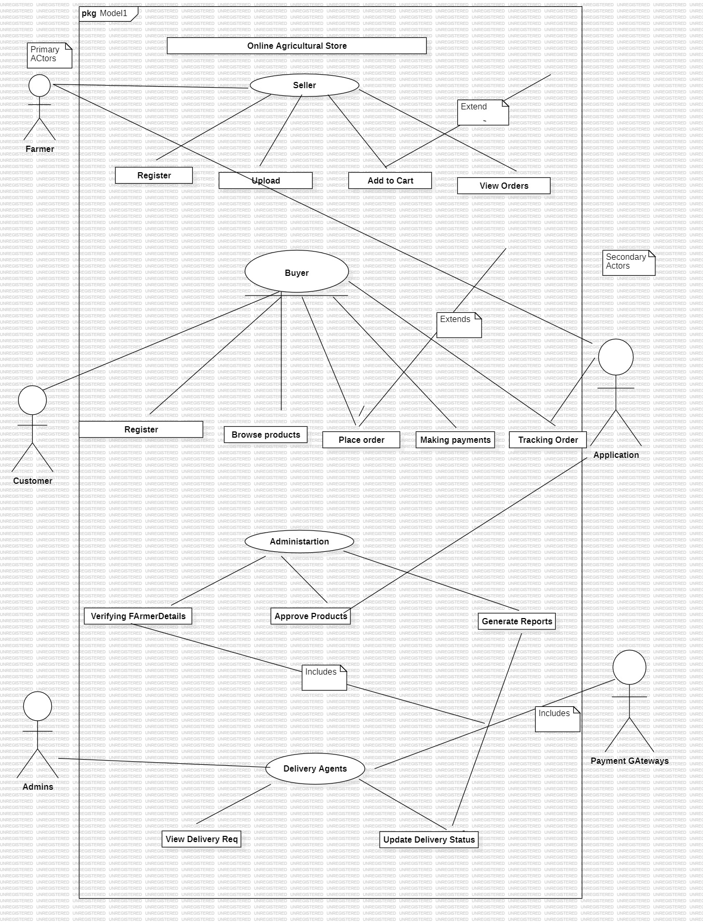

Question 11- Prepare Use Case Specs for all Use Cases.

Use Case Specification – A use Case Specification generally a detailed textual

description of how a user interacts with the system to achieve a specific goal.
A Use Case Specification Generally Consists of:
- Use Case ID and Name.

- Actors

- Pre-Conditions

- Post Conditions

- Alternative Flows.

- Uploading the products.

- Use Case Name And ID:
ID -UC1,
- Actors: Farmers, customers, Admins are the primary actors.
Online Application and Payment Gateway are the secondary actors.

- Pre -Conditions – Farmer is registered and logged in.

- Post -conditions- Product Details are saved in the system catalog.

- Alternative Flows- If Mandatory fields are missing -system shows an error

popup.

If farmer enters invalid data -prompt for correction.

- Updating of product information.

- ID – UC2

- Actors -Farmer

- Pre-Conditions- Farmer is registered, logged in and product exists.

- Post Conditions- Product details Updated Successfully.

The Basic Flow for this is the farmer selects the product from their list and the

farmer updates product details and system validate the changes then

updates are saved.

- Alternative Flow – If there is any Invalid update it shows the error message.

- Browsing the products.

- ID- UC3

- Actors- Customer

- Pre-Conditions -Customer is registered and logged in.

- Post Conditions- Customer views available products.

Here, the basic flow is that customer opens the store.

System displays product categories.

Customer searches or filters the products

System shows the related products.

- Alternative Flows- No product found – Display No results.

4-Place Order

- ID -UC4

- Actors – Customer

- Pre conditions- Customer is logged in, products are available.

- Post Conditions – Order is Created and saved in the system.

The basic Flow is the customer browses and selects the products.

Add the items to the cart.

Proceeds to check out.

Confirms the order

The system does the payment via Payment Gateways.

- Alternative Flows- Out of Stock – System shows availability
issues.

5- Make Payment

ID- UC5

Actors – Customer, Payment Gateway,

Pre-Condition- Customer has items in the cart and proceeds to check out.

Post condition- Payment confirmed, order finalized.

The basic Flow is customer selects payments method (UPI, Net Banking, Card)

System redirects to secure payments gateways.

Customer completes payment.

Payment confirmation will be received.

Alternative Flows – Payment Failed- Customer retries the payment.

6- Track Order

IC-UC 6

Actors – Customers

Pre-condition – Customers has placed an product.

Post -Condition – Customers views live status of the product.

The Basic Flow is customer selects Track order

System fetches delivery status.

Customer will be able to see the system order progress like

Processing, shipped, delivered

Alternative Flows – System shows Not Yet Shipped.

7 – Manage Users

ID- UC7

Actors – Admin

Pre conditions- Admin Logged in

Post conditions- User data is Updated.

The Basic Flow is the Admin selects the user management module.

Admin views list of users (Farmers, customers)

Admin can add, block or edit users.

Alternative Flows- Unauthorized Actions – Error pop up.

8 -Deliver the products –

ID -UC 9

Actors-Delivery Person

Pre-Conditions- Order is confirmed and assigned to delivery partner

Post Conditions -Product Delivered to customer.

The basic Flow is the delivery partner logs into the system

Views the assigned orders.

Collects the products from farmer /ware house.

Update’s the status as Delivered.

Alternative Flows- Failed Delivery- Status Updated as Delivery Attempt Failed.

Question 12- Activity Diagrams (Minimum 5)

Activity Diagrams – It is the flow of control and advanced version of flow chart.

It defines the workflow from one activity to another. It Includes different states and

notations like Actions, Final, Join, fork, Merge, Swim lanes and the control flow.

Below are the 5 Activity Diagrams describing the Uploading, Browsing, making

payments, Tracking the order, Delivery of the products.

- Uploading of the product

- Browse a placing order

- Making the payments

- Track the order

- Delivery of the order.

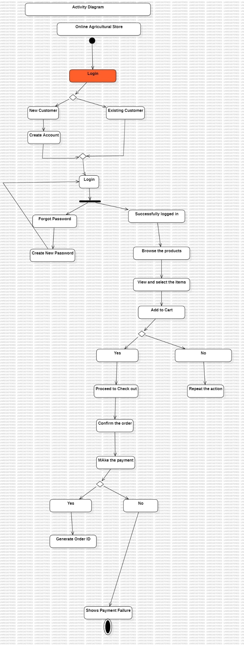
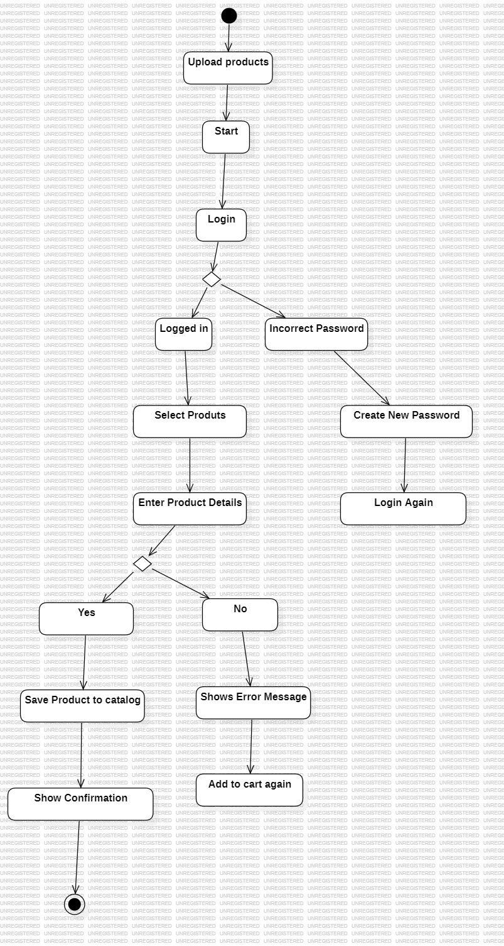
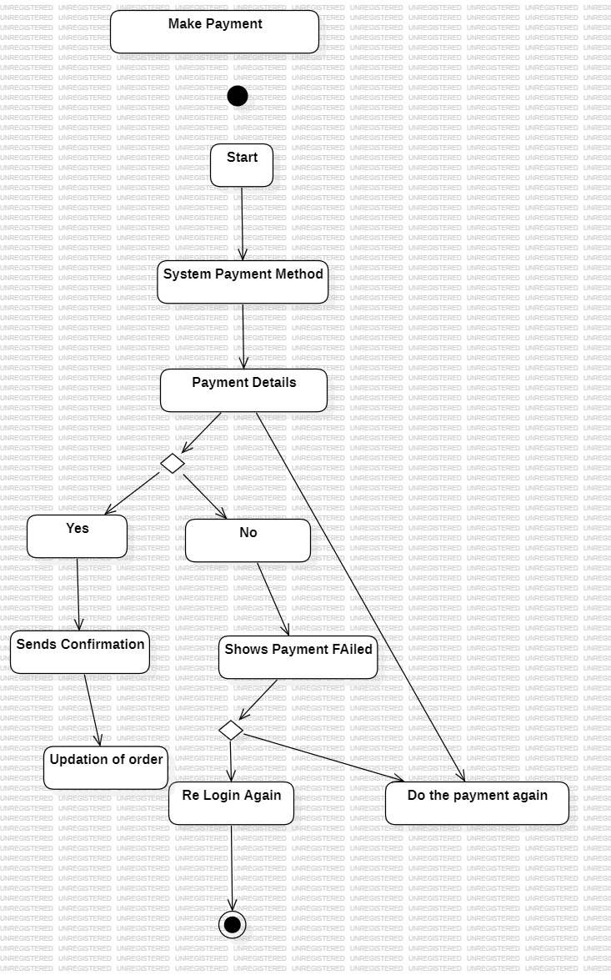
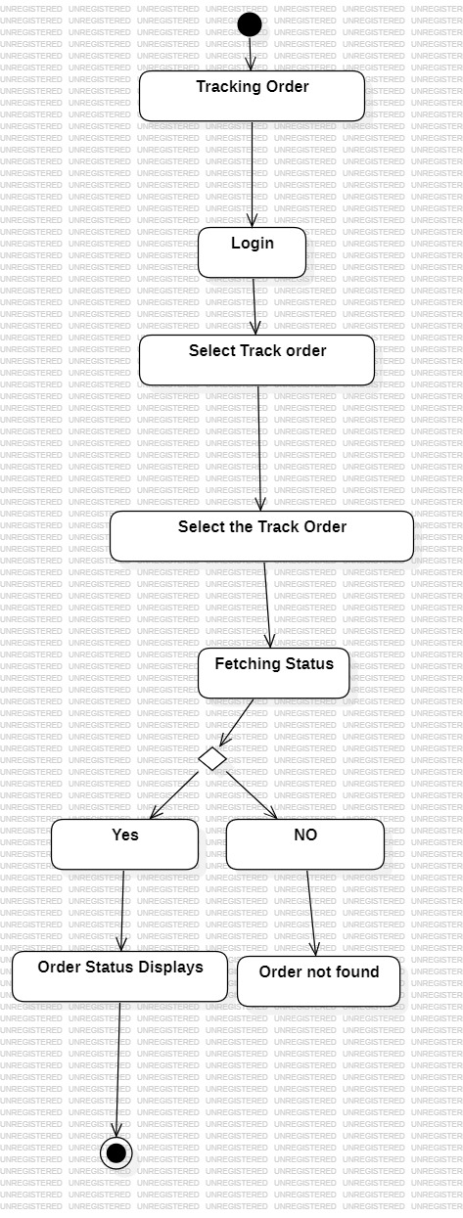
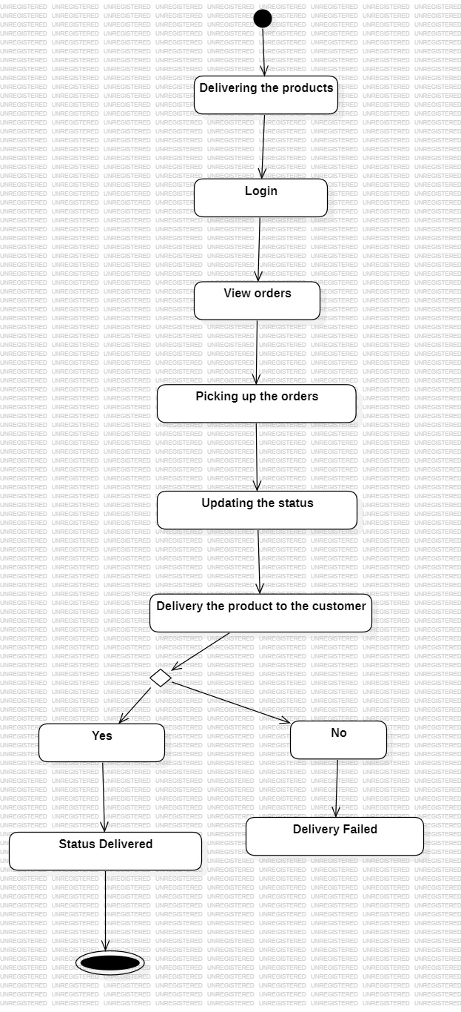
- Framers Uploads the product which are in the store and appears in the applications.

- Customer Browses, places the order and makes the payment.

- Admin looks into the order validation and reporting.

4 - Delivery Partners Picks up the orders

5 – The customer receives the order.

