Question 1 – Functional Requirements - 15 Marks
Identify minimum 20 functional requirements
Example :
Functional requirement: When an order is fulfilled, the local printer shall print a packing slip.
Non-Functional Requirement: Packing slips shall be printed on both sides of 4”x 6” white paper, the standard size for packing slips used by local printers.
Answer :
Functional Requirements : Functional requirements define the specific behaviours, functions, or operations of a system. They describe what the system should do, outlining the necessary tasks, actions, or activities it must perform to achieve its objectives. Functional requirements are from systems perspective and each functional requirement will have an ID <Proj ID><FR ID>. Each unique Noun and Verb will be functional requirement.
Req ID | Req Name | Req Description
FR001 | User Search Products | Users should be able to search for the available products by search option
FR002 | Users Browse Products | Users should be able to browse for the available products
FR003 | Users Login details | Users should be able to login with user credentials to application
FR004 | Users create login | Users should be able to register with the application
FR005 | Adding products to the cart | Users should be able to add the products to the cart
FR006 | Adding products to the wishlist | Users Should be able to add the products to the wishlist
FR007 | Placing order | Users should be able to place the order
FR008 | Users forget password | Users should be able to create new password if they click forget password
FR009 | User credentials email | Users should be able to receive email with the login id and password details
FR010 | Payment with different modes | Users should be able to make payment with different modes
FR011 | Email confirmation for order | Users should be able to get email confirmation regarding their order status
FR012 | Product delivery tracking | Users should be able to track the whereabouts of the orders placed
FR013 | Payment with COD | Users should be able to select payment option by Cash on delivery mode
FR014 | Payment with Card | Users should be able to select payment option by card
FR015 | Payment with UPI | Users should be able to select payment option by UPI
FR016 | Quantity to order | Users should be able to select the number of pieces of products to order
FR017 | Manufactures can add products descriptions | Manufacturers should be able to add products description in the application
FR018 | Manufactures can display product images | Manufacturers should be able to add images of products in the application
FR019 | Manufactures add quantities | Manufacturers should be able to add quantities of products in the application
FR020 | Users to add delivery address | Users should be able to add their delivery address to their account

Non Functional requirements : Non Functional requirements will describe the qualities and attributes of a system, focusing on how the system performs rather than specific behaviours or functions
Req ID | Req Name | Req Description
NFR001 | Usability | The Application should have an intuitive and user friendly
NFR002 | Performance | The Application must load pages within 3 seconds
NFR003 | Security | The Application must ensure secure user authentication
NFR004 | Compatability | The Application should be compatible with major web browsers
NFR005 | Response Time | The Application should respons to user inputs within 2 seconds
NFR006 | WCAG 2.1. | The System must meet Web Content Accesibility Guidelines WCAG 2.1.
NFR007 | Packing Slips | Packing Slips should be printed in order to paste on the product parcel with tracking ID details
NFR008 | Delivery tracker | Delivery person should be able to update product delivery on application link once the product is delivered
NFR009 | Invoice | The Invoice should be printed and added with the parcel
NFR010 | Delivery Guy making call | Delivery person should be able to make call to customer for making delivery using application device

Question 2–Minimum 5 page designs - 15 Marks
Make wireframe and prototypes
Answer :
Wireframe : A Wireframe is a simplified, visual blueprint of a website or application interface, focusing on structure, layout, and functionality rather than aesthetics. It helps to translate complex business requirements into a clear visual design that facilitates early collaboration and feedback from stakeholders. Wireframe helps the stakeholders to explain their requirements efficiently of the system. Wireframe is without any colour and functionality and can be designed on paper with a pen or pencil. It is designed by the business analyst in almost every project.

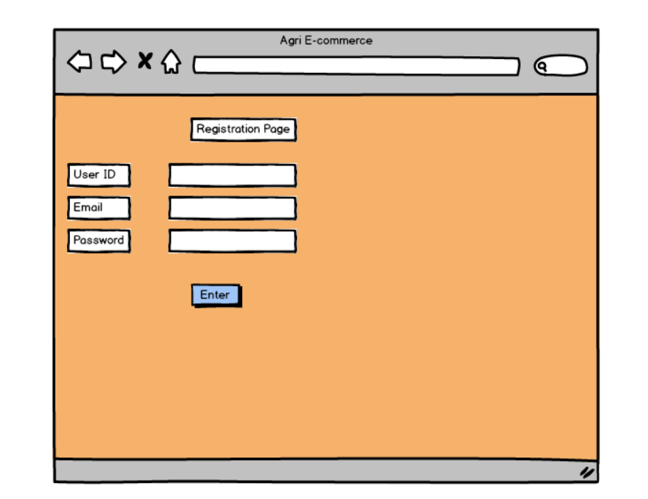
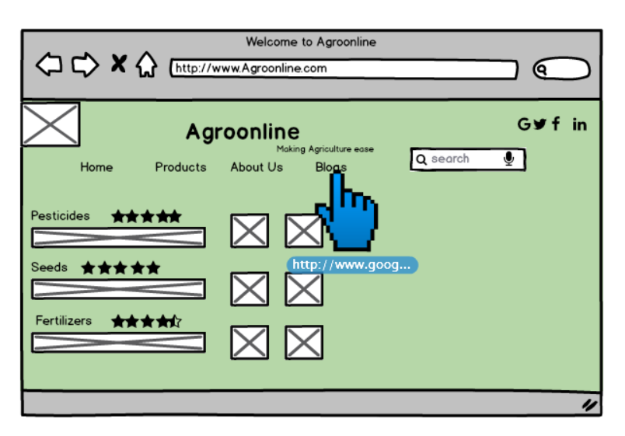
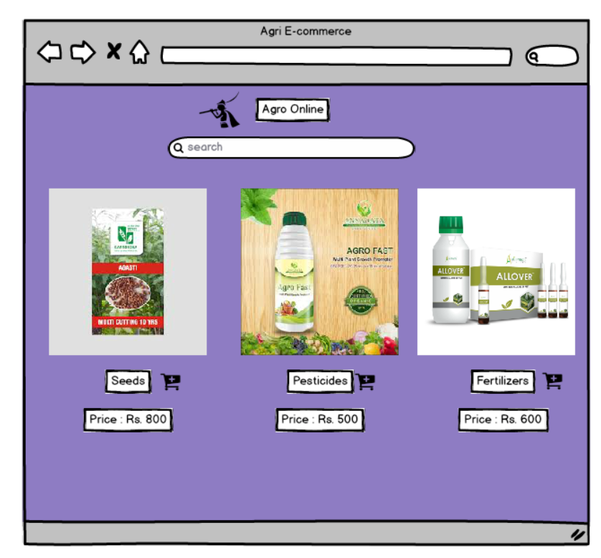
Prototypes : A Prototype is a preliminary, interactive model of a software application or website that helps visualize and validate requirements with stakeholders before development begins. It can range from low-fidelity wireframes to high-fidelity, clickable simulations that closely resemble the final product. A prototype is a replica of the future system which is meant to simulate user interaction. Prototype of a product is designed and developed by the developer and business analyst to understand the system. Prototype take more time to develop. Prototype may not be required for all the projects.
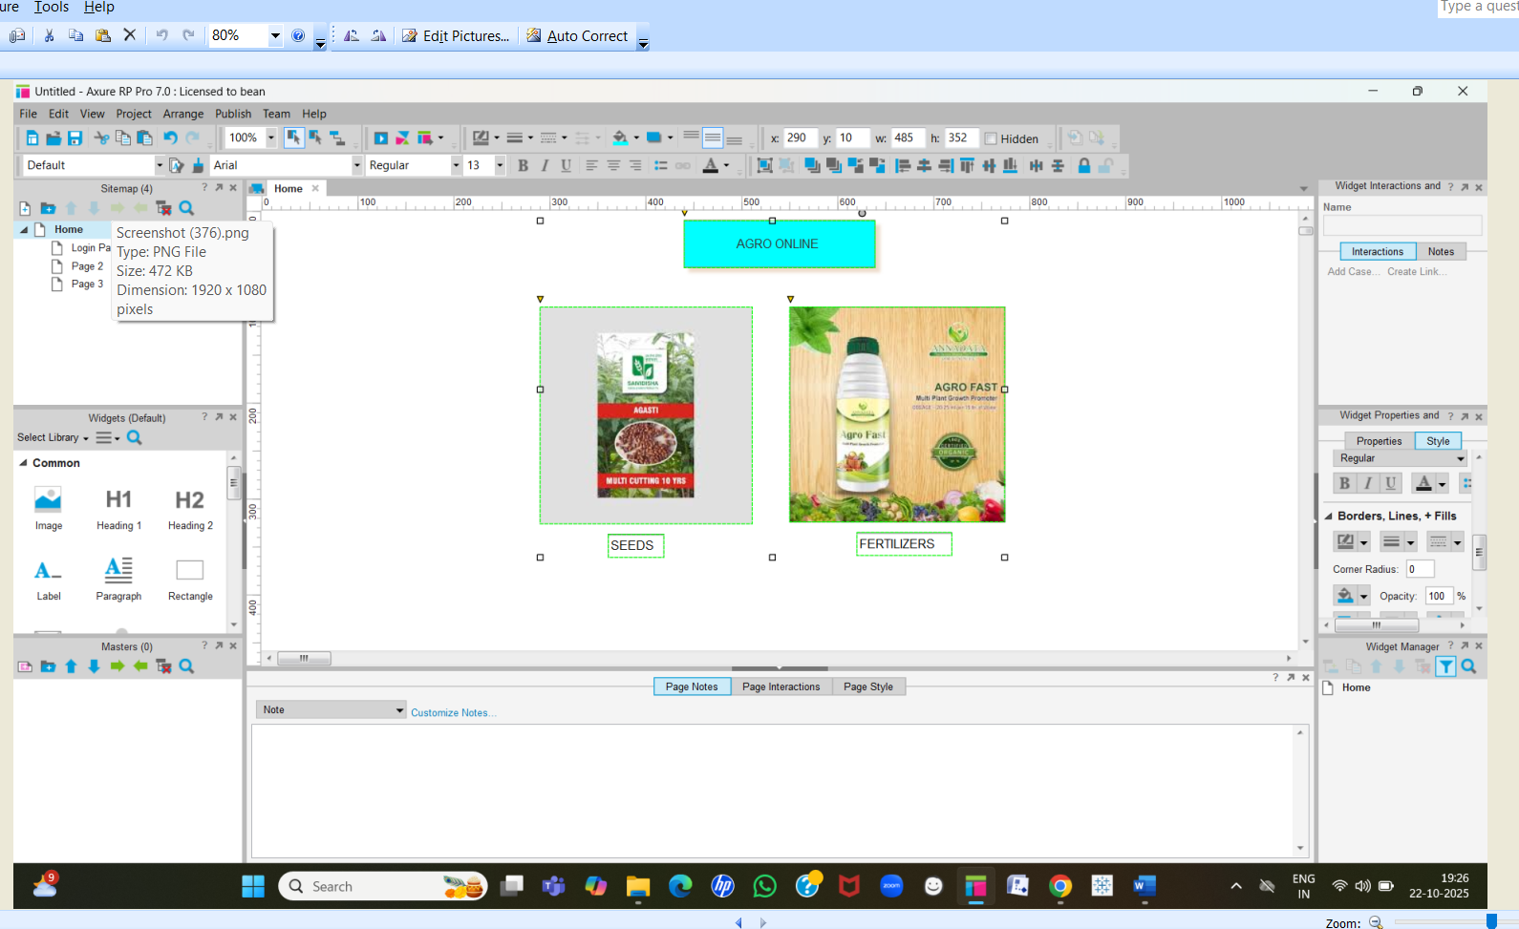

Question 3 – Tools (Visio, Balsamiq) - 15 Marks
Make a note of the Tools, which you are using for above concepts.
Answer :
Microsoft Visio : Microsoft Visio is a diagramming and vector graphics application used to create diagrams, flowcharts, and other visual representation of complex information. It is a diagramming tool that helps visualize, document and communicate complex business processes, systems and requirements to stake holders. It is used for creating process maps, flowcharts, UML diagrams, and organizational charts to visualize requirements and model "as-is" and "to-be" business states. It translates complicated information into clear easy to understand diagrams.
Balsamiq : Balsamiq is a rapid wireframing tool used to create mock-ups/Wireframes and prototypes of user interfaces. Balsamiq tool enables the quick creation of low fidelity, hand drawn sketches of user interfaces for websites and mobile applications. It helps visualize requirements, clarify user flows, and gather early stakeholder feedback on functionality and structure, not aesthetics. Its sketch-like design prevents stakeholders from getting distracted by visual details, allowing them to focus on core functionality and user flow. This facilitates clear communication, validates requirements, and ensures alignment before development begins.
Axure : Axure is a more advanced prototyping tool used to create high-fidelity, interactive wireframes and prototypes for web and mobile applications. Axure tool is used to create detailed, functional and interactive prototypes of applications and websites without writing any code. It helps visualize complex business logic and user interactions for stakeholders, allowing for early validation of requirements and improving communication with technical teams. BAs can use conditional logic, dynamic panels, and variables to create realistic user flows for validation and to bridge communication gaps with development teams.
Question 4 – RTM - 6 Marks
A business analyst’s key responsibilities are to keep track of the requirements and make sure that no requirement is missed.
Mr. Henry and peter have approached you regarding the current status of the project. How will you tackle this situation?
Answer :
Requirement Traceability Matrix (RTM) is a document to track the requirements throughout the project lifecycle, ensuring that they are met and that no requirements are overlooked. I will show Mr. Henry and Peter the below mentioned Matrix with the updates regarding the current status of the project.
 |  |  | D1 T1 | D2 T2 | D3 | T3 | D4 | T4
Req ID | Req Name | Req Description | Design | Code | UT (Unit Testing) | CT (Component Testing) | ST (System Testing) | SIT (System Integration Testing) | UAT (User Acceptance Testing)
FR001 | User Search Products | Users should be able to search for the available products by search option | Complete | Complete | Complete | Complete | Complete | Complete | Incomplete
FR002 | Users Browse Products | Users should be able to browse for the available products | Complete | Complete | Complete | Complete | Incomplete | Incomplete | Incomplete
FR003 | Users Login details | Users should be able to login with user credentials to application | Complete | Complete | Complete | Complete | Incomplete | Incomplete | Incomplete
FR004 | Users create login | Users should be able to register with the application | Complete | Complete | Complete | Complete | Incomplete | Incomplete | Complete
FR005 | Adding products to the cart | Users should be able to add the products to the cart | Complete | Complete | Complete | Complete | Incomplete | Incomplete | Incomplete
FR006 | Adding products to the wishlist | Users Should be able to add the products to the wishlist | Complete | Complete | Complete | Complete | Complete | Incomplete | Incomplete

Question 5 – 10 Test Case Documents - 10 Marks
Prepare 10 Test Case Documents
Answer :
A Test case document is a detailed outline used by testers to ensure that a software application or system is working as expected. A Test case document is a structured artifact that outlines a set of steps, data, and conditions to verify that a specific function of a software application works correctly and meets its business requirements. A test case document helps a business analyst ensure that a solution is not only technically correct but also functionally relevant to the end-user.
Test Case ID | PQ01TS003 | Test Case Name | Search Query
Project ID | PQ01 | Project Name | Online Agricultural products
PM ID | 1234 | PM Name | Sreedhar
Test Strategy ID | PQ01TS002 | Tester ID
Test Plan ID | PQ01TP001 | Tester Name
Test Schedule ID | PQ01TS002 | Date of Test
Scenario | Search for Product
Link to that page | www.sample.in
 | Set 1 | Set 2 | Set 3
Input Data | Pesticides  5 Kg  Expiry 2027  Powder  Liquid | Seeds  2 kg  Expiry 2026  vegetables  Fruits | Fertilizers  10 Kg  Expiry 2027  Powder  Liquid
Expected Behaviour | 15 Products to display | 20 Products to display | 10 Products to display
Actual Behaviour
Comments
Result Pass/Fail

Test Case ID | PQ01TS004 | Test Case Name | Registration
Project ID | PQ01 | Project Name | Online Agricultural products
PM ID | 1234 | PM Name | Sreedhar
Test Strategy ID | PQ01TS005 | Tester ID
Test Plan ID | PQ01TP001 | Tester Name
Test Schedule ID | PQ01TS005 | Date of Test
Scenario | User Registration
Link to that page | www.Agroonline.co
 | Set 1 | Set 2 | Set 3
Input Data | Email Address | Password | Mobile No
Expected Behaviour | Valid Email to be used for creating login | Password should be Alpha numeric | Valid Mobile No should be used to get SMS
Actual Behaviour
Comments
Result Pass/Fail

Test Case ID | PQ01TS008 | Test Case Name | Add to Cart
Project ID | PQ01 | Project Name | Online Agricultural products
PM ID | 1234 | PM Name | Sreedhar
Test Strategy ID | PQ01TS009 | Tester ID
Test Plan ID | PQ01TP001 | Tester Name
Test Schedule ID | PQ01TS009 | Date of Test
Scenario | Product add to cart
Link to that page | www.Agroonline.co
 | Set 1 | Set 2 | Set 3
Input Data | User Login to Account  Select which product to add to cart  view added product in Cart
Expected Behaviour | Users should compulsory login in order to add products to cart  Users should be able to view the list of products added to cart
Actual Behaviour
Comments
Result Pass/Fail

Test Case ID | PQ01TS010 | Test Case Name | Add to Wishlist
Project ID | PQ01 | Project Name | Online Agricultural products
PM ID | 1234 | PM Name | Sreedhar
Test Strategy ID | PQ01TS007 | Tester ID
Test Plan ID | PQ01TP001 | Tester Name
Test Schedule ID | PQ01TS007 | Date of Test
Scenario | Product add to wishlist
Link to that page | www.Agroonline.co
 | Set 1 | Set 2 | Set 3
Input Data | User Login to Account  Select which product to add to cart  Wishlist
Expected Behaviour | Users should compulsory login in order to add products to wishlist  Users should be able to view the list of products added to wishlist
Actual Behaviour
Comments
Result Pass/Fail

Test Case ID | PQ01TS006 | Test Case Name | Place order
Project ID | PQ01 | Project Name | Online Agricultural products
PM ID | 1234 | PM Name | Sreedhar
Test Strategy ID | PQ01TS008 | Tester ID
Test Plan ID | PQ01TP001 | Tester Name
Test Schedule ID | PQ01TS008 | Date of Test
Scenario | Place order
Link to that page | www.Agroonline.co
 | Set 1 | Set 2 | Set 3
Input Data | Users should compulsory login in order to Place the order for product  Users should be able to view the list of products added to cart  Users can place order from cart added products | Users should compulsory login in order to Place the order for product  Users should be able to view the list of products added to wishlist  Users can place order from wishlist added products | Users should compulsory login in order to Place the order for product  Users should be able to place the order directly from product list page
Expected Behaviour | Compulsory login and confirm the order  Email confirmation of order  SMS confirmation of Order | Compulsory login and confirm the order  Email confirmation of order  SMS confirmation of Order | Compulsory login and confirm the order  Email confirmation of order  SMS confirmation of Order
Actual Behaviour
Comments
Result Pass/Fail

Test Case ID | PQ01TS011 | Test Case Name | Select Payment
Project ID | PQ01 | Project Name | Online Agricultural products
PM ID | 1234 | PM Name | Sreedhar
Test Strategy ID | PQ01TS010 | Tester ID
Test Plan ID | PQ01TP001 | Tester Name
Test Schedule ID | PQ01TS010 | Date of Test
Scenario | Select Payment
Link to that page | www.Agroonline.co
 | Set 1 | Set 2 | Set 3
Input Data | Select Payment method of UPI  Select bank | Select Payment method of COD | Select Payment method of Card  Select type of card
Expected Behaviour | Compulsory valid bank Account UPI  Show payment done message  Show order confirmation message | Show payment selected option  Show confirm order message | Compulsory valid bank Account Card  Show payment done message  Show order confirmation message
Actual Behaviour
Comments
Result Pass/Fail

Test Case ID | PQ01TS003 | Test Case Name | Search
Project ID | PQ01 | Project Name | Online Agricultural products
PM ID | 1234 | PM Name | Sreedhar
Test Strategy ID | PQ01TS002 | Tester ID
Test Plan ID | PQ01TP001 | Tester Name
Test Schedule ID | PQ01TS002 | Date of Test
Scenario | Search by category
Link to that page | www.sample.in
 | Set 1 | Set 2 | Set 3
Input Data | By Name  Pesticides  Seeds  Fertilizers | By Price  price range 1$ to 1000 $  Price range 1001 $ to 2000$  Price range 2001 $ and above | By Location  Newyork  Washington  New Delhi  Mumbai
Expected Behaviour | 30 Products to display each category 10 products | 20 Products to display | 3 Products to display per location
Actual Behaviour
Comments
Result Pass/Fail

Question 6 – DB Design – 8 Marks
After the requirements are thoroughly explained to the entire project team by business analyst, the Database architects have decided to do the database design and also to represent the in-flow and out-flow of data.
Draw database schema and ER diagram
Answer :
DB Schema : DB Schema is a blueprint that outlines the structure of a database, including its tables, fields, relationships, constraints and other characteristics. Understanding the schema is critical because it dictates how data can be accessed, analyzed, and used to generate business insights and drive decisions. All tables with their entities is called DB Schema. The Core concepts of DB Schema are
- Tables (or entities): Represent a type of business object, like Customers, Products, or Orders.
- Columns (or attributes/fields): Define the properties of a table, such as a FirstName or OrderDate.
- Rows (or records): Contain individual records of data within a table.
- Primary Key (PK): A unique identifier for each record in a table, ensuring no duplicates. For example, CustomerID in a Customers table.
- Foreign Key (FK): A field in one table that links to the primary key of another table, establishing a relationship. For instance, the CustomerID in an Orders table connects an order to a specific customer.
- Relationships: The connections between tables, defined by foreign keys. Common types include one-to-one, one-to-many, and many-to-many.
- Instance vs. Schema: The schema is the static blueprint, while the instance is the dynamic data stored at any given moment.

Entity-Relationship Diagram (ERD) : An Entity Relationship Diagram is a visual representation of the relationships between entities in a database. It depicts the entities (Such as tables), attributes (Properties or fields), and relationships between them.
DB Schema + Entity Relationship Diagram is called DB Design

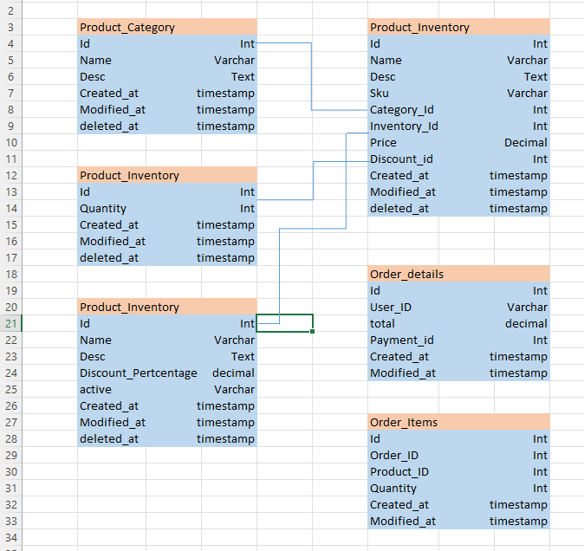

Question 7 – Data Flow Diagram - 3 Marks
What is a data flow diagram? Draw a data flow diagram to represent the in-flow and out-flow of data when a Farmer is placing an order for the product
Answer :
A Data Flow Diagram (DFD) is a graphical representation of the flow of data within a system. It visually shows how data moves from one person to another, how it’s stored, and where it ends up.
It helps analysts and designers understand the flow of data within a system, identify bottlenecks or inefficiencies and communicate system requirements to stake holders

Question 8 – Change Request - 10 Marks
Due to change in the Government Taxation structure . we should change the Tax structure How do you handle change requests in a project?
Answer :
A change request is a formal proposal to alter a system, product, or project. We should do the below mentioned steps to handle change request. BA along with the Project Manager has to carefully review and follow a rigorous change control process.
- Understand the scope of change request and document the change request in a central change log.
- Do the impact analysis – project scope, schedule, budget, resources and risks. This includes identifying any affected systems, business processes, or project deliverables and analyzing risks.
- Prioritize change requests based on its urgency, importance, impact on project. The BA works with stakeholders to prioritize the CR based on its business value, impact, and feasibility.
- The BA presents the documented analysis to a Change Control Board (CCB) or other decision-makers. They clearly communicate the pros and cons to help the team make an informed decision to approve, reject, or defer the change. Seek approval from the project sponsor for the change request
- Communicate the change request and its potential impacts to all relevant stakeholders, including the project team. This includes notifying all affected stakeholders of the decision and explaining the reasons behind it.

Question 9 – Change Request Vs an Enhancement - 5 Marks
As the project is in process, Ben and Kevin have contacted you. The reason is to inform you that they want the Farmers to sell their crop yields through this application i.e. Farmers should be able to add their crop yields or products and display to general public and should be able to sell them. They also want to introduce Auction system for their Crop yields. As a BA, what will be your response?
Is this a change request or an enhancement???
Answer :
Change Request : Change Request is a formal proposal to alter a project's baselined requirements, scope, or design. Its meaning is rooted in establishing a controlled process to manage inevitable project changes, preventing scope creep, and ensuring the final product aligns with evolving business needs.
Enhancement : Enhancement is a planned improvement that adds new capabilities or features to an existing system, going beyond the original scope. Unlike a bug fix, which corrects an error, an enhancement introduces new value and evolves the software to meet changing business or user needs.
In this case, introducing Auction system for the crop yields would be considered an enhancement as it involves adding new features to the system.
As a Business Analyst, we should document the requirements and work with the development team to determine the feasibility and impact of the new features. We should also consider the potential benefits, risks and cost associated with the enhancements before making any recommendations to the client.
Question 10 – Estimations - 6 Marks
Come up with estimations – How many Manhours required
Answer :
Man hours are the required effort of the resources to complete a project. Man hours represents the total amount of uninterrupted effort, measured in hours, needed by a team to complete specific tasks or a project. It is a critical metric for project planning, costing, and resource management. The projects can be divided into there 3 types based on the manhours of work needed to complete the project.
Small Project : Upto 500 Man Hours
Medium Project : Upto 1000 Man Hours
Large Project : Upto 1500 Man Hours and above
Analysis :
As per the case study, the duration of the project is 18 months and the current team size is around 11. This will come under Large project.
As the structure of the project is new and the time allocated is 18 months, we will need around 33000 manhours to complete the project by considering total of 250 working days in an year and 375 days for 18 months project by removing the weekends and festival and other holidays.

Question 11 – UAT – 6 Marks
Project has finally completed all the stages i.e., design, development, testing etc. Now, it is the role of a business analyst to contact the client for testing of the final product and have to successfully complete it. How are you going to handle this situation? And once it is done, what will be the process to close the project?
Explain UAT Acceptance process
Answer :
User Acceptance (UAT) process is the final stage of testing. For a business analyst (BA), UAT signifies the formal procedure of verifying and gaining sign-off from end-users that the developed solution meets their defined business requirements and is fit for purpose. The process is owned by the business users, with the BA serving as a crucial facilitator.
The primary objective of the UAT process is to validate that the software works as the end-users expect it to in real-world, day-to-day scenarios, not just that it is technically functional. This final quality gate helps to uncover any gaps, usability issues, or missed requirements before the product is released to production.
UAT Acceptance process is done by BA by doing the below processes.
Planning : In this step, Blue prints are made to implement UAT testing for every feature that needs to test and minimum standards for accepting the test.
Designing : Here the Test cases are designed to hide all the possibilities of software packages in a real world environment.
UAT Testers : A Testing team consists of a end users that meet the criteria for implementing testing. They should know the test cases to run and understand the functionalities.
Bug Fixing : Whatever Bugs are found in the UAT Testing, the development team should work on them and make it software error free.
Sign Off : After removing all the bugs, the testing team indicates acceptance of the completion of the bugs. In this phase, all the stakeholders come to a conclusion that the software is ready to GO LIVE and sign it off.

Question 12 – Project Closure Document - 6 Marks
Explain Project closure document
Answer :
A project closure document, also known as a project closure report is a formal document that summarizes the key outcomes, lessons learned, and final details of a completed project.
Project closure document serves as a comprehensive record of the project’s accomplishments, challenges and overall performance, providing valuable insights for stakeholder and future projects.
Business Analyst should include the below mentioned points in the project closure document.
- Project overview
- Achievements
- Lessons Learned
- Quality Assurance
- Resource Utilization
- Risk Management
- Challenges
S.No | Points to Include | Details | Reference Link
1 | Did the client signed off on the UAT Testing |  | Business Scope document.doc
 | Date of the Signoff | 20-10-2025 | Business Scope document.doc
 | Name of the resource | Mr. Henry | Business Scope document.doc
2 | Objectives of the project
 | User Friendliness | Achieved
 | Customer satisfaction | ROI in 6 months
 | More Categories | Achieved
3 | Functionalities worked on
 | Secure payment processing | Achieved
 | Categories | Achieved
4 | Infrastructure
 | Softwares Installed | Achieved
 | Laptops purchased | Achieved
5 | Funding |  | Finance breakdown.doc
 | Amount Approved | Rs. 1 Crore | Finance breakdown.doc
 | Amount Used | Rs. 95 Lakhs | Finance breakdown.doc
6 | Overall project Information
 | Escalations | 50
 | Customer satisfaction | High
7 | Value to the company
 | Positive / Negative | Positive - 90%  - Company has gained an edge over the competitors  - Increased clients  - Trained employees  - New project in pipeline

