COEPD – Traditional Development
Capstone Project 3 – Part 2/2 – 100 Marks

Document 6: Please prepare a use case diagram, activity diagram and a use case specification document.
1. Use case Name 2. Use case Description 3. Actors Primary Actors Secondary actors 4. Basic Flow 5. ALTERNATE FLOW 6. Exceptional flows 7. Pre- Conditions 8. post-conditions 9. Assumptions 10. Constraints 11. Dependencies 12. Inputs and Outputs 13. Business Rules 14. Miscellaneous Information

Use Case Specification Document
- Use Case Name:
Recharge Mobile

- Use Case Description:
This use case enables a customer to recharge their prepaid mobile number via the Vodafone web or mobile application using real-time plan recommendations and integrated payment processing.

- Actors:
- Primary Actor: Customer
- Secondary Actors: Payment Gateway, Recharge API System, Notification Service

- Basic Flow:
- Customer logs into the application.
- System displays personalized plan options.
- Customer selects a recharge plan.
- System displays recharge summary.
- Customer proceeds with payment.
- Payment is processed via payment gateway.
- Recharge is initiated via the backend API.
- Confirmation is shown and notification is sent.

- Alternate Flow
- If the customer does not log in, they can use OTP login.
- Customer can browse all plans manually using filters.

- Exceptional Flows:
- Payment failure Show error and allow retry.
- Recharge API timeout Notify user and retry or schedule.
- Network failure Show offline message or save request.

- Pre-Conditions:
- Customer has an active mobile number.
- Customer has an internet connection.

- Post-Conditions:
- Mobile number is recharged successfully.
- Confirmation sent to user.

- Assumptions:
- Plans are fetched in real-time via an external API.
- Payment gateway integration is secured and active.

- Constraints:
- Recharge amount limits per transaction.
- API response time must be < 5 sec.

- Dependencies:
- Telecom plan API availability.
- Third-party payment gateway uptime.

- Inputs and Outputs:
- Inputs: Mobile number, plan selection, payment details.
- Outputs: Recharge confirmation, SMS/email receipt.

- Business Rules:
- Customers must be authenticated before recharge.
- GST and surcharge auto-calculated.
- Real-time offer eligibility checks.

- Miscellaneous Information:
- Application logs all steps for compliance.
- Recharge history is stored in user profile.

Use Case Diagram for Recharge Mobile:

Activity Diagram for Recharge Mobile:

Document 7: Screens and pages
Please follow the following steps to create the mock-ups 1. Kindly use balsamic or Axure. 2. Always start with a home page of an application. 3. Take a feature and follow it to the end a. Eg: Home page of SCRUM Foods b. Select Login- Create a login page c. Let’s assume, you want to search a restaurant d. Search page- Type the restaurant name and select the dish e. Add to cart page f. Payment page g. Logout page
Screens and Pages for Vodafone Project:
- Login Page:
- Purpose: Allow existing customers to log in
- Elements:
- Mobile Number or Email & Password fields
- Login button
- Links for: Forgot Password, Register, and Login with OTP

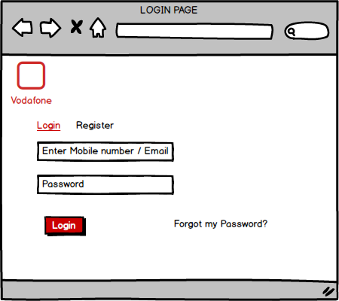

- Home Page:
- Purpose: Entry point of the Vodafone web portal
- Elements:
- Vodafone logo and tagline
- Navigation bar: Home, Recharge, Plans, My Account
- Banners: Promotions and Offers
- Quick access: Recharge Now, View Plans, Log In

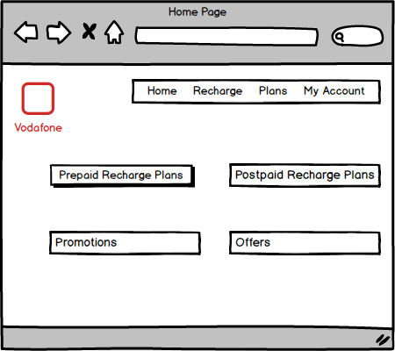

- Recharge Search Page:
- Purpose: Search and select recharge plans
- Elements:
- Search bar: Enter Mobile Number
- Circle/Region dropdown
- Plan types: Data, Talktime, Combo
- List of plans with prices, validity, and "Add to Cart" button

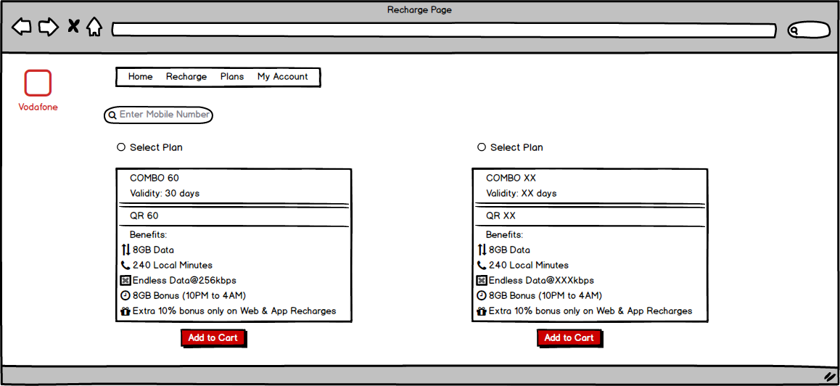

- Cart Page:
- Purpose: Review selected plans before payment
- Elements:
- Plan details: Amount, Validity
- Option to edit/delete plans
- Total price
- Proceed to payment button

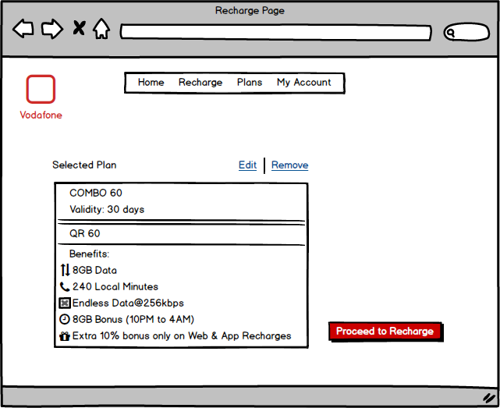

- Payment Page:
- Purpose: Complete the transaction
- Elements:
- Order summary
- Payment options: Card, UPI, Net Banking, Wallets
- Promo code field
- Pay Now button

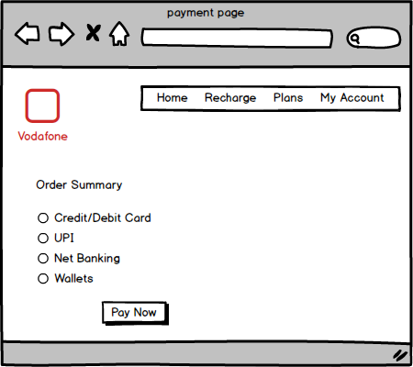

- Logout Page / Confirmation:
- Purpose: Securely end user session
- Elements:
- Confirmation message
- Logout and Cancel buttons
- Redirect to Home after logout

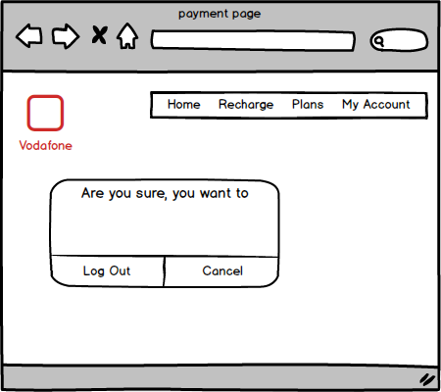

Document 8- Tools-Visio and Axure
Write a paragraph on your experience using Visio and Axure for the project.
As a Business Analyst on the Vodafone E-Commerce project, I leveraged Microsoft Visio for creating detailed diagrams such as Use Case, Activity, and Process Flow Diagrams to represent user interactions and system behaviour clearly. Visio helped in simplifying complex workflows and was particularly useful during requirement analysis and design discussions. Additionally, I used Axure RP to develop interactive wireframes and page prototypes that simulated real-time user journeys, including login, plan search, cart, and payment flows. These visual aids made it easier for stakeholders to validate the UI/UX early in the lifecycle and provided developers with clear implementation direction. Both tools significantly improved communication, reduced ambiguities, and contributed to smoother project execution.

Document 9- BA experience: My experience as BA in following phases:
Business Analyst Experience Document: Vodafone E-Commerce Project
- Requirement Gathering Phase:
- Applied the MOSCOW prioritization technique to identify and categorize business needs.
- Faced temporary unavailability of client; proactively identified alternate points of contact to gather essential inputs.
- Validated all collected requirements using the FURPS model (Functionality, Usability, Reliability, Performance, Supportability).
- Identified and eliminated duplicate or redundant requirements.
- Used prototyping (e.g., wireframes) to clarify requirements and obtain precise feedback from stakeholders.

- Requirement Analysis Phase:
- Developed UML diagrams (use case, class, and sequence diagrams) to visualize requirements.
- Created activity diagrams to define detailed process flows.
- Presented visual artifacts to the technical and QA teams for review.
- Handled discrepancies or disagreements among team members with a collaborative approach; incorporated constructive feedback to revise diagrams.
- Drafted and finalized Business Requirement Specification (BRS) and System Requirement Specification (SRS) documents.

- Design Phase:
- Derived comprehensive test cases from finalized use case diagrams.
- Communicated with the client to confirm solution and design documents.
- Created both positive and negative test cases to ensure functional robustness.
- Emphasized test case coverage to avoid missing critical validations.
- Created test data sets for QA execution.
- Updated and maintained the Requirement Traceability Matrix (RTM) to ensure all business requirements are mapped to test cases.

- Development Phase:
- Organized and facilitated Joint Application Development (JAD) sessions.
- Addressed and clarified developer queries related to business logic and functionality.
- Managed team conflicts tactfully; held one-on-one discussions with uncooperative team members to realign their focus and emphasize the importance of collaboration.
- Referred requirement diagrams to support and guide unit development.
- Scheduled and led regular sync-up meetings with the technical team and client, even accommodating absentees with recorded sessions and individual follow-ups.

- Testing Phase:
- Prepared test cases directly from use cases.
- Conducted high-level functional testing to ensure application readiness.
- Collected required test data by coordinating with the client.
- Ensured RTM was up to date with complete coverage.
- Coordinated with the client to receive formal sign-off on testing deliverables.
- Played a key role in User Acceptance Testing (UAT) preparation by educating and enabling the client’s team.

- Deployment Phase:
- Forwarded updated RTM to the client for inclusion in the project closure documentation.
- Managed the creation and distribution of end-user manuals.
- Planned and conducted training sessions for end users and internal staff.
- Monitored and confirmed full attendance in training sessions for effective user onboarding.
This hands-on involvement across the entire SDLC (Software Development Life Cycle) enabled successful project delivery while maintaining strong collaboration with both technical teams and client stakeholders.

