Document 1- Business Case Document
Project Name: ICS Global Proxy Services – Certificate Automation
Project ID: ICS-PRJ-2025
Version ID: V1.0
Author: Anirudh Gottipamula, Business Analyst
1. Why is this project initiated?
This project is initiated to automate the end-to-end process of certificate issuance within ICS Global Proxy Services at Broadridge.
Currently, certificates and confirmations are created manually through MOCHA Mainframe screens and internal tools, leading to inefficiencies and risks.
Automation will ensure accuracy, timeliness, scalability, and compliance while enhancing client satisfaction and operational efficiency.
2. What are the current problems?
- High Risk of Errors: Manual entry in MOCHA mainframe screens leads to typographical or processing mistakes.
- Delays in Processing: Manual workflows increase turnaround time for proxy service deliverables.
- Missed Communications: Some corporate action / proxy mail instructions may be overlooked.
- Scalability Limitations: Manual effort struggles with increased global volumes during peak proxy season.
- Compliance Risks: Regulatory deadlines (SEC, corporate governance rules) may not always be met.
3. With this project how many problems could be solved?
The proposed solution will address the following:
- Eliminate human errors through automated data entry and validation.
- Reduce turnaround time for certificate / proxy processing by 50% or more.
- Ensure no client / shareholder communication is missed using automated parsing and alerts.
- Enable scalability to handle 2x current peak season volumes.
- Enhance compliance with built-in regulatory & market-specific rules.
- Improve client satisfaction and strengthen Broadridge’s market position in proxy services.
4. What are the resources required?
People (Human Resources):
- From Broadridge (Client side): Business Stakeholders (2–3), Process Experts (2–3).
- From IT Solutions Pvt. Ltd.: Project Manager (1), Java Developers (5), DBAs (2), System Admins (2), QA Testers (3), Business Analyst (1).
Time (Timeline):
- Requirement Gathering – 1 month
- System Design – 1 month
- Development – 3 months
- Testing – 1–1.5 months
- Deployment – 0.5 month
- Support & Stabilization – 1–2 months post-deployment
Total Duration: ~7–8 months
Budget (Indicative): ₹35–45 Lakhs INR (Development, Infrastructure, Licensing, Training, Support).
Other Resources:
- Hardware: Dedicated servers, backup systems
- Software: Java IDEs, MOCHA integration tools, database tools, email parsing software
- Network: Secure VPN, high-speed internet, secure gateways
5. How much organizational change is required to adopt this technology?
Medium-level change management required:
- Training staff on the new automated proxy certificate system.
- Change management for employees who are used to manual MOCHA-based processing.
- Alignment of existing workflows with automated proxy handling.
6. Time frame to recover ROI (Return on Investment)?
Expected ROI: 12–18 months post-implementation.
Savings will come from:
- Reduced errors & rework.
- Faster turnaround time improves client retention.
- Handling larger volumes without extra manpower.
7. How to identify Stakeholders?
Stakeholders are identified based on impact and influence:
- High Influence / High Interest: Project Sponsor (Broadridge Senior Management), Global Proxy Services Heads.
- Medium Influence / High Interest: Process Experts, End Users.
- High Influence / Medium Interest: IT Project Manager, Business Analyst.
- Medium Influence / Medium Interest: Developers, QA Testers, DBAs, Admins.
Document 2: BA Strategy
Business Analyst Approach Strategy
1. Requirement Elicitation Techniques
- Conduct interviews with business stakeholders and SMEs.
- Use workshops/JAD sessions to gather group inputs.
- Questionnaires/surveys for large stakeholder groups.
- Observation/Job shadowing for existing manual processes.
- Document analysis of legacy certificates, client emails, compliance guidelines.
2. Stakeholder Analysis
- Identify stakeholders: business users, IT team, compliance team, client representatives.
- Classify stakeholders: High/Low influence, High/Low interest (Stakeholder Matrix).
- Prepare RACI Matrix (Responsible, Accountable, Consulted, Informed) to define roles.
- Maintain ILS (Interface Level Sheet) to document interfaces between systems, teams, and clients.
3. Documentation to Prepare
- Business Case Document (Why project is initiated).
- BRD (Business Requirement Document) – Functional + Non-Functional requirements.
- FRD (Functional Requirement Document) – Detailed technical requirements.
- Use Case Diagrams / Process Flows.
- Requirement Traceability Matrix (RTM) – Map requirements to test cases.
- Change Request Log – Maintain changes post sign-off.
- UAT Scenarios and Test Cases.
- Client Project Acceptance Form for UAT sign-off.
4. Approval & Sign-off Process
- Submit draft documents (BRD/FRD/RTM) to stakeholders.
- Walkthrough sessions with business and IT teams.
- Collect formal approval via email or e-signature (tools: JIRA, Confluence, SharePoint).
- Update version history to ensure traceability.
5. Communication Channels
- Weekly status meetings with stakeholders.
- Daily stand-ups with the development team (Scrum/Agile).
- Email communication for formal approvals.
- Use collaboration tools (JIRA, Confluence, MS Teams, Slack).
- Status reports distributed weekly/monthly.
6. Handling Change Requests
- Capture CR in Change Request Form with impact analysis.
- Review change impact on scope, time, cost, quality.
- Discuss with client and project manager.
- Update BRD/FRD & RTM if approved.
- Maintain Change Log for audit purposes.
7. Updating Project Progress
- Weekly project status reports (progress, blockers, next steps).
- Maintain project dashboards (JIRA dashboards or Excel trackers).
- Escalate risks/issues in RAID log (Risks, Assumptions, Issues, Dependencies).
- Share updates in stakeholder review meetings.
8. UAT & Client Sign-off
- Prepare UAT Test Scenarios & Cases aligned with requirements.
- Facilitate UAT Execution with business users.
- Capture defects/feedback and resolve before closure.
- Once accepted, collect formal sign-off via Client Project Acceptance Form.
- Transition project into production & support phase.
Document 3- Functional Specifications
Project Details
Project Name: ICS Global Proxy Services – Certificate Automation
Project ID: ICS-PRJ-2025
Version ID: V1.0
Author: Anirudh Gottipamula, Business Analyst
Functional Requirement Specifications
Req ID | Req Name | Req Description | Priority
FR0001 | Login | User should be able to log in to the application securely with role-based access. | 10
FR0002 | Email Extraction | System should automatically extract incoming emails and parse attachments. | 10
FR0003 | Data Validation | Extracted data should be validated against predefined business rules. | 9
FR0004 | Certificate Creation | System should auto-generate insurance certificates in PDF format. | 10
FR0005 | Certificate Delivery | Certificates should be delivered via email or uploaded to client portal. | 9
FR0006 | Error Handling | System should log errors and notify admin for failed processes. | 8
FR0007 | Audit Trail | Every action (creation, modification, delivery) should be logged for compliance. | 7
FR0008 | User Management | Admin should be able to create, update, and deactivate user accounts. | 8
FR0009 | Reports & Dashboard | Generate daily/weekly reports of processed certificates and system usage. | 7
FR0010 | Compliance Check | Ensure all certificates comply with U.S. insurance regulatory standards. | 9
Non-Functional Requirement Specifications
Req ID | Req Name | Req Description | Priority
NFR0001 | Performance | System should process meeting updates within 3 seconds. | 10
NFR0002 | Scalability | System should support 2x current volume of proxy events. | 9
NFR0003 | Availability | Ensure 24/7 system availability with 99.9% uptime. | 10
NFR0004 | Security | Provide role-based access with Single Sign-On (SSO). | 10
NFR0005 | Compliance | System must comply with SEC & Broadridge internal audit standards. | 9
NFR0006 | Usability | Interface should be user-friendly and require minimal training. | 8
NFR0007 | Auditability | Maintain logs for all updates for audit & compliance tracking. | 9
NFR0008 | Maintainability | System should allow easy modifications with minimal downtime. | 8
NFR0009 | Reliability | Auto backup every 15 minutes to prevent data loss. | 9
NFR0010 | Integration | Must seamless
Document 4- Requirement Traceability Matrix
Req ID | Req Name | Req Description | Design | D1 | T1 | D2 | T2 | UAT
FR0001 | Login | User must be able to log in to access the application | Yes | Pending | No | Yes | Yes | YES
FR0002 | Email Extraction | System should automatically extract emails & parse attachments | Yes | Yes | No | Yes | Yes | YES
FR0003 | Data Validation | Extracted data should be validated against business rules | Yes | Pending | No | Yes | Yes | YES
FR0004 | Certificate Creation | System should auto-generate insurance certificates in PDF format | Yes | Yes | No | Yes | Yes | YES
FR0005 | Certificate Delivery | Certificates should be delivered via email or uploaded to portal | Yes | Yes | No | Yes | Yes | YES
FR0006 | Error Handling | System should log errors and notify admin | Yes | Pending | No | Yes | Yes | YES
FR0007 | Audit Trail | Every action should be logged for compliance | Yes | Yes | No | Yes | Yes | YES
FR0008 | User Management | Admin should be able to manage user accounts | Yes | Yes | No | Yes | Yes | YES
FR0009 | Reports & Dashboard | Generate reports of processed certificates | Yes | Pending | No | Yes | Yes | YES
FR0010 | Compliance Check | Ensure compliance with U.S. insurance regulatory standards | Yes | Pending | No | Yes | Yes | YES
Document 5- BRD Template
ICS Global Proxy Services Project
- Project Name: ICS Global Proxy Services – Certificate Automation System
- Project ID: ICS-GPS-2025-001
- Version ID: v1.0
- Author: Anirudh Gottipamula (Business Analyst)
- Date: 21-Aug-2025
- Reviewed By: Project Manager – Mr. Suresh Reddy
- Approved By: Client Sponsor – JP Morgan
- Confidentiality Level: Internal Use Only
1. Document Revisions
Date | Version Number | Document Changes
21-08-2025 | 0.1 | Initial Draft created
25-08-2025 | 0.2 | Added Business Case section
28-08-2025 | 0.3 | Added BA Strategy document
01-09-2025 | 0.4 | Added Functional Specs
03-09-2025 | 0.5 | Added Requirement Traceability Matrix
05-09-2025 | 1 | Final Version Approved
2. Approvals
Role | Name | Title | Signature | Date
Project Sponsor | Mr. Rajesh Sharma | Director – Patra India |  | 21-08-2025
Business Owner | Ms. Anjali Verma | VP – Business Operations |  | 21-08-2025
Project Manager | Mr. Suresh Reddy | Project Manager – IT Solutions Pvt. Ltd. |  | 21-08-2025
System Architect | Mr. Arvind Kumar | Lead Architect |  | 22-08-2025
Development Lead | Ms. Priya Nair | Development Lead |  | 22-08-2025
User Experience Lead | Ms. Kavya Rao | UX Lead |  | 23-08-2025
Quality Lead | Mr. Sanjay Malhotra | QA Manager |  | 23-08-2025
Content Lead | Ms. Ritu Singh | Documentation Lead |  | 23-08-2025
3. RACI Chart for This Document
Name | Position | R | A | S | C | I
Rajesh Sharma | Project Sponsor |  |  |  | C | I
Anjali Verma | Business Owner |  | A |  | C | I
Suresh Reddy | Project Manager |  | A | S |  | I
Arvind Kumar | System Architect | R |  | S | C
Priya Nair | Development Lead | R |  | S | C
Kavya Rao | User Experience Lead | R |  | S | C
Sanjay Malhotra | Quality Lead | R |  | S | C
Ritu Singh | Content Lead | R |  | S | C
Explanation:
- Project Sponsor (Rajesh Sharma) → ultimate approval authority and needs to be consulted & informed.
- Business Owner (Anjali Verma) → accountable for business accuracy.
- Project Manager (Suresh Reddy) → ensures accuracy, supports document creation.
- System Architect / Dev / UX / QA / Content Leads → responsible for sections, provide supporting inputs.
4. Introduction
4.1. Business Goals
The primary goal of ICS Global Proxy Services is to enhance transparency, compliance, and operational efficiency in the proxy voting and certificate management process.
Organization Goals & Need:
- Ensure regulatory compliance with global governance standards.
- Provide secure and timely certificate generation for proxy voting.
- Reduce manual effort and errors by introducing automation.
- Enhance client satisfaction by delivering accurate reports and certificates.
- Improve scalability to handle increasing volumes of proxy-related documentation.
4.2. Business Objectives
To provide an IT Solution for:
- Certificate Generation Automation (for proxy voting events).
- Mobile application for Android and iOS to track proxy events and certificates.
- E-Learning Management System (LMS) to train internal teams and clients on proxy regulations and system usage.
- Human Resource Management System (HRMS) integration to streamline internal staff management and training allocation.
4.3. Business Rules
The system must adhere to the following policies, procedures, and regulations:
- All certificate generation must comply with SEC, SEBI, and global governance standards.
- System must support multi-level approvals before final certificate issuance.
- Audit trail of every action must be recorded and retrievable.
- Role-based access control (RBAC) must be enforced for data security.
- Certificates cannot be modified once issued – only reissued with version control.
- SLA compliance: Certificates must be generated within 24 hours of proxy event closure.
4.4. Background
ICS Global Proxy Services has been managing proxy voting events for multiple institutional investors and custodians. Currently, manual certificate generation leads to:
- Delays in reporting.
- Risk of compliance breaches.
- Lack of scalability with increasing global events.
The Certificate Automation System project was proposed to overcome these issues by digitizing and automating certificate creation, approval, and delivery. The expected benefits include faster turnaround times, improved accuracy, reduced costs, and enhanced compliance monitoring.
4.5. Project Objective
The objective of the Certificate Automation System is to:
- Develop an automated platform for proxy certificate generation.
- Enable seamless interaction with existing ICS proxy voting systems and reporting tools.
- Provide a mobile-friendly experience for end-users and clients.
- Ensure compliance with global corporate governance standards.
- Improve operational efficiency by reducing manual intervention and turnaround time
4.6. Project Scope
4.6.1. In-Scope Functionality
- Automated certificate generation for proxy voting events.
- Mobile applications for Android & iOS.
- Integration with E-Learning Management System for compliance training.
- HRMS integration for workforce management.
- Role-based access management for certificate creation and approval.
- Audit trail and reporting module.
- Multi-level approval workflow.
- Secure storage and retrieval of certificates.
4.6.2. Out-of-Scope Functionality
- Real-time voting system changes (only certificate automation is covered).
- Third-party custodial systems integration beyond current client base.
- AI-based analytics or predictive modeling (future enhancement).
- Legacy system migration beyond certificates module.
- End-to-end HRMS development (only integration is included).
5. Assumptions
The following assumptions have been made while preparing this Business Requirements Document (BRD). These assumptions form the basis for defining requirements, scope, and project planning:
- Data Availability & Accuracy
  - All proxy event and shareholder data required for certificate generation will be accurately provided by existing ICS systems or client feeds.
- System Integration
  - Existing ICS systems (Proxy Voting Platform, Reporting Tools, HRMS, LMS) will be available and accessible for integration without major re-engineering.
- Regulatory Guidelines
  - Global regulatory frameworks (e.g., SEC, SEBI, ESMA) will remain stable during the project timeline, with only minor adjustments required for compliance updates.
- User Accessibility
  - End-users will have access to internet-enabled devices (desktop, mobile, tablet) to use the system and mobile applications.
- Infrastructure
  - Required infrastructure (servers, cloud hosting, security tools) will be available and provisioned by the IT team before UAT.
- Stakeholder Availability
  - Key stakeholders (Business Owner, Compliance Officer, Development Leads) will be available for requirement validation, approvals, and UAT participation.
- Third-Party Dependencies
  - Third-party services (e.g., SMS/Email notifications, cloud storage APIs) will be stable, available, and within budgeted service limits.
- User Training
  - Employees and clients will undertake training through the integrated E-Learning system before go-live.
- Change Requests
  - Any scope changes outside the agreed BRD will follow a formal Change Request (CR) process.
- Security & Compliance
All data sharing, storage, and processing will comply with ICS information security policies and international data privacy regulations (e.g., GDPR).
6. Constraints
The following constraints apply to the development, deployment, and operation of this project:
- Budgetary Constraints
  - The project must be completed within the allocated budget approved by senior management.
- Time Constraints
  - The project must be delivered within the agreed timeline (12 months), including development, testing, and deployment phases.
- Regulatory Compliance
  - All processes must adhere strictly to global proxy regulations, data privacy laws (GDPR, CCPA), and local compliance standards.
- Technology Constraints
  - The system must be developed using the approved ICS technology stack (e.g., Java/.NET backend, Angular/React frontend, Oracle/SQL database).
  - Any deviation requires formal approval from IT Governance.
- Resource Availability
  - Skilled resources (Developers, QA, Business Analysts, Compliance Experts) are limited and must be shared across multiple ICS initiatives.
- Integration Limitations
  - The new system must integrate with existing ICS applications (HRMS, LMS, Proxy Voting Platform, Reporting Systems) without major architectural changes.
- Security Requirements
  - All system components must comply with ICS Information Security Policies including encryption standards, secure authentication, and access controls.
- Infrastructure Constraints
  - Deployment must align with ICS’s existing cloud and on-premises infrastructure strategy (hybrid model).
  - Data hosting in specific regions may be restricted due to local data residency laws.
- User Training & Adoption
  - Training must be delivered within the constraints of client schedules and internal resource availability.
- Change Management Constraints
All change requests outside the approved BRD must go through the formal Change Control Board (CCB), which may impact project timelines.
7. Risks
Risks are potential events or conditions that may adversely affect the successful delivery of the project. Risks are continuously monitored, reviewed, and updated throughout the project lifecycle.
7.1 Technological Risks
- Integration Issues with Legacy Systems
  - Likelihood: Medium
  - Impact: High (could delay deployment)
  - Strategy: Mitigate – conduct early integration testing and maintain technical fallback procedures.
- System Downtime During Migration
  - Likelihood: Medium
  - Impact: High (service disruption for global clients)
  - Strategy: Avoid – schedule phased rollouts with backup systems.
- Cybersecurity Vulnerabilities
  - Likelihood: High
  - Impact: High (data breach, regulatory penalties)
  - Strategy: Mitigate – implement robust encryption, penetration testing, and compliance audits.
7.2 Skills Risks
- Lack of Skilled Developers in Proxy Services Domain
  - Likelihood: Medium
  - Impact: Medium
  - Strategy: Mitigate – hire/train staff in advance and engage external SMEs if needed.
- Limited Availability of Compliance Experts
  - Likelihood: Low
  - Impact: High (could affect regulatory approvals)
  - Strategy: Transfer – outsource compliance validation to certified vendors if internal expertise is insufficient.
7.3 Political Risks
- Changes in Regulatory Policies (e.g., SEC, GDPR)
  - Likelihood: Medium
  - Impact: High
  - Strategy: Mitigate – continuous monitoring of global regulations and timely system updates.
- Geopolitical Instability in Certain Data Hosting Regions
  - Likelihood: Low
  - Impact: Medium
  - Strategy: Accept/Mitigate – ensure data redundancy across multiple regions.
7.4 Business Risks
- Project Cancellation Due to Budget Cuts
  - Likelihood: Low
  - Impact: High (loss of investment, reputational damage)
  - Strategy: Accept – business decision beyond project control.
- Client Resistance to System Adoption
  - Likelihood: Medium
  - Impact: Medium
  - Strategy: Mitigate – conduct change management and end-user training workshops.
7.5 Requirements Risks
- Incorrectly Captured Requirements
  - Likelihood: Medium
  - Impact: High (rework, scope creep)
  - Strategy: Avoid – validate requirements via JAD sessions, walkthroughs, and UAT sign-offs.
- Changing Business Priorities Mid-Project
  - Likelihood: High
  - Impact: Medium
  - Strategy: Mitigate – follow agile/scrum approach with regular backlog refinement.
7.6 Other Risks
- Vendor Dependency Risks
  - Likelihood: Medium
  - Impact: Medium
  - Strategy: Transfer – establish SLAs with vendors for accountability.
- Training Delays for End Users
  - Likelihood: Low
  - Impact: Medium
  - Strategy: Mitigate – prepare e-learning modules for self-paced learning.
8. Business Process Overview
This section outlines the existing (AS-IS) manual process followed in certificate issuance and the recommended (TO-BE) automated process, highlighting improvements and efficiencies introduced by the new system.
8.1 Legacy System (AS-IS)
Explanation:
Currently, the certificate generation process is manual and email-driven. Client requests for proxy certificates are received via email, which are then reviewed and processed manually by employees. This results in:
- Delays in certificate issuance.
- High risk of errors in manual data entry.
- Missed communications due to overlooked emails.
- Scalability issues as client volume increases.
Process Flow (AS-IS):
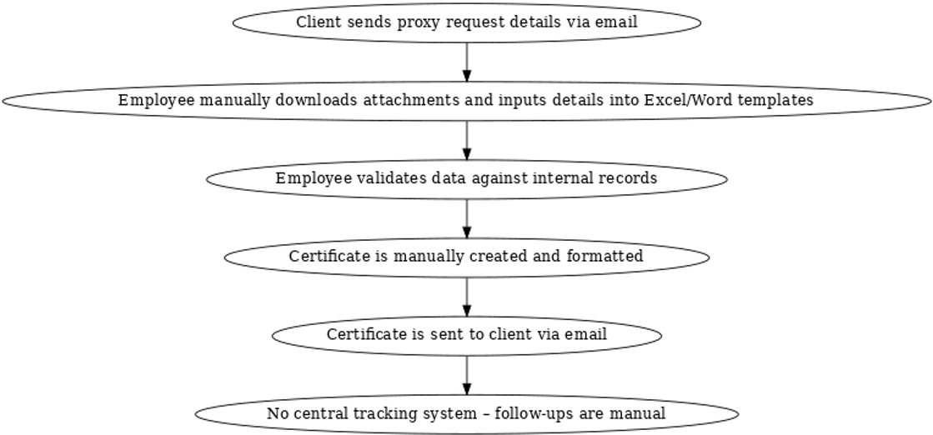
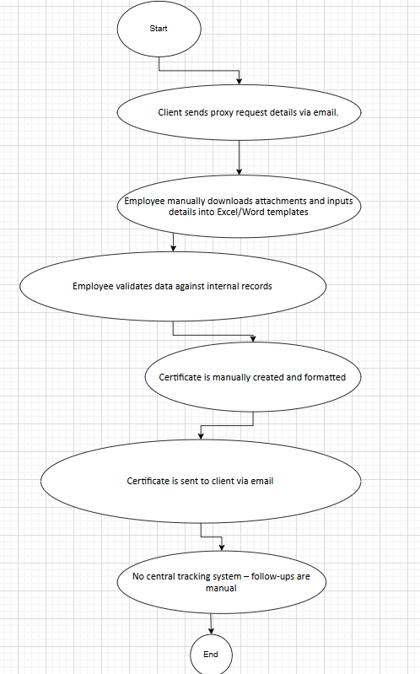
Steps:
- Client sends proxy request details via email.
- Employee manually downloads attachments and inputs details into Excel/Word templates.
- Employee validates data against internal records.
- Certificate is manually created and formatted.
- Certificate is sent to client via email.
- No central tracking system – follow-ups are manual.
8.2 Proposed Recommendations (TO-BE)
Explanation:
The proposed solution introduces an automated certificate generation system integrated with email parsing, validation workflows, and centralized tracking. This will:
- Automate data extraction from client emails.
- Validate automatically against predefined rules and compliance standards.
- Generate certificates instantly in approved templates.
- Provide dashboards & tracking for monitoring request statuses.
- Reduce errors, delays, and missed communications.
Process Flow (TO-BE):
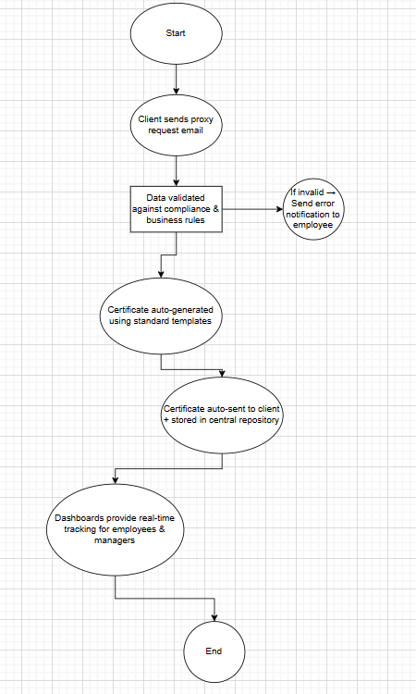
Steps:
- Client sends proxy request email.
- System automatically parses email and extracts structured data.
- Data is validated against compliance and business rules.
- Certificate is auto-generated using standard templates.
- Certificate is sent automatically to client and logged in central repository.
- Dashboards provide real-time tracking for employees and managers.
9. Business Requirements
The following business requirements have been elicited from stakeholders at Patra India and ICS Global Proxy Services. These requirements are categorized by priority (High/Medium/Low) and area of functionality to enable smooth tracking throughout the project lifecycle.
Where applicable, references to use cases, functional specifications, and traceability matrix are provided.
9.1 Functional Requirements
Req ID | Requirement Description | Priority | Area of Functionality | Reference/Notes
FR-01 | System must parse client emails and extract certificate-related data (vendor details, insurance type, dates, nominee details). | High | Email Extraction | Use Case UC-01
FR-02 | System must validate extracted data against predefined business rules and compliance standards. | High | Data Validation | Use Case UC-02
FR-03 | System must auto-generate proxy certificates in a standardized format (PDF/Word). | High | Certificate Generation | Use Case UC-03
FR-04 | Certificates must be delivered automatically via email and uploaded to client portal. | High | Delivery/Integration | Use Case UC-04
FR-05 | Provide a dashboard for tracking certificate status (Pending, Processing, Completed, Error). | Medium | Monitoring & Reporting | UI Mockup Ref-01
FR-06 | System must maintain an audit trail of all generated certificates. | High | Compliance | Regulatory Requirement
FR-07 | System should support both manual override (employee edits) and automated processing. | Medium | Flexibility | Stakeholder Request
FR-08 | Mobile application support for managers to approve/reject exceptions. | Low | Mobility | Phase 2
9.2 Non-Functional Requirements
Req ID | Requirement Description | Priority | Category | Reference/Notes
NFR-01 | System must process certificate requests within 2 minutes of email receipt. | High | Performance | SLA Requirement
NFR-02 | Ensure data encryption (AES-256) for data at rest and in transit. | High | Security | Compliance
NFR-03 | System should be available 99.9% uptime. | High | Reliability | Hosting SLA
NFR-04 | User interface should be simple, intuitive, and require < 2 hours training. | Medium | Usability | UX Guideline
NFR-05 | System should be scalable to handle 10,000+ certificate requests/day. | Medium | Scalability | Future Growth
NFR-06 | Ensure compatibility with Java-based backend and existing email systems (Outlook/Exchange). | High | Technical Compatibility | Tech Spec Doc
9.3 Business Requirement Categories
- Automation Requirements – Email parsing, data extraction, certificate auto-generation.
- Compliance Requirements – Regulatory adherence, audit trails, secure data handling.
- Operational Requirements – Dashboards, reporting, exception handling.
- Performance Requirements – High processing speed, scalability, and system availability.
- User Experience Requirements – Intuitive UI, mobile app access for approvals.
9.4 Traceability Matrix Reference
All the above requirements will be maintained and tracked in the Requirement Traceability Matrix (RTM) to ensure coverage in:
- Functional Specifications
- System Design Documents (SDD)
- Test Cases & UAT Scenarios
10.Appendices
10.1 List of Acronyms
Acronym | Full Form | Description/Usage
BRD | Business Requirement Document | Formal document capturing business requirements.
RTM | Requirement Traceability Matrix | Tool to map requirements → design → test cases.
UAT | User Acceptance Testing | Final phase of testing by end users.
SLA | Service Level Agreement | Defines expected service standards (e.g., uptime, performance).
ROI | Return on Investment | Measure of financial benefit from the project.
ICS | Investor Communication Solutions | Division of Patra India handling Global Proxy Services.
PDF | Portable Document Format | Format for generated proxy certificates.
HRMS | Human Resource Management System | Related IT system for employee management.
API | Application Programming Interface | Integration mechanism with email and client systems.
UI/UX | User Interface/User Experience | Frontend design and usability standards.
10.2 Glossary of Terms
Term | Definition
Proxy Certificate | Document issued to clients/vendors for proxy voting authorization in insurance/financial services.
Legacy System | The existing manual or semi-automated process for certificate issuance.
Automation Workflow | End-to-end process of extracting, validating, generating, and delivering certificates automatically.
Compliance | Adherence to U.S. insurance and financial regulatory standards.
Audit Trail | A chronological record of system activities to ensure accountability and traceability.
Stakeholder | Any individual, group, or entity impacted by or contributing to the project.
Exception Handling | Manual intervention required when automation cannot process a certificate request.
Business Rule | Predefined conditions or policies (e.g., certificate validity period, mandatory fields).
10.3 Related Documents
The following documents are related and should be referred to along with this BRD:
- Business Case Document – Justification for project initiation and ROI analysis.
- BA Strategy Document – Defines approach for requirement gathering, stakeholder management, and documentation.
- Functional Specification Document (FSD) – Detailed system design specifications.
- Requirement Traceability Matrix (RTM) – Mapping between business requirements, functional requirements, and test cases.
- Project Charter – High-level authorization and scope statement.
- UAT Plan & Test Cases – Final validation documents for stakeholder sign-off.

