Ans 1 – A project to build an online agriculture product store for farmers — here’s a detailed explanation of how quarterly audits (Q1–Q4) would happen for a Business Analyst (BA). Project Overview
- Project Name: Online Agriculture Products Store
- Duration: 18 months
- Stakeholders: Mr. Henry, Peter, Kevin, Ben, APT IT Solutions, farmers, manufacturing companies
- My Role: Business Analyst (BA)
Q1 (Month 1–3): Business Understanding & Requirements Gathering
Audit Focus:
- Understanding farmers’ problems (fertilizer shortages, seed unavailability, pesticide issues)
- Capturing requirements from all stakeholders (Henry, Peter, Kevin, Ben)
- Documenting functional and non-functional requirements
BA Tasks & Deliverables:
- Business Requirement Document (BRD)
- Stakeholder matrix and communication plan
- Use case diagrams and specs
- Requirements traceability matrix (RTM)
Audit Checkpoints:
- All farmer pain points accurately captured?
- Requirements signed off by committee and sponsor?
- Elicitation and documentation verified?
Q2 (Month 4–8): Functional Design & UI/UX Planning Audit
Audit Focus:
- Design of user-friendly UI (especially for rural farmers)
- Mapping requirements to screens, modules, and data flow
- Verifying compatibility for mobile/web usage
BA Tasks & Deliverables:
- Functional Specification Document (FSD)
- Screen Mock-ups / Navigation flow
- UML diagrams (Activity, Sequence)
- Updated RTM mapping requirements to features
Audit Checkpoints:
- Is the application designed to be simple and usable for first-time users?
- Does each screen/flow solve a real farmer pain point?
- Are features aligned with technical feasibility?
Q3 (Month 9–13): Development & Testing Prep Audit
Audit Focus:
- Supporting dev team during build
- Preparing UAT plans & scenarios
- Handling requirement changes
BA Tasks & Deliverables:
- UAT Test Scenarios mapped to use cases
- Change request documentation with impact analysis
- Functional walkthrough sessions with testers
- Weekly sprint demo notes (if Agile)
Audit Checkpoints:
- Are test cases aligned with the farmer/business workflows?
- Are all CRs logged, approved, and reflected in documentation?
- Has the BA participated in development validations?
Q4 (Month 14–18): UAT & Go-Live Planning Audit
Audit Focus:
- Validating app with end users (farmers, committee)
- Finalizing launch checklist and training content
BA Tasks & Deliverables:
- UAT Sign-off documents
- Farmer feedback reports
- Go-live readiness checklist
- User manuals and training aids
Audit Checkpoints:
- Did users understand and use the platform as expected?
- Were bugs tracked and resolved before sign-off?
- Was training effective and documented?
Ans 2 – As a BA, my approach strategy to complete the project successfully will follow a structured methodology.
- Elicitation Techniques – to gather the requirements from stakeholder I will use the combination of Interview with Mr. Henry & farming stakeholders & questionnaire/survey for wide user inputs.
- Stakeholder mapping – I will perform stakeholder mapping and maintain RACI Matrix to define the role.
- Responsible – Developer, tester (Mr Teyson, Ms Lucie, Mr Tucker, Mr Bravo, Tester - Jason and Ms Alekya)
- Accountable – Project Manager
- Consulted - Client (Mr. Henry & farmer)
- Informed – DB Admin (Mr. John)
- Documents to Prepare like _ Business requirements document (BRD), functional requirement specification (FRS), use case/stories, Meeting Minutes.
- Formal sign off will be taken on the documentation.
- Schedule walkthrough/demo with Mr. Henry.
- Daily stand ups & status reports , Review meetings to establish a communication.
- Support Testers (Mr Jason & Ms. Alekya) in UAT.
- Get formal sign off on UAT & prepare project closure document.
Ans 3 – 3-tier Architecture is widely used software development model that separates an application into 3 layers. It is easy to maintain and update each tier independently. It Improves scalability & Performance and also separation of concerns.

Presentation Tier (UI – Web/Mobible app/Client Layer)
- Farmer Login
- View Products
- Place Order
Application Tier (Business Logic/API)
- Validate order
- Check Inventory
- Manage Approvals
Data Tier (database Server)
- User Data
- Product catalog
- Transactions

Ans 4 – when a BA prepares to frame a questions for stakeholders , like an online agriculture product store, it is crucial to structure the thought process.
- 5W 1H Technique – (Basic Exploration)- who are the users?, what the requirements, when will they use the application, where will this be used as there is limited connectivity, how will it function etc.
- SMART Goal – Specific,Measurable,Achievable,Realistic,Time bound – what feature should be there in app, how will the success measured (procuring), are features feasible in the budget,is internet connectivity realistic, what is the project time line?
- Use cases & specifications- user journey – how does farmer place an order? Pre and post steps for key flows.
- Activity Diagram – Workflow(Farmer login then searches the product – place order), decision( what happens if product is out of stock)
Ans 5- As a BA, I know about below elicitation techniques which is require to understand from the stakeholders what they want to achieve through the given project.
- Requirement workshop - This is a structured meeting attended by multiple stakeholders and the business analyst may work with a group of stakeholders to develop a model. And at the end of meeting BA can discuss what was accomplished, what remains to be done, and what the next steps are and follow up on those points.
- Interview - Interviews involve asking questions, listening to the answers, and asking follow-up questions. Interviews can be done one-on-one, but they can also be done in a small group. It can be an informal or formal setting by asking questions and documenting the responses.
- Observation- observation is an effective means of understanding how a user does their job by assessing (like shadowing)their work environment. This technique can be used to understand requirements.
- Document Analysis - involves actively reading a document, such as a regulation, a standard, a competitive product review, or customer suggestion logs. you need to identify which materials are suitable and relevant for analysis.
- Brainstorming - It’s a way to think out of the box and to get people thinking about ideas and solutions that might not come to mind in a more formal session. It is like spontaneous.
- Prototyping – it is technique where an early version of product from which future versions are developed. A lot of times we work with users who don’t really know what they want and have a lot of trouble expressing their true needs and desires, but they’re very clear when they see something that represents what they don’t want.
- Questionnaires - questionnaires are used to gather information from many people who answer a specific question.
Ans 6 – Based on the selected elicitation techniques for the Online Agricultural Product store are –
- Prototyping - Prototyping helps to quickly demonstrate how the product will look and function. This visual tool allows stakeholders to provide concrete feedback early in the development cycle, ensuring the product aligns with their expectations.
Justification –
- Since the project involves creating a user-facing platform with features like:
    - Login for different user types (farmers, manufacturers)
    - Product catalog
    - Search and filtering options
    - Add-to-cart or "buy later" options
    - Delivery tracking
2. Use Case Specifications - Use case specs will help capture how different users(farmer, Manufacturers) interact with the system. This technique gives clarity on the system functional requirements.
Justification:
- Each user type (farmer, manufacturer) has distinct needs. Use cases helps in detail:
  - Actions (e.g., a farmer browsing catalog, placing an order)
  - System interactions (e.g., login, payment gateway)
  - Expected outcomes (e.g., confirmation email, delivery tracking)
3. Document Analysis - This technique ensures that the new system integrates smoothly with existing data sources and processes. It helps in reducing gaps & duplication of work.
Justification:
- Analyzing existing documents (such as product catalogs, manufacturer agreements, current order or delivery systems) will provide:
- A clear understanding of existing workflows.
- Data formats and terminologies already in use
- Existing pain points or gaps
4. Brainstorming - It is especially useful in the early phase to gather diverse inputs and expectations. It encourages open discussion and collaboration during the requirement gathering phase.
Justification:
- Since multiple stakeholders (Henry, Peter, Kevin, Ben) have different viewpoints, brainstorming sessions can help:
- Generate a wide range of ideas and requirements.
- Identify potential issues and improvements.
- Encourage collaboration and shared understanding
Ans 7 –
- BR001 – Farmers should be able to search for available products in fertilizers, seeds, pesticides.
- BR002 – Manufacturers should be able to upload and display their products in the application.
- BR003 - Farmers must be able to register and log in using their email ID and password.
- BR004 - The app should provide a product catalog with filtering and sorting options (e.g., by type, price).
- BR005 - Buy Later or Wishlist feature should allow users to save products.
- BR006 - The application should have multiple payment modes, including COD, credit/debit cards, and UPI.
- BR007 - A delivery tracking system to help farmers track order status.
- BR008 - An automated email/SMS notification sent after order placement, dispatch, and delivery.
- BR009 - The platform should include support care system for managing users, orders, and resolving disputes.
- BR010 – The application should be mobile-friendly and support regional language.
Ans 8-
Assumption 1 – users include farmers & Manufacturers ( farmers are end user and manufactures are vendors).
Assumption 2 – Platform is web based and mobile friendly interface for rural access.
Assumption 3 – Login and registration is required through mobile number or email id.
Assumption 4 – there is product catalog that includes fertilizer , seeds, and pesticides.
Assumption 5 – Buy Later or Wishlist features for farmers to save product which they can later purchase.
Assumption 6 – security measures like password encryption and secure login.
Ans 9 -
Req ID | Req Name | Req description | Priority
BR001 | Farmer Search for Products | Farmers should be able to search for available products in fertilizers, seeds, pesticides. | 10
BR002 | Manufacturers upload their Products | Manufacturers should be able to upload and display their products in the application. | 9
BR003 | Register & Login in | Farmers must be able to register and log in using their email ID and password. | 9
BR004 | Filtering & sorting of Product catalog | The app should provide a product catalog with filtering and sorting options (e.g., by type, price). | 8
BR005 | Features like buy later & Wish listing of products | Buy Later or Wishlist feature should allow users to save products. | 6
BR006 | Payment modes to make payment | The application should have multiple payment modes, including COD, credit/debit cards, and UPI. | 8
BR007 | Tracking mechanism for farmers | A delivery tracking system to help farmers track order status. | 7
BR008 | Notifications after placing the order | An automated email/SMS notification sent after order placement, dispatch, and delivery. | 6
BR009 | Issue resolving system through customer care or chat | The platform should include support care system for managing users, orders, and resolving disputes. | 7
BR010 | Visual should be friendly & supportive | The application should be mobile-friendly and support regional language. | 8
Ans 10- 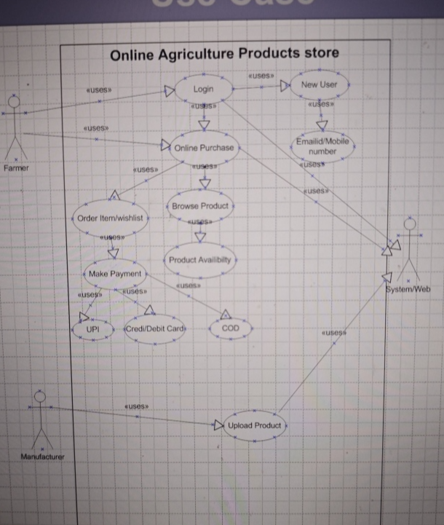

Ans 11 – Use Case Specifications for all the requirements are:
- Search Product – Primary actor would be Farmer and preconditions will be that he must have logged in.
- Upload Product – Primary actor would be Manufacturer where user must logged in and upload the products (Fertilizers, pesticides, Seeds)
- Filter & Sorting – Primary actor would be Farmer and user search results must be available.
- Wishlist/ Buy Later - Primary actor would be Farmer and user must have add to wishlist or product is saved to user list.
- Payment Mode - Primary actor would be Farmer and product is selected by user for purchase and selected the payment mode.
- Order Tracking - Primary actor would be Farmer and Order must be placed and user opens order tracking screen and sees the status.
- Notification - Primary actor would be system and system sends the status update to user.
- Support & Issue - Primary actor would be Farmer/Manufacturer and user can generate the ticket or raise issue.
- Mobile Friendly UI - Primary actor would be Farmer and app should be accessed via Mobile.
Ans 12 –
Search the product

Pay
Not Found
Add product to cart

Found

Buy more product? Yes

No

Payment Initiated

Debit Card
UPI

Payment Done

Order Confirmed

Order Cancelled
Click on cancel
Select the order
Go to Order
Login

Register

Email
Mobile No.

Set Password

Customer registered

Registration

Login

Edit profile

Email
Mobile No.
My Account

Login

