Student Name: Sagar Shinde
Sub: Proj 1 Part 1

Question 1 – BPM
Goal | To bridge the gap between farmers and Manufacturers
Inputs | Customer Data, Seed, fertilizers, Pesticides Data
Resource | Office space for IT employees, Application, Software, Ware Houses
Output | Sale revenue, Purchase of seeds and pesticides by farmers, delivery at farmers location
Activities | Customer satisfaction through user friendly application and timely delivery and service, Selection of Material by farmers and upload of stock by manufacturers
Value | Delivery of product at farmer location  User friendly application  Direct to customer

Question 2- SWOT

Strengths | Talent pool, Online Platform for Details, Budget and Duration
Weakness | Domain Exp, New BA, Waterfall Model
opportunities | Large No of Farmers Market and Business Expansion
Threats | Climatic Changes, Changes in requirements from Farmers in terms of Brands and other products

Question 3 -Feasibility study
- Hardware Requirements
Servers- For hosting Java based Application
Networking- High speed internet connectivity
- Trained Resources
Developer: Juhi, Bravo
DB Admin: John
Network Admin: Mike
Tester: Jeyson
BA: Myself
- Budget: Considering hardware, software licenses, development and testing 18 months , 2 crores budgets is sufficient
- Time Frame- 18 Months
Requirement Gathering: 2 Months
Design: 2 Months
Dev: 8 months
Testing: 3 Months
Deployment: 1 Month
Buffer: 1 Month
- Software Requirement: Database SQL

Question 4. Gap Analysis
Aspect | As- Is | To be
Product Procurement | Farmers travels long distance to buy fertilizers and seeds | Farmers can order online using mobile or web apps
Availability | Limited Stock in shop, dependency on middleman | Wide range of products available online from Diff. Manufacturer
Order tracking | No tracking, farmers wait for update | Real time order tracking and delivery status through App
Payment Method | Cash based transactions | Multiple payment options- UPI, Net banking, COD
Support Guidance | Not available | Access to product details, instructions on App

Gaps Identified:
- Lack of Digital platform for Procurement
- Absence of real time tracking
- No online payment option

Question 5. Risk Analysis
A. Internal Risk
-Skill Gap: Team may lack domain knowledge in agriculture
-Communication Gap: Misalignment between internal team may lead to rework
- Resource Unavailability: Key team members may be reassigned or may be on leave
B. External Risk
Farmers tech Literacy- farmers may not be familiar with App
Internet connectivity- Poor or no internet in remote areas
Market risk: Similar Platform may emerge
C. BA Risk
Incomplete Requirement: Farmers may not express their needs clearly
Changing Requirement: Stakeholder may change requirement mid project
Improper Prioritization: Failing to identity Critical vs Non critical farmer
D. Project Risk
Timeline Delay: May be due to scope creep or tech issue
Deployment and testing related challenges

Question 6 Stakeholder Analysis (RACI Matrix)

Activity | R | A | C | I
Project Vision | Mr. henry | Mr. henry | Mr. Pandu | All
Requirement gathering | BA (Me) | BA (Me) | Mr. Dooku, Peter, Kevin | PM
Budget Allocation | Mr. Pandu | Mr. Pandu | Mr. henry | Mr. Dooku,
Technical Architecture | Mike and John | Juhi | BA, PM and Developer | PM
Development | Developers | Juhi | BA, PM | Tester
Testing and QA | Jason, Alekya | Pm | BA | Developers
Deployment | PM | Karthik | Network and Admin | BA and Sponsor

Question 7 – Business Case Document
- Why this project is initiated
To empower by providing easy access to essential agricultural products through user friendly web/mobile app
- what are current problems
Limited access to agricultural products
Lack of direct communication
Low awareness about product availability
Manual procurement process
- How these problem will be solved
Problem | Solution
Difficulty in procurement | Direct listing and order from manufacturer
No Direct Communication | In App messaging or enquiry
Delivery Challenges | Integrated Logistics and tracking
Lack of Transparency | Online availability of details

- Sources Required
Resource | Details
Human | BA, Developers, testers, PM and Admins
Technology | Web and Mobile, Development tools and Servers
Finance | Budget ( 2 Crore)
Inputs | Stakeholders and Farmer Details
Training and Support | Helpdesk and Tutorials

- Organizational change required to adopt technology
Farmers- Moderate Change- Need basic training to use technology
Manufacturer- Minimal change- Need to prepare and upload catalogue
APT IT Solution- Alignment across department
- Frame to Recover ROI
ROI can be measured in terms of social impact and platform sustainability
Type | Time Frame
Social ROI | 6-9 Months Post launch
Operational ROI | 12-15 months
Financial ROI | 18-24 Months

- Identify stakeholders
Method | Stakeholder
Problem Interview | Peter, Kevin , Ben (Farmers)
Team Structure | IT Solution team member
End user Analysis | Farmers
Organisational Mappings | Henry , Pandu, Dooku
Vendor Engagement | Fertilizers, Seeds Manufacturer

Question 8 – Four SDLC Methodologies

SDLC: It is a structured process used by software development teams to design, develop, test and deploy software’s with high quality

- Waterfall (Sequential): Linear and step by step approach where each pphase must be completed before moving to next
Best for-Projects with well-defined and unchanging requirement
- Government systems
Pros | Cons
Simple to Manage | No flexibility of change
Clear documentation and Milestone | Late discovery to issues

- Iterative: System developed in iteration or parts and each part is improved upon successive cycles based on feedback
Best for- For Projects where requirement may evolve
- System needing frequent updates
Pros | Cons
Easy to manage | Can be costly
Early working version | Required good planning

- Evolutionary: Combination of iterative and incremental development. Product evolve over time with continuous user feedback and enhancement
Best for- Complex system with unclear requirement
-Prototype and research-based projects
Pros | Cons
High user involvement | Cost and timeline
Flexible and Adaptive | Scope Creep

- Agile: Adaptive and collaborative approach where project is broken into sprints (2-4 weeks) and team delivers working software frequently with continuous feedback
Best for- Dynamic Project and changing requirement
-Cross functional Team and fast paced environment
Pros | Cons
High customer Satisfaction | Require experienced team
Quick Delivery | Less documentation

Question 9 Waterfall RUP Spiral and Scrum Models

- Waterfall Model: A linear, sequential software development process where each phase must be completed before the next begins.
- Strengths:
  - Simple and easy to understand.
  - Well-suited for projects with fixed requirements and minimal expected changes.
  - Clear documentation at each stage.
- Limitations:
  - Not flexible if requirements change mid-project.
  - Testing happens late, so issues may surface very late in the cycle.
B. Rational Unified Process (RUP): An iterative and incremental software development methodology, divided into four phases – Inception, Elaboration, Construction, Transition.
- Strengths:
  - Allows iterative development (feedback incorporated after each cycle).
  - Strong focus on risk management and requirement traceability.
  - Balances documentation and flexibility.
- Limitations:
  - Can be complex to implement, requires experienced teams.
  - More time-consuming compared to Agile approaches.
C. Spiral Model: A risk-driven model that combines iterative development with systematic risk analysis. The project passes through repeating cycles (Planning → Risk Analysis → Development → Testing → Evaluation).
- Strengths:
  - Best suited for projects with high risks and evolving requirements.
  - Continuous risk assessment helps avoid failures.
  - Stakeholders see prototypes early and give feedback.
- Limitations:
  - Complex and costly for small/medium projects.
  - Heavy reliance on risk analysis expertise.
D. Scrum (Agile Framework) : An Agile framework where work is divided into short, time-boxed iterations called Sprints (2–4 weeks). The team delivers working software at the end of each Sprint. Roles include Product Owner, Scrum Master, and Development Team.
- Strengths:
  - Highly flexible, accommodates changing requirements.
  - Farmers and companies (stakeholders) can give continuous feedback.
  - Delivers usable software early, improving stakeholder confidence.
  - Encourages collaboration and transparency.
- Limitations:
  - Requires high customer involvement and quick feedback.
  - May face scope creep if requirements keep changing without control.

For current Project V Model is recommended
- SME preferred V model because structured approach and emphasis on validation
- Testing is not left at end. It happens parallelly which improves product quality
- Core features are already defined. Seeds fertilizer, pesticides which makes V model stable and understood
- Application will be used by farmer so usability testing is critical or it will be lead to loss of trust

Question 10 – Waterfall Vs V-Model

Aspect | Waterfall Model | V-Model (Verification & Validation Model)
Definition | Linear and sequential software development model. | Extension of Waterfall; development phases mapped directly to testing phases.
Process Flow | Flows step by step: Requirements → Design → Implementation → Testing → Deployment. | V-shape: Development on the left side, testing on the right side, meet at coding.
Focus | Focus mainly on completing development, testing occurs later. | Equal focus on development (verification) and testing (validation).
Testing Approach | Testing begins after implementation is completed. | Testing activities are planned in parallel with development.
Flexibility | Very rigid; hard to go back once a phase is done. | More structured than Waterfall, but still less flexible than Agile.
Error Detection | Errors often found late in testing phase. | Errors can be identified earlier through test planning at each stage.
Documentation | Heavy documentation at each phase. | Heavy documentation with strong emphasis on test cases.
Suitability | Suitable for projects with stable, fixed requirements. | Suitable for projects where quality and reliability are critical (e.g., healthcare, defence).

Question 11 – As a BA, state your reason for choosing one model for this project
As a BA, I would suggest using V Model for this online Agriculture product Store based on below points
    - This product will be used by farmers so usability testing in V model will improve product reliability.
    - Core Functionalities such as Browing product, placing order , delivery and tracking are well defined. V model works bests when requirements are elaborated and unlikely to change.
    - This model include parallel testing which will help in early defect detection
    - SMEs are also advocating for V model based on strong validation process which will help in smoother alignments and collaboration

Question 12. Gantt Chart –
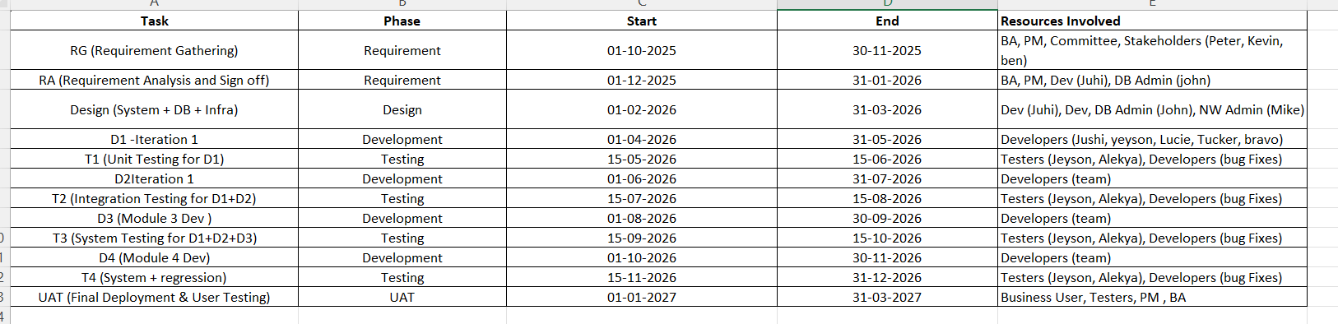
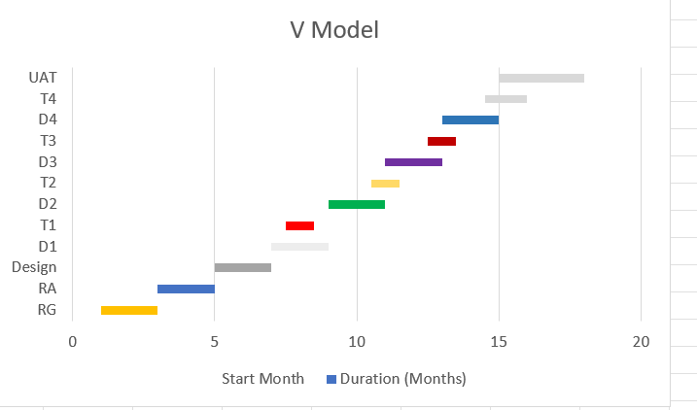
Question 13: Fixed Bid Vs Billing
Fixed Bid: In this type of Project, timeline and cost are agreed upfront. The vendor commits to delivery the project within fixed budget regardless of actual effort or time
Billing: In this type of Project, client pays based on actual time and resources used.
 | Fixed Bid | Billing
Cost | Fixed | Variable
Scope | Well defined | Flexible
Risk | Vendor | Client
Change management | Difficult | Easy
Client Involvement | Low | High

Question 14 – Preparer Timesheets of a BA in various stages of SDLC
Design Timesheet for BA
Activity | Description | Estimated Work Hrs | Remark
Requirement Validation | Ensures requirements are complete and ready for design | 6 hrs | Prepare for design hand off
Design Collaboration | Work with Design team to shape system design | 8 hrs | Align design with business needs
Wireframe and mock up review | Review and refine | 6 hrs | Ensure clarity
Use case process flow creation | Create use case and detailed flow | 6 hrs | Support Design and development
Design review meeting | Participate in discussion and share feedback | 5 hrs | Ensure alignment
Traceability matrix | Map requirement and components | 4 Hrs | Ensure Coverage
Document updates | Update BRD and FRD | 3 Hrs

Development Timesheet for BA
Activity | Description | Estimated Work Hrs | Remark
Requirement Clarification | Support developers by clarifying business needs | 10 hrs | Support
Change request Analysis | Evaluate documents Scope changes and enhancements | 8 hrs | Vary of Project type
Review technical design Documents | Validate against Requirements | 6 hrs | Logic is intact
Defect Triage and Support | Assist in analysing defects raised | 5 Hrs | Root Cause
Stakeholder Communication | Provide updates and Gather feedback | 4 Hrs | Keep them informed
Document updates | Update BRD and FRD | 3 Hrs

Testing Timesheet for BA
Activity | Description | Estimated Work Hrs | Remark
Test Case Review | Review Test cases | 6 hrs | Review Alignment
Requirement traceability | Validate test cases against requirement | 4 hrs | Complete Coverage
Defect Analysis and triage | Analyse defect and clarify logic | 8 Hrs | Defect Prioritization
Functional Validation | Functional testing to validate business needs | 5 Hrs | Coverage
UAT Preparation | UAT Scripts and coordination | 5 Hrs | Acceptance Criteria
Document updates | Update BRD and FRD | 3 Hrs

UAT Timesheet for BA
Activity | Description | Estimated Work Hrs | Remark
UAT Planning | Coordinate with Stakeholders for scope and AC | 5 hrs | Environment set up
Script Preparation | Create Scripts and scenarios | 6 hrs | Business requirement
UAT Execution Support | Assist users and clarify doubts | 8 Hrs | Support
Defect logging and Analysis | Document Issues and root cause | 6Hrs | Prioritise Fix
Sign off | Compile Results and sign off Documents | 4Hrs | Closure
Document updates | Update BRD and FRD | 3 Hrs

Deployment and Implementation Timesheet for BA
Activity | Description | Estimated Work Hrs | Remark
Go Live Planning | Coordinate with tech and PM for deployment schedule | 4 hrs | Cut Over planning
Release documentation | Release Notes and user guides | 4 hrs | Business requirement
Stakeholder Communication | Notify users about go live | 8 Hrs | Ensure Transparency and readiness
Production Validation | Validate Deployed Schedule | 6 Hrs | Ensure system behaviour
Document updates | Update BRD and FRD | 3 Hrs

