Question 1 - Functional Requirements
ANS:
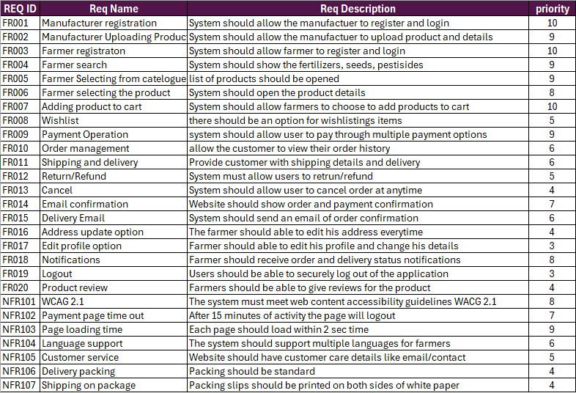

Question 2 - Minimum 5 page designs Make wireframe and prototypes
ANS:
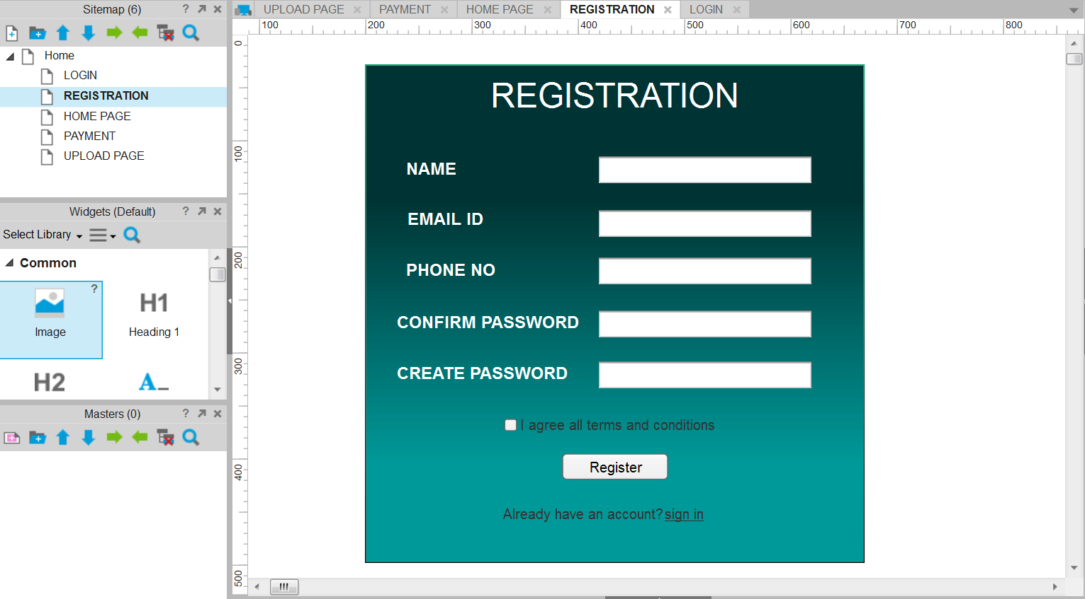
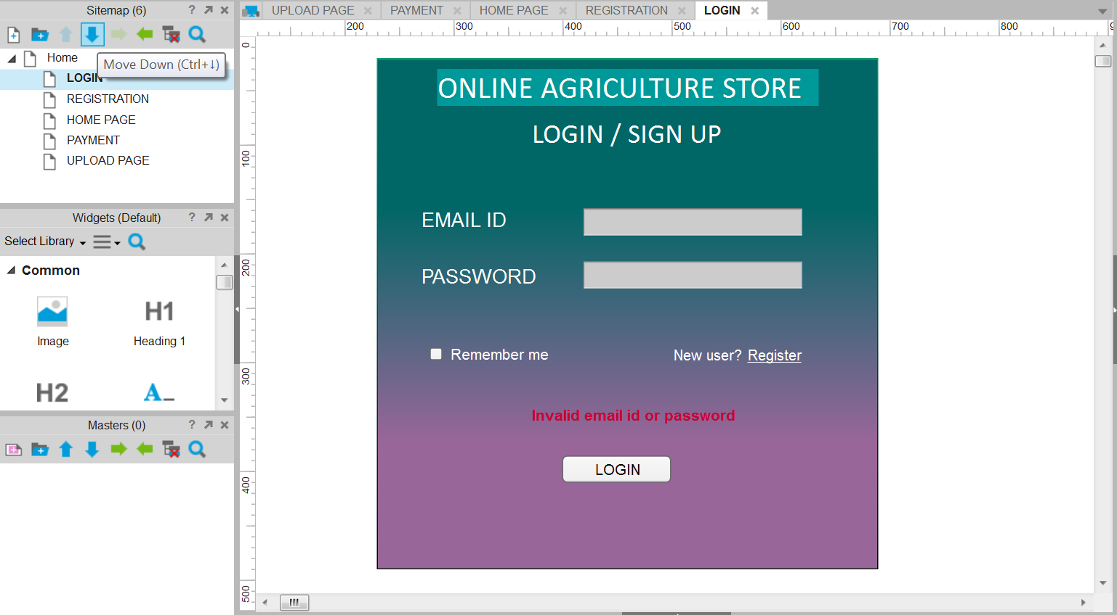

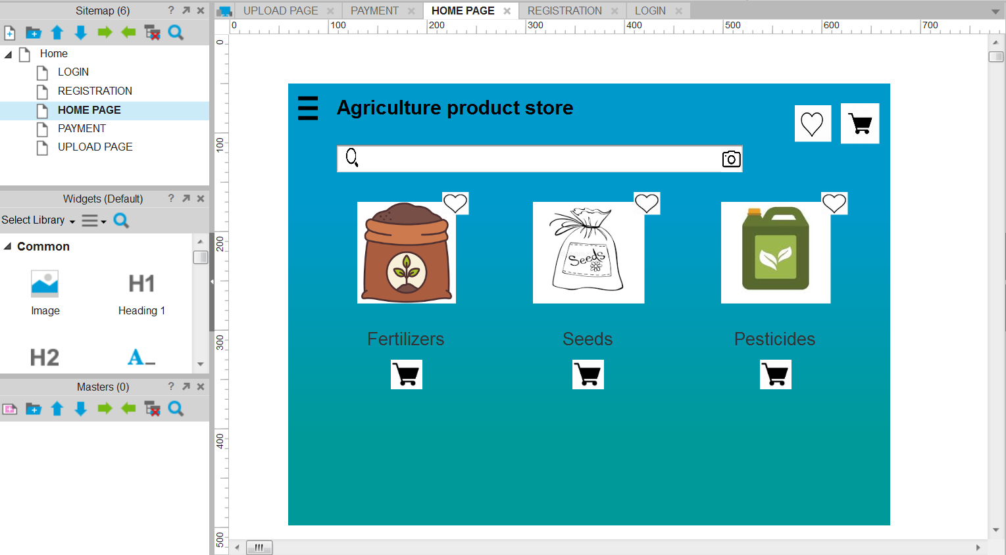

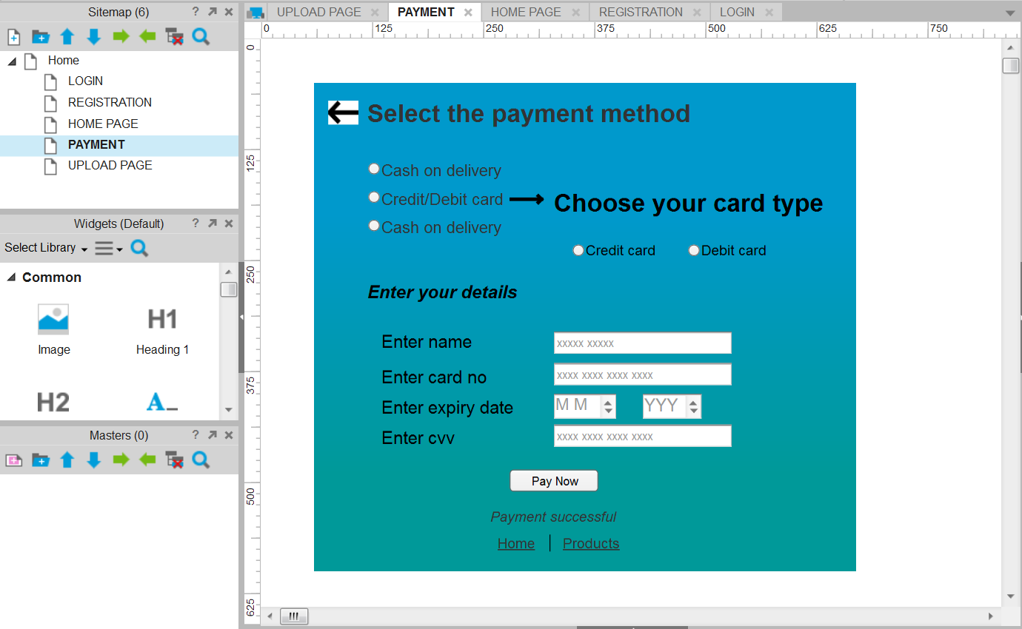

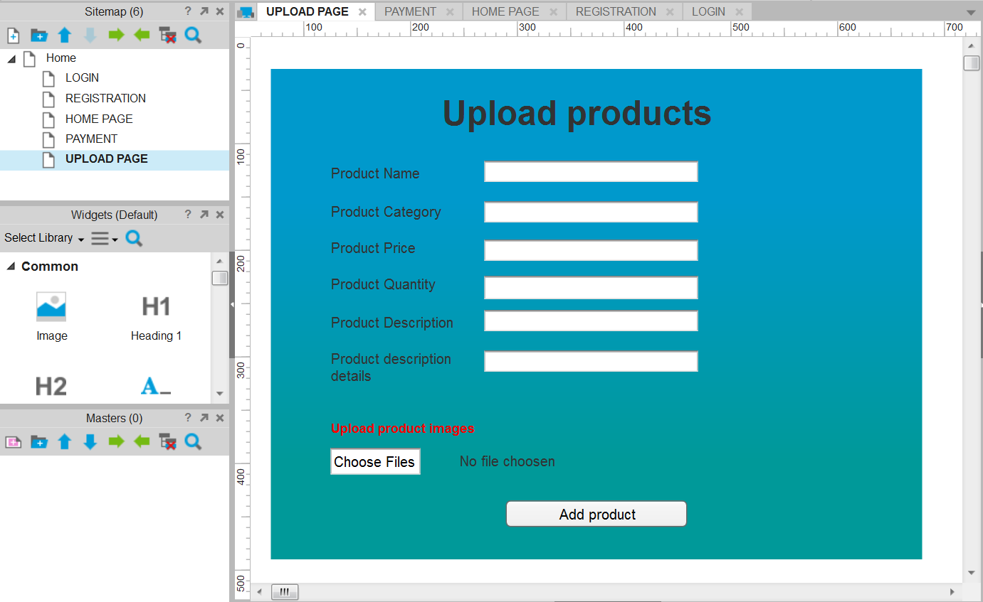
Question 3 – Tools (Visio, balsamiq)
ANS:
MS-Visio:
This is a Microsoft windows-based diagramming software that includes templates and symbols allowing users to create flowcharts, organizational charts, data flow diagrams, process flow diagrams, business process modelling, network diagrams, mind maps, 3D maps and many more. Visio lets you transform complicated text and tables that are hard to understand into visual diagrams that communicate information at glance. Default file saving format for MS Visio is (.vsd)`
Balsamiq:
It is a web-based user interface design tool for creating wireframes (sometimes called mockups or low-fidelity prototypes). It is used for creating wireframes and mockups to visualize concepts and ideas quickly to develop an application or website. It allows to picture ideas and concepts through a simple drag-and-drop interface. Default file saving format for Balsamiq is (.bmml)
Axure RP:
It is a leading wire framing and prototyping software that allows designers, developers, and product managers to create detailed wireframes, mockups, and prototypes. With its powerful features and easy to use interface, Axure simplifies the process of designing interactive and responsive web and mobile applications. Default file saving format for Axure RP is (.rp)
For this project I have used MS-Visio & Axure RP tools for UML diagrams, so that the client can understand it clearly.

Question 4 - RTM
ANS:
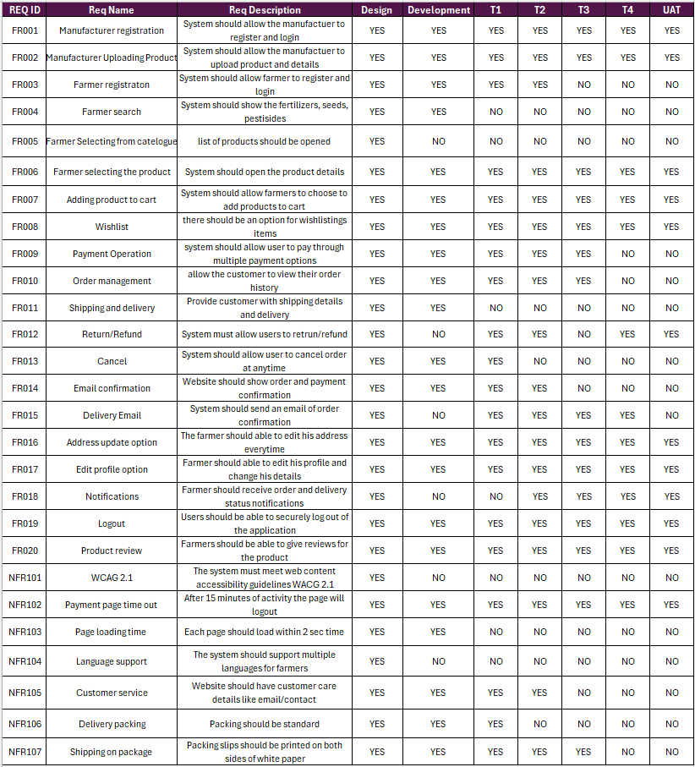

Question 5 - 10 Test Case Documents
ANS:
1. New User
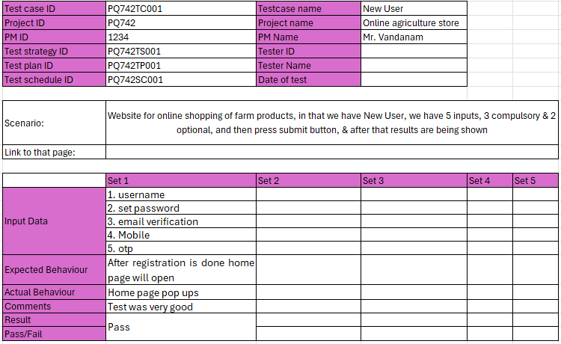
2. Login
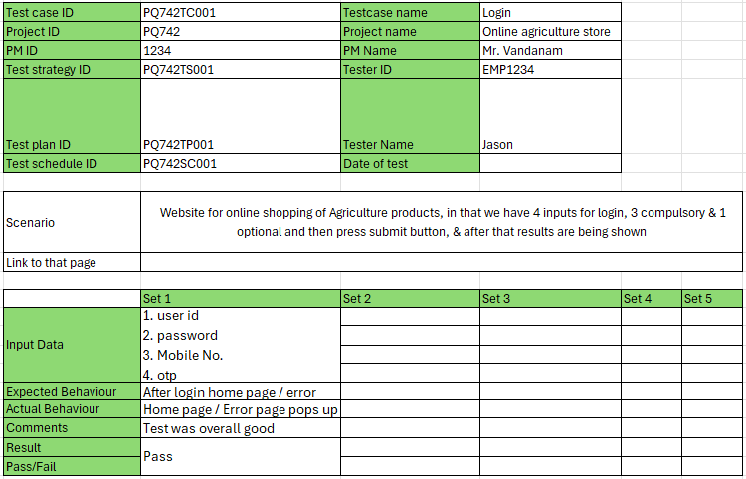

3. Upload products
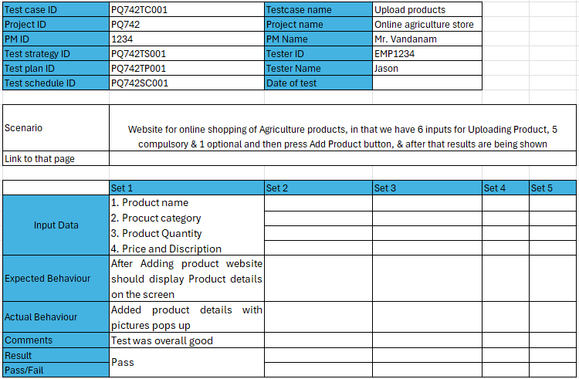
4. Product search
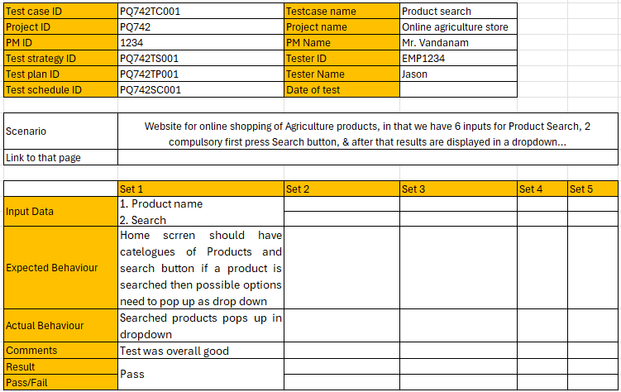

5. Product availability
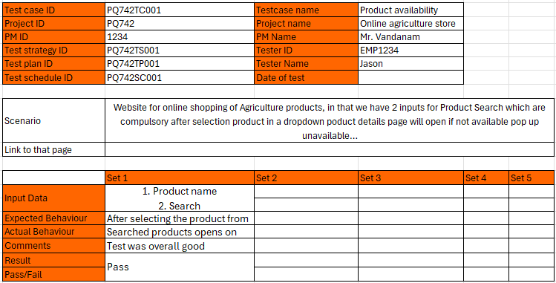
6.Product selection
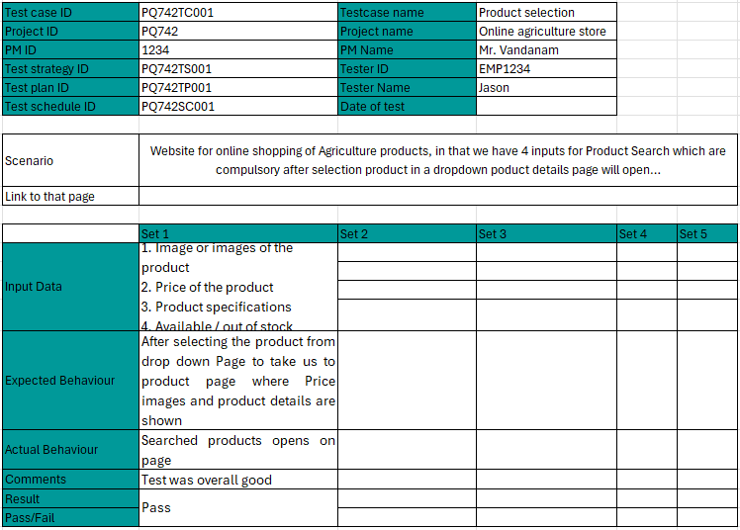

7.Payment gateway
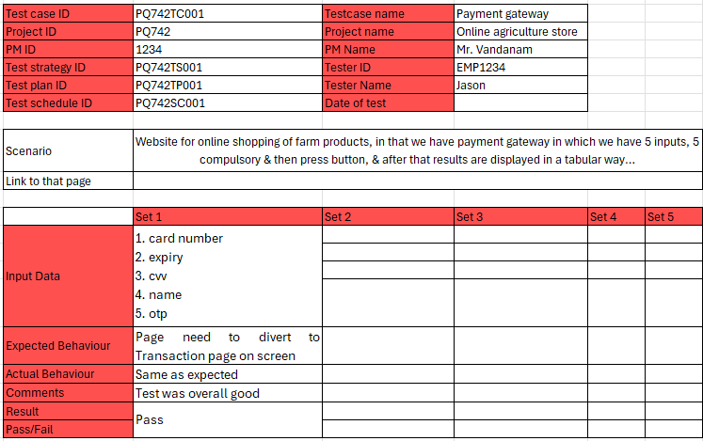
8.Reviews and ratings
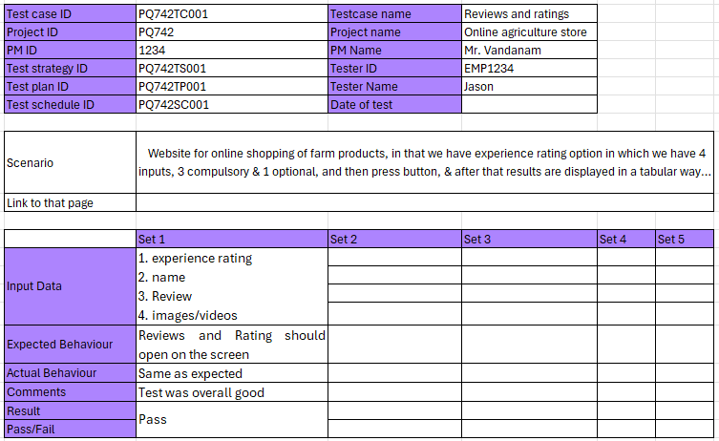

9.Cancel order
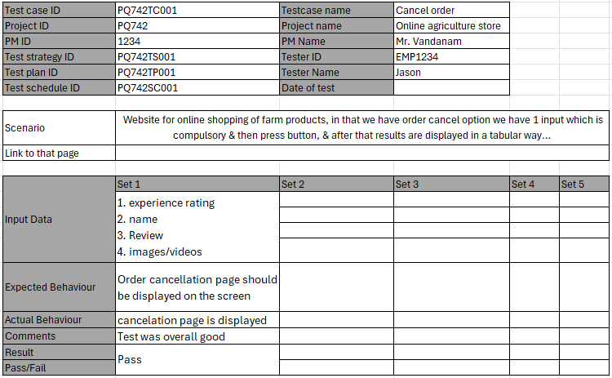
10.Helpline
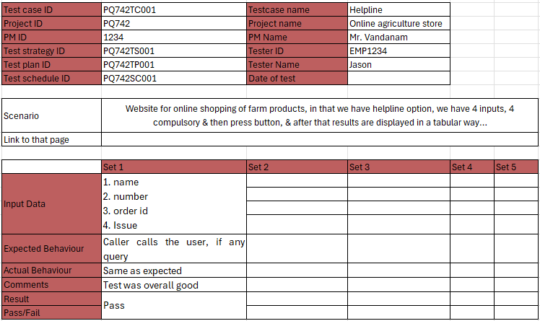

Question 6 - DB DESIGN – Draw Database Schema and ER Diagram
ANS: Database Schema Diagram for online agricultural Product Store

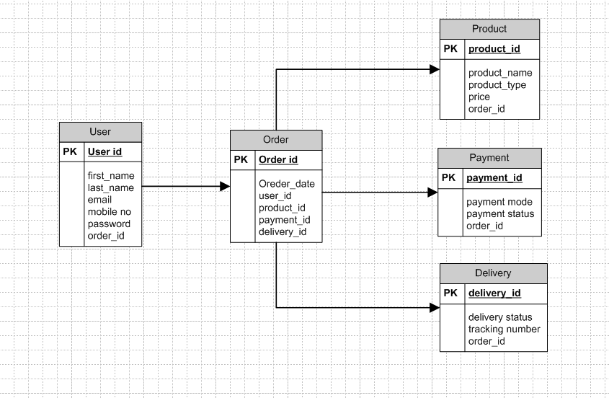

ER Diagram
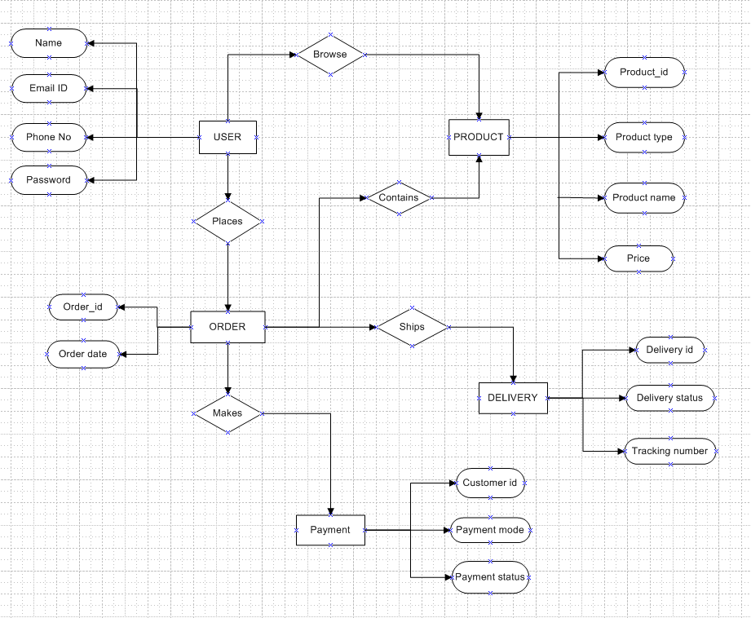

Question 7 - Data Flow Diagram
ANS:
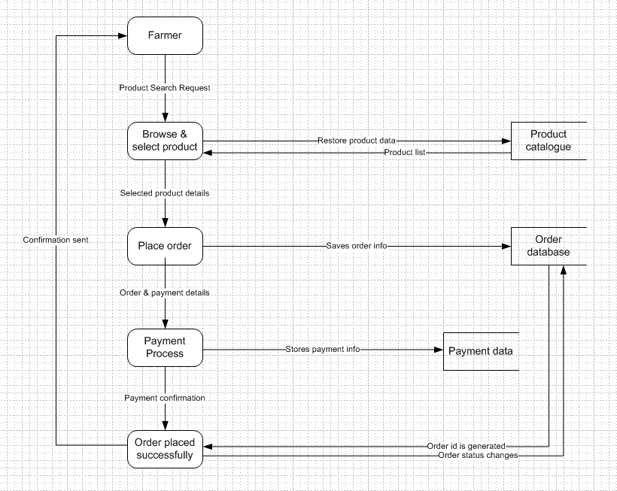

Question 8 - Change Request
ANS:
As a BA, first I will document and analyse the change request. Then I will take an approval from the project manager to process this change request. When a change request is introduced that impacts on project scope and budget.
For this online agriculture project, whenever there is a sudden change in the tax structure by the government the entire project cost gets affected. Initially we will call for a meeting and discuss how we are going to tackle the situation. We will discuss the areas where we can do the cost cutting and if we are not able to do it then we will reach our client and make him understand the situation and then convince him to increase the budget if it’s necessary.
If this is approved Project deliverables need to be updated like all the business documents. Once these updates have been made, the change request implementation needs to be done by the responsible team members for the project.

Question 9 - Change Request Vs Enhancement
ANS:
Change Request: A change request is either changing the way of an existing function or adding a new function or new features.
Enhancement: It is an improvement to existing functionality. It is a request to improve the defects or any faults of the working of the functionality of a system.
In this project, it is a change request situation, as a new requirement has been introduced after the project is initiated. They said Farmers should be able to sell their crop yields through this application, which was not discussed while initiating & developing the project. The auction system was also introduced as a new requirement later. So, it is a change request.
Question 10 - Estimations
ANS:
We have 12 members who are working on this project for 18 months.
Mr. Karthik - Delivery Head – 18 months
Mr. Vandanam - project Manager – 18 months
Ms. Shivani – BA – 18 months
Mr. Mike - Network Admin – 15 months
Mr. John - DB Admin – 15 months
Ms. Juhi - Senior Java Developer – 12 months
Mr. Teyson, Ms. Lucie, Mr. Tucker, Mr. Bravo - Java Developers – 12 months
Mr. Jason and Ms. Alekya - Testers – 12 months
One person need to work 8 hrs per day
40 hours (per week) x 18 months x 3 mem = 3,600 man hrs
40 hours (per week) x 15 months x 2 mem = 1,200 man hrs
40 hours (per week) x 12 months x 7 mem = 3,360 man hrs
Total man hours we required to complete the whole project is 8160 man hours.
Question 11 - UAT
ANS:
User Acceptance Testing or UAT is also called Application testing or End user testing. It is a software testing process that generally takes place at the last stage of software development to test how acceptable the software is in real time. The main purpose of the UAT is to know the actual status of the software application which is created for the targeted end users.
As a BA I will contact the client and test the software application then if they are fulfilled with their requirements and happy with the output, then will do the deployment of the application. And will proceed to close the project by finalizing and transferring the project deliverables to the client. Finally, we will analyze the project according to the project plan and tally it after the completion of the project with its output and hand it over to the client & take sign off from client on “Client Project Acceptance Form”.
Question 12 - Project Closure Document
ANS:
A Project Closure Document (PCD) is a formal document created at the end of a project to confirm that all project activities are completed, deliverables are accepted by the client, and the project is formally closed. It acts as official evidence that the project has been successfully delivered and provides a reference for future projects.
Points to be included in the Project closure document are:
- Project Overview
- The online agriculture store is initiated by MR. Henry under CSR initiative through SOONY Company and developed by APT IT SOLUTIONS. The project aimed to create a platform for farmers to purchase the fertilizers, pesticides, seeds online and facilitate communication with manufacturers.
- Duration: 18 months
- Budget: 2CR
- Achievements
- User-friendly interface website where all the help will be available through customer care.
- Delivered the project within budget and timeline with all stakeholder’s satisfaction
- Lessons Learned
- Early stakeholder engagement is crucial for gathering
- Planning, Executing, being patience, focusing on main activities and business needs.
- Proper impact analysis for change requests prevents delays.
- Quality Assurance
- UAT with key stakeholders ensured that the system meet business requirements.
- Payment gateway and delivery tracking are thoroughly tested for reliability and assurance.
- Resource Utilization
- Team include:
Project Manager - Mr Vandanam
Senior Java Developer - Ms. Juhi
Java Developers - Mr Teyson, Ms Lucie, Mr Tucker, Mr Bravo
Network Admin - Mr Mike
DB Admin - Mr John
Testers - Mr Jason and Ms Alekya
BA – Janya sree
Risk Management
- Challenges
- Coordinating with stakeholders in remote areas for requirement validation and UAT.
- Ensuring system usability for first time users with limited tech knowledge.
- Adapting to the changes like new tax structure during the development.
