AGILE DOCUMENTS

Document 1: Definition of Done
As Per Agile Extension to the BABOK® Guide v2, Definition of Done is a technique where the team agrees on, and prominently displays, a list of criteria which must be met before a backlog item is considered done.
DOR(Definition Of Ready): when user id done with the development he will pass it to the testers before that developer will check what are the are the areas are covered and ready for the testing is called definition of ready
DOD(Definition of Done):
When user sending user stories to the client you again have checklist what criteria should met in order to say the user stories has been completed
That is the team has to create a well-defined, unambiguous, measurable, agreed-upon, and shared Definition of Done between all team members.

Criteria Category | Criteria Description
Code Completion | - Code is written, peer-reviewed, and merged to main branch.
 | - No major bugs or critical issues remain.
Code Quality | - Code adheres to agreed coding standards and guidelines.
 | - Static analysis tools/linting tools show no critical errors.
Unit Testing | - Unit tests are written for all new code and pass successfully.
 | - Minimum 80% test coverage is maintained.
Integration Testing | - Service integration tested end-to-end (e.g., MQTT → Kafka → DB → UI).
 | - Alerts successfully flow through entire pipeline and display correctly.
UI Functionality | - Frontend displays data accurately and reflects expected interactions (e.g., Ack/Delete).
 | - Responsive UI behavior across major screen sizes.
Security | - All API endpoints secured with authentication/authorization.
 | - Sensitive data handling verified.
Documentation | - Feature-level documentation updated (Confluence, ReadMe, etc.).
 | - Code is commented where necessary.
Validation | - Business acceptance criteria are met.
 | - Validated by QA or Product Owner.
Deployment | - Feature deployed to staging or QA environment.
 | - Deployment scripts or CI/CD pipelines updated if needed.
UX/Accessibility | - UI reviewed for accessibility and usability (basic keyboard navigation, labels, etc.).
Alert Specific | - Alert types match definition/severity logic.
 | - Templates and notification triggers function as expected.
Approved by PO | - Product Owner reviewed and approved the feature/story.

Definition of Done – Alert Management System

Category | Criteria Description
Functionality | - All 8 core components (MQTT → Kafka → Microservices → UI, Alert Templates, Definitions, Notifications) work end-to-end.
 | - Admin can view, filter, acknowledge, delete, and configure alerts as per business rules.
Data Flow Integration | - MQTT successfully receives and pushes messages when AP issues occur.
 | - Kafka correctly receives formatted messages from microservice 1.
 | - Kafka consumer (microservice 2) transforms and persists data into DB.
UI Verification | - Alerts are shown with correct metadata (type, severity, timestamp) for last 7 days / 1 month.
 | - Acknowledge, delete, and filtering by Alert Template function correctly.
 | - UI displays real-time bell/notification icon for Critical alerts.
Alert Template | - Admin can create/update/delete alert templates scoped to organization or site.
 | - Filtering logic works based on selected templates.
Alert Definition | - Every alert type is defined with correct default severity (Critical/Major).
 | - Admin can override severity level via Definition UI and changes persist.
Notification System | - Bell icon/real-time notification triggers for Critical alerts.
 | - Admin is notified only once per critical alert (no duplication).
Testing | - Unit tests cover at least 80% of backend and frontend logic.
 | - Integration tests confirm data consistency across services (MQTT → Kafka → DB → UI).
 | - UI automation tested for alert display, template selection, definition editing.
Security & Roles | - Admin privileges verified for alert configuration and editing definitions.
 | - Unauthorized users cannot access sensitive features or endpoints.
Performance | - System handles concurrent alerts without significant delay (load-tested).
 | - UI renders alert history within 2 seconds for 1-month window.
Documentation | - Developer documentation updated for microservices and APIs.
 | - User documentation updated for alert handling, definitions, and templates.
Deployment | - Deployed to staging/UAT environments with successful smoke and regression tests.
 | - CI/CD pipelines updated with necessary scripts for microservices and frontend.
Acceptance | - Product Owner/QA has validated acceptance criteria for each module/component.
Post Conditions | - Feature flagged or toggle-enabled for phased rollout (if applicable).

Document 2- Product Vision

Scrum Project  Name:
  Access Point Alert Management
Venue: | Company HQ Meeting Room
Date: | Start time: | End time: |  | Duration:
Client:
Stakeholder list:
  - IT Admins
  - Network Engineers
  - Product Owner
  - Support Team
  - Security & Compliance Officers
  - IT Admins
  - Network Engineers
  - Product Owner
  - Support Team
  - Security &
  Compliance
  Officers
  - IT Admins
  - Network Engineers
  - Product Owner
  - Support Team
  - Security & Compliance
  Officers
Scrum Team
Scrum Master: | Prem K. | Prem K. |  | Prem K.
Product owner: | Anil K. | Anil K. |  | Anil K.
Scrum Developer 1: | Santhosh S. | Santhosh S. |  | Santhosh S.
Scrum Developer 2: | Arjun E. | Arjun E. |  | Arjun E.
Scrum Developer 3: | Maheswari K. | Maheswari K. |  | Maheswari K.
Scrum Developer 4: | Panneerselvam L. | Panneerselvam L. |  | Panneerselvam L.
Scrum Developer 5: | Prabhu R. | Prabhu R. |  | Prabhu R.

Vision: To provide a real-time, intelligent, and customizable alert management system for network administrators, ensuring quick detection, notification, and resolution of issues in Access Points across large enterprise or campus networks.
Target group  Enterprise IT departments, University Network Admins, Large Office/Corporate Network Teams, Airport Network Managers.  Network administrators, IT support teams, operations engineers, and CIOs responsible for ensuring 24x7 uptime and reliability of WiFi and network access. | Needs  Difficulty in identifying and reacting to Access Point failures or anomalies in a timely manner; lack of customizable alerts and automation. The system provides real-time detection, intelligent alert filtering, prioritization, and configurable severity levels to ensure focused operational response. | Product  A backend-driven, microservice-based Alert Management System integrated with MQTT and Kafka, enabling real-time processing of alerts, UI-based alert configuration templates, severity definitions, and visual notifications. The product is unique due to its full-stack integration, admin customization, and real-time scalability. Yes, it is technically feasible due to the use of scalable technologies and standard protocols. | Value  The product enhances network reliability, reduces downtime, and enables proactive maintenance. Business goals include increased customer satisfaction, reduced incident resolution time (MTTR), and a potential SaaS-based recurring revenue model by offering this as a managed alerting solution for network infrastructure clients. Business model could be subscription-based per site or device.

Document 3: User stories

User story No: US-001 | Tasks: Build microservice to read MQTT and push to Kafka |  | Priority: High
Value statement:
As a backend service, I want to read from MQTT and push formatted alerts to Kafka topic for further processing.
BV:100 |  | CP: 8
Acceptance criteria:
- MQTT receives alert message when AP fails
- Message format includes alert ID, type, timestamp, severity

User story No: US-002 | Tasks: Build microservice to read MQTT and push to Kafka |  | Priority: High
Value statement:
As a system, I want to push access point issues to MQTT so that alert data is captured in real-time.
BV:100 |  | CP: 5
Acceptance criteria:
- Microservice subscribes to MQTT and logs messages
- Successfully publishes formatted message to Kafka topic

User story No: US-003 | Tasks: Implement UI logic to fetch and show alerts |  | Priority: Medium
Value statement:
As a user, I want to view alerts from DB via UI so that I can monitor and manage issues.
BV:50 |  | CP: 3
Acceptance criteria:
- UI fetches and displays alert list
- Alerts are sorted, filterable by date/severity/type

User story No: US-004 | Tasks: Implement Notification system |  | Priority: High
Value statement:
As an admin, I want to be notified via bell icon for critical alerts so that I can take prompt action.
BV:100 |  | CP: 5
Acceptance criteria:
- Critical alerts trigger bell notification
- Clicking bell shows unread critical alerts
- Alerts marked as read after viewing

User story No: US-005 | Tasks: Create Alert Display Page |  | Priority: High
Value statement:
As an admin, I want to view alerts by time and severity so that I can acknowledge or delete them.
BV:100 |  | CP: 5
Acceptance criteria:
- Alerts shown with filters: last 7 days, 1 month
- Buttons available: Acknowledge, View, Delete

User story No: US-006 | Tasks: |  | Priority: Medium
  Implement UI logic to fetch and show alerts
Value statement:
As a user, I want to view alerts from DB via UI so that I can monitor and manage issues.
BV:10 |  | CP: 3
Acceptance criteria:
- UI fetches and displays alert list
- Alerts are sorted, filterable by date/severity/type

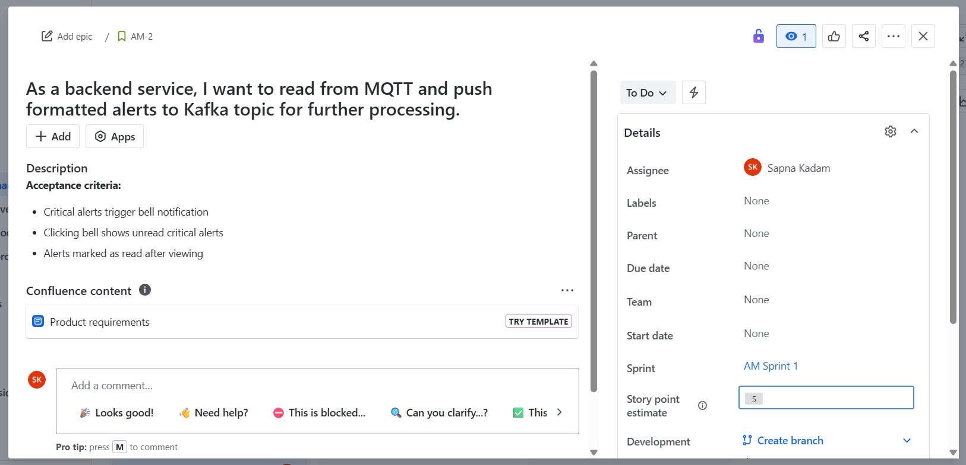
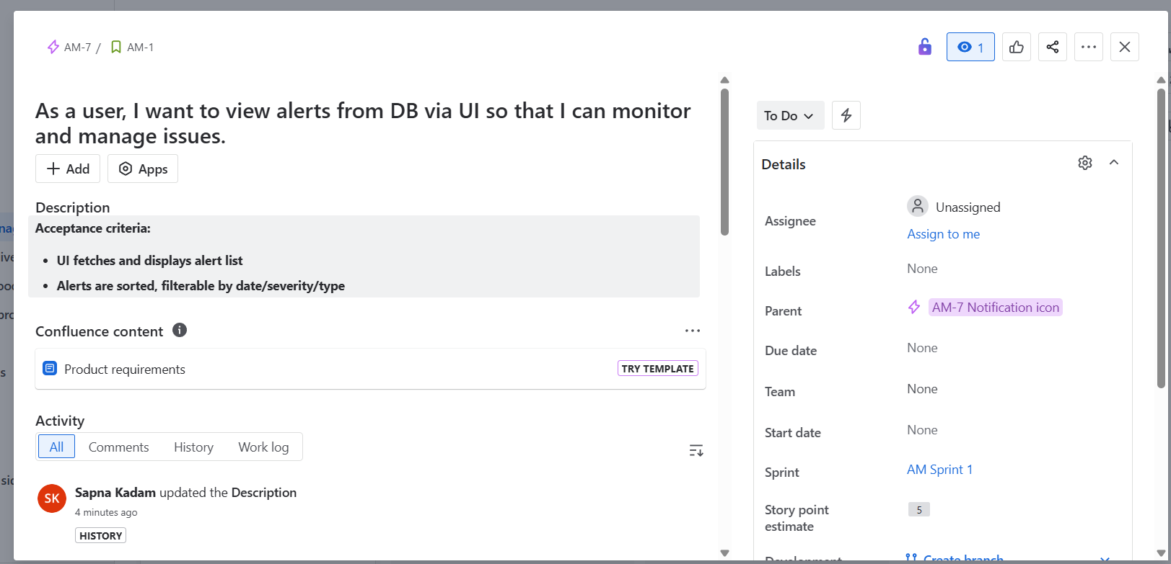
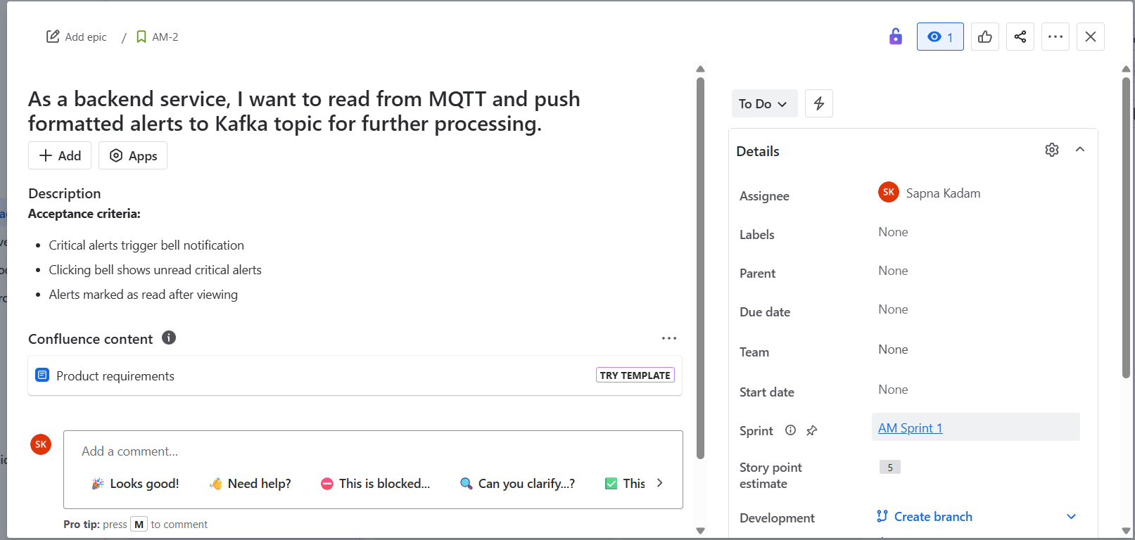

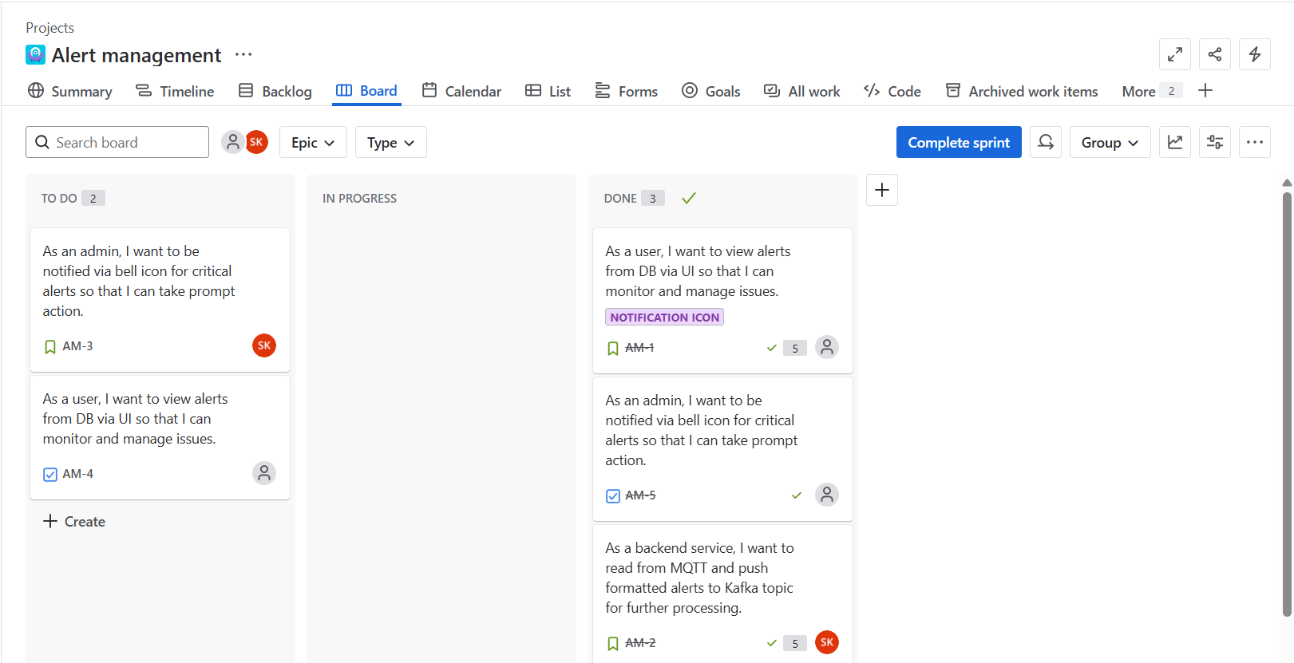

Burn up chart
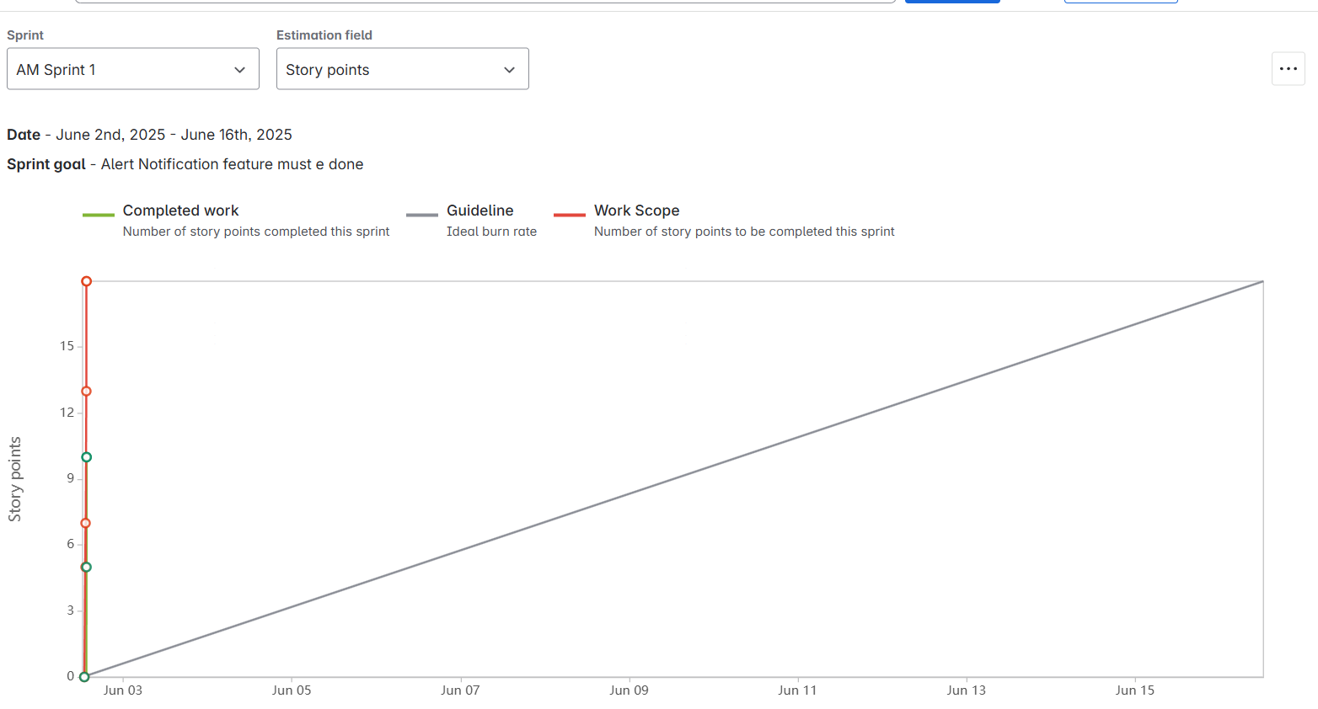

Burn Down chart:
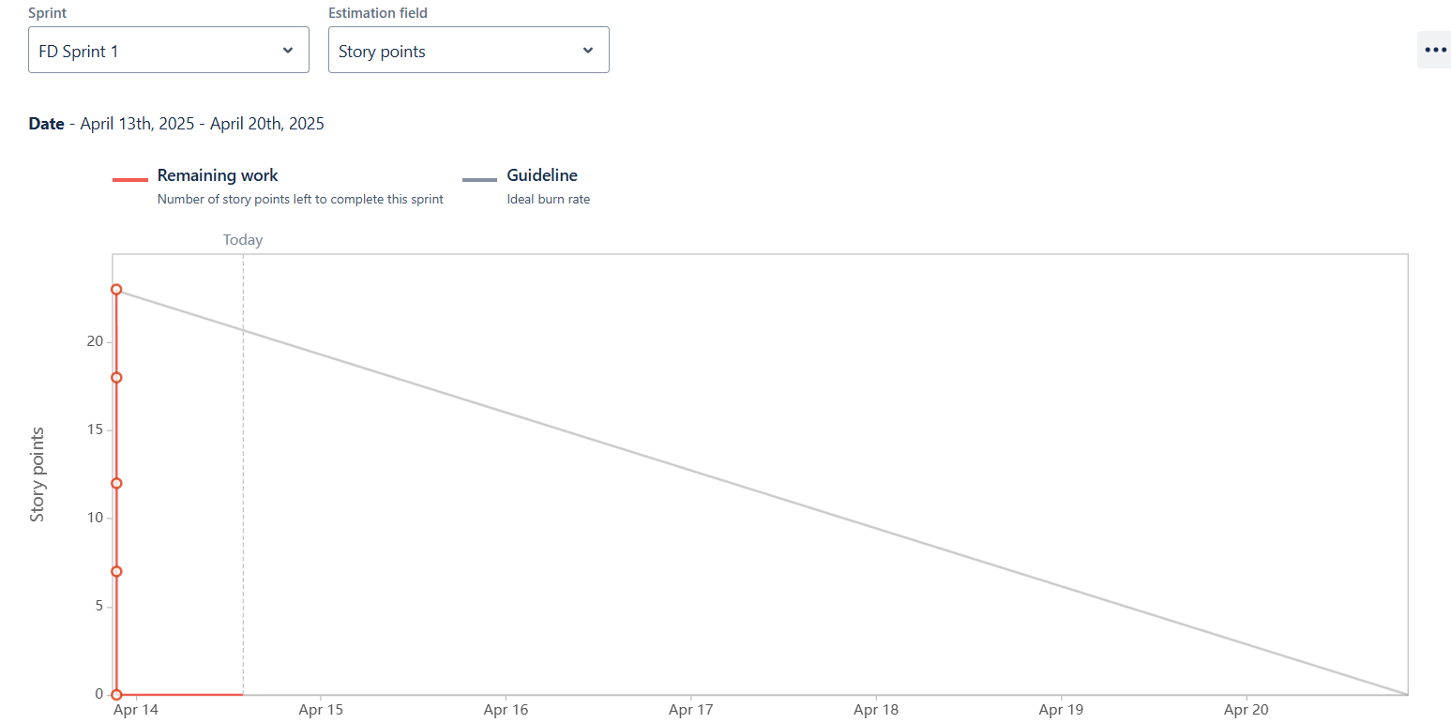

Product BurnDown Chart:

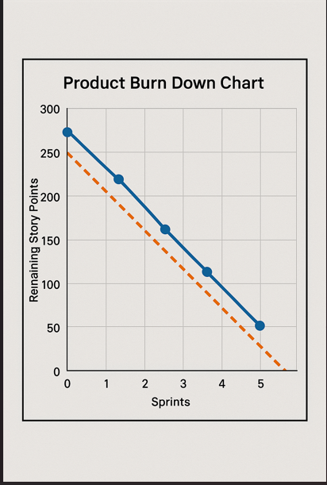

Document 4: Agile PO Experience
The Product Owner has a vision of the product keeping the domain/industry experience and the market need.
- Following are the responsibilities of PO in a project
- From this project I have learned how to handle sprint meetings such as

1. Sprint Planning Meeting
Objective: Define the scope of work for the upcoming sprint.
Area | Product Owner Responsibility for Alert Management
Backlog Preparation | Ensure that user stories related to Alert Ingestion, Alert Display, Alert Definition, Notification, and Alert Templates are well-defined and prioritized.
Sprint Goal | Define a clear sprint goal (e.g., “Complete backend pipeline for alert ingestion and display basic alert list on UI”).
Clarify Requirements | Provide acceptance criteria for stories like: "As an admin, I want to configure alert templates for my site."
Define Priorities | Prioritize critical features like MQTT→Kafka pipeline over less urgent ones like alert template UI.
Capacity Planning | Work with Scrum Master to ensure realistic scope based on team's capacity.

2. Daily Scrum Meeting
Objective: Quick check-in to track progress and surface blockers.
Area | Product Owner Participation
Availability | Be available to quickly answer questions or clarify requirements from developers.
Review Progress | Listen in to hear about progress on Kafka integration, DB schema, or UI template rendering.
Unblock Issues | If developer is stuck on alert type definition, you help refine requirement or update backlog.
Adjust Priorities if Needed | If there's a blocker in ingestion microservice, reprioritize downstream UI tasks.

3. Sprint Review Meeting
Objective: Demonstrate what has been built and get feedback.
Area | Product Owner Role
Demo Participation | Evaluate completed work: e.g., "Show me how MQTT pushes alert and it appears in DB."
Validate Against Criteria | Ensure stories like "Admin can delete alerts" meet the acceptance criteria.
Collect Feedback | Ask stakeholder (e.g., IT Manager) for input on usability of Alert Display page.
Decide on Release | If features like alert templates and definitions are stable, approve them for production release.

4. Sprint Retrospective Meeting
Objective: Improve team processes and performance.
Area | Product Owner Contribution
Give Feedback | Provide input on what went well (e.g., fast Kafka implementation) and what didn’t (e.g., unclear alert severity rules).
Listen to Team | Understand developers’ pain points, such as ambiguous user stories or frequent requirement changes.
Actionable Improvements | Suggest writing sample JSON alert messages to help devs test alert pipeline better next sprint.

5. Backlog Refinement Meeting
Objective: Continuously groom and prioritize the product backlog.
Area | Product Owner Activities
Decompose Epics | Break large stories like “Alert Notification System” into smaller stories: UI bell icon, backend notification logic, severity filters.
Clarify Requirements | Provide exact rules for alert severity (Major vs Critical) based on alert definitions.
Estimate Effort | Collaborate with team to estimate complexity using story points.
Reprioritize | Move urgent alert types (e.g., AP offline alert) up in priority based on user feedback.
Ensure DoR | Make sure stories are "Ready" with clear acceptance criteria before sprint starts.

Also, User stories creation and what things will be included in user stories such as
- Story no
- Tasks
- Priority
- Acceptance criteria
- BV & CP value
- In Scrum, a product owner serves as the liaison between multiple areas of an organization. This person communicates with business stakeholders and collaborates closely with Scrum teams to keep all areas of the business informed on a project's development.
- The product owner develops a vision of a product's function and operation, which in turn allows this Scrum team member to define product features and break those features into product backlog items.

1. Market Analysis
Area | Analysis
Target Audience | IT Network Administrators, Network Engineers, NOC teams in enterprises, universities, airports, etc.
Market Need | Need for real-time monitoring, proactive alerts, issue identification and resolution for wireless infrastructure.
Competitor Landscape | Competing with enterprise network management tools like Cisco DNA Center, Aruba AirWave, PRTG, etc.
Opportunity | Provide a lightweight, modular, scalable solution with customizable alert templates and real-time MQTT/Kafka support.

2. Enterprise Analysis
Area | Analysis
Business Drivers | Minimize network downtime, increase visibility of network issues, enable quicker response time.
Stakeholders | Network Admins, IT Managers, DevOps Teams, CIO/CTO, Security teams.
Business Objectives | - Ensure SLA compliance  - Reduce network issue resolution time  - Enable centralized monitoring
Constraints | Scalability, real-time processing requirement, data privacy, cross-site compatibility.

3. Product Vision & Roadmap
Area | Analysis
Vision Statement | To deliver a scalable and customizable alert management system that enables real-time visibility, prioritization, and resolution of network access point issues.
Short-Term Goals (0–3 months) | - Build MQTT → Kafka → DB pipeline  - UI alert display with filtering  - Define alert templates
Medium-Term Goals (3–6 months) | - Implement alert severity definition  - Create notification mechanism  - Multi-org/site customization
Long-Term Goals (6–12 months) | - Advanced analytics  - Machine learning based alert predictions  - Third-party system integrations (email, Slack, Jira)

4. Managing Product Features
Step | Activity
Feature Breakdown | Break alert lifecycle into atomic features: Ingestion, Storage, Display, Filtering, Definition, Notification.
Prioritization Model | MoSCoW (Must Have, Should Have, Could Have, Won’t Have) or WSJF (Weighted Shortest Job First)
Traceability | Map each feature to business goal or user need for traceability.
Dependencies | Align Kafka/DB microservices before UI alert pages or templates.

5. Managing Product Backlog
Step | Activity
Epic/User Story Creation | Write epics per major module (e.g., Alert Ingestion, Display, Templates, Notifications). Decompose into user stories with BV/CP and acceptance criteria.
Backlog Grooming | Weekly refinement with Scrum Team to ensure clarity, split large stories, remove stale items.
Prioritization | Use stakeholder inputs, urgency of monitoring capabilities, and delivery impact to prioritize.
Definition of Ready/Done | Clearly define DoR/DoD to ensure development readiness and completion quality.

📈 6. Managing Overall Iteration Progress
Tool | Activity
Sprint Planning | Select stories that match team capacity and align with iteration goals.
Daily Scrum Participation | Collaborate with Scrum Master and developers to clarify requirements, unblock tasks.
Review & Demo | Review sprint deliverables, validate against acceptance criteria, collect stakeholder feedback.
Burndown Tracking | Monitor velocity and sprint burndown charts to track progress.
Adjustments | If scope/priority changes, replan upcoming sprints or adjust backlog priorities.

Document 5: Product and sprint backlog and product and sprint burndown charts

Based on your Alert Management System requirements, here's a complete Product Backlog and Sprint Backlog following agile methodology.

Product Backlog
ID | User Story | Priority | Est. Story Points (SP) | Acceptance Criteria
PB-01 | As a system, I want to publish alert messages to MQTT when AP fails | High | 5 | MQTT receives alert message immediately after an AP failure
PB-02 | As a backend service, I want to read from MQTT and push formatted data to Kafka | High | 8 | Correctly formatted data appears in Kafka topic
PB-03 | As a backend service, I want to convert Kafka data and store alerts in the DB | High | 8 | Data is persisted in the alerts DB in proper structure
PB-04 | As a UI, I want to fetch and display alert info from DB | High | 5 | Alerts are shown on UI with correct filtering
PB-05 | As an admin, I want to filter alerts by last 7 days / 1 month | Medium | 3 | Date filters work correctly on alert display page
PB-06 | As an admin, I want to acknowledge or delete alerts from display | Medium | 3 | Acknowledge/delete actions reflect in DB
PB-07 | As an admin, I want to define templates with selected alert types | High | 5 | Admin can create and save alert templates
PB-08 | As an admin, I want to assign templates to organization or site level | Medium | 3 | Template scope is saved and applied appropriately
PB-09 | As an admin, I want to define the severity of alert types (Major/Critical) | High | 4 | Alert definitions are editable and stored
PB-10 | As an admin, I want to change severity of a specific alert type | Medium | 2 | Updated severity reflects for future alerts
PB-11 | As an admin, I want to receive bell icon notifications for Critical alerts | High | 4 | Notification shown in UI on critical alert
PB-12 | As a QA/Dev, I want to simulate alert generation for system testing | Low | 2 | Simulated alerts flow through entire pipeline
 | As a system, I want real-time updates of alerts via websockets or polling | Medium | 5 | UI gets real-time or near-real-time alert updates

Sprint Backlog (Sprint 1: Foundation - 2 Weeks)

Sprint ID | From Product  Backlog | Task | Est. SP | Owner | Status
SB-01 | PB-01 | Implement MQTT publishing on AP failure | 5 | Backend Dev | To Do
SB-02 | PB-02 | Consume MQTT, process message, and push to Kafka | 8 | Backend Dev | To Do
SB-03 | PB-03 | Consume Kafka and store alert in DB | 8 | Backend Dev | To Do
SB-04 | PB-04 | Create API to fetch alerts from DB for UI | 5 | API Dev | To Do
SB-05 | PB-12 | Build alert simulation tool for end-to-end testing | 2 | QA/Dev | To Do

Total Story Points for Sprint 1: 28 (Ideal for a team of 3–5 over a 2-week sprint)

Sprint Goals
- Establish the core ingestion pipeline: MQTT → Kafka → DB
- Enable end-to-end testing with simulated alerts
- Backend APIs ready for UI integration

Upcoming Sprints (Outline)
Sprint 2: UI, Alert Templates & Filtering
- Implement alert display UI (PB-04, PB-05)
- Filtering logic (last 7 days / 1 month)
- Build alert templates (PB-07, PB-08)
Sprint 3: Definitions, Notifications & Severity
- Alert definition editing (PB-09, PB-10)
- Notification system (PB-11)
- Real-time update support (PB-13)

Document 6: Sprint meetings

Meeting Type 1: Sprint Planning meeting

Date | 03-06-2025
Time | 7:00Pm -8:30 PM
Location | Meeting Room
Prepared By | Sapna K.
Attendees | Product Owner  Scrum Master  Development Team Members (Developers, QA, etc.)  UX/UI Designer (if involved in the sprint)  DevOps/Infrastructure Engineer (optional, if deployment or backend setup needed)  Stakeholders or Business Analysts (optional, if deeper clarifications needed)

Agenda Topics

Sprint Planning Meeting Agenda
Topic | Presenter | Time Allotted
1. Welcome & Objective of Sprint | Scrum Master | 5 minutes
2. Review of Product Vision & Goal | Product Owner | 5 minutes
3. Review of High-Priority Product Backlog Items | Product Owner | 10 minutes
4. Discussion on Sprint Goal | Team + Product Owner | 10 minutes
5. Detailed Review of User Stories for Sprint | Scrum Master / Dev Team | 15 minutes
6. Technical Discussion & Task Breakdown | Developers / Tech Lead | 15 minutes
7. Estimation of User Stories (if not done) | Dev Team + Scrum Master | 10 minutes
8. Capacity Planning | Scrum Master | 5 minutes
9. Finalizing Sprint Backlog | Scrum Master + Team | 10 minutes
10. Q&A, Risks, and Impediments | Entire Team | 10 minutes
11. Wrap-up and Action Items | Scrum Master | 5 minutes

Meeting Type 2: Sprint review meeting

Date | 31-05-2025
Time | 4:30
Location | Meeting Room
Prepared By | Prem K.
Attendees | - Product Owner  - Scrum Master  - Dev Team  - QA/Testing Team  - UX Designer  - Stakeholders (optional)

Sprint status | Things to demo | Quick updates | What’s next
- Sprint Duration: 2 weeks  - Sprint Goal: Implement core alert lifecycle from data ingestion to alert display & customization  - Completion: 85% of sprint backlog stories delivered successfully  - Pending: Notification bell integration, edit severity persistence logic | 1. MQTT Integration – Access point pushing alert to MQTT  2. Kafka Pipeline – Microservice reads MQTT → formats → sends to Kafka  3. Kafka Consumer – Backend service stores alert into database  4. Alert Display Page – Admin UI with filters (7 days/30 days, severity, type)  5. Alert Template Config – Admin defines custom alert sets by site/org  6. Definition Page – Admin reclassifies alert severity  7. Data Fetching UI – UI pulls alert data dynamically from DB | - Backend integration tested with mock alerts  - Kafka throughput optimized for multiple alert types  - UI responsive for alert viewing & filtering  - Alert template feature tested at org and site level  - Issue: Notification bell API partially implemented | - Complete and deploy Notification bell icon with push alerts for critical events  - Implement acknowledge/delete audit logging for alerts  - Add role-based access control (RBAC) for alert actions  - Performance testing with bulk alert ingestion & UI pagination  - Begin work on email/SMS notifications for critical alerts

Meeting Type 3: Sprint retrospective meeting

Date
Time | 3:00PM to 3:30 Pm
Location | Meeting Room
Prepared By | Sapna K.
Attendees | - Senior Stakeholders (if requested to observe improvement)  - Support or Operations Teams (especially for Alert Management domain)

Agenda | What Went Well | What Didn’t Go Well | Questions | Reference
MQTT Data Ingestion | Successfully integrated MQTT with Access Points for real-time alert pushing | Lack of proper mocking tool caused delays in MQTT simulation | Can we add MQTT test harness for quicker dev validation? | Point 1
Kafka Integration Pipeline | Kafka message flow was robust with retry logic | Initial confusion over topic structure and partitioning | Should we document Kafka topic schema for all consumers? | Point 2
Alert Processing & DB Sync | Microservice properly parsed and stored alerts in application DB | Some alerts were malformed due to edge case in parsing | Do we need a validation layer before DB insert? | Point 3
UI Alert Fetching & Display | Alert UI could fetch and render based on time filters and type | Performance degraded with large volume of alerts (>10,000) | Should we implement server-side pagination or lazy loading? | Point 4 & 6
Alert Template Configuration | Admin can now save & apply alert templates per site/org | UI template form validation needs improvement | Can we enforce unique template names across org/site combinations? | Point 5
Alert Definition & Severity Edit | Admin can reclassify alert types from Major to Critical | Updated severity wasn't always reflected immediately in UI | Can we apply caching or refresh indicators for updated definitions? | Point 7
Notification Bell for Criticals | Basic bell icon functionality demoed | Real-time push not working consistently due to WebSocket disconnection | Do we want fallback polling for critical alerts in case of WebSocket failure? | Point 8
Team Collaboration & Velocity | Cross-functional team helped backend and frontend align quickly | Dependencies between teams sometimes not highlighted early | Can we improve grooming to surface inter-team dependencies earlier? | General

Meeting Type 4: Daily Stand-up meeting

Question | Name / Role | Week “X” (from 03-06-2025 to 09-06-2025) | Monday | Tuesday | Wednesday | Thursday | Friday | Saturday | Sunday
What did you do yesterday? | Developer 1 |  | Set up MQTT listener and test topic messages | Fixed parsing logic for Kafka producer | Improved Kafka schema validation | Added logging for message pipeline | Refactored service error handling | – | –
 | Developer 2 |  | Created basic DB schema for alert storage | Integrated DB insert with Kafka consumer | Optimized alert fetch queries | Built query filters for org/site config | Unit tested DB read/write APIs | – | –
 | Developer 3 |  | Built initial UI for alert display | Hooked UI to backend DB | Worked on filtering alerts by severity | UI: Implemented acknowledge/delete buttons | UI: Style & Bell notification icon | – | –
What will you do today? | Developer 1 |  | Kafka producer service | Kafka retry mechanism | Push-to-Kafka error handling | Message validation logic | Finalize service & doc | – | –
 | Developer 2 |  | Kafka consumer store to DB | Add alert type config | Alert definition handling | Admin config settings | DB API testing & cleanup | – | –
 | Developer 3 |  | Alert list pagination | Alert definition editor | UI config for alert template | Notification alert trigger UI | Bell icon notification test | – | –
What (if any) is blocking you? | Developer 1 |  | No blockers | Schema changes delayed | Kafka retry strategy unclear | None | None | – | –
 | Developer 2 |  | Waiting for alert type list | DB indexing delays | Need final API contract | None | None | – | –
 | Developer 3 |  | Backend not fully ready | UI alert severity map pending | UI freeze on large alert sets | None | None | – | –

