- Identify Business Process Model for Online Agriculture Store – (Goal, Inputs, Resources, Outputs, Activities, Value created to the end Customer)
Ans:
Goal:
The goal of an online agriculture store is to provide a platform for customers to purchase agricultural products and services conveniently through the internet.
Inputs:
The inputs for an online agriculture store include:
- Product information: Details about the agricultural products available for sale, such as descriptions, prices, and availability.
- Customer information: Data about the customers, including their preferences, contact details, and purchase history.
- Order information: Details about the orders placed by customers, including the products, quantities, and delivery preferences.
Resources:
The resources required for an online agriculture store include:
- Website or online platform: A user-friendly website or platform where customers can browse and purchase agricultural products.
- Inventory management system: A system to track and manage the availability of products.
- Payment gateway: A secure payment system to process customer payments.
- Delivery logistics: A mechanism to handle product delivery to customers.
Outputs:
The outputs of an online agriculture store include:
- Completed orders: Products that have been successfully purchased by customers.
- Order confirmations: Notifications sent to customers to confirm their orders.
- Delivery updates: Notifications sent to customers to track the progress of their deliveries.
- Customer feedback: Feedback provided by customers regarding their shopping experience.
Activities:
The activities involved in the business process model for an online agriculture store include:
- Product listing: Uploading and maintaining accurate and up-to-date product information on the website.
- Order processing: Receiving and processing customer orders, including payment verification and order fulfillment.
- Inventory management: Monitoring and updating product availability to ensure accurate stock levels.
- Customer support: Providing assistance to customers regarding product inquiries, order tracking, and issue resolution.
- Marketing and promotions: Implementing marketing strategies to attract and retain customers, such as discounts, promotions, and loyalty programs.
Value created to the end Customer:
The online agriculture store creates value for the end customer in several ways:
- Convenience: Customers can browse and purchase agricultural products from the comfort of their homes or offices.
- Access to a wide range of products: Customers have access to a diverse selection of agricultural products from various suppliers.
- Transparency: Customers can view detailed product information, prices, and customer reviews to make informed purchasing decisions.
- Timely delivery: Customers receive their orders at their preferred locations, saving them time and effort.
- Customer support: Customers can seek assistance and resolve any issues they encounter during the shopping process.
By implementing this business process model, an online agriculture store can effectively serve its customers and create value in the agricultural industry.
2. Mr Karthik is doing SWOT analysis before he accepts this project. What Aspects he Should consider as Strengths, as Weaknesses, as Opportunity and as Threats.
Ans: To conduct a SWOT analysis for an online agricultural store, Mr. Karthik should consider the following aspects:
Strengths:
- Wide range of products: The online store may have a diverse selection of agricultural products, catering to the needs of different customers.
- Convenience: Online shopping offers convenience to customers, allowing them to browse and purchase products from the comfort of their homes.
- Cost-effective: Operating an online store can be more cost-effective compared to a physical store, as it eliminates the need for rent and other overhead expenses.
- Accessibility: The online store can reach a wider audience, including customers from remote areas who may not have access to physical stores.
Weaknesses:
- Limited sensory experience: Customers cannot physically touch or examine the products before purchasing, which may lead to hesitation or dissatisfaction.
- Technical issues: Online stores may face technical glitches or downtime, affecting the user experience and potentially leading to lost sales.
- Lack of personal interaction: Online stores may lack the personal touch and customer service that physical stores can provide.
- Shipping and logistics: Managing the logistics of delivering agricultural products can be challenging, especially for perishable items or large quantities.
Opportunities:
- Market expansion: The online store can tap into new markets and reach customers beyond their local area, potentially increasing sales and revenue.
- Diversification: The online store can explore offering additional services or products related to agriculture, such as consulting or educational resources.
- Partnerships: Collaborating with other agricultural businesses or influencers can help increase brand visibility and attract new customers.
- Data-driven decision making: The online store can leverage customer data to gain insights into purchasing patterns and preferences, enabling targeted marketing strategies.
Threats:
- Competition: The online agricultural store may face competition from other online retailers or local physical stores offering similar products.
- Cybersecurity risks: Online stores are vulnerable to cyber threats, such as data breaches or hacking attempts, which can compromise customer information and damage the store's reputation.
- Changing consumer behavior: Shifts in consumer preferences or buying habits can impact the demand for agricultural products and affect the store's sales.
- Regulatory challenges: Compliance with agricultural regulations, such as certifications or permits, can pose challenges and increase operational costs.
By considering these aspects, Mr. Karthik can gain a comprehensive understanding of the strengths, weaknesses, opportunities, and threats associated with the online agricultural store, helping him make informed decisions about accepting the project.
3. Mr Karthik is trying to do feasibility study on doing this project in Technology (Java), Please help him with points (HW SW Trained Resources Budget Time frame) to consider in feasibility Study.
Ans: When conducting a feasibility study for an online agricultural store, there are several key points to consider. These points include hardware and software requirements, trained resources, budget, and time frame. Let's explore each of these points in detail:
Hardware Requirements
- Servers: Determine the number and specifications of servers required to host the online store. Consider factors such as website traffic, database storage, and processing power.
- Networking: Assess the network infrastructure needed to ensure smooth and secure communication between the online store and customers, suppliers, and other stakeholders.
- Devices: Identify the devices (computers, tablets, smartphones) that customers and employees will use to access the online store. Ensure compatibility across different platforms and screen sizes.
Software Requirements
- E-commerce Platform: Choose a suitable e-commerce platform that supports agricultural products and provides features like product listings, shopping cart, payment gateways, and inventory management.
- Content Management System (CMS): Consider using a CMS to manage website content, product descriptions, and images. This will make it easier to update and maintain the online store.
- Security Measures: Implement robust security measures to protect customer data, prevent unauthorized access, and ensure secure online transactions.
Trained Resources
- Technical Expertise: Assess the availability of trained resources with expertise in Java and web development. Consider their knowledge of e-commerce platforms, CMS, and security protocols.
- Marketing and Sales: Determine the skills required for marketing and promoting the online agricultural store. This may include digital marketing, social media management, and customer support.
Budget
- Development Costs: Estimate the costs associated with website development, including software licenses, server infrastructure, and hiring developers if needed.
- Maintenance Costs: Consider ongoing expenses such as hosting fees, software updates, security measures, and customer support.
- Marketing and Promotion: Allocate a budget for marketing and advertising campaigns to attract customers and increase brand visibility.
Time Frame
- Development Timeline: Define a realistic timeline for website development, testing, and deployment. Consider factors such as complexity, customization requirements, and availability of resources.
- Launch and Growth: Plan for the time required to attract customers, establish partnerships with suppliers, and optimize the online store based on user feedback.
By considering these points in your feasibility study, Mr. Karthik will be able to assess the viability and potential success of an online agricultural store in the Java technology domain.
4. Mr Karthik must submit Gap Analysis to Mr Henry to convince to initiate this project. What points (compare AS-IS existing process with TO-BE future Process) to showcase in the GAP Analysis.
Ans: To showcase the gap analysis for an online agricultural store, you need to compare the existing AS-IS process with the future TO-BE process. Here are some points you can include in your gap analysis:
- Website Design and User Experience: Compare the current website design and user experience with the desired future state. Identify any gaps in terms of navigation, layout, responsiveness, and overall user-friendliness.
- Product Catalog and Inventory Management: Analyze the existing product catalog and inventory management system. Identify any gaps in terms of product categorization, search functionality, stock management, and integration with suppliers.
- Order Processing and Fulfillment: Evaluate the current order processing and fulfillment process. Identify any gaps in terms of order placement, payment processing, order tracking, and delivery management.
- Customer Relationship Management: Assess the existing customer relationship management system. Identify any gaps in terms of customer data management, personalized marketing, customer support, and feedback management.
- Marketing and Promotion: Compare the current marketing and promotion strategies with the desired future state. Identify any gaps in terms of online advertising, social media presence, email marketing, and customer engagement.
- Analytics and Reporting: Evaluate the existing analytics and reporting capabilities. Identify any gaps in terms of data collection, analysis, reporting, and decision-making support.
- Security and Privacy: Assess the current security and privacy measures in place. Identify any gaps in terms of data protection, secure transactions, user privacy, and compliance with regulations.
- Integration and Scalability: Analyze the existing system's integration capabilities and scalability. Identify any gaps in terms of integrating with third-party systems, scalability to handle increased traffic and transactions, and future expansion plans.
- Training and Support: Evaluate the current training and support provided to users. Identify any gaps in terms of user documentation, training materials, customer support channels, and self-help resources.
By comparing these aspects of the AS-IS and TO-BE processes, you can showcase the gaps that need to be addressed in order to improve the online agricultural store. This analysis will help Mr. Henry understand the areas that require attention and convince him to initiate the project.
5. List down different risk factors that may be involved (BA Risks And process/Project Risks)
Ans: Business Analysis Risks
- Market Demand: There may be a lack of demand for agricultural products online, leading to low sales and revenue.
- Competition: The presence of established online agricultural stores may make it difficult to attract customers and gain market share.
- Supplier Reliability: Dependence on suppliers for timely delivery of agricultural products may lead to delays or stockouts.
- Pricing Strategy: Incorrect pricing strategies may result in either low profit margins or uncompetitive prices.
- Customer Adoption: Customers may be hesitant to adopt online platforms for purchasing agricultural products due to trust or convenience issues.
Process/Project Risks
- Technology Infrastructure: Inadequate or unreliable technology infrastructure may lead to website downtime or slow performance.
- Data Security: The online store may be vulnerable to data breaches, leading to the compromise of customer information.
- Payment Processing: Issues with payment processing systems may result in failed transactions or financial losses.
- Logistics and Delivery: Challenges in managing logistics and ensuring timely delivery of agricultural products to customers.
- Regulatory Compliance: Failure to comply with agricultural regulations and certifications may result in legal penalties or loss of reputation.
It is important for the online agricultural store to identify and mitigate these risks through proper planning, implementation, and ongoing monitoring. Regular risk assessments and contingency plans can help minimize the impact of these risks on the business.
6. Perform stakeholder analysis (RACI Matrix) to find out the key stakeholders who can take Decisions and Who are the influencers,
Ans: Responsible: Rasika as a BA and the technical team are responsible for the project things. Accountable -Mr. Vandanam as a project manager is accountable and approves of the project guidance. Informed: Customers- Peter, Kevin and Ben. Consultant : Ms. Juhi, Mr. Tyson, Mr. Tucker, Mr. Bravo, Mr. Mike, Alkeya and Jhon , Mr. Pandoo and Mr. Dooku. Supportable: Mr. Henry is a sponsor so he is a supportable. Name Position R A S C I Rasika K. BA Yes Mr. Vandanam Project manager Ye s Peter, Kevin and Ben Farmers (Customer) Ye s Mr Dooku, Mr. Pandoo Business stakeholders Ye s Ms. Juhi, Mr. Tyson, Mr. Tucker, Mr. Bravo, Mr. Mike, Alkeya and Jhon , Mr. Pandoo and Mr. Dooku Developer, tester, network admin, DB admin and Business stakeholders .
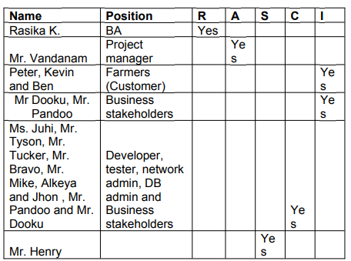
7. Help Mr Karthik to prepare a business case document
Ans: Mr. Henry initiated this project to help his farmer friends and other farmers. The framers in remote areas are facing the problem as not getting fertilizers, pesticides and seeds on time to perform their day to day farming activities. In the business case documents MR. Karthik needs to analyse the things like
A business case is a package of information, analysis & recommendations. A business case is prepared by Sr. BA, Business Architect & Pre-sales team. A business case also helps in identifying key stakeholders who are affected by the problem.
1. Why is this project initiated?
2. What are the current problems?
3. What are the resources required?
4. How much organizational change is required to adopt this technology?
5. With this project how many problems could be solved?
6. Time frame to recover ROI?
7. How to identify Stakeholders? This mobile application will be beneficial for all the farmers, fertilizers and pesticides companies. The time frame for return on investment is 4 to 5 years. To complete this project we need PM, BA, software developers, testers, technical team, DB. We need some organizational changes.

8. The Committee of Mr. Henry , Mr Pandu , and Mr Dooku and Mr Karthik are having a discussion on project development approach.
Mr Karthik explained to Mr. Henry about SDLC. And four methodologies like Sequential Iterative Evolutionary and Agile. Please share your thoughts and clarity on Methodologies

Ans: - 1. Sequential- This waterfall model is referred as a linear –sequential life cycle model. It is simple and classic life cycle model. In this waterfall model each phase must be completed and review is done and if project is good to continue, then only next phase will start or project can be discard. In this sequential –waterfall methodology below are the stages. 1. Requirement gathering
2. Requirement analysis
3. Design
4. Development- Coding
5. Testing
6. UAT
7. Configuration management
8. Deployment
2. Iterative-RUP ( Rational Unified Process)- The Rational Unified Process is an iterative software development process framework. RUP is based on a set of building blocks describe what is to be produced, the skill required and setp by step explanation how we can achieve or develop goal. It has four project life cycle phase i) Inception- what we build ii) Elaboration- del or design need to deliver iii) Contraction- implementation iv) Transition- delivery, defect correction, UAT.
3. Evolutionary- This spiral model gives more emphases placed on risk analysis. The spiral model has four phases: 1. Planning, 2.Risk analysis, 3. Engineering,4. Evaluation. This model is good for large and critical projects.
4. Agile- Scrum – This model can be implemented in which project the faster delivery is required. No documentation. There are 12 principles of this software – Late changes are accepted, All projects and business people should work together daily. Fast delivery of software. It has face to face conversation within Development team.
9. They discussed models in SDLC like waterfall RUP Spiral and Scrum . You put forth your understanding on these models. When the APT IT SOLUTIONS company got the project to make this online agriculture product store, there is a difference of opinion between a couple of SMEs and the project team regarding which methodology would be more suitable for this project. SMEs are stressing on using the V model and the project team is leaning more onto the side of waterfall model. As a business analyst, which methodology do you think would be better for this project.
Ans- 1.Waterfall - waterfall methodologies where each phase must be completed in its entirety before the next phase can being and at the end of each phase, a review takes place to determine if the project is on the right path whether or not continuous or discard the project.
2. Rational unified process is based on a set of building blocks or content elements describing what is to be produced the necessary skills required and the step-by-step explanation describing how specific development goals are to be achieved.
3. Spiral in the model gives more emphasis placed on risk analysis, it has four looks out to work planning, risk analysis, engineering, and evaluation.
4. Agile scrum in the scrum model where can implement either at the beginning of the project or when you sense that project is falling behind schedule. The V model SDLC methodology would be best for this project. This is small project and V model works well for small project. In this project the requirements are very well understood. And in this V model, in each phase testing and review process done, so we will know the project is going on correct path or not.
10. Write down the differences between waterfall model and V mode.
Ans: Waterfall model V-model
1.The waterfall model is simple. The V mode is intermediate.
2. The waterfall model is rigid. The V model is little flexible.
3. Re-usability of model is limited. V-model can be Re-use for some extent.
4. Waterfall model’s steps move in a linear way. V-model’s steps don’t move in linear way.
5. The cost of Waterfall model is low. V model is expensive.
6. Waterfall model is a continuous process. V model is a simultaneous process.
7. In Waterfall model testing activities start after the development activities are over in V-model testing activities start with the first stage.
8.Guarantee of success through Waterfall model is low. Guarantee of success through V model is high.
9. Software made using Waterfall model, the number of defects is less in comparison of software made using V model. Software made using V-model, the number of defects is greater in comparison of software made using Waterfall model.
10.Waterfall model is less used now-a-days in software engineering. V-model is widely used in software engineering.

Q.11.Justify your choice- As a BA, state your reason for choosing one model for this project. Ans- As a BA, I would like to choose V model for this project as this is a small project. Also the V model is very flexible and in each phase testing and review process done.
Q.12. The Committee of Mr. Henry, Mr Pandu, and Mr Dooku discussed with Mr Karthik and finalised on the V Model approach (RG, RA, Design, D1, T1, D2, T2, D3, T3, D4, T4 and UAT) Mr Vandanam is mapped as a PM to this project. He studies this Project and Prepares a Gantt chart with V Model (RG, RA, Design, D1, T1, D2, T2, D3, T3, D4, T4 and UAT) as development process and the Resources are PM, BA, Java Developers, testers, DB Admin, NW Admin.
Ans- Gantt Chart
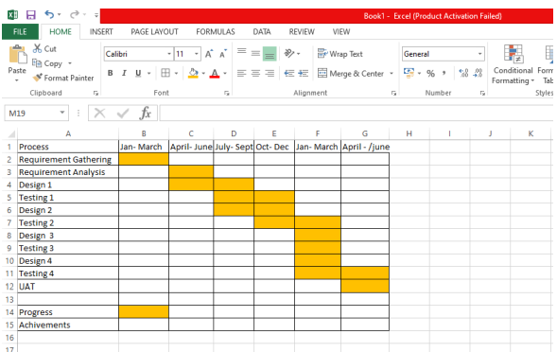

13. Explain the difference between Fixed Bid and Billing projects

Ans: In simple terms, a Fixed Bid project means the client pays a set amount upfront, regardless of the actual time or resources used. Conversely, a Billing project (often referred to as "Time and Materials" or "T&M") means the client pays based on the time spent and materials used on the project.

Fixed Bid (or Fixed Price):
- Price: A predetermined, fixed price is agreed upon before the project starts.
- Scope: The project scope is well-defined and should be relatively stable.
- Time: Requires a start and end date, as it's duration-based.
- Flexibility: Less flexible to changes in scope, as any changes may require additional negotiation and a new contract.
- Risk: The vendor (the one delivering the project) bears more of the financial risk, as they must manage costs within the fixed budget.
- Suitable for: Clear and well-defined projects with a stable scope and budget.
Billing (Time and Materials):
- Price:
The client is billed based on the actual time spent and materials used.
- Scope:
Can be more flexible to changes in scope as the project progresses, as the client is typically billed for any changes.
- Time:
Can be more indefinite, with potential for project extensions depending on the scope and actual time needed.
- Flexibility:
Allows for more flexibility in budget adjustments based on actual hours worked and materials used.
- Risk:
The client (the one paying for the project) typically bears more of the financial risk, as they are responsible for the actual costs.
- Suitable for:
Projects where the scope is not yet clearly defined or may change significantly, or for long-term projects.
Question 14 – Preparer Timesheets of a BA in various stages of SDLC
➢ Design Timesheet of a BA, Development Timesheet of a BA, Testing Timesheet of a BA, UAT Timesheet of a BA, Deployment n Implementation Timesheet of a BA
Ans: Design Time sheet of BA
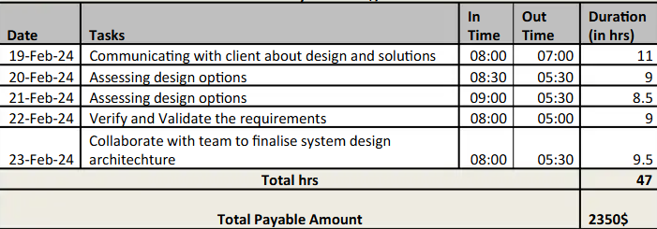
Development Timesheet:
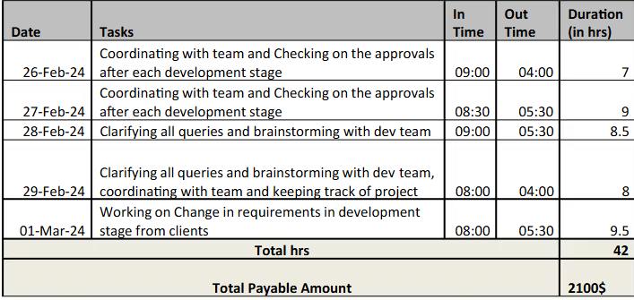
Testing Timesheet:
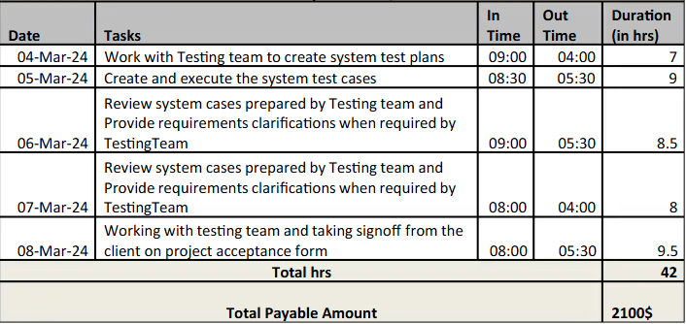
UAT Timesheet: 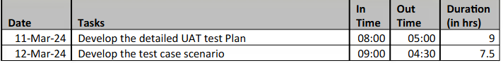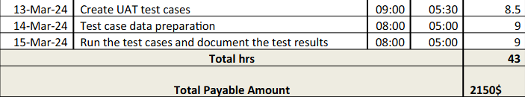
Deployment & Implementation timesheet:
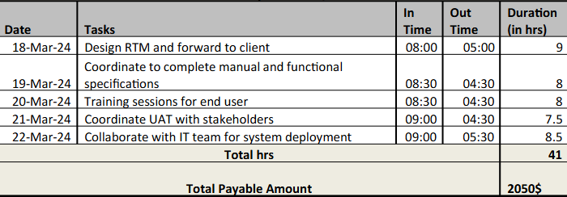
RA Timesheet of a BA : After gathering requirement we will do analysis through techniques . Design Timesheet of a BA: Once the analysis completed we will design the product, Development
Timesheet of a BA : Developer team will design the product.
Testing Timesheet of a BA : Testing team will do testing of the developed product.
UAT Timesheet of a BA : This UAT testing will be done by BA. Deployment n Implementation Timesheet of a BA: after user acceptance test done, then deployment and implementation will be done.

